Some considerations on the construction and operation technology of water mills in the Surkhan oasis
Sanjar Choriyev
Termiz State University, Termiz, Uzbekistan
^{a)} Corresponding author: sanjarchoriyev593@gmail.com
Abstract. The article examines the construction, operation, and role of water mills in the Surkhan Oasis (Uzbekistan) during the 19th–20th centuries in meeting the population's demand for grain products. The research details the traditional technology of water mills, developed over centuries, including the selection and preparation of millstones, the operation of the mechanism (axle, water wheel, flume, mill wheel), and how they produce high-quality flour. The study emphasizes the superior quality and natural properties of flour produced by water mills and draws attention to the potential for the continued relevance of this ancient technology under modern development conditions.
INTRODUCTION
At the end of the 19th and beginning of the 20th century, water mills played a significant role in meeting the grain demands of the population in the Surkhan Oasis. According to sources, in the late 19th and early 20th centuries, there were 128 water mills in Sherobod, 105 in Denov, and 66 in Boysun. Water mills continued to be widely used in the oasis until the 1950s, and in mountainous villages, the use of this ancient technology persisted until the 1960s.

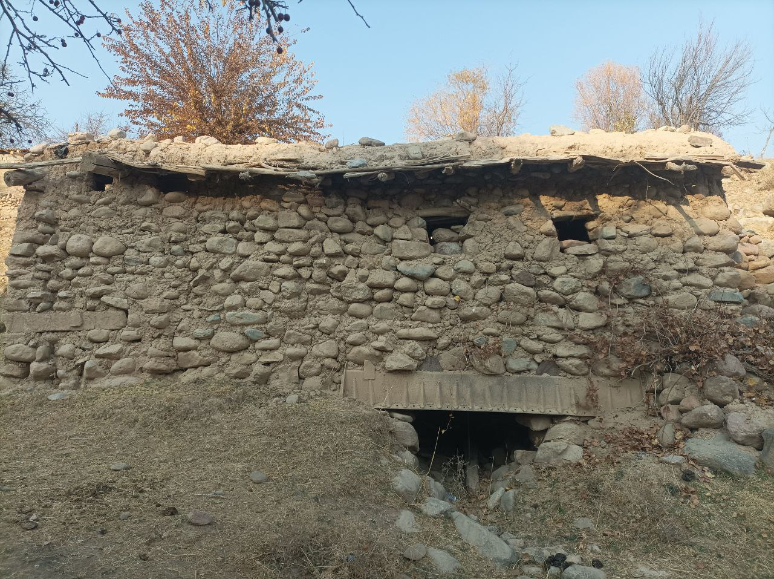 | 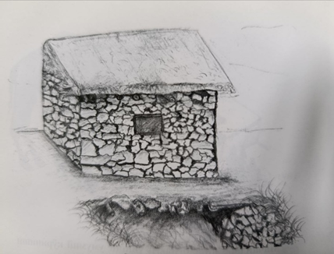
a) | b)
FIGURE 1. Three images show a 20th-century watermill and millstones. a) View of the existing water mill in the Konpurtepa area. b) A view of a 20th century water mill

EXPERIMENTAL RESEARCH
This research is dedicated to studying the traditions of watermill craftsmanship in the Surkhandarya oasis. The study is primarily based on fieldwork, i.e., examining mill remnants, conducting interviews (oral history method) with the last master craftsmen in this field and local residents, as well as analyzing archival data and previously conducted written sources. The main methods of data collection consist of:
- Practical observations: studying the condition of mill remnants, stones, and wooden mechanisms.
- In-depth interviews with specialists (master craftsmen from the later period) and local residents.
- Comparative analysis of historical and ethnographic sources.
The research focuses on the core component of the watermill—the technology of preparing the millstone, the criteria for its selection, and the general operating principle of the mill. Simultaneously, the study examined the mill equipment, the traditional materials and methods used in their construction and installation, as well as the historical geography of mill usage.
RESEARCH RESULTS
The following results were obtained during the research process:
1. Historical Significance and Distribution of Watermills: Watermills were widely used in the oasis until the 1950s and in mountainous regions until the 1960s as a primary auxiliary production tool. Although their importance later declined in the plains, they remained the main grain grinding tool in mountain villages for a long time.
2. Millstone Preparation Technology: Material Selection: Only hard, bluish-grey granite stones were selected for millstones. One of the most important criteria for the stone was that it must not produce sand (fine sandstone particles) during the grinding process. Such a defect could spoil the quality of the flour and render the craftsman's labor futile. Stone Sources and Preparation: In the Surkhandarya oasis, millstones were mainly quarried from deposits near the villages of Shalkon and Sherjon in the Poskhurd-Zarabog depression. Transporting the stones down from the mountains using horses, on sleds, or by sliding them over logs was a difficult process. Shaping and Tools: The stone was "hewn" (shaped) in a special workshop. Tools used included a metal file, polishing stone, chisel, drill, and various hammers.
Sizes: Millstones were prepared according to order and the power of the water source. Stones with a thickness of 15 cm and a diameter of 0.8-0.9 m were used for small spring streams, while stones with a thickness of 20-30 cm and a diameter of 1.2 m were used for large canals.
3. Mill Construction and Operating Principle: Structure: A watermill consists of two stones (a rotating upper stone and a stationary lower stone), a metal axle connecting them, a water chute (nov), a waterwheel (charx), a grain hopper (döl), and a flour collection area (oxur).
Mechanism: Water channeled from a height (3-6 meters) through the nov strikes the charx, setting it in motion. The charx rotates the upper millstone via the axle. Grain fed evenly from the döl is ground between the stones and emerges as flour. Materials: Almost all parts of the mechanism (nov, charx, döl, bowl (chanoq), oxur) were made from local types of wood—mulberry, poplar, and others. The rotating joints of wooden parts were lubricated with linseed oil.
Master Craftsmen: Dynasties of master craftsmen, such as Boboyor, Usmon, and Doniyor from Zarabog, passed down the craft of making and installing millstones from generation to generation.
4. Alternative Grain Grinding Methods: Apart from the main device—the watermill—the following traditional tools were used domestically: Yorg'ichoq: A hand-operated grinder consisting of two circular stones. The upper stone was rotated using a wooden lever.
Keli: A tool made of wood or stone, used with a pestle (kosov) to pound grain, separating it from the husk or for grinding.
CONCLUSIONS
The watermill was a developed traditional technology that was in practice in the Surkhandarya oasis, particularly in mountainous regions, until the mid-20th century. It successfully integrated local resources (granite stone, mulberry and poplar wood), natural power (water flow), and high-level craftsmanship.
The process of selecting, preparing, and installing the millstone was highly complex, requiring deep knowledge, skill (mastery), and significant physical labor. The quality of the stone (its property of not producing sand) directly affected the quality of the flour and bread. The mill's construction was adapted to local conditions (water flow force, topography), distinguished by its simplicity, reliability, and energy efficiency. The design and functionality of the wooden mechanisms demonstrate a high level of engineering.
The advantages of flour ground in a watermill – the grain not overheating, preserving its natural flavor and pleasant aroma, and the bread made from it not going stale for a long time – are still valued today.
Although the practical use of watermills has sharply declined due to the widespread adoption of modern technology and electrical energy, they retain their historical, cultural, and scientific significance as an important element of the region's material culture, technological development, and traditional knowledge system. This tradition is a valuable heritage, demonstrating the existence of local schools of craftsmanship and the master-apprentice system
REFERENCES
- "Central Statistical Department of the Central Executive Committee of the USSR" Materials of the All-Union Population Census of 1926 in the Uzbek SSR. Issue I. Population Census. - Samarkand, 1927.153-157 p.
- Qobilov E. Surkhon Oasis Farm. Tashkent: Akademiknashr, 2012. 275 p.
- Qobilov, E. Field notes on the water mills of the Surkhan oasis (Zarabog village, Sherabad district). Personal archive of Eshbolta Qobilov, Termez State University, Termez, Uzbekistan. (1999).
- Qobilov, S. Field notes on the water mills of the Surkhan oasis (Salovat village, Termez district). Personal archive of Eshbota Qobilov, Termez State University, Termez, Uzbekistan. (2000).
- Choriyev, S. Field notes on water mills and traditional grain grinding methods of the Surkhan oasis (Konpurtepa, Sherabad district). Personal archive of Sanjar Choriyev, Termez State University, Termez, Uzbekistan. (2018).

