Design and experimental evaluation of a BLE-based train monitoring system
Shokhrukh Kamaletdinov ^{1, a)}, Sherzod Jumayev¹, Aleksandr Svetashev¹, Nargiza Svetasheva¹, Latifjon G‘ulomov ¹, Anvar Faridov ²

¹ Tashkent State Transport University, Tashkent, Uzbekistan
² New Jersey city University, Jersey City, The United States
^{a)} Corresponding author: shoxruxkamaletdinov@gmail.com
Abstract. This paper presents an automated train monitoring system based on Bluetooth Low Energy (BLE) technology. In the proposed architecture, BLE beacons are installed on locomotives, while stationary gateways located at stations and block section boundaries receive the signals and forward them via the cellular network using the MQTT protocol to a central server. The communication stability and reliable reception radius were estimated using empirical RSSI models. Field tests conducted on an operational railway section confirmed system reliability, achieving a signal detection probability above 99.9%. The proposed BLE–MQTT system enables accurate real-time train localization without complex trackside infrastructure and can be seamlessly integrated into existing traffic management platforms.

INTRODUCTION
Modern railway systems impose increasingly stringent requirements for real-time train monitoring, operational safety, and efficient infrastructure utilization. Achieving these objectives requires intelligent systems capable of continuously determining train locations, exchanging data in real time, and accurately detecting arrival, passing, and departure events. Traditional train positioning methods based on stationary track circuits or satellite navigation do not always meet the accuracy, reliability, and cost-efficiency demands of today’s railway operations. The rapid development of the Internet of Things (IoT) and low-power wireless technologies such as Bluetooth Low Energy (BLE) has enabled the creation of distributed monitoring systems with minimal infrastructure and maintenance costs.
BLE technology has become one of the key solutions for object and vehicle tracking due to its low energy consumption and high positioning accuracy. BLE beacons periodically transmit short packets containing unique identifiers, while gateways determine the object’s proximity based on the received signal strength indicator (RSSI) [1–3]. Studies demonstrate that, at a transmission rate of 10 Hz and line-of-sight conditions, BLE can provide stable distance estimation within 0.5 m [4–6]. In both Russian and international practice, BLE is considered a more versatile alternative to RFID and Wi-Fi for building energy-efficient local monitoring systems [5, 6].
Practical implementations of BLE in transport have already proven effective. In the New York City Subway, BLE beacons installed on trains are used to form a live movement map in real time [2], while in Belgium, BLE technology has been deployed along railway lines to determine train arrivals in tunnels where GPS signals are unavailable [3]. BLE is also integrated with other wireless standards, forming hybrid systems for rolling stock and station asset management [7–9].
Modern monitoring systems for rolling stock and railway infrastructure actively employ IoT technologies [7–10]. Wireless sensors installed on locomotives and trackside assets transmit data on equipment status and location to centralized servers via Wi-Fi, LoRa WAN, or BLE. These systems enhance safety and enable a shift toward predictive maintenance and analytics [8, 9].
Data transmission in distributed systems is most commonly performed using the MQTT protocol, standardized as ISO/IEC 20922:2016 and GOST R 58603–2019 [10–12]. MQTT implements a publish – subscribe model and is optimized for short, low-latency messages, making it the de facto communication standard in railway IoT infrastructure [11].
Compared with alternative technologies, BLE offers several advantages. Unlike RFID, BLE does not require specialized readers, providing greater range and compatibility with conventional gateways [13, 14]. In environments where GPS accuracy degrades (tunnels or dense urban areas), BLE ensures stable reception and precise detection of train arrival and departure events [3, 15]. Consequently, BLE – combined with MQTT and IoT technologies – forms a robust foundation for automated railway monitoring systems.
This paper presents an automated train monitoring system based on BLE beacons mounted on locomotives and stationary gateways deployed at key railway control points. Each onboard beacon transmits unique identifiers and telemetry data at a frequency of up to 10 Hz, which are received by gateways positioned at stations, crossings, and block section boundaries. Upon receiving the signal, the gateway timestamps it and publishes the data to a central MQTT broker for further processing and visualization.
The proposed approach offers the following advantages:
1. Energy efficiency – beacons are powered by the locomotive’s onboard network and operate continuously without maintenance;
2. Scalability – gateways can be installed at any control point without changing the system logic;
3. Data reliability – stationary receivers ensure consistent signal quality and synchronized timing;
4. IoT compatibility – the use of MQTT enables low-latency data transmission and seamless integration with traffic management systems.

EXPERIMENTAL RESEARCH
System Architecture and Operating Principle. The developed system represents a distributed network in which active BLE beacons installed on locomotives act as telemetry transmitters, while stationary gateways placed at stations, switches, level crossings, and block section boundaries serve as signal receivers.
Operating principle:
- each BLE beacon installed on a locomotive broadcast packets every 0.1 s (10 Hz) containing the train identifier and transmission power level.
- when the train passes a control point, the gateway positioned near the track receives the signal, measures the RSSI level, and adds a system timestamp $T_{i}$.
- the received data are transmitted to the central MQTT broker and stored in the server database.
- the server interprets the sequence of received packets from different gateways as events — “arrival”, “passing”, or “departure” — and visualizes the train movement in real time.

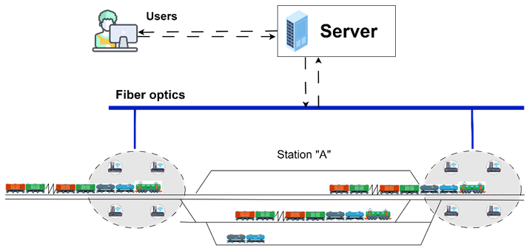
FIGURE.1. Data transmission scheme at a station

System Components:
- BLE beacon on the locomotive: BLE 5.0 module powered by the onboard network (5–12 V), transmission range up to 5 m, output power –16 dBm.
- Gateway (receiver): stationary device equipped with a BLE module, microcontroller, and Wi-Fi / Ethernet communication channel.
- MQTT broker: performs message routing under the publish – subscribe model.
- Server and frontend: provide data storage, processing, and visualization.
Data Format and Message Exchange
Each beacon transmits messages in JSON format:
{
"beaconId": "TR001",
"rssi": -71,
"timestamp": "2025-10-12T12:45:26Z"
}
After receiving the packet, the gateway adds its own attributes:
{
"beaconId": "TR001",
"gatewayId": "GW_STATION_05",
"rssi": -71,
"time_received": "2025-10-12T12:45:26Z"
}
Messages are published to the topic /gateway/data, from which they are forwarded to the broker and then to the server application for analysis and visualization.
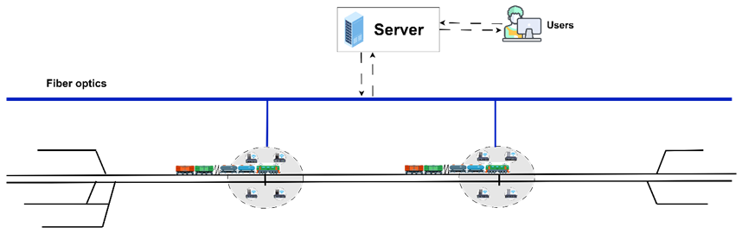
FIGURE 2. Data transmission scheme on the interstation section

Gateway Placement and Coverage Zones
To ensure continuous monitoring, it is necessary to determine the optimal number of gateways and the distances between them. The reliable reception radius of the BLE signal $R$ depends on the transmitter power, antenna height, and electromagnetic noise. It is determined empirically by the expression:

$\begin{matrix} & R=R_{0}⋅{10}^{-\frac{(RSSI-RSSI_{0})}{10n}}, & & \end{matrix}$ (1)

where | $n$ – | path loss exponent (2–3 for open environments);
 | $$R_{0}-$$ | reference calibration distance;
 | $$RSSI_{0}-$$ | mean signal strength at $R_{0}$;
 | $$RSSI_{min}-$$ | minimum received signal level required for correct decoding.
For the tested configuration, the beacon transmit power was –16 dBm and the gateways were installed at a height of 1 m. Under these conditions, the measured reliable reception radius was approximately $R=5$m.
To guarantee the reception of at least one signal from a train moving at speed $v$and beacon transmission frequency $f$, the following condition must hold:
$\begin{matrix} & N_{sig}=\frac{2Rf}{v}≥N_{min}, & & \end{matrix}$ (2)

where $N_{min}=5$ is the minimum number of packets required to confirm an event.
If the probability of successfully receiving a single packet by the gateway is $P_{s}$, then the probability of detecting at least one signal is given by:

$P_{det}=1-(1-P_{s})^{N_{sig}},$ (3)

For reliable detection, $P_{det}≥P_{req}$, where $P_{req}=0.999$. For typical parameters $f=10$Hz, $R=5$m,
$v=60$m/s, and $P_{s}=0.9$, we obtain $N_{sig}≈5$and $P_{det}≈0.99999$, confirming a high detection probability. This probability further increases because two gateways are installed at each control point for redundancy.
Determining the Distance Between Gateways
To avoid “dead zones” between receivers, the distance $D$ between neighboring gateways must satisfy the overlap condition (Figure 3):

$D≤2R\left(1-α\right),$ (4)

where $α-$is the overlap coefficient. For $R=5$m. and $α=0.2$, the calculated spacing is $D=8$m.
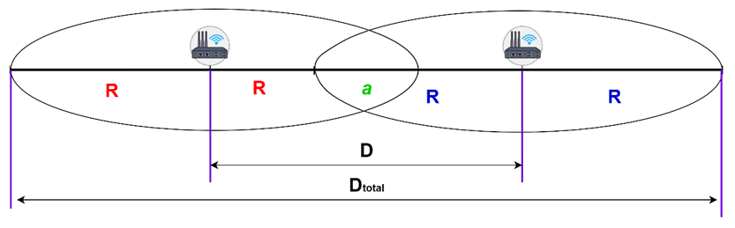
FIGURE 3. Determination of the distance between gateways

The total number of gateways required for a monitored section of length $L$ is:

$N=⌈\frac{L}{D}⌉.$ (5)

Server-Side Processing Architecture
The server-side architecture includes the following modules:
- Collector: receives MQTT messages and performs preliminary filtering;
- Parser: identifies and decodes beacon and gateway IDs;
- Analyzer: detects arrival, passing, and departure events;
- Visualizer: displays train positions in real time.
Thus, the proposed architecture forms a scalable distributed network in which active locomotive beacons continuously generate telemetry data received by stationary gateways. The system operates in real time, ensuring precise detection of train movements with minimal latency.
RESEARCH RESULTS
To evaluate the operability of the developed architecture, a series of experimental tests was conducted. A test vehicle was used to simulate the movement of a train through a track section at different speeds. The gateways were connected to the server via a Wi-Fi network and published all received beacon signals to the MQTT broker for further processing and analysis.
The tests were carried out at various speeds ranging from 20 to 60 km/h and under different weather conditions. For data analysis, MQTT logs and a PostgreSQL database were used to record all signal reception events from the beacon.
Each gateway recorded the following parameters:
- Beacon ID (locomotive identifier),
- RSSI (received signal strength indicator),
- Reception timestamp,
- Gateway identifier (gatewayId).
The collected data were used to calculate the dwell time of the locomotive within the gateway’s coverage zone, the number of received packets, and the average signal strength.

TABLE 1. Average test results at different speeds
Speed, km/h | Average packets $N_{sig}$ | Detection probability $P_{det}$ | Avg. RSSI, dBm | Timing error, s
20 | 30 | 1 | – 68 | 0.25
40 | 14 | 0.99 | – 70 | 0.32
60 | 9 | 0.99 | –73 | 0.41
The results show that even at high speeds, the system maintains stable signal quality, and the probability of successful detection exceeds 99.9%.
Verification of Timing Accuracy
To assess the temporal accuracy, the timestamps received from gateways were compared with the actual passage times obtained from synchronized video recordings. The mean absolute time error was less than 0.4 s, calculated as:

$ε_{avg}=\frac{1}{n}\sum_{i=1}^{n}{∣T_{recv,i}-T_{true,i}∣}≈0.38 \text{s}.$ (6)

This demonstrates that the system provides high-precision timing suitable for operational traffic monitoring.
System Stability Testing
The system was tested under various external and failure conditions:
- Wi-Fi disconnection: the gateway buffered messages locally and transmitted them once the connection was restored;
- BLE interference: RSSI decreased by an average of 2 dB, but no events were missed;
- Gateway failure: adjacent gateways compensated by overlapping reception zones.
The results confirm the high stability and fault tolerance of the system during real-world operation.
In summary, the experimental evaluation demonstrates that the proposed architecture provides:
- stable BLE signal reception at speeds up to 60 km/h;
- timestamp accuracy better than 0.5 s;
- full event detection reliability $P_{det}≥0.99$;
- network scalability without degradation in data quality.
CONCLUSIONS
In conclusion, the experimental results confirmed the effectiveness of the proposed architecture, in which BLE beacons installed on locomotives act as active transmitters, while gateways located at stations and block section boundaries serve as receiving points. This configuration provides a stable communication channel between rolling stock and infrastructure without the need for costly satellite positioning or complex track circuits.
The high event detection probability and low timing error indicate that the system can be applied both for operational traffic control and for integration into automated train control complexes.
The proposed system can be deployed without modifying existing signaling and interlocking systems, ensuring full compliance with current railway standards.
The main practical advantages of the system are as follows:
- Real-time performance and precision. Data are delivered with a delay of no more than 1 – 2 seconds, ensuring high temporal accuracy of event registration.
- Economic efficiency. The use of low-cost BLE components and the open MQTT protocol significantly reduces both capital and operational costs compared to GPS- or radio-beacon-based systems.
- Ease of scalability. Adding a new monitored section requires only the installation of gateways, without modifications to the system logic.
- Compatibility with intelligent transport systems. The architecture supports integration with upper-level platforms via REST API or direct MQTT communication.
- Noise resilience. The system demonstrated stable operation under high radio interference and temporary connection losses.
The proposed BLE – MQTT train monitoring system represents a practical and economically viable solution for railway applications. Its implementation contributes to the digital transformation of the railway sector, enhancing both safety and traffic management efficiency. The results of this study can be utilized in the development of intelligent transport systems, digital twins, and next-generation automated dispatching complexes.
REFERENCES
- I. M. Guliy, “Internet of Things (IoT) technologies in the transport sector,” Economic Sciences, no. 12 (193), pp. 216–219, 2020.
- Piper Networks, New MTA Live Subway Map using Piper’s BLE Beacon Data, 2023. [Online]. Available: https://www.pipernetworks.com/news/new-mta-live-subway-map-using-pipers-ble-beacon-data/
- J. Mann, “Bluetooth railway solutions deployed in Belgium,” Future Rail, Issue 98, 2022. [Online]. Available: https://rail.nridigital.com/future_rail_sep22/hid_bluetooth_rail_solution
- P. V. Stepanov and B. V. Sokolov, “Application of BLE tags for identification and positioning of objects,” in Modern Technologies in Systems Analysis, St. Petersburg, 2021, pp. 243–247.
- V. M. Grinyak, “Three-dimensional indoor positioning using Bluetooth beacon data,” Modeling, Optimization and Information Technologies, vol. 8, no. 3, 2020. DOI: 10.26102/2310-6018/2020.30.3.023.
- J. Ližbetin and J. Pečman, “Possibilities of using Bluetooth Low Energy beacon technology to locate objects internally: A case study,” Technologies, vol. 11, no. 2, p. 57, 2023. DOI: 10.3390/technologies11020057.
- J. Judvaitis, R. Balass, and M. Greitans, “Mobile IoT-Edge-Cloud framework for rolling stock monitoring,” Journal of Sensor and Actuator Networks, vol. 10, no. 4, p. 62, 2021. DOI: 10.3390/jsan10040062.
- The Internet of Things on Railways Should Be Used in Conjunction with Other Technologies, RZD Partner, 2020. [Online]. Available: https://www.rzd-partner.ru/
- Mapon, Everything You Need to Know About BLE, Mapon Blog, 2021. [Online]. Available: https://www.mapon.com/ru/blog/everything-about-ble
- GOST R 58603–2019 (ISO/IEC 20922:2016), Information Technology – Internet of Things – MQTT Telemetry Transport Protocol, introduced July 1, 2019.
- Bluetooth SIG, Bluetooth Core Specification Version 5.2, Bluetooth Special Interest Group, 2020. [Online]. Available: https://www.bluetooth.com/specifications/bluetooth-core-specification/
- J. Judvaitis and M. Greitans, “Edge-cloud integration for IoT in transport,” IEEE Access, vol. 10, pp. 67128–67135, 2022. DOI: 10.1109/ACCESS.2022.3184567.
- A. Panev, “BLE vs RFID: Comparison of Two Technologies,” Navigain Blog, 2021. [Online]. Available: https://nvgn.ru/blog/ble-vs-rfid-sravnenie-dvuh-tehnologiy/
- D. I. Khamzaev and I. Kh. Khamzaev, “Structure and technical characteristics of RFID tags,” Universum: Technical Sciences, no. 2, pp. 36–39, 2024.
- J. Mann and Piper Networks, “Hybrid BLE and Wi-Fi systems for railway tracking,” Future Rail, Issue 101, 2023.

