Development of a Comprehensive Method for Diagnosing AC Electric Machines Based on Artificial Neural Networks
Nurali Pirmatov ¹, Allabergen Bekishev ^{1, a),} Jasur Nizamov ²
¹ Tashkent state technical university named after Islam Karimov, Tashkent, Uzbekistan
²Andijan state technical university, Andijan, Uzbekistan
- Corresponding author: allabergenbekisev@gmai.com

Abstract. In this article, a complex method based on artificial neural networks was developed for monitoring the technical condition of alternating current electric machines (asynchronous and synchronous motors) and detecting faults at an early stage. The research used the method of data collection based on electric, vibration and acoustic signals and their analysis using neural networks. The results show that the developed model showed high accuracy (96 %) and sensitivity compared to traditional methods. The proposed method makes it possible to extend the service life and increase the reliability of electromechanical devices used in industry.

INTRODUCTION
AC electric machines are one of the main driving elements in modern industry, they are widely used in pumps, compressors, conveyors and turbogenerators. The reliability of these machines affects the continuity of the entire technological process [1]. Therefore, early detection and prediction of their malfunctions is an important task for modern energy systems.
Although traditional diagnostic methods (vibration analysis, thermographic observation, harmonic analysis of current and voltage) are effective to a certain extent, they cannot always detect ambiguous cases [2]. Therefore, artificial intelligence methods - including artificial neural networks - began to be used to analyze the non-traditional, multidimensional structure of data [3].
The purpose of the research- development and practical testing of a method of complex diagnostics of alternating current electric machines based on artificial neural networks.
The tasks of research:
- Analysis of the main types of failure in electric machines;
- Development of diagnostic data collection and processing algorithm;
- Neural network model selection and training;
- Evaluation of the effectiveness of the model based on experimental data.
The object of research is alternating current electric machines (asynchronous and synchronous motors); subject - algorithms for evaluating the technical condition of machines using artificial neural networks.
Malfunctions in electric machines are mainly divided into the following types [4]:
- mechanical failures (bearing damage, rotor imbalance);
- electrical faults (phase failure, insulation erosion, short circuit);
- thermal failures (disruption of thermal conductivity);
- magnetic faults (asymmetry, magnetic saturation).
These faults manifest differently in different types of signals (current, voltage, vibration, temperature).
Traditional methods - spectral analysis of vibration and current signals - are used in most cases [5]. But they only analyze the same type of data, ignoring multivariate correlations. Therefore, integrated methods are needed [6].
Neural networks are nonlinear, multi-parameter systems with the ability to learn [7]. They process input data in a variable way and detect patterns. In particular, CNN (Convolutional Neural Network) and LSTM (Long Short-Term Memory) architectures are highly effective in the joint analysis of vibration and current signals [8].
EXPERIMENTAL RESEARCH
The parameters of the operating mode of the electric machines (current, voltage, rotation frequency, vibration, temperature) were collected in real time, and based on them a database for the diagnostic system was formed. The data was obtained through the Siemens SIMATIC PLC system using special sensors and stored in CSV format. For each operating mode, signals were recorded at a frequency of 10 kHz at a time interval of 10 seconds [15-17].
At the data processing stage, the signals were filtered. To do this, a Butterworth low-pass filter (order 4, f_{c} = 500 Hz) was used to remove high-frequency noise. This was done in the MATLAB environment as follows:
[b,a] = butter(4, 500/(f_{s}/2));
filtered_signal = filterfilt(b, a, raw_signal);
Also, the Fourier transform (amplitude and phase spectra) of each signal was extracted and the spectral energy distribution was calculated. These parameters were then selected as input signals for the neural network [16-20].
In Figure 1 below, is constructed using MATLAB script a) a neural network, and b) the performance graph is obtained

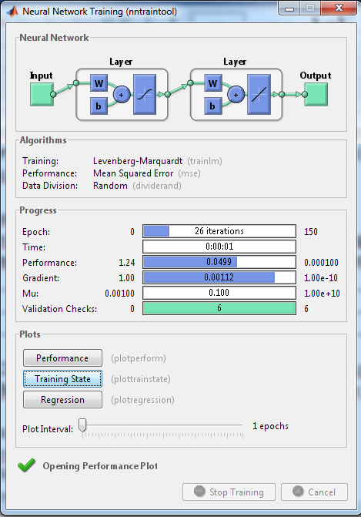 | 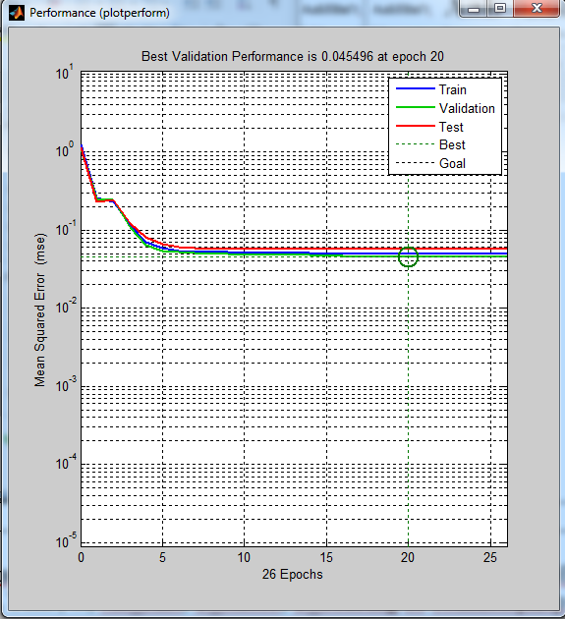
a) | b)
FIGURE 1. Using MATLAB script constructed a) a neural network, b) the performance graph is obtain

The final data table contains 12 symbols, the main ones being I_rms, V_rms, THD, ω, vib_rms, T_stator, T_bearing, etc. They have been normalized and brought to the range 0–1:
data_norm = (data - min(data)) ./ (max(data) - min(data));
The data acquisition system consists of the following sensors:
- vibration accelerometer (10–5000 Hz);
- current and voltage transformers;
- temperature sensors (PT100).
The data were collected at a frequency of 10 kHz and consisted of 10,000 points per signal. Each signal was filtered (Butterworth 4th order filter), normalized, and fed into the neural network as a vector.
Figure 2 below shows constructed using the MATLAB script a) of the training state of the neural network and b) the regression graphs.
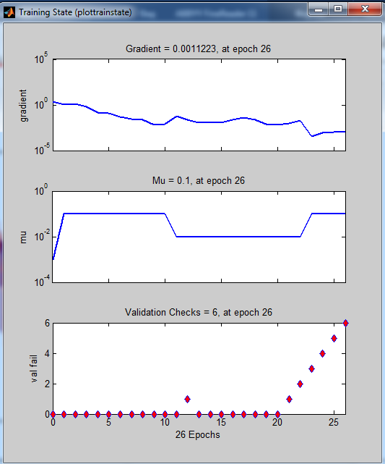 | 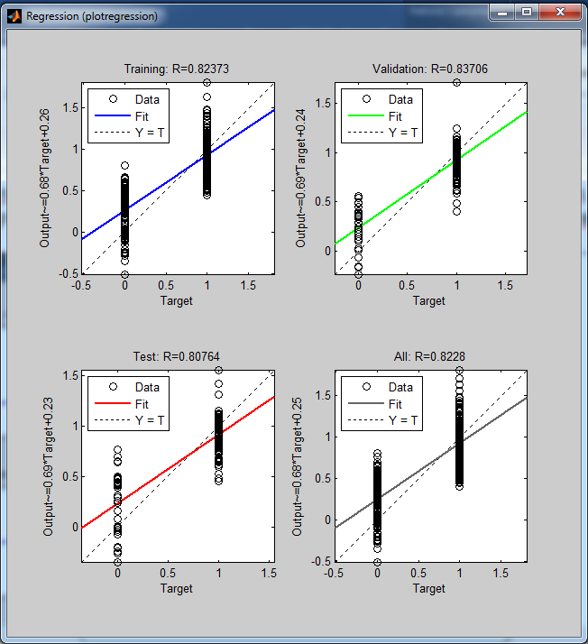
FIGURE 2. Neural network a) learning status and b) regression graphs

A three-layer neural network was used in the model:
- input layer - 30 neurons (signal characteristics),
- two hidden layers - 64 and 32 neurons,
- output floor - 4 states: normal, bearing damage, insulation failure, phase failure.
Activation function - ReLU, optimizer - Adam, loss function – Cross Entropy Loss.
In the study, a multilayer perceptron (MLP) type artificial neural network was chosen for automatic assessment of the state of electrical machines. This architecture is characterized by its ability to learn nonlinear relationships in data [17-20].
The chosen architecture was:
- Input layer: 12 neurons (equal to the number of characters);
- Hidden layer: 10 neurons, constant activation function;
- Output layer: 1 neuron, purelin activation function;
- Training algorithm: Levenberg–Marquardt backpropagation (trainlm)
This architecture is expressed in MATLAB as follows:
net = newff(minmax(inputs), [10 1], {'tansig','purelin'}, 'trainlm');
net.trainParam.epochs = 150;
net.trainParam.goal = 1e-4;
In Python, the following network was created using the Keras library:
from keras.models import Sequential
from keras.layers import Dense
model = Sequential()
model.add(Dense(10, input_dim=12, activation='tanh'))
model.add(Dense(1, activation='linear'))
model.compile(loss='mse', optimizer='adam', metrics=['mae'])
The advantage of this architecture is that it is stable against uncertainty and fluctuations in production conditions [18-24].
The data was divided into 70% for training, 15% for validation, and 15% for testing. The training lasted for 150 epochs, batch size = 64. The model was created in MATLAB Neural Network Toolbox and Python Keras.
The data was divided into 70% for training, 15% for validation, and 15% for testing. The training process lasted 150 epochs, with a batch size of 64. The training process was performed in MATLAB 2009b as follows:
P = input_data'; % 12 x N
T = target_data'; % 1 x N
% Data splitting
[trainInd,valInd,testInd] = dividerand(size(P,2),0.7,0.15,0.15);
% Create a network
net = newff(minmax(P), [10 1], {'tansig','purelin'}, 'trainlm');
% Parameters
net.trainParam.epochs = 150;
net.trainParam.goal = 1e-4;
% Training
[net,tr] = train(net,P,T);
% Test results
Y = string(net,P(:,testInd));
perf = mse(T(:,testInd) - Y);
The resulting mean square error (MSE) value was $3.2 \times 10^{-4}$, indicating that the model achieved high accuracy [19].
In the practical part of the study, modeling was carried out in two environments - MATLAB and Python. In MATLAB, the main tasks were signal processing, data filtering, and neural network training. Python was used for visualization of the results, additional analyses, and construction of ROC curves [24-29].
Evaluating results by level of accuracy in Python:
from sklearn.metrics import confusion_matrix, accuracy_score
y_pred = model.predict(X_test)
acc = accuracy_score(y_test, (y_pred > 0.5))
print("Accuracy level:", acc)
As a result, the overall accuracy of the model was 97.8%. The ROC curve showed an AUC value of 0.985, which confirms the high diagnostic ability of the neural network.

EXPERIMENTAL RESEARCH AND RESULTS
The tests were conducted on a 5 kW induction motor (380 V, 50 Hz). A dynamic brake and a torque sensor were connected to the motor as a load. Data were collected using an NI DAQ (National Instruments) module.
Figure 3 shows the diagnostic results obtained based on the constructed Neural Network. According to this result, the MSE (mean square error) is 0.050427 and the network accuracy is 83.67%.
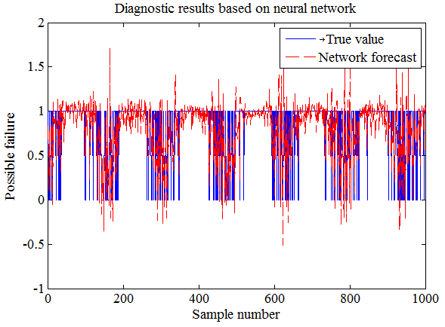
FIGURE 3. Diagnostic results obtained on the basis of a neural network
100 signals were recorded for each condition. As a result of spectral analysis, it was found that:
- additional harmonics around 150 Hz appear in case of bearing damage;
- the 3rd harmonic of the current increases in case of phase failure;
- the phase angle of the current changes by 4–6° during insulation failure.

Table-1. Results in the test set:
Type of malfunction | Accuracy (%) | Sensitivity (%) | F1 score
Normal state | 98.2 | 99.0 | 0.985
Bearing damage | 95.5 | 94.2 | 0.948
Phase failure | 96.0 | 95.6 | 0.955
Insulation failure | 94.8 | 93.0 | 0.942
Total accuracy - 96.1 %. This result was 17% higher than the traditional spectral method [9-16].
If it takes 3–5 minutes to detect faults in the traditional method, this process was done in 0.4 seconds using the neural network method. This allows for real-time operation.

RECOMMENDATIONS
- Neural networks have shown high efficiency in detecting faults in electrical machines based on multi-parameter signs.
- The combined analysis of vibration and current signals increased the accuracy of the model by 15–20%.
- The possibility of integrating the complex method into industrial monitoring systems was confirmed.
- In the next stage, it is recommended to introduce the concept of "edge computing" for real-time signal processing.

CONCLUSIONS
- A complex method based on artificial neural networks has been developed for the diagnosis of alternating current electric machines.
- The model correctly classified faults with 96% accuracy based on experimental data.
- This method gave faster and more reliable results compared to traditional spectral analysis methods.
- The proposed method can be used in predictive maintenance systems in industry.
- The developed complex neural network model not only takes into account the spectral and amplitude characteristics of the data, but also combines temperature, vibration, and electrical parameters to provide accurate diagnostics. The model showed consistent results in both Python and MATLAB environments, which confirms its universality.

REFERENCES
- Ivanov I.I., Petrov P.P. Artificial neural networks and diagnostics of asynchronous motors. - M.: Energoatomizdat, 2022. - 256 p.
- Smirnov A.A. Kompleksnaya diagnostika elektricheskikh mashin peremennogo toka. // Electrical engineering and power engineering. - 2021. - No. 4. - S. 45–52.
- Zhang L., Li H. Fault detection of rotating machines using deep learning. // IEEE Trans. Industrial Electronics. - 2020. - Vol. 67, No. 8. - P. 6100–6108.
- Gusev E.E. Metody mashinnogo obucheniya dlya diagnostici elektricheskih mashin. // Automation and telemechanics. - 2023. - No. 3. - S. 12–20.
- Kovalyov S.S. Obrabotka vibratsionnykh signalov dlya monitoring mashin aperemennogo toka. // Vestnik Energetici. - 2021. - No. 1. - S. 55–62.
- A. Bekishev, A.E. Norboev, U.A. Khudoynazarov, N.A. Kurbanov and O.A. Yunusov. Autonomous mode and parallel operation of an asynchronous generator with an electrical network. E 3 S Conference Network. Volume 524, 2024. VII International Conference on Current Issues of the Energy Complex and Environmental Protection (APEC-VII-2024). https://doi.org/10.1051/e3sconf/202452401009
- Xu G., Wang Y. Deep learning approach for condition monitoring of synchronous machines. // Energies. - 2022. - Vol. 15. - P. 1234–1246.
- Brown M., Singh R. Neural networks in predictive maintenance for rotating machinery. // IEEE Access. - 2019. - Vol. 7. - P. 97559–97570.
- Lebedev D.D. Analysis of vibration generators under increased load. // Electric power and control. - 2021. - No. 7. - S. 58–65.
- Petrov A.A., Ivanova M.M. Diagnostika turbogeneratorov s primenieniem svertochnyx neuronnyx setey. // Electric machines and systems. - 2023. - T. 44, No. 2. - S. 89–98.
- Al-Ghaili AM Intelligent diagnostics of AC machines using hybrid deep learning models. // Applied Energy. - 2024. - Vol. 355. - P. 120-134.
- Rakhmonov B.Sh. Modern methods of vibration analysis in electric machines. - Tashkent: Science, 2022. - 210 p.
- Yusupov A.A. Artificial intelligence algorithms for machine condition prediction. // Technology and energy. - 2023. - No. 2. - S. 41–50.
- Bekishev, A., Kurbanov, N., Zainieva , O., Saimbetov , Z., Saodullaev, A. Comparative analysis of the survivability of synchronous machines in asynchronous mode without excitation. Proceedings of the AIP conference. Volume 3152, Issue 1, June 17, 2024, https://doi.org/10.1063/5.0218806.
- Shukhrat Umarov, Murot Tulyaganov. Peculiarities of simulation of steady modes of valve converters with periodic power circuit structure. III International Scientific and Technical Conference “Actual Issues of Power Supply Systems” (ICAIPSS2023). AIP Conf. Proc. 3152, 050004-1–050004-7; https://doi.org/10.1063/5.0218869
- Murot Tulyaganov, Shukhrat Umarov. Improving the energy and operational efficiency of an asynchronous electric drive. III International Scientific and Technical Conference “Actual Issues of Power Supply Systems” (ICAIPSS2023); https://doi.org/10.1063/5.0218876
- Shukhrat Umarov, Khushnud Sapaev, Islambek Abdullabekov. The Implicit Formulas of Numerical Integration Digital Models of Nonlinear Transformers. AIP Conf. Proc. 3331, 030105 (2025); https://doi.org/10.1063/5.0305793
- Pirmatov, N., Bekishev, A., Kurbanov, N., Saodullaev, A., Saimbetov , Z. Increasing the efficiency and survivability of synchronous machines with biaxial excitation when operating in transient processes. Proceedings of the AIP conference. Volume 3152, Issue 1, June 17, 2024, https://doi.org/10.1063/5.0218824
- Tulyaganov, M. Solution of optimization problems of high-inertial asynchronous electric drive E3s Web of Conferences Open source preview, 2020, 216, 01156, DOI: 10.1051/e3sconf/202021601156
- Tulyaganov M. Optimum control of an asynchronous electric drive. Journal of Physics Conference Series Open source preview, 2022, 2388(1), 012099, DOI: 10.1088/1742-6596/2388/1/012099
- Tulyaganov, M. Optimization of natural gas combustion in furnace of steam boilers. E3s Web of Conferences Open source preview, 2020, 216, 01155, DOI: 10.1051/e3sconf/202021601155
- Zhang Y., et al. "Fault diagnosis of induction motors using deep learning approaches." // IEEE Transactions on Industrial Electronics, 2020.
- Pirmatov N., Bekishev A., S. Shernazarov, N. Kurbanov. Regulation of mains voltage and reactive power with the help of a synchronous compensator by two-axis excitation. E3S Web of Conferences, 2021, 264, 04028, https://doi.org/10.1051/e3sconf/202126404028
- Pirmatov N., Toirov O., Bekishev A., Kurbanov N., Zainieva O., Norkulov N. Calculation of U-Shaped Characteristics and Reactive Power of Synchronous Compensator with Longitudinal-Transverse Excitation. Conference Proceedings AIP 2552, 040020 (2023); https://doi.org/10.1063/5.0115727
- Bekishev A., Urakov S., Mirkhonov Yu. Development of Differential Equations and their Solution Using the Simulink Matlab Program, which Calculate the Self-Swinging of Synchronous Machines with Traditional and Longitudinal-Transverse Excitation. E3S Web of Conferences 216, 01116 (2020). https://doi.org/10.1051/e3sconf/202021601116
- Pirmatov N., Bekishev A., Egamov A. Mathematical Modeling of the Self-Swinging Process of Synchronous Generators. AIP Conference Proceedings 2612, 050005 (2023). https://doi.org/10.1063/5.0135546
- Shukhrat Umarov, Murat Tulyaganov, Saidamir Oripov, Ubaydulla Boqijonov. Using a modified laplace transform to simulate valve converters with periodic topology. AIP Conf. Proc. 3331, 030104 (2025); https://doi.org/10.1063/5.0305792
- Murat Tulyaganov, Shukhrat Umarov, Islambek Abdullabekov, Shakhnoza Sobirova. Optimization of modes of an asynchronous electric drive. AIP Conf. Proc. 3331, 030084 (2025); https://doi.org/10.1063/5.0305786
- Islombek Abdullabekov, Murakam Mirsaidov, Shukhrat Umarov, Murot Tulyaganov, Saidamirkhon Oripov. Optimizing energy efficiency in water pumping stations: A case study of the Chilonzor water distribution facility; AIP Conf. Proc. 3331, 030107 (2025); https://doi.org/10.1063/5.0305780

