The introduction of digital technologies to optimize the work of the transport sector of the republic of Uzbekistan
Rasuljon Khamraqulov, Shokhrukh Abdimuratov ^{a)}, Abdusalom Aliyev, Sabohat Kazakova
Tashkent State Transport University, Tashkent, Uzbekistan
^{a)} Corresponding author: shokirxuja8687@gmail.com
Abstract: This article contains information on ensuring the quality and improving the control of transport operation, studying and analyzing the state of this area, information on the legislative framework for improving road safety. Also, the laws and regulations of the country's leadership concerning the studied industry are given. The measures and measures taken and carried out within the framework of the program on the introduction of digital technologies to optimize the work of the transport sector of the Republic of Uzbekistan are listed. The priority directions of the Digital Uzbekistan 2030 program, strategic goals, priorities and medium– and long-term objectives for the development of the digital economy and e-government of the Republic of Uzbekistan are described. The results of the analysis, monitoring, and study on the implementation of the adopted program for the introduction of digital technologies in the country's transport sector are presented. Information is provided on plans and projects implemented in the future as part of the implementation of the program. In conclusion, conclusions are made about the results of economic efficiency, optimization of transport operation, as well as about the amenities and new opportunities provided to the population of the country.
INTRODUCTION
In the era of the formation of the modern information society, when information and knowledge have become a strategic factor of development, the development of the country and ensuring its competitiveness is associated with the introduction of modern information and communication and "digital" technologies in all spheres of society and the state [1-7].
To this end, on 05.10.2020, Presidential Decree No. PF-6079 was adopted.on the approval and measures for its effective implementation of the Digital Uzbekistan 2030 strategy.
The decree approved:
1. The Digital Uzbekistan 2030 Strategy, as well as the Roadmap for its implementation. The roadmap for the implementation of the strategy covers the development goals of e-government, digital industry, digital education and digital infrastructure.
2. Programs of digital transformation of territories and industries for 2020-2022.
Within the framework of the program: ¬
- to increase the level of connection of settlements to the Internet, including by increasing the number of broadband access ports to 2.5 million, the construction of 20 thousand km of fiber-optic communication lines and the development of mobile communication networks, will be increased from 78% to 95%;
- implementation of more than 400 information systems, electronic services and other software products in various areas of socio-economic development of the regions;
- organization of training in the basics of computer programming with coverage of 587 thousand people, including 500 thousand young people within the framework of the One million Programmers project;
- implementation of more than 280 information systems and software products for automation of management, production and logistics processes at enterprises of the real sector of the economy;
- "In order to improve digital literacy and qualifications of employees of khokims, government agencies and organizations, to train them in information technology and information security, appropriate higher educational institutions will be attached in the regions, and 12 thousand of their employees will be trained in the field of information technology.”
EXPERIMENTAL RESEARCH
In accordance with the Digital Uzbekistan 2030 strategy, the country is implementing a set of measures to digitalize sectors and territories of the economy, introduce state information systems and electronic services, as well as ensure the widespread use of digital technologies in the field of public education, public services, judicial, financial and banking systems [8-13].
The priority direction is the implementation of the Digital Uzbekistan 2030 program, the widespread introduction of Smart, Safe City, and Internet of Things technologies, the further development of telecommunications infrastructure, ensuring on this basis a 30 percent growth in the country's GDP and becoming one of the leading countries in international indices, readiness for the digital economy and development ICT.
According to an analysis by scientists around the world, during 2008-2009, the number of Internet-connected devices and systems exceeded the number of people on earth, and by 2016 their number amounted to 25 billion. And by 2021, this figure has increased two and a half times, to 63 billion. In this view, the processes of transition from the concept of "Internet and people" to the concept of "Internet of Things", that is, IoT (Internet of Things), are going up. The Internet of Things (IoT) is a system of interaction and information exchange between various devices and machines that allows you to automate management and control processes using various "smart devices" and significantly reduce the participation of people in them [14-18].
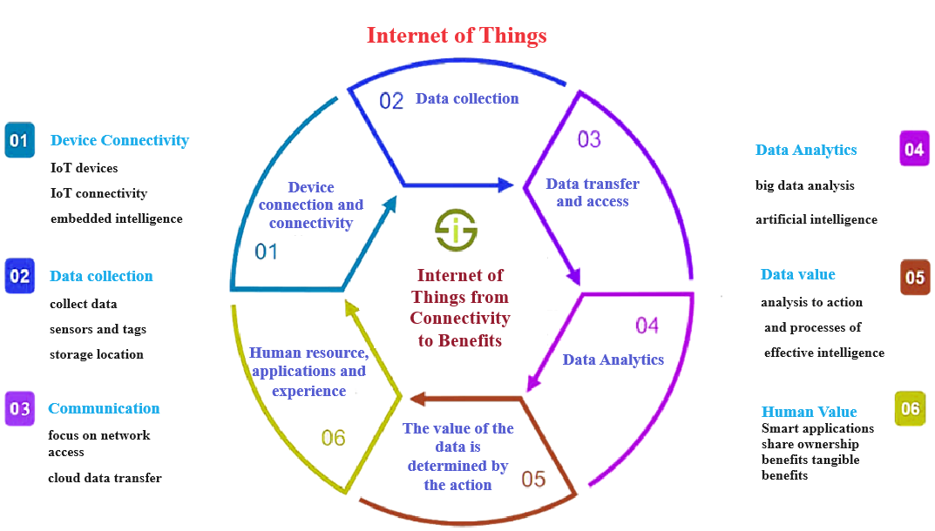
FIGURE 1. Internet of things from connectivity to benefits

The Digital Uzbekistan 2030 Strategy has been developed in order to ensure accelerated digital development of economic sectors, the social sphere and the public administration system, including further improvement of mechanisms for providing electronic public services. This Strategy defines strategic goals, priorities, and medium- and long-term objectives for the development of the digital economy and e-government of the Republic of Uzbekistan, and also serves as the basis for wider adoption of digital technologies, based on the UN Sustainable Development Goals and priorities identified in the e-government development rating.
According to the decree, the strategy "Digital Uzbekistan – 2030" was approved, which provides only in 2020-2022, as part of the digital transformation of territories and networks, the level of connection of settlements to the Internet, including by increasing to 2.5 million broadband access ports, the construction of 20 thousand kilometers of fiber-optic communication lines and the development of mobile communication networks, was brought to 78 to 95 percent [19-25].
As part of the implementation of the decree, the timeliness of the implementation by responsible executors of more than 1,600 projects and activities aimed at the digital transformation of territories where implementation was scheduled for 2020-2022, as well as 483 projects and activities aimed at the digital transformation of industries, was monitored.
In particular, the implementation of more than 220 priority projects has begun, providing for the improvement of the e-government system, the further development of the local market of software products and information technologies, the creation of IT parks in all regions of the republic, as well as providing the industry with qualified personnel [26-38].
The national concept of "Digital Uzbekistan – 2030" opens up new opportunities in our country (Fig.1).
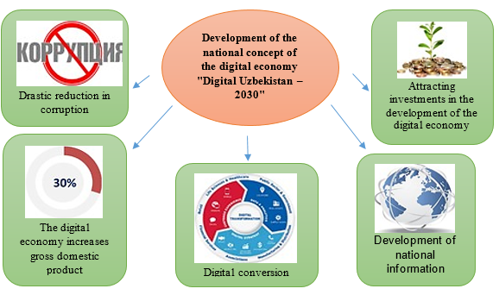
FIGURE 2. The possibilities of digitization

Connecting government organizations to a real–time online system, ensuring communication between the public sector and citizens with a single electronic tool showed that the Republic of Uzbekistan sets serious goals for entering the modern information age.
Innovative approaches to the registration of offenses. Today, there is not a single industry that has not been penetrated by modern information technology. Information and communication technologies are developing day by day, and the process of informatization in our country is significantly increasing. This, in turn, creates wide access for our citizens to the necessary information and various government interactive services.
Employees of the State Road Safety Service carry out their duties to further improve the industry, ensure transparency and, most importantly, strengthen the fight against corruption.
In order to develop the industry, the Government has adopted a number of resolutions and decrees. For example:
- Resolution No. 975 of the Cabinet of Ministers of the Republic of Uzbekistan dated December 01, 2018 "On approval of the Regulations on the procedure for interaction of traffic patrol officers with road users and the use of special devices" was adopted.
- The Cabinet of Ministers adopted Resolution No. 431 dated 07/08/2021 "On additional measures to introduce an electronic system for conducting cases of administrative offenses."
The following document was adopted in order to ensure the implementation of PU-6079 "On approval of the presidential strategy "Digital Uzbekistan-2030" dated 5.10.2020 and the implementation of PU-6118 "On measures to further improve the system of execution of court documents and documents of other bodies" dated 11/24/2020.
The Resolution approved the regulation on the procedure for conducting cases related to administrative offenses through the unified electronic system of proceedings in cases of administrative offenses (hereinafter referred to as the "E-Mamury ish" system - Electronic Administrative Case).
In recent years, the State Road Safety Service has been introducing many innovations. One of them is modern tablets, which are being introduced in order to increase the efficiency of work to ensure the safety of movement. On the basis of the relevant resolution of the Cabinet of Ministers, the procedure for filing an application in electronic form in relation to road users, where inspectors of the road patrol service commit violations, was introduced. The inspectors of the Department of Internal Affairs were given tablets, and the protocols also switched to electronic form. Currently, electronic statements are processed using tablets.
The electronic application is processed through the Republican centralized server and at the same time verification is carried out with the data entry of offenders into the tablet in the databases of the following structures:
- migration;
- search;
- crimes that remain unsolved;
-on debtors and other operational databases.
In this case, an electronic decision is made and sent online to the phone numbers of the vehicle owner, the driver:
- a perfect violation;
- classification of violations according to current laws;
- the amount of fines prescribed in them;
- an SMS message will be sent with the details of the individual account number for payment.
The unified information system "E-mamury ish" also provides an inextricable link between law enforcement agencies. The completed documents are stored in electronic form. The risk of losing them is drastically reduced. The main thing is that citizens can fully control the condition of the issued administrative statements in relation to them. Calls are sent by mail or SMS notification.
It also provides for the formation of administrative protocols for persons who have committed an administrative offense through a single electronic system on administrative offenses, consideration of cases of administrative offenses and electronic maintenance of information on premises using the system by authorized state bodies. "E-mamuriy ish" allowed the competent authorities to verify information about persons brought to administrative responsibility in cases of administrative offenses, obtain the necessary information and use it.
RESEARCH RESULTS
Within the framework of the implementation of the decree, the implementation of the tasks set in 2022-2030 according to the plan of target indicators is carried out consistently.

TABLE 1. Target indicators of the strategy "DIGITAL UZBEKISTAN - 2030"
№ | Index name | Unit of measurement | Current status | Year cross-sectional goals
 |  |  |  | 2022 | 2025 | 2030
1. | Length of fiber optic communication network built throughout the Republic | thousand km | 41 | 70 | 120 | 250
2. | The level of coverage of the regions of the Republic with the high-speed Internet world Information Network | % | 67 | 74 | 85 | 100
3. | High-speed Internet of social objects the level of access to the world Information Network | % | 45 | 100 | 100 | 100
4. | The level of household broadband internet access to the world Information Network | % | 67 | 74 | 85 | 100
5. | The level of coverage of settlements with a broadband mobile network | % | 78 | 100 | 100 | 100
6. | Efficiency indicator of the "e-Government Development Index" in the international ranking of e-government development | ball (In the range 0 - 1) | 0,66 | 0,70 | 0,75 | 0,86
7. | The share of electronic public services provided through the unified interactive public services portal in relation to public services provided by public service centers | % | 34 | 60 | 70 | 90
8. | Single interactive public services portal share of electronic public services with the possibility of using mobile devices in relation to electronic public services | % | 5 | 30 | 42 | 60
9. | Share of transactional services provided through the unified interactive public services portal | % | 25 | 45 | 60 | 75
10. | The share of large economic entities that introduced the enterprise resource management system (ERP) | % | 20 | 40 | 65 | 100
11. | Number of users of online banking services (legal entities and individuals) | million people | 10 | 15 | 17 | 20
12. | Number of startup projects included in the incubation and acceleration programs of the technological park of software products and information technologies | pieces | 50 | 250 | 700 | 2 300
13. | The number of quotas for admission to higher education and secondary special education institutions for training personnel in the field of Information Technology | thousand | 7 | 12 | 15 | 20
Note. To achieve the above indicators, state bodies and organizations provide practical assistance within their competence.
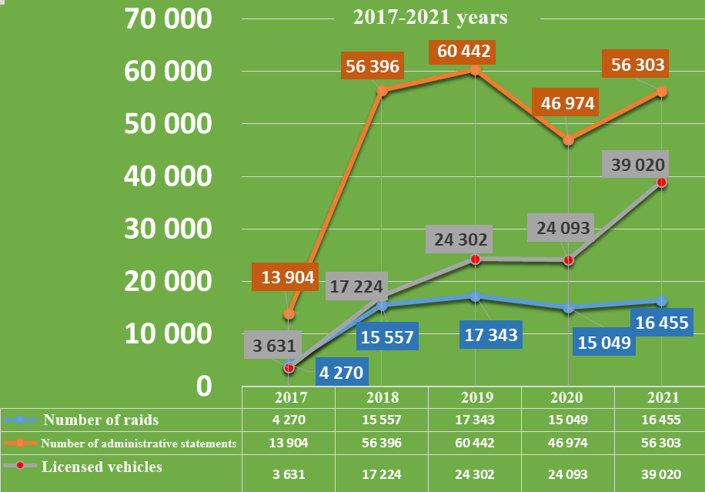
FIGURE 3. The work carried out in the field is taxable

Since 2022, a "tablet" has been introduced into practice, and protocols are being formalized electronically. 200 tablets were distributed to the Holy sections.
As a result,
The number of administrative statements issued in January-April 2022 is a total of 30,791, including
- 5,769 in January
- 7,002 in February
- 7,697 in March
- In April, however, 10,304 is still standing.
Since 2022, the formalization of administrative statements in the territorial sections in electronic order (tablet) has been introduced into practice. As a result, the effectiveness of the raids and events carried out increased:
1. The protocol rationalization process has been simplified
2. Lightness was created in clarifying the personality of the hoofbush
3. Administrative cases are issued to judicial bodies for short periods
4. The decision made on the case appears in electronic format
5. Execution on the fate of cases passed to the Bureau of compulsory execution looks electronic
6. It was possible to make short-term taxing of cases that stood in the courts and were sent to the re-enquiry
7. Facilities such as electronic reading of ID Di cards on a tablet, electronic signature, electronic payment have been created
In the plan of the settlement: to identify a citizen by face image, connect with a technical passport, a database on a travel certificate and a license base, take action on persons who have not paid a fine (AUTOCOM)
Statistics in the field of road construction control. About 400 violations were found in road construction facilities.
Quality control was carried out at 1519 facilities during January-May of this year, organized by the employees of” self-improvement " in general use and in order to establish quality control in the construction, reconstruction, perfect and current repair, storage facilities of regional highways and artificial structures.
For five months, "Özyolinspektsiya" identified about 400 violations at road facilities in Uzbekistan. In 20 cases, administrative statements were drawn up against officials, and in 52 cases, a request was made to exclude from payment the volume of construction and installation work performed in poor quality.
As a result, the responsible employees of the customer, contractor, designer, custodian and other organizations for the elimination of 389 violations identified at road construction facilities were given a written instruction, on the implementation of which 254 were mandatory. Of the 254 guidelines, the implementation of 202 is ensured. Control over the execution of the remaining 52 instructions is established.
20 administrative statements were formalized and sent to the judicial authorities in order to apply appropriate measures to officials who have committed gross violations at road construction facilities and did not eliminate the instructions issued by state inspectors within the prescribed period, and a fine of Rs 19.8 crore was applied in 14 cases.

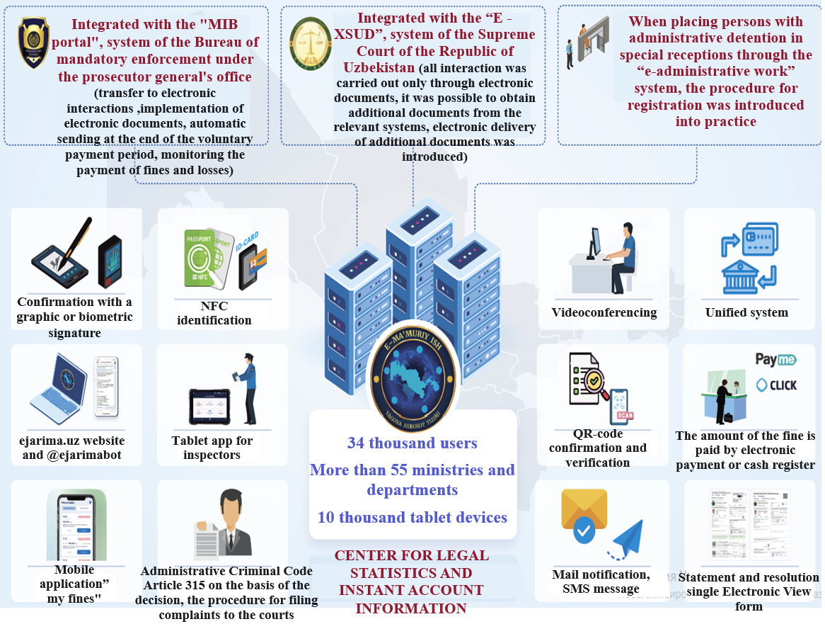
FIGURE 4. Center for legal statistics and instant account information

In 52 cases, an application was made to exclude from payment the volume of construction and installation works performed at a low quality of 1958.99 million soums, and 31 applications for 619.48 million soums were provided. Control over the execution of the remaining applications is established.
Also, the requirements of regulatory documents on technical regulation include a submission to their heads to consider the issue of disciplinary responsibility for employees responsible for deficiencies in the registration of executive documents established.
CONCLUSION
In conclusion, to date, various transport companies and owners of personal vehicles support the widespread introduction of intelligent systems into the transport system. This makes it possible to effectively control such factors as the driver's operating mode, the operating mode of the car, the technical condition of the vehicle, and the direction of movement. The operation of the built-in intelligent tools in real time increases control and the ability to use the vehicle effectively, as well as ensures maximum safety during operation of the vehicle.
REFERENCES
- Decree of the President of the Republic of Uzbekistan dated April 28, 2020 ―PQ-4699 "On measures for the widespread introduction of the digital economy and e-government", https://lex.uz/pdfs/4800657
- Kapsky, D., Abdurazzokov, U., & Ziyaev, K. (2025). Measures to improve operation of passenger transport and urban mobility. 060021. https://doi.org/10.1063/5.0266810
- Khalilova, G. Kh., Choriyeva, M. Sh., Samatov, R. G., Abdurazzokov, U. A., & Urunov, D. A. (2025). AI Integration in Smart Car Parking Stations (pp. 125–133). https://doi.org/10.1007/978-3-031-88846-5_15
- Khalmukhamedov, A., & Anvarjonov, A. (2024). Specific features of improving automobile road complex of the Republic of Uzbekistan. E3S Web of Conferences, 515, 01016. https://doi.org/10.1051/e3sconf/202451501016
- Khalmukhamedov, A., Samatov, R., & Rajapova, S. (2024). Prospects for the use of an automatic system for weight and dimensional control of vehicles in the Republic of Uzbekistan. 050031. https://doi.org/10.1063/5.0197415
- Kuvondik, U., Yusupov, U., Zilola, R., & Mashrab, I. (2025). Improvement of the classification of causes for the decommissioning of large-size tires. Vibroengineering Procedia, 58, 291–299. https://doi.org/10.21595/vp.2025.24964
- Makhmudov, G. (2024). Development of methods for calculating thermal conductivity of gas condensates-alternative motor fuels. E3S Web of Conferences, 515, 03002. https://doi.org/10.1051/e3sconf/202451503002
- Mikhaltsevich, M., & Ziyaev, K. (2024). Modeling the braking process for motorcycle with ABS. E3S Web of Conferences, 592, 07002. https://doi.org/10.1051/e3sconf/202459207002
- Mukhitdinov, A., Yusupov, U., Tukhtamishov, S., & Urinbayev, Q. (2024). Results of the study of the influence of an average longitudinal slope of routes on the life of tires in the quarry. 040041. https://doi.org/10.1063/5.0197301
- Petrovich, B. V., & Ugli, A. A. A. (2025). Analysis of static load on a tire in quarry operating conditions. 030017. https://doi.org/10.1063/5.0266786
- Tursunbaev, B. H., Fayzullaev, E. Z., Akbarov, N. A., & Nigmatov, H. (2023). A new methodology for evaluating the efficiency of complex machine mechanisms. 040098. https://doi.org/10.1063/5.0145575
- Tursunov, S. R., Khikmatov, R. S., & Khusanov, S. N.-U. (2024). Increasing the efficiency of the use of mining transport due to increasing the periodicity of maintenance time. 050021. https://doi.org/10.1063/5.0197547
- Tursunov, S. R., Sharipov, S. S., & Khikmatov, R. S. (2024). Saving natural gas through the use of used oils in replacement by the method of their safe burning. 050022. https://doi.org/10.1063/5.0197545
- Yusupov, U., & Shavkatov, X. (2024). Development of a standard mileage for large-sized tires under moderately severe quarry conditions. BIO Web of Conferences, 141, 04034. https://doi.org/10.1051/bioconf/202414104034
- Yusupov, U., Urinbaev, K., Boykov, V., & Israilov, M. (2025). Optimizing TKPH for Large-Sized Tires in Quarry Conditions (pp. 381–391). https://doi.org/10.1007/978-3-031-95649-2_33
- Ziyaev, K., & Omarov, J. (2024). Research of passenger traffic in public transport. 040030. https://doi.org/10.1063/5.0197314
- Ziyaev, K., Vokhidov, D., Shavkatov, K., Khadiyeva, G., & Yangiyeva, I. (2025). Influence of traffic light management on traffic capacity of Urban highways. 060038. https://doi.org/10.1063/5.0266822
- Khalmukhamedov, A.S., Samatov, R.G., Islamov, E.B. and Narziyev, J.S. (2025) Assessment of the Highway Network of International Importance of the Republic of Uzbekistan. Lecture Notes in Networks and Systems https://doi.org/10.1007/978-3-031-99028-1_21
- S. Rajapova, and Y. Juraev, “Innovative ways to train drivers and improve their skills,” AIP Conf. Proc. (2022), https://www.scopus.com/record/display.uri?eid=2-s2.0-85133001621.
- S. Turdibekov, U. Isoxanov, S. Shermatov, and E. Abdusamatov, “Road traffic incidents involving pedestrians in areas with limited visibility,” E3S Web Conf. 549, 06012 (2024), https://doi.org/10.1051/e3sconf/202454906012.
- S. Turdibekov, U. Isoxanov, S. Shermatov, and E. Abdusamatov, “Analysis of the parameters of technological material sprinkling devices of special road vehicles (wδ=const): MAN CLA 18.280 4×2 BB CS45,” E3S Web Conf. 549, 02016 (2024), https://doi.org/10.1051/e3sconf/202454902016.
- E. Abdusamatov, “The impact of driver turnover on traffic safety,” E3S Web Conf. 549, 06011 (2024), https://doi.org/10.1051/e3sconf/202454906011.
- S. Khakimov, “Vehicle ride regime as a main factor for GHG emission reduction,” AIP Conf. Proc. 2432, 030127 (2022), https://doi.org/10.1063/5.0089563.
- K. Kutlimuratov, S. Khakimov, A. Mukhitdinov, and R. Samatov, “Modelling traffic flow emissions at signalized intersection with PTV Vissim,” E3S Web Conf. 264, 02051 (2021), https://doi.org/10.1051/e3sconf/202126402051.
- S. Khakimov, E. Fayzullaev, A. Rakhmonov, and R. Samatov, “Variation of reaction forces on the axles of the road train depending on road longitudinal slope,” E3S Web Conf. 264, 05030 (2021), https://doi.org/10.1051/e3sconf/202126405030.
- R. Samatov and U. Samatov, “Improvement of methods for assessing the quality of road transport services,” AIP Conf. Proc. 2432, 030094 (2022), https://doi.org/10.1063/5.0091190.
- E. Faizullaev, A. Rakhmonov, U. Mukhtorjanov, S. Turdibekov, and S. Nasirjanov, “Parameters of the access road for disaster situations on the roads in the mountain area,” E3S Web Conf. 401, 03022 (2023), https://doi.org/10.1051/e3sconf/202340103022.
- K. Sharifbaeva, G. Niyazova, D. Abdurazzakova, I. Abdurashidov, and R. Alimardonov, “Formation of methodical competence of special subjects teachers in technical universities,” AIP Conf. Proc. 2432, 050043 (2022), https://doi.org/10.1063/5.0089618.
- O. Rabat, Sh. Pirnaev, K. Rustamov, I. Usmanov, Sh. Shermatov, and K. Magdiyev, “Development of corrosion-resistant material for asphalt concrete cutting part,” E3S Web Conf. 587, 03012 (2024), https://doi.org/10.1051/e3sconf/202458703012.
- S. Korabayev, J. Yuldashev, U. Isokhanov, S. Makhkamova, and N. Saparboyeva, “Overcoming obstacles: solving cutting resistance problems,” E3S Web Conf. 587, 03015 (2024), https://doi.org/10.1051/e3sconf/202458703015.
- U. Isokhanov, S. and Turdibekov, “A method of experimental study of the operation of technological material distributors,” E3S Web Conf. 587, 03013 (2024), https://doi.org/10.1051/e3sconf/202458703013.
- Turdibekov, S., Xamraqulov, R., Negmatov, N., and Raximbayev, Z. “The method of calculating the parameters of the materials delivery mechanism of the technological materials distributor,” BIO Web of Conferences 145, 03025 (2024) https://doi.org/10.1051/bioconf/202414503025
- Khalilova, G., Abdusamatov, E., and Shermatov, S., “Methodology for Calculating the Share of Parking-Searching Vehicles in Traffic Congestion on Multi-Lane Roads,” International Conference of Young Specialists on Micro/Nanotechnologies and Electron Devices, EDM. (2025) https://doi.org/10.1109/EDM65517.2025.11096677
- Improving the method of assessing road safety at intersections of single-level highways. Botir Abdullaev, Davron Yuldoshev, Tolqin Muminov and Dilmurod Axmedov, E3S Web Conf., 264 (2021) 05027. DOI: https://doi.org/10.1051/e3sconf/202126405027
- A. Kuziev, M. Juraev, Z. Yusufkhonov, D. Akhmedov; Application of multimodal transportation in the development of future flows of the region. AIP Conf. Proc. 15 March 2023; 2612 (1): 060027. https://doi.org/10.1063/5.0134950
- Zokirkhan Yusufkhonov, Malik Ravshanov, Akmal Kamolov, and Dilmurod Ahmedov, "Prospects for the development of transport corridors of Uzbekistan", AIP Conference Proceedings 2432, 030074 (2022) https://doi.org/10.1063/5.0089689
- Management of consumers needs for volume of transportation, taking into account the probable nature. Mukhiddin Zhuraev, Jamshid Togaev and Zokirkhon Yusufkhonov. E3S Web of Conf., 401 (2023) 01066 DOI: https://doi.org/10.1051/e3sconf/202340101066
- A. A. Shermukhamedov, M. N. Juraev, S. N. Kenjayev; Efficient distribution of motor vehicles of different loading capacities on routes. AIP Conf. Proc. 15 March 2023; 2612 (1): 060013. https://doi.org/10.1063/5.0134786

