Starting modes of asynchronous motors control by the supply voltage amplitude
Murоt Tulyaganov^{1, a)} , Alexandr Petrushin ², Shuxrat Umarov ¹, Murat Shamiev¹, Abror Pulatov¹
¹ Tashkent state technical university named after Islam Karimov, Tashkent, Uzbekistan
² Rostov State Transport University Rostov-on-Don, Russia
^{a)} Corresponding author: murattstu@yandex.ru
Abstract. Electric drives with asynchronous electric motors with a squirrel-cage rotor are quite widespread due to their operational reliability and fairly high energy characteristics. The article proposes a method for further improving the energy characteristics of an asynchronous electric motor in starting modes controlling by the amplitude of the supply voltage. Based on the mathematical model of a generalized electric machine in fixed axes α and β, an algorithm has been developed that allows reducing electrical energy losses in the windings of an asynchronous electric drive in starting modes. Using the maximum principle and the Newton-Raphson method, the optimal functional dependence of the amplitude of the supply voltage of an asynchronous motor on the time of the transient process is determined. The minimum square of the voltage supplying the electric motor was chosen as the optimization criterion. Based on the calculation results, graphs of currents changes, electromagnetic moment of rotation angular frequency and electrical losses in the asynchronous motor windings under optimal control actions were obtained. The possibility of the starting time reducing of asynchronous motors with optimal control action was investigated. Practical recommendations on the application of the optimal control algorithm are given.
INTRODUCTION
Asynchronous motors with a squirrel-cage rotor have become widely used in all areas of human activity where the conversion of electrical energy into mechanical energy is required. The modern trend in the use of asynchronous motors is that an increasing number of them are used as part of a controlled electric drive. [1-3]. Requirements for improving the energy and weight-size parameters of electric drives, expanding the range of regulation of operating speeds, increasing speed, reliability are constantly increasing, and the element base of the frequency converter is being updated, new items appear in circuit solutions [4–11]. Intensive work is underway to further improve the control laws of an asynchronous frequency electric drive [12–17]. There are quite a few areas of application for asynchronous motors where they often operate in starting modes. These are various types of metalworking equipment, robotic execution of technological operations in mechanical engineering, traction drives of vehicles and others. It is known that in these dynamic starting modes, as well as the transition from one rotation frequency to another, the efficiency of asynchronous motors is significantly lower than in the nominal mode. The heat generated in the windings and magnetic circuit significantly limits the intensity of use of the electric motor. Efficiency in starting modes can be increased by optimally adjusting the supply voltage parameters.
Among the methods for regulating the rotation frequency of asynchronous motors, the most effective is the frequency control method, in which both the frequency and the amplitude of the supply voltage change [18-20]. Less commonly used is a control method in which only the amplitude of the supply voltage changes while the frequency remains constant. This changes the motor slip. This control method is classified as parametric. Parametric control is inferior to frequency control in energy efficiency and is used mainly for soft starting of powerful asynchronous motors, or for regulating the rotation speed in a narrow range near the nominal value [21]. The practical implementation of the parametric method of controlling asynchronous motors is simpler and cheaper than frequency control. The parametric method of controlling the AM can be used to organize starting modes in combination with optimization algorithms, which will allow obtaining high energy indicators.
Optimization algorithms used in the field of electric drives have proven their effectiveness in practical implementation [22-25]. The maximum principle has become widely used in the optimal control of AC and DC electric drives. [25-27].
This article proposes an algorithm for optimal parametric control of starting asynchronous motors, in which the amplitude of the supply voltage changes so as to ensure a minimum of the following functionality:
$Ф=\int_{0}^{Т}{u^{2}}dt⇒min$ (1)
where $u$– is relative supply voltage (the ratio of the current voltage value to the base value); t – is the time, T – the period of time during which the transition process takes place.
Minimization of functionality (1), as further calculations showed, allows to significantly reduce electrical losses in the stator and rotor windings of asynchronous motors, which in the processes of starting and braking make up the majority of all losses emitted in the electric motor.

SOLVING THE OPTIMAL CONTROL PROBLEM
For the mathematical description of an asynchronous motor, the equations of a generalized electric machine were used, written in the following form [28]:
$$\left[\begin{matrix}i_{sα}^{/} \\ i_{rα}^{/} \\ i_{sβ}^{/} \\ i_{rβ}^{/}\end{matrix}\right]=\left[\begin{matrix}-cR_{s} & dR_{r} & ωdL_{sr} & ωdL_{r} \\ dR_{s} & -bR_{r} & -ωbL_{sr} & -ωbL_{r} \\ -ωdL_{sr} & -ωdL_{r} & -cR_{s} & dR_{r} \\ ωbL_{sr} & ωbL_{r} & dR_{s} & -bR_{r}\end{matrix}\right]×\left[\begin{matrix}i_{sα} \\ i_{rα} \\ i_{sβ} \\ i_{rβ}\end{matrix}\right]+\left[\begin{matrix}c \\ -d \\ 0 \\ 0\end{matrix}\begin{matrix}0 \\ 0 \\ c \\ -d\end{matrix}\right]×\left[\begin{matrix}u_{sα} \\ \\ \\ u_{sβ}\end{matrix}\right],$$$ω^{/}=\frac{pP_{б}}{{ν_{б}}^{3}J}\left[L_{sr}\left(i_{sβ}i_{rα}-i_{sα}i_{rβ}\right)-М_{c}\right],$ (2)
The following notation is used in equations (2)
$$b=\frac{L_{s}}{L_{s}L_{r}-{L_{sr}}^{2}}; c=\frac{L_{r}}{L_{s}L_{r}-{L_{sr}}^{2}}; d=\frac{L_{sr}}{L_{s}L_{r}-{L_{sr}}^{2}}; P_{б}=\frac{3}{2}u_{б}i_{б},$$
where $i_{sα},i_{rα},i_{sβ},i_{rβ}$ – projections of stator and rotor currents of an asynchronous motor onto fixed coordinate axes α and β; $\frac{di_{sα}}{dt},\frac{di_{rα}}{dt},\frac{di_{sβ}}{dt},\frac{di_{rβ}}{dt}$ – time derivatives of the projections of stator and rotor currents along the coordinate axes α and β; $R_{s},R_{r}$ – active resistances of the stator and rotor; $p$ – number of pole pairs; $ω$ – angular rotation frequency; $L_{s},L_{r}$– stator and rotor inductances; $L_{sr}$– mutual inductance between stator and rotor; $M_{e}$– electromagnetic moment; $M_{s}$– static moment of resistance on the shaft of the asynchronous motor, $J$– moment of inertia of the rotor.
The projections of the supply voltages on the stator and rotor windings along the coordinate axes α and β were calculated from the expressions:
$u_{sα}=U_{m}u\cos{(}ωt); u_{sβ}=U_{m}u\sin{(}ωt),$ (3)
The electromagnetic moment was calculated using the formula:
$M_{e}=M​(i_{rα}i_{sβ}-i_{rβ}i_{sα})$ (4)
Electrical losses in the transient process for the time from 0 to T were calculated using the expression:
$Р_{e}=​\int_{0}^{Т}{{i_{sα}}^{2}R_{s}dt}+\int_{0}^{Т}{{i_{sb}}^{2}R_{s}dt}+\int_{0}^{Т}{{i_{ra}}^{2}R_{r}dt}+\int_{0}^{Т}{{i_{rb}}^{2}R_{r}dt}$ (5)
The transformation of the projections of the stator currents of the asynchronous motor $i_{sα},i_{rα},i_{sβ},i_{rβ}$ in the coordinate axes α and β into phase currents $i_{а},i_{b},i_{c}$ is performed using the following formulas [18]:
$i_{а}=i_{sα}; i_{b}=-\frac{1}{2}i_{sα}-\frac{\sqrt{3}}{2}i_{sβ} i_{b}=-\frac{1}{2}i_{sα}+\frac{\sqrt{3}}{2}i_{sβ}.$ (6)
Calculations of variables were performed in relative units. The following basic values are adopted:
$$ω_{б}=2πf_{н};​P_{б}=(3/2)i_{б}u_{б};​M_{б}=P_{б}/ω_{б};​L_{б}=x_{б}/ω_{б};​J_{б}=M_{б}/ω_{б};t_{б}=1/ω_{б}.$$
In the mathematical modeling of asynchronous motors, assumptions were used that correspond to the concept of a “generalized electric machine” [28].
The mathematical model takes into account fast-moving electromagnetic transient processes in asynchronous motors. The presence of the equation of motion in the mathematical model makes the entire system of equations (2) quite rigid, since the time constants of electromagnetic and electromechanical transients differ significantly. Rigid mathematical models require choosing an integration step that is consistent with the smallest time constant.
The maximum principle was used to solve the optimization problem. The Hamilton function H is defined:
$H=u^{2}ψ_{0}+i_{sα}^{/}ψ_{1}+i_{rα}^{/}ψ_{2}+i_{sβ}^{/}ψ_{3}+i_{rβ}^{/}ψ_{4}+ν^{/}ψ_{5}$ (7)
In equation (7) we take $ψ_{0}=-1$.
Differential equations for auxiliary functions are compiled $ψ_{1}-ψ_{5}$:
$$\left[\begin{matrix}ψ_{1}^{/} \\ ψ_{2}^{/} \\ ψ_{3}^{/} \\ ψ_{4}^{/}\end{matrix}\right]=\left[\begin{matrix}cR_{s} & -dR_{s} & ωdL_{sr} & -ωbL_{sr} \\ -dR_{r} & bR_{r} & ωdL_{r} & -ωbL_{r} \\ -ωdL_{sr} & ωbL_{sr} & cR_{s} & -dR_{s} \\ -ωdL_{r} & ωbL_{r} & -dR_{r} & bR_{r}\end{matrix}\right]×\left[\begin{matrix}ψ_{1} \\ ψ_{2} \\ ψ_{3} \\ ψ_{4}\end{matrix}\right]+\left[\begin{matrix} \\ αψ_{5}L_{sr} \\ \\ \end{matrix}\right]×\left[\begin{matrix}i_{rβ} \\ i_{sβ} \\ i_{rα} \\ i_{sα}\end{matrix}\right]$$$ψ_{5}^{/}=(ψ_{3}d-ψ_{4}b)(L_{r}i_{rα}+L_{sr}i_{sα})-(ψ_{1}d-ψ_{2}b)(L_{r}i_{rβ}+L_{sr}i_{sβ}).$ (8)
The optimal control action – the relative amplitude of the supply voltage $u^{*}$ is found from expression $\frac{∂H}{∂u}=0$ according to the maximum principle.
$u^{*}=\frac{U_{н}}{2}\left[\left(ψ_{1}-ψ_{2}d\right)×\cos\left(ωt\right)+\left(ψ_{3}c-ψ_{4}d\right)×\sin\left(ωt\right)\right].$ (9)
The initial conditions of the auxiliary functions in differential equations (8) are not known in advance. $ψ_{1}-ψ_{5}$ in differential equations (8) are unknown in advance. To determine them, the Newton-Raphson method was used from the condition of obtaining the desired rotor speed of an asynchronous motor at the end of the transient process [19]. The advantage of the Newton-Raphson method over other optimization methods is its quadratic convergence near the desired solution. However, there is a disadvantage - a small convergence region (smaller than that of the gradient method). The influence of this drawback on the convergence process can be eliminated by using an iterative transition from the initial convergence region, determined by arbitrary values of auxiliary functions, to the convergence region with a predetermined rotor speed at the end of the transient process.
The expressions defined by the Newton-Raphson method for determining the initial conditions of the auxiliary functions $ψ_{1}-ψ_{5}$ have the following matrix form:
$ψ^{j+1}(0)=ψ^{j}(0)-{\left[K^{j}\right]}^{-1}\left[y^{j+1}(Т)-y^{j}(Т)\right],$ (10)
where $ψ^{j+1}(0)$– initial conditions of auxiliary functions at the subsequent iteration; $ψ^{j}(0)$– initial conditions of auxiliary functions at the previous iteration; $y^{j+1}(Т)$– values of currents and rotation frequency $i_{sα},i_{rα},i_{sβ},i_{rβ},ω$ at the end of the transient process at the subsequent iteration; $y^{j}(Т)$– values of currents and rotation frequency $i_{sα},i_{rα},i_{sβ},i_{rβ},ω$ at the end of the transient at the previous iteration.
The calculations were performed for the АИР80В4У3 electric motor with a power of 1.5 kW with the following parameters of the equivalent circuit in relative units:
$R_{s}=0,098;​R_{r}=0,06;L_{sr}=2,1;L_{s}=2,176;​L_{r}=2,23.​$ (11)
Calculations were performed for starting an asynchronous motor up to the rated rotation speed with a direct connection to a 380 V supply voltage source with a frequency of 50 Hz. The results of calculations without load on the shaft are shown in Fig. 1. The nominal rotation speed was achieved in 8.3 relative units (r.u.), the electrical losses in the stator and rotor of the asynchronous motor $Рe$, determined from expression (5), amounted to 22.9 r.u.
Fig. 2 shows the results of calculations for the optimal start of an asynchronous motor up to the rated rotation speed. The optimal amplitude of the supply voltage was determined from expression (9). Electrical losses in the stator and rotor amounted to 13.4 r.u. or 58.5% of the losses during start-up without optimization of the supply voltage (Fig. 1). As can be seen from Figure 2, the amplitude of the supply voltage at the beginning and end of the start is significantly less than the nominal value.
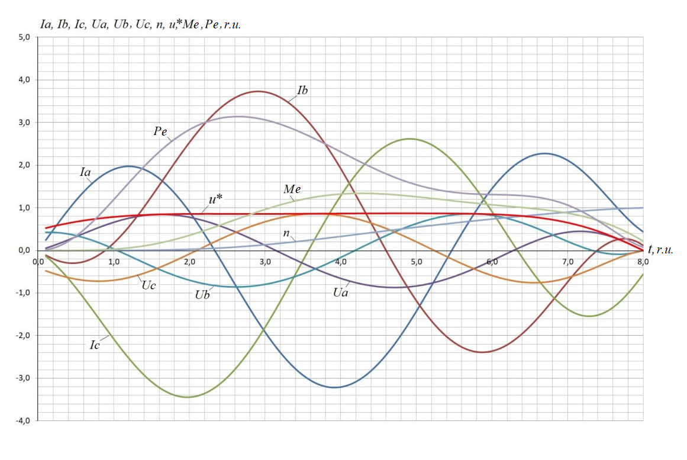
FIGURE 1. Direct start of the asynchronous motor

Such a significant reduction in electrical losses in the stator and rotor of an asynchronous motor occurred for the following reasons. It is known that when directly connected to an alternating current network, in the first period of the supply voltage, significantly more energy enters the electromagnetic circuit of an asynchronous motor than the increase in mechanical energy as a result of electromechanical conversion over the same period [28]. For this reason, an oscillatory process of energy exchange occurs between the power source and the electromagnetic circuit of the asynchronous motor. This in turn leads to an increase in electrical losses in the windings of the asynchronous motor.
A distinctive feature of optimal parametric control is the smooth increase in the amplitude of the supply voltage in the initial period of the starting mode to the nominal value. This allows for optimal dosing of the energy supply from the source to the electromagnetic circuit of the active part of the asynchronous motor, followed by electromechanical energy conversion.
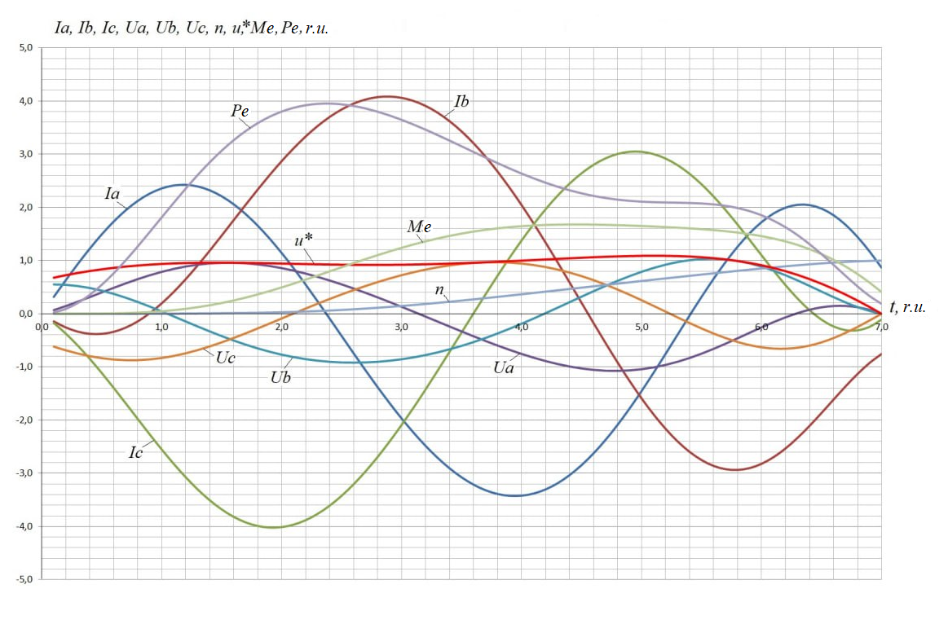
FIGURE 2. Optimal start of the asynchronous motor with a time of 8 r.u.

Optimal parametric control allows starting an asynchronous motor in a shorter time. Figures 3 and 4 show the results of calculations of the optimal start of an asynchronous motor to the rated speed in 7 r.u. and 6.1 r.u., respectively. When the starting time is reduced, electrical losses in the stator and rotor windings of the asynchronous motor increase. Electrical losses (Fig. 3) are 14.1 r.u. or 61.6% of the losses during start-up without optimization.
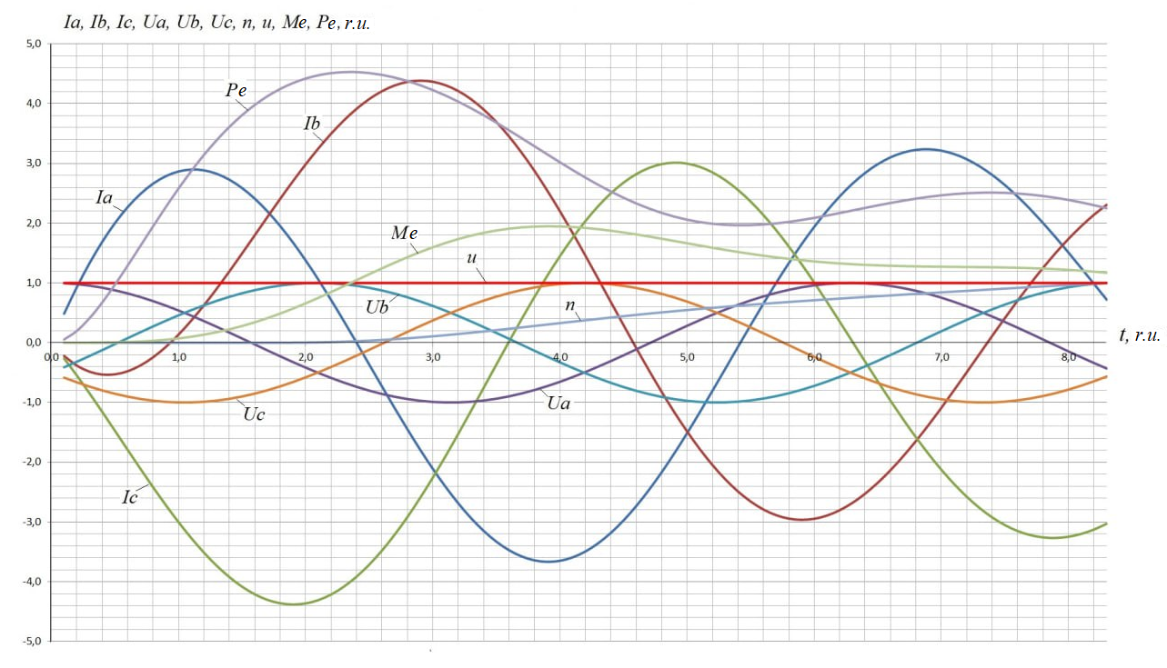
FIGURE 3. Optimal start of the asynchronous motor with a time of 7 r.u.

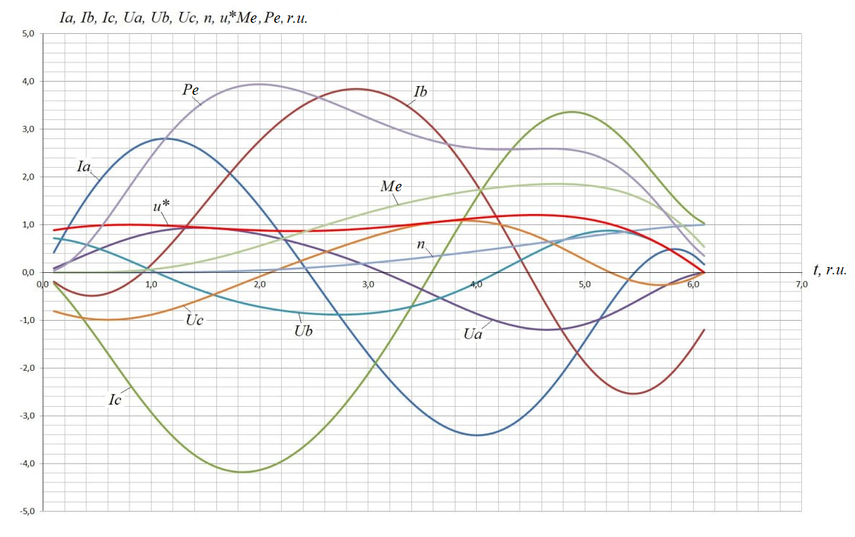
FIGURE 4. Optimal start of the asynchronous motor with a time of 6.1 r.u.

Fig. 5 shows the results of calculations for the optimal start of an asynchronous motor to the rated speed with a constant load on the shaft equal to 15% of the rated value. All other things being equal, compared to the optimal idle start (Fig. 3), electrical losses in the stator and rotor windings increased and amounted to 16.1 r.u. When compared with direct starting without optimization, the electrical losses of the optimal start with a constant load of 15% (Fig. 5) turned out to be lower and amounted to 70.3% of the losses during starting without optimization (Fig. 1).
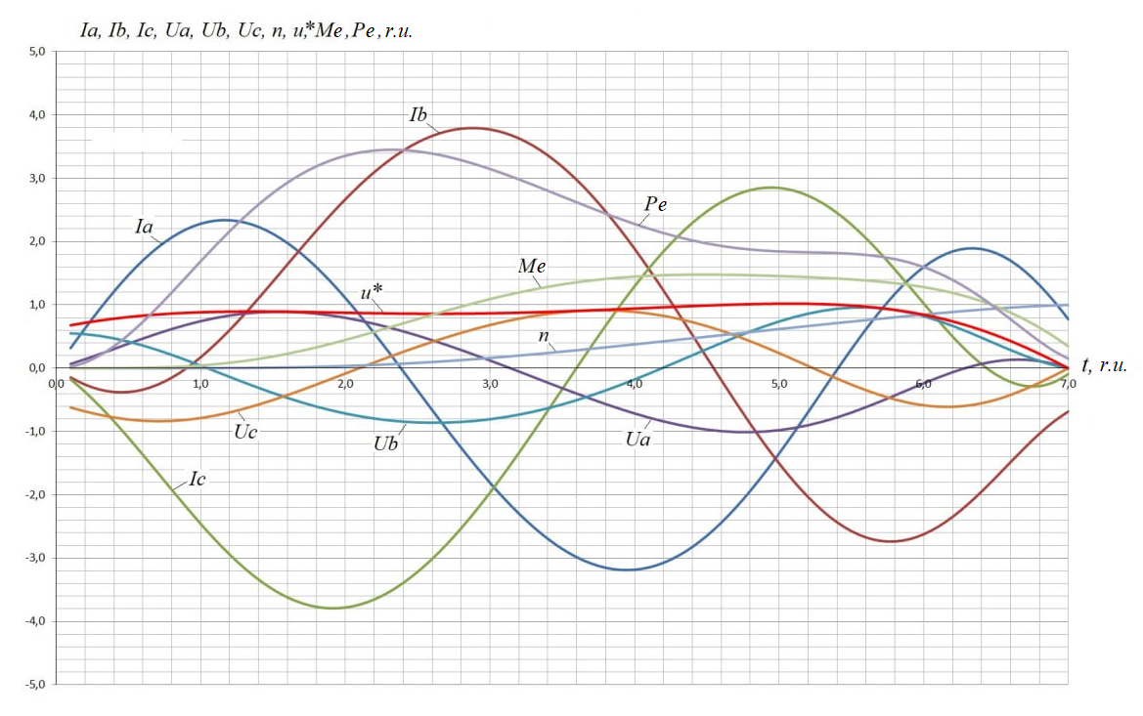
FIGURE 5. Optimal start of an asynchronous motor with a load on the shaft

The table shows comparative data on electrical losses in the stator and rotor of an asynchronous motor based on the calculations performed.
Table 1. Comparison of parameters of optimal parametric control of an asynchronous motor with direct starting
№ | Comparative data
№ | Transient type | Electrical losses in stator and rotor, r.u.(%) | Transition time, r.u.
1 | Direct start at idle speed (Fig. 1) | 22,9 (100%) | 8.3
2 | Optimal idle start (fig. 2) | 13,4 (58,5%) | 8.0
3 | Optimal idle start (fig. 3) | 14,1 (61,6%) | 7.0
4 | Optimal idle start (fig. 4) | 15,3 (66,8%) | 6.1
5 | Optimal start with a load of 15% of the nominal value (Fig. 5) | 16,1 (70,3) | 7.0
The parameters of an asynchronous motor, such as active and inductive resistances, have a significant impact on the starting processes. Thus, the decrease of $L_{sr}$ corresponds to an increase in the air gap between the stator and the rotor with a constant supply voltage. This leads to a decrease in magnetic flux, an increase in the transient time and, consequently, an increase in electrical losses. Previously conducted studies have shown [28] that there are optimal relationships between the parameters of an asynchronous motor that ensure the most favorable course of transient processes. Optimal control algorithms make transient processes energy efficient.
THE PRACTICAL SIGNIFICANCE OF THE PROPOSED OPTIMIZATION ALGORITHM
The practical significance of the obtained results is that the reduction of electrical losses in the windings of an asynchronous motor with optimal parametric control is an important factor in increasing its energy efficiency.
In practice, the optimal algorithm for starting an asynchronous motor can be implemented using power semiconductor switches. One of the possible ways to implement optimal parametric control is to use pulse-width modulation in an AC power circuit without using an intermediate DC link. With all the variety of circuit solutions for the parametric starting method, the process is characterized by the fact that the change in rotation frequency is achieved by changing the slip at a constant frequency of the supply voltage with the release of slip energy in the form of losses.
The recommended area of practical application of the optimal parametric start of asynchronous motors relates to medium and high power electric motors that often operate in starting modes.
The optimal parametric control algorithm can also be used in soft starters for asynchronous motors, which are mass-produced. The main problems of asynchronous electric motors during starting are:
- starting current, which during direct starting can be 5-8 times greater than the nominal current;
- electromagnetic torque that reaches large values in a fraction of a second, which can damage the actuator and disable the drive kinematic chain;
- low efficiency in transient process.
A soft starter allows you to avoid these problems by accelerating and braking the motor with controlled values ​​of current and electromagnetic torque, eliminating jerks in the mechanical part of the drive. Using the optimal control algorithm will allow the implementation of a built-in energy saving mode.
CONCLUSIONS
An electric drive with asynchronous electric motors uses a significant amount of electricity for its operation. The energy efficiency of electromechanical energy conversion can be significantly increased by using optimal control algorithms built on a mathematical model of an asynchronous electric motor that takes into account fast-moving electromagnetic transient processes. During start-up periods, which are characterized by low efficiency, the proposed algorithm of optimal parametric control allows to reduce electrical losses in the stator and rotor of an asynchronous motor operating as part of various machines and mechanisms.
The presented main parameters of an asynchronous motor during the start-up process (Fig. 1–5): currents and voltages by phases, rotation frequency, electromagnetic torque, total electrical losses in the stator and rotor allow a clear assessment of the physical processes occurring when using the optimization algorithm.
The proposed algorithm of optimal parametric control can be used to improve the energy efficiency of an asynchronous electric drive and is relevant for asynchronous electric drives that operate in frequent starting modes.
REFERENCES
- Belov, M. P. “Automated electric drive of standard production mechanisms and technological complexes textbook for universities” – 2- e ed., erased. – Moscow Academy, 2004. 576 p.
- Prakht, V. A. “Comparative analysis of the characteristics of an asynchronous and synchronous motor with electromagnetic excitation in the drive of an all-terrain cargo vehicle based on mathematical modeling” // South Siberian Scientific Bulletin. – 2024. – № 3(55), pp. 102-119.
- J. Girisha and J. Pinto, “Fazzy Logic Controller for Indirect Vector Control of Induction Motor,” Advances in Communication, Signal Processing, VLSI, and Embedded Systems, vol. 614, pp. 519-534, 2019.
- Shukhrat Umarov, Murot Tulyaganov. Peculiarities of simulation of steady modes of valve converters with periodic power circuit structure. III International Scientific and Technical Conference “Actual Issues of Power Supply Systems” (ICAIPSS2023). AIP Conf. Proc. 3152, 050004-1–050004-7; https://doi.org/10.1063/5.0218869
- M M Mirsadov, B KH Fayzullayev, I A Abdullabekov, A S Kupriyanova, D I Kurbanbayeva and U A Boqijonov. The mutual influence of electromagnetic and mechanical processes in dynamic modes of inertial vibrating electric drives. IOP Conf. Series: Materials Science and Engineering 862 (2020) 062081IOP. https://iopscience.iop.org/article/10.1088/1757-899X/862/6/062081
- Islombek Abdullabekov, Murakam Mirsaidov, Furkat Tuychiev, Ravshan Dusmatov. AIP Conf. Proc. 3152, 040007 (2024) https://doi.org/10.1063/5.0218880
- Pirmatov N., Bekishev A., Kurbanov N., Saodullaev A., Saimbetov Z. Increasing the efficiency and survivability of synchronous machines with biaxial excitation when operating in transient processes. Proceedings of the AIP conference. Volume 3152, Issue 1, June 17, 2024, https://doi.org/10.1063/5.0218824
- Bekishev A., Kurbanov N., Zainieva O., Saimbetov Z., Saodullaev A. Comparative analysis of the survivability of synchronous machines in asynchronous mode without excitation. Proceedings of the AIP conference. Volume 3152, Issue 1, June 17, 2024, https://doi.org/10.1063/5.0218806
- Pulatov A., Shamiev M. & Mirsaidov, U. Energy-efficient asynchronous electric drive as a means of increasing the reliability and energy efficiency of pumping plants in the urban water supply system. E3S Web of Conferences, 2023, 390, 06039. https://doi.org/10.1051/e3sconf/202339006039
- Farrukh Akbarov; Rustam Kabulov; Anvar Alimov; Erkin Abduraimov; Dildora Nasirova. Dependence of output parameters of photovoltaic module based on CIGS solar cells on external temperatures. AIP Conf. Proc. 3331, 040046 (2025). https://doi.org/10.1063/5.0305885
- Pulatov A.A., Shaimiev M.F. & Mirsaidov U.M. Automation of production mechanisms using energy-efficient asynchronous electric drives based on intelligent converter technology. Journal of Physics: Conference Series, 2022, 2388(1), 012127. https://doi.org/10.1088/1742-6596/2388/1/012127
- Tulyaganov M. Solution of optimization problems of high-inertial asynchronous electric drive. E3S Web of Conferences 216, 01156 (2020) RSES 2020, https://doi.org/10.1051/e3sconf/202021601156 .
- Murot Tulyaganov. Optimum control of an asynchronous electric drive. APITECH-IV - 2022. IOP Publishing Journal of Physics: Conference Series 2388 (2022) 012099 IOP Publishing https://doi.org/10.1088/1742-6596/2388/1/012099
- Murot Tulyaganov, Mirabid Mirkhaydarov, Shokhrux Atajiev and Yunis Ibragimov. Application of numerical optimization methods for solving the problems of researching the reliability of electric drives control. AIP Conference Proceedings 2552, 040013 (2023); https://doi.org/10.1063/5.0111953
- Murot Tulyaganov, Shukhrat Umarov. Improving the energy and operational efficiency of anasynchronous electric drive. AIP Conf. Proc. 3152, 030014 (2024) https://doi.org/10.1063/5.0218876
- M M Khamudkhanov, I A Abdullabekov, N B Khamudkhanova, R K Dusmatov and B KH Fayzullayev. Controls of the modes of operation of the pumping station with application of frequency-controlled electric drivel. IOP Conf. Series: Materials Science and Engineering 862 (2020) 062048IOP. https://iopscience.iop.org/article/10.1088/1757-899X/862/6/062048
- Pirmatov N.B., Panoev, A.T. Energy Saving by Ensuring Steady Operation of Asynchronous Motor of Fodder Grinding Devices in Static and Dynamic Modes. Aip Conference Proceedings Open source preview, 2024, 2969(1), 060004
- Makarov, V. G. “Model of an asynchronous electric drive with frequency speed control while maintaining the position of the flow coupling of the stator in Matlab” Bulletin of the Technological University. - 2018. – vol. 21, No. 4, pp. 167-173.
- Evsikov, A. A. Automated electric drive with frequency control. textbook - Dubna: State University "Dubna", 2020, 121 p.
- R. Bharti, M. Kumar and B. M. Prasad, “V/F Control of Three Phase Induction Motor,” International Conference on Vision Towards Emerging Trends in Communication and Networking, vol. 5 no. 12, pp. Vellore, India, pp. 31-44, 2019.
- Belyaev, V. P. “Investigation of the start-up of an asynchronous electric drive with parametric control” Proceedings of BSTU, Series 4, Print and Media Technologies. 2024 No. 2 (285). pp. 5-12.
- Makarov, V. G. Asynchronous electric drive with optimal operating modes : Monograph – Kazan : Kazan National Research Technological University, 2010, 300 p.
- Samoseiko, V. F. “Optimal control of an asynchronous motor by the criterion of energy losses,” Bulletin of the Admiral S. O. Makarov State University of Marine and River Fleet. - 2020. - Vol. 12.- No. 4. - pp. 775-788.
- Petrushin, A.D., Titova, T.S., Nikitin, V.V., Maznev A.S. “Optimal frequency control of asynchronous traction electric motors of an electric train” Electrical Engineering. – 2021. – No. 10. – pp. 10-14.
- V.A. Prakht, V.A. Dmitrievsky, A.S. Anuchin, V.M. Kazabekov, “Application of the Nelder-Mead method for optimizing a like-pole synchronous motor for a mining dump truck,” Bulletin of the Tomsk Polytechnic University. Engineering of georesources, vol. 333, Issue‏ 1, pp. 134–144, January 2022.
- Alexsandr D. Petrushin, Murot Tulyaganov. Optimization of Dynamic Modes of an Asynchronous Electric Drive. Proceedings - 2023 International Conference on Industrial Engineering, Applications and Manufacturing, ICIEAM 2023, p.464–468.
- Alexandr D. Petrushin, Murot Tulyaganov. Optimal Control of the Switched Reluctance Motor of High-Speed Rail Transport with an On-Board Energy Source. 2024 International Conference on Industrial Engineering, Applications and Manufacturing (ICIEAM). -2024, https://doi:10.1109/icieam60818.2024.10553741
- L. S. Pontryagin, V. Boltianski, R. Gamkrelidze, and E. Mitchtchenko, The Mathematical Theory of Optimal Processes (John Wiley and Sons, New York, 1962).
- I.P. Kopylov, Mathematical modeling of electrical machines, Moscow: Higher School, 2001.
- Afanaskin, I. V. “The use of the Newton-Raphson method in multicomponent mathematical modeling of the development of deposits of liquid and gaseous hydrocarbons” Bulletin of Cybernetics. – 2018. – № 2(30), pp. 32-42.

