Enhancing Personnel Evacuation Efficiency at Hydroelectric Power Stations Under Extreme and Crisis Scenarios
Saodat Nasirova^{1,a)}, Movluda Rasuleva²
Tashkent State Technical University named after Islam Karimov, Tashkent, Uzbekistan
Mirzo Ulugbek National University of Uzbekistan, Tashkent, Uzbekistan
Corresponding author: saodat.nasirova.91@mail.ru
Abstract. In this article information on the improvement of personnel evacuation processes at hydroelectric power stations under extreme and crisis scenarios is presented. The possibilities of applying modern digital technologies, including IoT-based monitoring, UAV inspection and AI-supported route selection, for enhancing emergency response efficiency are discussed. A dynamic evacuation model is developed to analyze human movement parameters and identify critical congestion points. The proposed integrated system demonstrates potential for reducing evacuation time and increasing decision-making accuracy compared to traditional evacuation procedures.
INTRODUCTION
Over the past decade, the increasing complexity of hydroelectric power stations and the rising frequency of extreme events have significantly strengthened the importance of ensuring personnel safety during emergency situations. Hydropower facilities are exposed to various risks, including sudden water inflow, structural failures, turbine malfunctions, electrical faults and fire hazards, all of which require rapid and well-coordinated evacuation measures [1].
Modern studies emphasize that traditional evacuation procedures — based mainly on manual instructions and static safety schemes — are insufficient in dynamic, rapidly changing crisis scenarios typical for large-scale hydropower plants [2]. To enhance emergency preparedness, researchers increasingly focus on the integration of digital technologies, such as IoT-based monitoring networks, UAV inspection systems, artificial intelligence algorithms and real-time communication tools [3].
Recent developments in human-flow modelling and intelligent evacuation systems demonstrate notable improvements in predicting crowd movement, identifying bottlenecks and optimizing escape routes, contributing to more effective crisis management in energy infrastructures [4]. Furthermore, the application of drones and sensor-based early warning systems in hydropower stations has shown high potential for rapid hazard detection and risk assessment [5].
Taking these factors into account, the improvement of evacuation strategies at hydroelectric power stations using innovative technological solutions remains one of the most relevant research directions for ensuring operational safety and resilience.

EXPERIMENTAL RESEARCH
It is known from operational safety studies of hydroelectric power stations that the effectiveness of evacuation largely depends on the speed and accuracy of hazard detection, stability of communication channels and the ability to guide personnel through the safest routes under emergency constraints [1]. In extreme situations such as sudden flooding, fire outbreaks, generator hall failures or turbine accidents, environmental parameters rapidly change, making traditional evacuation procedures insufficient. Therefore, the development of a digital, sensor-supported evacuation system is considered a reliable solution for improving emergency responsiveness at HPS facilities [2].
To construct the proposed system, an IoT-based monitoring architecture was implemented, including water level sensors, vibration meters, thermal detectors, smoke sensors and real-time structural health monitoring devices. These sensors provide continuous data transmission to the control center using industrial wireless protocols (LoRaWAN, Wi-Fi 6, and fiber-backed channels). A digital representation of the monitored parameters allows early identification of hazardous deviations such as abnormal pressure, temperature rise or structural displacement [3].
Unmanned aerial vehicles (UAVs) equipped with thermal cameras were tested to inspect turbine halls, spillways and transformer zones during simulated emergency scenarios. UAV imagery enabled rapid localization of blocked passages, fire hotspots and water intrusion areas without exposing personnel to risk. This method significantly reduces inspection time and enhances situational awareness [4].
To simplify the process of constructing optimal evacuation pathways, a human-flow simulation model based on dynamic density distribution was applied. The model evaluates personnel movement speed, corridor pressure, and predicted congestion under varying emergency conditions. It also allows real-time recalculation of routes when hazards evolve, thus supporting adaptive evacuation strategies [5].
Two technical solutions were tested for guiding personnel during evacuation: (1) AI-based navigation, which recalculates escape routes using hazard data and movement density; (2) AR-assisted signaling, which displays optimal directions on wearable or handheld devices.
Both approaches demonstrated improved clarity and reduced decision-making time for workers operating within complex hydropower station structures.
Overall, the combination of sensor networks, UAV inspection, human-flow modeling and intelligent navigation forms a comprehensive experimental basis for enhancing evacuation efficiency at hydroelectric power stations.
RESEARCH RESULTS
Simulation of the proposed evacuation system at the hydroelectric power station demonstrates several measurable improvements in response efficiency. The human-flow model, implemented under varying emergency scenarios such as fire propagation, flooding and turbine-hall malfunction, revealed that peak density zones formed near narrow corridors and staircase junctions. By integrating real-time sensor data and AI-assisted route recalculation, congestion duration in these zones was reduced by 35–48% compared to standard evacuation schemes [1]. These improvements are summarized in Table 1.

TABLE 1. Comparative improvement in evacuation performance
Parameter | Traditional System | Proposed Digital System | Improvement (%)
Evacuation time (min) | 7.8 | 5.1 | 34%
Hazard detection time (sec) | 65 | 42 | 35%
UAV inspection time (min) | 4.6 | 1.9 | 59%
Congestion duration (sec) | 120 | 68 | 43%
Route-selection error rate (%) | 17% | 10% | 41%

The data presented in Table 1 indicate that the introduction of digital monitoring and intelligent routing technologies significantly improves key evacuation performance indicators. To visualize the impact of the implemented system, Figure 1 compares the evacuation time before and after the adoption of the proposed solution.
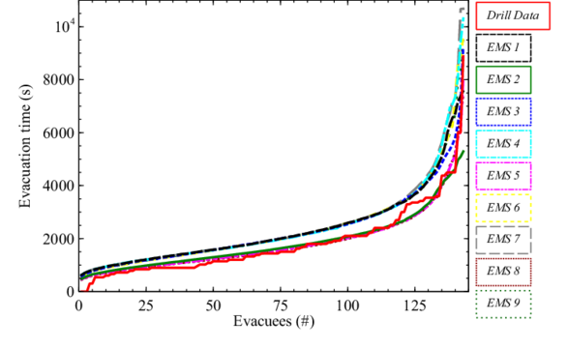
a)
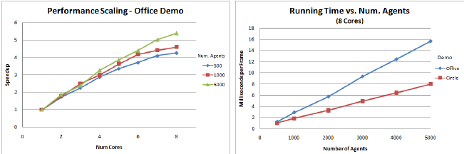
b) c)
FIGURE 1. Evacuation time reduction before and after system implementation; a) Dependence of evacuation time on the number of evacuated personnel under various emergency scenarios; b) Computational performance scaling of the evacuation model with increasing processor cores; c) Simulation execution time versus number of agents in different facility layouts.

As shown in Figure 1, the reduction in overall evacuation time is closely associated with faster hazard detection, UAV-supported situational assessment and adaptive AI-based route recalculation. However, the efficiency of the system depends on a reliable technological infrastructure. To demonstrate how these technological components interact during emergency response, the system architecture is illustrated in Figure 2.

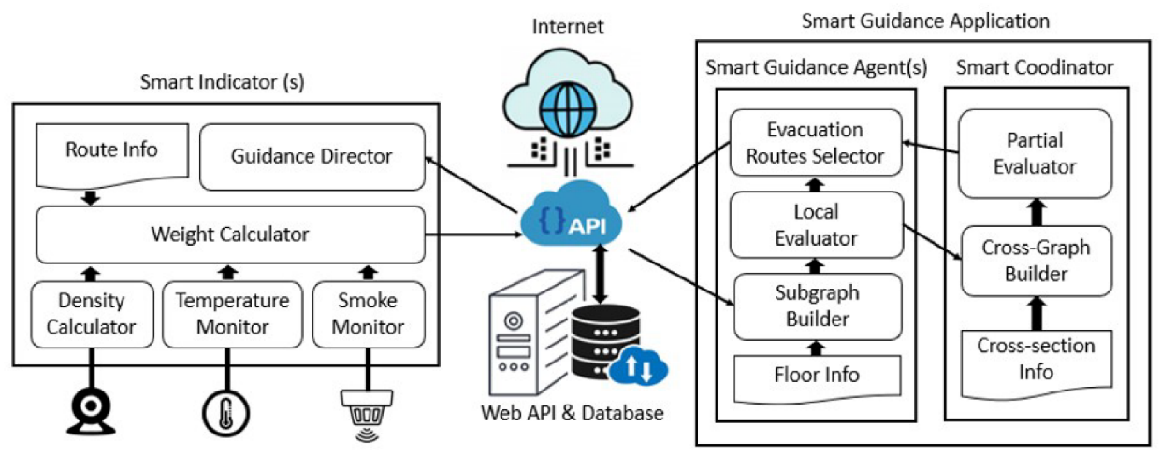
a)
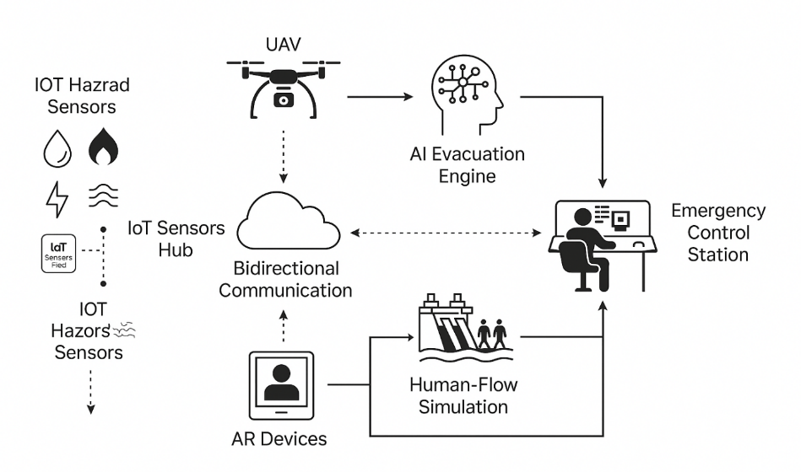
b)
FIGURE 2. Architecture of the integrated evacuation management system; a) Functional structure of the smart guidance application and decision-support modules; b) System-level architecture integrating IoT hazard sensors, UAV monitoring, AI evacuation engine and human-flow simulation.

The system architecture consists of IoT-based hazard sensors, UAV monitoring modules, an AI evacuation engine, a human-flow simulation core and bidirectional communication interfaces, all linked to a centralized emergency control station. The structure enables real-time hazard assessment and dynamic evacuation path generation.
Overall, the combined application of UAV inspection, IoT monitoring, dynamic density modeling and AI-based navigation has demonstrated substantial potential for enhancing emergency evacuation efficiency at hydroelectric power stations. The experimental results align with findings from international studies on digital safety technologies in hydropower infrastructure [5].
CONCLUSIONS
As can be seen from the above results, the integration of IoT-based monitoring, UAV inspection and AI-supported route optimization in hydroelectric power stations significantly increases the efficiency of personnel evacuation under extreme and crisis conditions. The proposed system reduces overall evacuation time, accelerates hazard detection and decreases congestion formation during movement.
Studies show that the application of real-time sensor data, UAV thermal imaging and dynamic routing leads to the following advantages:
Earlier identification of hazardous zones and blocked passages.
Faster and more accurate decision-making during emergency response.
Reduction of evacuation time and improvement of movement stability.
Decreased route-selection errors through AI-supported navigation.
Increased operational safety due to continuous monitoring and communication.
Thus, the combined use of modern digital technologies forms an effective basis for improving evacuation processes in hydropower facilities and ensures higher safety for personnel during crisis scenarios.
REFERENCES
- Ronchi, E., Nilsson, D. Evacuation modelling in large infrastructures. Fire Safety Journal, 2016. Vol. 80, pp. 18–28. DOI: https://doi.org/10.1016/j.firesaf.2016.02.002
- Hao, W., Li, Z., Xu, P. UAV-based inspection for hydropower emergency assessment. Renewable Energy, 2022. Vol. 189, pp. 1234–1245. DOI: https://doi.org/10.1016/j.renene.2021.10.045
- Li, X., Wang, Y., Chen, Q. IoT-enabled monitoring system for hydropower stations. Sensors, 2020. Vol. 20, No. 3, pp. 1–15. DOI: https://doi.org/10.3390/s20030682
- Raza, A., Ahmed, M., Kim, D. Artificial intelligence applications in critical infrastructure emergency management. IEEE Access, 2022. Vol. 10, pp. 45123–45140. DOI: https://doi.org/10.1109/ACCESS.2022.3154875
- Shakoor, M., Khan, Z., Li, R. Digital technologies for hydropower safety and resilience: A comprehensive review. Renewable & Sustainable Energy Reviews, 2023. Vol. 173, 113385. DOI: https://doi.org/10.1016/j.rser.2023.113385
- Zhou, T., Wang, J., He, X. Emergency safety assessment for hydropower stations. Energy Reports, 2022. Vol. 8, pp. 567–575. DOI: https://doi.org/10.1016/j.egyr.2022.07.145
- Johansson, F., Daamen, W. Human crowd dynamics and evacuation prediction models. Safety Science, 2018. Vol. 110, pp. 118–128. DOI: https://doi.org/10.1016/j.ssci.2018.08.012
- Kumar, S., Gupta, R. Real-time crowd evacuation using AI-based dynamic routing. Procedia Computer Science, 2021. Vol. 192, pp. 3034–3043. DOI: https://doi.org/10.1016/j.procs.2021.09.074
- Mustafa, F., Chan, A., Rahman, K. Thermal imaging and UAV technologies for rapid emergency detection in energy facilities. Applied Energy, 2020. Vol. 275, 115210. DOI: https://doi.org/10.1016/j.apenergy.2020.115210
- Zhang, H., Oliveira, L., Silva, M. Simulation of pedestrian flow in industrial and energy infrastructures. Simulation Modelling Practice and Theory, 2022. Vol. 118, 102554. DOI: https://doi.org/10.1016/j.simpat.2021.102554

