Analysis of electric energy losses in the traction power supply system
Abdurauf Safarov¹, Intizam Kudenov², Isa Gayipov^{2,a)}, Gulayim Esemuratova³, Baxadir Allamuratov²
¹ Tashkent State Transport University, Tashkent, Uzbekistan
² Nukus State Technical University, Nukus, Uzbekistan
³ Karakalpak State University named after Berdakh, Nukus, Uzbekistan
- Corresponding author: i.gayipov@gmail.com
Abstract. An analysis of the influence of structural and operational deficiencies of the traction power supply system on the levels of electric energy losses in the traction network has been performed. Furthermore, problems arising from imperfections in the current commercial electric energy metering system have been identified and characterized.
INTRODUCTION
Under contemporary conditions characterized by an increasing deficit and rising costs of fuel and energy resources, issues of energy conservation and enhanced efficiency in electric energy utilization are acquiring particular relevance. The sustained growth in energy prices intensifies the necessity for rational energy consumption across all sectors of the economy, including the transportation sector.
Railway transport, as one of the largest consumers of electric energy, faces particularly acute challenges in enhancing energy efficiency. A substantial share of consumed energy is attributed to the traction power supply system of electrified railways, where electric energy losses reach significant magnitudes. In this context, the problem of their reduction is considered as one of the key directions in ensuring energy conservation in transport and improving the overall operational efficiency of the traction network [1,2,3].
An electrified railway operating on alternating current represents an asymmetric nonlinear consumer of electric energy with an irregular load profile. This system constitutes an extended electricity receiver, consequently precluding the possibility of supplying its traction substations from a single point of connection to the external power supply system, which causes an energy imbalance in the traction power supply system (Figure 1).
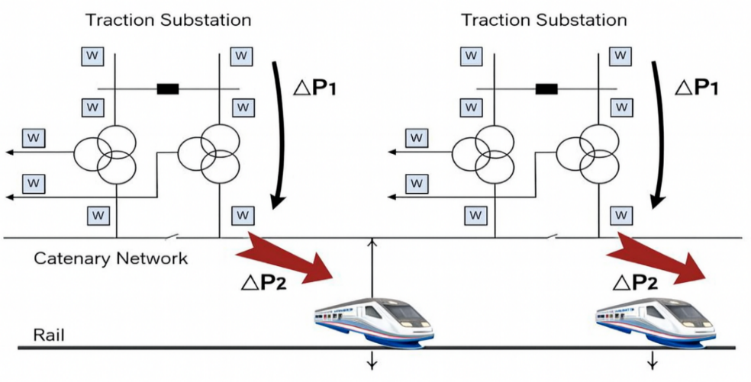
Figure 1. Diagram of energy imbalance in the traction power supply system
The discrepancy between actual and calculated values of electric energy losses is attributable to unsatisfactory technical condition and deficiencies in the organization of electric energy metering systems at traction substations (ΔP₁) and on electric rolling stock (ΔP₂).
Consequently, to ensure effective management of traction network operating modes and enhance its energy efficiency, merely determining actual electric energy losses, even with high accuracy of calculations and measurements, is insufficient. It is necessary to conduct an analysis of the loss structure, identify the main factors affecting their magnitude, and determine network sections with losses exceeding calculated values, which will enable the justified development and implementation of measures for their reduction.
Thus, at present, there exists an objective necessity for developing a comprehensive system of scientific, technical, and organizational measures, implemented in the form of an automated electric energy metering and control system (AEMCS), taking into account the aforementioned factors.
The implementation of such a system will enable the identification of sections with elevated electric energy losses, the development and implementation of measures for their reduction, the decrease of overall electricity consumption in the traction power supply system, as well as the improvement of its technical and economic indicators.
Objective of the work. Analysis of electric energy losses in the traction power supply system and recommendations for their reduction.
MATERIALS AND METHODS
Traction substations receive power from different nodes of one or several power systems. The difference in voltage magnitudes and phases at the substation connection points to the power systems leads to the emergence of power flows in the traction power supply system between adjacent substations, even in the absence of traction load. The connection between the external power supply system and the traction power supply system in terms of power transit is conventionally characterized by an equalizing current flowing in the traction network [4,5].
Power transit in the traction network causes additional electric energy losses during power transmission to electric rolling stock. Losses from the equalizing current in the traction network are determined by the formula [6], kW·h:

$ΔW_{eq}^{2}= I_{eq}^{2}· R_{11}· L · T · {10}^{-3}$ (1)
where L is the length of the inter-substation zone, km; T_{eq} is the duration of equalizing current flow through the traction network, h; R₁₁ is the active resistance of 1 km of traction network for a single-track AC section, Ω/km.
Electric energy losses in the traction network caused by the flow of equalizing currents significantly depend on the supply and sectioning scheme of the inter-substation zone. Their magnitude is determined by the nature of the traction load, parameters of system elements and operating modes of external and traction power supply systems, as well as the values of equalizing currents arising when utilizing bilateral supply schemes for the inter-substation zone.
During operation, the aforementioned factors are subject to variation; therefore, operational assessment of electric energy losses in the traction network for different inter-substation zone supply schemes acquires particular significance, enabling the selection of an optimal supply scheme that ensures minimal energy losses.
To form a complete picture of electric energy consumption distribution across all elements of the traction power supply system, it is necessary to implement metering of electricity consumption both through contact network feeders and on electric rolling stock.
The implementation of an automated electric energy metering and control system (AEMCS) in the traction power supply system, in addition to ensuring continuous monitoring and metering of electricity, will enable the assessment of the technical condition of power supply equipment, conduct operational control of electricity losses and power quality indicators, as well as identify cases of irrational electric energy consumption [7].
The development and implementation of such a system on electric rolling stock will enable: control of the reliability of electric energy metering results recorded by measuring instruments installed on electric rolling stock.
The primary prerequisite for ensuring high operational efficiency of automated commercial electric energy metering systems (AEMCS) is the stable and high-precision operation of primary current measuring transducers (CMT) employed in the electric power industry. These transducers are designed to generate reliable and complete information about the operating modes of electric power systems and their individual elements, which constitutes a necessary condition for the correct functioning of metering and analysis systems.
Despite the fact that modern measuring instruments, such as electronic meters, possess high accuracy classes (0.2), their readings are formed based on primary information received from current measuring transformers (transducers), which currently do not fully comply with modern accuracy class requirements (0.5) imposed on elements of automated electric energy metering and control systems, which in turn imposes certain specific requirements on current measuring transducers.
As a result of studying existing current measuring transducers, it was established that electromagnetic current transducers, according to their technical characteristics (wide conversion range, high precision and reliability), most comprehensively meet the requirements of AEMCS.
Figure 2 shows a simplified structural diagram of the current transducer developed by the authors, whose operating principle is based on the magnetomodulation effect [8,9].
The current transducer operates as follows. If the measured direct current I_{x}​ flows through the current-carrying busbar 7 (see Fig. 2), then oppositely directed magnetic fluxes Ψ_{a} and Ψ_{b} are created in the left and right C-shaped magnetic cores, which have maximum values on segments A-A and B-B (where output windings 9 and 10 are also located), and decrease toward the middle of connecting elements 3 and 4 on segment O-O due to magnetic flux leakage through the air gap. In the C-shaped magnetic cores and in the central part of the connecting elements (on segment O-O), these magnetic fluxes are equal (Ψ_{a} = Ψ_{b}) to each other. Output winding 11 encompasses the core pairs at both ends of the cutout, where flux differences Ψ_{A}−Ψ_{b}=ΔΨ_{b} exist (segment B-B). The directions of these differential fluxes are shown in Fig. 4.2, a; in magnitude they are equal (ΔΨ_{a}=ΔΨ_{b}) to each other, since on the paths of fluxes Ψ_{a} and Ψ_{b}​ there is identical magnetic resistance, both in the magnetic core and through the air gap.
From the fluxes Ψ_{a}, Ψ_{b}, ΔΨ_{a} and ΔΨ_{b} in output windings 9, 10, 11 (winding 11 consists of two parts located on segments A-A and B-B and connected in series) of the transducer, EMFs are induced that are proportional to the large converted current.

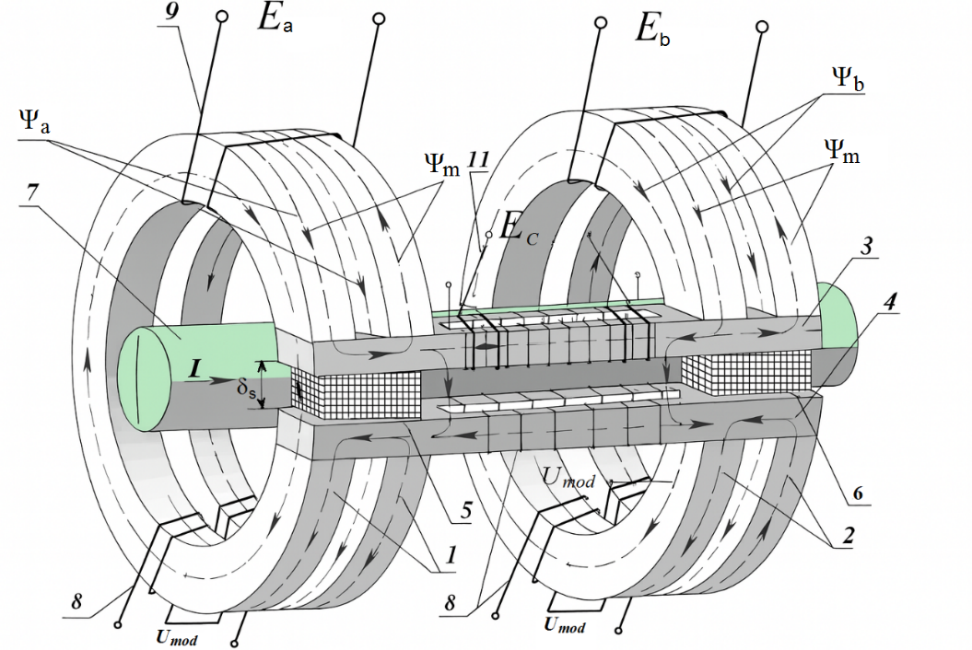
Figure 2. Simplified structural diagram of the current transducer

The current transducer with a disconnected modulating voltage source (U_{mod}=0) can be utilized for converting alternating current (according to the operating principle of a measuring current transformer).
The expansion of functional capabilities is achieved by the fact that the proposed device enables measuring both direct and alternating current, as well as using three output windings that have practically no mutual magnetic coupling for its connection to measurement circuits, relay protection and automation systems.
The absence of magnetic coupling between the output windings reduces conversion error caused by exceeding the maximum permissible values of load parameters, since in the presence of magnetic coupling between output windings, an increase in the load of one of them for measurement, relay protection and automation circuits inevitably leads to an increase in mutual inductance with other windings, consequently to a change in the output signal (EMF), i.e., to an increase in conversion error, respectively, in error.
Moreover, the execution of cutouts in the two C-shaped sections of the transducer's magnetic core allows for a reduction in its weight.
If the output signal is required in a unified form, known electronic (rectifier) circuits can be connected to the output windings of the transducer for both types of conversion.
CONCLUSION
Analysis of the structural and operational characteristics of the traction power supply system on electric energy loss levels in the traction network has demonstrated that this system represents an extended electricity receiver, consequently its traction substations cannot be supplied from a single point of connection to the external power supply system, which causes an energy imbalance in the traction power supply system.
It has been established that high-quality and reliable current transducers based on the magnetomodulation effect provide high operational efficiency for automated commercial electric energy metering systems employed in the electric power industry.
REFERENCES
1. Zakaryukin V.P. Methods and algorithms for joint modeling of traction and external power supply systems of AC railways. Dissertation abstract for the degree of Doctor of Technical Sciences. Omsk, 2009.
2. Kashtanov A.L. Improving the efficiency of electricity consumption control and conditions for coordination of external and traction power supply systems based on AEMCS data. Dissertation abstract for the degree of Candidate of Technical Sciences. Omsk, 2007.
3. Bardushko V.D. Analysis and parametric synthesis of traction power supply systems. Dissertation abstract for the degree of Doctor of Technical Sciences. Moscow, 2004.
4. Kostyukov A.V., Chernov A.V., Markin A.S. Intelligent automatic control system for reducing equalizing currents in the traction network // Fundamental Research. 2015. No. 3. pp. 100-105.
5. Osipov V.A. Patterns of equalizing current flow in electric traction networks and methods for their minimization. Dissertation abstract for the degree of Candidate of Technical Sciences. Rostov-on-Don, 2006.
6. Cheremisin V.T., Kvashchuk V.A. Control of equalizing currents, methodology for assessing losses in AC traction networks and measures for their reduction // Proceedings of the Second International Symposium ENSB-KE-EMS-EME-2000. Moscow: MIIT. 2000.
7. Lifanov E.I. Principles of constructing modern AEMCS systems / E.I. Lifanov // Ecological Systems. – 2005. – No. 12.
8. Patent of the Republic of Uzbekistan No. 04217. Device for current conversion / Amirov S.F., Safarov A.M., Turdybekov K.Kh., Rustamov D.Sh., Khushbokov B.Kh. // Official Bulletin. – 2010. – No. 8.
9. A.M. Safarov, D. Sh. Rustamov .The intellectually gauge of a current for control systems duty works of traction engines. // WCIS – 2012 Seventh world conference on intelligent systems for industrial automation Tashkent, Uzbekistan November 25-27, 2012. 129-132
10. Rafikova, G., Gayipov, I., Mirzoev, D., Mamatkulov, A. Assessment of the Economic Effectiveness of Energy Saving Measures. AIP Conference Proceedings 3152(1), 2024. https://doi.org/10.1063/5.0218928
11. Djalilov, A., Sobirov, E., Nazarov, O., Urolov, S., & Gayipov, I. (2023, March). Study on automatic water level detection process using ultrasonic sensor. In IOP Conference Series: Earth and Environmental Science (Vol. 1142, No. 1, p. 012020). IOP Publishing. https://doi.org/10.1088/1755-1315/1142/1/012020
12. Lezhnina, Y., Abubakiro, A., Gaipov, I., & Eshmuratov, N. (2023). Monitoring of asymmetric values and parameters of electric networks. In E3S Web of Conferences (Vol. 371, p. 03068). EDP Sciences. https://doi.org/10.1051/e3sconf/202337103068

