Integrated Thermal Modeling of Engine, Coolant, and Automatic Transmission Oil Loops for Passenger Vehicles
Seyran Asanov^{1,a)}, Fikret Umerov¹, Avaz Yangibaev², Oybek Daminov², Jakhongir Mirzaabdullaev², Khumoyun Urakov²
¹ Turin Polytechnic University in Tashkent, 100095, Tashkent, Uzbekistan
² Tashkent state technical university named after Islam Karimov, Tashkent, Uzbekistan
^{a)} Corresponding author: seyran.asanov@polito.uz
Abstract. This study introduces a dynamic system-level thermal model of an integrated vehicle cooling architecture, which includes the engine coolant, engine oil, and automatic transmission fluid (ATF) circuits. The model accurately depicts a passenger car with an automatic transmission, such as the Chevrolet Gentra, utilizing the Simscape Thermal-Liquid framework in MATLAB/Simulink. A lumped-parameter model shows how heat is made, moved, and stored in the engine block, radiator, oil-coolant heat exchangers, and transmission housing. The flow regime, vehicle speed, and the operation of the cooling fan have been exploited as input parameters when modeling convective heat transfer coefficients. The cooling system has been tested through a driving situation containing urban and sub-urban velocity modes. Among the driving conditions are also used stop-and-go traffic in cities, steady cruising, and at high speeds. The simulation results show that the engine block, the coolant, and the engine oil are all very close to each other in temperature. The ATF takes longer to heat up because it has more thermal inertia. It is cooled indirectly through the oil-coolant heat exchanger. When the machine is running at a high speed and load, the temperature is at its highest. Thermal stabilization happens when the radiator gets enough air to flow through it. The model shows how the temperature changes over time in all major thermal domains and how these changes are the same across different operating conditions.
INTRODUCTION
Thermal management is very important for modern passenger cars with automatic transmissions and internal combustion engines to perform well, last a long time, and be reliable. In the past, engine coolant systems only had to keep the engine from overheating [1]. A lot of small and medium-sized cars have built-in oil-coolant heat exchangers that connect to the engine oil and the automatic transmission fluid (ATF) [2,3] .This kind of coupling makes it hard for different thermal loops to operate together. To know when temperatures will change and when they will stay the same, one must analyze the whole system [4,5].
For vehicles with automatic transmissions, it's very important to keep the ATF temperature in a good range. The transmission may not operate as well if the ATF temperature is too high or too low [6,7]. This can cause oil to break down faster, make friction materials less durable, and make the transmission work worse. Also, if the temperature is too low, it can cause more viscous losses, which makes the system less efficient overall [8,9]. The way the transmission works with heat can change a lot based on the engine load, the weather, or how you drive. This is because the engine coolant circuit often cools the ATF [10].
Most of the time, traditional thermal analyses of vehicle cooling systems use steady-state assumptions or simplified lumped-parameter models that don't fully show how coolant, engine oil, and transmission oil interact with each other in a transient way [11,12]. But in real life, the engine speed, load, vehicle speed, and cooling airflow all change all the time [13]. This means that dynamic modeling methods that can show how thermal and hydraulic phenomena are linked are needed. Model-based simulation tools are a good way to deal with these problems early in the design and optimization process [14,15].
This work concentrates on the creation of a detailed dynamic thermal model for an integrated engine cooling system featuring interconnected engine oil and automatic transmission oil loops. The model is built in MATLAB/Simulink using the Simscape Thermal-Liquid environment [16]. It shows the main physical parts of a production passenger vehicle cooling system, such as the radiator and fan system, thermostat with bypass, expansion tank, oil-coolant heat exchangers, hydraulic pumps, and distributed thermal masses [17]. The proposed model allows for a detailed analysis of how temperature changes and how thermal load is spread across the system by capturing the interactions between coolant, engine oil, and ATF when the system is running in a transient state.
METHODS
The thermal model developed in this study illustrates a unified cooling architecture typical of compact passenger vehicles with automatic transmissions, using the Chevrolet Gentra as a case study. The Gentra cooling system features a single engine coolant loop that simultaneously regulates the thermal states of the engine block, engine oil, and automatic transmission fluid (ATF) through dedicated oil-coolant heat exchangers. This kind of setup is common in production cars because it saves space and money, but it makes subsystems very thermally connected [9,18].
The modeled system has three thermal-hydraulic loops: the engine oil loop, the engine coolant loop, and the automatic transmission oil loop. The radiator in the coolant loop has forced air convection, an electric cooling fan, a thermostat with a bypass hose, an expansion tank, connecting hoses, and a mechanically driven coolant pump. The engine oil loop and the ATF loop are both powered by separate pumps. Each loop has an oil-coolant heat exchanger built in that lets them trade heat with the coolant.

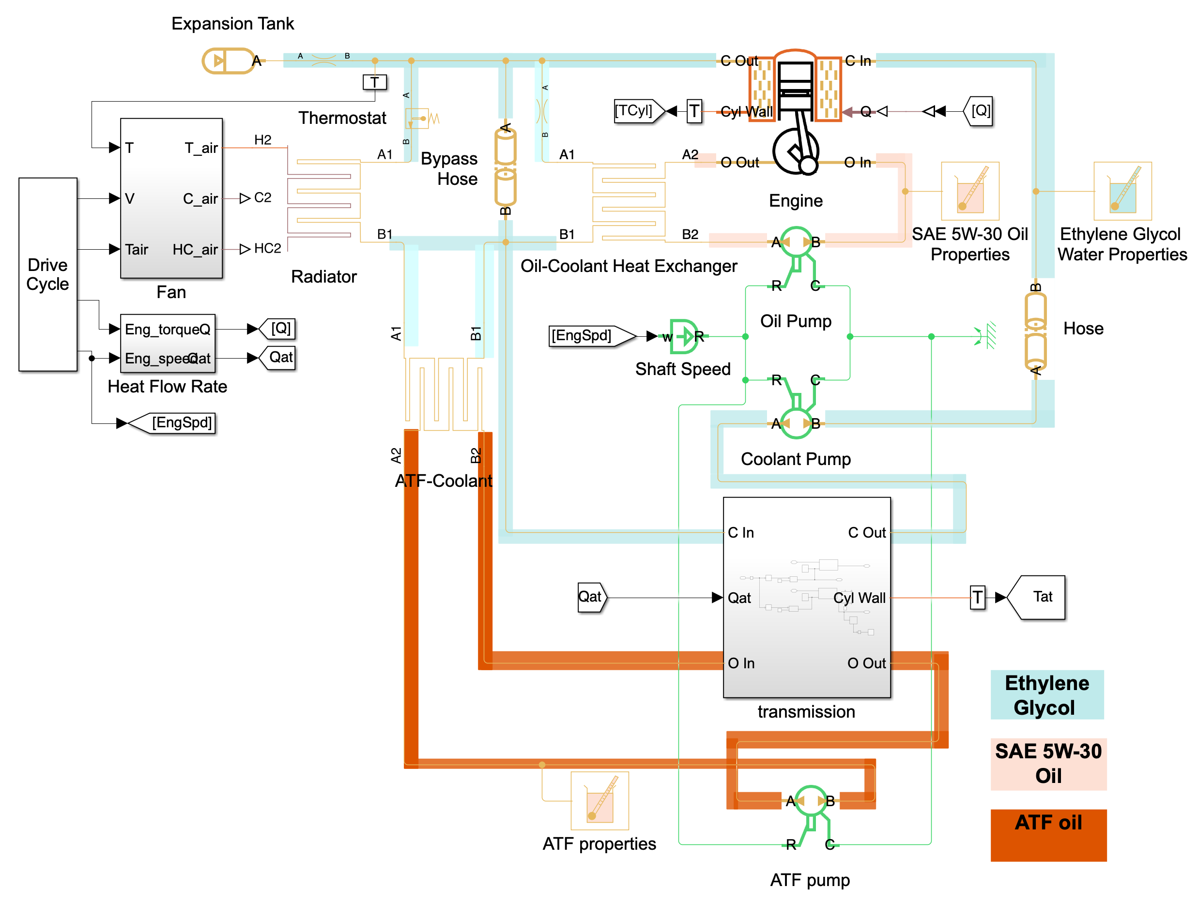
FIGURE 1. Overall view of the engine and transmission cooling system realized in Simulink/Simscape environment

The fan and the vehicle’s forward speed control the air flow through the radiator. This method lets the model consider both the effects of ram air when the car is going fast and forced convection when the car is going slowly or not at all. The thermostat controls how much coolant flows between the radiator and the bypass branch based on how hot the coolant is [19,20].
The Simscape Thermal-Liquid library in MATLAB/Simulink is used to implement the model. We use one-dimensional, incompressible flow assumptions to describe all fluid circuits. We use friction correlations and equivalent local resistance lengths to model pressure losses. Lumped thermal masses are used to account for thermal energy storage, and convective heat transfer coefficients are used to show how heat moves between fluids and solid boundaries.
The engine block, coolant volume, engine oil, and ATF are all given distributed thermal masses so that they can respond to variations in temperature. The effective thermal properties and masses are chosen to match the physical features of the Gentra powertrain, such as the aluminum engine structure, normal coolant volume, engine oil capacity, and ATF capacity. This method lets the model show realistic warm-up dynamics and the effects of thermal inertia.
By looking at the engine's speed and torque, one can figure out how much heat the engine and automatic gearbox are making. The rates of heat transfer change over time and depend on the driving cycle. You can practice driving in a lot of different situations, like in cities, at a steady speed, and when the load changes suddenly. The ambient air temperature around the radiator influences its heat dissipation efficiency [21,22].
We use a two-dimensional lookup table to determine the velocity of air passing through the radiator, contingent upon the vehicle's speed and the power supplied to the fan control [23]. This method makes it easier to switch between natural and forced convection modes. The cooling fan is seen to cover just a portion of the radiator, which is typical for the Gentra cooling system.
The oil-coolant heat exchangers transfer heat from the engine oil circuit to the ATF circuit and subsequently to the coolant circuit. We use liquid–liquid heat transfer blocks to make these heat exchangers work. Each fluid has its own set of thermal and hydraulic properties. The model set up allows the heat to move in both directions. This illustrates that oil heats up when it's freezing and cools down when it gets too hot.
The proposed model uses energy balance equations based on lumped-parameter assumptions to describe how heat moves between fluid circuits that are interacting with each other. An equivalent thermal mass represents each fluid control volume, and convective heat transfer relations are used to model heat exchange between fluids and solid boundaries.
The following energy balance equation controls how the temperature of a generic fluid volume (like coolant, engine oil, or ATF) changes over time [2,24]:
$m_{f}c_{p,f}\frac{dT_{f}}{dt}=\dot{Q_{in}}-\dot{Q_{out}}+\sum{\dot{Q_{ht}}}$ (1)

where
$m_{f}$is the effective fluid mass,
$c_{p,f}$is the specific heat capacity,
$T_{f}$is the fluid temperature,
${\dot{Q}}_{ht}$represents heat transfer rates exchanged with adjacent fluids or solid components.
Heat transfer between two fluids, such as engine coolant and engine oil or automatic transmission fluid, transpires via an intermediary solid barrier in the oil-coolant heat exchanger. The rate at which heat moves is described as [25] :
$\dot{Q}=UA\left(T_{hot}-T_{cold}\right)$ (2)

where $A$ is the effective heat transfer area, and $T_{hot}$and $T_{cold}$are the bulk temperatures of the interacting fluids. The overall heat transfer coefficient $U$is defined as
$\frac{1}{U}=\frac{1}{h_{1}}+R_{wall}+\frac{1}{h_{2}}+R_{fouling}$ (3)

Here, $h_{1}$and $h_{2}$are the convective heat transfer coefficients on the respective fluid sides, $R_{wall}$is the thermal resistance of the separating wall, and $R_{fouling}$represents additional resistance due to surface fouling [26].
The convective heat transfer coefficient is related to the Nusselt number according to
$h=\frac{Nu k}{D_{h}}$ (4)

where $k$ is the thermal conductivity of the fluid and $D_{h}$is the hydraulic diameter of the flow passage. The Nusselt number is defined as a function of Reynolds and Prandtl numbers,

$Re=\frac{ρvD_{h}}{μ}$ (5)
$Pr=\frac{c_{p}μ}{k}$ (6)
where $ρ$ is the fluid density, $v$is the mean flow velocity, and $μ$ is the dynamic viscosity [27,28].
Heat rejection from the engine coolant to ambient air through the radiator is modeled using

$\dot{Q_{rad}}=U_{rad}A_{rad}(T_{coolant}-T_{air})$ (7)
The effective air-side heat transfer coefficient depends on how fast the vehicle is moving and whether the cooling fan is working. A two-dimensional lookup table shows how the airflow speed across the radiator core changes based on the vehicle speed and the fan control voltage [29].
The engine block and gearbox casing are examples of solid parts that are shown as lumped thermal masses. The transient temperature of a solid component is ascertained by
$m_{s}c_{p,s}\frac{dT_{s}}{dt}=\sum{\dot{Q_{in}}}-\sum{\dot{Q_{out}}}$ (8)
where $m_{s}$ and $c_{p,s}$ denote the mass and specific heat capacity of the solid component, respectively [30,31].

RESEARCH RESULTS
Figure 2 shows the driving conditions that were used to see how well the engine, coolant, and automatic gearbox cooling system worked together. The top graph shows how the engine speed and the vehicle speed change over time. The graph at the bottom shows the engine torque profile that goes with this.
The car mostly drives in cities during the first part of the simulation (about 0-8 000 seconds), which is full of stop-and-go situations. When this happens, the speed of the vehicle changes between 0 and about 50 km/h, and the speed of the engine mostly changes between 800 and 2 300 rpm. The engine torque changes quickly, with both positive and negative values. This is typical of urban traffic, where the engine speeds up, slows down, and brakes. These operating conditions put a lot of short-term stress on the cooling system. This is because the radiator doesn't get enough air from outside, so the cooling fan must work harder to move air around.
During the middle portion of the simulation (about 8 000-10 500 seconds), the vehicle shifts to suburban and stable cruising settings. The speed of the vehicle gradually rises and stays between 60 and 80 km/h, while the engine speed stays steady between 1600 and 2000 rpm. In this operational zone, the engine torque is mostly positive and smoother, which means that the load doesn't change as much. When a vehicle goes faster, the radiator works better to cool the engine by using ram air. This means that the engine rejects heat differently than when it is going slowly.
The car reaches highway driving conditions in the last part of the simulation (about 10 500-12 000 s). The speed goes up to about 120 km/h, and the engine speed goes up to about 2 800-3 000 rpm. During this time, the engine torque reaches its highest sustained levels, which means that the powertrain is under more stress from heat. These conditions show the highest coolant heat rejection capacity because the radiator's airflow speed is higher, which also means that the engine and gearbox are producing the most heat at the same time.
After about 12 000 seconds, the speed of both the vehicle and the engine drops to zero. This means that the vehicle has stopped and the engine has turned off, making it easier to keep track of the system's thermal inertia and cooling behavior.

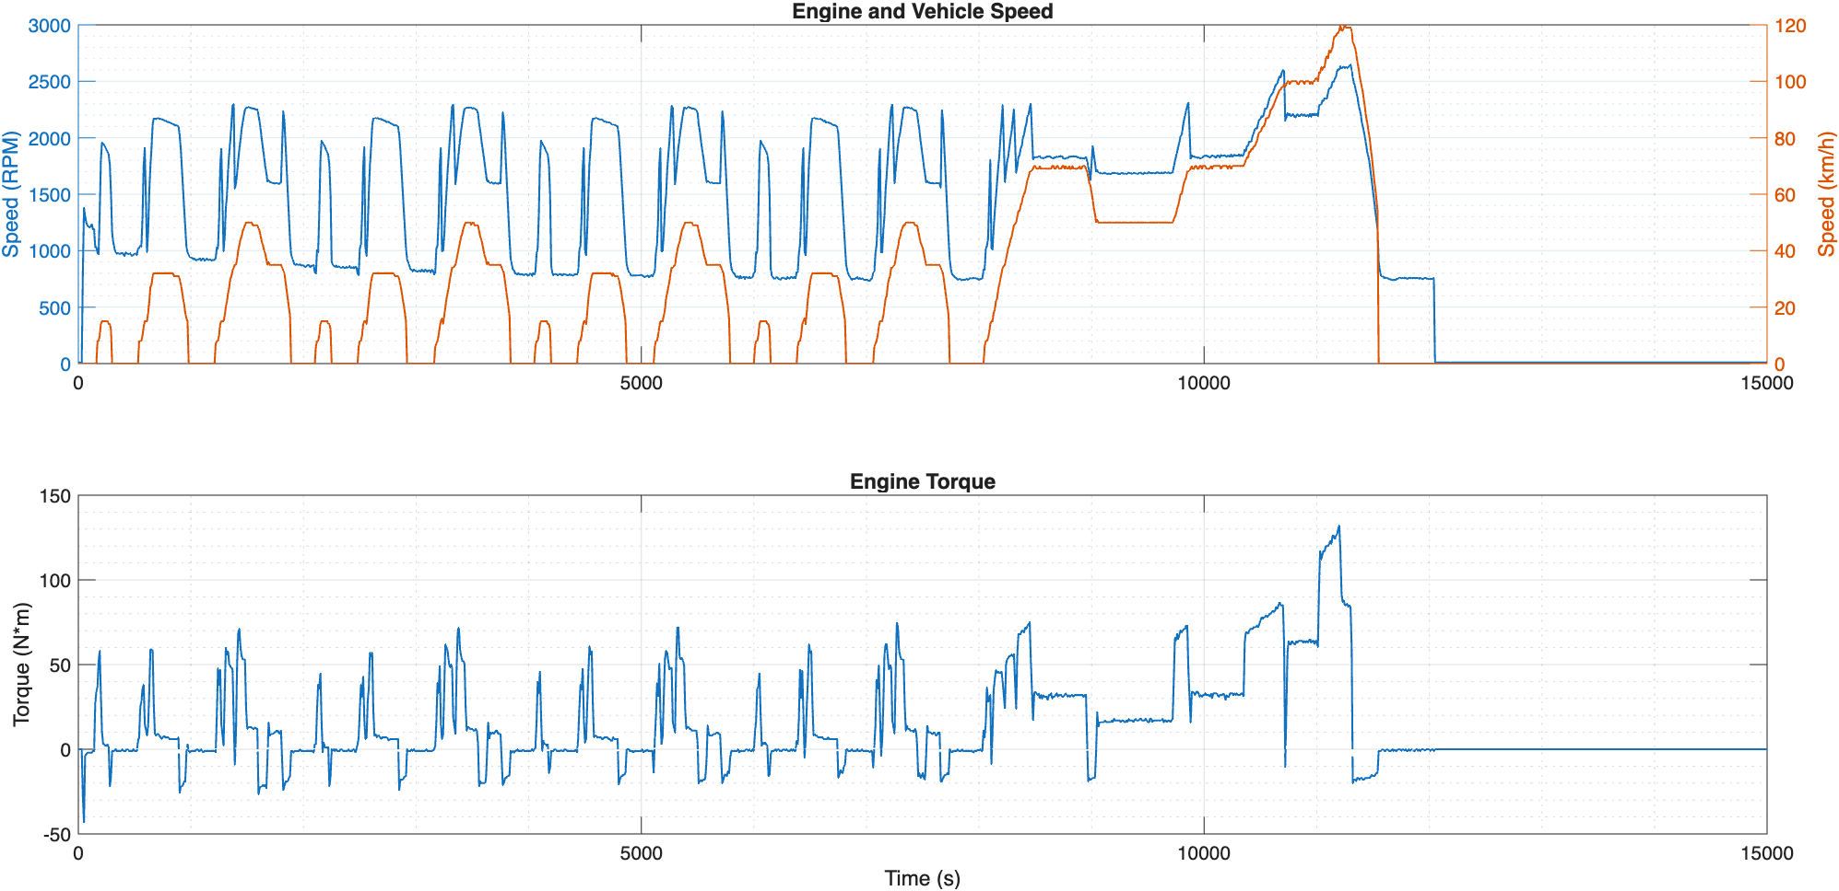
FIGURE 2. Time-dependances of vehicle speed, engine speed and torque in the simulation of the cooling system

Figure 3 shows how the engine oil, engine block, automatic transmission fluid (ATF), and engine coolant's temperatures changed over time during the simulated operating cycle. The results show how the car's built-in cooling system works with heat in a way that changes over time.
During the first warm-up phase, the temperatures slowly rise from levels that are close to room temperature. During the simulation, the engine block and coolant temperatures rise quickly and stay close to each other. This means that the walls of the combustion chamber and the cooling system are doing a good job of moving heat. The curves show that the car speeds up in steps over the course of the drive. During these times, the engine load and heat output rise for a short time.
The temperature of the engine oil follows a similar pattern, but it stays a little higher than the temperature of the coolant as the system gets closer to its normal operating range. This behavior shows that the oil is directly heated by friction and combustion, and the oil-coolant heat exchanger also cools it down. The temperature graphs for the engine block, coolant, and engine oil are all very similar. This shows how well the Gentra cooling system keeps things cool.
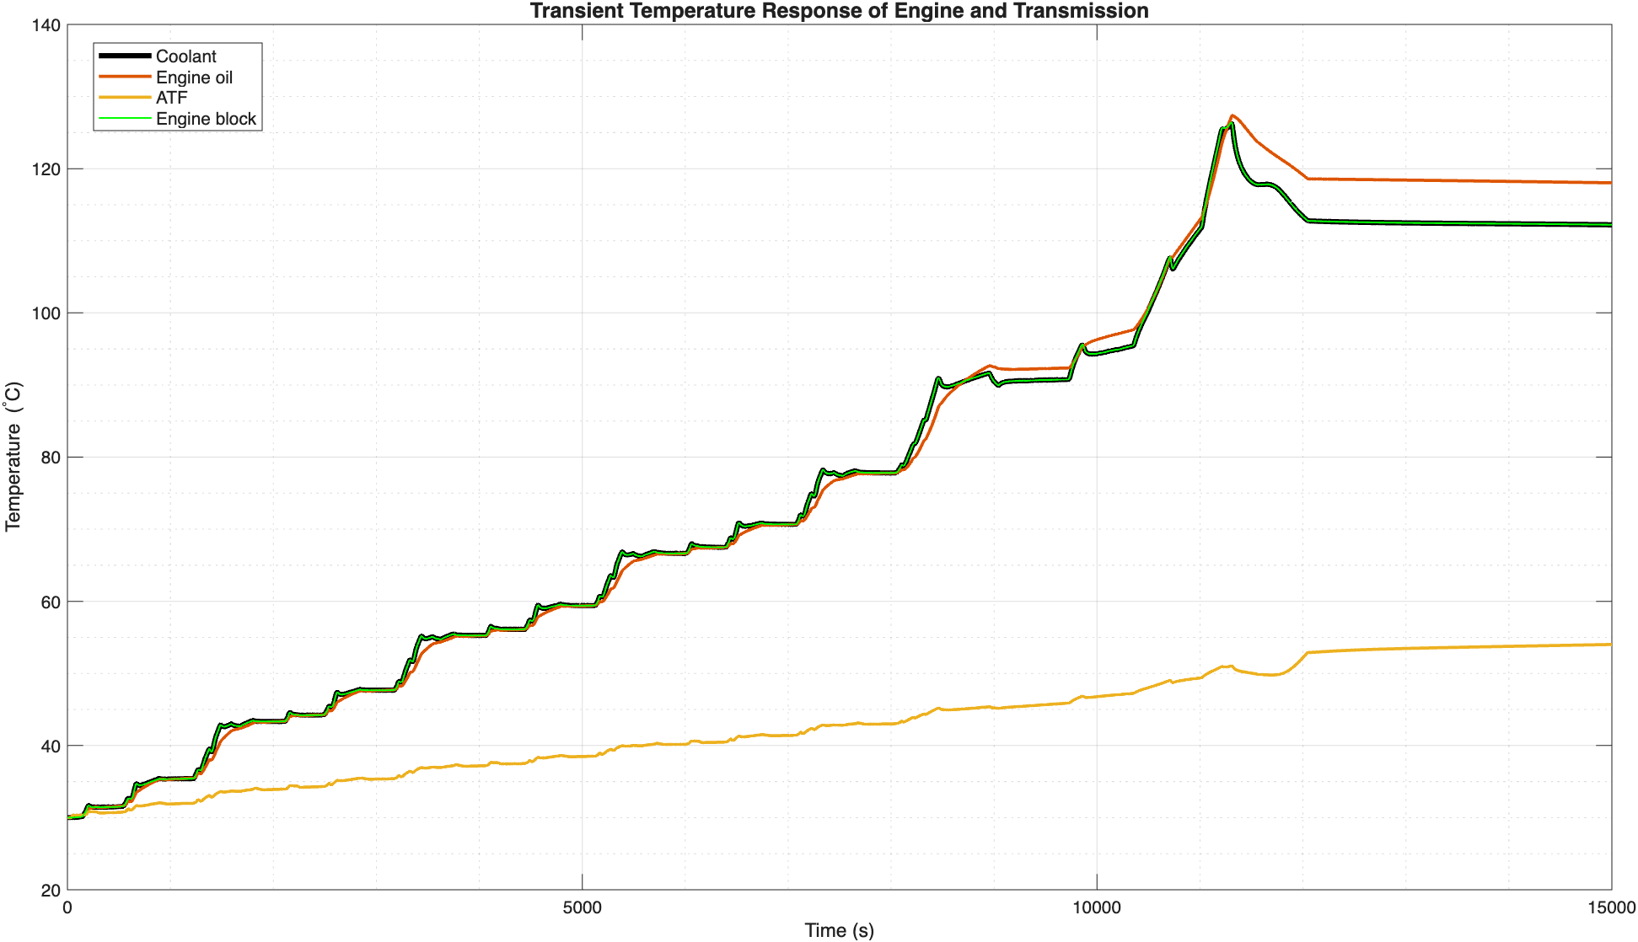
FIGURE 3. Time-dependances of temperatures of the coolant, engine oil, engine block and automatic transmission fluid (ATF)

The ATF, on the other hand, takes longer to warm up and stays much cooler than the engine for the whole experiment. The reaction takes longer because the transmission system has a higher thermal inertia. The ATF and coolant don't move heat directly from one to the other, either. The ATF temperature stays normal even when the transmission is working hard and fast. This means that the default ATF-coolant heat exchanger is doing a good job of keeping the transmission from getting too hot.
The temperature is highest when the engine and the car are both going as fast as they can. This happens when you speed up. This peak means that the engine and gearbox get hotter when they are under a lot of stress. After this point, the temperature starts to drop because the engine load drops and the cooling capacity goes up. This shows that the cooling system can keep the engine stable even when it is running in different ways.
The results show that the proposed model does a good job of showing how the temperature of the coolant, engine oil, engine block, and ATF changes over time and how they affect each other. The picture shows that the integrated cooling system keeps the temperature stable in a lot of different situations that are similar to how cars are used in real life.
CONCLUSIONS
This work introduced a detailed dynamic thermal model of an integrated engine cooling system, including interlinked engine oil and automatic transmission fluid (ATF) circuits, exemplified by a production passenger car like the Chevrolet Gentra. We developed the model using the Simscape Thermal-Liquid framework inside MATLAB/Simulink. It encompasses all the essential physical components that regulate the powertrain's generation, movement, and storage of heat.
The simulation results demonstrate that the proposed model effectively replicates the transient thermal dynamics of the engine block, coolant, engine oil, and ATF across various operating scenarios, including stop-and-go city traffic, steady cruising, and high-speed operation. Significant thermal interaction occurred among the engine block, coolant, and engine oil, indicating the efficacy of the integrated cooling architecture. The ATF's temperature gradually increased and remained within a narrow range because to the indirect cooling provided by the oil-coolant heat exchanger and its significant thermal inertia.
The model illustrates how thermal responses may vary with changes in vehicle speed, engine load, and airflow through the radiator. The findings indicate that forced and ram-air convection are crucial for preventing overheating under substantial loads. The proposed modeling technique is a physically valid and computationally efficient instrument for analyzing the systemic aspects of vehicle cooling systems with automatic gearboxes. This facilitates the examination of designs and the formulation of control strategies at an early stage.
MODEL LIMITATIONS
The proposed model, while successfully encapsulating the essential transient thermal interactions within the integrated cooling system, is limited by specific simplifying assumptions that reduce its predictive accuracy. Lumped-parameter methods with uniform temperatures are used to model how fluids and solid parts behave thermally. This means that local temperature gradients in the engine block, radiator core, and transmission housing cannot be explicitly resolved. The airflow through the radiator has an effective speed that depends on how fast the vehicle is moving and whether the fan is running. However, the uneven flow distribution caused by partial fan coverage and complex aerodynamics under the hood is not directly addressed. Furthermore, convective heat transfer coefficients are derived from empirical correlations and calibrated parameters rather than explicit geometric representations, which introduces uncertainty in extreme operational or environmental conditions. Quite often the long-term effects of wear and tear, like the cooling system aging, changes in oil properties, buildup of dirt, and changes in pump or fan performance over the life of the vehicle are taken into account. These assumptions work well for system-level analysis, but they might not be as accurate for localized thermal evaluations.
FUTURE RESEARCH PERSPECTIVES
Future research will focus on improving the developed model to make it easier to test cooling performance and make it more flexible for control. Adding a second cooling fan is one important thing to do. This is becoming more common in modern vehicle cooling systems because it makes it easier for the system to get rid of heat and makes the air flow better over the radiator surface. One can investigate staged and independently controlled fan operation by adding a second fan. This will help keep the vehicle cooler at low speeds and when it's parked, and it will also help it stay cooler when it's hot and carrying a lot of weight for a long time. In the future, improving the radiator airflow model to account for spatial non-uniformities, adding distributed thermal masses to capture internal temperature gradients, and testing the model with data from vehicle tests would be beneficial. These changes will make the model better at making predictions and help it be used to improve cooling systems, come up with new ways to control temperature, and plan the next generation of powertrain architectures.
REFERENCES
- Koriko OK, Oreyeni T, Oyem OA. On the Analysis of Variable Thermophysical Properties of Thermophoretic Viscoelastic Fluid Flow past a Vertical Surface with nth Order of Chemical Reaction. OAlib 2018;05:1–17. https://doi.org/10.4236/oalib.1104271.
- Reyes A, Negrete D, Mahn A, Sepúlveda F. Design and evaluation of a heat exchanger that uses paraffin wax and recycled materials as solar energy accumulator. Energy Convers Manag 2014;88:391–8. https://doi.org/10.1016/j.enconman.2014.08.032.
- Yu C, Zhang W, Wang G, Huang M, Sui J, Zhao H. Experimental study of dual-cycle thermal management system for engineering radiator. Sci Rep 2024;14:19691. https://doi.org/10.1038/s41598-024-70882-w.
- Selvin PA, Palayya ACR, Paul SHJ, Sharon S, Palayyan RK. Mathematical modelling of ship central engine cooling system, 2025, p. 50002. https://doi.org/10.1063/5.0269341.
- Mu H, Wang Y, Teng H, Jin Y, Zhao X, Zhang X. Cooling system based on double-ball motor control valve. Advances in Mechanical Engineering 2021;13. https://doi.org/10.1177/16878140211011280.
- Burke R, Brace C, Cox A, Lewis A, Hawley JG, Pegg I, et al. Systems Approach to the Improvement of Engine Warm-Up Behaviour. Proceedings of the Institution of Mechanical Engineers, Part D: Journal of Automobile Engineering 2011;225:190–205. https://doi.org/10.1243/09544070JAUTO1595.
- S.Asanov, F.Umerov, J.Inoyatkhodjaev N. Bekmurodov B.Kodirov. Influence of Powertrain Topology (FWD vs RWD) on Regenerative braking capabilities in Electric Vehicles. 74th International Conference on Vibroengineering in Tashkent. Vibroengineering Procedia, 2025.
- Brace CJ, Hawley G, Akehurst S, Piddock M, Pegg I. Cooling system improvements — assessing the effects on emissions and fuel economy. Proceedings of the Institution of Mechanical Engineers, Part D: Journal of Automobile Engineering 2008;222:579–91. https://doi.org/10.1243/09544070JAUTO685.
- Kula S. Design Studies of Two Stage Cooling Loop for New Generation Vehicles. Academic Perspective Procedia 2020;3:550–9. https://doi.org/10.33793/acperpro.03.01.104.
- Farrell EF. Transmission Cooling Systems - Oil to Water Type, 1962. https://doi.org/10.4271/620238.
- Kambarov I, D’Antonio G, Aliev K, Chiabert P, Inoyatkhodjaev J. Uzbekistan Towards Industry 4.0. Defining the Gaps Between Current Manufacturing Systems and Industry 4.0, 2018, p. 250–60. https://doi.org/10.1007/978-3-030-01614-2_23.
- Yakhshilikov J, Cavana M, Inoyatkhodjaev J, Giarola S, Leone P. Long-term energy and emissions outlook for the road transport sector of Uzbekistan: Insights from an agent-based energy model. Energy 2025;339:139106. https://doi.org/10.1016/j.energy.2025.139106.
- Kobilov N, Khamidov B, Rakhmatov K, Abdukarimov M, Daminov O, Shukurov A, et al. Investigation and study of oil sludge of oil refinery company in Uzbekistan, 2025, p. 040076. https://doi.org/10.1063/5.0269039.
- Serrano JR, Arnau FJ, García-Cuevas LM, Samala V. A Robust Adiabatic Model for a Quasi-Steady Prediction of Far-Off Non-Measured Performance in Vaneless Twin-Entry or Dual-Volute Radial Turbines. Applied Sciences 2020;10:1955. https://doi.org/10.3390/app10061955.
- Espinosa-Martínez É-G, Quezada-García S, Escobedo-Izquierdo MA, Cázares-Ramírez RI. Comparative and Sensibility Analysis of Cooling Systems. Energies (Basel) 2024;17:4452. https://doi.org/10.3390/en17174452.
- Mathworks-Simscape. www.mathworks.com .
- Mukherjee K, Bhattacharjee P, Mukherjee A, Roy S, Das MC. A software analysis to predict the performance and emission characteristics of a diesel engine, 2025, p. 040003. https://doi.org/10.1063/5.0309471.
- Matmurodov F.M., Daminov O.O., Sobirov B.Sh., Abdurakxmanova M.M., Atakhanov F. Dynamic simulation of force loading of drives of mobile power facilities with variable external resistance. E3S Web of Conferences 2024;486:03001. https://doi.org/10.1051/e3sconf/202448603001.
- Bai M, Liu N, Liu J, Li L, Zhang W, Kreschel M. A review of thermal management technologies for electric vehicles. J Energy Storage 2026;143:119658. https://doi.org/10.1016/j.est.2025.119658.
- Kirkpatrick AT. Introduction to Internal Combustion Engines. Internal Combustion Engines, Wiley; 2020, p. 1–34. https://doi.org/10.1002/9781119454564.ch1.
- J.Heywood. Internal combustion engine fundamentals. Choice Reviews Online 1988;26:26–943. https://doi.org/10.5860/CHOICE.26-0943.
- Umerov F, Asanov S, Daminov O, Komiljonov U, Avazov I. Energy savings in public transport: Estimating the impact of regenerative braking in electric buses in public transport of Tashkent, AIP Publishing 2025, p. 30080. https://doi.org/10.1063/5.0306144.
- Umerov F, Daminov O, Khakimov J, Yangibaev A, Asanov S. Validation of performance indicators and theoretical aspects of the use of compressed natural gas (CNG) equipment as a main energy supply source on turbocharged internal combustion engines vehicles, AIP Publishing 2024, p. 30017. https://doi.org/10.1063/5.0219381.
- Daminov O, Mirzaabdullaev J, Umerov F, Khimmataliev D, Daminov L, Sharipov Y, et al. Electric vehicle battery technology and optimization, AIP Publishing 2025, p. 60026. https://doi.org/10.1063/5.0306143.
- Hatami M, Ganji DD, Gorji-Bandpy M. Experimental and thermodynamical analyses of the diesel exhaust vortex generator heat exchanger for optimizing its operating condition. Appl Therm Eng 2015;75:580–91. https://doi.org/10.1016/j.applthermaleng.2014.09.058.
- Ghajar A, Cengel Y. Heat and Mass Transfer - Fundamentals and Applications, 6th Edition, McGraw-Hill Education, New York, NY, 2020. 2021.
- Koriko OK, Oreyeni T, Oyem OA. On the Analysis of Variable Thermophysical Properties of Thermophoretic Viscoelastic Fluid Flow past a Vertical Surface with nth Order of Chemical Reaction. OAlib 2018;05:1–17. https://doi.org/10.4236/oalib.1104271.
- Brace CJ, Hawley G, Akehurst S, Piddock M, Pegg I. Cooling system improvements — assessing the effects on emissions and fuel economy. Proceedings of the Institution of Mechanical Engineers, Part D: Journal of Automobile Engineering 2008;222:579–91. https://doi.org/10.1243/09544070JAUTO685.
- Kula S. Design Studies of Two Stage Cooling Loop for New Generation Vehicles. Academic Perspective Procedia 2020;3:550–9. https://doi.org/10.33793/acperpro.03.01.104.
- Umerov F, Asanov S, Daminov O, Mirzaabdullaev J, Yangibaev A. Improving the performance of light vehicle cooling system with mechatronic system, AIP Publishing 2025, p. 30079. https://doi.org/10.1063/5.0306145.
- Serrano JR, Arnau FJ, García-Cuevas LM, Samala V. A Robust Adiabatic Model for a Quasi-Steady Prediction of Far-Off Non-Measured Performance in Vaneless Twin-Entry or Dual-Volute Radial Turbines. Applied Sciences 2020;10:1955. https://doi.org/10.3390/app10061955.
- Aliev K, Narejo S, Pasero E, Inoyatkhodjaev J. A Predictive Model of Artificial Neural Network for Fuel Consumption in Engine Control System, 2018, p. 213–22. https://doi.org/10.1007/978-3-319-56904-8_21.

