The architecture of the control system and parameters of electric vehicle components and their calculation basis
Fikret Umerov¹, Seyran Asanov^{1,a)}, Jamshid Inoyatkhodjaev^{1,2}, Rustem Yunusov³, Rustam Tillakhodjaev⁴, Jamoliddin Turdiev⁴, Abbosxon Ataxanov⁴, Oybek Daminov⁴
¹ Turin Polytechnic University in Tashkent, 100095, Tashkent, Uzbekistan
² Inha University in Tashkent, Tashkent, Uzbekistan
³ Tashkent Institute of Irrigation and Agricultural Mechanization Engineers
(National Research University), Tashkent, Uzbekistan
⁴ Tashkent state technical university named after Islam Karimov, Tashkent, Uzbekistan
^{a)} Corresponding author: seyran.asanov@polito.uz
Abstract. This article presents a systematic examination of the control architecture of modern electric vehicles, considered as cyber-physical platforms integrating power electronics, traction drives, battery management systems, and auxiliary electronic subsystems into a unified control framework. Particular emphasis is placed on the interaction between the propulsion system components-namely the inverter, motor control unit, and battery management system-and their influence on performance indicators such as torque response, regenerative energy conversion, thermal stability, and energy efficiency. The study demonstrates that vector control with direct torque regulation constitutes the most suitable strategy for traction applications, ensuring high dynamic accuracy, smooth torque delivery, and enhanced regenerative braking capability, while satisfying operational safety and vehicle stability requirements. The dual-voltage power distribution architecture (400-800 V high-voltage and 12 V auxiliary circuits) is identified as a fundamental design solution, enabling energy flexibility and functional reliability across vehicle subsystems. Additionally, the research highlights the critical role of integrated thermal management, advanced diagnostic electronics, and communication protocols in sustaining battery longevity and traction system reliability under variable climatic and driving loads. The results contribute to the development of a structured understanding of electric vehicle control system typologies and provide a technological foundation for future localization of software-hardware control platforms in the domestic electric transport industry.
INTRODUCTION
The development of electric vehicles is a key area of innovative growth in the Uzbekistan and worldwide automotive industry and one of the key factors in the transition to environmentally sustainable modes of transport [1,2]. In today's environment, improving electric vehicle control systems is particularly important, as they determine the efficiency of the traction electric drive, the reliability of the batteries, and the overall performance of the vehicle.
The electric vehicle control system is a complex software and hardware complex that ensures the coordinated operation of all energy subsystems-power sources, converters, electric motors, and recuperation systems [3]. Parameters such as acceleration dynamics, fuel efficiency, traffic safety, and power equipment durability directly depend on the architecture and control algorithms.
In electric vehicle design practice, there has been active development of proprietary solutions in the field of electronic control systems based on modern microcontrollers, intelligent sensor modules, and adaptive control algorithms. These developments are aimed at improving energy efficiency, simplifying maintenance, and adapting the design to climatic and operating conditions. Thus, researching the architecture of the control system of electric vehicles is a pressing task of significant scientific, technical, and practical importance. The results obtained can be used in the design of new electric transport models, the modernization of existing systems, and the formation of a development strategy for the domestic electric vehicle industry [4].
The qualitative difference between an electric vehicle and a conventional vehicle is the use of an asynchronous or synchronous three-phase electric machine instead of a traditional gasoline engine. Controlling an electric machine requires a certain degree of responsiveness and the creation of the necessary torque on the shaft. Various electric machine control systems are used for this purpose [5].
To understand the role of the electric machine in the vehicle and how it is controlled, let us consider the block diagram of a promising electric vehicle shown in Figure 1 [5–7]. The diagram shows the main components, namely:
‒ electric machine;
‒ high-voltage battery;
‒ simplified transmission equipped with a single-stage gearbox;
‒ inverter;
‒ on-board charger to enable charging from a household outlet;
‒ electronic control system for structural elements;
‒ DC-DC converter;
‒ auxiliary battery (typically 12V), which is used to power the climate control, audio system, and lighting.
‒ electric vehicle control [6,8,9].
METHODS
The control system of electric vehicles has a structure typical for modern electric vehicles, based on the interaction of several key electronic systems and components.
The structure includes the following main subsystems and components:
-Motor/torque control unit (MCU/VCU): the central element responsible for controlling the traction motor. It regulates energy supply, controls torque, and provides driving modes (acceleration, braking, regeneration) [10–12].
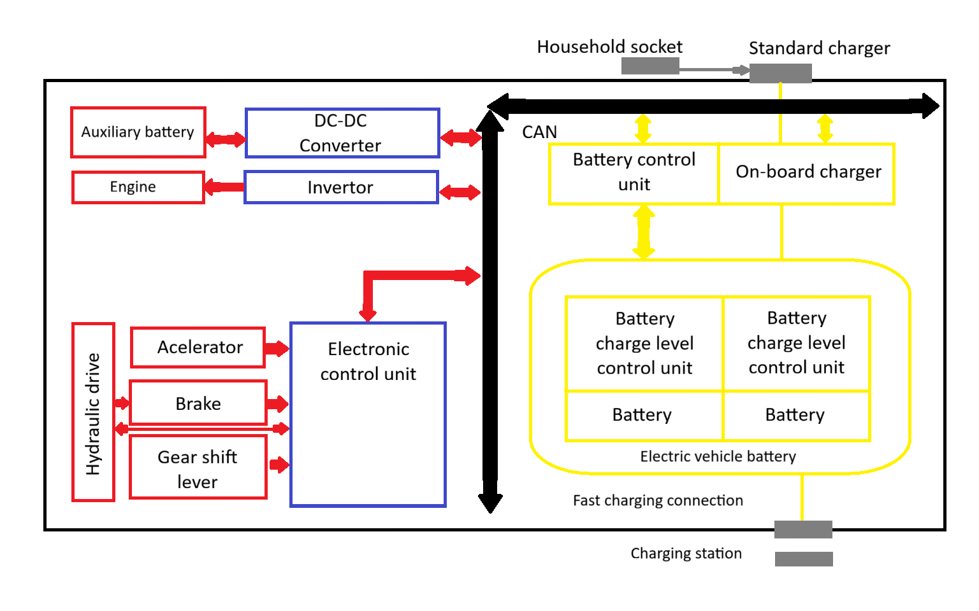
FIGURE 1. General block diagram of electric vehicle control

- Battery Management System (BMS): A critical system that monitors the state of the traction battery, controls charging and discharging processes, provides thermal management (maintaining optimal temperature), and balances cells. The BMS also transmits data on the charge and condition of the battery to the central computer[13].
- Inverter: a component that converts direct current into three-phase alternating current and includes a motor control system. The motor control determines how much torque to allocate during traction/regeneration modes. To understand which parameters affect the control system, let's look at the structure of the inverter shown in Figure 2 [14–16].
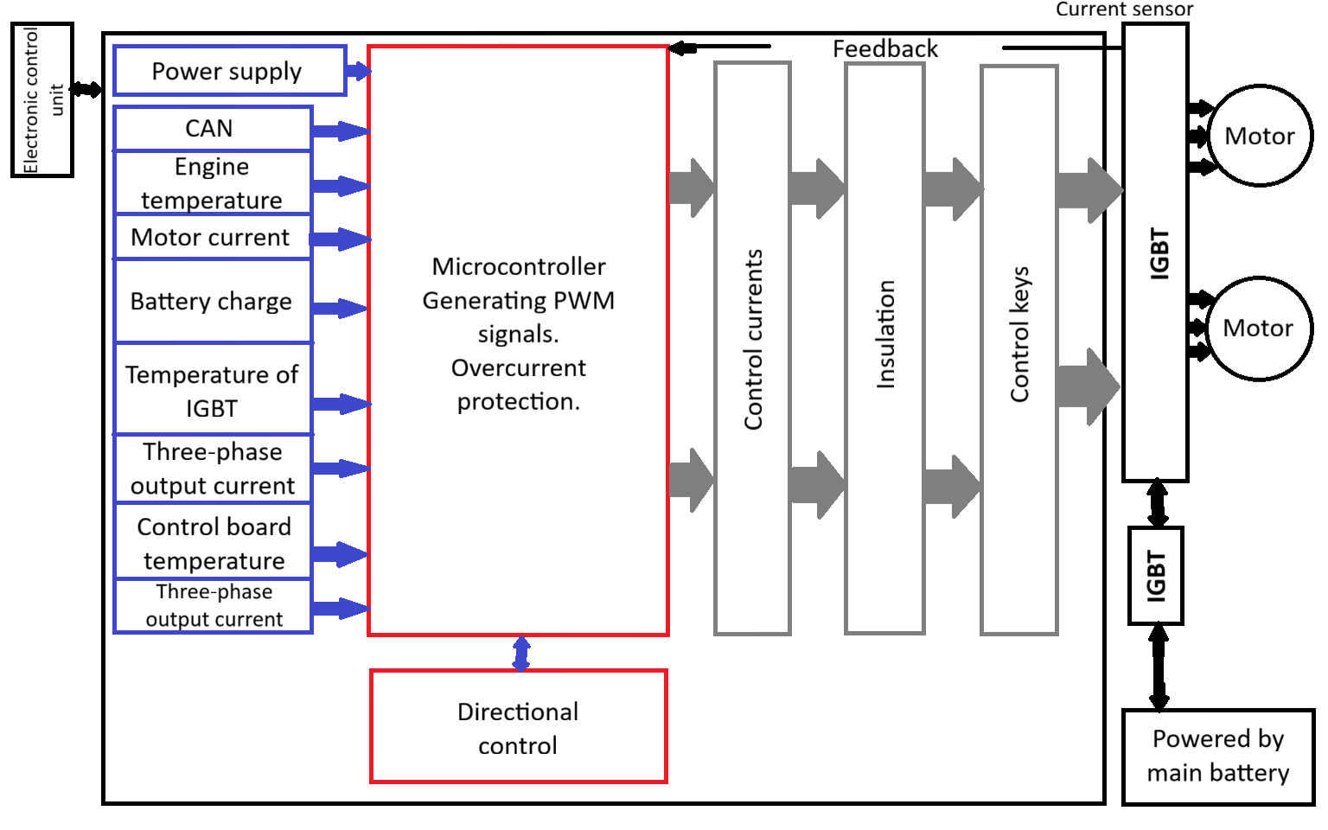
FIGURE 2. Block diagram of inverter control in electric vehicles

- Regenerative braking system: Integrated with the overall control system. Allows part of the kinetic energy of the vehicle to be converted back into electrical energy and stored in the battery during braking, increasing efficiency [13].
- Electronic safety and driver assistance systems (ADAS): include systems that are standard in modern vehicles, such as ABS (anti-lock braking system), ESP (electronic stability program), and sensors for controlling functions such as automatic door opening [17].
- On-board computer and user interface displays information about the vehicle's status, charge level, and range, and allows the driver to select driving modes and adjust comfort functions.
Most domestic (Uzbek) electric vehicles currently available on the market are localized assemblies or adaptations of foreign (mainly Chinese) models. Accordingly, the basic architecture of the control systems of these electric vehicles complies with international standards.
Promising domestic developments, such as the BYD electric vehicle, involve deeper localization and the development of proprietary software and electronic components (e.g., multimedia and body control systems) [18,19].
The experience of various companies in the creation and implementation of electric vehicles accumulated to date allows us to put forward certain requirements not only for the electric vehicle itself, but also for the vehicle drive control system in particular. From the whole range of requirements for electric vehicles, we will select those that relate to the engine control system and improve the consumer qualities of the vehicle as a means of transportation [7,20].
Basic requirements for the electric drive control system:
‒ smooth speed change.
‒ stability of automatic maintenance of the speed set by the driver at no less than 10%; this requirement allows for energy-efficient use of energy in urban conditions;
‒ smooth control of traction and braking torque during acceleration and braking, respectively;
‒ automatic limitation of maximum torque and power at a certain level;
‒ limitation of charging current during regenerative braking at a certain charge level;
‒ the ability to coast with subsequent smooth acceleration or regenerative braking[3].
The frequency converter microcontroller runs software that controls the speed and torque of the motor by changing the frequency, voltage, and intermediate currents in various coordinate systems. The main control methods are shown in Figure 3.
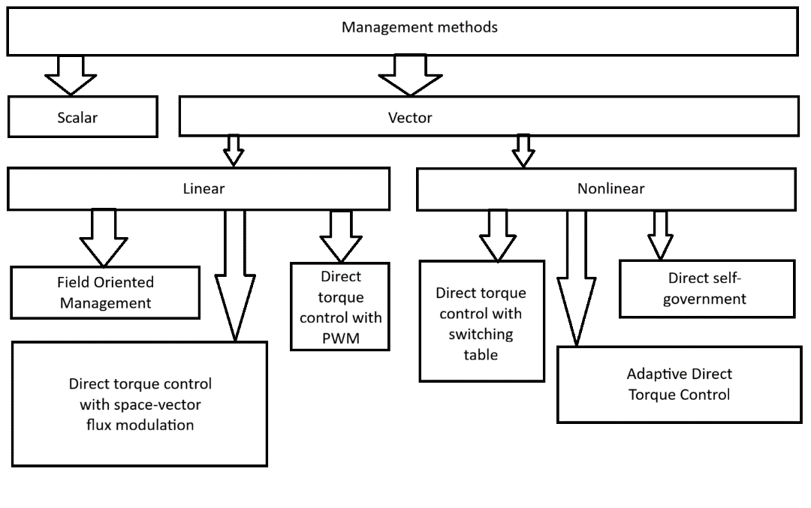
FIGURE 3. Management methods

Let's consider the control systems most commonly used in various frequency converters.
Scalar control, also known as frequency control, is a method of controlling an AC electric motor that maintains a constant voltage/frequency ratio across the entire operating speed range. Consequently, changing the frequency changes the voltage, and with it the speed of the rotor. This ratio is calculated based on the nominal voltage and frequency values. By maintaining this ratio at a certain level, the magnetic flux can be maintained at a certain level [6,9,10]. A significant advantage of this system is its simplicity of implementation. This sole advantage is offset by such disadvantages as:
‒ It is impossible to implement a sensorless control system for an asynchronous motor with load compensation, and a system with a speed sensor has low load control accuracy; a synchronous motor may lose synchronization altogether when the torque exceeds the limit [21].
‒ It is impossible to control both the torque and the speed of the motor simultaneously.
Most often, scalar control is used in systems with a wide speed control range. In our case, this control system is not suitable because an electric vehicle requires precise speed control with load on the shaft, and because scalar control does not allow for smooth changes in torque on the shaft [8].
Unlike scalar control, vector control allows independent and virtually inertia-free control of the rotational speed and torque on the motor shaft. As practice shows, it is not enough to control the voltage and frequency; it is also necessary to control the phase, i.e., to control the value and angle of the spatial vector [22]. Existing torque control methods are usually classified into two groups based on the structure of the controllers used, namely: linear and nonlinear (hysteresis). This article does not intend to provide an in-depth analysis of all control systems due to the complexity of the theory behind each of them, so we will consider the features, advantages, and disadvantages of vector systems with torque control [14].
Field-oriented control involves separate control of both torque and stator field using stator field vector components. All features of this system are related to specifying the correct and accurate motor characteristics in the program, i.e., using an adequate electric drive model . When using a system with direct torque control with spatial vector voltage modulation, it is necessary to accurately calculate the load on the shaft [23,24]. The linearity of the regulator reduces torque ripple, allows the motor to start smoothly and operate reliably at low speeds, but worsens the dynamic characteristics. A feature of a nonlinear controller with direct torque control is that the order of switching on the transistor keys is determined by a table containing various states of the voltage vector. The characteristics of the system depend on its settings and the frequency of comparison with the voltage vector. Increasing the frequency leads to an increase in cost accordingly. The characteristic features of direct control are the full utilization of the inverter's voltage capabilities, as well as excellent dynamics when working with a constant and weakening field [7,25].
RESEARCH RESULTS
The most suitable control system for an electric vehicle is a vector control system with direct torque control and a switch-on table. By reflecting all possible vector states in the table and increasing the frequency of iterations, it is possible to obtain excellent static and dynamic characteristics, as well as meet all other requirements for the system. At this stage of electric vehicle development, this control system will definitely lead to a significant increase in the cost of the control system and, consequently, the entire electric vehicle, but in the future, as electric cars become more popular, experts predict that the price will decrease, while the quality of control will remain high [18,26,27].
Thus, the structure of the electric vehicle control system follows the generally accepted principles of electric vehicle engineering, combining power electronics, battery management system, and various auxiliary electronic systems under the overall control of central control units .
Modern electric vehicles have a dual-circuit system with high voltage (400-800 V) for the main drive and a low-voltage system (12 V) for auxiliary needs. Electric machines can be synchronous or asynchronous, operating on alternating current.
For a dual circuit system, provided that the drive power P (in Watts) and the bus voltage $V_{HV}$ are known, the electric current $I_{HV}$ can be computed [25,28]:
$I_{HV}=\frac{P}{V_{HV}}$ (1)
For a three-phase system (RMS line-line $V_{HV}$, with power factor being $cosφ$):
$I_{line}=\frac{P}{{\sqrt{3}V}_{LL}cosφ}$ (2)
Losses in the electric circuit can modeled with the help of Joule-Thompson effect. Given the line resistance $R$(Ohms), power lost is evaluated as:
$P_{loss}=I^{2}R$ (3)
High-voltage battery can be sized taking into account required battery capacity $C_{Ah}$ and nominal open-circuit voltage $V_{nom}$
$E_{bat}=V_{nom}∙ C_{Ah} (Wh)$ (4)
An important part of battery sizing and modeling is the battery state-of-charge estimation which is realized by means of the equation [29]:
$SOC\left(t\right)=SOC\left(t_{0}\right)-\frac{1}{C}\int_{t_{0}}^{t}{I\left(τ\right) dτ}$ (5)
It is important to note that for the equation the electric current during discharging is negative while for the charging process it is taken to be positive
The power on DC-DC converter can be modelled as the sum of all power loads running on the 12 V battery [7]:
$P_{12}=\sum{P_{aux}}$ (6)
$I_{12}=\frac{P_{12}}{V_{12}}$ (7)
Input and output powers are linked by means of the electric efficiency η [30]:
$P_{in}=\frac{P_{out}}{η},$ $I_{HV}^{(conv)}=\frac{P_{in}}{V_{HV}}$ (8)
The limitation of the DC fast-charging process is defined by the maximum permissible charge current $I_{chg}$ . Under constant-current charging conditions, the instantaneous charging power is expressed as:
$$P_{chg}=V_{bat}∙I_{chg}$$
Additionally, the charge acceptance capability of the battery must consider thermal constraints and the allowable state-of-charge (SOC) range, both of which significantly influence charging dynamics [31].
Regenerative braking represents the reverse energy flow returned to the battery system. The instantaneous regenerative power ​$P_{reg}$ (t) is integrated over time as follows :
$E_{reg}=\int_{t_{1}}^{t_{2}}{P_{reg}(t)dt}$ (9)

The actual energy absorbed by the battery, considering the regenerative efficiency coefficient $η_{reg}$​, is determined by:
$E_{bat,inc}=η_{reg}E_{reg}$ (10)

The maximum allowable regenerative current and voltage are limited by the Battery Management System (BMS) and the inverter. Hence, the battery’s ability to accept energy during regeneration is governed not only by electrochemical factors but also by control algorithms implemented within power electronics and the BMS [32].
An electric vehicle constitutes a cyber-physical platform, in which all functional subsystems—from propulsion to climate control—are coordinated through electronic control units (ECUs).
The principal components of the power and control architecture are as follows:
-Inverter, converting DC to AC;
-Battery Management System (BMS), providing monitoring and protection functions;
-Motor control unit;
-CAN bus, serving as the communication protocol between electronic subsystems [33]

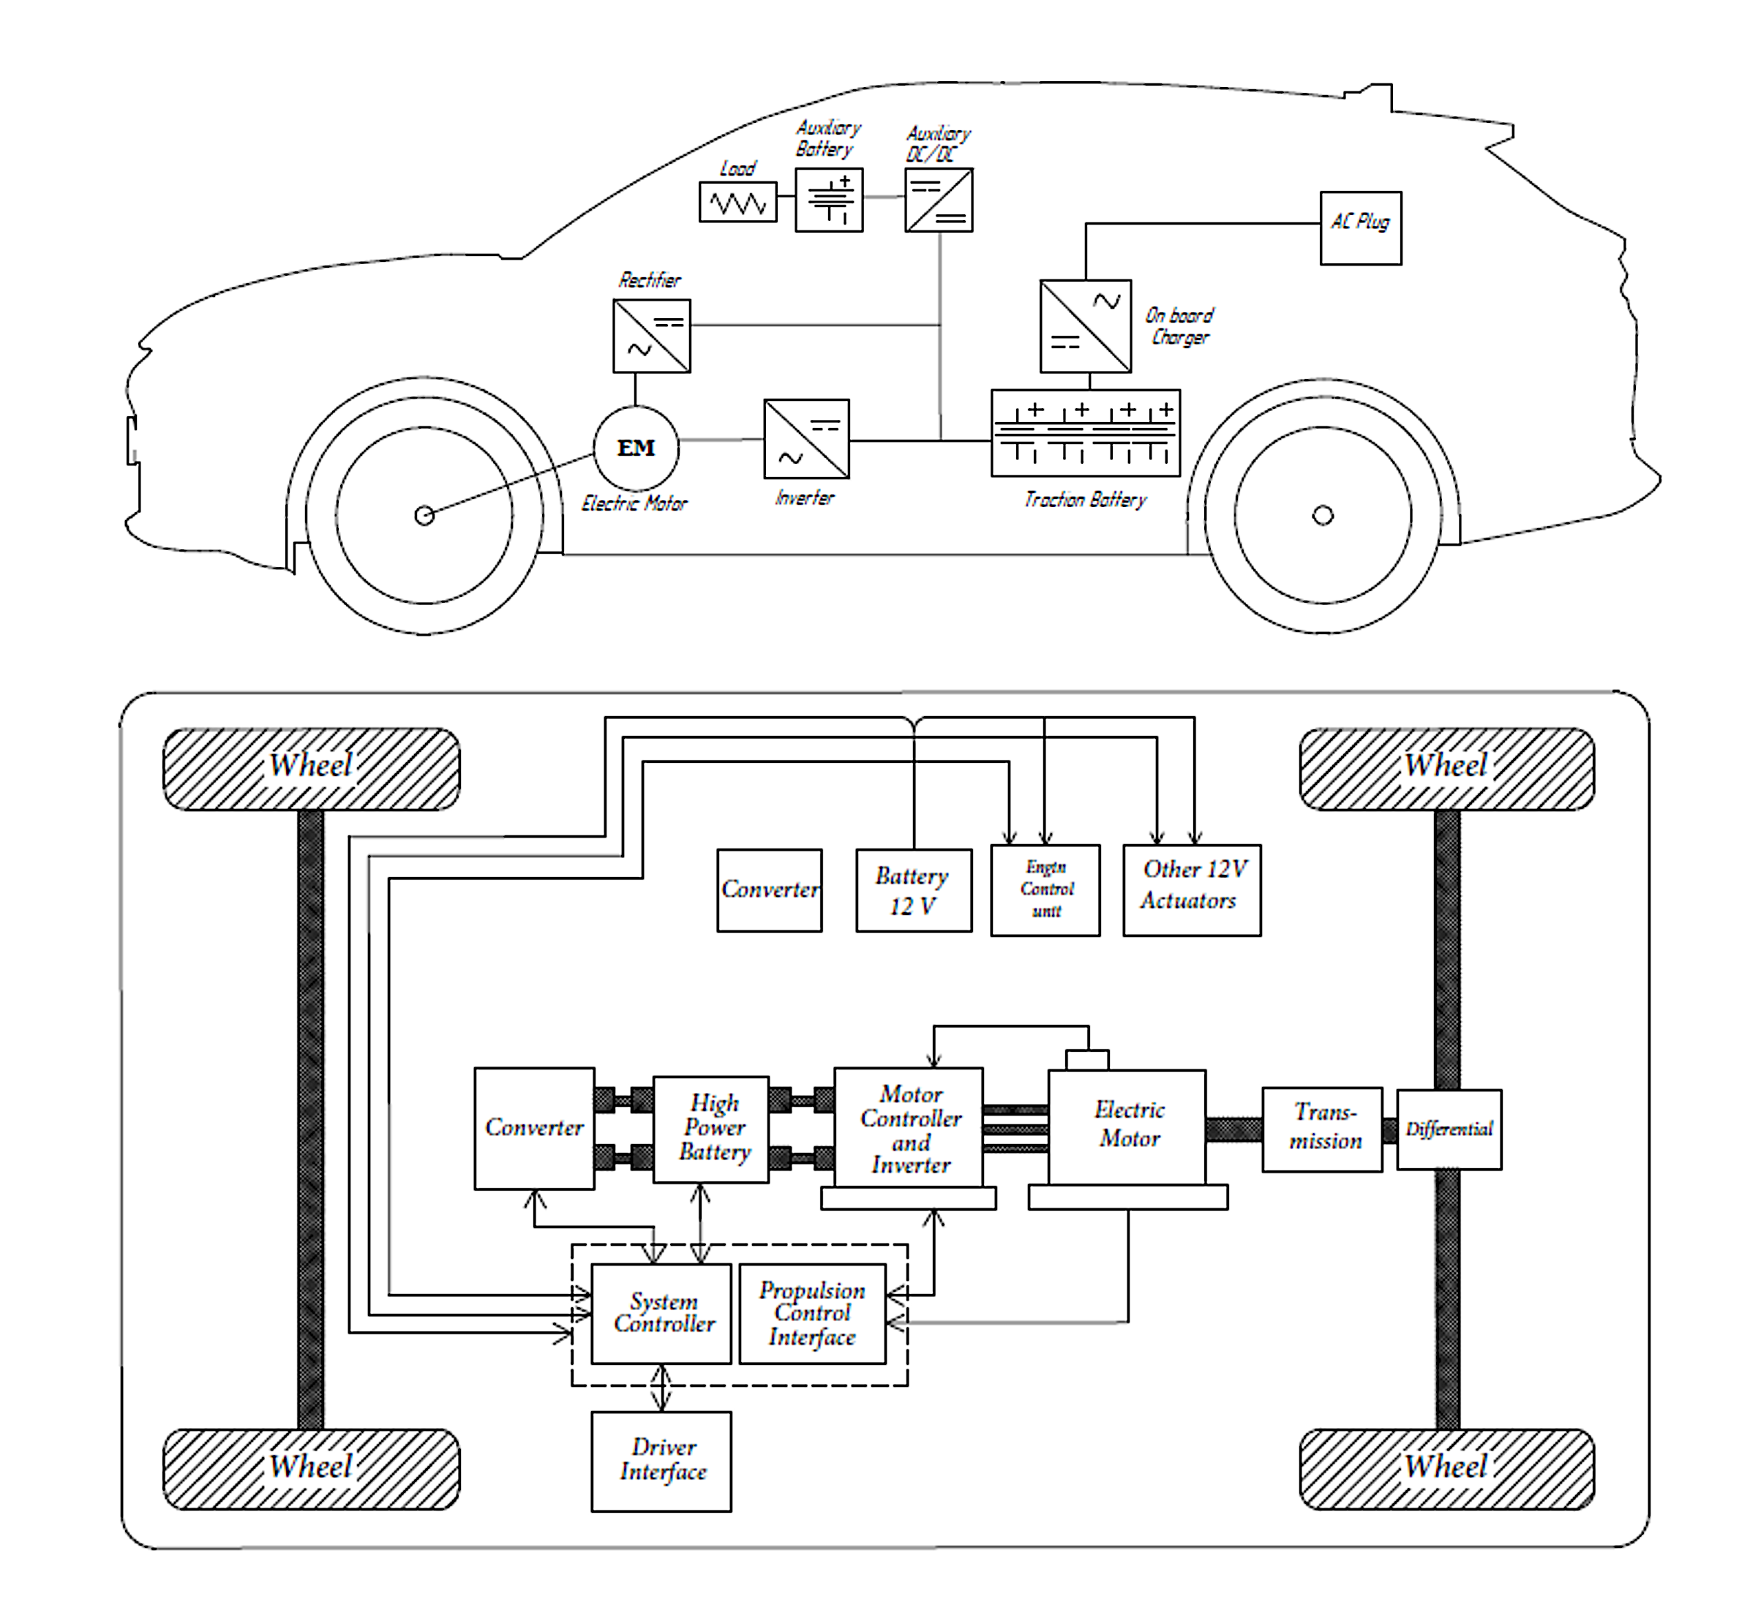
FIGURE 4. Structural diagram of the BYD Song Plus electric vehicle control units

The electric vehicle control system is a complex of interconnected electronic and power modules that ensure efficient energy distribution, motion control, and monitoring of the vehicle's technical condition. The main elements of the block diagram are shown in Figure 5.
Electric vehicles use liquid or air cooling for batteries and motors. Battery thermal stabilization is particularly important during fast charging (DC) or in hot climates [34,35] .
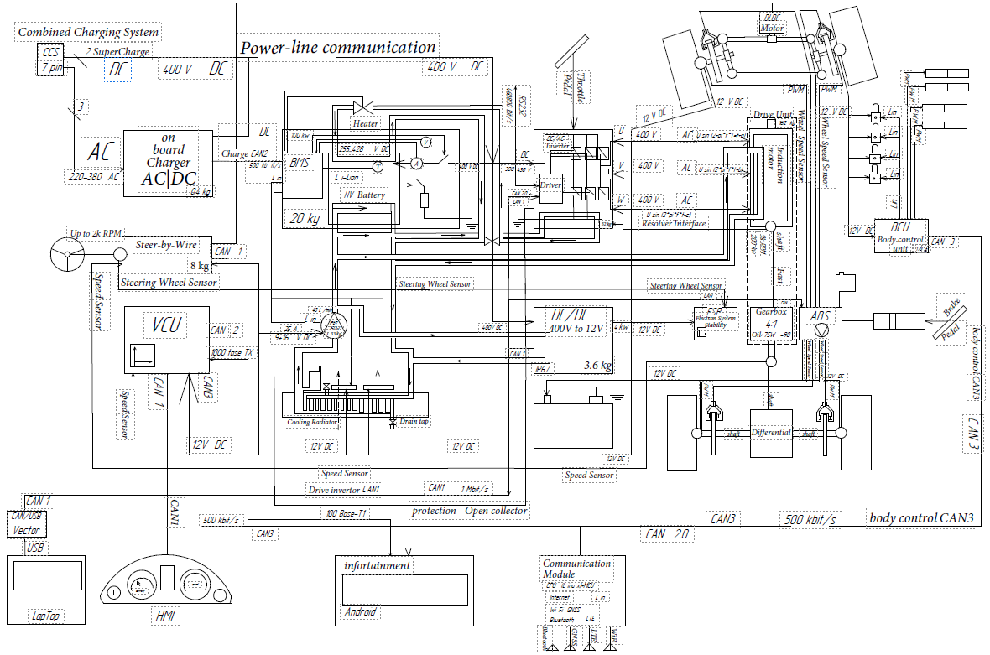
FIGURE 5. Architecture of the BYD Song Plus electric vehicle control system

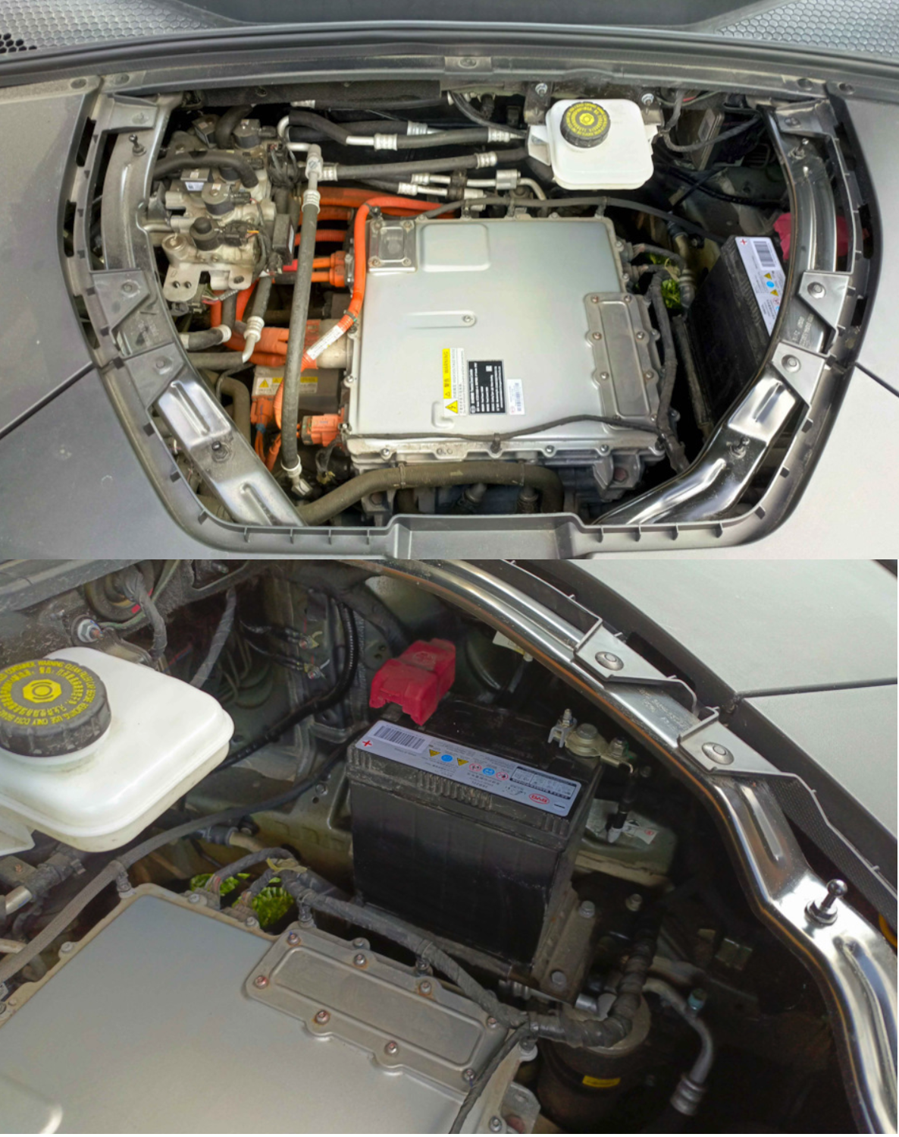
FIGURE 6. Physical layout of the BYD Song Plus power and control components

The design of modern electric vehicles incorporates a dedicated thermal management loop for the traction battery, as well as a heat pump system that enables efficient cabin heating without negatively affecting the vehicle’s driving range [20,36]. In comparison with internal combustion engine platforms, the use of smaller radiators and reduced-dimension cooling fans becomes feasible due to the absence of high-temperature exhaust and engine heat loads [37]. The elimination of a conventional engine block and transmission structure allows for new possibilities in vehicle packaging and interior architecture, including the integration of a front storage compartment (frunk) and the reconfiguration of internal space for enhanced comfort [18].
From an operational perspective, the electric vehicle layout provides several notable advantages. The floor structure of the passenger compartment is fully flat, thereby improving ergonomic characteristics and facilitating more convenient passenger ingress and egress. Interior volume utilization is also improved, offering increased capacity for passengers and luggage. Furthermore, the placement of the battery pack within the lower structural plane of the chassis results in a significantly reduced center of gravity, which positively influences handling, driving stability, and rollover resistance, ultimately contributing to improved vehicular safety and dynamic controllability.
CONCLUSIONS
In the scope of the present article, the control architecture of a modern electric vehicle has been examined and systematized, conceptualized as a complex cyber-physical and software–hardware integrated platform coordinating the operation of the traction drive, the battery system, power electronics, and auxiliary control units. The analysis demonstrated that the overall efficiency, operational reliability, and performance characteristics of the electric vehicle are significantly determined by the control system architecture and the regulatory algorithms employed.
The study provides a detailed examination of the principal subsystems of the vehicle control domain, including the motor and torque control unit, the battery management system (BMS), inverter assemblies, the regenerative braking management system, safety-related electronic subsystems, and driver interaction interfaces. It is emphasized that a dual-voltage power supply architecture (high-voltage and low-voltage circuits) constitutes a fundamental engineering solution, ensuring energy flexibility and the functional robustness of the electric vehicle powertrain.
The comparative assessment of traction control methodologies indicated that under real-world operational conditions, vector control with direct torque regulation demonstrates the highest level of practical relevance. This control paradigm enables superior dynamic and steady-state performance of the traction system, improved motion smoothness, and enhanced regenerative braking efficiency, while also ensuring compliance with core requirements imposed on electric vehicle control systems. Despite the relative increase in hardware and software complexity, the implementation of such control strategies is regarded as a promising trend in contemporary electric vehicle engineering.
Special attention was devoted to the integration of diagnostic electronics, thermal management systems, and energy flow control mechanisms, which is particularly critical under conditions of high operational stress and elevated ambient temperatures. The findings suggest that further advancement of electric vehicle control systems should focus on increasing system localization, developing proprietary software solutions, and adapting management algorithms to real-world operational environments.
The outcomes of this research may be applied to the design, development, and modernization of control systems for electric vehicles produced domestically and may also be incorporated into academic curricula aimed at training specialists in electric transport technologies and mechatronic control systems.
REFERENCES
- Kambarov I, D’Antonio G, Aliev K, Chiabert P, Inoyatkhodjaev J. Uzbekistan Towards Industry 4.0. Defining the Gaps Between Current Manufacturing Systems and Industry 4.0, 2018, p. 250–60. https://doi.org/10.1007/978-3-030-01614-2_23.
- Kobilov N, Khamidov B, Rakhmatov K, Abdukarimov M, Daminov O, Shukurov A, et al. Investigation and study of oil sludge of oil refinery company in Uzbekistan, 2025, p. 040076. https://doi.org/10.1063/5.0269039.
- Iqbal MN, Kütt L, Lehtonen M, Millar RJ, Püvi V, Rassõlkin A, et al. Travel Activity Based Stochastic Modelling of Load and Charging State of Electric Vehicles. Sustainability 2021;13:1550. https://doi.org/10.3390/su13031550.
- Umerov F. The prospects for the development of electric vehicles in Uzbekistan. Acta of Turin Polytechnic University in Tashkent 2022;12.
- Matmurodov F.M., Daminov O.O., Sobirov B.Sh., Abdurakxmanova M.M., Atakhanov F.M. Dynamic simulation of force loading of drives of mobile power facilities with variable external resistance. E3S Web of Conferences 2024;486:03001. https://doi.org/10.1051/e3sconf/202448603001.
- J. Wang. Battery electric vehicle energy consumption modelling, testing and prediction: a practical case study. Technische Universiteit Eindhoven, 2016.
- Wang JM, Jeong C-H, Zimmerman N, Healy RM, Wang DK, Ke F, et al. Plume-based analysis of vehicle fleet air pollutant emissions and the contribution from high emitters. Atmos Meas Tech 2015;8:3263–75. https://doi.org/10.5194/amt-8-3263-2015.
- S.Asanov F.Umerov, J. Inoyatkhodjaev, N. Bekmurodov, B.Kodirov. Influence of Powertrain Topology (FWD vs RWD) on Regenerative braking capabilities in Electric Vehicles. 74th International Conference on Vibroengineering in Tashkent. Vibroengineering Procedia, 2025.
- Asef P, Milan M, Lapthorn A, Padmanaban S. Future Trends and Aging Analysis of Battery Energy Storage Systems for Electric Vehicles. Sustainability 2021;13:13779. https://doi.org/10.3390/su132413779.
- Sanguesa JA, Torres-Sanz V, Garrido P, Martinez FJ, Marquez-Barja JM. A Review on Electric Vehicles: Technologies and Challenges. Smart Cities 2021;4:372–404. https://doi.org/10.3390/smartcities4010022.
- Israilov M, Mukhitdinov A, Yusupov U, Anvarjonov A. Analysis of the method for calculating the actual indicator ton kilometer per hour of large tires and its disadvantages. AIP Conf Proc 2025;3256:060039. https://doi.org/10.1063/5.0266854.
- Yangibayev A, Zokirov O, Umerov F. Improvement of the operational characteristics of a vehicle cooling system using a mechatronic control system 2025. https://doi.org/10.5281/zenodo.15637475.
- Aliev K, Narejo S, Pasero E, Inoyatkhodjaev J. A Predictive Model of Artificial Neural Network for Fuel Consumption in Engine Control System, 2018, p. 213–22. https://doi.org/10.1007/978-3-319-56904-8_21.
- Liu W, Zhang X, Huang Y, Jiang B, Chang Z, Xu C, et al. β-MnO2 with proton conversion mechanism in rechargeable zinc ion battery. Journal of Energy Chemistry 2021;56:365–73. https://doi.org/10.1016/j.jechem.2020.07.027.
- Denton T. Automobile Electrical and Electronic Systems, 1995.
- Ehsani M, Gao Y, Ebrahimi KM, Longo S. Modern electric, hybrid electric, and fuel cell vehicles, third edition, 2018.
- Cui G, Dou J, Li S, Zhao X, Lu X, Yu Z. Slip Control of Electric Vehicle Based on Tire‐Road Friction Coefficient Estimation. Math Probl Eng 2017;2017. https://doi.org/10.1155/2017/3035124.
- Yakhshilikov J, Cavana M, Inoyatkhodjaev J, Giarola S, Leone P. Long-term energy and emissions outlook for the road transport sector of Uzbekistan: Insights from an agent-based energy model. Energy 2025;339:139106. https://doi.org/10.1016/j.energy.2025.139106.
- Kholkhujaev J, Abdurakhmonov N, Ruzimov S, Abdukarimov N, Inoyatkhodjaev J, Saidov A. Ray tracing simulation of wing mirrors for ultrasonic sensor based blind spot monitoring system. 2020 IEEE 14th International Conference on Application of Information and Communication Technologies (AICT), IEEE; 2020, p. 1–6. https://doi.org/10.1109/AICT50176.2020.9368615.
- Chen W, Cheng Z, Wen Q, Wendler M, Volkova O, Liu J. High‐Strength Nonoriented Electrical Steel with Excellent Magnetic Properties Accomplished by Cu–Ni Multialloying. Steel Res Int 2025;96. https://doi.org/10.1002/srin.202400254.
- Correa FC, Eckert JJ, Silva LCA, Santiciolli FM, Costa ES, Dedini FG. Study of Different Electric Vehicle Propulsion System Configurations. 2015 IEEE Vehicle Power and Propulsion Conference (VPPC), IEEE; 2015, p. 1–6. https://doi.org/10.1109/VPPC.2015.7353024.
- Martina Wikström. Electric vehicles in action. KTH Royal Institute of Sweden, 2015.
- Liu T, Zheng J, Su Y, Zhao J. A Study on Control Strategy of Regenerative Braking in the Hydraulic Hybrid Vehicle Based on ECE Regulations. Math Probl Eng 2013;2013:1–9. https://doi.org/10.1155/2013/208753.
- Saiteja P, Ashok B, Wagh AS, Farrag ME. Critical review on optimal regenerative braking control system architecture, calibration parameters and development challenges for EV. Int J Energy Res 2022;46:20146–79. https://doi.org/10.1002/er.8306.
- Gao X, Wu H, Li W, Tian Y, Zhang Y, Wu H, et al. H + ‐Insertion Boosted α‐MnO 2 for an Aqueous Zn‐Ion Battery. Small 2020;16. https://doi.org/10.1002/smll.201905842.
- Umerov F, Daminov O, Khakimov J, Yangibaev A, Asanov S. Validation of performance indicators and theoretical aspects of the use of compressed natural gas (CNG) equipment as a main energy supply source on turbocharged internal combustion engines vehicles, 2024, p. 030017. https://doi.org/10.1063/5.0219381.
- Daminov O, Mirzaabdullaev J, Umerov F, Khimmataliev D, Daminov L, Sharipov Y, et al. Electric vehicle battery technology and optimization, 2025, p. 060026. https://doi.org/10.1063/5.0306143.
- Chin CS, Gao Z, Chiew JHK, Zhang C. Nonlinear Temperature-Dependent State Model of Cylindrical LiFePO4 Battery for Open-Circuit Voltage, Terminal Voltage and State-of-Charge Estimation with Extended Kalman Filter. Energies (Basel) 2018;11:2467. https://doi.org/10.3390/en11092467.
- Kim M-J, Chae S-H, Moon Y-K. Adaptive Battery State-of-Charge Estimation Method for Electric Vehicle Battery Management System, 2020, p. 288–9. https://doi.org/10.1109/ISOCC50952.2020.9332950.
- Prasetiyo A, Yaningsih I, Prija Tjahjana DDD, Ubaidillah U, Budiana EP, Nizam M. Battery thermal management system with liquid immersion cooling method: A review, 2024, p. 070008. https://doi.org/10.1063/5.0228412.
- Venugopal P, T. V. State-of-Health Estimation of Li-ion Batteries in Electric Vehicle Using IndRNN under Variable Load Condition. Energies (Basel) 2019;12:4338. https://doi.org/10.3390/en12224338.
- Pramesti NP, Basuki I. Prioritizing contextual indicators for bridge performance evaluation in Indonesia: A literature-based and data-driven approach, 2025, p. 050003. https://doi.org/10.1063/5.0300797.
- Umerov F, Asanov S, Daminov O, Mirzaabdullaev J, Yangibaev A. Improving the performance of light vehicle cooling system with mechatronic system, 2025, p. 030079. https://doi.org/10.1063/5.0306145.
- Chaturvedi NA, Klein R, Christensen J, Ahmed J, Kojic A. Algorithms for Advanced Battery-Management Systems. IEEE Control Syst 2010;30:49–68.
- Duclos J, Hofman T. Battery-Electric Powertrain Design Analysis for an Efficient Passenger Vehicle. 2021 IEEE Vehicle Power and Propulsion Conference (VPPC), IEEE; 2021, p. 1–8. https://doi.org/10.1109/VPPC53923.2021.9699155.
- Umerov F, Asanov S, Daminov O, Komiljonov U, Avazov I. Energy savings in public transport: Estimating the impact of regenerative braking in electric buses in public transport of Tashkent, 2025, p. 030080. https://doi.org/10.1063/5.0306144.
- Ukhov I, Sotskov A, Anisimov V, Ryabtsev F, Marusin A, Marusin A. Influence of performance criteria on the selection of electric traction equipment and a temperature control system for a battery-powered vehicle with an electric traction drive. Transportation Research Procedia 2021;57:711–20. https://doi.org/10.1016/j.trpro.2021.09.104.

