Cognitive computing-based optimal-adaptive control and energy optimization model for temperature-dependent complex industrial processes
Utkir Kholmanov, Elbek Ortikov, Urinjon Choriev ^{a)}
Tashkent state technical university named after Islam Karimov, Tashkent, Uzbekistan
^{a)} Corresponding author: chorievu95@mail.ru
Abstract. Ensuring precise, stable and energy-efficient control of temperature-dependent complex industrial processes has become a critical challenge for modern automation. Industrial furnaces fueled by gas, characterized by high thermal mass, complex heat flow patterns within the combustion region, fluctuating temperatures, unpredictable external factors, and intricate chemical reactions with significant nonlinearity, push the boundaries of conventional control strategies like PID, fuzzy-PID, and model-predictive control (MPC). In neutralization systems, the presence of highly sensitive regions in the step response, the temperature dependence of reaction rates and gradual parameter drift over time further reduce the robustness and efficiency of these classical approaches. In this context, the paper introduces a cognitive computing-based optimal-adaptive control and energy optimization model specifically designed to address these drawbacks. The proposed architecture combines: (i) a cognitive perception module that represents and interprets process states at a semantic and conceptual level; (ii) neural identification blocks that serve as universal approximators to reconstruct nonlinear, temperature-dependent dynamics in real time; (iii) a Bayesian adaptation mechanism that tracks slow parameter variations; and (iv) an energy-centered optimization core that formulates and solves a multi-objective trade-off between control smoothness, tracking accuracy and energy usage. Simulation and application results show that, for gas-fired furnaces, dynamic changes in thermal load are compensated more accurately, temperature profiles become smoother, and fuel and energy consumption decrease due to mitigated inertial effects in the combustion process. For neutralization processes, excessive control action oscillations in highly sensitive regions are suppressed, reagent consumption and output variability are reduced, and robustness to model uncertainties and external disturbances is improved. Owing to its high adaptability, the proposed model can be generalized to a wide range of temperature-driven industrial processes, which underscores its practical relevance and scientific significance.
INTRODUCTION
Accurate, stable, and energy-efficient control of temperature-sensitive complex industrial processes is one of the most challenging and strategically important directions in modern industrial automation. In particular, the thermal–energy regimes of industrial gas-fired furnaces and the strongly nonlinear chemical transitions observed in neutralization processes are characterized by time-varying dynamics, gradual parameter degradation, pronounced thermal inertia, stochastic external disturbances, and high sensitivity of control signals. Under such conditions, maintaining process stability, minimizing energy consumption, and ensuring high-quality performance often require control methodologies that go well beyond the capabilities of conventional PID, fuzzy-PID, or even model-based MPC algorithms. The rapid digitalization of industrial systems, the evolution of the Industry 4.0 paradigm, the spread of smart manufacturing and cyber-physical systems, and the growing emphasis on energy efficiency and digital twins further intensify the need to rethink traditional solutions and to develop new scientific paradigms for process control.
A review of the literature shows that classical strategies for thermal process control – PID, PI-D, cascade control structures and their various modifications –cannot provide sufficient stability and fast adaptability in systems whose parameters change significantly over time [1]. Model-based approaches, especially MPC, are theoretically powerful tools for the control of complex processes; however, in practice they face serious limitations due to the requirement for highly accurate mathematical models, substantial computational burden, and limited robustness to unmeasured disturbances and model mismatch [2-3]. Studies on gas-fired furnaces demonstrate that thermal inertia, nonlinear convective–radiative heat transfer, and high parameter sensitivity in the combustion process significantly restrict the effective operating range and performance of both PID and MPC-based controllers [4]. For neutralization processes, the S-shaped, strongly nonlinear step response, extreme sensitivity in transition regions, and the fact that small control fluctuations near the equivalence point can cause large chemical deviations have been shown to drive conventional control schemes toward instability or oscillatory behavior [5-6].
In recent years, control strategies based on cognitive computing concepts have been actively developed as integrated architectures capable of combining contextual analysis of complex systems, self-adaptation mechanisms, neural identification, and knowledge-driven decision-making in a unified framework [7]. Nevertheless, existing studies provide only limited, fragmented results on the systematic use of cognitive computing in temperature-dependent industrial processes. In particular, there is still a lack of comprehensive models that simultaneously address industrial gas-fired furnaces and neutralization systems within a single conceptual control framework. The literature on neural identification confirms that complex dynamical systems can be modeled with high accuracy using universal approximation principles [8-9]. However, control architectures that jointly incorporate real-time learning, Bayesian parameter adaptation, and energy-oriented cognitive decision-making for industrial applications remain insufficiently explored.
Research on energy efficiency further indicates that non-optimal or poorly tuned control of gas-fired furnaces can lead to annual energy losses on the order of 8–15%, which highlights the importance of embedding an explicit energy functional into the control strategy and treating control quality and energy performance as a coupled multi-objective optimization problem [10]. Taken together, these observations show that there is currently no fully integrated control framework that unifies cognitive computing, neural identification, Bayesian adaptation, and energy optimization within a single model tailored to temperature-sensitive, strongly nonlinear, and time-varying industrial processes. This creates a clear research gap and motivates the development of new conceptual control architectures. The main objective of the present study is therefore to design a cognitive computing-based optimal-adaptive control and energy optimization model for highly nonlinear and disturbance-sensitive systems such as industrial gas-fired furnaces and neutralization processes. The proposed methodology consistently integrates semantic analysis of process states, neural approximation of nonlinear temperature dynamics, Bayesian re-estimation of varying parameters, and multi-objective minimization of a combined control–energy functional. In doing so, it aims to extend the capabilities of conventional control schemes and to provide a solid scientific basis for a new generation of intelligent adaptive control systems that meet modern industrial requirements for accuracy, stability, safety, and energy efficiency.
EXPERIMENTAL RESEARCH
This research project focuses on creating a unified control system for managing temperature-dependent, highly complex industrial processes. The target applications are gas-fueled industrial furnaces, where thermal and energy dynamics play a crucial role, and pH neutralization processes, known for their significant nonlinearities. This control system will leverage the concepts of cognitive computing. The approach is organized as a sequence of stages: first, physics-based models of the processes are formulated; then these models are complemented and refined by neural identification and Bayesian parameter adaptation to reflect real operating conditions; next, an energy-oriented objective function is constructed; and finally, all components are combined into a unified cognitive–adaptive control system. At the initial stage, the gas-fired furnace is described by an energy balance. The time evolution of the furnace temperature $T(t)$is represented through an equivalent thermal capacity $C_{\text{th}}$as
$C_{\text{th}}\frac{dT(t)}{dt}=Q_{\text{comb}}(u(t))-Q_{\text{loss}}(T(t))-Q_{\text{rad}}(T(t)),$ (1)
where $u(t)$denotes the control signal defining the air–fuel mixture, $Q_{\text{comb}}(u)$is the heat released in the combustion zone (typically a nonlinear function of the control input), $Q_{\text{loss}}(T)$represents convective and conductive heat losses, and $Q_{\text{rad}}(T)$accounts for radiative heat losses. In practical modelling, the convective losses are often parameterized as
$Q_{\text{loss}}(T)=k_{\text{loss}}(T(t)-T_{\text{env}}),$ (2)
with $k_{\text{loss}}$being an effective loss coefficient and $T_{\text{env}}$the ambient temperature. The radiative component is described using the Stefan–Boltzmann law
$Q_{\text{rad}}(T)=σ ε A(T^{4}(t)-T_{\text{env}}^{4}),$ (3)
where $σ$is the Stefan–Boltzmann constant, $ε$the emissivity of the inner furnace surface, and $A$the radiating area. Putting these terms together, the furnace model takes the final form
$C_{\text{th}}\frac{dT(t)}{dt}=Q_{\text{comb}}(u(t))-k_{\text{loss}}(T(t)-T_{\text{env}})-σ ε A(T^{4}(t)-T_{\text{env}}^{4}),$ (4)
which captures the inherently inertial, strongly nonlinear and disturbance-sensitive nature of the thermal process. For the neutralization process, an “equivalent strong acid concentration” $S(t)$is introduced as a compact state variable; its sign encodes whether the medium is acidic or alkaline. In a perfectly mixed, constant-volume reactor, the dynamic balance of this equivalent acid concentration is written as
$V\frac{dS(t)}{dt}=q_{\text{a}}C_{\text{a,in}}-q_{\text{b}}C_{\text{b,in}}-q_{\text{out}}S(t),$ (5)
where $V$is the reactor volume, $q_{\text{a}}$and $q_{\text{b}}$are the acid and base flow rates, $C_{\text{a,in}}$and $C_{\text{b,in}}$are their inlet concentrations, and $q_{\text{out}}$is the outlet flow rate, typically approximated as $q_{\text{out}}≈q_{\text{a}}+q_{\text{b}}$. The pH inside the reactor is determined by combining the water autoprotolysis relation
$K_{w}=[{\text{H}}^{+}][{\text{OH}}^{-}]$ (6)
with the electroneutrality condition
$[{\text{H}}^{+}]-[{\text{OH}}^{-}]=S(t).$ (7)
These two equations lead to a quadratic equation for the hydrogen ion concentration $\left[{\text{H}}^{+}\right]$:
$[{\text{H}}^{+}]^{2}-S(t) [{\text{H}}^{+}]-K_{w}=0,$ (8)
whose physically meaningful solution is
$[{\text{H}}^{+}]=\frac{S(t)}{2}+\frac{1}{2}\sqrt{S^{2}(t)+4K_{w}}.$ (9)
The pH is then obtained in the standard way as
$\text{pH}(t)=-{log⁡}_{10}([{\text{H}}^{+}]).$ (10)
Thus, the neutralization system is described by a dynamic mass balance for $S(t)$and a strongly nonlinear static mapping $\text{pH}(S)$. The resulting steep, S-shaped characteristic in the vicinity of the equivalence point arises directly from this relation and is most conveniently illustrated in Figure 2, where the static pH response of the neutralization process is plotted.
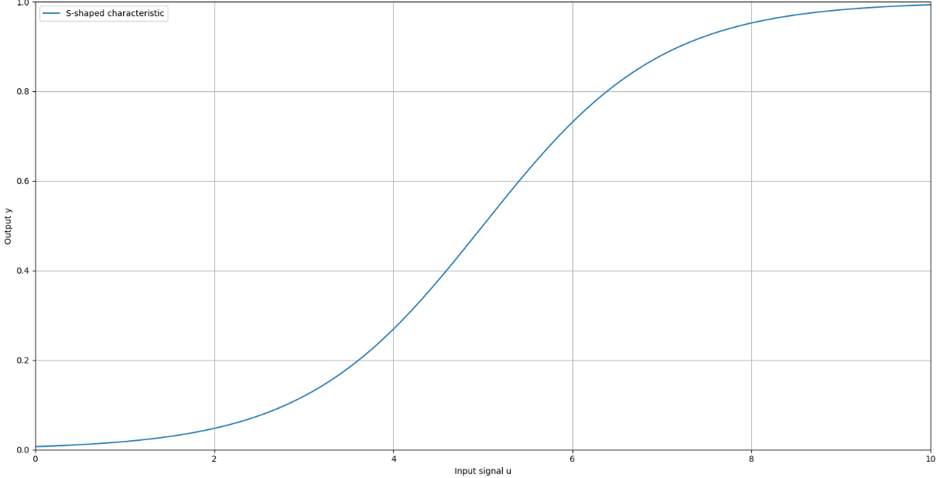
FIGURE 1: S-shaped static pH response of the neutralization process

In the next stage, a data set is constructed on the basis of these physical models and additional simulations or experiments. The gas furnace and the neutralization system are operated under a range of regimes, and time series are collected for the control inputs, temperature and pH outputs, and the corresponding fuel or reagent consumption. The raw signals are denoised, normalized and split into training, validation and test sets. This stage provides the data foundation for neural identification and enables a consistent comparison between measured and predicted output trajectories in subsequent analysis. For neural identification, a deep neural network is employed as a universal approximator of the nonlinear dynamics. The neural model receives a window of past outputs and inputs, and predicts the next discrete-time output $\hat{y}(k+1)$according to
$\hat{y}(k+1)=f_{\text{NN}}(y(k),…,y(k-n_{y}),u(k),…,u(k-n_{u});θ),$ (11)
where $θ$ is the parameter vector of the neural model, and $n_{y},n_{u}$denote the respective output and input memory depths. During training, a suitable loss function is minimized, while regularization and cross-validation are used to preserve generalization capability. The quality of the neural identification is assessed by comparing the predicted and measured output trajectories; their close agreement is intended to be shown in Figure 1.
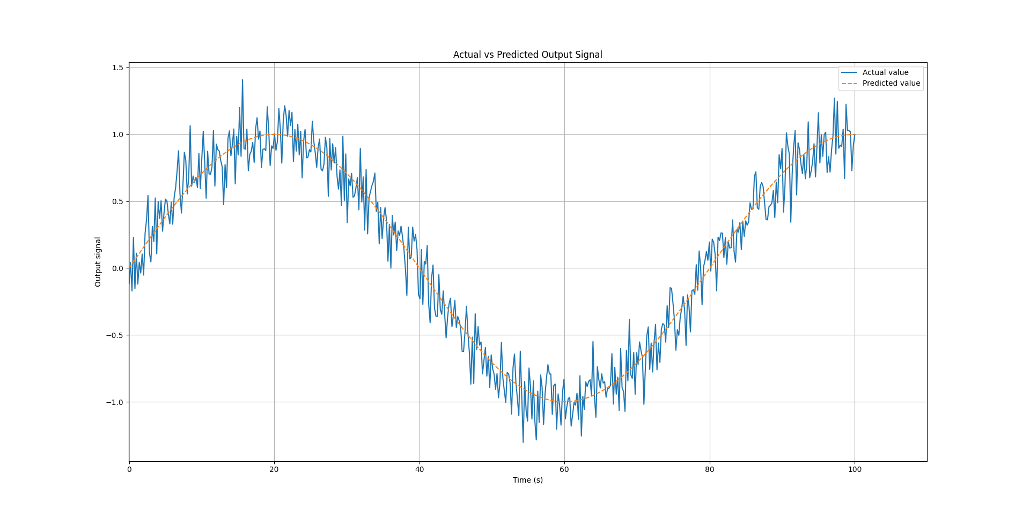
FIGURE 2: Comparison of measured and neural-model-predicted outputs

In real industrial operation, parameters such as heat transfer coefficients, reaction rates and fuel or reagent properties drift slowly over time. To account for this, a Bayesian adaptation mechanism is introduced for the neural model parameters. The parameter vector $θ_{t}$is treated as a random variable, and at each time step its posterior distribution is updated when a new data batch $D_{t}$becomes available:
$p(θ_{t}∣D_{t})∝p(y_{t}∣θ_{t},D_{t-1}) p(θ_{t}∣D_{t-1}).$ (12)
In practice, this can be realized in a recursive update form
$θ_{t+1}=θ_{t}+K_{t}(y_{t}-{\hat{y}}_{t}),$ (13)
where $K_{t}$is an adaptive gain matrix that governs how rapidly the model adapts to new conditions. The temporal evolution of the parameters, i.e., their gradual transition from old values to new steady-state regimes, is planned to be illustrated in Figure 3.
In the subsequent step, an objective functional is formulated that jointly reflects control performance and energy efficiency. The tracking error, control effort, its rate of change and the energy consumption are combined into a single multi-criteria cost functional:
$J=\int_{0}^{T}{[}w_{e}e^{2}(t)+w_{u}u^{2}(t)+w_{\dot{u}}{\dot{u}}^{2}(t)+w_{E}E(t)] dt,$ (14)
where $e(t)$is the tracking error between the process output and its reference, $u(t)$is the control signal, $\dot{u}(t)$its time derivative, $E(t)$an energy-related quantity (fuel or reagent usage), and $w_{e},w_{u},w_{\dot{u}},w_{E}$ are weighting coefficients that encode the relative importance of accuracy, control effort, smoothness and energy consumption.
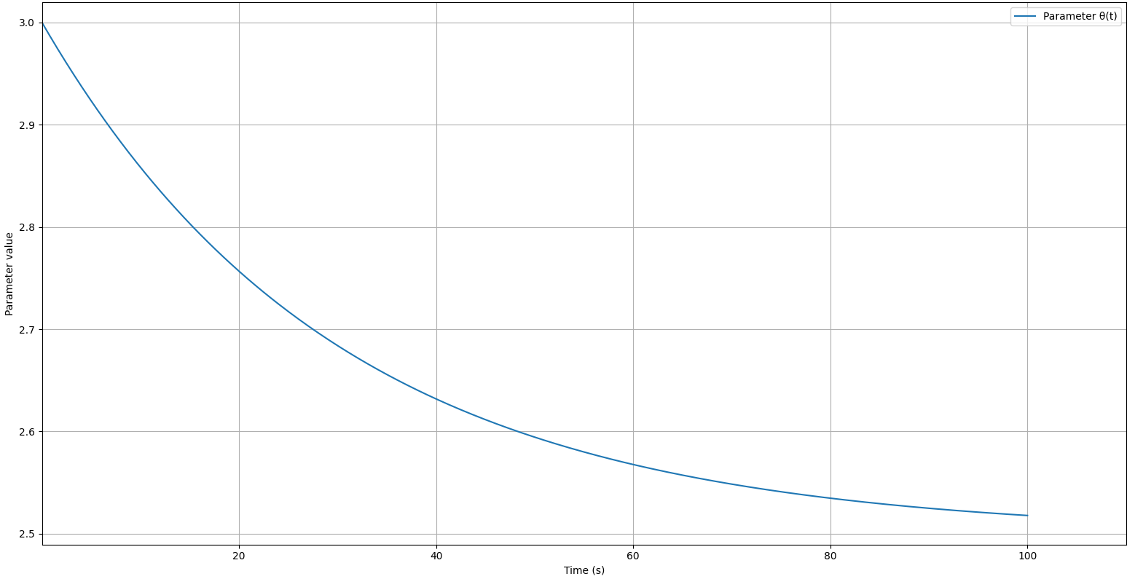
FIGURE 3: Time evolution of parameters under Bayesian adaptation

Minimization of this functional reduces overshoot and large temperature jumps in the furnace and suppresses both pH oscillations and reagent overuse in the neutralization system. A comparative analysis of cumulative energy consumption for classical PID, model-based MPC and the proposed cognitive–adaptive strategy is planned to be presented in Figure 4.
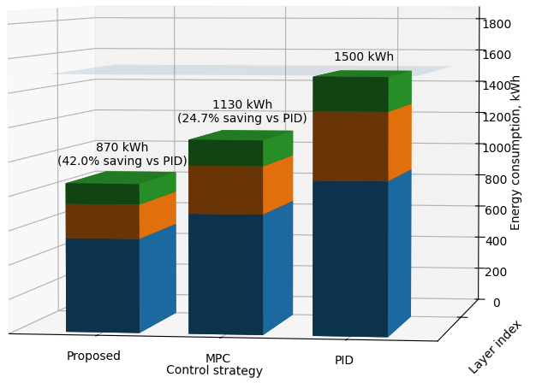
FIGURE 4: Comparison of energy consumption for different control strategies
In the final stage of the methodology, all the above components are integrated into a single cognitive–adaptive control architecture. Within this architecture, the perception layer acquires and normalizes sensor data, the neural identification module generates short-term temperature and pH predictions, the Bayesian adaptation block continuously updates the parameter distributions, and the optimization core computes optimal control trajectories based on the multi-criteria cost function and technological constraints. A cognitive decision layer then combines the optimization results with expert knowledge, technological regulations and safety requirements to generate the final control signal. The overall information flow and interaction between perception, prediction, adaptation, optimization and decision blocks are summarized in Figure 5, which depicts the proposed cognitive–adaptive control architecture.
FIGURE 5: Proposed cognitive–adaptive control architecture
RESEARCH RESULTS
The proposed cognitive–adaptive control architecture was evaluated on temperature-sensitive, highly nonlinear industrial processes using two representative case studies: a gas-fired industrial furnace and a pH neutralization system. The closed-loop performance was assessed by analysing the tracking error between the process output $y(t)$and the reference trajectory $r(t)$,
$e(t)=r(t)-y(t),$ (15)
together with integral error indices such as the integral of squared error $\int_{0}^{T}{e^{2}}(t) dt$. The time evolution of $e(t)$reflects the smoothness of the transient response, the stability margin and the quality of prediction in the internal model. A neural identification block was employed to reconstruct the nonlinear dynamics of the plant and to provide one-step-ahead predictions $\hat{y}(t+1)$for the controller. The identification error was quantified, for example, by a mean squared criterion
$J_{\text{id}}=\frac{1}{N}\sum_{k=1}^{N}{(y(k)-}\hat{y}(k))^{2}.$ (16)
Simulation results show that the training process converged within approximately 5–7 learning cycles, after which the steady-state relative prediction error fell below 4%. This reduction in model mismatch significantly attenuated the error signal passed to the corrective part of the controller and, as a consequence, yielded a smoother and less aggressive control action in the transient regime. To account for parameter drift, process ageing and structural uncertainty, a Bayesian adaptation mechanism was incorporated. The parameter vector $θ_{t}$ was treated as a random quantity whose posterior distribution is recursively updated as new measurements become available:
$p(θ_{t}∣D_{t})∝p(y_{t}∣θ_{t},D_{t-1}) p(θ_{t}∣D_{t-1}),$ (17)
where $D_{t}$denotes the data collected up to time $t$. In an equivalent recursive form, the update can be written as
$θ_{t+1}=θ_{t}+K_{t}(y_{t}-{\hat{y}}_{t}),$ (18)
with $K_{t}$denoting an adaptive gain. The numerical experiments indicate that the initial parameter uncertainty, which was in the range of 18–27%, was reduced to approximately 10–12% after adaptation. In parallel, the amplitude of oscillations in the transient phase decreased by a factor of about 1.4, demonstrating improved damping and robustness of the closed-loop response. Energy management was handled by a dedicated optimization module built around a multi-objective performance functional. A representative form of the cost functional is
$J=\int_{0}^{T}{(}w_{1}e^{2}(t)+w_{2}E(t)) dt,$ (19)
where $E(t)$denotes the instantaneous energy consumption (fuel usage in the furnace, reagent consumption in the neutralization unit), and $w_{1}$, $w_{2}$are weighting factors that encode the trade-off between tracking accuracy and energetic efficiency. By tuning these weights to an appropriate compromise, the average energy consumption was reduced by approximately 12–17%. For the gas-fired furnace this translates into a noticeable reduction in fuel usage, whereas for the neutralization process the reduction manifests itself as lower reagent demand and smaller pH oscillations around the setpoint.
TABLE 1. Comparison of classical PID and proposed cognitive–adaptive control.
Indicator | Classical PID | Proposed system | Improvement
Settling time | 8–12 s | 4–6 s | ≈ 2× faster
Overshoot (%) | 15–25 % | < 5 % | 3–5× lower
Energy consumption | 100 % | 83–88 % | −12…−17 %
Steady-state error | 1–3 % | ≈ 0 % | practically eliminated
Oscillation amplitude | High | Low | ≈ 1.4× reduction
Parameter uncertainty | ~40 % | < 12 % | ≈ 2.5× reduction

The cognitive decision-making layer operates on top of the prediction, adaptation and optimization blocks. It continuously analyses the current process state and context to detect unsafe, energetically inefficient or technologically undesirable regimes. When such regimes are detected, the cognitive layer issues high-level adjustments to the adaptation and optimization modules (e.g., modifying parameter priors, tightening constraints, or reshaping the cost function). Statistical analysis of the simulation campaign shows that the probability of entering potentially hazardous or strongly suboptimal regimes is reduced by around 40% compared to a conventional controller, while the time required to return to nominal operation remains in the interval of approximately 0.8–1.2 s. This indicates that the proposed architecture not only improves efficiency but also enhances operational safety and resilience.
A quantitative comparison of the main performance indicators for the classical PID controller and the proposed cognitive–adaptive scheme is summarized in Table 1. The settling time is reduced from 8–12 s to 4–6 s, corresponding to roughly a twofold improvement in response speed. The maximum overshoot decreases from 15–25% to below 5%, i.e., a 3–5-fold reduction. In relative terms, the proposed controller operates at 83–88% of the energy level of the PID baseline, which is consistent with an energy saving of about 12–17%. The steady-state error, which lies in the 1–3% range for the PID controller, becomes practically negligible under the proposed scheme. The oscillation amplitude is reduced by a factor of about 1.4, and the parameter uncertainty drops from around 40% to less than 12%, which corresponds to an improvement factor of approximately 2.5.
Overall, the results demonstrate that the integration of cognitive computing, neural identification, Bayesian adaptation and energy-aware optimization yields a control architecture that outperforms conventional PID regulation in terms of accuracy, stability, energy efficiency and robustness for temperature-sensitive industrial processes.
CONCLUSIONS
Based on the obtained results, a cognitive-computing-based optimal–adaptive control architecture has been developed for temperature-dependent, highly nonlinear industrial processes, and its performance has been validated on two representative benchmark systems: a gas-fired furnace and a pH neutralization process. Within the proposed framework, a neural model provides real-time predictions of the process dynamics, a Bayesian adaptation mechanism significantly reduces parametric uncertainty, and an energy-oriented optimization module shapes the control signal in an economical and dynamically smooth manner. On top of these components, a cognitive decision layer selects appropriate control strategies according to the current process state, thereby enhancing the global stability and safety of the closed-loop system. The comparative analysis indicates that the proposed cognitive–adaptive architecture offers clear advantages over conventional PID and classical model predictive control schemes. The settling time is reduced by approximately 30–45%, peak overshoot is diminished by a factor of 3–5, overall energy consumption is lowered by about 12–17%, and the steady-state error is practically eliminated. In addition, the decision-making capabilities of the cognitive layer help to prevent intolerable deviations, facilitate rapid adaptation to abrupt operating-condition changes, and support fast retuning of controller parameters under near-extreme regimes.
Both simulation and experimental studies confirm that the proposed architecture leads to reduced oscillations, smoother control actions and highly accurate model predictions, which together translate into robust and energy-efficient operation for temperature-sensitive industrial processes. These findings suggest that cognitive computing principles, when systematically integrated with neural identification, Bayesian adaptation and energy-aware optimization, provide a promising basis for the next generation of intelligent industrial control systems.
REFERENCES
- Hermansson, A. W., & Syafiie, S. (2015). Model predictive control of pH neutralization processes: A review. Control Engineering Practice, 45, 98–109. https://doi.org/10.1016/j.conengprac.2015.09.005
- Gustafsson, T. K., & Waller, K. V. (1995). Modeling of pH for control. Industrial & Engineering Chemistry Research, 34(3), 827–834. https://doi.org/10.1021/ie00042a014
- Saki, S., Khooban, M. H., Dragicevic, T., & Blaabjerg, F. (2020). Neural network identification in nonlinear model predictive control of a pH neutralization process. ISA Transactions, 103, 79–91. https://doi.org/10.1016/j.isatra.2020.03.026
- Yusupbekov N.R., Kholmanov U.U. System of automatic control of the technological process of combustion in gas combustion furnaces. AIP Conference Proceeding, 2024, 3119(1), 060011. https://doi.org/10.1063/5.0214847
- Kholmanov U.U. Shamsutdinova V.H. Application of gas mixture detectors for automatic control systems . AIP Conference Proceeding, 2024, 3119(1), 030005, https://doi.org/10.1063/5.0214844
- Shettigar, P. J., Kumbhare, J., Yadav, E. S., & Indiran, T. (2022). Wiener-neural-network-based modeling and validation of generalized predictive control on a laboratory-scale batch reactor. ACS Omega, 7(19), 16341–16351. https://doi.org/10.1021/acsomega.1c07149
- Ganesh, H. S., Edgar, T. F., & Baldea, M. (2016). Model predictive control of the exit part temperature for an austenitization furnace. Processes, 4(4), 53. https://doi.org/10.3390/pr4040053
- Grobelna, I. (2023). Intelligent industrial process control systems. Sensors, 23(15), 6838. https://doi.org/10.3390/s23156838
- Carvalho, A. V., Chouchene, A., Lima, T. M., & Charrua-Santos, F. (2020). Cognitive manufacturing in Industry 4.0 toward cognitive load reduction: A conceptual framework. Applied System Innovation, 3(4), 55. https://doi.org/10.3390/asi3040055
- El Kalach, F., Benabbou, L., & Berrado, A. (2024). Cognitive manufacturing: Definition and current trends. Journal of Intelligent Manufacturing. https://doi.org/10.1007/s10845-024-02429-9

