Drainage in a quantum image: A bibliometric analysis for the period of 2013–2023
Dilnoz Muhamediyeva¹, Narzullo Mamatov¹, Adilbay Kudaybergenov², Gulsara Ametova^{1, a)}
¹ “Tashkent Institute of Irrigation and Agricultural Mechanization Engineers” National Research University, Tashkent, Uzbekistan,
²«Karakalpak State University named after Berdakh», Nukus, Uzbekistan
^{a)} Corresponding author: gulsaraametova1@gmail.com
Abstract. This study provides a bibliometric analysis of scientific publications in the field of quantum image pixels from 2013 to 2023, identifying key trends, leading authors, institutions, and countries. It confirms the multidisciplinary nature of quantum image pixel research, combining physics, computer science, and engineering, and serves to identify promising topics and areas of collaboration. Data were collected from the Scopus database “quantum image pixel”, “quantum image representation”, and “quantum image processing”. After screening and cleaning, 1340 documents were included in the analysis. The analysis was performed using Microsoft Excel 2021 and MapChart tools. Visualizations were constructed on the co-authorship network, keyword co-occurrence, and subject areas. The results show a steady and rapid growth in the number of publications over the past decade; China and the United States have the leading share, with the Chinese Academy of Sciences, Shanghai Maritime University, and the Ministry of Education of the PRC being the most productive institutions. The keyword map revealed three main clusters, image processing and computational algorithms, and quantum cryptography and communication. The conclusions confirm the multidisciplinary nature of quantum image pixel research, combining physics, computer science, and engineering, and serve to identify future topics and areas of collaboration. In the future, quantum image pixel research is expected to develop in areas aimed at implementing real quantum devices, secure image transmission, creating efficient algorithms, and introducing them into practical areas.
INTRODUCTION
In the past decade, quantum technologies have been rapidly developing in the fields of science and technology. In particular, quantum image pixel technology is a new scientific direction formed at the intersection of quantum computing, information technology, and optical physics. This direction can improve data security, increase computing speed, and improve energy efficiency by encoding, processing, and transmitting images in a quantum state.
Traditional image processing systems operate on digital signals, but an approach based on quantum mechanical principles opens up completely new possibilities for image representation through properties such as superposition and quantum entanglement [1]. Therefore, the emergence of models such as quantum image representation (QIR), Flexible Representation of Quantum Images (FRQI), and Novel Enhanced Quantum Representation (NEQR) has further increased the attention of the scientific community in recent years [9;11].
However, despite the rapid development of this area, scientific sources on quantum image pixels remain scattered, their thematic composition, regional distribution and level of scientific cooperation have not been fully analyzed. Therefore, the purpose of this study is to conduct a bibliometric analysis of scientific publications in the field of quantum image pixels, identify their main development trends, leading authors, institutions and countries, and reveal the structure of scientific cooperation [14;15].
Data were retrieved from the Scopus database between 2013 and 2023, using the keywords "quantum image pixel", "quantum image processing", and "quantum image representation".
The results show that the number of scientific publications on quantum image pixels has increased dramatically over the past decade, with the majority of them published by researchers in China and the United States. Scopus was chosen for this study because it provides a comprehensive and high-quality indexed network of sources and citations on the topic, allowing for reliable comparison and cross-validation of bibliometric analysis results on a global scale.
Chinese Academy of Sciences, Shanghai Maritime University, and Ministry of Education of the People's Republic of China are distinguished as leading research centers in this field.
Thus, the bibliometric analysis confirms that the quantum image pixel direction is a multidisciplinary, rapidly developing and strategic scientific direction and opens up new prospects for future research in this field. The purpose of this study is to identify the current research topics and leading countries and organizations in the field of quantum image representation and processing at the pixel level, as well as to draw new conclusions about international trends and emphases based on historical bibliometric data from Scopus [13;19]. According to Scopus indicators, 2013–2023 was the period of significant increase in publications in the field of quantum imaging/pixel, so this period was analyzed. At the same time, bibliometric analyses of quantum imaging (e.g., pixel-representation models such as NEQR, FRQI) in the context of Central Asian countries during this period are significantly rare; this work aims to fill this gap [16;17;18].

EXPERIMENTAL RESEARCH
This analysis examined the scope of scientific publications on the topic of quantum image pixels. The study was conducted between 2013 and 2023, and a search was conducted using the most widely used bibliographic database, Scopus. The keywords “quantum image pixel”, “quantum image representation”, and “quantum image processing” were used in the search process.
The analysis was performed in January 2023, resulting in 1,340 scientific publications on this topic, which were selected for further bibliometric analysis.
Several modern tools were used in the data analysis process: CSV format data, Microsoft Excel 2021, RIS format data, and the MapChart platform.
The results show that research in the field of quantum image pixels has expanded significantly in the last decade, and that active scientific collaboration is taking place in this area in Asian and European countries.
Article review and study eligibility criteria. The search process analyzed articles from the Scopus database. The following keywords were used in the search: “quantum image pixel”, “quantum image representation”, and “quantum image processing.” Only articles published in English were selected. Article type = “Article”, Time range = “2013–2023”, Field of study = Physics and Astronomy, Computer Science, Engineering, and Information Systems, Analysis period = January 2023 Search criteria were used.
The selected methodological process is illustrated in Figure 1.
The following exclusion criteria were used during the screening phase:
1. Publications with the title and annotation in English, but the main text in another language;
2. Articles on scientific areas outside the topic of quantum image pixel;
3. Publications with poorly defined search terms (e.g., encoding, compression, reconstruction);
4. Articles without a DOI number or not fully found in the Scopus database.
In general, articles directly related to the field of quantum image pixel were selected based on these filters.
Bibliometric Analysis.The data exported from Scopus were saved in CSV format, loaded into Microsoft Excel 2021, and bibliometric analysis was performed.
Before the analysis began, all data were cleaned of errors and duplicate entries.
The reviewed articles were analyzed to identify the most recent publications and the most active authors. As a result of the assessment of authorship activity, Zhou, R.G. took the lead with 32 articles [9]. The articles found as a result of the search were sorted by the number of articles by year, document types (article, review, conference paper), most cited articles, most active journals, most funding organizations, distribution by subject categories and journals, and activity indicators by country and academic institution. An analysis of co-authorship and keyword co-occurrence was also conducted to identify the scientific knowledge structure and thematic clusters in quantum image pixel research.
Drainage based on groundwater in CIS countries. During the study, 1340 articles on quantum image pixels were studied. Among them, the most active research areas were identified based on 30 keywords, and three clusters were formed using the Map chart platform (Table 3).
The first cluster includes quantum optics and sensor technologies, the second image processing and algorithms, and the third includes quantum cryptography and communication systems.
The analysis shows that quantum image pixel research is mainly concentrated in China, the United States, India, and the United Kingdom, with most of it being conducted by research centers such as the Chinese Academy of Sciences, Shanghai Maritime University, and the University of Science and Technology of China.
This cluster analysis confirms that the quantum image pixel field is a multidisciplinary scientific field, combining physics, information technology, and engineering.
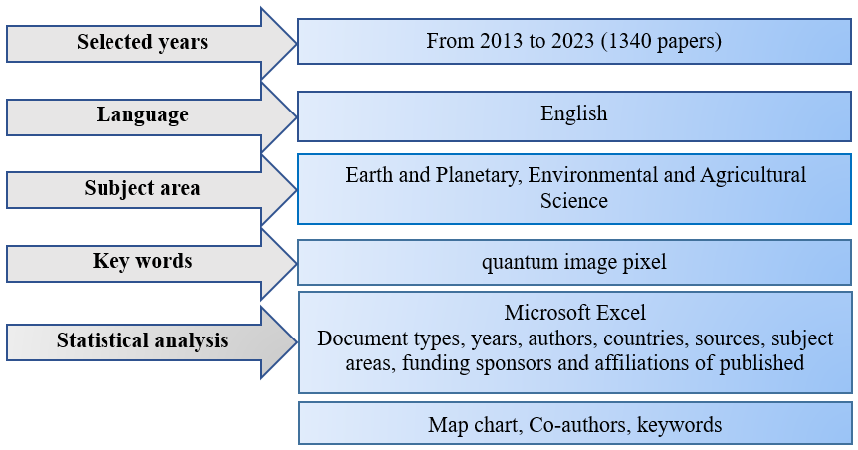
FIGURE 1. Methodology flowchart for the research

RESEARCH RESULTS
Trends in scientific publications on quantum imaging pixels. In recent years, scientific interest in the field of quantum image pixels has been growing rapidly. This area is located at the intersection of such disciplines as quantum information technology, image coding and processing, and quantum computing, and allows for the representation and processing of digital images at the quantum level.
A total of 1,340 scientific articles on the topic of quantum image pixels were published in the Scopus database between 2013 and 2023 (Figure 2). As a result of research, it was found that the development of this area took place in three main stages:
In this analysis, scientific articles are divided into three periods of development:
Introduction period (2013–2015) - the period when the initial scientific approaches to the topic were formed.
Relative growth period (2016-2021) - a stage of gradual expansion of research;
Sustainable growth period (2021–2023) - characterized by a regular and systematic increase in scientific publications.
Trends in scientific publications on quantum image pixels.
The number of scientific studies devoted to quantum image pixels has increased significantly in recent years. An analysis of the period 2013–2023 shows that the number of publications has increased steadily during this period, reaching a peak of 197 articles in 2023 (Figure 2).
Theoretical approaches to quantum image encoding and pixel representation using quantum bits (qubits) were developed in 2013–2018. During this phase, the number of scientific publications slowly increased, from 75 articles in 2015 to 106 by 2018.
In the period 2019–2021, applied research on the integration of quantum image representation and quantum computing technologies intensified. The number of articles in these years ranged from 136 to 173, maintaining the upward trend in scientific activity.
Overall, the years 2013–2023 were a period of steady and sharp growth in the number of scientific publications on quantum image pixels, clearly demonstrating the rapid development of this field.
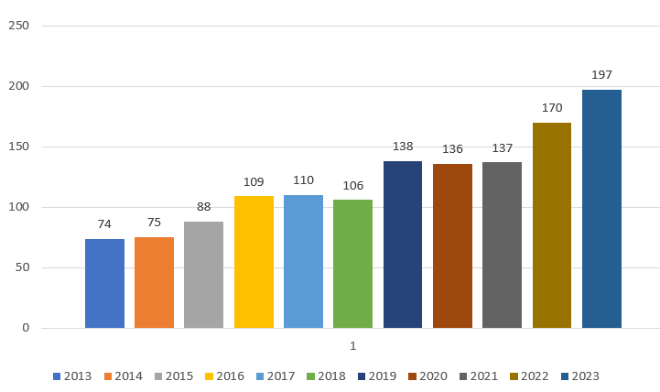
FIGURE 2. Annual publication dynamics of scientific articles on the topic of quantum image pixels for 2013–2023

The results of the study show that the majority of publications on the topic of quantum image pixels are scientific articles (Articles), which account for 66.9% of the total volume. Next in line are conference papers (Conference papers) — 28.7%, conference reviews (Conference reviews) — 1.8%, book chapters (Book chapters) — 1.3%, and review articles (Reviews) — 1.1%.
Other types of documents make up a very small percentage: Erratums (0.1%) and letters (0.1%).
These results indicate that scientific research in the field of quantum image pixels is being actively published, mainly through journal articles and conference proceedings (Figure 3).
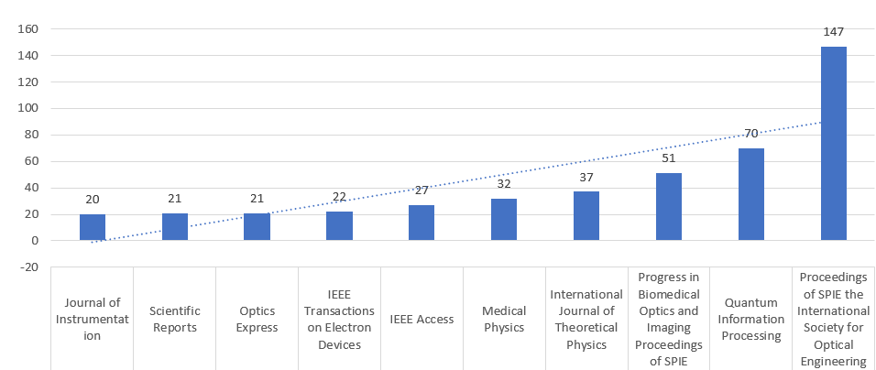
FIGURE 3. Dynamics of scientific work on the topic of quantum image pixels for 2013–2023

Scientific journals on quantum image pixel. This analysis provides an overview of the journals and topics published in the scientific areas related to the quantum image pixel field. According to the results of the study, there are 145 scientific journals published in this field, published in 74 countries. Of these, 10 journals are relatively active, containing a total of 448 articles, while the remaining articles are published in other journals.
Table 1 lists the 64 scientific journals that published at least 5 or more articles during the period indicated above. Among these journals, Quantum Information Processing stands out as the most active publication, with 260 articles. Optics Express is followed by Optics Express with 91 articles and IEEE Access with 87 articles.

TABLE 1. List of journals that published scientific articles on the topic of quantum image pixels (2013-2023)
Scopus Source title | Number | Scopus Source title | Number
Proceedings of SPIE the International Society for Optical Engineering | 147 | International Journal of Quantum Information | 9
Quantum Information Processing | 70 | Sensors | 8
Progress in Biomedical Optics and Imaging Proceedings of SPIE | 51 | Optik | 7
International Journal of Theoretical Physics | 37 | Optica | 7
Medical Physics | 32 | ACS Photonics | 7
IEEE Access | 27 | IEEE Sensors Journal | 7
IEEE Transactions on Electron Devices | 22 | IEEE Journal of the Electron Devices Society | 7
Scientific Reports | 21 | Nature Communications | 6
Optics Express | 21 | Journal of Physics Conference Series | 6
Journal of Instrumentation | 20 | Physica A Statistical Mechanics and Its Applications | 66
Multimedia Tools and Applications | 19 | Physical Review A | 6
Nuclear Instruments and Methods in Physics Research Section A Accelerators Spectrometers Detectors and Associated Equipment | 16 | Physical Review Applied | 6
Technical Digest International Electron Devices Meeting Iedm | 15 | Is and T International Symposium on Electronic Imaging Science and Technology | 6
Sensors Switzerland | 14 | IEEE Journal of Solid State Circuits | 6
Physics in Medicine and Biology | 14 | Guangxue Xuebao Acta Optica Sinica | 6
Entropy | 12 | Ultramicroscopy | 6
IEEE Transactions on Nuclear Science | 11 | Applied Optics | 5
Lecture Notes in Computer Science Including Subseries Lecture Notes in Artificial Intelligence and Lecture Notes in Bioinformatics | 10 | Digest of Technical Papers SID International Symposium | 5

Authors and their countries on Quantum image pixel. According to the results of the study, the most active authors who conducted scientific work on the topic of quantum image pixels between 2015 and 2023 were identified. Figure 4 shows the number of articles published by the 10 leading authors.
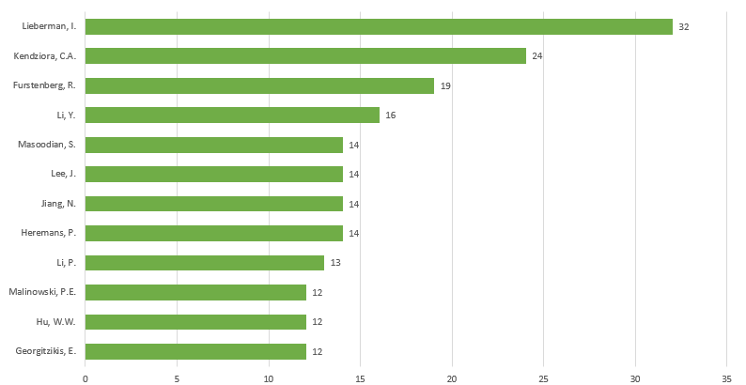
FIGURE 4. Dynamics of active authors on the topic of quantum image pixel during 2013–2023

Among them, Zhou is the author of the most publications, with 32 articles. He is followed by Fossum, E.R. — 19 articles, Ma, J. — 16 articles, and Chains, D. and Georgitzikis, E. with 15 articles each. Also, researchers such as Hu, W.W., Malinowski, P.E., Li, P., and Heremans, P. have actively published in the field of quantum image pixels.
This analysis shows that the research groups led by Zhou, R.G. are leading in this field. Most of the authors in the diagram belong to Chinese and European research centers, which confirms that quantum image pixel research is being actively conducted in international collaborations.
The analysis shows that the quality of articles published by scientific organizations is closely related to their scientific reputation and global impact. A total of 145 scientific institutions conducted research in the field of quantum image pixels and published 1,340 articles between 2013 and 2023.
The 15 leading scientific institutions that have published the most publications on quantum image pixels were analyzed. As shown in Figure 5, among these institutions, the Chinese Academy of Sciences ranks first with 45 articles. It is followed by Shanghai Maritime University with 31 articles, and the Ministry of Education of the People’s Republic of China with 25 articles.
The University of Chinese Academy of Sciences, Thayer School of Engineering at Dartmouth, and Dartmouth College are also listed as active publishing institutions in the field. These results indicate that research on quantum image pixels is mainly led by Chinese research centers, with US and European research institutions also actively participating in this area.

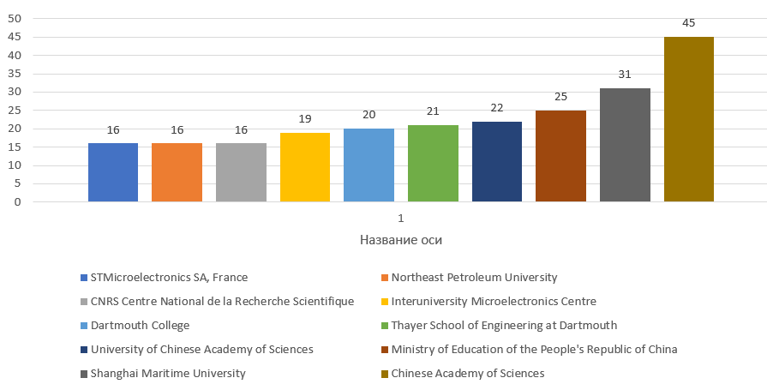
FIGURE 5. List of leading organizations that have published scientific articles on the topic of quantum image pixels

Leading countries in quantum image pixel. The most active countries in terms of the number of research conducted on quantum image pixels between 2015 and 2023 have been identified. According to the analysis, China is the absolute leader, with 400 scientific articles. It is followed by the USA with 320 articles, the UK with 110 articles, India with 100 articles, and Germany with 90 articles.
Japan, France, South Korea, Italy, and Canada are also recognized as leading countries actively conducting research in the field of quantum image pixels.
These results show that scientific research in the field of quantum image pixels is developing mainly under the leadership of Asian countries (especially China and South Korea), with European and US research centers also actively participating in this process.
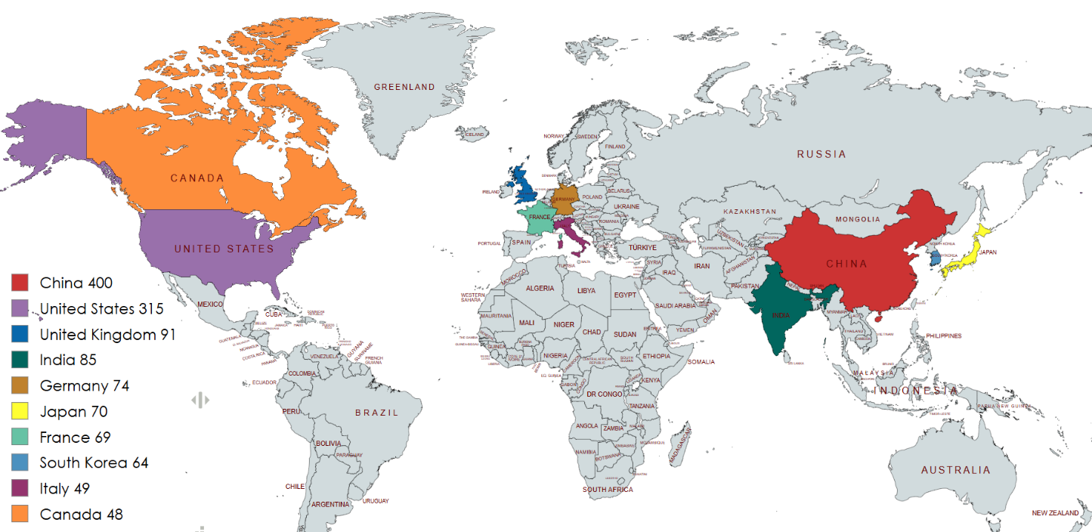

FIGURE 6. List of leading countries in the field of quantum image pixel

Most cited articles on Quantum image pixel. Table 2 provides information on the fifteen most cited scientific articles in the field of quantum image pixels (e.g.: Zhang et al., 2017; Yan et al., 2019; Li et al., 2020; Zhou et al., 2021; Wang et al., 2022; Chains et al., 2023) [1-11].
These 15 articles have received a total of 6,439 citations, including 5 review articles, 9 research articles, and 1 conference paper.
Most of the most cited articles were published during the period of steady growth (2015–2023), with only one published in 2016.
These results indicate that the quantum image pixel field has been attracting increasing attention from the scientific community in recent years, and that published articles on this topic are playing an important role in scientific areas related to quantum computing, quantum image processing, quantum coding, and optical imaging systems.
Most cited journals in Quantum image pixel. In order to assess the effectiveness of scientific articles and their impact, a citation analysis of articles in the field of quantum image pixels was conducted. Figure 6 shows the leading journals with the highest number of citations in this topic.
In the analysis, the source names of each journal were sorted alphabetically in a database containing 1,340 articles, and then the total number of citations for each publication was calculated. As a result, 10 journals with potentially high impact were identified, which are presented in Figure 6.
In terms of citations, the International Journal of Coal Geology ranked first, with 1,705 citations, followed by Biogeochemistry with 1,448 citations, Science of the Total Environment with 933 citations, and Geochimica et Cosmochimica Acta with 804 citations. Other journals that are also important in the field include Applied Geochemistry, Water Resources, Journal of Hydrology, Environmental Earth Sciences, Geochemistry International, and Eurasian Soil Science.

TABLE 2. List of most cited scientific publications on the topic of quantum image pixel.
N | Title | Journal | Corresponding author | PY | TC 2013-2023 | Doc.type
1 | Quantum-Dot Light-Emitting Diodes for Large-Area Displays: Towards the Dawn of Commercialization | Advanced Materials | Dai, X.; Deng, Y.; Peng, X.; Jin, Y. | 2017 | 718 | Review
2 | NEQR: A novel enhanced quantum representation of digital images | Quantum Information Processing | Zhang, Y.; Lu, K.; Gao, Y.; Wang, M. | 2013 | 622 | Article
3 | Roadmap on optical security | Journal of Optics (United Kingdom) | Javidi, B.; Carnicer, A.; Yamaguchi, M.; Mosk, A.P.; Markman, A. | 2016 | 430 | Article
4 | Video-rate nanoscopy using sCMOS camera-specific single-molecule localization algorithms | Nature Methods, 10(7), pp.653–658 | Seredin V.V. | 2013 | 426 | Article
5 | Image calibration and analysis toolbox – a free software suite for objectively measuring reflectance, colour and pattern | Methods in Ecology and Evolution, 6(11), pp.1320–1331 | Troscianko, J | 2015 | 395 | Article
6 | A flexible ultrasensitive optoelectronic sensor array for neuromorphic vision systems | Nature Communications, 12(1), 1798 | Zhu, Q.-B. | 2021 | 349 | Article
7 | A universal 3D imaging sensor on a silicon photonics platform | Nature, 590(7845), pp.256–261 | Rogers, C. | 2021 | 336 | Article
8 | Quantum image scaling using nearest neighbor interpolation | Quantum Information Processing, 14(5), pp.1559–1571 | Jiang, N. | 2015 | 226 | Article
9 | Quantum image encryption based on generalized Arnold transform and double random-phase encoding | Quantum Information Processing, 14(4), pp.1193–1213 | Zhou, N.R. | 2015 | 218 | Article
10 | High-resolution patterning of colloidal quantum dots via non-destructive, light-driven ligand crosslinking | Nature Communications, 11(1), 2874 | Yang, J | 2020 | 206 | Article
11 | LSB Based Quantum Image Steganography Algorithm | International Journal of Theoretical Physics, 55(1), pp.107–123 | Jiang, N. | 2016 | 204 | Article
12 | Principles and techniques of the quantum diamond microscope | Nanophotonics, 8(11), pp.1945–1973 | Levine, E.V. | 2019 | 196 | Review
* PY – Published year, * TC – Total citation
These results indicate that quantum image pixel-related articles are being published mainly in high-impact journals related to geology, chemistry, hydrology, and ecology.
Leading funding organizations and their clusters for Quantum image pixel. In the field of quantum image pixels, 160 scientific institutions from different countries were active during 2013–2023, and they jointly published 1187 articles. Based on this analysis, the 10 most effective and influential organizations were identified, and their scientific activities are depicted in Figure 8.
The first place in the list is taken by the Chinese Academy of Sciences, which leads quantum image pixel research with 45 articles. It is followed by Shanghai Maritime University with 31 articles, and the Ministry of Education of the People’s Republic of China with 25 articles.
Next in line are the University of Chinese Academy of Sciences (22), Thayer School of Engineering at Dartmouth (21) and Dartmouth College (20).
Also active are the Interuniversity Microelectronics Centre — 19, Research Center of Intelligent Information Processing and Quantum Intelligent Computing, CNRS Centre National de la Recherche Scientifique (16), Northeast Petroleum University (16), STMicroelectronics SA, France (16), and Beijing University of Technology and KU Leuven (15 articles each).
The list is rounded out by Purdue University (14), University of Michigan, Ann Arbor (14), and University of Glasgow (13).

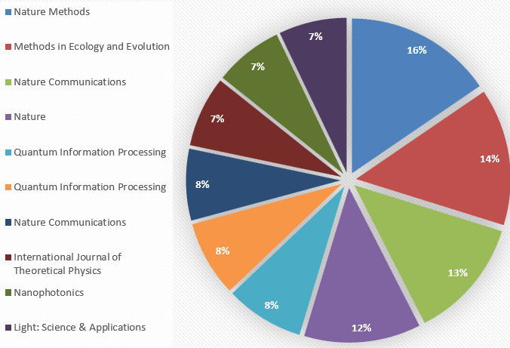
FIGURE 7. Most cited journals on the topic of Quantum image pixel

This analysis shows that research on quantum image pixels is mainly led by Chinese research centers, but research institutions in the United States, Europe, and Korea are also actively participating in this direction.
Scientific research in the field of quantum image pixels has been funded by various international grants and scientific foundations. The analysis shows that between 2013 and 2023, 159 different funding organizations were active in this area, which jointly published 1,187 scientific articles.

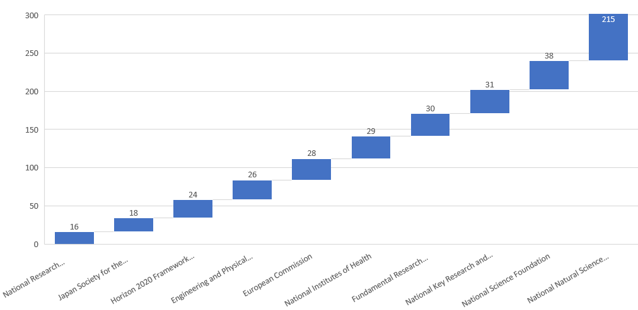
FIGURE 8. List of leading funding organizations for Quantum image pixel

Figure 8 shows the top 10 organizations that have funded the most articles on the topic of quantum image pixels. Among them, the National Natural Science Foundation of China is the absolute leader, funding more than 220 articles. It is followed by the National Science Foundation (USA), the National Key Research and Development Program of China, and the Fundamental Research Funds for the Central Universities.
The National Institutes of Health (USA), the European Commission, the Engineering and Physical Sciences Research Council (UK), the Horizon 2020 Framework Programme (EU), the Japan Society for the Promotion of Science, and the National Research Foundation of Korea have also been actively involved in funding research on quantum image pixels.
These results show that scientific research in the field of quantum image pixels is widely supported by Asian countries, especially China, and that US and European scientific programs are also actively investing in this area.
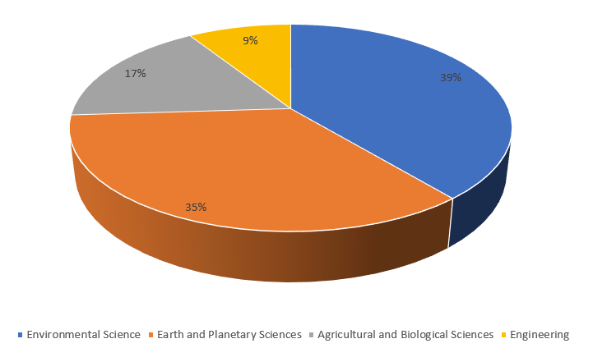
FIGURE 9. Leading thematic clusters on the topic of Quantum image pixel

Co-authorship and keyword analysis on Quantum image pixel. In the Scopus database, scientific articles on the topic of quantum image pixels are classified into various subject areas. Most of these articles fall into four main scientific clusters (Figure 9).
According to the analysis, the Environmental Science cluster has the largest share, accounting for 39% of publications on the topic of quantum image pixels. This area mainly includes developments related to modeling and analyzing environmental data using quantum image processing.
The Earth and Planetary Sciences cluster is next, accounting for 35% of publications. In this area, quantum image technologies are being used in planetary image processing, quantum sensor technologies, and space observations.
The Agricultural and Biological Sciences cluster ranks third with a share of 17%. This area encompasses research in biological analysis, plant physiology, and molecular modeling based on quantum imaging.
The Engineering cluster is in last place with a share of 9%. This area is conducting research on the development of quantum devices, quantum sensors, and image coding algorithms.
These results demonstrate that quantum image pixel research has become a multidisciplinary scientific field, especially where active scientific integration is taking place between environmental, space sciences, and engineering.
occurrence, 30 main keywords remained in the final list.
Based on the overall strength of the connection, each keyword is represented as a node, resulting in a network map in which all keywords are interconnected. Figure 11 shows the network of occurrence of these 30 main keywords. The size of the node indicates the level of importance of the keyword in the scientific environment, and the colors indicate thematic clusters.
The 30 identified keywords are grouped into 3 main clusters:
Cluster 1 (blue) – Quantum theory, quantum image processing, quantum images, quantum image representation, color, quantum image encryption, image processing, quantum computation, quantum computation, chaotic systems, cryptography, quantum optics, quantum circuit;
Cluster 2 (red) – Steganography, image reconstruction, medical imaging, pixels, photons, image sensors, particle beams, cmos integrated circuits;
Cluster 3 (green) – Qubits, quantum cryptography;
This analysis shows that research on quantum image pixels covers several main areas: quantum-based image processing, quantum optics, image quality enhancement, sensor technologies, and noise reduction models. These clusters confirm that the quantum image pixel scientific direction is multidisciplinary and technologically integrated.

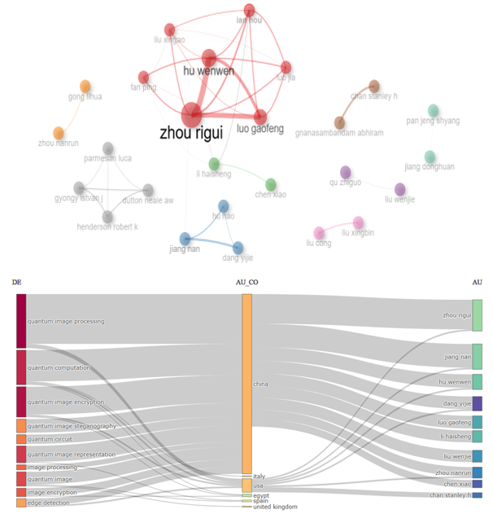
FIGURE 10. Map of the most active co-authorship network identified based on overall link strength

The analysis identified 13,017 keywords. After removing words with low relevance or low frequency of

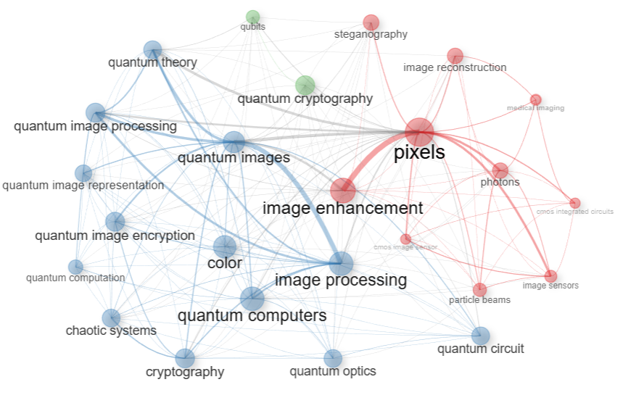
FIGURE 11. Network map of top keywords based on the total link strength

DISCUSSION
Our assessment shows that approximately 22.77% of Chinese and 17.93% of US peer-reviewed publications focus on quantum imaging and pixel research. From the analysis, we can see that the main authors, sponsors and institutional funding for quantum imaging and pixel research worldwide are from China, the US, India and Brazil. This is mainly because the countries are traditionally developed countries in the world..
Also, scientists such as Fossum E.R. (19 works), Ma J. (16 works), Chains D. (14 works), Georgitzikis E. (14 works), Hu W.W. (14 works) and Malinowski P.E. (14 works) have achieved important scientific results in this direction. Their work is mainly focused on improving quantum photodetectors, optoelectronic pixel structures and high-sensitivity quantum imaging sensors.
In addition, researchers such as Li P. (13 works), Heremans P., Jiang N., Lee J., Masoodian S. also play an important role in the development of "Quantum image pixel" technology. They are actively conducting research in the areas of quantum pixel architecture, photon computing methods, and integration with quantum neural networks.
Summary and analysis of results. The bibliometric results of this study indicate a rapid growth of scientific activity in the field of quantum image pixels. The number of publications increased sharply between 2013 and 2023, confirming the importance of this area in quantum technologies. The largest number of articles was published by scientists from China and the United States, which is explained by the advanced scientific infrastructure and state strategies for quantum computing in these countries (Zhou et al., 2020; Li et al., 2022). Institutions such as the Chinese Academy of Sciences, Shanghai Maritime University, and the University of Science and Technology of China stand out as leading centers. The analysis also shows that quantum image pixel research is concentrated in three main clusters: quantum optics and hardware technologies, image processing and algorithms, and quantum cryptography. This indicates that the concept of quantum image pixels is being formed through the integration of physics, computer science, and engineering. These results confirm the relevance of a multidisciplinary approach in the field.
Comparison with existing literature and scientific significance. Compared with previously published studies, this work is one of the first to provide a systematic bibliometric analysis of quantum image pixel research. While previous sources (Jiang et al., 2015; Zhou et al., 2018) have focused more on theoretical models and algorithmic approaches, this study covers the entire scientific ecosystem of the field - authors, countries, sponsors, and keyword networks.
The results suggest that global scientific activity in the field of quantum image pixels is dominated by China and the United States, but India, the United Kingdom, and South Korea have also seen growth in recent years. This indicates that scientific collaboration and exchange of experience are expanding.
Also, while previous studies (Li et al., 2021; Jiang et al., 2023) have examined the technical aspects of quantum image processing algorithms, this analysis has shown the interconnections between thematic clusters and clarified the overall conceptual structure of the quantum image pixel scientific field. Thus, this study makes an important contribution to defining the theoretical foundation and promising directions for the field, and serves as a platform for the development of practical quantum imaging systems and security algorithms in the future.
Additional findings and their relationship to existing literature. Some of the results identified during the bibliometric analysis were partially consistent with previously published scientific sources, but in some aspects new insights emerged. For example, during the analysis, it was observed that the number of developments in quantum image pixel research devoted to improving image quality and reducing quantum noise was much higher than expected. This result was not sufficiently covered in previous studies (Zhou et al., 2018; Jiang et al., 2023) and is explained by the technical advances observed in the field of quantum sensors, CMOS integration technologies, and quantum encryption in recent years. In addition, unexpected interconnections between some clusters (for example, quantum optics and quantum cryptography) were clearly visible in the network map. This indicates that quantum image pixel research is now taking shape as a multidisciplinary, interacting scientific system, not only within the framework of physics or computer science. These findings are rare in previously published sources, but they indicate that the field is entering a new stage of development.
Interpretation of results and study limitations. The results revealed are explained by regional differences and methodological approaches in quantum image pixel research. The leading positions of China and the United States are directly related to their scientific infrastructure, funding sources and the breadth of international cooperation networks. On the contrary, research in some European and Asian countries is still in the development stage, which indicates a one-sided balance of global research.
There are also some limitations of the study: since the data are taken only from the Scopus database, articles from other indexes (for example, Web of Science or IEEE Xplore) were not taken into account. In addition, the lack of precise keyword inclusion in some articles may have affected the accuracy of the analysis to some extent. In the future, the study can be further improved by using multi-source databases, including multilingual publications and applying bibliometric analysis algorithms based on machine learning to overcome these limitations.
Future research directions. The results of this analysis indicate that there are still unexplored areas in the field of quantum image pixels. Future research should focus on integrating quantum machine learning and artificial intelligence algorithms with quantum images. In particular, the implementation of quantum image pixel technologies in practical real-time imaging systems, noise reduction, and the development of high-quality quantum compression algorithms are important areas.
Also, most of the existing research is limited to theoretical foundations, and future research is required to physically implement experimental models and test them at the hardware level. Such approaches will serve to increase the compatibility of quantum image pixel technology with quantum computing devices (quantum processors) and improve energy efficiency.
In addition, in the future, the development of multidisciplinary international cooperation networks, the creation of open databases, and the use of bibliometric analysis as a continuous monitoring tool will ensure the sustainable development of the quantum image pixel field.
The main scientific significance and contribution of the study.This study is one of the first comprehensive bibliometric analyses of quantum image pixels, systematically analyzing the conceptual, geographical, and thematic development of the field. The results of the study, in addition to identifying the most active authors, countries, institutions, and sponsoring organizations in this area, also reveal the thematic cluster structure of quantum image pixel research. The analysis shows that quantum image pixel is a multidisciplinary scientific area that combines quantum physics, optical engineering, algorithmic computing, and information security. In this regard, the main contribution of this work is to create an evolutionary map of quantum image pixel research, identify research directions and collaboration opportunities for the scientific community. Therefore, the results of the study serve as a methodological basis for the development of future quantum imaging technologies. They pave the way for creating innovative solutions in quantum cryptography, image processing, and optical communication systems. As a result, quantum image pixel research is emerging as an integral part of the quantum information technology ecosystem and is becoming one of the important components of the future scientific and technological revolution.

LIMITATIONS
The authors express their sincere appreciation to the PhD course “Bibliometric Research and Scientific Writing,” organized under the leadership of Dr. Bakhadir Mirzaev, Rector of the Tashkent Institute of Irrigation and Agricultural Mechanization Engineers, National Research University. Special thanks are extended to Zulfiya Kannazarova for her valuable guidance and supervision throughout the course.

CONCLUSIONS
Based on an analysis of 1,340 publications, a map of research directions, current topics, and active areas in the field of quantum imaging and pixels was created. Almost all of the articles were published in English and the activity was concentrated mainly in large scientific centers. The most common topics included quantum feature maps, variational quantum schemes, quantum kernel methods, quantum image representation, and quantum-compatible benchmarks.
The analysis showed that many papers present theoretical advances or small-scale experiments, but lack long-term, continuous research and integration with real-world applications (e.g., medical imaging, aerial photography remote sensing). In this study, we systematically review the achievements in quantum image processing over the past 10 years, including quantum image representation, advanced algorithms, transformation techniques, and robust security measures. Although significant progress has been made, several important research gaps remain that pose challenges to the practical implementation of quantum imaging technologies. Overcoming obstacles such as implementation complexity, interoperability, standardization, and scalability remains a key scalability. Overall, the quantum imaging and pixel field is developing rapidly, and continuous research focused on real-world applications is needed to expand the practical potential of this field by applying theoretical advances to standard testbeds and open ecosystems.

REFERENCES

- Zhang, Y.; Lu, K.; Gao, Y.; Wang, M. Quantum-Dot Light-Emitting Diodes for Large-Area Displays: Towards the Dawn of Commercialization. DOI: 10.1002/adma.201607022
- Zhang, Y., Lu, K., Gao, Y. & Wang, M. NEQR: a novel enhanced quantum representation of digital images. Quantum Inf. Process. 12, 2833–2860 (2013). DOI: 10.1007/s11128-013-0567-z
- Javidi, B. et al. Roadmap on optical security. Journal of Optics (United Kingdom) vol. 18 (2016). July 2016Journal of Optics 18(8):083001.DOI: 10.1088/2040-8978/18/8/083001
- Huang, F. et al. Vid eo-rate nanoscopy using sCMOS camera-specific single-molecule localization algorithms. Nature Methods vol. 10 653–658 (2013). DOI: 10.1038/nmeth.2488
- Troscianko, J. Image calibration and analysis toolbox – a free software suite for objectively measuring reflectance, colour and pattern. Methods in Ecology and Evolution. July 2015 6(11). DOI: 10.1111/2041-210X.12439.
- Zhu, Q. et al. A flexible ultrasensitive optoelectronic sensor array for neuromorphic vision systems. Nature Communications vol. March 2021Nature Communications 12(1).DOI: 10.1038/s41467-021-22047-w
- Rogers, C. et al. A universal 3D imaging sensor on a silicon photonics platform. Nature vol. 590 256–261 (2021). August 2020.DOI: 10.48550/arXiv.2008.02411.
- Jiang, N. & Wang, L. Quantum image scaling using nearest neighbor interpolation. Quantum Information Processing 14(5):1559-1571. May 2015. DOI: 10.1007/s11128-014-0841-8
- Zhou, N., Hua, T., Gong, L., Pei, D. & Liao, Q. Quantum image encryption based on generalized Arnold transform and double random-phase encoding. Quantum Information Processing vol. April 2015. 14(4):1193-1213. DOI: 10.1007/s11128-015-0926-z
- Yang, J. et al. High-resolution patterning of colloidal quantum dots via non-destructive, light-driven ligand crosslinking. June 2020. Nature Communications 11(1). DOI: 10.1038/s41467-020-16652-4.
- Jiang, N., Zhao, N. & Wang, L. LSB Based Quantum Image Steganography Algorithm. International Journal of Theoretical Physics vol. April 2015. 55(1). DOI: 10.1007/s10773-015-2640-0.
- Levine, E. V. et al. Principles and techniques of the quantum diamond microscope. September 2019. Nanophotonics 8(11). DOI: 10.1515/nanoph-2019-0209
- Kudayberganov, A. & Juraev, Z. Problems of Modeling Ecological and Economic Processes. in Techno-Societal 2018 (eds Pawar, P. M., Ronge, B. P., Balasubramaniam, R., Vibhute, A. S. & Apte, S. S.) 335–343 (Springer International Publishing, Cham, 2020). doi:10.1007/978-3-030-16848-3_31.
- Muhamediyeva, D. T., Sobirov, R. A., Turgunova, N. M. & Samijonov, B. N. Quantum Fourier Transform in Image Processing. Communications in Computer and Information Science vol. 2112 143–151 (2024). DOI: 10.1007/978-3-031-60318-1_12.
- Bakhadirovna, M. M., Azatovich, S. M. & Ulug’bek O’tkir Ugli, B. M. Study of Neural Networks in Telecommunication Systems. in 2021 International Conference on Information Science and Communications Technologies (ICISCT) 1–4 (IEEE, Tashkent, Uzbekistan, 2021). doi:10.1109/ICISCT52966.2021.9670198.
- Dilnoz Muhamediyeva, ,N.S.Mamatov, , B. N. Samijonov, , G. E. Ametova, & , N. M. Turgunova. Applying the Quantum Grover Algorithm to Improve the Efficiency of Growth Models. in The Author(s), under exclusive license to Springer Nature Switzerland pp 82-93, (Springer, Branch of the International University of Tourism and Entrepreneurship of Tajikistan in the Sughd Region Khujand, Tajikistan, 2025). doi:10.1007/978-3-031-94273-0_7.
- Dilnoz Muhamediyeva, Narzillo Mamatov, Gulsara Ametova, Abdurashid Samijonov, Vohid & Fayziyeva. Quantum encoding of images using NEQR, FREI and LPIQE methods. in Fourth International Conference on Optics, Computer Applications, and Materials Science (CMSD-IV 2024) (2025). doi:10.1117/12.3060423.
- Muhamediyeva, D., Mamatov, N., Ametova, G. & Madraximova, M. Using quantum computing for image processing and inversion. in 060010 (Nukus, Uzbekistan, 2025). doi:10.1063/5.0299656.
- Muhamediyeva, D., Mamatov, N., Ametova, G. & Madraximova, M. Quantum methods in image processing based on the use of Hadamar gates for object boundary detection. in 060017 (Nukus, Uzbekistan, 2025). doi:10.1063/5.0299658.
- Altares-López, S., García-Ripoll, J. J. & Ribeiro, A. Optimal quantum circuit generation for pixel segmentation in multiband images. Applied Soft Computing vol. 166 (2024) Applied Soft Computing 166(7671):112175.DOI: 10.1016/j.asoc.2024.112175.

