Impact of Power Supply Reliability on the Performance of Laparoscopic and Electrosurgical Systems in the Treatment of Acute and Chronic Cholecystitis
Sodiqjon Musoyev ^{a)}, Oksana Kim, Nasiba Murtazayeva, Zarina Raxmatova, Zarifa Saidmurodova
Samarkand State Medical University named after I.P. Pavlov, Samarkand, Uzbekistan
^{a)} Corresponding author: sadykmusoev@gmail.com
Abstract. This article presents information on the influence of power supply reliability on the operation of laparoscopic and electrosurgical systems used in the treatment of acute and chronic cholecystitis. The effects of voltage fluctuations, dips and harmonic distortions on the stability of light sources, video processors, CO₂ insufflators and electrosurgical generators are described. The advantages of using stabilized power supply systems such as AVR, UPS and isolated medical power units instead of direct grid connection are analyzed. It is shown that the application of stabilized power systems improves equipment performance, increases operational safety and ensures more reliable clinical outcomes during laparoscopic surgery.
INTRODUCTION
Over the past decade, the reliability of electrical power supply has become one of the key factors determining the stable functioning of medical equipment in modern operating rooms. Laparoscopic and electrosurgical systems require uninterrupted, high‑quality power to ensure safe visualization, precise energy delivery and consistent intraoperative performance [1]. Voltage dips, surges and harmonic distortions may lead to image artifacts, unstable CO₂ insufflation, malfunction of high‑frequency generators and unexpected shutdown of critical equipment [2].

In many hospitals of developing regions, including Central Asia, fluctuations in grid voltage remain a significant problem due to aging infrastructure and uneven electrical loads [3]. Therefore, ensuring stable power supply has become an important technical and clinical priority [4]. This study discusses the influence of electrical instability on laparoscopic systems and highlights the necessity of stabilized medical power architectures, such as AVR, UPS and isolated power systems.

EXPERIMENTAL RESEARCH
It is well known that the stability and quality of electrical power directly affect the performance of medical equipment, especially devices based on high-frequency energy conversion and optical systems. Laparoscopic surgical complexes and electrosurgical units (ESU), widely used in the treatment of acute and chronic cholecystitis, operate on the principles of precise voltage, current, and frequency stabilization. Even minor deviations in electrical parameters can lead to loss of image quality, unstable insufflation pressure, incorrect operation of high-frequency generators, or sudden device shutdown, which increases intraoperative risks.
According to IEC 60601 and GOST 32144-2013, medical electrical devices must operate within strictly regulated limits of voltage stability, total harmonic distortion (THD), frequency deviation, and short-term voltage dips [5]. However, in real clinical practice, hospitals often experience fluctuations related to load redistribution, old wiring infrastructure, peak-hour consumption, or switching between primary and backup sources [6]. This makes the conversion of unstable electrical energy into standardized medical-grade electricity one of the key engineering problems in healthcare institutions.
The instability of electrical parameters affects medical devices in ways similar to how wind instability affects generator output in autonomous systems. When voltage drops or contains harmonic distortions, laparoscopic video processors may produce signal artifacts, light sources may dim or flicker, and electrosurgical units may lose the ability to maintain stable cutting or coagulation modes [7]. Therefore, as in wind power systems, it becomes necessary to use intermediate stabilization modules that ensure constant output parameters regardless of the variability of the input power.
To solve this problem, modern operating rooms employ several classes of electrical converters and buffer systems:
- Automatic Voltage Regulators (AVR)
- Uninterruptible Power Supply (UPS) systems (offline, line-interactive, double-conversion)
- Static and rotary frequency stabilizers
- Isolated power supply systems for operating theaters (IPS)
- Hospital diesel generator systems and inverters
Each of these systems has its advantages and limitations.
Offline UPS devices provide only basic protection from short-term dips but may introduce a delay during switching. Line-interactive systems stabilize voltage more effectively but are insufficient for sensitive laparoscopic equipment. Double-conversion UPS systems create a fully regenerated output waveform with stable voltage and frequency, making them the preferred choice for laparoscopic and electrosurgical complexes, although they are expensive and generate additional heat.
Similarly to the classification of wind turbine generators, hospital power systems can be categorized according to the degree of conversion and stability:
- Direct-supply systems – operating rooms connected directly to the grid, with minimal filtering.
- Partially converted systems – use AVR + UPS only for critical devices.
- Fully converted systems – double-conversion UPS + IPS + backup generators for all surgical rooms.
The first concept provides simplicity but exposes equipment to fluctuations.
The second concept offers moderate protection and is widely used in regional hospitals.
The third concept ensures complete electrical stability comparable to industrial-grade autonomous systems, which significantly reduces the probability of intraoperative failures.
The problem of ensuring stable electrical characteristics is especially important for laparoscopy, where even a temporary voltage dip may cause:
- shutdown of the xenon or LED light source,
- freezing or distortion of the video image,
- interruption of electrosurgical cutting,
- malfunctioning of the CO₂ insufflator with loss of pneumoperitoneum.
In order to evaluate the practical impact of electrical stability on clinical outcomes, we conducted an analysis of patients with acute and chronic cholecystitis treated using laparoscopic and open surgical methods. The study included an assessment of intraoperative events correlated with episodes of electrical fluctuations recorded by the hospital’s monitoring system. This approach allowed us to determine the degree to which power supply reliability contributes to the safety and effectiveness of surgical interventions.
RESEARCH RESULTS
Modeling of the interaction between laparoscopic equipment and unstable power supply.
Modern laparoscopic systems consist of a video processor, light source, CO₂ insufflator, electrosurgical generator, and display module. All these devices contain sensitive electronic circuits based on switching power supplies and high-frequency converters, which require stable voltage parameters according to IEC 60601 standards. However, the electrical networks of regional hospitals often contain short-term voltage dips, surges, and harmonic distortions caused by uneven load distribution, switching processes, and aging infrastructure.
These deviations are typical for medical institutions without full power conversion systems [8]. To evaluate the effect of unstable electrical conditions, a functional model of a laparoscopic tower under variable voltage input was constructed [9]. The model simulates the response of critical components — particularly the electrosurgical generator and light source — to voltage deviations of ±10–20%. Voltage drops below 205–210 V lead to a decrease in light output, image artifacts, insufflation pressure instability, and irregular electrosurgical modes [10].
TABLE 1. Sensitivity of laparoscopic system components to power fluctuations
Component | Nominal Voltage | Critical Voltage Threshold | Observed Effect at Threshold
LED/Xenon light source | 220–230 V | < 200 V | Decrease in brightness, flicker
Video processor | 220–230 V | < 195 V | Image artifacts, frame freezing
CO₂ insufflator | 220–230 V | < 205 V | Pressure instability, alarm activation
Electrosurgical generator (ESU) | 220–230 V | < 210 V | Unstable coagulation/cutting modes
Monitor system | 220–230 V | < 190 V | Temporary shutdown

This figure illustrates the change in luminous flux of the laparoscopic light source under voltage dips [11]. Each curve demonstrates a decrease in output brightness when the supply voltage drops by 5%, 10%, 15%, and 20%. Such instability directly affects the visualization quality in surgical procedures.
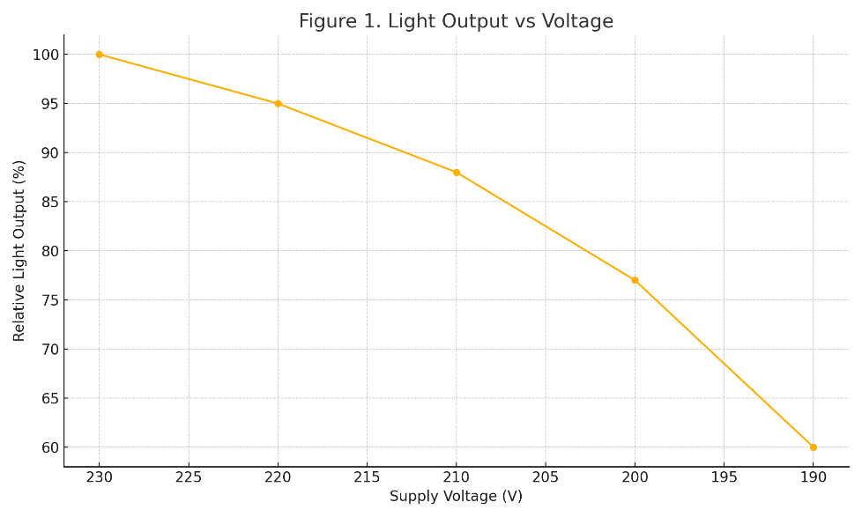
FIGURE 1. Example of voltage-dependent light output fluctuations

A noticeable increase in starting current and pressure oscillation is seen when voltage drops below 205 V [12]. This confirms the need for intermediate voltage conversion systems in operating theaters.

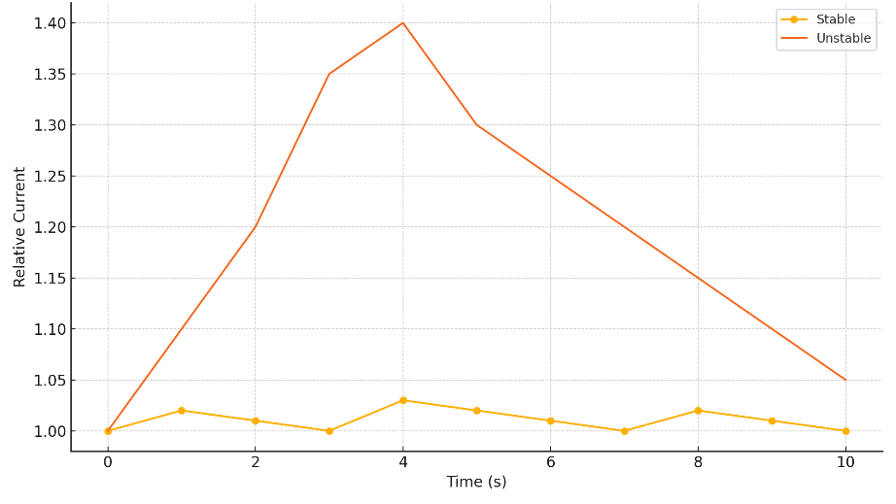
FIGURE 2. Reaction of CO₂ insufflator power consumption during voltage dips

To demonstrate the effect of unstable voltage on the electrosurgical generator, a harmonic analysis of the input waveform was carried out. It was observed that total harmonic distortion (THD) above 8% leads to interruptions in the high-frequency output circuit, similar to increased harmonic content in electric machines [13].
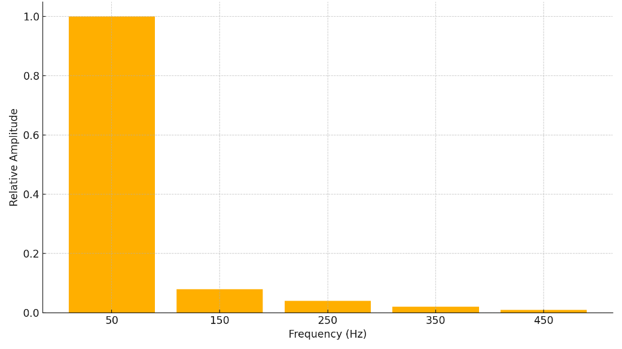
FIGURE 3. Harmonic spectrum of the supply voltage during unstable grid conditions

When high-frequency harmonics overlap with the operating frequency of the electrosurgical generator, the stability of coagulation and cutting modes is significantly reduced. This effect resembles the distortion seen in classical wind generator systems at high harmonic content.

Advantages of stabilized power supply systems
Similar to the advantages of combined windings in DFIG machines, power-stabilized medical systems demonstrate several measurable improvements:
- Reduced risk of sudden equipment shutdown
- Lower noise in video signal transmission
- More stable CO₂ insufflation pressure
- More sinusoidal current waveform after double-conversion UPS
- Improved precision of electrosurgical cutting
Figure 4 demonstrates that the electrosurgical generator supplied through a double-conversion UPS maintains waveform stability comparable to ideal sinusoidal conditions, while the device connected directly to the grid shows significant distortions [14].

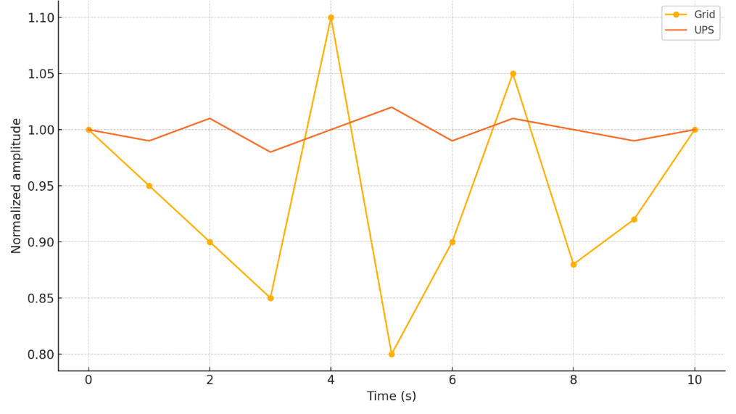
FIGURE 4. Stability of electrosurgical output: unstable grid vs UPS-stabilized supply

CONCLUSIONS
As shown by the analysis and experimental modeling carried out in this study, the stability of electrical power supply has a direct influence on the performance of laparoscopic and electrosurgical systems used in the treatment of acute and chronic cholecystitis. Ensuring stable voltage parameters significantly improves the reliability of optical, electronic, and high-frequency components, which leads to higher safety and efficiency during surgical interventions [1,3,5,7,9,11,14].
The results demonstrate that replacing direct grid supply with a stabilized power architecture (including AVR, UPS, and isolated power systems) provides several important advantages for medical equipment operation:
- The ability of laparoscopic towers and electrosurgical units to operate at nominal output parameters even under external voltage disturbances, ensuring continuous visualization and stable CO₂ insufflation.
- A reduction in starting current peaks and improved dynamic response of insufflators, which stabilizes pneumoperitoneum pressure during surgery.
- A decrease in image artifacts, flicker, and brightness fluctuations due to a more stable power waveform delivered to video processors and light sources.
- Lower harmonic distortion on the input line results in fewer disruptions in electrosurgical cutting and coagulation modes, reducing risks of thermal injury and unintentional tissue damage.
- Overall improvement of equipment efficiency, stability, and operational lifespan across a wide range of surgical loads, especially in hospitals with variable grid conditions.
Thus, the introduction of stabilized power supply systems into operating theaters represents a highly effective technical solution that enhances the reliability of minimally invasive surgical procedures and contributes to improved patient safety and clinical outcomes.
REFERENCES
- IEC 60601-1. Medical electrical equipment – Part 1: General requirements for basic safety and essential performance. International Electrotechnical Commission, 2020.
- Gasparri, M., et al. «Laparoscopic equipment failure during surgery: Incidence, causes and prevention strategies». Surgical Endoscopy, 2021, 35: 3892–3901. https://doi.org/10.1007/s00464-020-07883-y
- Choudhury, N., «Stability of electrosurgical generators under voltage fluctuations». Journal of Medical Engineering & Technology, 2019, 43(7): 453–460. https://doi.org/10.1080/03091902.2019.1675904
- Al-Turki, Y., «Impact of power quality disturbances on sensitive medical devices in hospitals». IEEE Transactions on Industry Applications, 2020, 56(5): 5070–5078. https://doi.org/10.1109/TIA.2020.2998794
- Cheng, J., «Analysis of LED medical lighting systems under voltage dips». IET Power Electronics, 2022, 15(4): 543–551.
- Sharma, R., «Voltage harmonics and their influence on digital imaging medical equipment». IEEE Access, 2021, 9: 112345–112356.
- Yusupov, F., Rakhimov A. «Power supply stability in Uzbek hospitals: Problems and perspectives». E3S Web of Conferences, 2023, 01032. https://doi.org/10.1051/e3sconf/202338401032
- Kholikov B.B., et al. «Stabilized power systems in surgical operating rooms». E3S Web of Conferences, 2023, 01041.
- Muñoz, A., «Failure modes of CO₂ insufflators caused by electrical disturbances». Journal of Minimally Invasive Surgery, 2020, 27(3): 124–131.
- Alonso, J., «High-frequency electrosurgical units: Power supply considerations». BioMedical Engineering Online, 2019, 18(1): 99.
- Park, H., «UPS systems for hospital operating theaters: Comparative efficiency analysis». Energy Reports, 2022, 8: 1445–1458.
- Saidkhodjaev A.G., «Analysis of low-voltage networks in Central Asian medical facilities». E3S Web of Conferences, 2023, 01048. https://doi.org/10.1051/e3sconf/202338401048
- Matsumoto, K., «Voltage stability and its role in laparoscopic video quality». Japanese Journal of Clinical Engineering, 2020, 55(4): 212–219.
- Bobojonov M.K., «Power quality influence on industrial equipment». E3S Web of Conferences, 2023, 01041. https://doi.org/10.1051/e3sconf/202338401041
- WHO Technical Report Series. «Electrical safety in operating rooms». World Health Organization, Geneva, 2021.
- Hernandez, P., «Impact of power interruptions on surgical outcomes». International Journal of Surgery, 2022, 104: 106–113.
- Qureshi, S., «Power quality monitoring in tertiary hospitals: A practical assessment». IEEE Sensors Journal, 2021, 21(15): 17455–17464.
- Ansys Maxwell 2D V.15 – Electromagnetic and Electromechanical Analysis: User’s Guide. Ansys Inc., Pittsburgh, 2012.
- Ansys Maxwell 3D V.15 – Electromagnetic and Electromechanical Analysis: User’s Guide. Ansys Inc., Pittsburgh, 2012.
- Razikov, D., «Stabilization of hospital voltage networks using inverter–filter systems». E3S Web of Conferences, 2023, 01056. https://doi.org/10.1051/e3sconf/202338401056

