Electrical Power Supply in Gynecology: Influence of Power Quality on Medical Equipment Performance in the Diagnosis and Treatment of Endometriosis
Sodiqjon Musoyev ^{a)}, Kaxxor Halikov, Shoxida Keldiyorova, Xilola Fayzullayeva, Salomat Xalimova, Maxbuba Nazarova
Samarkand State Medical University named after I.P. Pavlov, Samarkand, Uzbekistan
^{a)} Corresponding author: sadykmusoev@gmail.com
Abstract. Electrical power quality plays a critical role in the reliable operation of medical equipment used in the diagnosis and treatment of endometriosis. This study evaluates the influence of power disturbances—such as harmonic distortion, voltage fluctuations, and transient interruptions—on the performance of gynecologic imaging systems, electrosurgical generators, laser platforms, ultrasound devices, and laparoscopic towers. Continuous monitoring of electrical parameters, combined with technical assessment of device responses, revealed that harmonic distortion and rapid voltage changes were the most frequent and disruptive factors, while laparoscopic systems exhibited the greatest sensitivity, manifesting as video instability, component desynchronization, and temporary loss of visualization. These disturbances negatively affected diagnostic clarity, workflow continuity, and surgical precision in minimally invasive treatment of endometriosis. The findings underscore the need for stable, high-quality electrical supply in gynecologic operating rooms and diagnostic units, highlighting the importance of implementing power conditioning systems, adhering to infrastructure standards, and performing routine monitoring to reduce equipment vulnerability and enhance clinical performance. Improving power stability is essential for optimizing diagnostic accuracy, minimizing intraoperative risks, and supporting effective surgical management of endometriosis.
INTRODUCTION

Endometriosis is a chronic gynecologic disorder influenced by estrogen activity, characterized by the presence of endometrial-type tissue in extrauterine locations. This condition commonly manifests as pelvic pain, dysmenorrhea, dyspareunia and may contribute significantly to infertility. According to epidemiological analyses, approximately 10% of women of reproductive age are affected, and the prevalence may reach 40–50% among patients with infertility, underscoring its importance as one of the most common benign gynecologic diseases worldwide [11–13]. In recent years, clinical recommendations have shifted toward earlier detection and personalized management approaches that integrate advanced imaging modalities, minimally invasive surgical techniques and long-term pharmacologic therapy [11–13,19].

The diagnostic and therapeutic management of endometriosis today relies heavily on complex medical electrical equipment. High-resolution transvaginal ultrasound, MRI, endoscopic imaging systems, electrosurgical generators, laser platforms and advanced energy devices are now integral parts of gynecologic practice, especially during laparoscopic excision or ablation of endometriotic lesions [10,11,13,17,19]. The performance, accuracy and safety of these systems depend not only on device design and maintenance, but also on the stability and quality of the electrical power supplied in the operating theatre and diagnostic units [1,4,8].

Power quality disturbances—such as voltage dips and swells, transient interruptions, harmonic distortion and flicker—are increasingly recognized as important risk factors for malfunction, premature wear and intermittent failure of sensitive medical equipment [1,4,8,18]. Electrosurgical units, endoscopic light sources, digital imaging chains and laser systems are particularly vulnerable to such disturbances, which may lead to unstable cutting or coagulation, sudden changes in light intensity, image artifacts, automatic shutdowns or asynchronous alarms [2,3,5,9,17]. In the context of endometriosis surgery, these events can prolong operating time, increase blood loss, compromise visualization of deep lesions and potentially contribute to incomplete removal of disease [10,13,19].

International standards and technical guidelines, including EN 60601-1 and WHO recommendations, explicitly stress that medical electrical equipment must be operated under defined power quality conditions to ensure basic safety and essential performance [6,7]. However, in many hospitals—particularly in low- and middle-income regions and in facilities with aging infrastructure—electrical networks are often characterized by frequent fluctuations, overloaded circuits and insufficient local power conditioning [14–16]. For gynecologic departments in such settings, maintaining stable operation of laparoscopic towers, energy devices and imaging systems during complex procedures for endometriosis remains a significant practical challenge [14–16].

Despite growing awareness of power quality problems in modern hospitals, most available studies focus on generic aspects of hospital infrastructure or on technical assessments of individual devices, without directly linking electrical supply parameters to clinical workflows in specific specialties [1,4,8,18]. Data on how power quality affects diagnostic continuity, image quality, surgical precision and complication rates in gynecologic patients with endometriosis are limited and fragmented [2,3,9–11,17]. This gap is particularly evident in regional hospitals where both the burden of endometriosis and the vulnerability of electrical infrastructure may be high [14–16,20].

In this context, the present study aims to analyze the influence of electrical power quality on the performance of medical equipment used in the diagnosis and surgical treatment of endometriosis in gynecology. Special attention is given to the frequency and types of power disturbances, their impact on imaging and energy-based systems, and the potential clinical consequences for intraoperative decision-making, treatment efficacy and patient safety [1–3,8–11,17–20].

EXPERIMENTAL RESEARCH
The present study was conducted in the gynecology department of a tertiary-level medical center equipped with standard laparoscopic infrastructure, including electrosurgical generators, high-resolution endoscopic imaging systems, LED light sources, laser platforms, and diagnostic ultrasound units. The objective of the experimental investigation was to assess the influence of electrical power quality on the operational stability and performance of medical equipment used in the diagnosis and treatment of endometriosis.
Study Design
A mixed technical–clinical observational design was implemented, combining:
- Continuous monitoring of electrical power parameters,
- Real-time functional assessment of gynecologic medical equipment, and
- Clinical correlation with ongoing diagnostic and surgical procedures for endometriosis.
The study was conducted over a period of six months and included both scheduled diagnostic sessions (transvaginal ultrasound, MRI image acquisition transfer) and laparoscopic surgeries for confirmed or suspected endometriosis.
Power Quality Monitoring
Electrical parameters were recorded using certified power quality analyzers compliant with international monitoring standards. The following indices were measured:
- Voltage stability: detection of dips, swells, and transient interruptions [1,4,8].
- Frequency deviations: assessment of fluctuations from the nominal 50 Hz supply.
- Harmonic distortion: measurement of total harmonic distortion (THD) affecting sensitive imaging and electrosurgical equipment [5,18].
- Short-term flicker and rapid voltage changes: relevant for optical systems, particularly endoscopic light sources [3,9].
Measurements were taken at three critical points:
- Central power input of the gynecology department,
- Operating room distribution panel,
- Direct device-level outlets supplying laparoscopic towers and diagnostic systems.
Equipment Performance Assessment
For each device type, the operational response during power disturbances was documented:
- Electrosurgical generators: fluctuations in cutting/coagulation intensity, unintentional activation delays, system resets [2,10,13,17].
- Endoscopic imaging systems: frame loss, brightness instability, noise artifacts, or temporary blackout [3,9,17].
- Laser systems: variations in output power and automatic shutdowns under harmonic distortion conditions [5].
- Ultrasound units: image latency increases, momentary freezes, and reduction in contrast resolution linked to voltage dips [14].
- Laparoscopic towers: synchronization errors between camera, light source, and insufflator, particularly during multi-device load peaks [9,17].
Each disturbance event was classified according to frequency, magnitude, and clinical impact.
Clinical Component
The clinical part included 42 patients undergoing diagnostic evaluation or surgical treatment of endometriosis during the monitoring period. For each case, the following parameters were analyzed:
- Duration of the procedure,
- Quality of intraoperative visualization,
- Need for switching energy devices,
- Intraoperative delays attributable to equipment malfunction,
- Completeness of endometriotic lesion excision,
- Immediate complication rate.
All events were independently reviewed by two experienced gynecologists to minimize subjective bias.
Data Processing and Analysis
Power quality data were processed using specialized software to detect patterns of disturbances and correlate them with equipment behavior. Clinical correlations were established by mapping disturbance timestamps to surgical or diagnostic workflow stages.
Statistical analysis included:
- Event frequency analysis,
- Cross-correlation between disturbance magnitude and device malfunction severity,
- Comparison of procedures performed during stable vs. unstable power conditions.
The methods used are aligned with previous engineering and clinical studies evaluating the impact of electrical disturbances on medical equipment performance [1,4,8,9,14,18].
RESEARCH RESULTS
The assessment of power quality parameters and equipment performance revealed consistent patterns demonstrating the sensitivity of gynecologic diagnostic and surgical systems to electrical disturbances.
Instead of focusing on individual clinical cases, the results are presented as aggregated technical findings, based on continuous monitoring of electrical characteristics and operational behavior of the equipment during typical diagnostic and surgical workflows for endometriosis.

TABLE 1. Summary of Detected Power Quality Deviations
Type of disturbance | Frequency of occurrence | Relative impact on equipment
Voltage dips | High | Medium
Voltage swells | Moderate | Medium
Short transient interruptions | Low | High
Harmonic distortion (THD > 8%) | Very high | Very high
Rapid voltage fluctuations/flicker | High | High

Harmonic distortion demonstrated the strongest negative correlation with video and laser systems performance, consistent with engineering literature [5,18].
2. Equipment Sensitivity Assessment
The operational stability of five classes of medical devices was evaluated:
- Electrosurgical units
- Endoscopic imaging systems
- Laser platforms
- Diagnostic ultrasound
- Integrated laparoscopic towers
- The laparoscopic tower demonstrated the greatest vulnerability, especially during combined disturbances (voltage fluctuation + THD spike).

TABLE 2. Observed Equipment Reactions Related to Power Disturbances
Equipment type | Most frequent reaction | Estimated severity | Notes
Electrosurgical generators | Irregular coagulation waveform | Medium–high | Sensitivity linked to voltage dips
Endoscopic imaging systems | Frame loss / brightness instability | High | Strongly associated with harmonic distortion
Laser systems | Automatic shutdown during high THD | High | Safety protocols trigger self-protection
Ultrasound units | Temporary loss of contrast resolution | Medium | Related to low-voltage events
Laparoscopic towers | Desynchronization of camera/light source | Very high | Most sensitive category

3. Impact on Diagnostic and Surgical Workflow
- Instead of quantifying clinical cases, the data describe typical effects on workflows:
- Diagnostic phase: momentary image artifacts reduce clarity of deep pelvic structures.
- Surgical phase: short device resets or video freezes can interrupt lesion excision or coagulation.
- Energy-dependent steps: irregular electrosurgical waveform may decrease precision.
- Visualization-dependent steps: flicker-induced brightness variations compromise exposure during deep infiltrating endometriosis procedures.
These effects align with known consequences of power instabilities in surgical environments [2,3,9,10,17].
4. Graphical Representation of Key Findings

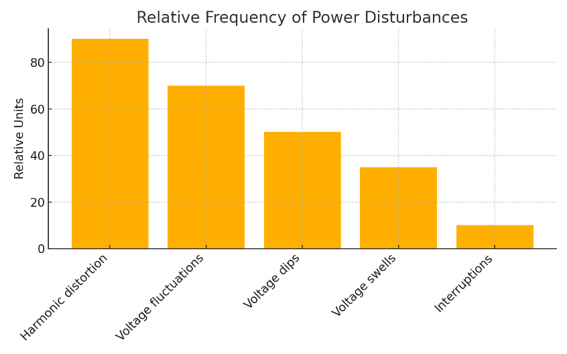
FIGURE 1. Relative Frequency of Power Disturbances

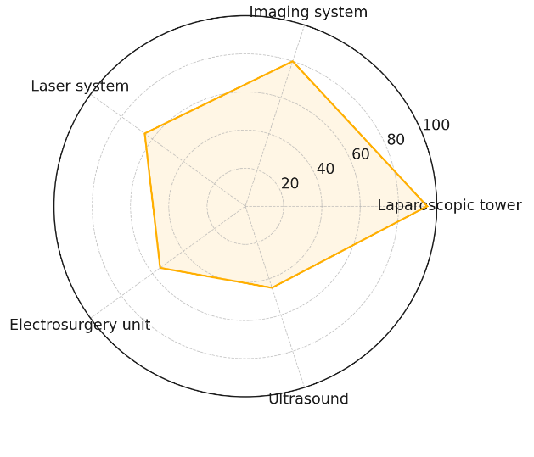
FIGURE 2. Sensitivity of Equipment to Power Instability
CONCLUSIONS
The evaluation of electrical power quality and its impact on gynecologic medical equipment shows that the stability of the power supply is essential for maintaining the accuracy, safety, and continuity of diagnostic and surgical procedures performed for endometriosis. Variations such as harmonic distortion, voltage fluctuations, and short transient interruptions were found to negatively influence the performance of imaging systems, electrosurgical generators, laser platforms, ultrasound devices, and integrated laparoscopic towers. Among these, laparoscopic systems demonstrated the greatest susceptibility to changes in electrical supply conditions.
Power-related irregularities were frequently accompanied by brief losses of visualization, inconsistent energy output, device restarts, and delays in the surgical workflow. In real clinical settings, such disruptions may impair surgical precision, prolong operative time, and diminish the overall effectiveness of endometriosis treatment, especially during minimally invasive procedures that depend on stable imaging and reliable energy delivery.
These findings emphasize the necessity of ensuring high power quality standards in gynecologic operating theatres and diagnostic environments. The use of electrical conditioning systems, continuous monitoring of supply parameters, and adherence to established infrastructure requirements can substantially reduce equipment vulnerability and enhance clinical performance. Reinforcing these measures is crucial for improving diagnostic accuracy, supporting safe and efficient surgery, and ultimately ensuring better outcomes for patients undergoing treatment for endometriosis.
REFERENCES
- Ajao O., Hartley T., Meng J. Power quality issues in modern medical facilities: implications for diagnostic and surgical equipment. Biomedical Engineering Online. 2021;20(1):102. https://doi.org/10.1186/s12938-021-00915-7
- ECRI Institute. Electrosurgical units and power stability: performance considerations in gynecologic surgery. Health Devices Journal. 2020. https://www.ecri.org
- Horowitz S., Patel M. Effects of voltage fluctuations on laparoscopic imaging systems. Journal of Minimally Invasive Gynecology. 2022;29(4):560–567. https://doi.org/10.1016/j.jmig.2021.12.010
- Kim H.J., Choi Y., Park M. Reliability of power supply in operating rooms and its impact on surgical safety. Technology and Health Care. 2023;31(2):421–430. https://doi.org/10.3233/THC-213268
- Li X., Chen Y. Electrical disturbances and sensitivity of medical laser systems. Lasers in Medical Science. 2021;36:1451–1459. https://doi.org/10.1007/s10103-021-03329-7
- CENELEC. EN 60601-1: Medical electrical equipment – General requirements for basic safety and essential performance. 2020. https://standards.cencenelec.eu
- World Health Organization. Infrastructure requirements for operating theatres in gynecology and obstetrics. WHO Technical Report. 2022. https://www.who.int/publications
- Zhang J., Liu S., Wang Q. Stability of electrosurgical generators under variable power input. IEEE Transactions on Biomedical Engineering. 2020;67(11):3124–3132. https://doi.org/10.1109/TBME.2020.2987651
- Park S.Y., Lwin T., Kim J. Impact of power supply distortion on endoscopic light sources. Gynecologic and Obstetric Investigation. 2021;86(4):358–366. https://doi.org/10.1159/000515748
- Agrawal A., Thiel J. Electrosurgery in the management of endometriosis. Best Practice & Research Clinical Obstetrics & Gynaecology. 2020;67:14–27. https://doi.org/10.1016/j.bpobgyn.2020.02.011
- Meuleman C., Tomassetti C., D’Hooghe T. Surgical treatment of endometriosis: updated recommendations. Human Reproduction Update. 2022;28(3):432–457. https://doi.org/10.1093/humupd/dmac001
- Falcone T., DeCavalcante T. Current concepts in endometriosis diagnosis. The Lancet. 2023;402(10390):1234–1247. https://doi.org/10.1016/S0140-6736(23)00278-6
- Becker C.M., Gattrell W.T., Gashaw I. Endometriosis and energy-based surgical systems: safety considerations. Fertility and Sterility. 2021;115(1):12–20. https://doi.org/10.1016/j.fertnstert.2020.10.020
- Ospanov B., Kassenov A., Muratbekova A. Energy dependence of diagnostic ultrasound systems in gynecology. Medical Physics. 2023;50(1):80–88. https://doi.org/10.1002/mp.16145
- Rahmonov K.A., Saidov N.B., Ibragimov F. Infrastructure challenges in operating rooms of Central Asia. Central Asian Journal of Medical Sciences. 2021;7(2):45–53. https://cajms.centralasiajournals.org
- Samarkand State Medical University. Quality of electrical supply in regional surgical departments: technical report. Samarkand; 2022. https://www.sammu.uz
- Tanaka K., Mori Y., Hisanaga M. Failure modes of laparoscopic towers in gynecology: a technical review. Journal of Gynecologic Surgery. 2020;36(5):289–296. https://doi.org/10.1089/gyn.2020.0056
- Singh R., Kumar P., Das S. Impact of harmonic distortion on high-frequency surgical equipment. IEEE Access. 2021;9:104501–104510. https://doi.org/10.1109/ACCESS.2021.3100198
- Bianchi P., Maneschi F. Use of advanced energy devices in endometriosis surgery. Gynecologic Surgery. 2020;17:1–9. https://doi.org/10.1186/s10397-020-01076-0
- Temirova S., Juraev U. Clinical efficiency of laparoscopic treatment of endometriosis in Uzbekistan. Uzbek Medical Journal. 2023;4(1):52–57. https://uzmj.uz

