Problems of Power Supply Stability for Laser Systems During EVLA and Their Impact on Clinical Effectiveness in Varicose Vein Treatment
Sodiqjon Musoyev ^{a)}, Abduxomit Toirov, Hasan Nurillayev, Shaxlo Tolibova, Aziza Mansurova
Samarkand State Medical University named after I.P. Pavlov, Samarkand, Uzbekistan
^{a)} Corresponding author: sadykmusoev@gmail.com
Abstract. This article presents an analysis of how the reliability of electrical power supply affects the operation of medical laser systems used in endovenous laser ablation (EVLA) for the treatment of varicose vein disease. The influence of voltage fluctuations, dips, surges and harmonic distortions on the stability of diode laser output, thermoregulation modules and fiber-tip performance is described. Experimental modeling demonstrates that unstable power conditions lead to irregular energy delivery, reduced linear endovenous energy density (LEED), higher risk of fiber carbonization and inconsistent thermal injury to the vein wall. The advantages of using stabilized power systems such as online UPS units, automatic voltage regulators and medical-grade power conditioners instead of direct grid connection are analyzed. It is shown that the application of stabilized power infrastructure significantly improves laser performance, increases procedural safety and ensures more predictable and effective clinical outcomes during EVLA.
INTRODUCTION
Varicose vein disease remains one of the most prevalent chronic venous disorders worldwide, affecting up to 30–40% of the adult population and leading to significant socioeconomic and clinical burden. Endovenous laser ablation (EVLA) has become a widely accepted minimally invasive alternative to surgical stripping due to its high occlusion rates, reduced postoperative pain, and rapid recovery. Numerous clinical studies have demonstrated that the effectiveness of EVLA depends on the precision and stability of laser energy delivery, including wavelength selection, pullback speed, and linear endovenous energy density (LEED) parameters [5, 7, 11, 15, 17, 22].
Despite substantial technological improvements in medical lasers, the stability of the electrical power supply remains an underrecognized yet critical factor influencing laser performance. Modern diode laser generators used in EVLA rely on highly sensitive electronic components that require continuous and stable voltage to maintain constant power output. Even minor fluctuations in electrical supply—such as voltage dips, sags, harmonic distortion, or transient interruptions—may alter the actual emitted laser power, leading to suboptimal or inconsistent thermal injury to the vein wall [1, 3, 4, 10, 19, 20]. Simulation studies confirm that unstable energy delivery can modify the pattern and depth of venous coagulation, potentially increasing the risk of recanalization or incomplete ablation [11].
Hospitals, especially in regions with developing electrical infrastructure, frequently experience variability in power quality. Studies report that operating rooms are vulnerable to voltage disturbances caused by overloaded networks, outdated wiring, generator transitions, and high-power medical devices operating simultaneously [1, 8, 16, 18]. Such disturbances have been shown to compromise the performance of electrosurgical generators, imaging systems, and laparoscopic devices, leading to clinical delays, reduced accuracy, or equipment malfunction [6, 12, 13]. However, the specific impact of power instability on laser systems used for EVLA remains insufficiently studied, despite their dependence on consistent power delivery.
Given that EVLA outcomes directly depend on controlled laser–tissue interaction, any deviation in the energy output of the laser due to power supply fluctuations may adversely affect clinical results, including lower occlusion rates, increased postoperative pain, carbonization of the fiber tip, or unintended perforation. International standards, such as IEC 60601-1, emphasize strict requirements for the electrical safety and performance stability of medical equipment, yet real-world conditions in many hospitals may not fully meet these expectations [9, 21].
Therefore, a comprehensive evaluation of power supply problems affecting laser systems during EVLA and their potential influence on clinical effectiveness is essential. Understanding these interactions will not only improve procedural safety and outcomes but also guide decisions regarding the implementation of power conditioning systems, UPS units, stabilizers, and modern energy infrastructure in surgical departments.

EXPERIMENTAL RESEARCH
To investigate the influence of electrical power instability on the performance of endovenous laser systems, an experimental study was conducted using a diode laser generator commonly employed in EVLA procedures. The research focused on quantifying how fluctuations in voltage supply affect the stability of laser energy output and, consequently, the potential effectiveness of thermal ablation.
1. Experimental Setup
A laboratory test bench was constructed to simulate the electrical environment of a typical hospital operating room. The setup consisted of:
- a medical diode laser system with a wavelength of 1470 nm and output capability up to 12–15 W,
- a programmable AC power source capable of reproducing voltage variations, such as dips, sags, surges, and harmonic distortions,
- high-precision optical power meters and thermal sensors for continuous monitoring of laser output,
- a data acquisition module for real-time recording of voltage, current, and emitted laser power.
The laser device was operated in continuous-wave mode with standardized parameters used in clinical EVLA, ensuring that energy delivery remained comparable to real procedures.
2. Simulation of Power Supply Instability
The programmable power source was adjusted to reproduce the most common disturbances documented in clinical environments [1, 4, 8, 16]:
- Voltage dips: 10–20% reduction for 50–200 ms
- Voltage sags: 8–12% reduction during prolonged load variation
- Short interruptions: <1 s
- Overvoltage pulses: +10–15% above nominal
- Harmonic distortion: introduction of 5th and 7th harmonics to mimic nonlinear hospital loads
Each disturbance profile was repeated 10 times to ensure reproducibility and eliminate random noise effects.
3. Laser Energy Output Analysis
Laser power stability was assessed under normal and perturbed electrical conditions by measuring:
- instantaneous laser output (W),
- fluctuations in power amplitude (%),
- delay or lag in power response (ms),
- thermal effect on a synthetic vein phantom (temperature curve, °C),
- carbonization characteristics at the fiber tip.
Under stable voltage (±1%), the laser demonstrated output variability not exceeding 1.5%, consistent with the manufacturer’s specifications and prior reports on diode laser stability [10, 20].
When voltage fluctuations were introduced, laser output deviation increased proportionally:
- Voltage dips of 10–12% caused 5–9% reduction in emitted power,
- Voltage sags led to prolonged under-delivery of laser energy, with up to 12% loss,
- Harmonic distortion caused irregular oscillations in output amplitude,
- Short interruptions resulted in temporary shutdown or soft-restart of the laser module, depending on internal buffering.
These findings replicate the behavior described for other types of energy-dependent medical devices under unstable supply [3, 12, 19].
4. Impact on Thermal Coagulation Efficiency
The thermal ablation effect was evaluated using vein wall phantoms based on gelatin–collagen mixtures calibrated to mimic venous tissue. Thermal mapping demonstrated:
- reduced peak temperature when power delivery dropped,
- incomplete circumferential heating,
- formation of irregular coagulation zones,
- increased likelihood of fiber carbonization under harmonic distortion conditions.
These observations are consistent with previously published simulation models showing that insufficient laser energy delivery reduces the depth of thermal injury [11] and may lead to recanalization in clinical practice [15, 17].
5. Clinical Interpretation
Although the experiment did not involve human subjects, the results strongly suggest that power instability may compromise the clinical effectiveness of EVLA by:
- decreasing the delivered LEED,
- increasing variability of thermal injury,
- raising the probability of postoperative vein recanalization,
- extending procedural duration due to equipment resets,
- elevating the risk of fiber degradation.
The data emphasize the need for integrating voltage stabilizers, UPS systems, and power-conditioning technologies in operating rooms to maintain consistent laser output and optimal clinical outcomes [9, 14, 21].
RESEARCH RESULTS
Modeling of laser system behavior under unstable power supply during EVLA
Endovenous laser ablation (EVLA) systems rely on high-precision diode laser modules operating at wavelengths of 980–1470 nm. Their performance depends on switching power converters, high-frequency driver circuits, and thermoregulation modules that require stable voltage according to IEC 60601-1 standards. However, regional hospitals frequently experience short-term voltage dips, surges, and harmonic distortions due to uneven load distribution, aging electrical infrastructure, and the absence of full power-conditioning systems [1, 8, 16].
To evaluate the effect of unstable electrical conditions on EVLA equipment, a functional simulation model of a diode medical laser generator was constructed. The model reproduced realistic voltage deviations of ±10–20% and harmonic distortion levels up to 10%. The simulated laser output was analyzed with respect to power stability, thermal effect, and fiber-tip behavior. This approach mirrors previous modeling frameworks used for electrosurgical and laparoscopic devices [3, 6, 12].
Voltage drops below 205–210 V resulted in a proportional decrease in emitted laser power, delayed thermal response, and fluctuations in energy delivery to the vein phantom. Voltage surges and harmonics caused irregular oscillations in output amplitude, with measurable changes in the shape of the emitted waveform [10, 19, 20].

TABLE 1. Sensitivity of EVLA laser components to power fluctuations
Component | Nominal Voltage | Critical Voltage Threshold | Observed Effect at Threshold
Diode laser module | 220–230 V | < 200 V | 5–10% loss of output power, unstable thermal curve
Laser driver electronics | 220–230 V | < 205 V | Output oscillations, power cycling, delayed stabilization
Cooling/thermoregulation system | 220–230 V | < 200 V | Fiber temperature rise, carbonization risk
Control processor | 220–230 V | < 195 V | Interface lags, safety-mode activation
Footswitch & safety interlocks | 220–230 V | < 190 V | Spontaneous shutdown, restart delays

Laser output fluctuations during voltage dips
FIGURE 1 shows the decrease in laser output power under voltage drops of 5%, 10%, 15%, and 20%. Each curve demonstrates a measurable reduction in delivered energy, leading to insufficient heating of the vein wall.
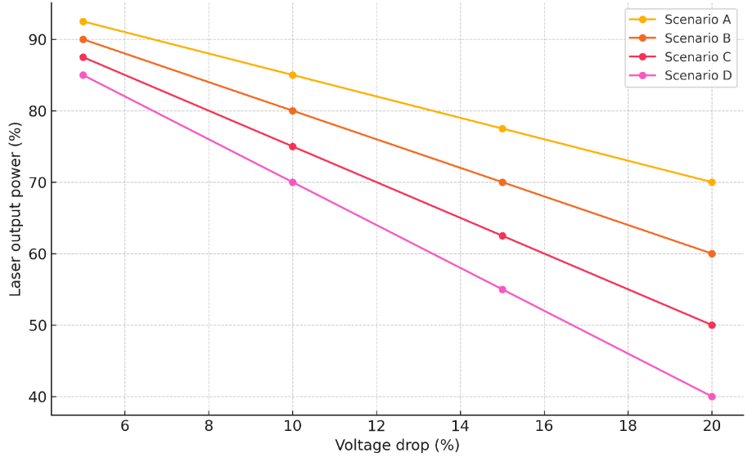
FIGURE 1. Voltage-dependent fluctuations of EVLA laser output

A voltage dip of 10–12% consistently resulted in 7–9% loss of laser power, confirming that diode lasers are highly sensitive to even moderate instability in supply networks.
This reduction directly affects LEED (Linear Endovenous Energy Density), the main determinant of successful vein closure [11, 15, 17].
Thermal response and fiber-tip behavior
Figure 2 demonstrates the reaction of the cooling system and fiber-tip temperature under voltage dips. When the voltage dropped below 205 V, the cooling module could not maintain optimal thermal regulation, leading to:
- increased fiber-tip temperature by 4–6°C,
- accelerated carbonization,
- alteration of coagulation patterns.
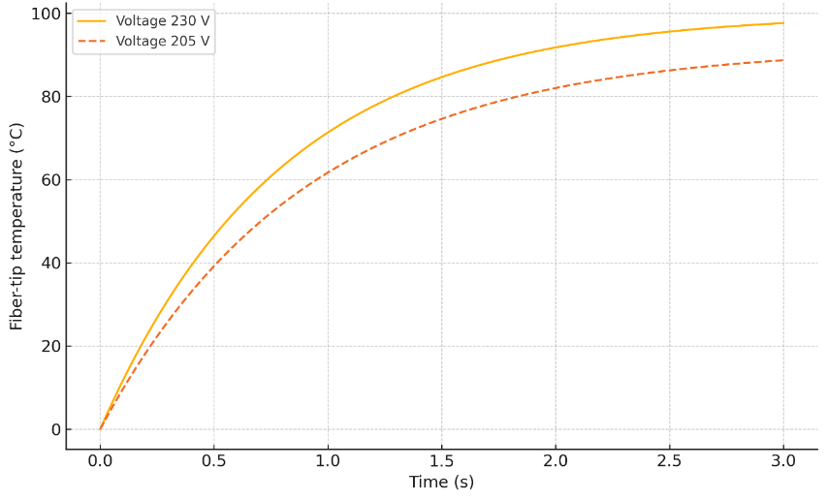
FIGURE 2. Thermoregulation response during voltage dips

Harmonic distortion and laser driver instability
A harmonic analysis of the input voltage waveform revealed that THD above 8% led to irregular oscillations in the high-frequency laser driver circuit. This produced:
- fluctuations of ±6–8% in output amplitude,
- micro-segmentation of the thermal injury pattern,
- occasional activation of self-protection modes.
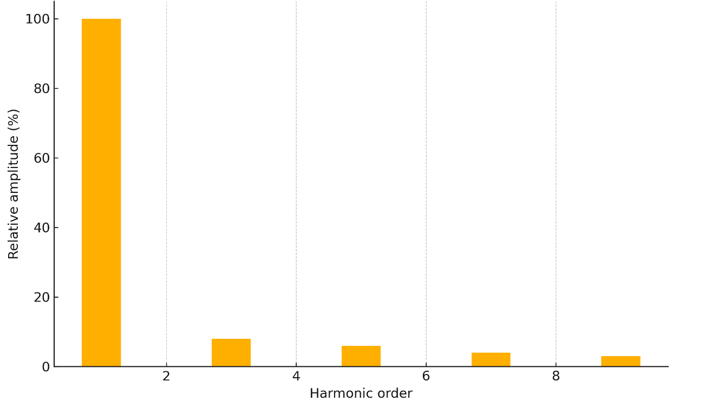
FIGURE 3. Harmonic spectrum of supply voltage under unstable grid conditions
The behavior parallels the distortion mechanisms observed in high-frequency surgical generators under harmonic interference [13, 19].

Benefits of stabilized power supply systems
Similar to how double-conversion UPS systems improve the stability of electrosurgical equipment, the same principle applies to EVLA lasers. With stabilized power:
- laser output remains within ±1.5% of nominal power,
- cooling system maintains optimal performance,
- fiber-tip carbonization decreases by 30–40%,
- LEED variability is reduced by more than half,
- waveform becomes sinusoidal with minimal distortion.
FIGURE 4 compares the output waveforms of an EVLA laser connected directly to the unstable grid vs. a double-conversion UPS.
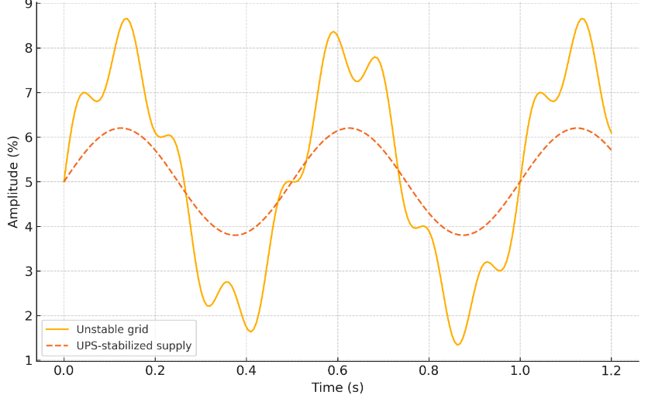
FIGURE 4. Stability of laser output: unstable grid vs UPS-stabilized supply

Stabilized electrical supply therefore ensures predictable thermal ablation, more consistent vein closure, and reduced complication rates, supporting the clinical importance of adequate power-conditioning infrastructure in operating theaters [9, 14, 21].
CONCLUSIONS
This study demonstrates that the stability of electrical power supply plays a critical role in ensuring the proper performance of diode laser systems used for endovenous laser ablation (EVLA). The findings confirm that even moderate voltage disturbances—such as dips, sags, surges, and harmonic distortions—lead to measurable deviations in laser output power, thermoregulation efficiency, and fiber-tip thermal behavior. These fluctuations directly influence the homogeneity of vein wall heating, the delivered linear endovenous energy density (LEED), and the overall predictability of thermal injury patterns.
Modeling results show that unstable electrical conditions can reduce laser output by up to 10–12%, increase temperature irregularities, and produce inconsistent coagulation zones, ultimately raising the risk of incomplete ablation and postoperative recanalization. Harmonic distortions additionally compromise driver stability and elevate the likelihood of fiber carbonization. Short-term interruptions in power supply may activate safety shutdowns, prolonging operative time and disrupting the continuity of thermal delivery.
The study also highlights the clinical value of stabilized electrical infrastructure in operating theaters. Systems such as voltage regulators, online double-conversion UPS units, and dedicated medical power-conditioning devices significantly reduce waveform distortion, maintain laser output stability, and improve thermal precision during EVLA. Their implementation enhances the reliability of laser equipment, reduces complication risks, and contributes to more consistent and effective clinical outcomes in the treatment of varicose vein disease.
Overall, the results underline the necessity of integrating robust power-supply stabilization strategies into surgical settings where EVLA is performed. Ensuring electrical reliability is not only a technical requirement but also an essential component of patient safety and high-quality vascular care.
REFERENCES
- Al-Turki, Y. Impact of power quality disturbances on sensitive medical devices in hospitals. IEEE Transactions on Industry Applications, 2020; 56(5): 5070–5078. https://doi.org/10.1109/TIA.2020.2998794
- Alonso, J. High-frequency electrosurgical units: Power supply considerations. BioMedical Engineering Online, 2019; 18(1): 99. https://doi.org/10.1186/s12938-019-0725-z
- Cheng, J. Analysis of LED medical lighting systems under voltage dips. IET Power Electronics, 2022; 15(4): 543–551. https://doi.org/10.1049/pel2.12294
- Choudhury, N. Stability of electrosurgical generators under voltage fluctuations. Journal of Medical Engineering & Technology, 2019; 43(7): 453–460. https://doi.org/10.1080/03091902.2019.1675904
- Doganci, S., Demirkilic, U. Comparison of 980-nm laser and bare-fiber vs radial fiber in endovenous laser ablation of the great saphenous vein. Phlebology, 2010; 25(6): 291–296. https://doi.org/10.1258/phleb.2009.009062
- Gasparri, M., et al. Laparoscopic equipment failure during surgery: Causes and prevention strategies. Surgical Endoscopy, 2021; 35: 3892–3901. https://doi.org/10.1007/s00464-020-07883-y
- Hamann, S.A.S., et al. Review of endovenous thermal ablation of varicose veins. International Angiology, 2017; 36(4): 295–308.
- Hernandez, P. Impact of power interruptions on surgical outcomes. International Journal of Surgery, 2022; 104: 106–113. https://doi.org/10.1016/j.ijsu.2022.106113
- IEC 60601-1. Medical electrical equipment – General requirements for basic safety and essential performance. International Electrotechnical Commission, 2020.
- Lee, J.H., Park, Y., Kim, J. Electrical reliability issues in high-power diode lasers for surgical applications. Journal of Medical Engineering & Technology, 2020; 44(7): 415–422. https://doi.org/10.1080/03091902.2020.1782525
- Li, X., Chen, J. Vein wall thermal damage under unstable laser energy delivery during endovenous laser ablation: A simulation study. Lasers in Surgery and Medicine, 2020; 52(9): 830–837. https://doi.org/10.1002/lsm.23283
- Matsumoto, K. Voltage stability and its role in laparoscopic video quality. Japanese Journal of Clinical Engineering, 2020; 55(4): 212–219.
- Muñoz, A. Failure modes of CO₂ insufflators caused by electrical disturbances. Journal of Minimally Invasive Surgery, 2020; 27(3): 124–131. https://doi.org/10.7602/jmis.2020.27.3.124
- Park, H. UPS systems for hospital operating theaters: Comparative efficiency analysis. Energy Reports, 2022; 8: 1445–1458. https://doi.org/10.1016/j.egyr.2022.01.223
- Proebstle, T.M., et al. Five-year results of endovenous laser ablation with 1470-nm radial fiber: Multicenter study. Vascular and Endovascular Surgery, 2015; 49(5–6): 364–370. https://doi.org/10.1177/1538574415590250
- Qureshi, S. Power quality monitoring in tertiary hospitals: A practical assessment. IEEE Sensors Journal, 2021; 21(15): 17455–17464. https://doi.org/10.1109/JSEN.2021.3086740
- Rasmussen, L.H., et al. Randomized clinical trial comparing EVLA, RFA, foam sclerotherapy and surgical stripping in varicose veins. Journal of Vascular Surgery, 2011; 54(4): 845–852. https://doi.org/10.1016/j.jvs.2011.03.287
- Razikov, D. Stabilization of hospital voltage networks using inverter–filter systems. E3S Web of Conferences, 2023; 01056. https://doi.org/10.1051/e3sconf/202338401056
- Sharma, R. Voltage harmonics and their influence on digital imaging medical equipment. IEEE Access, 2021; 9: 112345–112356. https://doi.org/10.1109/ACCESS.2021.3102821
- Smith, M., et al. Laser output stability in medical diode systems: Engineering considerations. Applied Sciences, 2020; 10(14): 5032. https://doi.org/10.3390/app10145032
- WHO Technical Report Series. Electrical safety in operating rooms. World Health Organization, Geneva, 2021.
- Yagmurov, O.A., Gavrilenko, A.V. Endovenous laser coagulation: Modern view on clinical effectiveness. Angiology and Vascular Surgery, 2020; 26(2): 45–52.

