Scheduling and Routing EV to Increase Resilience of the Distribution Network
Jasur Abdubannaev^{1,a)}, Mansur Khasanov² , Mohigul Kholyigitova ³,
Anvar Suyarov², Dilshod Yusupov¹
¹ Namangan State Technical University, Namangan, Uzbekistan
² Jizzakh Polytechnic Institute, Jizzakh, Uzbekistan
³ Jizzakh State Pedagogical University, Jizzakh, Uzbekistan
^{a)} Corresponding author: jasur2202@gmail.com
Abstract. The power outage has become a major concern in this modernized era due to its significant negative impacts on society and the economy. In this scenario, there is a need to make a shift towards advancement instead of sticking to traditional practices. The power system under the traditional approaches used high voltage distributed generators, large-scale power generation systems, and hydro turbines, due to which challenges were faced, such as large storage and space requirements, high emission rates due to combustion, and high voltage supply. Still, it was unable to bring quality power and dynamic response. However, it is predicted that the number of disasters would increase with time; therefore, researchers should try to develop intelligence-based methods for achieving more resilience and effectiveness under disaster. This research proposed the integration of microgrids and electric vehicles (EVs) to bring resilience optimization of distribution networks.
INTRODUCTION
A persistent change in weather has been seen since the past decades, due to which both the frequency and intensity of the disastrous events (natural disasters) have also been trending higher, as reported, around seven of the ten costliest storms in the U.S. history occurring in the previous decade. It is expected that these extreme weather conditions would continuously increase in the future thus, represent one of the most significant threats to the power grid which would adversely affect the socioeconomic factor and humans’ living [1]. Undeniably, the power distribution network is more vulnerable due to disastrous events, and it is alarming news that its destruction can spread quickly and widely which can initiate subsequent outages to large power systems. Disastrous events are the leading cause of blackouts, it is found that from 2003 to 2012, around 80% of major power failures were caused due to natural disasters which adversely affected the lives of millions of people and the socio-economic condition of the countries. After the disaster has passed, it is essential to quickly restore power and to provide continuous electricity to the critical load, particularly in areas such as hospitals, streets, water and gas stations. However, it can only be possible by the provision of a resilient distribution system [2]. The grid resilience is divided into four core parts i.e. resilience-planning, resilience-prevention, resilience-correction & restoration. Intensive research has been performed on the restoration of power supply to critical loads in the distribution network so that to mitigate substantial life threats; it highlights the significance of enhanced resilient energy distribution network. In previous researches, different techniques have been used such as micro-grid, decentralized, plugin and wireless, to supply electricity to the critical load in the absence of a utility power source. However, it is difficult to access interrupted loads after extreme weather events for utility power sources with a single technique or local resource. In contrast, rapid response for power restoration is one of the major requirements of a distribution network, because most recovery activities greatly depend on it. Therefore, this research is focused on the integration of multiple resources, like the inclusion of direct current (DC) generators and DC micro-grids in the distribution network for critical loads’ restoration and increasing resilience. For that reason, the DC distribution system has become increasingly popular for scheduling and routing EVs in the power industry at present due to its higher efﬁciency and rigour, and easier interconnection of sources as compared to AC [3].

critical review

Existing Metric Systems & Methodologies. The number of power failures and blackouts has been increasing yearly all over the world instead of excessive efforts performed by the grid planners. The major cause behind the electricity failure is disaster and uncertain weather changes which damages the electricity distribution network and bring an intolerable cost to society and the economy. Recently, in Japan due to the earthquake, millions of people left up without electricity power for more than a week, however, in 2012 due to cascading failure 10% of the world’s people affected just because of the lack of electric power supply [4]. In this section of the white paper past papers has been reviewed to critically analyze the existing metrics system & methodologies adopted for implementing the power distribution network. It has been found from the [3] that previously designed power distribution networks are reliable but lacking resilience, whereas due to natural disasters frequent increase in disruption has found which has put increasing pressure for making a more resilient distribution network. Resilience in infrastructure means that resist all the uncertain disastrous events and quickly effectively restore the electric power supply [4]. For this purpose, changes should be required in existing metrics and measures which could work efficiently for multipurpose. Therefore, should design a resilient enhancement model, so that even after the tripping in the primary feeder the other feeders serve the load flawlessly without disruption in voltage. In 2008, the underground distribution network had affected badly due to a lack of resilient infrastructure. Major failure in power supply brings a negative impact on the economy because secondary sources are mainly installed in the business districts. Therefore, to serve loads in the secondary sources are vital, thus, in the future, resilience against disastrous events should be the core element while designing smart power grid infrastructure [5].
The existing methodologies have evaluated the resilience by R4 framework i.e. robustness (ability to withstand disasters), redundancy (ability to restore system or provide backup), resourcefulness (ability to invest resources) and rapidness (ability to recover quickly). At present, resilience-based research has only emphasized the ability of loads to withstand extreme events, it does not mean that power supply to all loads, and at least there should be enough power that the status of critical loads could remain active. Thus, power grid resilience represents the ability of the distribution network to recover and support the critical loads under disastrous events [6]. In this regard, resilience enhancement measures are required to cope with the complex and uncertain nature of events. In the previous researches, several infrastructures have been suggested to model distribution network outages and restoration such as Transmission Availability Data System (TADS), generalized linear models (GLM) and generalized additive model (GAM). According to the TADS model, systematic infrastructure and environment are two factors reasonably responsible for inﬂuencing the susceptibility of the power distribution network. Hence, system data (such as land location and topology) and environmental data (weather/climate forecast, disaster duration & intensity) are required for the statistical model. However, GLM is a predictive analysis focused on the failure to power distribution network also includes measurement of data variables related to the power system performance [7]. In contrast to the GLM model, the GAM is purposefully designed to maximize the quality of predictive analysis [5].
The mathematical formulation for GLM:

$f_{γ }( y |α_{↑}λ)$~$\frac{τ(y_{i}+ α )}{τ \left(y_{i}+1\right) τ (α^{-1 })}$ × ${\left(\frac{α^{-1}}{α^{-1}+ λ_{i}}\right)}^{α^{-1 }}( \frac{λ_{i}}{α^{-1}+ λ_{i}})$ (1)
Log ($λ_{i}$) − $β_{o}+ Σi β_{i} x_{i}$ (2)

The mathematical formulation for GAM:
Log ($λ_{i}$) – $β_{o}+ Σi δ {(x}_{i})$ (3)

Another model named Accelerated Failure Time (AFT) is useful to anticipate power failure durations or the maximum likelihood of the power loss.

The mathematical formulation for AFT:
$ln \left(T_{i} \right)=X_{t}^{T}β+ σ_{i}$ (4)

Similarly, Classiﬁcation and Regression Trees (CART), Bayesian Additive Regression Trees (BART), Multivariate Adaptive Regression Splines (MARS), and Cox Proportional Hazard (COXPH) are some other models that have been used previously for forecasting weather and disaster impacts on the power distribution network [8]. Table 1 compares the Mean Absolute Errors of the models.
TABLE 1: Comparison of Models based on MAE
Models | Mean Absolute Error (MAE)
GLM | 21.4
GAM | 13.6
CART | 11.7
BART | 11.5
BART/CART | 10.3
BART/CART/GAM | 10.4
BART/CART/GAM/GLM | 12.0
Prediction by the Mean | 20.0

To measure the fitness & goodness of the model, it is necessary to compare predicted and observed data through applying metrics such as mean absolute error (MAE), mean absolute deviation (MAD), mean absolute percentage error (MAPE), and root mean squared error (RMSE). Thus, after reviewing previous researches about system restoration after the disastrous attack, it would be easy to improve the system’s resilience by focusing on the past experiences, gaps and limitations [9]. The remaining part of this white paper would focus on techniques for effective planning and preparedness so that resilience could be achieved in the power distribution system. Recently, hybrid and plug-in EV has gained much more importance due to its reduced emission rate and high efficiency, mobility, and bi-directional charging capability. Integration of EV in the power distribution network would provide an opportunity in terms of enhanced resilience [10].

resilience enhancement model & problem formulation

Deployment of smart grid system
The architecture of Smart Grid is based on digital technology which provides additional benefits to the power distribution network in terms of resiliency, reliability, and security. Smart grid is feasible for the electric system in both economic and energy point of view also work efficiently from the delivery system to end users on account of having a variety of power distribution resource technologies such as loads, AC-DC generators, IC storage, and electric vehicles [11]. Smart grid is a dynamic, open and interactive platform, its basic components include transformers, transmission lines, distributed generation, EV, end-user system, integrated Information and communication technology (ICT) management and measurement of the network. Moreover, its open-style network architect facilitates plug and play environment to create smooth interaction between components [12]. Figure 1 presents resilience assessment and evaluation processes.
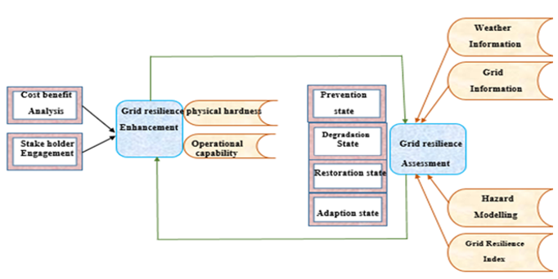
FIGURE 1. Power Grid Resilience Assessment and Enhancement Stages

- Integrated Communication networks: Smart grid is comprised of bi-directional communication technologies which ensure real-time high speed integrated service delivery and power exchange.
- Monitoring and measurement: remote measurement and monitoring provide improved resilience by timely detecting and responding towards faults.
- Advanced sensing components: In the smart grid, the presence of advance sensing technologies bring additional benefit like advance protection from energy theft, production of high-power densities and increase reliability [13].
- Advanced controlling techniques: adequate controlling of transmission and communication network enables rapid and real-time diagnosis, timely response towards demand, and support.
- Decision Support System (DSS) User Interface: Smart grid includes seamless and real-time technologies which ensure quick decision making.
For the appropriate performance of metrics, it is necessary to give serious consideration to measurement techniques and their implementation. Integration of smart grid network communication with power line communication are presented in Figure 2.
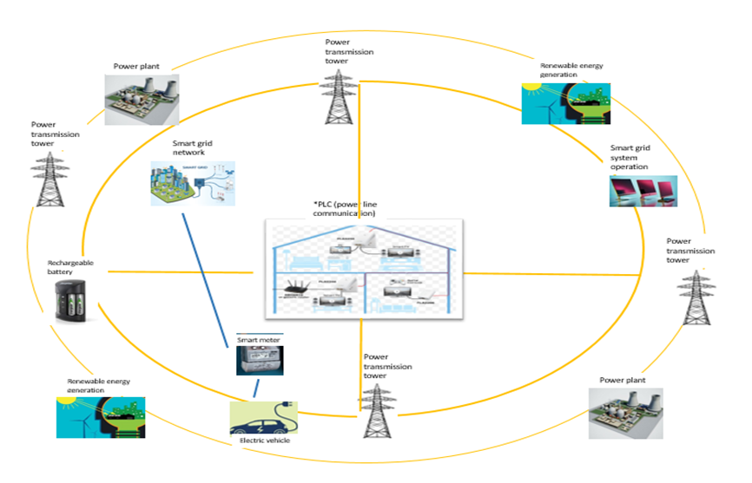
FIGURE 2. Power Line Communication: Integration within the Smart Grid Network

Functionality & Benefit Of Smart Grid
Smart grid is comprised of modern technology and compatible with next-generation technologies due to which it provides optimized asset utilization and efficient operation. Anticipating and responding to interruptions, automated condition-based programmable maintenance (transmit a signal while required equipment’s maintenance), effective controlling devices (resulting in reduced losses and congestion), and operational efficiency (ensures cost-effective power delivery and high-quality power, accommodation of all power generation and storage options). Smart grid can heal itself due to its advance automated features which provide benefit in terms of minimal disturbance and effective management throughout the delivery [14]. It’s one of the core functions is to respond resiliently towards extreme events because it can detect problematic elements timely. Its function is to adequately isolate the faults without interrupting the remaining system and restore the system to normal operation. Information and Communication system in the smart grid is accurate, updated and predictable due to the Advanced Metering Infrastructure (AMI) technology resulting in secure and reliable data delivery [15]. AMI is digital technology working in a real-time scenario that supports automated meter reading (AMR) that takes meter reading hourly and transmit the data to the service provider. Smart grid due to its high enabling power and capability could incorporate with EV and plug-in hybrid electric vehicles (PHEVs) to become more resilient under extreme conditions. EVs are the alternative fuel vehicles built to withstand comparatively moderate loads and thus having the potential to advance load shifting, moreover, as the shifting event occur consumer can gain access to power [16]. The proposed Smart Grid scenario is presented in Figure 3.
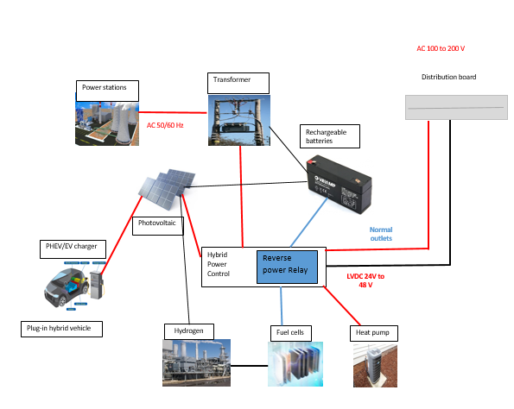
FIGURE 3: Proposed Smart Grid Scenario

Another metric provided by the smart grid is having multiple generators for power backup that could support alleviating peak loads and critical loads while needed. Centralized, distributed and decentralized modelling categories are central to the deployment of a smart grid. Through modelling these generation and storage categories it is easy to effectively meet the critical loads demand and facilitate intermittent renewable-energy resources [17]. However, implementation of multiple modelling proof to be more beneficial in terms of reliability, and resilience, but on the other side, it would become cause significant environmental emissions and cost. Therefore, an interconnection process would be required to accommodate these different models that will suitable and adaptable like plug and play environment. Integration of micro-grid increase the resilience of smart grid because it is capable of islanding operation i.e. frequent generation of power after power outages. The primary advantage of micro-grid under extreme events is its capability to operate independently as a single collective load without compromising power quality and reliability [18]. A smart grid has become a nascent aspect of the power grid station because of enhanced power resilience and enabling number of advanced technologies such as:
- Power Quality Metering System
- Load control switches and Smart appliances
- Magnetic energy storage devices
- Automated power generation devices that are capable to supply premium power to critical loads
- Dynamic control and management system of voltage regulators (VARs)
- Inverter based motor drivers and distributed generation
- AC & DC amplifier
- UPS (uninterruptible power supply)
- Electric Vehicles (EVs)
- Smart sensing appliances
- Micro-grids
- Substation automation equipment
Smart grid due to its sensing and responsive nature it has the potential to enhance the resiliency of power distribution networks under extreme conditions [19]. Data communication thermostats and various sensing appliances for forecasting weather changes are built-in features of the Smart grid which contributes in timely responding towards varying voltage (imbalances) and frequency deviations as well as limiting their propagation. These all benefits are helpful and play a significant role in the provision of dynamically balance power supply & demands thus, resulting in reduced power outages and rolling blackouts.

Smart grid & integration of EV for enhancing resilience
Smart grid provides a controlled and regulated environment to facilitate the charging and scheduling of Electric Vehicles (EVs). It enables the integration of sustainable power generation resources to large extent along with smooth and quality power signals. It also enables the vehicle to grid (V2G), grid to a vehicle (G2V) and vehicle to vehicle (V2V) features for supporting voltage controller and load regulators [20].
These attributes of smart grid are responsible for the efficiency and sustainability of the power distribution network in a way that consumers would able to regulate power consumption against varying prices and service providers would achieve optimized operation through monitoring and controlling power generation resources [21]. Figure 4 presents the Attributes of Smart Grid Technology. The smart grid shows compatibility with the EV as it facilitates charging and scheduling through AMI and bidirectional flow of communication among service providers and end-users (EV charging customers). The role of the aggregator in respect to EV loads and dispatcher is to control, measure, and monitor supply and demand. Moreover, an aggregator effectively coordinates in scheduling and routing of the EV charging with minimum cost. In the off-peak time, the overloading at the power grid is levelled by the aggregator through allotting the charging load simultaneously improve load curve is obtained by consuming surplus power. The information possesses by the EVs includes location, battery capacity and status, charging mode, time frame to achieve desired outcomes. This information is transmitted to the aggregator (grid operator) because its function is to operate EV activities by focusing on the interests of both parties i.e., service provider and users. Defined communication protocol/standard includes five layers to communicate with the smart grid as listed below table 2.
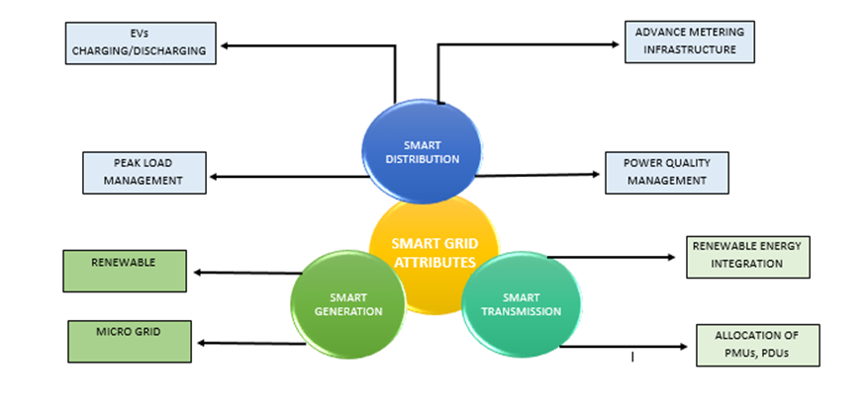
FIGURE 4. Attributes Of Smart Grid Technology

TABLE 2: Smart grid communication protocol layers
ISO Layers of Communication Protocol
Wireless (Wi-Fi)
Zig-Bee
Power Line Carrier (PLC)
Digital Subscriber Line (DSL)
Cellular Network (CN)

EV charging stations are used as an alternative to supply power at the time of power outages, EV buses have large battery capacity, easy to allocate, move as compared to other electric vehicles and therefore, it is feasible for load restoration. In this regard, this white paper proposed electric buses as a source for power generation and supply, it should be allotted in charging stations ahead of extreme events (natural disasters) to enhance resilience. EV charging stations are used as an alternative to supply power at the time of power outages, EV buses have large battery capacity, easy to allocate, move as compared to other electric vehicles and therefore, it is feasible for load restoration. In this regard, this white paper proposed electric buses as a source for power generation and supply, it should be allotted in charging stations ahead of extreme events (natural disasters) to enhance resilience. Table 3 provides the potential benefits and accompanying risks associated with the scheduling and routing of EVs.
The uncoordinated charging of EVs brings advantages in terms of improved power consumption but lacking power quality economic dispatch due to excessive power overload. In contrast, the coordinated charging of EVs is more appropriate and suitably designed to provide improved operational performance, smart management of load. However, cost-effectiveness in both the charging scenarios depends upon dynamic pricing policies. However, coordinated EV charging can be modelled through centralized, distributed and decentralized frameworks which are managed and controlled by aggregator/grid operator. The centralized framework offers full services but involves high computational complexity due to big data therefore can only modelled minimum EV charging at a time. In a centralized framework, several conditional statements are required to schedule the EV charging thus resulting in flexibility degradation. On the other hand, in a decentralized framework, the decision-making power is divided among each EV charging consumer, it empowers each consumer to make their own decision, however, optimization could not be guaranteed in this framework due to the absence of direct involvement of aggregator. In real-time coordination, high scalability in the framework is required, which is not possible with the centralized framework. As compared to a centralized framework, a decentralized and distributed framework provides flexibility and scalability.

TABLE 3: Potential Benefits & Risks of Scheduling and routing EVs
Benefits | Risks
Optimal utilization of distribution network capacity | Absence of primary ICT infrastructure throughout the power distribution system
Cost-effective | Transferring management of EV charging to the Third party
The reduced peak demand curve | Cyber-security issue - Exploitation of private information
Positive marketable surplus | ----------

Therefore, for scheduling and routing of EV charging, decentralized and distributed framework are highly encouraged. In this era, high attention has been given to sustainable renewable energy resources which have not relied upon oil or fuel consumption, in this regard, EV has gained much importance due to its economical and emission control benefit. The Electric Vehicle (EV) charging management framework is typically categorized into two primary domains: Coordination and Control Structure. The Coordination domain further comprises Coordinated and Uncoordinated strategies, while the Control Structure is classified into Centralized and Decentralized control schemes. Figure 5 presents a proposed hierarchical control structure for comprehensive EV charging management.

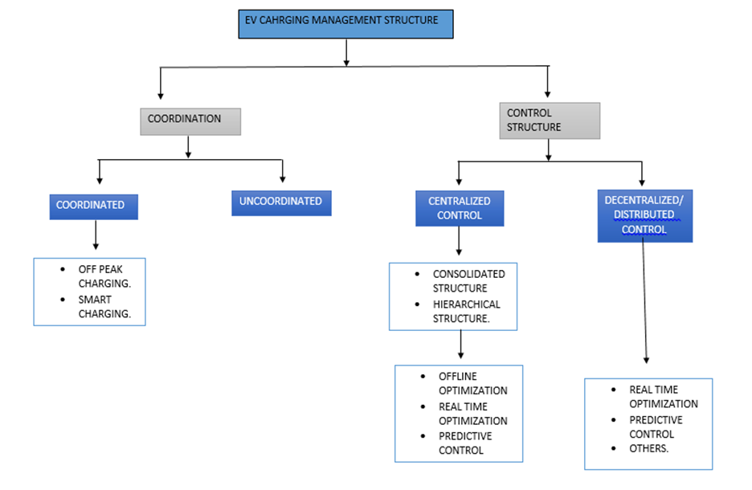

FIGURE 5. Proposed Hierarchical Control Architecture for EV Charging Management

EV charging scheduling Model & Algorithm. After evaluating the overall scenario of the EV charging scheduling system, it is encouraged to adopt an intelligence-based optimization technique i.e. meta-heuristic approach due to its high-level procedural design and compatibility with large data set. It has been designed for generating heuristic algorithm which ensures delivery of sufficient solution for existing problems. This white paper proposed a fuzzy logic (FL) as a Meta-heuristic tool for EV charging schedules. Most often, charging stations provides linear-rate charging due to which congestion has occurred at stations, thus, an Automatic Demand Response (ADR) based on Real-time pricing (RTP) has been proposed to reduce the negative impacts and cost. An RTP-based algorithm is selected due to its effectiveness in controlling and balancing high charging peaks. Moreover, Fuzzy C-Mean (FCM) and Fuzzy K-Mean (FKM) algorithms should be implemented in compliance with the RTP model. Furthermore, other negative impacts related to economy and cost performance can be controlled through Real-time Charging Price (RCP). Under the real-time scenario, Fuzzy Logic (FL) provides benefits for EV charging scheduling in terms of minimized cost and flatten power peaks. The factors that need to be considered in the algorithm includes length among units, delay in the process, and state of EV charging. Concerning EV and power grid, each of these scenarios (V2G, & G2V) could be adopted in compliance with Fuzzy Logic under Real-time conditions. Moreover, Fuzzy Logic as a programmable logic controller (PLC) has the eligibility to respond the real-time simulations. However, concerning Intelligence-based optimization the Fuzzy Logic algorithm have the best computational time and performance as evident from the below table 4:

TABLE 4: Computational performance of various optimization methods
Algorithmic Methods | Computational Time
ABC (Artificial Bee Colony) | 40.74 sec
PSO (particle swarm optimization) | 49.03 sec
(GA) Genetic Algorithm | 10.21 sec
(HGAGD) hybrid genetic algorithm- gradient Descent | 12.57 sec
(FL) Fuzzy Logic | 7.34 sec

Therefore, it is noted that the Fuzzy Logic-based algorithm is more reliable than others in terms of computational time and cost-effectiveness.

Conclusion
Large-scale disasters cause power outages and widespread blackouts, which bring a huge cost to the economy, commercial and people living in the society. Moreover, the number of extreme events and power failures has been increasing with time due to the persistent change in the atmosphere and the increase in pollution. Thus, it is necessary to strengthen our power distribution network through enhancing resilience and advanced technologies so that it can restore the electricity supply quickly. In this regard, a range of control and management activities should be required along with effective planning for the design of microgrid and EV-based grid systems. Microgrid and EV technology are renewable resources which possess a lower emission rate and high efficiency. Previously existing research is not enough for working on enhancing system resiliency because little evidence has been presented in past papers regarding the EV routing and scheduling for resilient response to extreme weather events. Therefore, further extensive research is required. However, it is suggested to encourage mobility in the system so that restoration time can be decreased.

References
- R. Huang, G., Wang, J., Chen, C., Qi, J., & Guo, C. (2017). Integration of preventive and emergency responses for power grid resilience enhancement. IEEE Transactions on Power Systems, 32(6), 4451-4463. https://doi.org/10.1109/TPWRS.2017.2685640
- Li, Z., Shahidehpour, M., Aminifar, F., Alabdulwahab, A., & Al-Turki, Y. (2017). Networked microgrids for enhancing the power system resilience. Proceedings of the IEEE, 105(7), 1289-1310. https://doi.org/10.1109/JPROC.2017.2685558
- Gao, H., Chen, Y., Mei, S., Huang, S., & Xu, Y. (2017). Resilience-oriented pre-hurricane resource allocation in distribution systems considering electric buses. Proceedings of the IEEE, 105(7), 1214-1233. https://doi.org/10.1109/JPROC.2017.2666548
- Ghazanfari, A., Hamzeh, M., & Mohamed, Y. A. R. I. (2016). A resilient plug-and-play decentralized control for DC parking lots. IEEE Transactions on Smart Grid, 9(3), 1930-1942. https://doi.org/10.1109/TSG.2016.2602759
- Yan, M., He, Y., Shahidehpour, M., Ai, X., Li, Z., & Wen, J. (2018). Coordinated regional-district operation of integrated energy systems for resilience enhancement in natural disasters. IEEE Transactions on Smart Grid, 10(5), 4881-4892. https://doi.org/10.1109/TSG.2018.2870358
- Wang, Y., Xu, Y., He, J., Liu, C. C., Schneider, K. P., Hong, M., & Ton, D. T. (2019). Coordinating multiple sources for service restoration to enhance resilience of distribution systems. IEEE Transactions on Smart Grid, 10(5), 5781-5793. https://doi.org/10.1109/TSG.2019.2891515
- Khederzadeh, M., & Zandi, S. (2019). Enhancement of distribution system restoration capability in single/multiple faults by using microgrids as a resiliency resource. IEEE Systems Journal, 13(2), 1796-1803. https://doi.org/10.1109/JSYST.2019.2890898
- Lei, S., Wang, J., Chen, C., & Hou, Y. (2016). Mobile emergency generator pre-positioning and real-time allocation for resilient response to natural disasters. IEEE Transactions on Smart Grid, 9(3), 2030-2041. https://doi.org/10.1109/TSG.2016.2605692
- Lei, S., Chen, C., Zhou, H., & Hou, Y. (2018). Routing and scheduling of mobile power sources for distribution system resilience enhancement. IEEE Transactions on Smart Grid, 10(5), 5650-5662. https://doi.org/10.1109/TSG.2018.2889347
- Ma, S., Li, S., Wang, Z., & Qiu, F. (2019). Resilience-oriented design of distribution systems. IEEE Transactions on Power Systems, 34(4), 2880-2891. https://doi.org/10.1109/TPWRS.2019.2894103
- Xia, J., Xu, F., & Huang, G. (2020). Research on power grid resilience and power supply restoration during disasters-A review. Flood Impact Mitigation and Resilience Enhancement.
- Chi, Y., Xu, Y., Hu, C., & Feng, S. (2018, August). A state-of-the-art literature survey of power distribution system resilience assessment. In 2018 IEEE Power & Energy Society General Meeting (PESGM) (pp. 1-5). IEEE. https://doi.org/10.1109/PESGM.2018.8586495
- Bie, Z., Lin, Y., Li, G., & Li, F. (2017). Battling the extreme: A study on the power system resilience. Proceedings of the IEEE, 105(7), 1253-1266. https://doi.org/10.1109/JPROC.2017.2679040
- Zhai, C., Chen, T. Y. J., White, A. G., & Guikema, S. D. (2021). Power outage prediction for natural hazards using synthetic power distribution systems. Reliability Engineering & System Safety, 208, 107348. https://doi.org/10.1016/j.ress.2020.107348
- Villegas, R., Nava, P., & Barua, M. (2019, April). Data mining-based techniques in critical operation of electrical transmission and distribution systems in a natural disaster event: Future direction review. In 2019 IEEE International Systems Conference (SysCon) (pp. 1-8). IEEE. https://doi.org/10.1109/SYSCON.2019.8836835
- Jufri, F. H., Widiputra, V., & Jung, J. (2019). State-of-the-art review on power grid resilience to extreme weather events: Definitions, frameworks, quantitative assessment methodologies, and enhancement strategies. Applied energy, 239, 1049-1065. https://doi.org/10.1016/j.apenergy.2019.02.017
- Lin, Y., Bie, Z., & Qiu, A. (2018). A review of key strategies in realizing power system resilience. Global Energy Interconnection, 1(1), 70-78. https://doi.org/10.14171/j.2096-5117.gei.2018.01.009
- Kurbanov, A., Khasanov, M., Suyarov, A., Jalilov, U., Narimonov, B., & Boliev, A. (2021). An Appropriate Wind Model for The Reliability Assessment of Incorporated Wind Power in Power Generation System. In E3S Web of Conferences (Vol. 264, p. 04083). EDP Sciences. https://doi.org/10.1051/e3sconf/202126404083
- Heinimann, H. R. (2016). 15. A Generic Framework for Resilience Assessment. An edited collection of authored pieces comparing, contrasting, and integrating risk and resilience with an emphasis on ways to measure resilience, 90.
- Wang, Y., Chen, C., Wang, J., & Baldick, R. (2015). Research on resilience of power systems under natural disasters—A review. IEEE Transactions on power systems, 31(2), 1604-1613. https://doi.org/10.1109/TPWRS.2015.2429656
- Abdubannaev, J., Lu, S., Ai, X., Sun, Y., Makhamadjanova, N., & Khasanov, M. (2021, October). Investigate the use of electric vehicles to improve resilience for active distribution network system. In 2021 IEEE 5th Conference on Energy Internet and Energy System Integration (EI2) (pp. 1041-1046). IEEE. https://doi.org/10.1109/EI252483.2021.9713572

