The Economic and Ecological Efficiency of Energy Recovery Technologies from Waste in the Production of Calcium Carbonate Soda (Waste-To-Energy)
Biybisuliu Ametova
Karakalpak State University named after Berdakh, Nukus, Karakalpakstan, Uzbekistan
Corresponding author: biybisuliwametova@gmail.com
Abstract. This article examines the potential for processing the waste generated during the production of calcined soda as an energy source. The role of Waste-to-Energy (WTE) technologies in reducing energy consumption in production, promoting efficient resource use, and decreasing environmental impact is analyzed. In addition, the economic efficiency of energy recovery from waste, the extent of carbon footprint reduction, and compliance with production standards are evaluated.
INTRODUCTION
Production of calcined soda (Na₂CO₃) is one of the key sectors of the chemical industry and is widely used in glass, paper, soap, metallurgy, and food industries. However, this process generates a large amount of waste and carbon dioxide (CO₂) emissions. Therefore, the introduction of Waste-to-Energy (WTE) technologies plays an important role in increasing the energy efficiency of the industry and reducing environmental impact.
Globally, WTE technologies are regarded as one of the main directions for enhancing recycling rates and ensuring energy security through the conversion of industrial waste into energy. During the production of calcined soda, significant amounts of solid waste (calcium chloride, calcium carbonate residues, filter sludges) as well as gaseous emissions (CO₂, NOx, SO₂) are generated. Eliminating or processing these wastes requires substantial energy input. Thus, converting waste into an energy source is considered an economically and environmentally advantageous approach [1].
The main objective of this study is to analyze the economic and environmental efficiency of Waste-to-Energy technologies in calcined soda production. To achieve this goal, we set the following tasks:
Identify the types of waste generated in soda production
• Examine the types and application potential of WTE technologies
• Analyze economic efficiency
• Evaluate environmental effectiveness (reduction of emissions and waste volume)
• Propose an optimal technological solution.
RESEARCH METHODOLOGY
For each type of waste, laboratory analysis includes an assessment of its physical properties-such as color, odor, moisture content, density-and its chemical composition, including the mass fraction of calcium carbonate and other mixed substances, pH level, solubility, and reactivity. The energetic value (calorific value) is examined to determine its potential for energy recovery. Environmental risk assessment covers the chemical hazard level of gaseous and liquid waste streams.
In the production process of calcined soda, the following types of waste are generated [5]:

TABLE 1. Types of waste generated in calcined soda production and their classification:
Type of waste | Description | Quantity per ton of production
Solid sludges | Mixture of calcium chloride and other solid substances generated in the Solvay process | 0.3-0.5
Aqueous sludges | **CaCl₂ solution with excess water from soda production** | 0.2-0.4
Gaseous emissions | CO₂, NOx, SO₂, and other gases | 0.5-1 (CO₂ main)
Mixed wastes | Mixture of solid and aqueous sludges as industrial waste | 0.1-0.2

In recent years, the development of advanced combustion technologies applied in WTE systems has been observed [4-7]. The extent to which the conversion of various wastes (municipal, industrial, agricultural, biomass) into energy has been modernized over the past 10–15 years can be understood from the following figure:
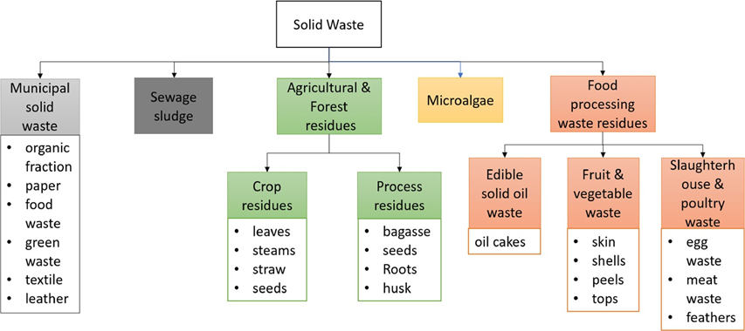
Fig.1. Classification of various wastes that can be used for energy production

From this classification, it can be seen that wastes used for energy production are divided into five main groups. Their calorific value depends on the content of organic matter (carbon), fats, cellulose, and lignin. These wastes are important resources for producing biogas, synthetic gas, biofuels, electricity, and heat energy.
WTE technology refers to “Waste-to-Energy” technology, meaning that this technology converts industrial, municipal, or production wastes into energy in the form of electricity, heat, or fuel through incineration, pyrolysis, gasification, or biological decomposition [1-6]. The main types of this technology are presented in the following table:

TABLE 2. Main types of WTE technologies and their brief description
Technology type | Brief description | Energy produced
Combustion | Waste is burned in specialized furnaces | Heat → Steam → Electricity
Pyrolysis | Waste is decomposed at high temperatures in an oxygen-free environment | Fuel gas, oil, heat
Gasification | Waste is converted into gas under limited oxygen conditions | Synthetic gas, electricity
Anaerobic Digestion | Organic waste is decomposed by bacteria | Biogas, heat, fertilizer
Plasma Conversion | Waste is decomposed at very high temperatures (1000°C+) | Clean gas and slag (minimal waste)
The advantages of WTE technology include reducing waste volume by 80–90%, generating electricity and heat, decreasing the load on landfills, reducing the carbon footprint, and, in some technologies, being environmentally friendly—for example, in biogas production.
Its disadvantages are high initial investment costs, potential gas emissions from some processes, incomplete waste elimination (ash or slag remains), and the need for technical supervision and environmental monitoring.
Calcined soda (Na₂CO₃) is a key raw material in the chemical industry. The most common method of its production is the Solvay process, which consists of the following main stages [2]:
• Preparation of ammonia brine
• Carbonation with carbon dioxide (CO₂)
• Precipitation of sodium bicarbonate (NaHCO₃)
• Drying and calcination to obtain Na₂CO₃.
During this process, a significant amount of waste is generated:
• Solid waste: calcium chloride (CaCl₂)
• Gaseous emissions: CO₂, SO₂, NOx
• Liquid waste: saline water, reactive solutions
Such wastes produced in calcined soda production pollute water resources, contaminate the air, occupy large areas with solid sludges, and negatively impact the natural environment. Therefore, reducing waste in production and utilizing it for valuable products or energy is one of the key directions for sustainable industrial development.
The application of WTE technologies in calcined soda production represents a modern solution aimed at recycling these wastes as resources, improving energy efficiency, and reducing environmental risks [7]. This approach treats industrial waste as a “secondary resource” and contributes to implementing the principles of a circular economy. WTE technologies are applied in the calcined soda production process as follows:

TABLE 3. Application of WTE technologies in the calcined soda production process
Type of Waste | WTE Technology | Benefits Obtained
CaCl₂ sludges | Gasification or Pyrolysis | Heat and synthetic gas
CO₂ emissions | CO₂ recovery and reuse | Reuse (carbonation)
NaCl and aqueous waste | Steam-based heat recovery system | Energy savings
Organic waste | Anaerobic digestion | Biogas production

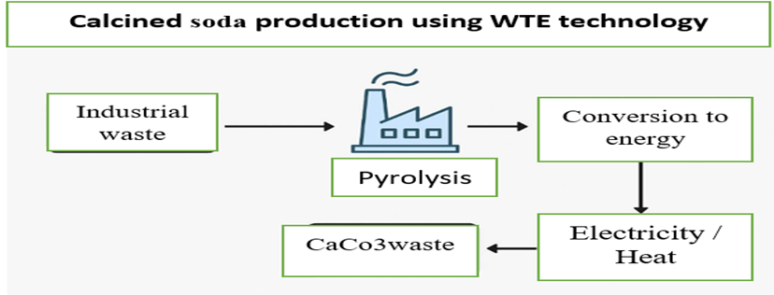
Fig.2. Application of WTE Technologies in Soda Ash Production
RESEARCH RESULTS
Economic Efficiency of WTE-Technologies in Soda Ash Production.
The economic benefits of implementing WTE (Waste-to-Energy) technologies can be assessed using the following indicators:
- Cost-Benefit Analysis:
- Initial Investment – costs associated with installing waste processing and energy generation equipment;
- Operating Costs – expenses for maintenance, labor, transportation, and waste disposal;
- Energy Production Value – the amount of heat or electricity produced (kWh) and the revenue generated from its sale;
- Reduction in Waste Disposal Costs – funds saved by generating energy from waste instead of sending it to landfills.
$E_{economical}=\left(D_{energy}+D_{waste}\right)-(C_{investment}+C_{operating}$) (1)
Here:$D_{energy}$- revenue from energy sales;
- $D_{waste}$- economic benefit from waste reduction;
- $C_{investment}$, $C_{operation}$- investment and operating costs.
Environmental Efficiency of WTE Technologies in Soda Production. The environmental efficiency of WTE (Waste-to-Energy) technology is assessed based on the extent to which it reduces the environmental impact of waste.

$R_{waste}=\frac{M_{intial}-M_{residual}}{M_{initial}}x100\%$ (2)
Here: $M_{initial}-$ The total waste mass present in the production process or at its initial stage, i.e., the quantity of waste before entering the WTE technology;
- $M_{residual}-$ The final residual waste mass remaining after the WTE process (usually in the form of ash, slag, or a small residual fraction after treatment);
- $R_{waste}-$ The percentage reduction of waste, indicating the proportion of waste that has been eliminated or converted into energy.

Table 4. Variation of Harmful Emissions into the Atmosphere from the Enterprise
Substance | Before WTE Implementation | After WTE Implementation | Reduction
CO₂ | 100% | 55-70% | ~40%
NO_{x} | 100% | 20-40% | ~60%
SO₂ | 100% | 10-20% | ~80%
Chang | 100% | 5-10% | ~90%

If the result is around 80–90%, the WTE technology can be considered highly effective. This indicator is one of the most important criteria for assessing the environmental efficiency of production.
The integration of international standards plays a crucial role in the implementation of WTE technology in soda ash production. This process significantly improves technical, managerial, environmental, and safety levels.
WTE technology involves multiple stages, including waste collection, sorting, combustion, thermal processing, energy recovery, gas purification, and residue disposal. When international ISO standards are integrated into these processes:
- Processes become stable and repeatable;
- The likelihood of equipment malfunctions decreases;
- Maintenance is carried out according to a planned system.
As a result, production downtime is reduced, and energy generation remains stable.
The implementation of WTE technology in accordance with the ISO 14001 international standard allows the enterprise to plan waste reduction strategies, monitor emissions to the atmosphere, and manage environmental risks. Consequently, the enterprise complies with environmental requirements and strengthens its position in the international market.
In terms of efficient energy use, ISO 50001 – Energy Management System – is critical for the implementation of WTE technology. It optimizes energy consumption, facilitates the selection of energy-saving equipment, and enables monitoring of energy efficiency. This standard is particularly important for energy-intensive stages of the Solvay process, such as calcination and heating.
To ensure industrial safety and employee health, compliance with ISO 45001 – Occupational Health and Safety – is essential. When WTE equipment operates under high temperatures, pressure, and chemical usage, adherence to this standard ensures:
- Safe working conditions for operators;
- Reduced risk of accidents and fires;
- Standardized management of hazardous waste.
Compliance with international standards enables the enterprise to obtain “green certificates,” access tax incentives and government grants, and enhance competitiveness in export markets.

CONCLUSIONS
The soda ash production process, due to its specific chemical characteristics, generates large amounts of solid (CaCl2 sludge, filter residues), liquid, and gaseous waste. The costs of conventional waste disposal are high, and the environmental burden is significant. Therefore, implementing Waste-to-Energy (WTE) technologies in production enterprises is a modern and environmentally acceptable solution.
Analyses indicate that the economic efficiency for the enterprise includes:
- With WTE technologies, the enterprise can generate 3,000–5,000 GJ of energy per year, reducing annual energy costs by 25–40%;
- Reduction in the volume of solid waste decreases landfill fees and disposal costs by 30–50%;
- The annual total economic benefit may reach 500,000–800,000 USD;
- The payback period for the investment is 3–6 years.
These results demonstrate that WTE technologies are an economically efficient solution for the enterprise.
The implementation of WTE technology in soda ash production provides the following environmental efficiency:
- A 60–70% reduction in waste volume significantly decreases the amount sent to landfills;
- Emissions of harmful substances such as NOx, SO2, dust, and CO2 are reduced by 40–80%;
- Greenhouse gas reduction lowers the enterprise’s carbon footprint by 25–35%;
- Water and soil pollution are brought under significant control.
As a result, the enterprise aligns with modern environmental standards and moves closer to the principles of a “green industry.”
WTE technology also offers the following technological efficiencies for soda ash production enterprises:
- The WTE process provides an additional energy source for the soda plant;
- Reuse of heat and electricity enhances production stability;
- Modernization processes simultaneously contribute to a reduction in product cost.
Overall, the implementation of WTE technologies demonstrates that they are an economically cost-effective, environmentally clean, and technologically stable solution for soda ash production enterprises.
Based on the results of our scientific research on the implementation of WTE technology in the enterprise, the following recommendations are proposed:
- Gradual implementation of WTE technologies: Enterprises should select incineration, gasification, pyrolysis, or RDF preparation technologies according to the composition and volume of waste. The most optimal option is to implement gasification or high-temperature incineration in the first stage.
- Implementation of an energy management system according to ISO 50001: This facilitates the monitoring of energy flows, increases efficiency, and reduces economic losses.
- Strengthening environmental monitoring: Continuous monitoring of emissions to the atmosphere should be established in accordance with ISO 14001 requirements. This reduces environmental risks and facilitates compliance with governmental regulations.
- Improvement of primary waste sorting: Sorting sludge and other solid fractions based on their chemical composition increases the efficiency of WTE equipment.
- Enhancement of energy integration: It is recommended to reuse the heat energy obtained from WTE in calcination, steam generation, and heating processes.
REFERENCES
- Ametova B.Kh, Boboyev G.G. Analysis of the production process of calcium. Science and innovation international scientific journal volume 2 ISSUE 4 April 2023. UIF-2022:8.2| ISSN: 2181-3337. https://doi.org/10.5281/zenodo.7854865
- Cleaner production in the Solvay Process: general strategies and recent developments.Georg Steinhauser. Journal of Cleaner Production. Volume 16, Issue 7, May 2008, Pages 833-841. https://doi.org/10.1016/j.jclepro.2007.04.005
- B.Ametova, G.Boboyev, N.Djumaniyazova. Implementation of an integrated management system in calcium soda production. E3S Web of Conferences 434, 02029 (2023). https://doi.org/10.1051/e3sconf/202343402029
- Agapi Vasileiadou. Advancements in waste-to-energy (WtE) combustion technologies: A review of current trends and future developments. Discover Applied Sciences.5may 2025.7:457. https://doi.org/10.1007/s42452-025-06907-4
- Natalia Czaplicka, Donata Konopacka-Lyskawa. Utilization of Gaseous Carbon Dioxide and Industrial Ca-Rich waste for calcium carbonate precipitation: A review.Energies 2020, 13, 6239. https://doi:10.3390/en13236239.
- C.Quan, V.S.Ravelomanantsoa, L.Olazar, L.Santamaria, G.Lopez, l.Liu, N.Gao. Thermochemical conversion of waste into energy: a review. Environmental Chemistry Letters.3november 2025. https://doi.org/10.1007/s10311-025-01889-6
- Maria F Gutierrez, Heike Lorenz, Peter Schuleze. Carbon-Negative production of Soda-ash: Process development and Feasibility Evoluation. 2025 May 30;64(23):11474-11496. https://doi:10.1021/acs.iecr.5c00483

