Analysis of ways to optimize the operating modes of electrically driven vehicles in hot climatic conditions, considering the loads on their battery packs and engines under various regimes
Oybek Daminov^{1,а)}, Akbar Juraboev¹, Jakhongir Mirzaabdullaev¹, Fikret Umerov², Fang Xianwen³, Seyran Asanov², Avaz Yangibaev¹, Lazizbek Daminov^{1,4}
¹Tashkent State Technical University named after Islam Karimov, 100095, Tashkent, Uzbekistan
²Turin Polytechnic University in Tashkent, 100095, Tashkent, Uzbekistan
³Anhui University of Science and Technology, Huainan, China
⁴Karshi State Technical University, Karshi, Uzbekistan
^{a)}Corresponding author: oybek.daminov@tdtu.uz
Abstract. The rapid global expansion of electric and hybrid vehicles has increased the importance of improving their operational efficiency under diverse climatic conditions. In hot and arid regions, particularly in Central Asia, elevated ambient temperatures have a significant impact on the performance, durability, and energy efficiency of battery packs, electric motors, and power electronic systems. This study presents a comprehensive and comparative analysis of the operating modes of electric and hybrid vehicles under high-temperature conditions, focusing on battery load characteristics, engine energy indicators, and overall energy consumption. The research examines the effects of thermal stress on commonly used lithium-ion battery technologies, including lithium iron phosphate and lithium cobalt oxide batteries, under various driving regimes. Experimental and analytical results demonstrate that battery discharge capacity, internal resistance, and energy efficiency are highly dependent on temperature variations, especially during urban driving cycles with frequent acceleration and deceleration. In addition, the stability of electric motors and power electronic components at elevated temperatures is evaluated, and the potential role of supercapacitors in reducing peak battery loads and improving energy utilization is investigated. The findings show that the implementation of optimized thermal management systems, adaptive energy control strategies, and appropriate selection of battery chemistry, combined with auxiliary energy storage solutions, can significantly reduce energy losses and extend vehicle range in hot climatic environments. The results provide practical recommendations for enhancing the performance, reliability, and service life of electric and hybrid vehicles operating in regions with high ambient temperatures.
INTRODUCTION
As a result of the consistent introduction of green technologies in the sectors of the economy, including the transport sector, the corresponding infrastructure is also developing. This is a positive and global trend. In order to actively introduce green technologies in all sectors, reduce the amount of harmful gases emitted into the atmosphere by supporting the production of electric vehicles and their components, a document “On measures to support the organization of the production of electric vehicles by the state” was signed, which set out the relevant tasks. A number of measures were established to support the production of hybrid and electric vehicles, provide incentives for imported components, raw materials, equipment and technological equipment, including spare parts for servicing.
One of the important factors in the increase in demand for electric vehicles in 2020-2030 is that the environment has its own path to reducing toxic gases, that is, emissions, which is one of the global environmental problems. Therefore, the demand for electric vehicles is growing every day in the world. Analysis of reports from the International and National Centers for Economic Research and Reforms shows that the active development of the segment of various electric vehicles is noticeably increasing compared to previous years. This trend is clear proof that not only on an international scale, but also in the countries of Central Asia, in particular in the republics of Uzbekistan and Kyrgyzstan, during 2021-2025, the popularity of this type of transport among the population has increased several times compared to popular cars with internal combustion engines [1][2][3][4].


FIGURE1. EV Global Market Sales Trends In BYD And Tesla
Date: BYD, Tesla's IR Data (2023), Note: BYD's EV sales do not include PHV

The number of people using electric vehicles is expected to increase in the future. [6][7] Thus, in different climatic regions of the world, it may be considered natural for people who prefer this type of transportation to want convenience and long-distance travel in turn.

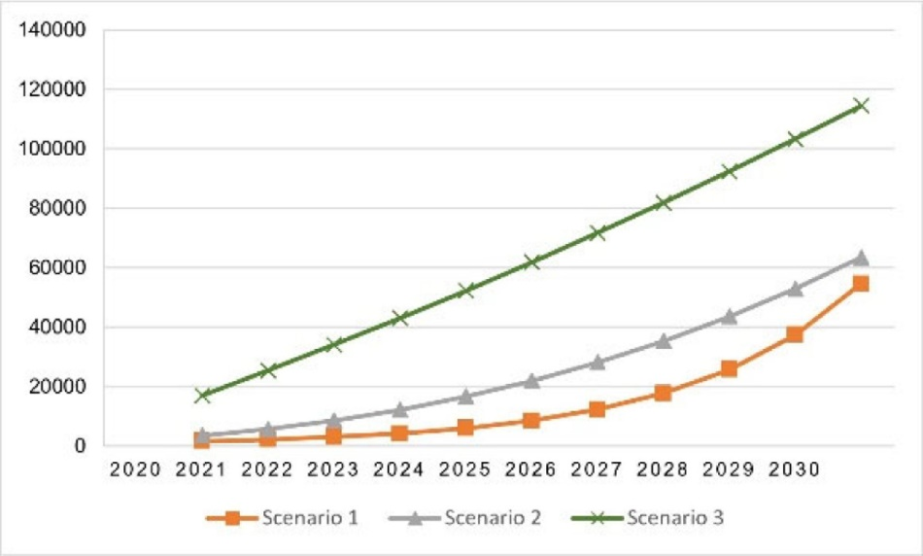
FIGURE2. EVs quantity in the region
EXPERIMENTAL RESEARCH
Advantages of electrically driven vehicles. Electrically driven vehicles are divided into these classes according to their production, which include battery electric vehicles (BEV), combined hybrid electric vehicles (PHEV), hybrid electric vehicles (HEV), and fuel-electric vehicles (FCEV), each of which has separate operational characteristics [11][12][13]. Across Central Asia, battery-powered and hybrid electric vehicles are widely popular. Regardless of their type, they have common parts. The main components include a battery and battery, a charging port, a DC converter or inverter, an electric motor, a side charger, a voltage and force electronic controller, a heat cooling system, and an electric drive [11][12][13]. One of the main advantages of electric vehicles is that they do not produce toxic and harmful gases while driving. At the same time, the absence of excessive noise, ensuring calm movement, is an important feature of automobiles with internal combustion engines [14][15][16].
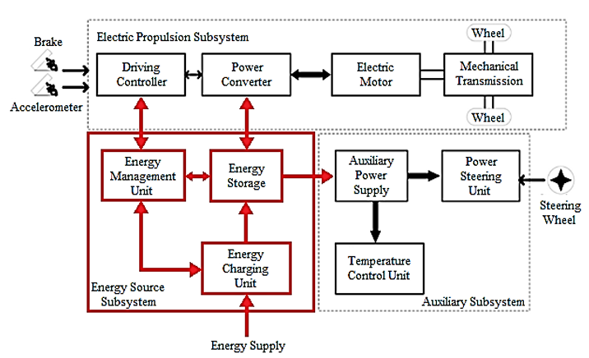
FIGURE 3. Subsystems of EVs

Main disadvantages of electric vehicles. According to the analysis of researchers, in most cases, due to certain types of problems in electric vehicles, it is noted that they arise due to the connection of the used batteries with energy reserves according to their characteristics. This, in turn, requires us to pay attention to increasing their demand for energy storage and optimal energy use [17][18][19]. Due to the uneven distribution of climatic conditions on Earth, one of the ways to reduce these causes is to conduct various analyses of vehicles used in one region before operating in another region. After all, it is natural that the loss of electricity and the internal resistance of the materials used in regions with a hot climate differs from the losses of countries moving in temperate weather. Therefore, research on the properties of the materials used, the cooling system, and control devices is one of the necessary factors for achieving high efficiency [20][21][22][23].
Electric vehicles, regardless of their type, consist of similar basic devices that perform the main function. The battery block, which is the main source, in addition to the constant supply of electricity to all main and auxiliary devices, receives an electric motor voltage to overcome various loads imposed by the driver, stability, and variability encountered by the vehicle on the road. These forces are constant, not only synchronous, but also different, causing different amounts of electrical energy to be consumed. As a result, in triband urban conditions, where the excitation movement is frequently repeated, energy consumption is somewhat higher [17][18][19][20][21]. Therefore, the stable operation of the cooling system in hot climates or the optimal use of battery packs in various warehouses serves to increase the power reserve [22][23].
RESEARCH RESULTS
Li ion-type batteries are more widely used in electric vehicles [1][2]. Analyses show that this type of battery has an average temperature range for normal heat operation, and the influence of hot or cold temperature fluxes on its results. Taking into account discharge efficiency and cycle duration, the operating temperature of lithium-ion batteries is around 10-40 °C [1][2][3]. It has been shown that the operating modes of electric motors are stable at a temperature of 40 °C [1][2]. Below are the graphs of these cases.

TABLE 1. Influence of temperature on the discharge capacity (1C) of a lithium iron phosphate battery [27].
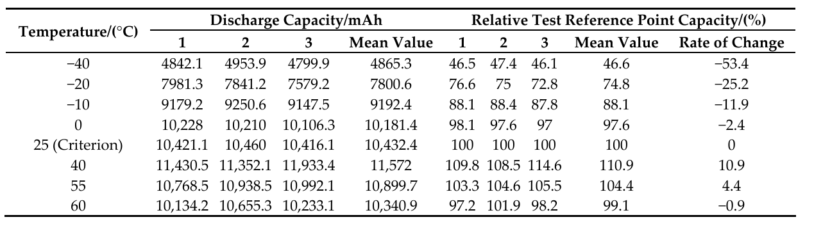

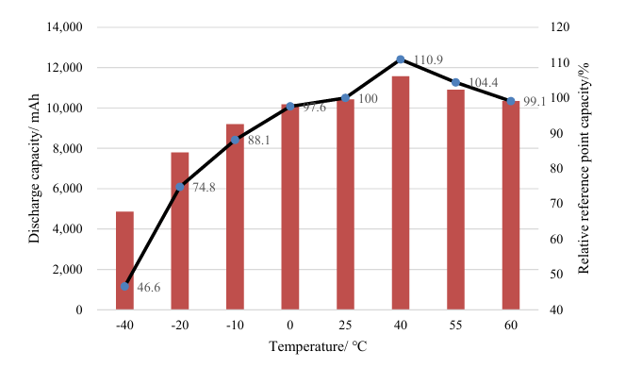
FIGURE 4. Discharge capacity of a lithium iron phosphate battery at different temperatures.

As can be seen from this table and diagram, at high temperatures, the energy storage capacity of lithium-iron phosphate batteries changes with increasing temperature, but at 60°C it approaches nominal values. In Central Asia, not only in the summer months, but also in late spring and early autumn, the air temperature is warmer than in other regions [32].

TABLE 2. Influence of temperature on the discharge capacity (1C) of a lithium cobalt oxide battery [28].
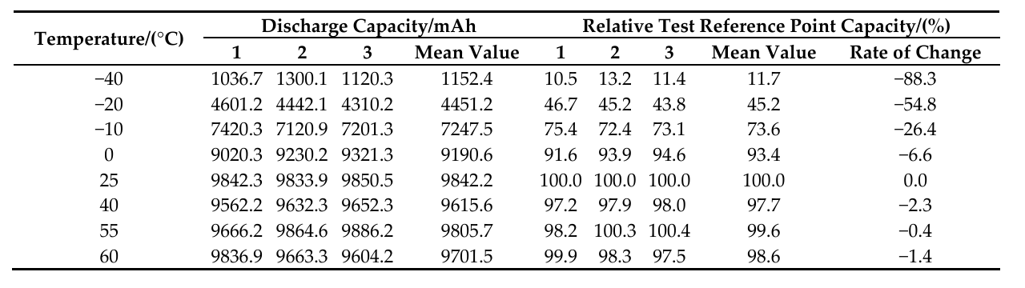

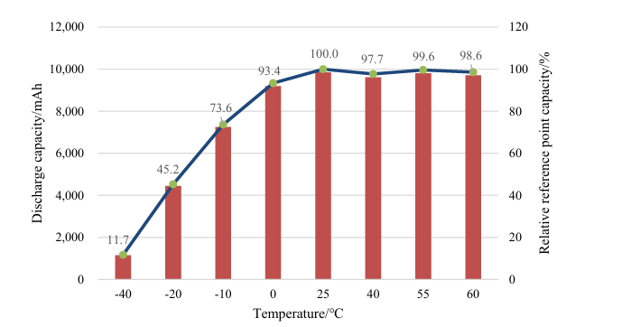
FIGURE 5. Discharge capacity of a lithium cobalt oxide battery at different temperatures.

The energy storage capacity of lithium cobalt oxide batteries changes even with increasing temperature based on relatively small indicators, remaining close to nominal values even at 60°C. During the charging mode of an electric vehicle, when the temperature of the battery block increases by several indicators [33-36], the use of the aforementioned battery type is likely to contribute to increasing the energy capacity.
CONCLUSIONS
This study investigated the optimization of operating modes for electrically driven vehicles under hot climatic conditions, focusing on the interaction between battery packs, electric motors, and varying load regimes. The analysis confirms that elevated ambient temperatures have a substantial impact on battery discharge characteristics, energy storage capacity, and overall vehicle efficiency. Lithium-ion battery technologies demonstrate different thermal responses, with lithium cobalt oxide batteries showing greater stability in high-temperature environments compared to lithium iron phosphate batteries.
The results highlight that frequent start–stop driving cycles in urban conditions increase energy consumption and thermal stress on battery systems, emphasizing the importance of effective cooling and thermal control strategies. Maintaining battery operating temperatures within an optimal range of approximately 10–40 °C is critical for preserving discharge efficiency and prolonging cycle life. Furthermore, the stable operation of electric motors at temperatures up to 40 °C suggests that coordinated thermal management between battery packs and drive systems can enhance overall system reliability.
In conclusion, the implementation of adaptive energy management algorithms, advanced cooling systems, and climate-oriented battery selection can significantly improve the operational efficiency and range of electric vehicles in hot regions. These findings provide a scientific basis for the development of region-specific design and operational strategies, supporting the sustainable expansion of electric mobility in countries with extreme climatic conditions.
In addition, the following general conclusion can be reached - that when using electric vehicles in hot climates, it is necessary to implement the following tasks to increase their mobility reserve:
1. Determination of the types of accumulator batteries suitable for a hot climate;
2. Research of the cooling system and development of the nominal temperature regime;
3. Application of the resistance of batteries to various rapidly changing loads;
4. Improvement of additional devices or cooling systems, taking into account the possibility of overheating of the electric motor.
By refining these results, we can optimize the current power state.
REFERENCES
- Miaomiao Tao, Boqiang Lin, Stephen Poletti; Some insights from an extended STIRPAT framework; Energy; Volume 316, 1 February 2025; 134473 Deciphering the impact of electric vehicles on carbon emissions: https://doi.org/10.1016/j.energy.2025.134473
- Shengbo Cui, Nanting Zhao; A Study on the Current Status and Future Prospects of EV Automotive Market. Journal of Social Science and Cultural Development 1(2) https://doi.org/10.70767/jsscd.v1i2.296
- https://www.iea.org/reports/global-ev-outlook-2025/trends-in-electric-car-markets-2
- C. N. Hewitt, K. Ashworth, and A. R. MacKenzie, “Using green infrastructure to improve urban air quality (GI4AQ),” Ambio, vol. 49, no. 1, pp. 62–73, 2020, https://doi.org/10.1007/s13280-019-01164-3.
- Teresa Nogueira, Ezequiel Sousa, Gustavo R. Alves; Impact on the distribution network power; Energy Reports, Volume 8, Supplement 3, June 2022, Pages 145-152; Electric vehicles growth until 2030: https://doi.org/10.1016/j.egyr.2022.01.106
- Bruno Cesar Krause Moras, Christina Marie Joslin, Konstantina Gkritza; Used or new electric vehicles Public preferences and market segments; International Journal of Sustainable Transportation 25 October 2025; https://doi.org/10.1080/15568318.2025.2572827
- Bazarov, B.I., Sidikov, F.S., Usmanov, I.I., Magdiyev, K.I. Computational determination of flow parameters of thermostat for combustion engine cooling system. Bio Web of Conferences, 2024, 105, 01022. https://doi.org/10.1051/bioconf/202410501022
- A. G. Olabi et al., “Battery electric vehicles: Progress, power electronic converters, strength, weakness, opportunity, and threat,” Int. J. Thermo fluids, vol. 16, p. 100212, 2022, https://doi.org/10.1016/j.ijft.2022.100212.
- Ragab A. Sayed, Sabry Allam, Sheeraz Iqbal, MdShafiullah, and Muhammad Aurangzeb; A Brief Overview of Electric Vehicle (EV) Components, Types, Technologies, Challenges, Impacts, Battery Technologies, and Future Development Directions; J. Electrical Systems 21-2 (2025): 161-181
- M. K. Metwaly et al., “Smart integration of drive system for induction motor applications in electric vehicles,” International Journal of Power Electronics and Drive Systems, vol. 12, no. 1, pp. 20-28, 2021, https://doi.org/10.11591/ijpeds.v12.i1.pp20-28., “The state of the art of electric and hybrid vehicles,” Proceedings of the IEEE, vol. 90, no. 2, pp. 247-275, 2002, https://doi.org/10.1109/5.989873.
- Ahmed Abd El Baset Abd El Halim, Ehab Hassan Eid Bayoumi, Walid El-Khattam, Amr Mohamed Ibrahim; Electric vehicles: a review of their components and technologies; International Journal of Power Electronics and Drive Systems (IJPEDS) December 2022, pp. 2041~2061; https://doi.org/0.11591/ijpeds.v13.i4.pp2041-2061
- Jorge P. Arenas; On the impact of electric vehicle transition on urban noise pollution; Current Opinion in Environmental Science & Health, Volume 45, June 2025, 100623; https://doi.org/10.1016/j.coesh.2025.100623
- Muhammad Javid, Raed Ali Al-Mestneer, Introduction of electric vehicles in Saudi Arabia: Impacts on oil consumption, CO2 emissions, and electricity demand; Energy Strategy Reviews Volume 62, November 2025, 101982; https://doi.org/10.1016/j.esr.2025.101982
- M. Elassy, M. Al-Hattab, M. Takruri, and S. Badawi, “Intelligent transportation systems for sustainable smart cities,” Transp. Eng., vol. 16, p. 100252, 2024, doi: https://doi.org/10.1016/j.treng.2024.100252.
- T. Selmi, A. Khadhraoui, and A. Cherif, “Fuel cell–based electric vehicles technologies and challenges,” Environ. Sci. Pollut. Res., vol. 29, no. 52, pp. 78121 78131, 2022, https://doi.org/10.1007/s11356-022-23171-w.
- Gaston Maggetto, Joeri Van Mierlo; Electric vehicles, hybrid electric vehicles and fuel cell electric vehicles-state of the art and perspectives; Annales de Chimie Science des Matériaux Volume 26, Issue 4, July–August 2001, pp 9-26;
- Farah Elida Selamat, Junta Tagusari; Assessing health risk reduction from road traffic noise: The impact of vehicle composition and traffic speed in the transition to electric vehicles – A prediction in Sapporo City, Japan; Hygiene and Environmental Health Advances, Volume 14, June 2025, 100125; https://doi.org/10.1016/j.heha.2025.100125
- Sacha Baclet, Julien Cesbron, Pierre Aumond , Arnaud Can, Romain Rumpler; A correction model for the noise emissions of light electric vehicles during acceleration; Applied Acoustics ,Volume 236, 5 June 2025, 110713; https://doi.org/10.1016/j.apacoust.2025.110713
- O. M. F. Camacho and L. M. Popa, “Fast charging and smart charging tests for electric vehicles batteries using renewable energy,” Oil & Gas Science and Technology–Revue d’IFP Energies nouvelles, vol. 7, no. 1, pp. 1-12, 2016, https://doi.org/10.2516/ogst/2014001.
- Joanna Czerepko, Piotr Sliż, Aleksander Jagiełło; Which Electric Cars Disadvantages Are Most Significant from the Users' Perspective? An Analysis of Key Factors; Which Electric Car Disadvantages Are Most Significant from the Users’ Perspective? An Analysis of Key Factors; Journal of Management and Financial Sciences June 2025; https://doi.org/10.33119/JMFS.2025.56.1
- J. Deng, C. Bae, A. Denlinger, and T. Miller, “Electric Vehicles Batteries: Requirements and Challenges,” Joule, vol. 4, no. 3, pp. 511–515, 2020, doi: https://doi.org/10.1016/j.joule.2020.01.013.
- Yuki Kobayashi, Tomoyasu Adachi, Hiroyuki Yamamoto, Ryo Shiozaki, Masahiro Kato, Yuki Asada, Development of Heating System for Electric Vehicles Combining Refrigerant and Coolant Circuits; Mitsubishi Heavy Industries Technical Review Vol. 60 No. 2 (June 2023)
- L. C. Rosario, a dissertation for the degree of doctor of philosophy “Power and Energy Management of Multiple Energy Storage Systems in Electric Vehicles” Cranfield University 2007.
- Daminov, O.; Mirzaabdullaev, J.; Umerov, U.; Khimmataliev, D.; Daminov, L.; Sharipov, Y.; Kurbanov, R. Electric vehicle battery technology and optimization. AIP Conf. Proc. 3331, 060026 (2025) https://doi.org/10.1063/5.0306143
- Juraboev A. Z., Scientific adviser: ass.prof. O.Daminov; Optimization of the resource-determining operating modes of the batteries of electric vehicles; a dissertation for the degree of master degree; Tashkent 2022
- U.S. Department of Energy. Alternative Fuels Data Center. https://afdc.energy.gov/vehicles/electricbatteries.
- International Renewable Energy Agency (IRENA); IRENA (2024), Critical materials: Batteries for electric vehicles, International Renewable Energy Agency, Abu Dhabi.
- Lv, S.; Wang, X.; Lu, W.; Zhang, J.; Ni, H. The Influence of Temperature on the Capacity of Lithium Ion Batteries with Different Anodes. Energies 2022, 15, 60. https://doi.org/10.3390/en15010060
- Shuai Maa, Modi Jianga, Peng Taoa, Chengyi Songa, Jianbo Wua, Jun Wangb, Tao Denga,Wen Shanga,; Temperature effect and thermal impact in lithium-ion batteries: A review; Progress in Natural Science: Materials International, Volume 28, Issue 6, December 2018; https://doi.org/10.1016/j.pnsc.2018.11.002
- Yuqiang Zeng, Divya Chalise, Sean D. Lubner,1 Sumanjeet Kaur,1 Ravi S. Prasher; A review of thermal physics and management inside lithium-ion batteries for high energy density and fast charging; Energy Storage Materials, Volume 41, October 2021, Pages 264-288; https://doi.org/10.1016/j.ensm.2021.06.008
- Haydon Kerk Motion Solutions / Pittman Motors; Temperature effects on motor performance; 534 GODSHALL DRIVE, HARLEYSVILLE, PA 19438
- Drexler David, Kampker Achim, Born Henrik, Nankemann Michael, Hartmann Sebastian, Kulawik Tobias; Advances in electric motors: a review and benchmarking of product design and manufacturing technologies; Elektrotechnik und Informationstechnik, 2025/07/15; https://doi.org/10.1007/s00502-025-01331-3
- Umirov, N., Abdurokhmonov, S., Ganiboyeva, E., Alimova, Z. Thermal equilibrium of the tractor and vehicle engines' cooling systems in agriculture technological processes. Bio Web of Conferences, 2024, 105, 05020. https://doi.org/10.1051/bioconf/202410505020
- Daminov O.O., Juraboev A.Z., Daminov L.O., Kurbanov A.M. Analysis of energy sources for electric vehicles. International Conference on Electrical Facilities and informational technologies 2022 (ICEF 2022). "New Intelligence Technology: Past, Present and Future". Turin polytechnic university in Tashkent, Uzbekistan. August 10-13, 2022. pp. 37–41.
- Aliev K, Narejo S, Pasero E, Inoyatkhodjaev J. A Predictive Model of Artificial Neural Network for Fuel Consumption in Engine Control System, 2018, p. 213–22. https://doi.org/10.1007/978-3-319-56904-8_21.
- S. Asanov, F. Umerov, J. Inoyatkhodjaev, N. Bekmurodov, B. Kodirov. Influence of Powertrain Topology (FWD vs RWD) on Regenerative braking capabilities in Electric Vehicles. 74th International Conference on Vibroengineering in Tashkent. Vibroengineering Procedia, 2025.

