Architectural improvement of the buildings of the scientific center for career guidance of creative youths
Ilhom Kosimov ^{a)}, Bakhodir Dedahanov, Azamat Hasanov, A’zamjon Abdullayev, Muzaffar Mukhiddinov, Feruza Qodirova
Namangan State Technical University, Namangan, Uzbekistan
^{a)} Corresponding author: ilhom130588@gmail.com
Abstract. In this article, the author presents suggestions that serve to strengthen the practical application of theoretical knowledge. Proposals and recommendations on the improvement of the design of innovative creative-production scientific centers for youth career guidance are highlighted.The article deals with the issues of further enrichment of theoretical knowledge of young people, proper formation of scientific research and work on ideas, production of samples, commercialization of developments and presentation to practice. In addition, it sets out the basics of creating great opportunities for young people to put their innovative proposals into practice by jointly designing individual buildings and experimental rooms in each direction regarding the improvement of the design of innovative creative-production scientific centers of young people, to inform young people about interest, motivation and final results . issues of mobilizing creativity aspirations, and studying the experiences of developed countries, raising innovative centers to the level of state policy for the development of the state, theoretical and practical knowledge being required from young people in a harmonious manner.
INTRODUCTION
The development of society and its development are determined by many economic, social and political factors. But an even more important indicator than these factors is the youth of this society, more precisely, their worldview, how well they can understand the tasks facing the nation, and the potential to serve these interests and the rational use of this potential. In this respect, youth are considered to be the power that moves the social structures of the state and society. In addition to their importance as a labor resource in society, they also serve as an intellectual reserve. The result of the long-term and promising plans of our country's youth policy is the result of gradual system reforms in creating a new generation.
Using the opportunities given to young people, it is necessary to improve the infrastructure of the existing centers in the architectural improvement of the buildings of the scientific center for career guidance of creative youth . The result of the envisaged goal will certainly serve to add the Republic of Uzbekistan to the ranks of developed countries.
The most active design and construction of scientific innovation centers for career orientation was implemented in developed countries, Jop World in Korea, vocational schools in Japan, Silicon Valley in the USA, Skolkovo innovation center in Russia, vocational training centers in Turkey were launched.
The proposed project is to gather the talented young people of the Republic in one place in the form of regions, to train them in the profession from a young age. Processes are taught online by organizing online courses for youth who cannot attend the center.
There is a need to design such centers in 3 types in districts, regions, republics.

EXPERIMENTAL RESEARCH
Factors of the emergence of professions:
1. Changes in the conditions of life and society: socio-economic changes in society, population growth, prospects for technical development - all this affects the emergence of new professions and the strengthening of the role of some of them.
2. Technical progress: the emergence of new technologies and innovations is also a factor that contributes to the emergence of new professions.
3. Demographic changes: changes in the composition of the population, the average life expectancy and the prospect of a longer retirement age for some segments of the population are influencing the emergence of new professions and changing existing ones.
4. Advances in science and education: Advances in science and education create new occupations involving high technology and highly skilled labor.
Career development stages:
1. Emergence stage: during this period, the profession is not yet widespread and not officially recognized by society. There are no established rules, standards and requirements in the developing profession.
2. Development stage: in this stage the profession is recognized and widely accepted in the society. There are established rules, standards, rules of conduct and the formation of professional ethics.
3. Expansion stage: at this stage, the profession expands its scope and develops in all aspects, including the use of new technologies, the development of science and pedagogy, professional development, etc.
4. Maturity Stage: At this stage, the profession reaches its highest level of development. There is optimization of rules and standards, removal of redundant restrictions and increased professional freedom.
5. Decline stage: in this stage, the profession begins to lose its importance, competing professions and new technologies appear. As a rule, the profession is eventually replaced by others.
The modern architectural classification of vocational guidance centers may include several types of buildings depending on their functional purpose and work activities. Several types of centers that can be used in various fields of education and profession:
1. Multi-center - multi-room large-scale buildings designed for various forms of vocational guidance. Usually these are large two- or three-story complexes with several halls, conference rooms, laboratories, studios, auditoriums, and meeting rooms.
2. Mini-centers - compact buildings, for example, in the form of small villas, houses or offices, and are designed for small events and individual consultations.
3. Distance learning centers are facilities that can host online courses, webinars, and other types of distance learning.
4. Centers located in educational institutions such as schools, colleges, universities and vocational schools. These centers provide career information for pupils and students, as well as help them identify career paths and choose appropriate educational programs.
5. Centers located in state and public organizations that provide employment services and support job search. These centers can also offer career guidance services to help people choose the right career and develop a personal career plan.
6. Centers located in large companies that represent workplaces and are part of a corporate social responsibility program. In such centers, career orientation events can be held for young professionals and trainees who are just starting their careers.
Factors affecting the construction and use of vocational guidance centers are as follows:
1. Demographic changes: the age structure of the population, the growth or decrease of the population in the region, changes in the demand for certain professions.
2. Labor market requirements: labor market dynamics, changes in the requirements for the skills of workers, transition to new technologies.
3. Economic conditions: investment environment, unemployment level, state by financial help _
4. Education policy: to education from the budget separable funds change, addition education system development, higher study countries the number increase.
5. Social situation: professional to grow hindrance doer social tension, their social and economic the situation improve demand doer of the population weak layers existence.
To profession orientation to the centers to be placed requirements:
1. Qualified specialists: labor market requirements with familiar has been qualified teachers and of advisers existence.
2. Adequate equipment: modern requirements answer giving equipment and software of supply existence and teaching opportunities.
3. Comfortable location : region population for convenience , availability of convenient transport .
4. For the target audience attractiveness : interesting and diverse learning programs availability , convenient lesson table , attractive design.
5. Quality service : friendly and qualified employees , relevant study Payments are flexible payment conditions.
RESEARCH RESULTS
In the practice important means has studying the Young people creativity centers buildings visit of the commanders comfortable to use provide in order to climatic , natural-geographical and man-made factors account take need
1. Temperature , humidity and precipitation like climate factors conditioner system or from moisture protection to do necessity like to the technical requirements of the building effect to do can
2. Building design and in construction natural geographical factors , including the area geology and topography too account taken need For example , on a slope or water basins nearby construction addition foundation stability or water flood protection demand to do can
3. Building nearby roads or industry of objects existence like man-made factors the air to quality or of the building water to press effect to do can That's why for building design and in construction harmful from the effects protection doer materials and from technologies use need
4. From this besides , social and economic factors , for example , the building different category people , including the disabled for convenience , building to build and storage expenses account taken need
5. In general at least , young people creativity center the building design and in construction this of factors all of them account get of young people creative activity for comfortable and safe field to create service does
Proposals and recommendations on the principles of organizing vocational guidance centers and architectural design.
1. The principle of individual approach to each visitor. Career guidance and architectural design centers should consider the individual needs and interests of each visitor. To do this, it is necessary to provide guidance to the profession and various methods of architectural design, as well as to provide expert advice.
2. The principle of availability. Vocational guidance and architectural design centers should be open to all groups of the population, including the disabled.
3. The principle of complexity. Vocational guidance and architectural design centers should provide comprehensive services, including not only professional guidance or design, but also information support, selection of educational programs, and more.
4. The principle of innovation. Career and architectural design centers must be prepared to use the latest technologies and methods of career guidance and design to better meet the new demands and needs of visitors.
5. The principle of cooperation. Career and architectural design centers should establish cooperation relations with representatives of educational institutions, employers and other interested organizations in order to increase the effectiveness of their activities.
6. The principle of modernity. Vocational guidance and architectural design centers must meet modern requirements for the quality of service and educational services, as well as use modern methods and tools of vocational guidance and design.
7. The principle of environmental cleanliness. Architectural projects must take into account the environment, its natural features and resources, as well as the prospects and requirements for ecological use of buildings.
Architectural design and recommendation
1. Create a comfortable environment: Career centers should look good and be comfortable for visitors. This can be achieved by modern design and furniture, quality lighting, maintaining a comfortable temperature and equipping the center with technical means such as air conditioning and electronic displays.
2. Creation of information space: conference halls, exhibition halls, platforms for presentations and roundtable discussions with the participation of experts, in combination with visual materials and modern multimedia devices, will allow to effectively organize the career guidance process.
3. Creating comfortable conditions for visitors: comfortable and convenient places for storing and working with documents, stationery, copying and computers.
4. Creating opportunities for communication: providing opportunities for communication between organizers, experts and customers, video conferences thanks to modern technological solutions.
5. Ensuring Privacy: Private rooms should be provided with a high level of privacy for visitors who wish to maintain their privacy.
6. Directions: The infrastructure of the centers should be convenient and understandable. Indicators and signs should help visitors navigate the area.
7. Attracting attention: creating an atmosphere around career centers, posters, brochures, social media events should help to present the center in an interesting way and attract attention to them.
The capacity of the vocational training center, i.e. how many students it is intended for, is determined based on the formation of classes of 15 participants (in the future no more than 20 participants) and the educational period of 11 years, where the number of classes 1-11 takes into account the coverage of children of school age (township or city taking into account the main aspects of the composition of the population of the microdistrict by age) is determined. The maximum capacity of the vocational training center should not exceed 40 groups.
The calculation of vocational guidance center networks is carried out in accordance with the demographic (age) structure (structure) of the population of settlements, cities, districts, taking into account the number of children of school age.
It is recommended that the orientation of the main rooms of the vocational centers should include the south and southeast orientation of the classrooms and cabins, and the north orientation is preferable for the fine arts and drawing, computer science cabins.
North orientation can be used for other classrooms and laboratories, except for classes 1-4 and bio lab.
In order to prevent overheating and to restore proper insolation of educational places, sun protection should be provided in the orientation of the windows towards 75-285 ^{0 azimuth.} The choice of solar protection devices is determined by the project according to local conditions.
North orientation is recommended for hot kitchens. For low-rise (one- and two-story) vocational guidance centers, protection from the sun can be provided by landscaping. In such cases, trees should be placed at least 10 m away from the building.
Requirements for land plots. The land plots of vocational guidance centers are as follows: physical education-sports; educational experience; the main functional zones, such as recreation and economic zones, should be considered.
The area of green areas of vocational guidance centers is 30-40% of the plot area, recreation in the green area, planting of fruit trees in the green area (holding festivals in the heart of nature with international partners), green areas of physical training and educational experience zones and protective belts and vocational training including green fences around the site.
Requirements for volumetric solutions and main rooms. The composition and area of the rooms in the buildings of vocational guidance centers are determined by calculations based on the functional-organizational and pedagogical requirements, taking into account the hourly load of the classrooms in the curriculum.
Vocational guidance rooms. It is recommended that the area of vocational guidance and cocktail training rooms be accepted in accordance with Table 1 . As a rule, training rooms for professions and cocktails, as they are sources of noise, must have additional exits directly outside the processing combined workshops or from classrooms, classrooms and laboratories without exit doors, through a corridor (corridor) connected to the workshop.
The number of seats in the meeting hall should be 20-25% of the calculated capacity, and the exhibition space should be 50%.
TABLE 1. Room classification
T/r | Rooms | Area per participant, m ²
T/r | Rooms | 20 participants
1 | Classrooms | 2.0
2 | Classrooms of native literature, history, geography, mathematics | 2.0
3 | Informatics classrooms | 4.0-5.0
4 | Foreign language classrooms | 3.0
5 | Laboratory, art and drawing room | 3.0

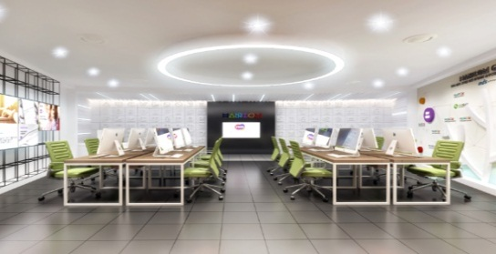
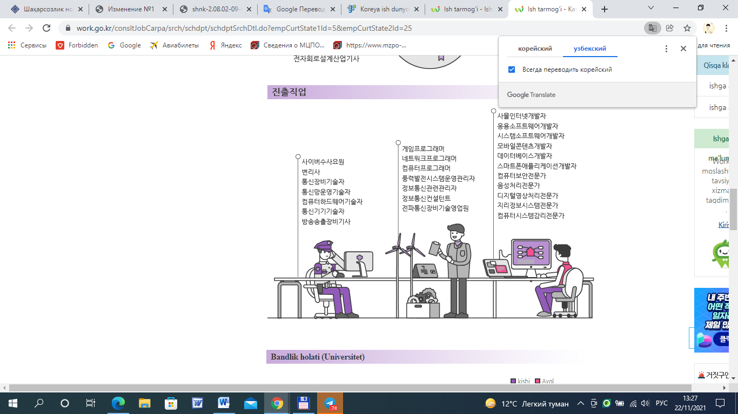
FIGURE 1. The composition of the vocational training center consists of the following groups of rooms:
a) elementary classes (grades 1-4) with classrooms, exhibition rooms for career choices, cocktail training rooms, recreation, toilet room, vestibule wardrobe; b) senior class (grades 5-11) classrooms, classrooms and laboratories, special rooms for the chosen profession, professional orientation rooms; v) places common to the center: educational and sports and meeting hall, library, educational and spiritual rooms, rooms for clubs and general activities, kitchen, administrative and medical service rooms, recreation, toilet room, bedroom, with a vestibule wardrobe.
DISCUSSION
It can be said without a doubt that today in our motherland, a modern education and training system and educational facilities have been established, which attract the attention of other countries of the world. These educational institutions provide an opportunity to master the secrets of the most advanced science and development, master several professions, foreign languages, Internet and information and communication technologies, and prepare mature competitive young people who meet the demands of the times. The important thing is that our young people, after graduating from schools, lyceums, vocational schools, technical institutes and higher educational institutions, will be loyal children to our motherland and Motherland, will be able to take a conscious step in life and take their rightful place in society.
CONCLUSIONS
It is necessary to take into account a number of features and requirements in the architectural improvement of the building of the Scientific Center for Career Orientation of Creative Youth.
The first step in the design of the building is to consider the functional requirements related to the function of the career guidance center. The building should be designed in such a way as to provide a comfortable working environment for visitors, as well as to effectively conduct various activities, including trainings, seminars and conferences.
In addition, the external appearance of the building should be taken into account so that it matches the image of the career center and attracts the attention of visitors. It is important to pay attention to architectural design and use modern technologies and materials to create a modern, functional and thoughtful design.
It is also necessary to take into account the requirements for landscaping around the building. The external area should be designed in such a way as to create a comfortable environment for the visitors and staff of the vocational center. Native plants and trees should be used to create an environmentally friendly and attractive environment.
Based on the above factors, it can be concluded that the architectural improvement of the building of the Scientific Center for Vocational Orientation of Creative Youth is an exciting and complex process that requires careful planning and organization. However, with the right approach, it can create a unique and comfortable space that attracts visitors and contributes to the development of the science center.
The ideas of young people are combined into inventions in innovation centers, and new promising strategic plans of development are created.
REFERENCES
- Mirziyoev Sh.M. "We will build our great future together with our brave and noble people".- Tashkent: "Uzbekistan".- 2017.
- Maribovich , QI (2023). Architectural Improvement of Professional Centers. Nexus : Journal of Advances Studies of Engineering Science , 2 (3), 85-91.
- Ozodovich , HA, & Maribovich , QI (2022). Improving the Design of Youth Innovative-Creative and Development Scientific Centers. Eurasian Scientific Herald , 7 , 72-76.
- Khamidov, A., Akhmedov, I., & Umarov, I. (2023). Moisture loss from freshly laid concrete, depending on the temperature and humidity of the environment. In E3S Web of Conferences (Vol. 390, p. 06040). EDP Sciences.
https://doi.org/10.1051/e3sconf/202339006040
- Usmonov, K., Berdimurodov, U., Khakimov, S., Globin, A. N., Daus, Y. V., & Boboeva, S. (2025). Biotechnological production of protein feeds from alcohol industry waste. In BIO Web of Conferences (Vol. 161, p. 00055). EDP Sciences. https://doi.org/10.1051/bioconf/202516100055
- Kholmirzaev, S. A., & Alinazarov, A. K. (2005). Temperature-vs-thickness variation in reinforced beam columns of expanded-clay lightweight concrete exposed to solar radiation. Applied Solar Energy, 41(2), 21-24.
- Mukhitdinov M. B., Dadakhanov F. A., Nuritdinov Z. D. Study of the influence of ultrasound on the wear resistance of coatings made of composite polymer materials for the shape of architectural and artistic reinforced concrete products //BIO Web of Conferences. – EDP Sciences, 2024. – Т. 105. – С. 06011.
- Migda N. S. et al. Dynamics and prospects for the development of the Russian compound feed industry in the period from 2010 to 2025 //BIO Web of Conferences. – EDP Sciences, 2025. – Т. 161. – С. 00070.
- Ruzinazarov M.R. Current source converter into stabilized voltage source based on electromagnetic ferromagnetic circuit // E3S Web of Conferences 384. 2023. РР, 01050, 1-5. https://doi.org/10.1051/e3sconf/202338401050.
- Bobojanov M.K., Rismukhamedov D.A., Tuychiev F.N., Shamsutdinov Kh.F. Development of new pole-changing winding for lifting and transport mechanisms // E3S Web of Conferences 365. 2023. РР, 04024, 1-10. https://doi.org/10.1051/e3sconf/202336504024.
- Henning Kasten, Verbesserung der Betriebseigenschaften elektrischer Maschinen durch den Einsatz kombinierter Wicklung. TU Dresden, Zugl.:Dresden, Techn.Univ.,Diss,.2015
- R.Karimov. Improving the quality of 0.4 kV electricity in household appliances due to voltage regulation. E3S Web of Conferences, 384, 01056, (2023), https://doi.org/10.1051/e3sconf/202338401056
- Ansys Maxwell 2D V.15 - Electromagnetic and Electromechanical Analysis: user’s guide/ Ansys Inc. – Pittsburgh, 2012. - 628 p
- Ansys Maxwell 3D V.15 - Electromagnetic and Electromechanical Analysis: user’s guide/ Ansys Inc. – Pittsburgh, 2012. –1006 p.

