Creating forest protection plantations on deserted and degraded lands with the introduction of mechanized agroelectric technology of energy effects on the biological system «seed, soil, plant» is a practical solution for the protection and change of atmospheric air
Ashiraf Mukhammadiev¹, Alisher Pulatov^{2, a)}, Bekzod Choriyev², Shuxrat Turaev³, Zilola Khakimova⁴
¹Agency for Innovative Development of the Republic of Uzbekistan, Tashkent, Uzbekistan
² «Tashkent Institute of Irrigation and Agricultural Mechanization Engineers» National Research University, Tashkent, Uzbekistan
³BMKB-Agromash Joint Stock Company, Tashkent, Uzbekistan
⁴ALFRAGANUS University, Tashkent, Uzbekistan
a) Corresponding author: arsenalstroy-2014@mail.ru
Abstract: Once one of the full-flowing inland seas of the Eurasian continent, covering an area of more than 68,000 square kilometers, it has now turned into a desert with small areas of water surface totaling 8,000 square kilometers. The rest is the Aralkum Desert. Researchs have shown that the loss of this inland sea nearly doubled the amount of atmospheric dust in the region between 1984 and 2015, from 14 to 27 million metric tons. The airborne former lake bed has reduced air quality in neighboring cities, even at a distance of 800 kilometers, and is contributing to the acceleration of glacier melt. This further exacerbates the water crisis in the region. In our article, we want to consider one of the possible practical solutions for protecting and changing atmospheric air [1].
INTRODUCTION
The gradual drying up of the Aral Sea, the region's natural salty inland sea, has led to the formation, by the beginning of the 21st century, of an arid territory with a high content of sea salts, with a total area of more than 6 million hectares, instead of a full-fledged inland water body. The rapid drying up of the Aral Sea led to the birth of a new desert in the region - the Aralkum. This led to a decrease in the productivity of pastures and forage lands, a reduction in the area occupied by agricultural crops, the drying up of natural water bodies, and the shallowing of rivers in the Aral Sea region and the Aral Sea region. And with the disappearance of natural bodies of water and rivers, thickets disappear, tugai forests die, shipping ceases, fisheries are reduced to a minimum, and enormous damage is inflicted on the economic entities of a large region [2].
Along with the change of natural landscape and the change of vegetation, one of the components of humanity's natural environment is also changing. The atmospheric air, which is necessary for our respiration, is also changing. The amount of various impurities and dust particles increases in the composition of inhaled air, and its temperature rises.
Problem statement. At the current stage of the Republic's socio-economic development, one of the most in-demand and priority tasks of State policy is ensuring environmental safety, which has been put forward on the agenda based on the initiatives of the President of the Republic of Uzbekistan [3,4,5,6].
In connection with this, the purpose of this article is to consider one of the possible ways to solve the problem of environmental safety of the Aral Sea and the Aral Sea region - the introduction into agricultural and forestry work of a basic set of specialized technical means aggregated with installations of electrotechnological impact on the complex biological object "seed, soil, plant" for carrying out work on greening the dried bottom of the Aral Sea and the Aral Sea region, familiarization of a wide range of scientists, manufacturers, and specialists of forestry and farming enterprises with modern achievements in the development of mechanized agroelectrotechnology. [7]
EXPERIMENTAL RESEARCH
Materials and methods. Over the past 50 years, since the beginning of research on using electricity for agrotechnological operations such as stimulating sowing seeds and protecting both seeds and growing crops from diseases and pests, more than 100 inventions have been made for methods and devices in the field of electrical technology and electrical installations [8,9,10].
Environmentally friendly electrotechnological methods for preparing crop seeds for sowing, stimulating plants, and protecting them from diseases and pests have been developed. Technical means for implementing agroelectrotechnological methods in agricultural production have been manufactured and tested [8,9,10]
One of the directions in the development of agricultural technologies for the use of electricity is the impact on the complex biological object "seed, soil, plant" with ultraviolet rays of varying intensity. The authors have examined the effects of ultraviolet radiation on biological objects such as sown seeds, plants during the growing season, and the soil cover on which plants germinate.
As a result of ultraviolet radiation, physiological changes occur in seeds, seedlings, and plants, leading to increased bioenergetic and biosynthetic processes, which lead to an increase in the energy potential of seeds, seedlings, and plants. UVR mobilizes the genetic growth reserves in seeds, which are due to the centuries-old adaptation of plants to solar radiation, leading to increased growth and development of plants. [11]
Professor Muhammadiyev A. and his students have developed an electrical impact technology that is not limited to impacting only the seeds, or the soil, or the plant during the growing season. Here, electrical influence is carried out on a holistic complex multicomponent biological object "seed, soil, plant." By combining this agroelectrotechnology of energy impact on the biological object "seed, soil, plant" with full mechanization of forestry measures, we obtain a mechanized agroelectrotechnology of energy impact on the biological system "seed, soil, plant."
According to this universal agroelectric technology, the energy impact on the "seed, soil, plant" system is carried out by short-wave ultraviolet rays. According to this technology, electrical treatment begins with disinfecting storage facilities for seed material and inventory. (Figure 1) Such treatment fully ensures disinfection. [ L.V. Metlitskiy]

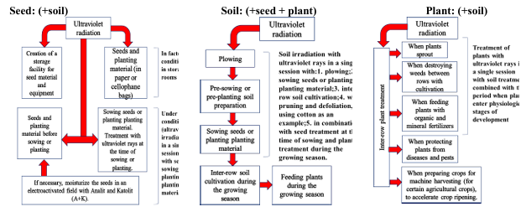
FIGURE 1 – Technological diagram of environmentally friendly universal agro-electrotechnology affecting the “seed, soil, plant” system

According to the proposed agroelectric technology, seed and planting material is subjected to UVL treatment before storage in disinfected storage facilities. Storage of seeds can be carried out in scattered, paper bags, or cellophane bags.
The radiation dose in each case for desert plant seeds is established experimentally.
If necessary, the next electrical impact of sowing seeds can be carried out simultaneously with sowing seeds. In electrical treatment, when sowing seeds, the soil is irradiated simultaneously, where the seeds are sown. (When using a mobile UHF unit aggregated with mounted equipment - a desert plant seeder)
Electrical impact on the soil is carried out during the sowing process, as well as during a single operation with inter-row cultivation of plants (Figure 2).

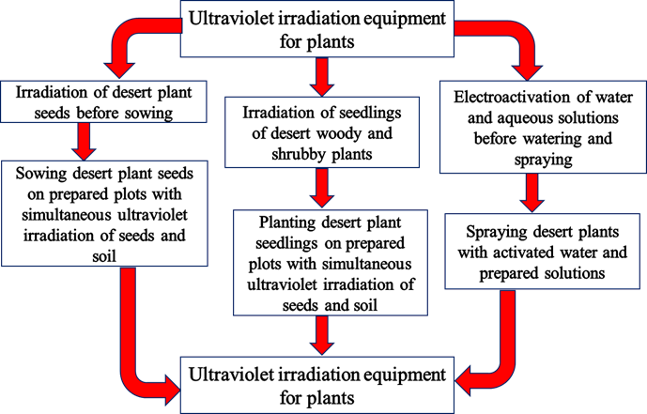
FIGURE 2. Diagram showing the use of ultraviolet irradiation equipment for desert plants during desert plant cultivation work.

Ultraviolet irradiation of the soil does not require separate agrotechnical operations, but is carried out simultaneously with sowing seeds, inter-row cultivation of plants, and soil cutting for irrigation.
The electrical effect of UVL on the plant is also carried out in a single session with widely used agrotechnical methods for plant care during the growing season. The electrical effect of UVL on the plant is also carried out in a single dose with soil irradiation.
Picture 3 shows the agrotechnical and electrotechnological operations for cultivating desert trees, shrubs, and pasture-meadow crops in the training grounds of forestry facilities. These agrotechnical operations were developed in the sectoral research laboratory of BMKB-Agromash JSC [12].
In the same picture, electrotechnological operations for agro-cultivating desert plants in specialized polygons in forestry nurseries of forestry enterprises are presented, which provide for UVR of the soil for one reception with plowing (sowing), UVR of the soil for one reception with soil preparation for sowing seeds, UVR of seeds before sowing, UVR of the soil for one reception with sowing seeds, UVR of the soil and plants (seedlings) for one reception with chemical and inter-row treatment of plants (seedlings) against diseases, pests, and weeds.

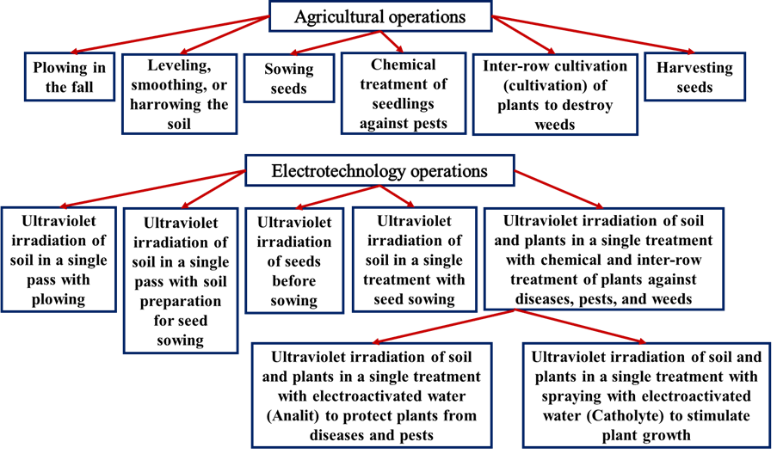
FIGURE 3 Agrotechnical and electrical operations for the cultivation of desert plants in forest nurseries.
In the final stage of the electrotechnological operation, UVR of the soil and plants during the growing season is provided for one dose with soil chiseling, spraying with electroactivated water - an analyte that has a disinfecting effect to protect seedlings from pests, as well as UVR of the soil and plants for one dose with spraying with electroactivated water - a catholyte that has a stimulating effect when exposed to plants and soil, to stimulate the emergence of desert plants of trees, shrubs, and pasture-meadow crops in specialized landfills in forest nurseries. [13]
To carry out electrotechnological operations of mechanized agroelectrotechnology of energy impact on the complex biological object "seed, soil, plant," specialists of "BMKB-Agromash" JSC, with the participation of scientists from the Forestry Research Institute of the Republic of Uzbekistan and "TIIIMSKh" Research Institute, developed a complex of specialized equipment for cultivating desert plants of tree and shrub crops in the climatic conditions of Karakalpakstan [14,15,16,17].
The proposed complex of 6 machine tools includes the following names:
- Chizel cultivator for pre-sowing soil cultivation;
- Desert plant seed drill;
- Plow for excavating desert plant seedlings in forest nurseries;
- Tree planting unit for planting seedlings;
- Stationary and mobile "Ultraviolet Plant Treatment Units";
- Sprayer for treating desert plants against pests and diseases
The energy impact of UVL on the complex biological system "seed, soil, plant" is carried out in one reception with widely used agrotechnical methods - on sowing seeds during sowing or on planted seedlings, as well as on the plant during the growing season, is carried out in one reception with soil irradiation (Picture 4).
By influencing the complex biological system "seed, soil, plant" with short-term energetic radiation, we put it in a stress state, resulting in plants beginning to "wake up" with so-called "sleeping genes" and the plant beginning to develop intensively. In the soil, various chemical and organic processes accelerate.
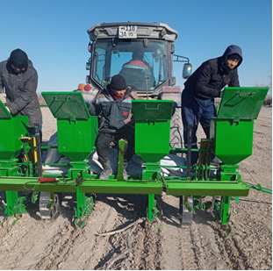 | FIGURE 4. Sowing seeds after exposing them to ultraviolet rays while simultaneously exposing the soil cover in a single pass

RESEARCH RESULTS
The results of such energy impact can be observed in the implementation of the innovative research project "Development of a universal agroelectric technology, a basic set of technical means and energy installations of electrical impact (UFL and EAV) on the "seed, soil and plant" system for the production of pasture crop seeds and the cultivation of planting material of desert plants for the landscaping of the Aral Sea bed on a cluster basis" (project manager, doctor of technical sciences, professor A. Mukhammadiyev), implemented in the State Forestry of the Karauzak district of the Republic of Karakalpakstan. This project combined the mechanization of forestry processes and the electrotechnological impact on desert plant seeds, soil cover, and desert plants during the growing season.
As experimental plants, plants of two different crops were selected: for laboratory studies - the seeds of the desert plant of the herbaceous crop Wheatgrass (Agropyron), and for field studies - the seeds of the desert plant of the tree-shrub crop Black Saxaul (Haloxylon apfyllum).
As a result of research conducted in the laboratories of the Research Institute of LC of the Republic of Uzbekistan and the Committee of Forestry of the Republic of Karakalpakstan, the following results were obtained:
Table 1. Conducting laboratory studies on the germination of Wheatgrass (Agropyron) seeds under laboratory conditions in the laboratory of the Forestry Committee of the Republic of Karakalpakstan
№ in order | Τ, sek | Н, sm | 3 day |  | 5th day |  | 7th day |  | 9th day
№ in order | Τ, sek | Н, sm | sprouted | did not sprout | sprouted | did not sprout | sprouted | did not sprout | sprouted | did not sprout
 |  |  | 15.01. |  | 18.01 |  | 20.01. |  | 22.01
1 | 11 | 10 | 79 | 21 | 86 | 14 | 91 | 9 | 93 | 7
 | CONTROL |  | 32 | 68 | 44 | 56 | 51 | 49 | 52 | 48
2 | 11 | 20 | 54 | 46 | 88 | 15 | 89 | 14 | 91 | 9
 | CONTROL |  | 35 | 65 | 43 | 57 | 54 | 46 | 54 | 46
 |  |  | 18.01. |  | 20.01. |  | 22.01. |  | 24.01.
3 | 22 | 10 | 62 | 38 | 78 | 22 | 86 | 14 | 86 | 14
 | CONTROL |  | 36 | 64 | 42 | 58 | 48 | 52 | 51 | 49
4 | 22 | 20 | 64 | 36 | 80 | 20 | 86 | 14 | 86 | 14
 | CONTROL |  | 37 | 63 | 43 | 57 | 56 | 44 | 56 | 44
 |  |  | 20.01. |  | 22.01. |  | 24.01. |  | 26.01.
5 | 33 | 10 | 68 | 32 | 76 | 24 | 84 | 16 | 87 | 13
 | CONTROL |  | 35 | 65 | 42 | 58 | 51 | 19 | 52 | 48
6 | 33 | 20 | 78 | 22 | 80 | 20 | 85 | 15 | 93 | 7
 | CONTROL |  | 36 | 64 | 44 | 56 | 54 | 46 | 54 | 46

Table 2. Conducting laboratory studies on the germination of the seeds of the desert plant Wheatgrass (Agropyron) under laboratory conditions in the laboratory of the Research Institute of Forestry of the Republic of Uzbekistan
№ in order | Τ, sek | Н, sm | 3 day |  | 5th day |  | 7th day |  | 9th day
№ in order | Τ, sek | Н, sm | sprouted | did not sprout | sprouted | did not sprout | sprouted | did not sprout | sprouted | did not sprout
 |  |  | 25.03. |  | 27.03. |  | 29.03. |  | 31.03.
1 | 11 | 10 | 80 | 20 | 88 | 12 | 90 | 10 | 91 | 9
 | CONTROL |  | 35 | 65 | 43 | 57 | 54 | 46 | 54 | 46
2 | 11 | 20 | 57 | 43 | 88 | 12 | 91 | 9 | 94 | 6
 | CONTROL |  | 37 | 63 | 45 | 55 | 56 | 44 | 56 | 44
3 | 11 | 30 | 65 | 35 | 80 | 20 | 88 | 12 | 89 | 11
 | CONTROL |  | 37 | 63 | 43 | 57 | 56 | 44 | 56 | 44
 |  |  | 03.04. |  | 05.04. |  | 07.04. |  | 09.04.
4 | 22 | 10 | 65 | 35 | 79 | 21 | 89 | 14 | 91 | 9
 | CONTROL |  | 38 | 62 | 43 | 57 | 43 | 57 | 48 | 52
5 | 22 | 20 | 78 | 22 | 80 | 20 | 85 | 15 | 93 | 7
 | CONTROL |  | 36 | 64 | 45 | 55 | 52 | 48 | 54 | 46
6 | 22 | 30 | 65 | 35 | 80 | 20 | 88 | 12 | 89 | 11
 | CONTROL |  | 35 | 65 | 42 | 57 | 52 | 48 | 56 | 44
 |  |  | 12.04. |  | 14.04. |  | 16.04. |  | 18.04.
7 | 33 | 10 | 65 | 35 | 80 | 20 | 88 | 12 | 89 | 11
 | CONTROL |  | 34 | 66 | 45 | 55 | 52 | 48 | 56 | 44
8 | 33 | 20 | 64 | 36 | 80 | 20 | 86 | 14 | 86 | 14
 | CONTROL |  | 37 | 63 | 43 | 57 | 56 | 44 | 56 | 44
9 | 33 | 20 | 78 | 22 | 80 | 20 | 85 | 15 | 93 | 7
 | CONTROL |  | 36 | 64 | 44 | 56 | 54 | 46 | 54 | 46

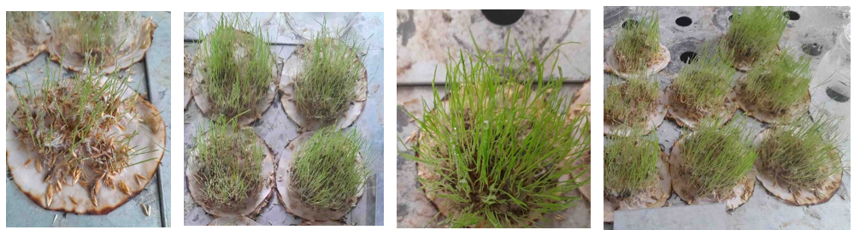
FIGURE 5. Results of laboratory studies on the germination of Wheatgrass (Agropyron) seeds in the laboratory of the Forestry Research Institute of the Republic of Uzbekistan

As can be seen from the values of seed germination and their viability shown in the table, the experimental samples surpass the development of control seed samples that were not subjected to energy exposure to ultraviolet rays.
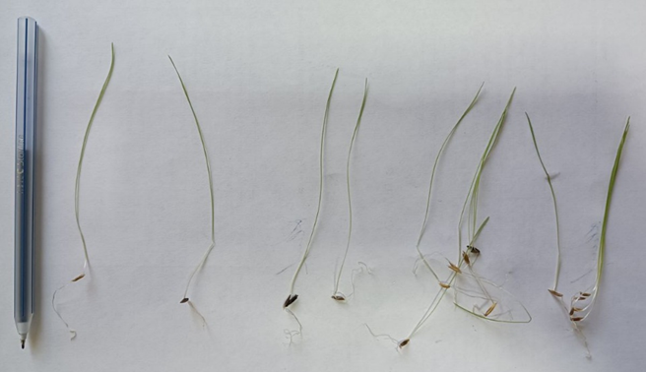
FIGURE 6. Conducting measurements of seedlings and root system in the desert plant Wheatgrass (Agropyron).

The height of the green shoots averaged 10-11 cm, and the length of the root hairs was 2.5-3.0 cm.
As a result of conducting field studies on the germination of Black saxaul (Haloxylon apfyllum) seeds under the conditions of a specialized testing ground, the following results were obtained: according to the pre-sowing irradiation of Black saxaul (Haloxylon apfyllum) seeds and subsequent repeated phased energy exposure to plants during the growing season, the germination density of seedlings (according to the irradiation time) per 1 p/m of planting averaged: 180 sec (3.0 min) - 21 seedlings, control - 10 seedlings. That is, the number of germinated and sprouted seeds in the experimental plot was 2.1 times higher than in the control plot.
When measuring biometric indicators, the following results were obtained:
The obtained positive results of field studies on the influence of ultraviolet radiation on the development of desert plants, tree-shrubs, and herbaceous crops for carrying out forestry work on landscaping and restoration of degraded and desertified lands, creating green forest plantations, indicate the need to introduce a new mechanized agroelectrotechnology of energy impact on plants into forestry activities. The main aspect of this mechanized agroelectrotechnology is the complete mechanization of planned work using stationary and mobile plants ultraviolet irradiation units - plants ultraviolet irradiation units are aggregated with a complex of specialized technical means.
The use of a complex of specialized technical means aggregated with installations for ultraviolet irradiation of desert plants, as well as stationary installations for UV radiation of desert plants, during forestry work, will allow for an increase in seed germination percentage, a reduction in germination time, an increase in the survival rate of planted seedlings, an increase in the growth and development rate of plants during the growing season, their protection from diseases and pests, obtaining high-quality seeds for subsequent forestry work, and obtaining viable grass and tree-shrub plantations. And most importantly, the use of mobile installations for ultraviolet irradiation of plants will allow avoiding the use of various toxic chemicals when treating plants to combat the harmful effects of disease-causing microbes and viruses, as well as other plant pests [18].

Table 3. Results of biometric indicators of Black saxaul (Haloxylon apfyllum) based on the results of the conducted experiments
№ in order | Radiation time  t, sek | Indicators | Numbers of experimental plant samples
№ in order | Radiation time  t, sek | Indicators | 1 |  | 2 | 3 |  | 4 | Average value
 | Experimental area
1 | 180 sek | Root length, mm | 325 |  | 264 | 298 |  | 285 | 291,25
1 | 180 sek | Stem length, mm | 472 |  | 325 | 462 |  | 318 | 394,25
1 | 180 sek | Total plant length, mm | 790 |  | 589 | 760 |  | 603 | 685,5
1 | 180 sek | Number of branches, units | 5 |  | 6 | 7 |  | 6 | 6
 | Control area
2 |  | Root length, mm | 160 |  | 242 | 148 |  | 234 | 196
2 |  | Stem length, mm | 176 |  | 250 | 176 |  | 289 | 222,75
2 |  | Total plant length, mm | 336 |  | 492 | 324 |  | 523 | 418,75
2 |  | Number of branches, units | 4 |  | 5 | 4 |  | 5 | 4,5
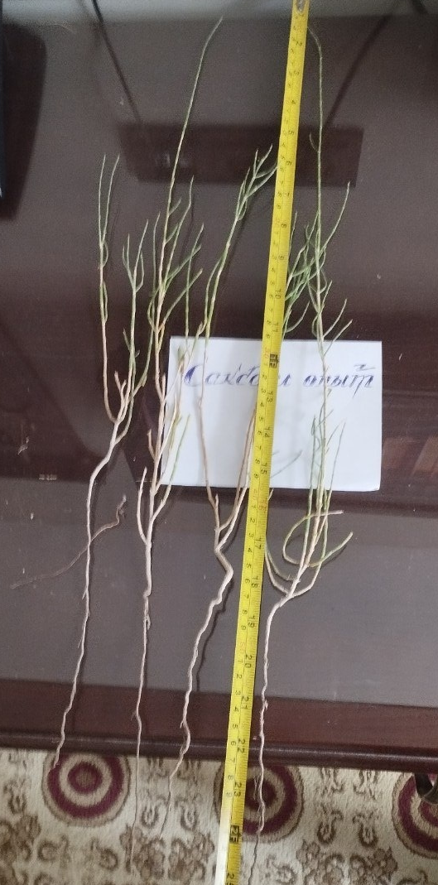 |  | 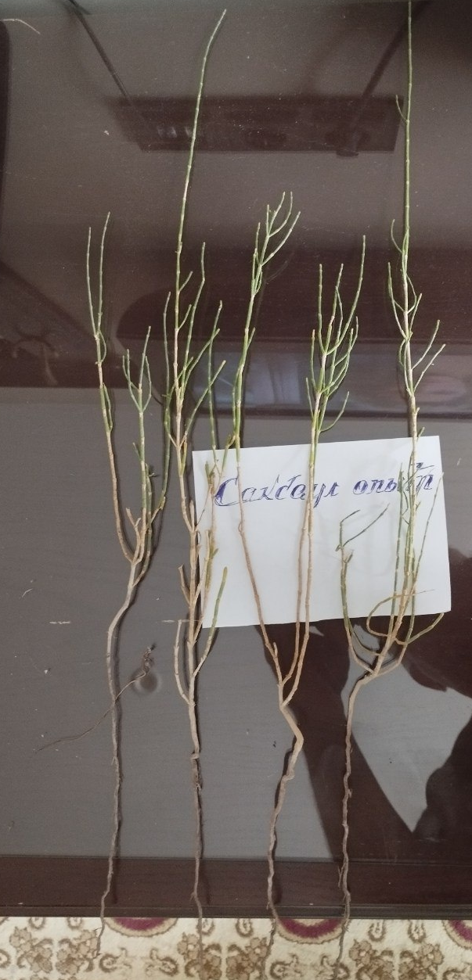 |  | 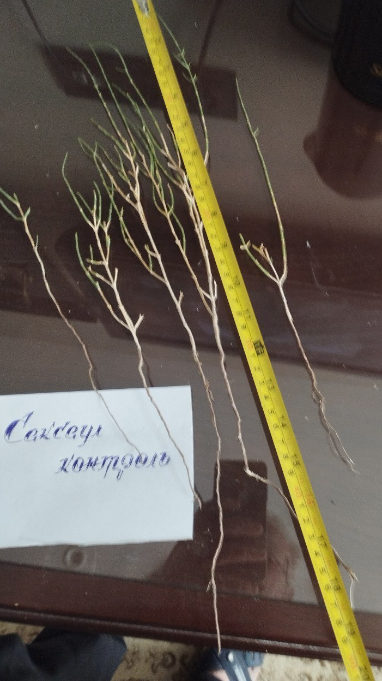 |  |  | 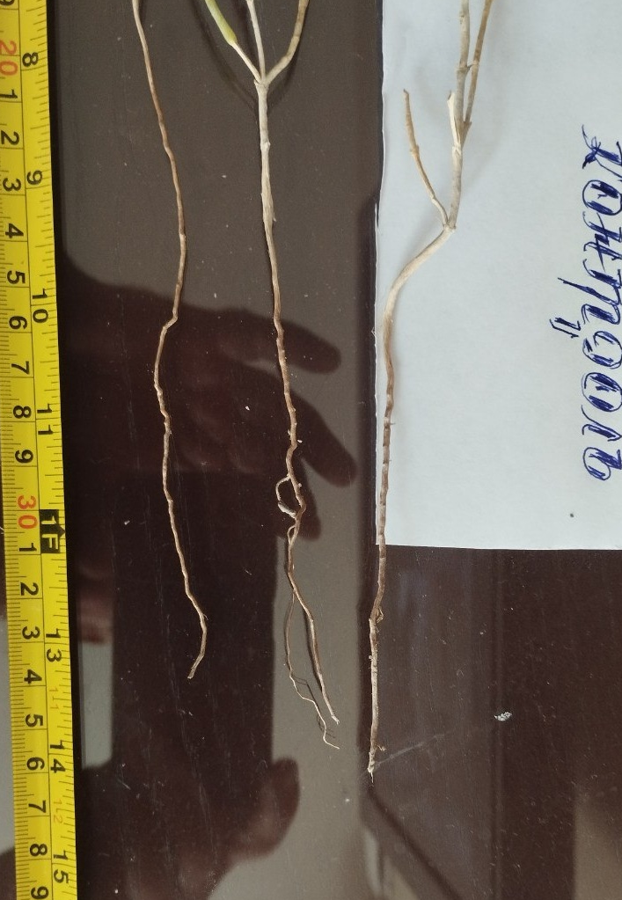

By applying this mechanized agroelectrotechnology for the development of specialized forest nurseries in the dried-up Aral Sea bed zone and the Aral Sea region, we obtain viable, activated seedlings of desert trees and shrubs, adapted to the harsh climatic conditions of desert and semi-desert climatic zones. [13,17,18,19,20,21,22]
Planted seedlings in desertified areas, after three to four years, form stable protective forest plantations, which, in turn, change the climatic component of the region, strengthen the soil, and purify the air from dust. And clean air is the health of the people living in these regions, the health of the nation.
During the implementation of the innovative research project "Development of a universal agroelectric technology, a basic set of technical means and energy installations of electrical influence (UFL and EAV) on the "seed, soil, and plant" system for the production of pasture crop seeds and the cultivation of plant material of desert plants for the landscaping of the Aral Sea bed on a cluster basis" (project manager, doctor of technical sciences, professor A. Mukhammadiyev), the economic component of mechanized agroelectric technology was determined. When performing mathematical calculations of the effectiveness of applying the mechanized agroelectric power technology of energy impact on the complex biological system "seed, soil, plant," the following cost and expenditure items were taken into account:
1. The cost of one set of machines of the specialized equipment complex amounted to 32 160.00 US dollars.
2. The costs associated with cultivating the desert plant Black saxaul (Haloxylon apfyllum) amounted to 1 165.00 US dollars.
3. Expenses for wages, taxes, utilities and equipment depreciation, spare parts and fuels and lubricants, current and major repairs of traction equipment amounted to 58 725.00 US dollars.
4. The total cost of cultivating the desert plant Black saxaul (Haloxylon apfyllum) in a forestry nursery at a specialized testing ground with a total area of 6.0 hectares and obtaining seedlings for further planting in the dried Aral Sea bed and other desert regions of our Republic amounted to 92 050.00 US dollars.
5. Considering the cost of selling seedlings for planting in desert areas, by simple mathematical calculations, we obtain a positive economic effect of 3 304 400.77 US dollars, or 550 733.46 US dollars/ha. [23]
CONCLUSIONS
As a result of implementing an innovative research project and introducing a new mechanized agroelectrotechnology for staged energy impact on the complex biological system "seed, soil, plant" into forestry production, the following results were obtained:
- In forest nurseries, a stable seed fund of desert plants of trees, shrubs, and pasture-meadow (herbaceous) crops resistant to disease-causing viruses and microbes will be created;
- A sustainable fund of tree and shrub plantations has been created to create green forest plantations during the implementation of the fight against desertification and land degradation, and the expansion of desert territories;
- A set of design and technical documentation has been developed, and the pilot production of stationary and mobile installations for ultraviolet irradiation of plants, aggregated with mounted and attached forestry machinery and installations, has been organized;
- Machines of a complex of specialized technical means, aggregated with installations for energy (ultraviolet) irradiation of plants, were manufactured and tested in the climatic conditions of desert territories (Republic of Karakalpakstan);
- Due to the introduction of new mechanized agricultural electrotechnology into forestry production, an improvement in the ecological situation at the bottom of the dried-up Aral Sea is observed; [21,22,24].
- The economic efficiency was obtained from the introduction of mechanized agroelectrotechnology into forestry production by energetically impacting the unified biological system "seed, soil, plant."
REFERENCES
- T.Titova, The world's fourth-largest lake turned into the newest desert: 3 million people suffered, focus.ua/expert/taya-titova, 06.02.2025
- Koksharova N.E. et al. Methods of creating protective plantations on the sandy part of the dried-up bottom of the Aral Sea. Trudы SradAz NII LX, vыpusk 23, st-12-19.
- Resolution of the President of the Republic of Uzbekistan No. 4204 dated 22.02.2019 "On measures to improve the effectiveness of work to combat desertification and drought in the Republic of Uzbekistan."
- Resolution of the President of the Republic of Uzbekistan No. 4850 "Concept for the Development of Forestry in the Republic of Uzbekistan until 2030" dated October 6, 2020.
- Resolution of the President of the Republic of Uzbekistan No. 5202 dated 29.07.2021 "On measures to implement the special resolution of the UN General Assembly dated 18.05.2021 "On declaring the Aral Sea region a zone of environmental innovations and technologies."
- The Decree of the President of the Republic of Uzbekistan No. PF-46 dated December 30, 2021 "On the protection of trees, shrubs, and expansion of their areas" provides for a number of measures to cultivate a large number of desert tree and shrub plants.
- A.M. Mukhammadiyev, A.T. Pulatov, Khakimova Z., Creation of protective forest plantations, greening of the dried-up bottom of the Aral Sea and restoration of the region's ecology using the complex, Materials of the MNC "Development of Higher Specialized Education and Science in the Context of Globalization: Problems and Opportunities," "TIIIMSKh" NIIU, Tashkent, 2025, 182-193.
- Khuzhaev O., Sultanov R. The main pests of desert plants. J.: Uzbekistan Qishloq va Suv Xo'jaligi. - No4, 2019. - P. 44.
- Matchanov R.D. Plant protection in the crop-pest-preparation-machine system. (Deserts and wastelands
- Matchanov R., Yuldashev A., Voinov S. Basic set of technical means for protecting desert fodder crops from pests, diseases, and weeds. J.: Agrotechnika dunyosi. - Tashkent, No. 11 (12), 2018. P. 31-33.
- Shalyapin S.N. Increasing Yield. Modern approach. Kharkiv, LLC "Kharkiv Engineering Company," 2013, 12 p.
- A.Muhammadiyev, A.Aripov, S.Mamajanov, D.Yusupov, Agroelectrotechnology for the production of pasture crop seeds in seed production areas, Monograph, Usmon Nosir Media, Namangan, 2022, 162 pages.
- Muhammadiyev A., Pulatov A.T., Aripov A.O., Rozmukhamedov D.D. Theses "Ultraviolet rays - one of the directions for the development of "green technologies" of MNPK for young scientists "Modern problems of physics, energy and heat engineering," Tashkent branch of "NIAU MIFI," Tashkent, 2023, 142 pages.
- Pulatov A.T., Aripov A.O., Shaburyan S.S., Yuldashev Kh.K., Mamajanov S.I., Justification of the development of new types of specialized forestry machinery for the sustainable development of forestry, International scientific and technical conference "Innovative solutions for the creation of highly efficient agricultural machinery and increasing the efficiency of the use of technical means," Gulbakhor, 2023, 360 pages/
- Pulatov A.T., Farmonov E.T., Mamajanov S.I., Perspective technologies and specialized complex of agricultural machinery for fodder production and seed production in arid pastures and hayfields, Collection of scientific works of MNTK "Agricultural Mechanization: Science and Innovation," Section 2 "Resource-saving technologies and innovative problems of agricultural mechanization," Fergana Polytechnic Institute 188-193 pages.
- Muhammadiyev A., Pulatov A.T., Khakimova Z., Ultraviolet irradiation of the complex biological object "seed, soil, plant" is one of the ways to landscape the dried bottom of the Aral Sea and restore the region's ecology, Uzbekistan agrar fani xabarnomasi (No3 (21/2) 2025, Maxsus son 2 qism, materials of MNPK "Innovative technologies in the development of environmental protection, climate change, soil fertility degradation," Tashkent State University, Tashkent 2025, 91-98 pages.
- Muhammadiyev A., Pulatov A.T., Belalov A.Kh., Hakimova Z., Exposure of plants to ultraviolet rays and complete mechanization of forestry processes is one of the main ways to combat the expansion of desert territories, Materials of the V-th MNTK "Innovative solutions: sustainable development in agriculture and food industry," I. Karimov TSUL, Tashkent, 2025, pp. 62-64.
- Pulatov A.T., Mukhammadiyev A., Aripov A.O., Choriyev B.S., "Green technologies as one of the ways to combat dust storms," "Prospects for the development of science, innovative technology and technologies" Part II of the Republican scientific and practical conference, Karshi, 2023, pp. 92-99/
- Muhammadiyev A., Pulatov A.T., Aripov A.O., Yusupov D.R., Mahmudov N.M. "Justification of the use of new achievements in the development of agroelectric technologies in relation to the introduction of salt- and drought-resistant desert plants - halophytes in forestry farms and forest nurseries," MNTK "Innovative solutions for the creation of highly efficient agricultural machinery and increasing the efficiency of the use of technical means," Gulbahor, 2023, 409 pages.
- A. Muhammadiyev, A. Pulatov, B. Choriyev "Ultraviolet rays - "green technologies" for combating dust storms and creating protective forest plantations and vast pasturelands," MNTK "Agricultural Mechanization: Science and Innovation," Fergana, 2024, 53-60 pages.
- Muhammadiyev A., Pulatov A.T., Yusupov D.R., Tagaev B.K., Akramov N, Hakimova Z. "Mechanized method of restoring pasture lands using a specialized complex of machines and installations for ultraviolet irradiation of plants," MNTK "Innovative solutions for creating highly efficient agricultural machinery and increasing the efficiency of using technical means," Gulbahor, 2023, Section IX 507 pages.
- A.T.Pulatov, A.O.Aripov, S.S.Shaburyan, H.K.Yuldashev, "Green spaces are a reliable shield of the dried bottom of the Aral Sea," Republican scientific-practical conference "Innovative machinery and technologies in agriculture and transport: problems, solutions, prospects," Karshi, 2023. (KIIE), 142 pages.
- Interim report on the implementation of the innovative research project "Development of a universal agroelectric technology, a basic set of technical means and energy installations of electrical impact (UFL and EAU) on the "seed, soil and plant" system for the production of pasture crop seeds and the cultivation of plant material of desert plants for the landscaping of the Aral Sea bed on a cluster basis", Tashkent, 2025, pp. 43-45.
- Z.B.Novitskiy, G.Kh.Atadjanova, "Forest plantations in the revival of the dried bottom of the Aral Sea," MNPK "Innovations in Agriculture," 29-30.05.2024, Namangan-2024, 92-94 pp.

