Methods of reducing the impact of factors affecting the duration of operation of lighting devices
Ikromjon Rakhmonov ^{1, 4}, Mukhammadkhon Toirov ^{1, a)}, Tolkun Alibekova ², Feruz Raximov ³
¹Tashkent state technical university named after Islam Karimov, Tashkent, Uzbekistan
²Karakalpak State University named after Berdakh, Nukus, Uzbekistan
³Navoi State University of Mining and Technologies, Navoiy, Uzbekistan
⁴Termez State University of Engineering and Agrotechnology, Termez, Uzbekistan
^{a)} Corresponding author: muhammadxon.toirov@gmail.com
Abstract. In these days, the demand for lighting devices is increasing year by year. The reason for this is the increase in the number of electricity consumers. LED lighting devices are important for the devel-opment of the lighting system in human life. Because such lighting devices consume less power and emit more light. This is one of the most important issues today. This article presents the classi-fication of factors affecting the life of lighting devices and distinguishes the most influential factors among them. As a result of the conducted scientific research, it was found that voltage reduction and high temperature are factors that have a great impact on the life of the lighting device. Also, the analysis of schemes that allow solving problems related to the main negative factors affecting the life of the lighting device is presented.
INTRODUCTION
The demand for electricity in the world is increasing in proportion to the number of electricity consumers. The role of the lighting system in the life of mankind is huge. This is due to the fact that modern LED lighting devices are more efficient in several indicators. However, despite the large number of advantages of modern lighting devices, it also has its drawbacks. One of the main indicators of lighting devices is their service life. For example, the average operating time of LED lighting devices in the world is calculated in the range of 50000÷100000 hours, but in Uzbekistan conditions this figure is 20000÷30000 hours. We can see that 2 and 3 times LED lighting in our state indicates that the devices have less hours of operation. One of the main reasons for the occurrence of such a situation is the factors that indicate the influence of modern lighting on the duration of operation of devices, which is presented in table 1 [1].
TABLE 1. Factors affecting the life of lighting devices
1 | Component quality | 5 | Change of current
2 | Voltage instability | 6 | On/off frequency
3 | Certificates of device | 7 | User experience
4 | Temperature | 8 | Dust, dirty and humid environment

The factors in the table 1 listed above not only reduce the life of lighting devices, but also lead to their failure. This includes component quality, voltage instability, device certification, temperature, current changes, on/off mode, user experience, dust, dirt, and other conditions that adversely affect the lighting device. Among these factors, the most negative impact on the lighting device is voltage instability and temperature effects. The relative influence of the factors is presented in the cartogram below.
Figure 1 shows the share of factors affecting lighting devices. The biggest percentage is the negative impact of temperature and humidity on lighting devices. From the cartogram, the image and user experience factors accounted for the least share. Current variation and component quality accounted for 15% and 10% of the impact on the lighting fixture, respectively. [2,3,11].

FIGURE 1. Cartogram of factors affecting the lighting device

The factor for dusty, dirty and wet conditions was 7%, the same as the certification factor of the lighting device. Therefore, it is appropriate to focus on the factors that have the greatest impact. In the cartogram presented above, the factors affecting the lighting device are compared in terms of the degree of possibility to eliminate them through scientific

EXPERIMENTAL RESEARCH
We know that nowadays the most popular among lighting devices are LED bulbs. This is due to the fact that LED lighting devices have a longer service life and a lower consumption of the power they spend on lighting. Figure 2 cites the power consumption of lead, halogen, compact fluorescent and LED lighting devices. Incandescent bulbs produce a lot of heat, and this condition makes it difficult to work as a written on its passport’s parameter, and in cold weather it becomes difficult to heat the elements, as a result of which it becomes difficult to be able to give the desired illumination. Compact fluorescent light bulbs were calculated very impressively to temperature - that is, the temperature reduces its life at the expense of the correct exposure to the gas inside it. It also prevents normal operation of operating modes if the temperature is low. We know that the amount of power that LED lighting devices spend on lighting is lower than others. However, no matter how robust LED lighting devices are, they are much more sensitive to heat and cold, and as a result, the effect of temperature on its life is enormous. Hot temperatures negatively affect the operating time of the lighting device. Temperature can negatively affect in two ways. One of these is the fact that the temperature is higher than the quoted norm for the operation of the lighting device. In this case, when lighting devices operate at a temperature above the specified value, it becomes difficult for its main elements to cool down, which will be necessary for lighting, and as a result, the lighting device will heat up, which, after that, will lead to a rapid failure of the lighting device. The next reason is that the lighting device works at cold temperatures.

FIGURE 2. How much power the lighting device consumes compared to the lumen

Some lighting devices, notably fluorescent lighting, do not function as their normal value in wet weather conditions, and as a result can quickly lose their ability to operate. [7,8,11].
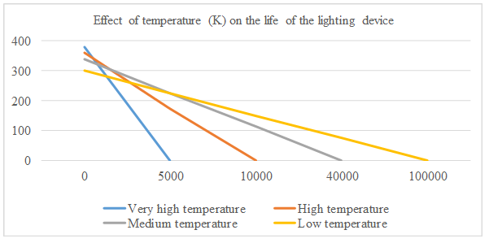
FIGURE 3. Effect of temperature (K) on the life of the lighting device

In Figure 3, presented above, we can see the effect of temperature on the life of the lighting device. In this case we can see that the temperature leads to a decrease in the life of the lighting device up to 100,000 – 5,000 hours in the range of 300-380K.
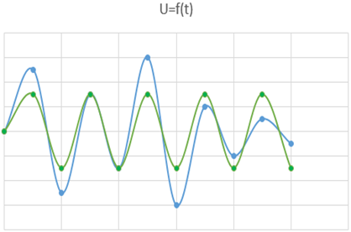 | 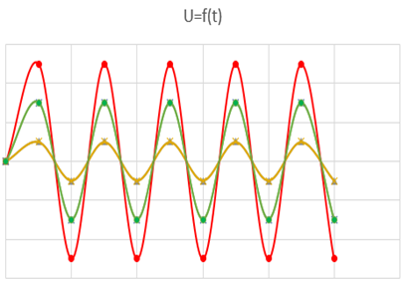
a) | b)
FIGURE 4. Deviation of the voltage value from the specified standard; a) Deviation of voltage from its normal value, b) A constant deviation of voltage from its standard value
The consequence of the formation of electrotechnical problems in the electrical energy transmission network can be the cause of premature failure of lighting devices. The fact that the voltage value in the transmission network is constantly too low, the voltage for the operation of the lighting device increases by a large amount from the established value, or the instability of the voltage has a huge negative effect on the normal operation of the electrical components of the lighting device as well as its main elements.
The figure 4 presents the difference in voltage from the specified value. In a) and b) cases, while the blue line represents that the voltage varies dramatically from the specified value, the green line represents the standard voltage, the red and yellow lines represent that the voltage value is exceeded and decreased by the specified value for a long time respectively [5,9,11].
Figure 5, cited below, represented the effect of the change in voltage value on the life of the lighting device. In this case, if the voltage is reduced 5%,10%,15%, 20% and more than 20% the lifespan of the lighting device decreases 5%, 15%, 20%, 30%, and 50% respectively.
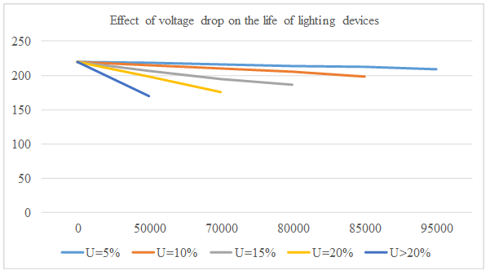
FIGURE 5. Effect of voltage drop on the life of lighting devices

The service life of the lighting device is estimated to be 100,000 hours, and the failure rate can be accelerated to 5,000, 15,000, 20,000, 30,000, and 50,000 hours, respectively, to the above per-centages
RESEARCH RESULTS
The electrical energy consumption of lighting devices is a process that attracts attention for each state. Schemes and methods can be used to make more efficient use of lighting devices. Such schemes are organized as part of the energy system consumer on the basis of eliminating problems with voltage in lighting systems and preventing the possibility of heating lighting devices to an extreme temperature. Through the information below, we can see suggestions and activities for solving the above problems. We will see the schemes and methods for temperature voltage related schemes and methods for solving problems. Because these two factors affect more seriously on lighting devices’ lifespan.
- The fact that lighting devices work for a long time leads to its overheating. These heating control circuits can also achieve the desired result by cooling. That is, after heating the lighting devices, the main elements of the lighting repair will be negatively damaged and the lifespan will be reduced. For this reason, circuits can be used that allow cooling of the lighting device. The first method is to use fans or radiators for the purpose of cooling lighting devices.
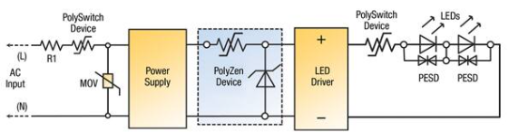
FIGURE 6. Scheme that prevents the heating of the lighting device

That is, through these devices, it is possible to use heat dissipation schemes that are inherent in lighting devices. The next solution is to use the heat-detecting sensors together with a circuit that can turn off the lighting device. With this sensor, the temperature of the lighting device is kept in control, and the circuit is automatically turned off at the right time. Figure 6 [13,14] expresses a scheme that prevents lighting devices from overheating to temperatures above the specified level. In this, the MOV-metal is an oxide varisator whose function is to function like resistance at normal voltage times, whereas at higher values of voltage it has an opposite effect-that is, it is usually used to protect the chain. The Polyzen device, on the other hand, serves to cool it by determining its temperature through the voltage that goes to the LED lighting device through the two edge polyconductors. PESD is a permanent electrical safety device [5,14].
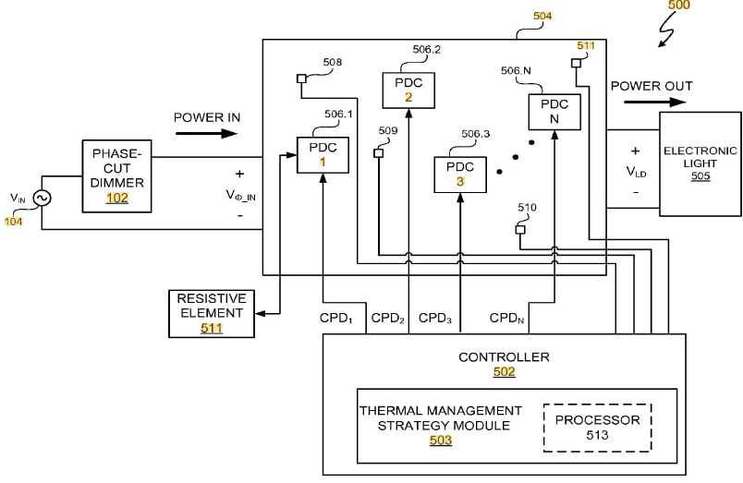
FIGURE 7. Power and thermal management scheme for lighting devices

2. Figure 7 [14] above shows a power and thermal management system that includes a thermal management processor. Phase-cut dimmer allows us to change input power by adjusting brightness. Power Delivery Circuits (PDC 506.1, 506.2, ..., 506.N): These circuits independently control the power supplied to the electronic light. Each circuit is regulated separately through signals from the Controller. Controller (502): This central unit oversees the power delivery circuits (PDCs) by receiving feedback through control signals (CPD_1, CPD_2, etc.). Within the controller, a Thermal Management Strategy Module (503) and a Processor (513) are likely responsible for temperature regulation and signal processing, ensuring efficient power delivery while preventing overheating. Thermal Management Strategy Module (503): This module focuses on monitoring and controlling the system's temperature, adjusting power distribution as necessary to avoid overheating. Resistive Element (511): This component adds extra resistance to the circuit, aiding in dissipating excess power or regulating current flow. Power flows from the phase-cut dimmer through the PDCs before reaching the electronic light. The controller actively adjusts each PDC to regulate power delivery based on the dimmer settings and thermal conditions. [7,8].
3. The use of the best electrical circuits by connecting lighting devices to the electrical network allows you to extend its lifespan. By using neutral ground-connected circuits, a lighting device can be used as a high-voltage protection system. The use of the lighting device through short circuit resisting circuits also helps to protect it.
4. Figure 8 below shows the scheme of controlling the lighting device by changing the voltage. Here is a description of the elements used in this image:Voltage to Current Converter: This core component converts an input voltage (V_IN) into an output current (I_OUT), which is then directed to the LED string. Since LEDs require a steady current for efficient operation and to prevent overdriving, this converter ensures stable current supply. Dimming Control: The dimming input enables brightness adjustment for the LED string, likely by interfacing with the LED Current Control block within the converter.
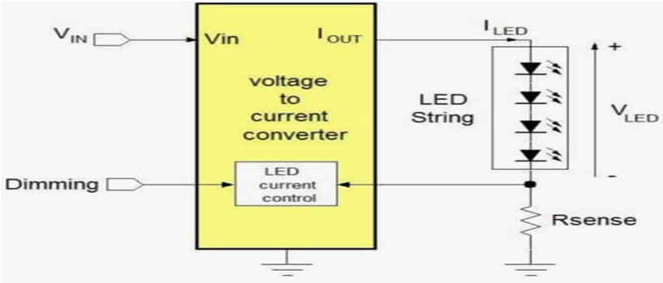
FIGURE 8. Scheme of controlling the lighting device by changing the voltage

By modifying the current flow through the LEDs, this input allows precise brightness control of the LED string. LED String: Serving as the load in this circuit, the LED string is powered by the converter’s output current (I_LED). Figure 8 [15] consists of multiple LEDs connected in series, emitting light as current flows through them. R_sense: This resistor monitors the current flowing through the LED string by generating a voltage drop (V_LED) proportional to the current. This voltage drop provides feedback to the system, helping maintain a safe, consistent current level. It may also assist in adjusting the current if the dimming control relies on feedback from the LED current.

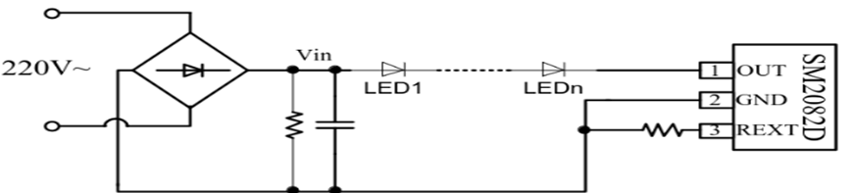
FIGURE 9. The circuit that protects the lighting device from an abnormal state of voltage

5. Above, in Figure 9 [16], the circuit that protects the lighting device from an abnormal state of voltage is presented. Newer designs often utilize multi-LED-element packages (e.g., 18V drop per package) that align their combined voltage with the rectified voltage (such as SMD2082D or NUD4001) instead of relying on switching buck converters. By implementing current limiting, the voltage across the LEDs should theoretically never exceed their forward voltage drop at that current. A resistor and a capacitor are connected in parallel to the lighting device, helping to keep the voltage going to the lighting device in a normal state through the current.[9,10]
CONCLUSION
The results of the analysis show that among the factors considered above, the biggest factors affecting the shortening of the life of the lighting device are the instability of the voltage coming from the network to the lighting device and overheating of the temperature above the normal level. Factors that reduce the lifespan of a lighting device slightly compared to the above factors are on/off frequency, user experience and dust/humid condition. Schemes that allow to eliminate the problem of the main factors that have a negative effect on the life of lighting devices have been considered. Also, it was mentioned that it is possible to solve the problems caused by lighting devices. Therefore, scientific research in this direction is important.
REFERENCES
- Enhancement of light extraction from light emitting diodes. A. I. Zhmakin, Phys. Rep. 498 (4-5) (2011) 189-241.
- Meter-scale large area LED-embedded Light Fabric for the Application of Fabric Ceilings in Rooms. S. Takamatsu, T. Yamashita, and T. Itoh, Microsyst. Technol., 2014.
- Energy saving potential and strategies for electric lighting in future North Europe-an, low energy office buildings. M.-C. Dubois and A. Blomsterberg, Energy Build. 43 (10) (2011) 2572-2582.
- Ye H, Mihailovic M, Wong CKY, van Zeijl HW, Gielen AWJ, Zhang GQ, Sarro PM. Two-phase cooling of light emitting diode for higher light output and increased efficiency. Applied Thermal Engineering 2013; 52: 353–359.
- American National Standards Institution, ANSI C78.377:2008. Specifications for the Chromaticity of Solid State Lighting Products. New York: ANSI.
- Lighting glossary. In Rea MS, (ed). The IESNA Lighting Handbook Reference and Application, 9th Edition. New York: Illuminating Engineering Society of North America, 2000.
- Tang Y, Ding X, Yu B, Li Z, Liu B. A high power LED device with chips directly mounted on heat pipes. Applied Thermal Engineering 2014; 66: 632–639.
- Hsieh S, Hsu Y, Wang M. A microspray-based cooling system for high powered LEDs. Energy Conversion and Management 2014; 78: 338–346.
- Li J, Lin F, Wang D, Tian W. A loop-heat-pipe heat sink with parallel condensers for high power integrated LED chips. Applied Thermal Engineering 2013; 56: 18–26.
- Eugene C, Deswer JM. Photoelectric characterization of electroluminescent pho-todiodes. In: Mottier P. (ed)LEDs for Lighting Applications. London: ISTE, 2009: 193.
- I.U. Rakhmonov, M.T.Toirov. Analysis of factors affecting the life of lighting devices. Republican scientific and technical conference 2024 on the topic "Prospects of mining and processing of mineral raw materials in the eyes of young people" (dedicated to the 75th anniversary of JSC "Almaliq kmk"). page: 236-237.
- I.U.Rakhmonov, M.T.Toirov. Effect of voltage value change on the lifespan of lighting devices. IV international scientific and technical conference “current problems of the power supply system” 2024, pp: 98-100.
- I.U.Rakhmonov, M.T.Toirov. Analysis of circuits that extend the life of lighting devices. IV international scientific and technical conference “current problems of the power supply system” 2024, pp: 103-105.

