Automatic voltage sag recovery circuit
Ikromjon Rakhmonov ^{1,3}, Dinora Jalilova^{1, a)}, Eldor Usmonov^{1,4}, Guysenguli Bayram Ogli², Zhalalidin Galbaev ⁵
¹Tashkent state technical university named after Islam Karimov, Tashkent, Uzbekistan
² Azerbaijan Technical University, Baku, Azerbaijan
³ Karakalpak State University named after Berdakh, Nukus, Uzbekistan
⁴ Termiz State University of Engineering and Agrotechnologies, Termiz, Uzbekistan
⁵ Kyrgyz State Technical University n. a. I. Razzakov, Bishkek, Kyrgyz Republic
^{a)} Corresponding author: dinaramaster93@gmail.com
Abstract. Industrial power supply systems face pressing challenges related to electric power quality. At present, extensive scientific research is being conducted to address these issues in industrial enterprises. In this regard, the present scientific article is devoted to the development of a device schematic designed to prevent short-term severe voltage sags occurring in the power supply systems of spinning mills in the textile industry. To enable a comparative analysis, the article presents analogous and prototype circuit schemes, highlighting their respective advantages and disadvantages. In addition, the main proposed circuit, along with its structural components and operating principle, is described in detail.
INTRODUCTION
As a result of scientific research conducted at spinning enterprises of the textile industry, it was established that short-term severe voltage sags occur in the power supply system (fig. 1) [1, 7].
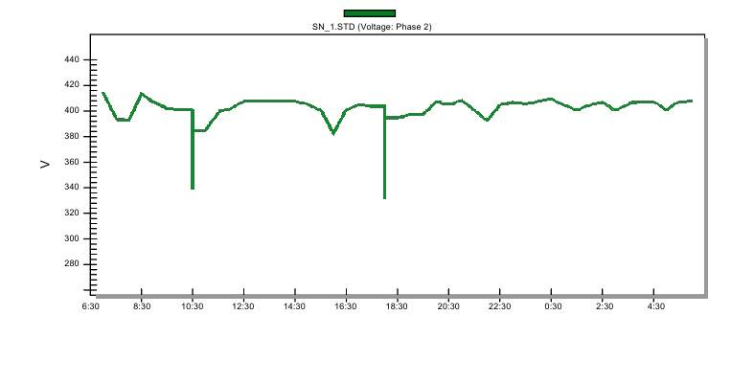
FIGURE 1. The voltage variation condition in the electrical network of a spinning enterprise

Figure 1 illustrates the voltage variation in the power supply network of a spinning enterprise, where it can be observed that the network voltage experienced two abrupt drops within a 24-hour period. As a result of a sharp deviation of the voltage magnitude from its nominal value, the issue of eliminating the energy-related and economic losses occurring in spinning mills remains highly relevant. To date, a number of studies have been carried out on this problem in industrial enterprises. The outcomes of these studies were considered in the present article as analogous and prototype solutions to the voltage regulation scheme proposed herein. Accordingly, the circuit configurations, advantages and disadvantages, and fields of application of these devices were analyzed. The following section provides a detailed description of these circuits.

EXPERIMENTAL RESEARCH
It is known that an alternating voltage regulator exists [2, 7, 8], which is connected to the power supply source via the first and second input terminals and to the load via the first and second output terminals, while the second input terminal and the second output terminal are interconnected (fig.2).
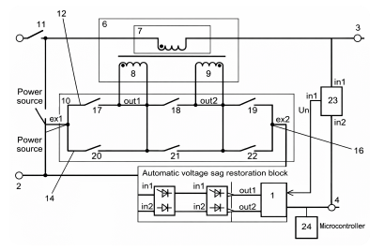
FIGURE 2. Schematic diagram of the alternating voltage regulator device

This device consists of a multi-winding transformer with a primary winding and secondary windings, a switched converter whose inputs are connected to the power supply source and whose number of outputs corresponds to the number of secondary windings of the multi-winding transformer, a voltage sensor, and a control unit. In this configuration, one end of the primary winding of the multi-winding transformer is connected to the first output terminal, while the secondary windings of the transformer are connected to the corresponding outputs of the switched converter. The first input of the voltage sensor is connected to the first output terminal, and its second input is connected to the second output terminal. The output of the voltage sensor is linked to the control unit and is equipped with first and second auxiliary controlled switches. The first auxiliary controlled switch is connected between the beginning of the primary winding of the multi-winding transformer and the second output terminal, whereas the second auxiliary controlled switch is connected between the beginning of the primary winding of the multi-winding transformer and the first input terminal.
The drawback of this scheme lies in the complexity of its design and the large number of electromechanical contacts, which leads to an increase in the cost of the device and a reduction in its overall reliability.
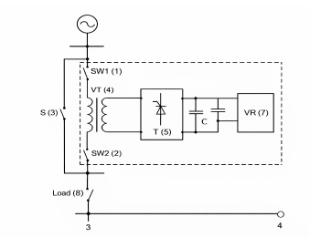
FIGURE 3. Dynamic voltage sag restoration device
In addition, a dynamic voltage sag restoration device is also known (fig.3) [3]. This device employs two independent power supply sources, sectioned by a backup switch and protected by switching circuit breakers, a boost (voltage-injecting) transformer connected in series with the load circuit, a thyristor-based converter, an absorbing compensator located in the DC circuit, and a charging unit.
Using this device, a compensated voltage is supplied in order to protect the electrical load from voltage sags during short-term power supply interruptions. The magnitude of this voltage is generated based on a pulse-width modulation (PWM) algorithm and is dynamically regulated via the control circuits of a thyristor converter powered by a charging unit located in the DC link.
An absorbing compensator, which performs the function of an energy damper for regulating power flows, is connected to this DC link. It serves to stabilize the required waveform, amplitude, frequency, and phase shift angle of the compensation voltage. The generated compensation voltage represents the difference between the nominal and the actual voltage and, under voltage sag conditions, is applied to the terminals of the electrical load through a boost (voltage-injecting) transformer until the short-term disturbance in the power supply is eliminated [3, 9].
The main drawback of this device is that the duration of compensation is strictly dependent on the amount of energy stored in the capacitor bank, which significantly limits the regulation range under conditions of very deep or very short-duration voltage sags.
As the closest analogue to the proposed invention, a contactless automatic voltage sag regulation device for electrical networks is known [4, 5, 10] (fig.4). This device includes a multi-winding boost (voltage-injecting) transformer (VDT), whose primary winding is connected in series with the power supply source and the load.
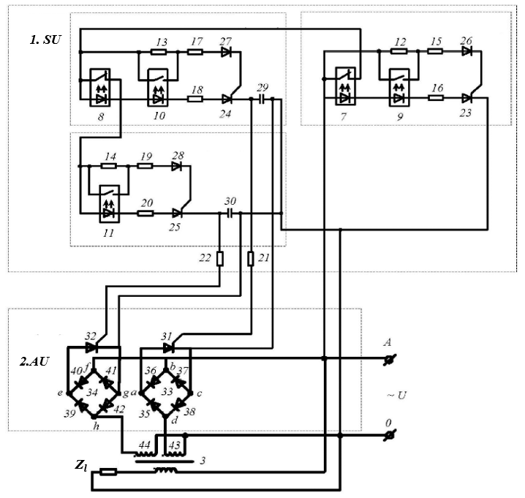
FIGURE 4. Schematic diagram of the contactless automatic voltage sag regulation device

In this configuration, a contactless voltage relay is connected to the first terminal of the supply network through the output of the first auxiliary resistor and the anode of the light-emitting diode of the first optorelay with a normally closed contact. At the same output of the first auxiliary resistor, the first terminal of the second optorelay with a normally open contact is also connected. The second output of the first auxiliary resistor is connected to the first output of the second resistor and to the second terminal of the first optorelay with a normally open contact.
The second output of the second resistor is connected to the anode of the first diode, whose cathode is connected to the gate electrode of the first thyristor. The cathode of the light-emitting diode of the first optorelay with a normally closed contact is connected to the anode of the light-emitting diode of the first optorelay with a normally open contact, whose cathode, in turn, is connected to the first output of the third resistor. The second output of the third resistor is connected to the anode of the first thyristor, while its cathode is connected to the second terminal of the supply network.
In this case, the first terminal of the normally closed contact of the first optorelay is connected to the anode of the light-emitting diode of the first optorelay with a normally open contact, while the second terminal of the normally closed contact is connected to the first output of the second auxiliary resistor, the first terminal of the normally open contact of the second optorelay, and the first terminal of the normally closed contact of the second optorelay. The anode of the light-emitting diode of the second optorelay with a normally closed contact is also connected to this node.
The second output of the second auxiliary resistor is connected to the first output of the third resistor, while its second output is connected to the anode of the second diode, whose cathode is connected to the gate electrode of the second thyristor. The cathode of the light-emitting diode of the second optorelay with a normally closed contact is connected to the anode of the light-emitting diode of the second optorelay with a normally open contact, and its cathode is connected to the first output of the fourth resistor. The second output of the fourth resistor is connected to the anode of the second thyristor, while its cathode is connected to the first plate of the first capacitor.
The second terminal of the normally closed contact of the second optorelay is connected to the first output of the third auxiliary resistor, the first terminal of the normally open contact of the third optorelay, and the anode of the light-emitting diode of the third optorelay with a normally open contact. The second output of the third auxiliary resistor is connected to the first output of the fifth resistor, whose second output is connected to the anode of the third diode, while the cathode of the diode is connected to the gate electrode of the third thyristor. The cathode of the light-emitting diode of the third optorelay with a normally open contact is connected to the first output of the sixth resistor, whose second output is connected to the anode of the second thyristor, and its cathode is connected to the first plate of the second capacitor.
The second plates of the first and second capacitors are interconnected and connected to the second terminal of the supply network. The first plate of the first capacitor is connected through the seventh resistor to the gate electrode of the fourth thyristor of the actuator, while its second plate is connected to the cathode of this thyristor. The cathode of the fourth thyristor is connected to the first output terminal of the first diode rectifier bridge, and the anode is connected to the second output terminal. The first input terminal of the first diode rectifier bridge is connected to the first input terminal of the second diode rectifier bridge and to the first terminal of the supply network. The second input terminal of the first diode rectifier bridge is connected, through the first magnetizing winding of the series-connected voltage-boost transformer (VDT), to the second terminal of the supply network.
The first plate of the second capacitor is connected through the eighth resistor to the gate electrode of the sixth thyristor of the actuator, while its second plate is connected to the cathode of this thyristor. The cathode of the sixth thyristor is connected to the first output terminal of the second diode rectifier bridge, and the anode is connected to the second output terminal. The second input terminal of the second diode rectifier bridge is connected, through the second magnetizing winding of the series-connected VDT, to the second terminal of the supply network [4, 6].
The main drawback of this device is associated with the complexity of the circuit and the large number of components, which leads to an increase in manufacturing cost and complicates the production process. In addition, the adjustment and synchronization procedures are sufficiently complex, requiring qualified technical maintenance.
RESEARCH RESULTS
The technical result of the proposed device consists in expanding the capabilities of contactless technical means intended for fast automatic regulation of voltage sags in electrical networks (Fig. 5).
The proposed utility model, similar to the prototype, consists of a control unit (1), a switching unit for the windings of a voltage-boost transformer (2), and a voltage-boost transformer with two secondary windings (13).
The control unit (1) includes a power supply module (3), whose LN input terminals are connected to the supply network terminals; the 5 V output terminal is connected to the IN+ input of the microcontroller (4), while the OUT output terminal is connected to the IN− input. The VCC terminal of the supply network voltage sensing module (5) is connected to the 5 V output of the microcontroller (4), and the LN input terminals of this module are connected to the supply network terminals.
The D1 output of the microcontroller (4) is connected to the anode of the diode of the first optorelay (6) with a normally open contact. The cathode of this diode is connected to the cathode of the diode of the second optorelay (7) with a normally open contact and to the GND terminal of the microcontroller (4). The anode of the diode of the first optorelay with a normally open contact is connected to the D2 output of the microcontroller (4).

FIGURE 5. Automatic voltage sag restoration scheme

The first terminals of the normally open contacts of the first and second optorelays (6 and 7) are interconnected and connected, through resistor (8), to the 12 V output terminal of the power supply module (3). The second terminals of the normally open contacts of optorelays (6 and 7) are connected, respectively, to the gate electrodes of the first (9) and second (10) thyristors located in the switching unit (2) of the voltage-boost transformer windings.
The anode of the first thyristor (9) is connected to the first common point (a) of the first diode bridge (11), while its cathode is connected to the second common point (b) of this bridge. The anode of the second thyristor (10) is connected to the first common point (e) of the second diode bridge (12), and its cathode is connected to the second common point (f).
The third points of diode bridges (11) and (12) are interconnected and connected to the first terminal of the supply network. The fourth common point (d) of the first diode bridge (11) is connected to the first terminal of the first secondary winding (14) of the voltage-boost transformer (13). The fourth common point (h) of the second diode bridge (12) is connected to the first terminal of the second secondary winding (15) of the voltage-boost transformer (13).
The second terminals of secondary windings (14 and 15) are interconnected and connected to the second terminal of the supply network. The primary winding (16) of the voltage-boost transformer (13) is connected in series with the load Zₙ and is linked to the second terminal of the supply network.
The proposed utility model operates as follows. When the supply network voltage is equal to the nominal value, the microcontroller (4) does not transmit any control signals to optorelays (6 and 7). When the supply voltage decreases by 5% relative to the nominal value 𝑈nom, the supply voltage sensing module (5) sends a signal to the microcontroller (4). This signal is converted by the microcontroller into a DC control signal that energizes the light-emitting diode of the first optorelay (6) with a normally open contact, causing its contact to close and generating a control signal to trigger the first thyristor (9). As a result, the secondary winding (14) of the voltage-boost transformer (13) is energized from the supply network.
When the supply network voltage decreases by up to 10% relative to 𝑈nom, the signal received from the supply voltage sensing module (5) is converted by the microcontroller (4) into a DC signal that energizes the light-emitting diode of the second optorelay (7) with a normally open contact. In this case, the optorelay contact closes and a control signal is applied to trigger the second thyristor (10), as a result of which the secondary winding (15) of the voltage-boost transformer (13) is energized from the supply network.
CONCLUSIONS
Short-term severe voltage sags in the power supply systems of spinning enterprises negatively affect the stability of technological processes and overall production efficiency. In this study, existing analogue and prototype devices were analyzed, and their main shortcomings were identified. To eliminate these drawbacks, a contactless device scheme designed for automatic voltage sag restoration was proposed. The proposed solution is distinguished by its simplified circuit structure, high response speed, and enhanced reliability, thereby enabling improved electric power quality in spinning enterprises.

REFERENCES
- Jalilova, D. A. Improving the energy efficiency of spinning enterprises by ensuring the continuity of technological processes (a case study of “WBM ROMITEX DIROMM” enterprise). Doctor of Philosophy (PhD) dissertation in Technical Sciences. Tashkent, 2023. 107 p.
- Patent No. 2680146 C1. Head of the Federal Service for Intellectual Property. IPC H02M (2006.1). Published on February 18, 2019.
- Patent No. 2393611 C1. Head of the Federal Service for Intellectual Property. IPC H02J 9/06 (2006.1). Published on June 27, 2010.
- Automatic voltage regulation device for electrical networks. Patent No. 2829056. Head of the Federal Service for Intellectual Property. October 23, 2024.
- Rakhmonov, I. U., Jalilova, D. A., & Mamarasulova, T. S. Current state of voltage sags in textile enterprises. Proceedings of the Republican Scientific and Technical Conference “Development of Modern Electrical Machines and Drives for a Green Economy.” May 15–16, Tashkent, 2025.
- Rakhmonov, I. U., Jalilova, D. A., & Mamarasulova, T. S. Methods for regulating voltage sags in textile enterprises. Proceedings of the Republican Scientific and Technical Conference “Development of Modern Electrical Machines and Drives for a Green Economy.” May 15–16, Tashkent, 2025.
- Raxmonov I.U., D.A.Jalilova, Najimova A.M. Techno-economic analysis of voltage sag mitigation systems. Science and Education in Karakalpakstan. 2025 №2/2 ISSN 2181-9203.
- Zadeh L.A., Yuan B. (eds.) Fuzzy Sets, Fuzzy Logic, and Fuzzy Systems: Selected Papers. Singapore: World Scientific, 1996. – 840 p.
- Klir G.J., Yuan B. Fuzzy Sets and Fuzzy Logic: Theory and Applications. Upper Saddle River, NJ: Prentice Hall, 1995. – 592 p.
- M.H. Rashid. Voltage Stabilizers for Domestic and Industrial Applications. Power Electronics Handbook (Elsevier). 2017.

