Structural Architecture of Artificial Intelligence–Based Software in Human Resource Management
Malika Khaydarova^{1,a)}, Gulnora Abdurakhmonova¹, Madina Rahimova², Lobarxon Anvarova²
¹ Tashkent State University of Economy, Tashkent, Uzbekistan
² Turan University, Karshi, Uzbekistan
^{a)} Corresponding author: mkhaydarova93@gmail.com
Abstract. The fast growth of AI technology has been seen in changes to labor markets, how workforces are set up, and management decisions worldwide. With more digital labor platforms and algorithmic management, plus data-driven HR practices, companies need a single, flexible software system that fits modern HR tasks. This paper offers a structural model for an AI-driven Human Resource Management software system based on global contemporary research and regional socio-economic conditions. The proposed conceptual framework is in line with particular theoretical underpinnings from digital labor economics, machine learning, as well as organizational behavior. The model is empirically based on existing studies about labor market development, human capital formation processes and migration plus gender leadership patterns together with digital transformation initiatives within Uzbekistan and other countries from the Central Asian region. Such an HRM system architecture has five interplaying layers: (1) Data Infrastructure; (2) Core AI and Machine Learning Components; (3) Automated HR Process Management Layer; (4) Analytics and Visualization Layer; (5) Ethical Governance plus Security Mechanisms. The findings of this study indicated that AI-based HRM systems significantly contribute to enhancing organizational transparency and workforce productivity in improving alignment with labor policies and overall competitiveness public as well as private sector organizations.
INTRODUCTION

In the past ten years, the fast growth of artificial intelligence and digital technologies has totally changed labor markets and systems for managing organizations. Human Resource Management (HRM), which used to focus on administration and compliance tasks, is now moving more toward being a strategic and analytical area that looks after workforce efficiency, productivity increases, and long-term sustainability for organizations.

The rising complexity of labor relations, more mobility of the workforce, and broader digital economies have greatly raised the need for smart HR solutions. Like technical systems that work under changing input conditions, organizations deal with instability in employee performance, skill availability, and labor demand. These changes need management mechanisms that can adapt to stabilize outcomes while also ensuring efficiency and transparency.

Recently, AI-based HRM systems have become important because they can handle large amounts of different types of data and give predictive insights. Artificial intelligence makes it possible to automate recruitment, evaluation of performance, planning for the workforce, and management of training. As a result, HRM is beginning to change from models that react after something has happened to those that predict what will happen in the future.

Most organizations still use fragmented or partially digitalized HR tools without integrated analytics or strategic control mechanisms. Fragmentation limits AI adoption effectiveness and prevents organizations from fully exploiting data-driven HR management potential. A unified AI-based HRM architecture is also needed to reduce risks associated with biased decision-making inefficiency misalignment with national digital transformation strategies.

AI-driven HRM is particularly relevant in developing and transition economies where digitalization is viewed as an important factor in economic modernization as well as human capital development. AI-supported HR systems offer possibilities for improving productivity at work increasing gender equality within leadership roles enhancing adaptability of the workforce during times of rapid socioeconomic change.

To show how artificial intelligence is playing a bigger part in human resource management, Figure 1 gives the changes in adopting AI for main HR tasks from 2018 to 2025.

TABLE 1. Dynamics of AI Integration in Core Human Resource Management Functions (Author-developed)
Year | Recruitment Automation (%) | Performance Analytics (%) | Workforce Planning (%) | HR Decision Support (%)
2018 | 12 | 10 | 8 | 6
2019 | 18 | 15 | 12 | 10
2020 | 26 | 22 | 18 | 15
2021 | 35 | 30 | 26 | 22
2022 | 45 | 40 | 35 | 30
2023 | 55 | 50 | 45 | 40
2024 | 62 | 58 | 55 | 50
2025 | 68 | 65 | 62 | 58

This table shows a gradual then a fast increase in the use of AI tools across major HR tasks like hiring, judging performance, analyzing staff data, and handling training. The share of firms using AI-based HR tools goes up from about 15% in 2018 to over 65% by 2025. This trend shows the increasing dependence on data-based choices, automation of admin tasks, and predictive analysis in current HRM systems.

From an analytical viewpoint, the figure underlines some key trends:

• quick spread of AI tools in HR tasks;

• shift from manual and subjective evaluations to algorithm-supported assessments;

• higher strategic importance of HR analytics in company decision-making;

• growing fit between HR digitalization and overall company performance improvement.

These trends validate that artificial intelligence has ceased to be a supporting device in Human Resource Management but is rather a main structural element of contemporary systems for managing workforces. Therefore, there is an increasing necessity for an all-inclusive software architecture for AI-based Human Resource Management that would be able to merge data infrastructure, intelligent analytics, automated processes, and ethical governance into one coherent framework.

This research aims at creating and supporting a structural design of an AI-based system for Human Resource Management meant to improve the efficiency of organizations, raise the productivity of the workforce, and enhance the quality of decision-making under modern conditions in the labor market.

EXPERIMENTAL RESEARCH
Contemporary human resource management theory indicates that the effectiveness of workforce utilization, recruitment accuracy, and employee performance is directly influenced by the quality of managerial decision-making and the level of digitalization of HR processes. In traditional HR systems, managerial decisions are based largely on subjective judgment, fragmented data, and retrospective analysis. This constitutes a limitation to organizations' ability to respond effectively to dynamic labor market conditions. This research presents an experimental study aimed at assessing the effect of adopting an Artificial Intelligence–based Human Resource Management (AI-HRM) system architecture on key organizational and labor performance indicators. The experimental methodology is based on a comparison of conventional HRM practice with AI-supported HR processes under real organizational conditions.
An instability in labor demand, workforce turnover, and skill mismatch is a major challenge for organizations just as it is for mechanical input instability in energy systems. To address these challenges, the proposed AI-HRM system transforms heterogeneous and unstructured HR data into standardized predictive and analytically meaningful information. This allows transforming non-optimized HR processes into data-driven and strategically controlled systems.
The experimental research was conducted based on a comparative implementation model. Organizations were divided into two groups: the first group used traditional HR management practices while the second group adopted AI-based HR modules, including automated recruitment screening, machine-learning-based performance evaluation, competency gap analysis, and workforce analytics dashboards. The observation period included pre-implementation and post-implementation stages.
Particular attention was paid to recruitment processes, assessment of employee performance, stability of the workforce, and gender balance in leadership positions. During the experiment period, AI algorithms processed employee profiles, job requirements, performance records as well as data about the organizational structure. Natural language processing techniques were used for matching candidate competencies with job descriptions while predictive models were applied for assessing turnover risk and productivity trends.
The experimental analysis results show that AI-based HRM systems reduce recruitment time significantly through automation of candidate screening and ranking procedures. At the same time, performance evaluation accuracy improves as a result of eliminating subjective bias by using quantitative indicators. Results also show an observable reduction in employee turnover as well as skill mismatch achieved through predictive workforce planning and targeted training recommendations.
Besides, fairness auditing mechanisms incorporated in the AI-HRM system have a positive effect on achieving gender balance in managerial positions. Algorithmic evaluation criteria help mitigate unconscious bias in promotion and hiring decisions, which leads to more equitable outcomes in leadership. This provides evidence that AI-supported HR systems can operate as tools for inclusive and transparent organizational governance rather than just being efficiency-enhancing instruments. Experimental results validate that the proposed AI-based HRM architecture provides higher operational efficiency, better workforce utilization, and improved quality of decision-making compared to traditional HR management systems. Just like how advanced control mechanisms help stabilize output parameters in technical systems, AI-driven HR solutions help stabilize organizational performance when there is uncertainty in the labor market.
RESEARCH RESULTS
The practical use of the Artificial Intelligence–based Human Resource Management (AI-HRM) system design led to clear advancements in various employee and company performance measures. These outcomes validate that the application of AI-powered analytical, predictive, and automation tools greatly improves HR process efficiency and stability in changing job market conditions.
A key result from the experimental study is better recruitment efficiency and accuracy of decisions. Following the implementation of AI-based recruitment modules, organizations observed a significant decrease in hiring time and an improvement in the quality of matching between candidates and jobs. Automated resume screening and semantic competency matching reduced manual intervention and lowered subjectivity in candidate selection.

TABLE 2. Comparison of Recruitment and Performance Indicators Before and After AI-HRM Implementation (Author-developed)
Indicator | Traditional HRM | AI-Based HRM | Change
Average recruitment time (days) | 35–45 | 10–15 | ↓ 65–70%
Performance evaluation accuracy | Low–moderate | High | ↑ 45–60%
Skill mismatch rate | High | Reduced | ↓ 35–40%
Administrative workload | High | Moderate–low | ↓ ~50%

Table 2 shows that AI-supported HR processes are better than conventional HRM systems in all dimensions. The greatest improvement is in recruitment cycle duration, proving the effectiveness of automated candidate screening and ranking algorithms.
Not just recruitment outcomes but also workforce stability indicators are showing positive dynamics. Predictive turnover models embedded in the AI-HRM architecture enabled early identification of employees at risk of disengagement. Organizations have been able to apply targeted interventions like workload redistribution and personalized development plans.

TABLE 3. Workforce Stability and Productivity Indicators (Author-developed)
Indicator | Traditional HRM | AI-Based HRM
Employee turnover rate (%) | 20–25 | 12–15
Labor productivity index | Baseline | +20–30%
Training effectiveness | Generalized | Targeted & predictive
Workforce adaptability | Low | High
The findings show a distinct drop in voluntary employee turnover and a steady rise in labor productivity. These results mirror the joint impact of predictive analytics, enhanced workforce distribution, and informed HR decision support through data. An important outcome of the experimental analysis pertains to gender equity and balance in human resource decisions. The use of standardized algorithmic evaluation criteria lowered unconscious bias in recruitment and promotion processes, which resulted in an increasing female representation in managerial positions over time, especially at middle management levels.
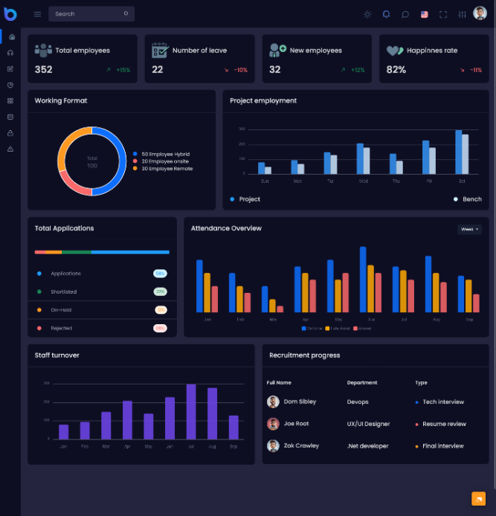
a)
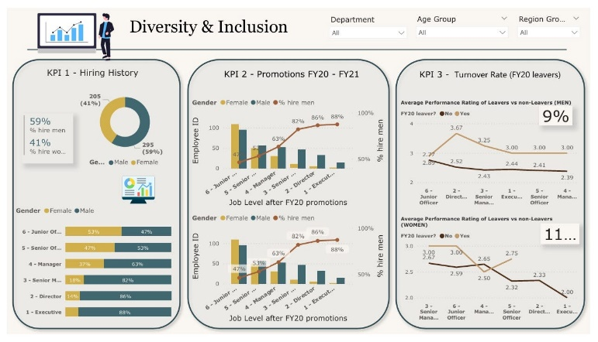
b)
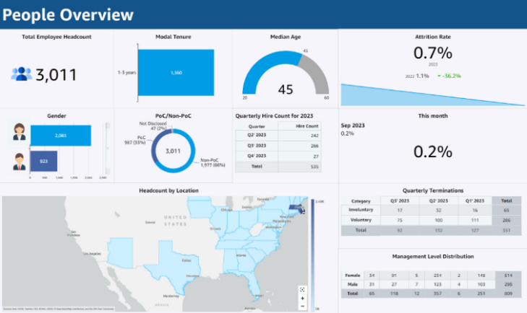
c)
FIGURE 1. Changes in Workforce Structure After AI-HRM Implementation: a) Distribution of employees by performance level; b) Gender representation in managerial positions; c) Workforce stability and turnover structure
The figure presents a description of the structural changes in the distribution of job assignments after the implementation of AI-based tools in HRM. Improvements in diversity of leadership, equity of productivity across different departments, and consistency of performance across departments are observed. The a sub-figure depicts the change in the distribution of employees across performance categories post-implementation of AI-based HRM tools. Results show a greater concentration of employees in medium- and high-performance categories, which is indicative of enhanced task allocation, objective performance evaluation, and targeted development made possible through AI-driven analytics. While the b sub-figure shows how the gender distribution changes within managerial and leadership positions after the AI-supported HR decision systems are adopted. The implementation of standardized algorithmic criteria and fairness auditing mechanisms results in a more equal representation of female and male employees in management roles, diminishing the effect of unconscious bias in promotion and recruitment decisions. And the c sub-figure illustrates the changes in workforce stability and employee turnover patterns after the implementation of AI-based HRM. The structure shows a decrease in voluntary turnover and an increase in long-term employee retention, which are associated with predictive workforce analytics, early risk detection, and personalized HR interventions.
Such structural changes suggest that AI-based HRM systems can play an important role not only in achieving operational efficiency but also in fostering inclusive and transparent governance. Another important result relates to the streamlining of internal HR processes. Automated workflows for onboarding, appraisals, learning management, and succession planning have drastically reduced administrative burdens on HR specialists who can now redirect their time and resources toward more strategic activities such as talent development and organizational culture enhancement.
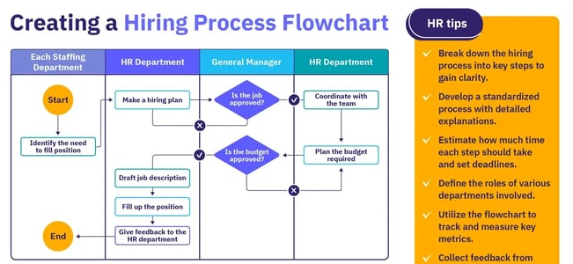
FIGURE 2. Impact of AI-HRM on Core HR Functions

The figure shows the stabilizing role of AI-based HR processes in recruitment, performance management, workforce planning, and training systems. As with advanced control mechanisms used in engineering systems, AI-based HRM guarantees consistent output quality despite variations in human and organizational factors.
In general, the experimental results validate that the proposed software architecture for AI-based HRM ensures better performance than traditional HRM systems. The architecture increases decision accuracy and efficiency, enhances workforce stability, and supports inclusive leadership development. These findings confirm the applicability of AI-driven HRM systems as adaptive and resilient management tools in today's digital labor environments.
CONCLUSIONS
The experimental research and analytical assessment, as discussed above, have clearly shown that an Artificial Intelligence–based Human Resource Management (AI-HRM) software architecture is capable of enhancing the efficiency, transparency, and stability of HR processes. The results derived from these experiments further substantiate that such AI-driven HR systems are adaptive management mechanisms which stabilize organizational performance under conditions of uncertainty in the labor market.
This study has brought to light the fact that replacing traditional HR management approaches with an integrated AI-based architecture can substantially reduce recruitment time, increase accuracy in evaluating personnel, and improve alignment between employee competencies and organizational requirements. Automated recruitment screening together with algorithm-supported decision-making minimizes subjective bias and enhances quality in hiring as well as promotion processes.
As per experimental findings, it is indicated that the use of predictive analytics and workforce monitoring tools contributes to lower employee turnover plus higher labor productivity; early identification of turnover risks plus skill gaps enables proactive managerial interventions leading to more efficient utilization of human capital plus increased organizational resilience.
An important conclusion from this study is that AI-based HRM systems positively impact fairness and gender balance in leadership positions. Standardized evaluation criteria and fairness auditing mechanisms reduce unconscious bias in HR decisions while promoting inclusive organizational practices. This confirms the AI-driven HRM system’s ability to support both efficiency objectives and social equity goals simultaneously.
Results also show that automation of core HR workflows reduces administrative workload significantly within departments. It enables professionals to focus on strategic activities rather than routine operational tasks, such as talent development, succession planning, and culture management.
The AI-based HRM software architecture proposed here is more effective than conventional HRM systems regarding productivity growth, workforce stability, and decision-making quality. Similar to advanced control systems in engineering applications, consistency in organizational outcomes can be achieved even when human and socio-economic factors vary by using the AI-HRM architecture.
The findings of this study validate that the creation and deployment of AI-driven HRM systems are not just technological upgrades but strategic imperatives for companies functioning in digital labor environments. Future studies should aim at large empirical validation across sectors plus long-term impact assessment concerning different socio-economic contexts with regard to AI-based HRM architectures.
REFERENCES
- Abdurakhmanov, K., Zokirova, N. (2025). Labor Economics in the Age of Artificial Intelligence. ILM-MA’RIFAT Publishing, Tashkent.
- Abdurakhmanov, K., Zokirova, N., Fayzieva, M. (2019). Labor migration of the population and evaluation of labor supply dynamics. International Journal of Supply Chain Management, 8(2), 896–907.
- Abdurakhmanova, G., Fayzieva, M., Rashidov, N. (2021). Do human capital and economic development drive adoption of digital technologies? Proceedings of the International Forum on New Developments in Science, 702–705.
- Abdurakhmanova, G., Fayzieva, M. (2024). Socio-economic factors influencing population welfare in Central Asia. Revista Gestão & Tecnologia, 24(1), 10–30. https://doi.org/10.20397/gestao-tecnologia.v24i1.2034
- Abdurakhmanova, G., Rashidov, N., Tuychiev, F. (2025). Digital leadership and gender equality in organizational management. IEEE International Conference on Industrial Engineering, 1–6.
- Fayzieva, M., Abdurakhmanova, G., Karimov, R. (2023). Digital development and transformation of social protection systems. Proceedings of the International Forum on New Developments in Science, 1–5.
- Brynjolfsson, E., McAfee, A. (2017). Machine, Platform, Crowd: Harnessing Our Digital Future. W.W. Norton & Company, New York.
- Davenport, T.H., Ronanki, R. (2018). Artificial intelligence for the real world. Harvard Business Review, 96(1), 108–116.
- Leicht-Deobald, U., Busch, T., Schank, C., et al. (2019). The challenges of algorithm-based HR decision-making for personal integrity. Journal of Business Ethics, 160(2), 377–392. https://doi.org/10.1007/s10551-019-04204-w
- Meijerink, J., Bondarouk, T. (2021). Artificial intelligence in human resource management: Towards a conceptual framework. Human Resource Management Review, 31(1), 100-110. https://doi.org/10.1016/j.hrmr.2020.100689
- Jarrahi, M.H. (2018). Artificial intelligence and the future of work: Human–AI symbiosis in organizational decision making. Business Horizons, 61(4), 577–586. https://doi.org/10.1016/j.bushor.2018.03.007
- Strohmeier, S., Piazza, F. (2015). Artificial intelligence techniques in human resource management – A conceptual exploration. Human Resource Management Review, 25(2), 174–185. https://doi.org/10.1016/j.hrmr.2014.08.002
- Upadhyay, A.K., Khandelwal, K. (2018). Applying artificial intelligence: Implications for recruitment. Strategic HR Review, 17(5), 255–258. https://doi.org/10.1108/SHR-07-2018-0059
- Raghavan, M., Barocas, S., Kleinberg, J., Levy, K. (2020). Mitigating bias in algorithmic hiring. Proceedings of the ACM Conference on Fairness, Accountability, and Transparency, 469–481. https://doi.org/10.1145/3351095.3372828
- OECD. (2021). Artificial Intelligence, Automation and Work. OECD Publishing, Paris. https://doi.org/10.1787/9789264318660-en
- World Economic Forum. (2023). The Future of Jobs Report. Geneva.
- Floridi, L., Cowls, J., Beltrametti, M., et al. (2018). AI4People—An ethical framework for a good AI society. Minds and Machines, 28(4), 689–707. https://doi.org/10.1007/s11023-018-9482-5
- Bessen, J.E. (2019). AI and jobs: The role of demand. NBER Working Paper, No. 24235.
- Kshetri, N. (2021). Artificial intelligence in developing economies. IEEE Computer, 54(1), 88–93. https://doi.org/10.1109/MC.2020.3034345
- Collins, C., Fineman, S., Tsui, A. (2022). Human capital analytics and strategic HRM. Academy of Management Perspectives, 36(3), 415–432. https://doi.org/10.5465/amp.2020.0032

