The method for assessing how well AI-driven changes work in managing human resources
Malika Khaydarova^{1,a)}, Gulnora Abdurakhmonova¹, Tillaoy Rakhmonova², Shakhnoza Kabilova²
¹ Tashkent State University of Economy, Tashkent, Uzbekistan
²Karshi State University, Karshi, Uzbekistan
^{a)} Corresponding author: mkhaydarova93@gmail.com
Abstract. The article deals with the methodological basics of determining and evaluating innovations in the Human Resource Management domain. It discusses managerial innovations in HRM, indicating some specific features that set them apart from technological and product innovations, which make their economic and social effects difficult to measure. The major approaches for assessing the effectiveness of innovations in HR management are systematized and classified according to the type of calculated effectiveness and evaluation methodology. Economic and social indicators are used for assessing HR innovations and their impact on organizational performance. Particular attention is paid to synergistic effects as well as intangible organizational outcomes impacted by HR innovations, such as stability of the workforce, motivation, and socio-psychological climate. An econometric modeling approach is suggested for establishing relationships between innovations in HR management and key performance indicators like productivity of labor, turnover of employees, and intensity of training. Innovations in human resource management lead to enhanced efficiency and flexibility at the organizational level, albeit with challenges in clearly attributing direct financial benefits. This methodological framework can be used for assessing HR innovation effectiveness at both organizational and subsystem levels; it may also serve managers in decision-making processes related to introducing new practice innovations in human resource management.
INTRODUCTION
Innovation has turned into the most significant stimulant for the competition of organizations and their sustainable development. Nonetheless, innovations in Human Resource Management have not been implemented and evaluated systematically as compared to technological and product innovations. This is primarily due to the fact that HRM innovations are complex in nature whose results are often intangible, delayed, and difficult to express through direct financial indicators. Innovations in human resource management are classified under managerial innovations and they are very much related to social, organizational, and behavioral factors. Unlike technological innovations which deal more with machinery or technology itself, HRM innovations deal more with motivating people inside an organization that eventually leads to productivity stability as well as a good socio-psychological climate within organizations. Therefore, assessing the effectiveness of such innovations requires consideration not only of economic outcomes but also social ones plus synergistic effects that arise from interactions among HR subsystems.
The relevance of assessing HRM innovations has recently intensified due to the processes of digital transformation. The widespread introduction of data-based tools, analytics, and artificial intelligence into HR processes creates new opportunities for increasing labor productivity and improving the adaptability of organizations. At the same time, these changes require a reliable methodological base for assessing the effectiveness of innovative HR practices in modern economic conditions. Although research on human resource management is becoming more extensive every day, there is still no single methodological approach to evaluating the effectiveness of innovations in human resource management. Existing approaches evaluate either the overall efficiency of the HR system or individual indicators without separating the influence of specific innovations. This proves that there is a need for a methodical approach that will combine criteria for economic and social effectiveness and hence assist evidence-based decisions.

The objective of this article is to systematize existing approaches to assessing innovation in human resource management and develop a methodological approach based on performance indicators and econometric analysis. This approach would help managers and researchers evaluate the results achieved by innovative techniques in human resource management as well as enhance organizational performance under changing economic conditions.

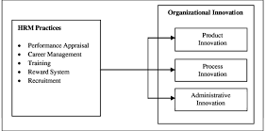

FIGURE 1. Conceptual Dynamics of HRM Innovation Impact on Organizational Performance

Figure 1 is a diagram that shows how changes in human resource management can affect how well an organization does. It is based on a logic created by the author, where innovations in HRM have an impact on both economic results (like productivity growth, efficiency, and reducing costs) and social results (such as employee happiness, stability of the workforce, and climate of the organization). The combination of these effects produces a synergy effect that defines the overall effectiveness of innovative HR practices.

EXPERIMENTAL RESEARCH
The experimental study is directed toward testing the applicability of the proposed methodological approach to evaluate innovations in Human Resource Management. The study has been undertaken based on an analysis of HR management innovations that have already been implemented within organizations, which operate under conditions of economic transformation accompanied by increasing competition.
The research design is based on a combined analytical and econometric approach wherein Innovations in HR management are treated as independent managerial interventions affecting key organizational performance measurements. The experimental setting takes place by trying to establish an association between the introduction of innovations in HRM and changes observed regarding economic and social performance indicators.
In order to carry out the experimental analysis, a set of quantitative and qualitative variables has been developed. The main dependent variable is employee productivity since it epitomizes the overall effectiveness of workforce utilization. Independent variables include indicators characterizing innovations in human resource management, such as the level of implementation of innovative HR practices, employee training intensity, and participation in professional development programs. Additional control variables include employee turnover and workforce satisfaction indicators.
Data for carrying out this empirical study were obtained from organizational reports, internal HR documentation, surveys, interviews as well as statistical data reflecting the results before and after innovation implementation in HR management activities. The analysis period covers comparable observation periods which allows minimizing external factors’ influence on the results.
An econometric modeling approach is applied to assess the effectiveness of HR management innovations. A multiple regression model is used to estimate the impact of HRM innovation indicators on employee productivity. The general form of the regression model is defined as:
Y=β0+β1·HRMI+β2·EE+β3·Tr+ε (1)
Where: Y – employee productivity indicator; HRMI – indicator of innovations applied in human resource management; EE– employee education and qualification level; Tr – training courses and professional development activities; βi – model coefficients; ε – error term.
The model parameter estimation reveals how significant and what direction the influence is for innovations in HR management regarding performance at an organizational level. With this experimental approach, it is possible to separate the effect of innovations in HRM from other factors that are also impacting productivity and efficiency. This methodology can fully assess economic and social effects resulting from innovation in human resources management while at the same time providing a practical instrument to judge the effectiveness of innovative practices related to HR on an organizational level.
RESEARCH RESULTS
The use of the suggested method framework allowed assessing the efficiency of innovations in Human Resource Management with the help of both economic and social performance indicators. The results obtained prove that HRM innovations have a tangible impact on organizational performance, although it is not easy to separate their direct financial effects. The econometric analysis proves that there is a positive relation between the level of implementation of HRM innovations and employee productivity. The results from the regression model show that the HRMI indicator has a statistically significant influence on productivity growth, thereby confirming innovative HR practices as contributing to more efficient human capital utilization. Employee training and professional development variables also demonstrate a positive effect, thus emphasizing continuous learning as a complementary factor for increasing the effectiveness of HRM innovations.
Besides economic results, there are significant enhancements in social performance indicators. Organizations that implement HRM innovations experience lower employee turnover, greater workforce stability, and higher levels of employee satisfaction. These effects showcase the indirect but crucial role played by HRM innovations toward organizational sustainability and long-term adaptability.

TABLE 1. Key Performance Changes After HRM Innovation Implementation
Indicator | Before HRM Innovation | After HRM Innovation | Observed Effect
Employee productivity | Baseline | Increased | Positive
Employee turnover | High | Reduced | Negative change
Training intensity | Low–moderate | High | Positive
Workforce satisfaction | Moderate | Improved | Positive

The comparison in Table 1 shows that the introduction of new practices in HR management consistently improves both economic and social aspects. Productivity growth comes with a decrease in turnover and an increase in training activity, indicating a synergistic effect from HRM innovations. The results also indicate that HRM innovations mainly influence organizational performance through indirect channels. Enhancements in motivation, skill development, and socio-psychological climate come before and support economic outcomes. This is what makes traditional evaluation approaches based only on financial indicators often underestimate the effectiveness of innovations in human resource management.
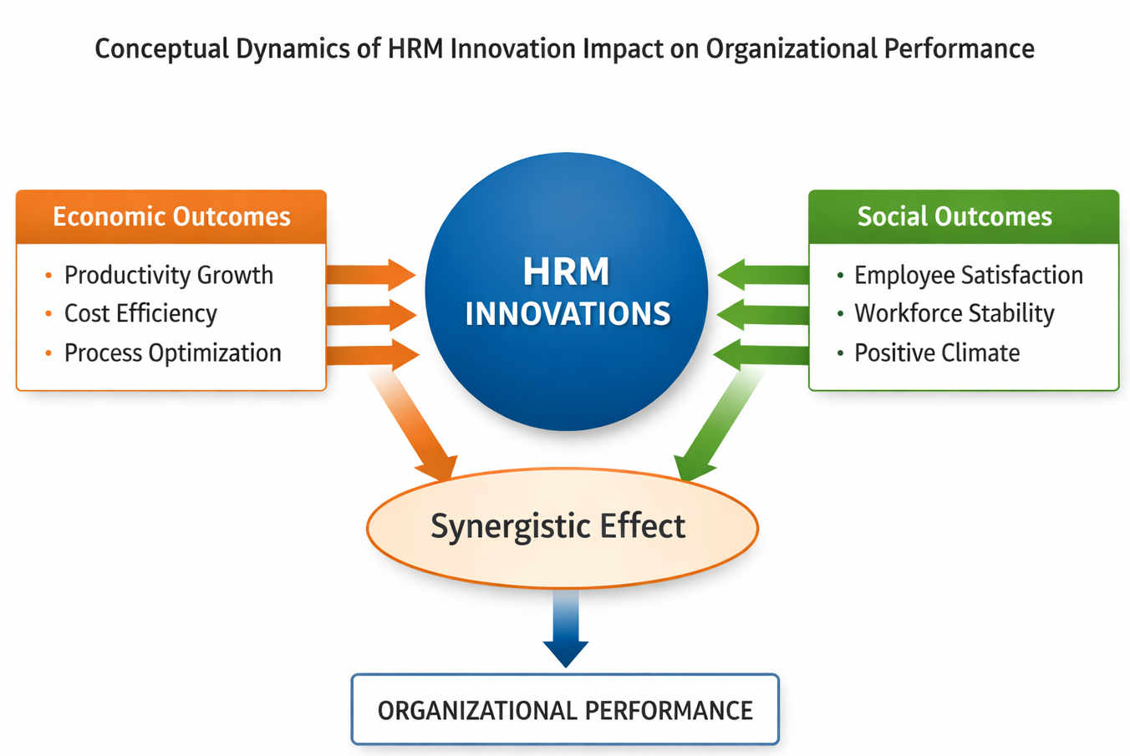
FIGURE 2. Conceptual Model of the Impact of Human Resource Management Innovations on Organizational Performance
The author’s conceptual framework presented in the figure above demonstrates how innovations in Human Resource Management impact organizational performance. Innovations in HRM lead to both economic outcomes (such as productivity growth, cost efficiency, and process optimization) and social outcomes (including employee satisfaction, labor stability, and a positive climate within the organization). These effects combine synergistically to improve the overall performance of the organization. In general, research results confirm that the proposed methodology for evaluating the effectiveness of innovations in human resource management is applicable. The findings support viewing HRM innovations as strategic managerial tools meant to improve organizational efficiency, adaptability, and stability under conditions of dynamic change in the economy.
CONCLUSIONS
The results of this study confirm that innovations in Human Resource Management represent a distinct category of managerial innovations whose effectiveness cannot be fully assessed using traditional financial indicators. Innovations in HRM are strongly linked with social, organizational, and behavioral factors; therefore, they generate both economic and social outcomes that together determine organizational performance.
The proposed methodological approach allows for the comprehensive assessment of HRM innovations by combining indicators of economic effectiveness, social performance, and econometric analysis. The use of regression modeling shows that innovations in HR management have a statistically significant positive impact on employee productivity, stability of the workforce, and efficiency at the level of the whole organization.
The study findings bring out that the effectiveness of HRM innovations is mainly manifested through indirect channels such as enhancing motivation among employees, professional development, and improving the socio-psychological climate within an organization. These impacts create a synergistic effect increasing organizational agility and sustainability over time under changing economic conditions.
It also brings out inadequacies in existing approaches to evaluating innovations in HR management since they do not isolate the contribution made by specific innovations or take into account their delayed and intangible effects. The proposed framework on the other hand provides a structured yet analytically sound tool for assessing innovation effectiveness at both organizational levels as well as individual HR subsystems.
In general terms, results show that systematic evaluation is necessary for evidence-based decision-making and efficient application of innovative practices in human resource management. The methodology proposed can be used by managers and researchers to better their management systems within human resources plus aid strategic developments within organizations. Further studies should work toward broadening empirical datasets plus testing this specific approach through varying sectors plus institutional contexts.
REFERENCES
- Abdurakhmanova, G.K. (2020). The role of small businesses in the market economy. Science and Practice, 3, 77–82.
- Abdurakhmanova, G.K. (2020). Human Resource Management. Tashkent: Textbook.
- Abdurakhmanova, G.K. (2023). Human Resource Management. Tashkent: Textbook.
- Abdurakhmanova, G.K., Shayusupova, N., Irmatova, A., Rustamov, D. (2020). The role of the digital economy in the development of the human capital market. Archive of Scientific Research, 25.
- Alberg, V.F. (1993). Formation of a Personnel Management System at an Enterprise Using Functional System Analysis: Organizational and Economic Aspect. PhD Dissertation, Moscow.
- Armstrong, M. (2014). Armstrong’s Handbook of Human Resource Management Practice. London: Kogan Page.
- Drucker, P. (2007). Innovation and Entrepreneurship. Oxford: Butterworth-Heinemann.
- Frascati Manual. (2002). Proposed Standard Practice for Surveys on Research and Experimental Development (6th ed.). OECD Publishing. https://doi.org/10.1787/9789264199040-en
- Frechette, H., Wertheim, E. (1985). Performance appraisal. In: Human Resource Management and Development Handbook (2nd ed.). New York: Amacom.
- Gomez-Mejia, L.R., Welbourne, T.M. (1988). The role of compensation in the human resource strategies of high technology firms. Southern Management Association Proceedings, 58–60.
- Grimm, M., Harttgen, K., Klasen, S., et al. (2010). Inequality in human development: An empirical assessment of 32 countries. Social Indicators Research, 97(2), 191–211. https://doi.org/10.1007/s11205-009-9497-7
- Jørgensen, F., Becker, K.L., Matthews, J.H. (2009). Human resource management and innovation: What are knowledge-intensive firms doing? In: Proceedings of the 10th International CINet Conference. Brisbane, 451–463.
- Khaitov, A.B. (2019). Human Resource Management. Tashkent: Textbook.
- Khaydarova, M.Sh. (2024). Innovation in company labor productivity management: Data science methods application. International Journal of Artificial Intelligence, 4(4), 13–26.
- Khaydarova, M. (2024). Opportunities for using artificial intelligence for managing human resources in the context of the digital economy. Journal of Academic Research and Trends in Educational Sciences, 3(2), 367–374.
- Khaydarova, M.Sh. (2024). Adaptive artificial intelligence in human resource management. Economy and Society, 3-2(118), 851–864.
- Lobanova, T.N. (2004). Organization and Personnel. Moscow: Gorodets.
- Nikolaev, A.A. (2001). Innovative development and innovative culture. Problems of Management Theory and Practice, 5, 44–51.
- Ovchinnikova, T. (2003). New paradigm of personnel management in transition economies. Personnel Management, 7, 34–39.
- Prigogine, A.I. (2003). Management innovations: Unidentified resources. Personnel Management, 1, 78–94.
- Sparrow, P.R. (1988). Human resource management in high technology firms. Journal of Organizational Behavior, 9(3), 289–291.
- Thurow, L.C. (1970). Investment in Human Capital. Belmont: Wadsworth Publishing.
- Ulrich, D., Lake, D.G. (1990). Organizational Capability: Competing from the Inside Out. New York: Wiley.
- Vodáček, L., Vodáčková, O. (2009). Management: Theory and Practice in the Knowledge Economy. Prague: Management Press.
- World Health Organization. (2007). Health: A Vital Investment for Economic Development in Eastern Europe and Central Asia. Copenhagen: WHO Regional Office for Europe.

