Energy-Efficient Management Solutions for the Alkaline Refining Process of Vegetable Oils
Yusuf Avazov, Umid Ruziev ª, Marufjon Shodiev, Kamola Abdullaeva, Elbek Ortiqov
Tashkent state technical university named after Islam Karimov, Tashkent, Uzbekistan
- Corresponding author: umidruziev7@gmail.com
Abstract: This article focuses on the analysis of energy-saving technologies employed in the alkaline refining process of vegetable oils, to enhance resource efficiency in production and minimize their environmental impact. Traditional technological solutions and new directions for their modernization are considered. These include the use of weak alkalis and low-temperature neutralization regimes, the introduction of membrane phase separation methods, and the reuse of thermal energy. Particular attention is paid to the issue of adjusting technological parameters to the specific characteristics of the raw materials, including the wax content in sunflower oil and gossypol in cottonseed oil. It is shown that the use of energy-saving technologies allows for reducing total energy consumption by 2-8%, reducing irreversible oil losses, and improving the preservation of natural microelements.
INTRODUCTION
Research on improving the neutralization process of vegetable oils remains relevant to increase resource efficiency and reduce technogenic impact. Particular attention is paid to reducing heat losses, reducing the volume of wastewater, and reducing reagent consumption while maintaining the target purification indicators. The need to optimize technological parameters is further enhanced by the specific characteristics of the composition of various oils. Cottonseed oil is characterized by the presence of gossypol and its derivatives, which must be almost eliminated to ensure safety. Thus, adapting alkaline refining to the composition of the raw materials is becoming an important scientific and practical task aimed at increasing the energy and environmental efficiency of the process [1,2].
Modern approaches to alkaline refining of vegetable oils The traditional method of alkaline neutralization involves preheating the oil, adding a standardized solution of NaOH, neutralization reaction with the formation of soapstock, separation of phases in a centrifuge, washing with hot water, and subsequent drying in a vacuum [3]. The process has high technological reliability, providing a reduction in the acid number to 0.05-0.1 mg KOH/g, the removal of free fatty acids, hydrated phospholipids, and part of the coloring matter [4]. The main technological limitations of the process are the irreversible loss of neutral oil due to unnecessary saponification, high energy consumption of heating, washing, and vacuum drying operations, as well as the formation of large volumes of wastewater. These factors determine the need to introduce methods aimed at increasing its energy efficiency, selectivity, and environmental friendliness. The directions for the modernization of alkaline refining include: the use of weak alkalis and low-temperature regimes, which reduce oil loss and preserve biologically valuable components; the introduction of membrane technologies instead of energy-intensive washing and centrifugation; the use of heat recovery and high-efficiency heat exchangers to reduce primary energy consumption; the acceleration of processes using ultrasound, reducing processing time and reagent consumption; as well as increasing the accuracy of control of technological parameters through intelligent digital control systems [5].
Multi-stage neutralization is an improved version of the basic process developed for the effective purification of oils with complex and high levels of impurities, especially cottonseed oil, which contains toxic gossypol pigment and similar colored compounds. The traditional three-stage scheme includes the following sequential stages: initial neutralization with a concentrated NaOH solution to remove the bulk of free fatty acids and primary gossypol; then a second treatment at high temperature, often with a weaker alkaline solution, for final clarification; and finally a final wash. Each stage is carried out with phase separation in centrifuges [6].

Table 1. Energy consumption at the main stages of the alkaline refining process
Process Parameter | Value | Energy Consumption  (MWh/t)
Neutralization temperature | 40-85 °C | 0,15-0,25
Wash temperature | 85-95 °C | 0,10-0,15
Vacuum drying | 90-95°C, <50 mbar | 0,20-0,30
Total energy consumption | - | 0,45-0,70

The advantage of this technology is that it is possible to reduce the residual content of gossypol and color to an extremely low level. However, the main disadvantage, in addition to the increased complexity of the equipment system, is a significant increase in energy consumption - 10-20% higher than in a single-stage scheme, which is associated with multiple heating of the streams and the operation of separation equipment at each stage.

Table 2. Limited activity at low temperatures
Technology Time, min | Temperature, °C | Residual P, mg/kg | Increase in yield, %
Acid degumming | 40-45 | 30 | 10-20
Quara Low | 70 | 240 | <10
Lecitase Ultra | 55-60 | 180 | <10
Purifine | 60 | 120 | <10
ALTERNATIVE CAUSTIC AGENTS
The use of alternative caustic agents is one of the most effective approaches to reduce energy consumption in caustic refining processes. The use of weak caustics such as Ca(OH)₂, MgO, or Na₂SiO₃ allows neutralization to be carried out at low temperatures (around 40 °C), which leads to a reduction in unnecessary saponification and ensures the preservation of biologically valuable components (tocopherols, phytosterols, and polyphenols) [7,8]. The use of Ca(OH)₂ at a concentration of 0.15% has been shown to reduce the amount of free fatty acids to ~0.05%, providing improved oxidation stability while reducing energy consumption. In addition, the environmentally sound use of CaO derived from natural raw materials (e.g., shells) can reduce environmental impact and contribute to the sustainability of production. In addition to changing the reagent stage, significant energy savings can be achieved by introducing heat recovery technologies, ultrasonic intensification, and alternative methods of impurity removal. High-efficiency heat exchange networks (HEN) reduce primary thermal energy consumption by 5-10%, and the cavitation effect of ultrasound reduces the duration of the degumming and bleaching processes by 10-15%, while reducing reagent consumption [6]. Cold refining of sunflower oil and micellar refining of cottonseed oil allow energy savings of up to 20-30% due to reduced heating and elimination of washing. Together, these approaches provide increased energy efficiency and technological selectivity, which confirms the promising prospects of comprehensive modernization of traditional refining schemes.

Table 3. Comparative analysis of technologies
Technology | Energy savings,  % | Reduction in oil losses, % | Payback period,  years
Traditional Alkaline Refining | 3-8 | basic | -
Membrane Desalting | 5-10 | 40-60 | 3-5
Enzymatic Desalting | 10-15 | 30-50 | 1-2
HEN Integration | 15-20 | 0-5 | 2-4
Weak Alkalis | 5-10 | 20-30 | 2-3
Ultrasound + Enzymes | 25-35 | 35-45 | 4-6
Cold Refining | 20-25 | 15-25 | 1-2
Miscella Refining | 20-25 | 25-40 | 2-3
ENERGY MANAGEMENT SYSTEMS
With the increasing demands on resource efficiency in the production of vegetable oils, the introduction of intelligent energy management systems (Energy Management Systems, EMS) is becoming the most important direction for increasing the energy sustainability of the industry. The main task of EMS is to ensure the rational distribution of heat and electricity flows at all stages of refining by analyzing data in real time and automatically regulating technological indicators [90]. The use of IoT sensors allows for continuous monitoring of temperature, pressure, reagent concentration, and energy carrier consumption in key parts of the equipment, while the integration of this data into SCADA systems provides centralized control and prevents deviations from optimal modes[10].
A significant increase in the efficiency of control systems is provided by the use of machine learning and predictive analytics methods that allow predicting energy consumption, taking into account the production schedule and the quality of incoming raw materials. For example, digital copies of production lines provide virtual testing of various operating modes without interfering with the real technological process, which allows you to pre-determine the control directions that require the least energy. Such solutions allow you to reduce specific energy consumption by 10-15 percent, reduce the time of starting and stopping the equipment, increase the readiness factor, and extend the service life of the equipment by eliminating emergencies. Figure 1 shows the change in product yield during alkaline neutralization at two different temperatures: 50 °C and 70 °C. An increase in the reaction temperature leads to a significant increase in product yield due to the acceleration of mass transfer processes and a more complete release of free fatty acids.
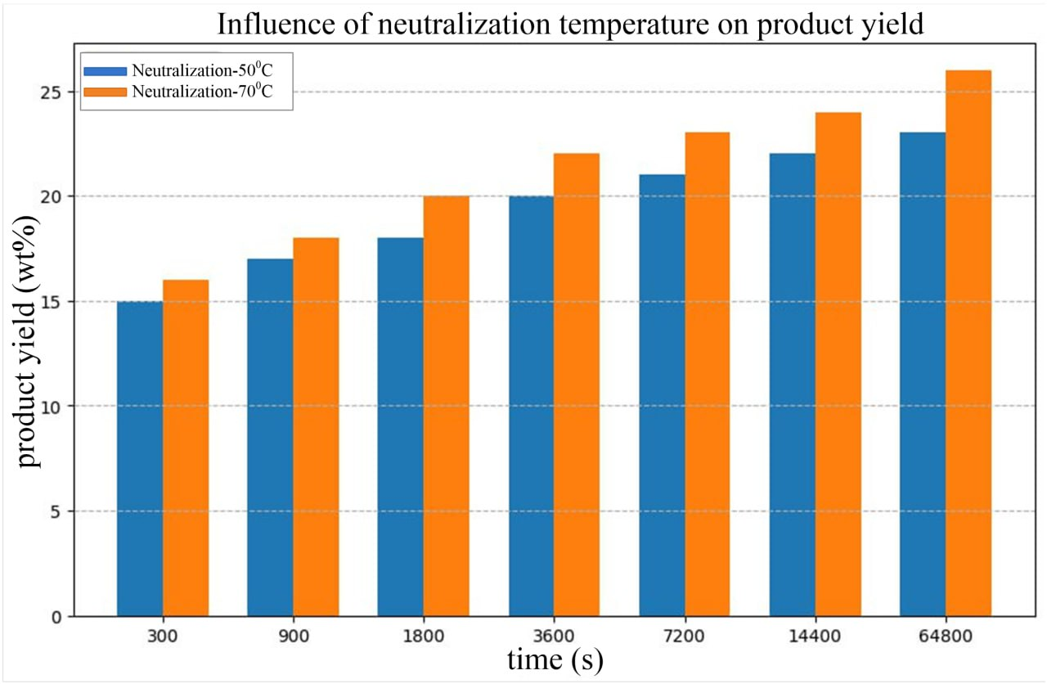
FIGURE.1. Effect of neutralization temperature on product yield over time

Figure 2 shows that the traditional method achieves maximum yield (~98-99%) faster, while green methods have slower kinetics, reaching 80-95% yield, but have the advantage of being environmentally friendly and preserving bioactive substances.

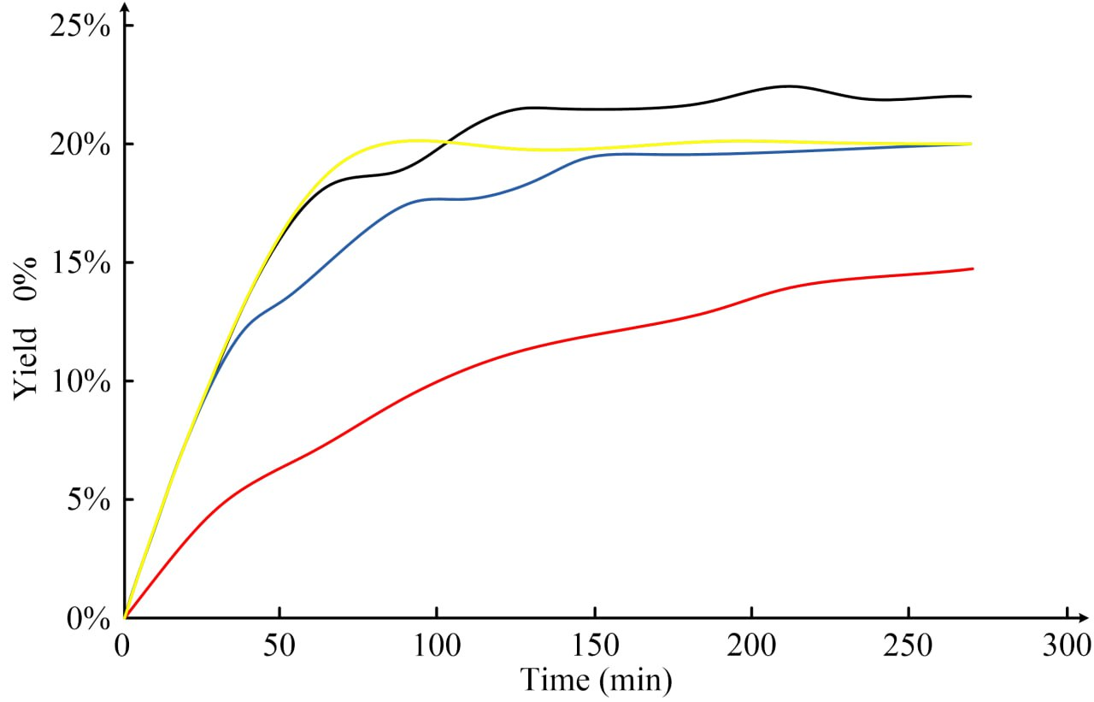
FIGURE 2. Kinetics of oil yield during the extraction of vegetable oils by different methods.
Yellow curve – aqueous enzymatic extraction, blue curve - supercritical CO₂ extraction, red curve – hydrostatic/mechanical pressing, black curve - traditional hexane extraction (reference data).
The integrated scheme of sunflower oil refining is aimed at minimizing energy consumption, reducing neutral oil losses, and increasing the environmental safety of the technological process [11]. At the first stage, enzymatic degumming is carried out for two hours at a temperature of 60 °C, which ensures the selective decomposition of phospholipids with moderate energy consumption. Then, minimal neutralization with weak alkali (Ca(OH)₂) is carried out at a temperature of 40 °C, which allows for significant reduction of unnecessary saponification and reagent consumption. At the third stage, membrane ultrafiltration is used, designed for fine separation of soap and residual hydrated phospholipids without the use of aqueous washes. The fourth stage consists of cold winterization with cold recovery at a temperature of 10-12 °C, which ensures high product clarity and eliminates additional heating. The final stage is bleaching with ultrasonic intensification, which reduces processing time and adsorbent consumption by increasing the efficiency of mass transfer. The complex integration of the above stages provides significant synergistic effects, including a 5-10% reduction in total energy consumption compared to traditional alkaline refining schemes, a reduction in irreversible oil losses to 1-1.5%, a 10-20% reduction in wastewater volume, and improved final product quality by preserving natural antioxidants (tocopherols, sterols). The overall carbon footprint of the process is reduced to 25%, which meets modern requirements for sustainable development and environmental safety of production. An integrated approach to cottonseed oil refining is based on the specific characteristics of its composition, including the need to almost completely remove the toxic gossypol pigment. At the initial stage, micellar refining in a hexane environment is used, which allows for the effective removal of both free fatty acids and unwanted pigments. Subsequently, anhydrous membrane separation is used, which increases oil yield and reduces wastewater volume. The energy-efficient distillation stage uses mechanical vapor recompression (MVR) technology, which significantly reduces the heat consumption of the process. The final stage is enzymatic additional purification, which provides stable organoleptic properties and additional removal of residual phospholipids. The installed system for utilizing the heat of hexane condensation allows for additional energy recovery within the technological cycle.

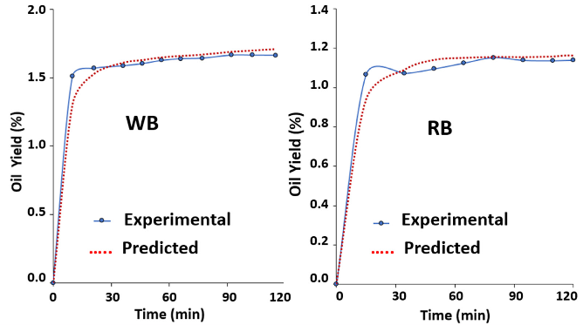
a) b)
FIGURE.3. Comparison of oil yields with different extraction strategies; a) Whole Bran, b) Refined Bran.

The use of this integrated scheme leads to significant energy savings of 5-10%, ensures high yields of refined oil, and allows obtaining a light-colored product without intensive bleaching. Thus, the proposed concept demonstrates high technological efficiency and can be implemented at existing enterprises with minimal modernization of equipment. The introduction of energy management systems (Energy Management Systems, EMS) ensures an increase in the energy efficiency of production by optimizing the operating modes of equipment in real time. The basis of such systems is the use of IoT sensors for continuous monitoring of temperature, pressure, and consumption of energy carriers, as well as the use of predictive analytics and machine learning algorithms to predict and minimize peak loads. Integration with SCADA platforms provides centralized control and early detection of unexpected deviations, while digital twins of technological lines allow testing operating modes without stopping the equipment. Practical results of EMS implementation show a reduction in specific energy consumption by up to 10%, a reduction in unplanned downtime through preventive equipment management, and an improvement in the distribution of energy loads depending on the time of day.
One of the main objects of digitalization is the alkaline neutralization process, which is traditionally characterized by high energy and raw material losses. The use of fuzzy logic, adaptive adjustment, and neural network algorithms allows you to automatically adjust the amount of alkali depending on the current acid number, oil viscosity, dispersion level, and phase separation efficiency. The introduction of such systems ensures a 20-30% reduction in excess alkali, which directly reduces unnecessary saponification and associated oil losses, as well as reduces the volume of wastewater.
In addition, intelligent control systems optimize the hydrodynamic conditions in the neutralization reactor by selecting optimal mixing parameters and retention times depending on the composition of the raw material. This allows reducing the process duration by 15-20% while maintaining or increasing the quality of the refined oil. It is important that such systems demonstrate high resistance to changes in the composition of the raw oil, which is especially relevant for small and seasonal refineries. Thus, intelligent control helps to form an energy-efficient, flexible, and environmentally friendly technological system.
During the refining of vegetable oils, especially during alkaline neutralization, a large number of by-products are formed. The main one among them is soapstock - a soapy residue containing fatty acid salts, neutral fats, phospholipids, and water. Traditionally, soapstock was considered a waste that must be disposed of, but in the framework of a circular economy, it is being evaluated as a valuable secondary resource. Its processing allows not only to reduce environmental damage, but also to obtain additional products and energy. Soapstock can be subjected to acid hydrolysis (using sulfuric or phosphoric acid). As a result, technical or food fatty acids (acid oil) are obtained, which are suitable for the production of soap, feed additives, or oleochemicals. Another method is enzymatic hydrolysis using lipases and phospholipases. This method provides milder conditions, high selectivity, and the absence of aggressive acid residues, allowing the product to be used even for food purposes. In addition, etherification reactions of soapstock with methanol or ethanol allow the production of fatty acid methyl esters (FAME). This is the basis for the production of biodiesel, which directly contributes to replacing fossil fuels and reducing the carbon footprint of the industry. Of particular interest is the anaerobic digestion of soapstock, often in combination with other organic waste (e.g., refinery wastewater or sludge). The biogas output is 0.3-0.5 m³ CH₄ per kilogram of dry matter. This is equivalent to 6-10 kWh of energy per kilogram. Covers up to 3-8% of the enterprise’s own electricity needs and reduces emissions. The resulting digestate can be used as an organic fertilizer, closing the nutrient cycle. Such approaches not only reduce the amount of waste that is disposed of in landfills or incinerated, but also turn by-products into renewable energy and material sources. This is fully consistent with the principles of the circular economy. The refining of vegetable oils generates large volumes of wastewater containing oils, fats, etc., which are causing groundwater pollution. If not properly treated, such wastewater leads to eutrophication of water bodies, groundwater pollution, and ecosystem degradation. Within the framework of environmental aspects and the circular economy, attention is paid to integrated technologies that reduce the volume and pollution of wastewater at source, as well as their treatment with resource recovery.
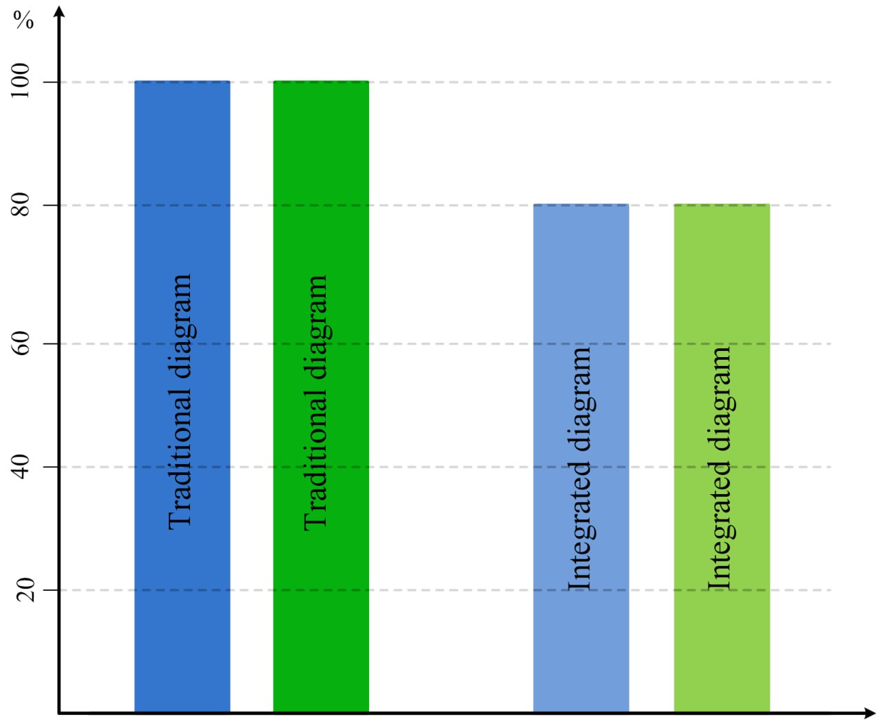
FIGURE.4. Comparison of wastewater and carbon footprint in traditional and integrated refining schemes

The use of physical refining instead of chemical refining significantly reduces the formation of soapstock and acid streams. Because the removal of free fatty acids is carried out not by neutralization with alkali, but by agitation. The membranes as alternative to coagulation-flocculation using membrane technologies (ultrafiltration, nanofiltration) and natural coagulants (for example, based on cactus or tannin) provides effective removal of oils and suspended particles with low energy consumption, reducing the volume of wastewater by 30-50%. Integrated energy-saving systems, including closed cycles of heat recovery and water use, reduce the overall water footprint of production.
CONCLUSIONS
Modern technologies for refining vegetable oils, developed and implemented from 2020-2024, demonstrate significant energy-saving potential while maintaining product quality. Special methods such as switching to weak alkalis and low-temperature processes, optimizing thermal networks, ultrasonic intensification, cold and micellar refining allow reducing energy consumption by 20-50%, minimizing waste, and increasing production sustainability. These approaches not only improve the economy of enterprises but also contribute to reducing the environmental impact of the industry. Further expansion of these technologies and integration with renewable energy sources will pave the way for the production of carbon-neutral vegetable oils.
REFERENCES
- Gao Y. Aqueous enzymatic extraction: A green, environmentally friendly technology for oilseeds / Y. Gao [et al.] // Industrial Crops & Products. – 2024. – DOI: 10.1016/j.indcrop.2023.117430.
- Oubannin S. Recent advances in the extraction of bioactive compounds and enrichment of vegetable oil / S. Oubannin [et al.] // Food Research International. – 2024. – DOI: 10.1016/j.foodres.2024.113929.
- Ding X. Effect of deodorization on beneficial trace components in soybean and rapeseed oils (dual-temperature approach) / X. Ding [et al.] // International Journal of Food Science & Technology. – 2025. – Vol. 60, iss. 1. – DOI: 10.1111/ijfs.17077.
- Kong M. Mitigating TFA formation via optimization of refining steps before deodorization in linseed oils / M. Kong [et al.] // Food Research International. – 2024. – DOI: 10.1016/j.foodres.2024.114583.
- Abrante-Pascual S. Vegetable Oils and Their Use for Frying: Degradation pathways and quality control / S. Abrante-Pascual [et al.] // Foods. – 2024. – Vol. 13, iss. 24. – Art. 4186. – DOI: 10.3390/foods13244186.
- Yildiz A. Y. Quality and stability of frying oils and fried foods in ultrasound- and vacuum-assisted frying / A. Y. Yildiz [et al.] // Comprehensive Reviews in Food Science and Food Safety. – 2024. – DOI: 10.1111/1541-4337.13405.
- Yusupbekov N.R., Avazov Yu.Sh., Rashidov G.Kh. Algorithms for analog-digital information transformation // Proceedings of the XXI International Scientific and Practical Conference "Development of Science in the XXI Century." - Dortmund (Germany), 2025. - PP.104-107.
- Yusupbekov N.R., Avazov Yu.Sh., Rashidov G.Kh. Designing a Gilbert filter for digital signal processing // Proceedings of the III International Scientific and Practical Conference "Bridging disciplines for scientific progress." - Marseille (France), 2025. - PP.34-37.
- Yusupbekov A.N., Gulyamov Sh.M., Turaev Kh.S. Optimization of the Rules Base of Genetic Fuzzy Systems // CEUR Workshop Proceedings, 2021, Vol. 2965, Kolomna, Russia, –PP. 120-125. (3, Scopus, IF 0.8)
- Avazov Yusuf, Marufjon Shodiev, Azamat Rajabov, Khurshid Turaev. Control of the lifecycle of a technological complex for the rectification of multicomponent mixtures under conditions of parameter uncertainty // E3S Web of Conferences 417, 05010 (2023). Scopus. https://doi.org/10.1051/e3sconf/202341705010
- Kholmanov U.U. Shamsutdinova V.H. Application of gas mixture detectors for automatic control systems // AIP Conference Proceeding, 2024, 3119(1), 030005 https://doi.org/10.1063/5.0214844

