Empirical analysis of machine learning models for predicting equipment malfunctions based on IoT sensor data
Yusuf Avazov^{1,а}, Kudirat Babamurotov², Marufjon Shodiev¹, Golibjon Rashidov¹, Husniddin Esonov², Bazarbaev Qabilbek¹
¹Tashkent state technical university named after Islam Karimov, Tashkent, Uzbekistan
²Termez State Engineering and Agrotechnologies University
^{a)} Corresponding author: yusufbek_avazov@mail.ru
Abstract. This article examines the problem of detecting and predicting industrial equipment faults using IoT sensor data through machine learning techniques. Sensor readings such as temperature, vibration, pressure, voltage, and current, as well as FFT-based features, were statistically analyzed. Class imbalance and low signal informativeness were identified as key factors limiting model accuracy. Results obtained from Logistic Regression, Random Forest, and XGBoost models were comparatively evaluated, showing that when ROC-AUC values remain around 0.5, distinguishing fault and non-fault states becomes challenging. Correlation and feature-importance analyses confirmed the absence of strong dominant indicators. The findings highlight the need to improve sensor architecture and apply targeted feature engineering techniques. This study demonstrates that in predictive maintenance, data quality is more critical than model complexity.
INTRODUCTION
In recent years, the issue of ensuring the reliability of equipment and reducing unscheduled downtime in industrial production systems has become increasingly relevant. In particular, as a result of the implementation of IoT (Internet of Things) technologies within the Industry 4.0 concept, it became possible to collect large volumes of sensory data from production equipment in real time. Based on these data, monitoring the condition of the equipment and preliminary identification of possible malfunctions is one of the main goals of the predictive approach to maintenance [1-6].
Traditional maintenance methods are often based on specified time intervals or a reactive approach. Such methods are considered limited in terms of economic efficiency, as they do not take into account the actual state of equipment operation. Therefore, in recent research, methods of intelligent analysis based on sensory data, including machine learning models and anomaly detection algorithms, are widely used [7-12].
Although in practice, many works offer models with high accuracy, research in the field of predicted maintenance shows that model results often strongly depend on data quality, sensory signal informativeness, and property engineering level. In particular, increasing the complexity of the model does not always give a reliable result. This is especially noticeable in datasets with synthetic or poorly marked datasets [13-16].
In this study, the issue of detecting equipment malfunctions based on IoT sensor data is comprehensively studied. The analysis utilizes indicators such as the sensor's readings in the time domain (temperature, vibration, pressure, voltage, and current), FFT-based characteristics obtained in the frequency domain, normalized values, and the anomalous score [17-20]. Classical (Logistic Regression) and ensemble (Random Forest, XGBoost-Extreme Gradient Boosting) machine learning models are used, and their effectiveness is assessed systematically.
The main objective of the study is to determine which factors limit the effectiveness of predicted maintenance models, rather than achieving high accuracy, including diagnosing model results. A comparative analysis of the classification and approaches to detecting anomalies is also carried out using a separate experiment of the "anomalous score" determination method.
The scientific significance of this work lies in the fact that it shows that even negative or low results in the field of projected maintenance can be scientifically correctly interpreted. The obtained conclusions will serve as a methodological basis for further improvement of sensory design, derivation of target characteristics, and development of models based on time series.
This study utilized "IoT-Based Equipment Fault Prediction Dataset" [21]. Dataset includes real-time data collected from industrial equipment through IoT sensors and is aimed at identifying and predicting equipment malfunctions. Table 1 The data includes a total of 33,478 observations, each of which shows the state of equipment operation at a certain time.

Table 1. The data includes a total of 33,478 observations, each of which is the operating state of the equipment at a certain time
# | Timestamp | Sensor_ID | Temperature | Vibration | Pressure | Voltage | Current | FFT_Feature1 | FFT_Feature2 | Normalized_Temp | Anomaly_Score | Fault_Type
0 | 2015-01-01 00:00:00 | S151 | 47.698252 | 34.225292 | 176.199516 | 241.587771 | 8.323269 | 0.224737 | 0.0934 | 0.524226 | 0.239856 | NaN
1 | 2015-01-01 00:01:00 | S192 | 67.260549 | 134.072771 | 110.942636 | 235.003165 | 11.072823 | 0.973402 | 0.6285 | 0.682771 | 0.776081 | NaN
2 | 2015-01-01 00:02:00 | S114 | 45.056722 | 70.595452 | 246.739554 | 232.244324 | 10.353556 | 0.566625 | 0.4173 | 0.502817 | 0.039005 | NaN
3 | 2015-01-01 00:03:00 | S171 | 40.260670 | 98.252385 | 202.632051 | 225.922517 | 10.228006 | 0.872516 | 0.9261 | 0.463947 | 0.584953 | NaN
4 | 2015-01-01 00:04:00 | S160 | 56.311983 | 138.959633 | 231.149735 | 198.928891 | 18.878552 | 0.876380 | 0.1745 | 0.594037 | 0.944961 | NaN
… | … | … | … | … | … | … | … | … | … | … | … | …
3473 | 2015-01-24 05:53:00 | S169 | 47.335313 | 63.125057 | 229.575330 | 207.613963 | 10.493408 | 0.922540 | 0.5321 | 0.521284 | 0.950982 | NaN
33474 | 2015-01-24 05:54:00 | S178 | 49.009477 | 52.283223 | 210.560744 | 202.075934 | 11.906123 | 0.386158 | 0.5203 | 0.534853 | 0.581093 | NaN
33475 | 2015-01-24 05:55:00 | S137 | 38.048880 | 57.717642 | 169.323637 | 214.145939 | 8.991280 | 0.044456 | 0.5901 | 0.446021 | 0.233686 | NaN
33476 | 2015-01-24 05:56:00 | S138 | 70.612223 | 124.756468 | 159.487059 | 225.854215 | 7.344537 | 0.001860 | 0.2627 | 0.709935 | 0.190741 | NaN
33477 | 2015-01-24 05:57:00 | S151 | 36.348994 | 70.525978 | 236.189623 | 230.447806 | 8.292388 | 0.022885 | 0.6417 | NaN | NaN | NaN

This dataset consists of 17 attributes, which include the timestamp and identifiers (Timestamp, Sensor_ID), the main physical indicators of the sensor, frequency range characteristics, normalized sensor values, and malfunction indicators. Timestamp and Sensor_ID attributes were not used as access properties in the modeling process, as they served to describe the data source. The main sensory indicators were temperature, vibration, pressure, voltage, and current parameters, which we considered sufficient for a comprehensive description of the thermal, mechanical, and electrical state of the equipment.
According to the results of descriptive statistics, the temperature values are concentrated around 50 °C on average, and the vibration and pressure parameters cover a wide range of approximately 100 Hz and 200 kPa, respectively. Electrical parameters also reflect various load states, in some cases negative values indicate the presence of sensory noise or abnormal measurements. To account for the dynamic characteristics of signals, we used the FFT_Feature1 and FFT_Feature2 attributes obtained based on FFT, which briefly describe the latent periodic changes in sensor signals.
Also, the dataset contains variants of all main sensory indicators, normalized within the range of 0-1, which allows for the analysis of data in different units of measurement on the same scale. Anomaly_Score and Binary Fault_Status attributes are indicated as fault indicators, with approximately 30% of observations being faulty. This indicates the presence of class imbalance and means that when evaluating the model, it is necessary to pay special attention to such metrics as recall and F1-score. Additionally, the Fault_Type attribute is set only for some observations and classifies malfunctions by type.
DATA ANALYSIS FOR RESEARCH PREPARATION
We perform this step to evaluate the overall structure of the dataset, distribute classes, and highlight sensory properties related to full states. First, we analyze the distribution of classes according to the Fault_Status property.
As can be seen from Figure 1, there is a significant class imbalance in the data set, approximately 70% of observations are non-fault cases, and the remaining portion is non-fault cases. This situation is characteristic of predictive maintenance tasks and indicates the need to apply special evaluation metrics at the next stage of modeling.
Let's depict the distribution of the main sensory indicators in the histogram in Figure 2. The values of temperature, vibration, pressure, voltage, and current cover a wide range and are located approximately close to the normal distribution. This indicates the presence of different operating modes and potential noise in the sensor data.

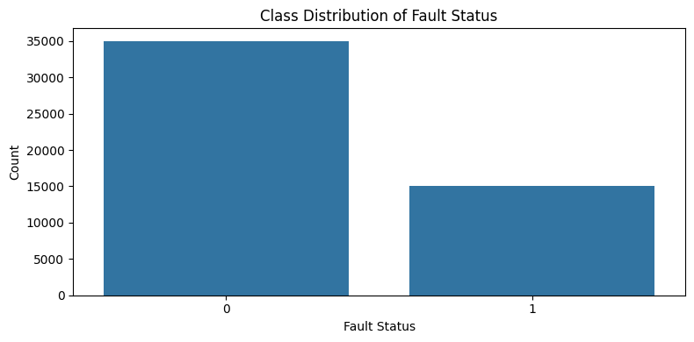
FIGURE 1. Class distribution of fault and non-fault samples in the dataset.

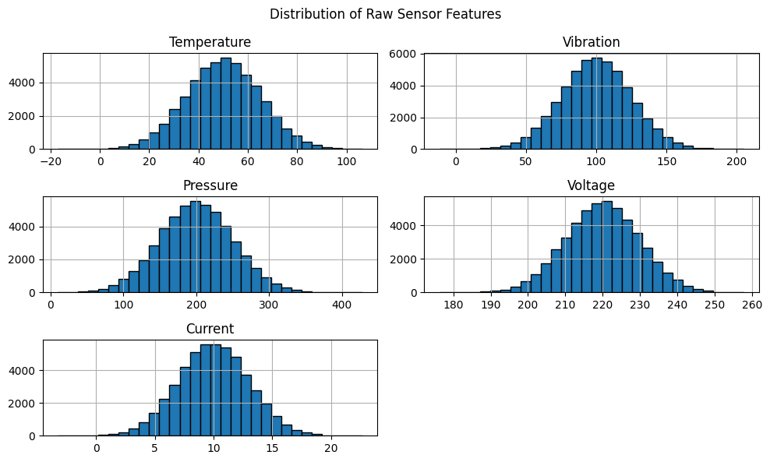
FIGURE 2. Distribution of raw sensor features including temperature, vibration, pressure, voltage, and current.

To assess the difference in sensor values relative to the fault and non-fault states, we will conduct a boxplot analysis (Figure 3). According to the results, there is no significant visual discrepancy between the two classes for all the main sensory parameters, i.e., there is a large overlap between the values.
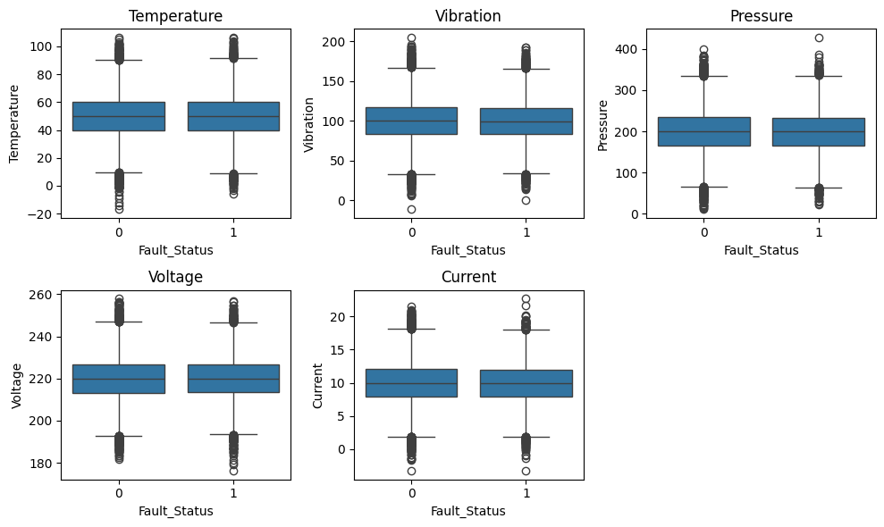
FIGURE 3. Boxplot comparison of sensor feature distributions for fault and non-fault conditions.

The distribution of FFT_Feature1 and FFT_Feature2 attributes related to the frequency domain is shown in Figure 4. These characteristics are distributed almost equally between 0 and 1, which also indicates that they cannot visually clearly distinguish faulty states.

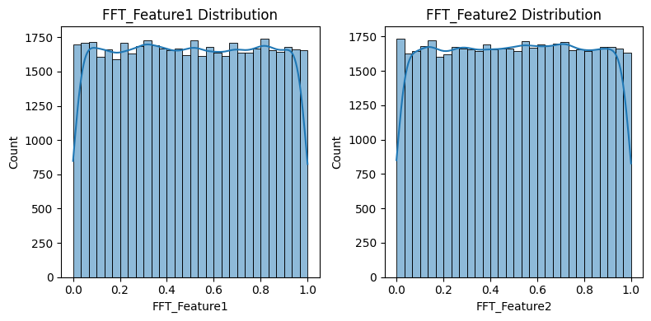
FIGURE 4. Distribution of FFT-based features (FFT_Feature1 and FFT_Feature2).

We also analyze the dependence of anomalies detection on malfunctions (Figure 5). The Boxplot results showed that the detection values of anomalies also do not have a large difference between normal and malfunctioning states, that is, the concepts of anomaly and malfunction do not fully coincide.
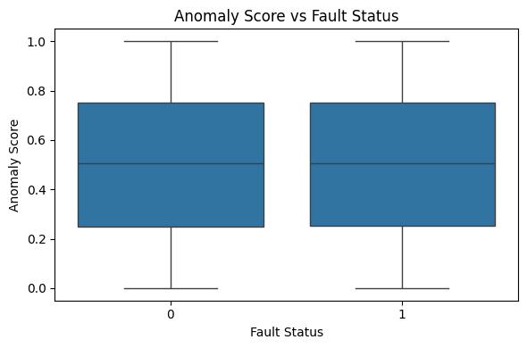
FIGURE 5. Comparison of anomaly score distributions for fault and non-fault samples.

Analysis of the correlation matrix between sensory, FFT, and abnormal characteristics shows that there are no strong linear relationships between most characteristics. This means that the signals used to reliably detect malfunctions are weak or scattered, and confirm the absence of clear dominant indicators in the dataset. Overall, the data analysis results before the study show that the patterns separating the characteristics of malfunctions in the dataset are limited, which provides a preliminary and logical explanation for the low discriminatory efficiency observed in subsequent machine learning experiments.
METHODOLOGY OF SCIENTIFIC RESEARCH
In this study, the issue of detecting equipment malfunctions based on IoT sensor data was systematically studied using CRISP-DM methodology. The research process included the stages of data preparation, property creation, modeling, and evaluation of results. The main task was formulated as a binary classification using the Fault_Status attribute and analyzed according to the scripts for identifying malfunctions important in industrial practice. The data were separated by verification and testing, which ensured the preservation of class distribution.
When evaluating the models, class disproportions were taken into account, with priority given to metrics such as completeness, F1-score, and ROC-AUC, not limited to accuracy. In addition to traditional classification models, a reframing approach based on analysis, highlighting essential characteristics, and assessing the anomaly was used, and the factors influencing model effectiveness were studied from a diagnostic perspective. This approach allowed for an objective assessment of the model's results in forecasting service tasks and the correct interpretation of their limitations.
DATA PREPROCESSING
At this stage, we carry out the process of preliminary processing to improve the quality of information, eliminate factors that negatively affect modeling, and preserve the distribution of classes. The missing values observed in some attributes were analyzed, and the Fault_Type attribute, which was not directly used in the binary classification problem, was removed, and observations with a small number of missing values in the remaining numerical characteristics were removed from the dataset.
Identifier attributes such as Timestamp and Sensor_ID, which do not directly reflect the state of the simulation equipment, have been removed. As a result, the main sensory indicators, FFT-based characteristics, normalized values, and anomaly assessments were retained as input characteristics. Taking into account the existing imbalance in the distribution of classes according to the Fault_Status feature, the data were separated by checking and testing in the 80/20 ratio, which ensures the preservation of the class ratio in both sets.
We also separately considered the issue of scaling, as the sensor readings have different units of measurement. For distant-sensitive models, standardization was applied, and existing normalized sensory values were evaluated in comparative experiments with raw data. These preliminary processing solutions serve as a solid foundation for the objective analysis of model results in subsequent stages and the correct interpretation of their impact on highlighting important characteristics in the data.
HIGHLIGHTING IMPORTANT CHARACTERISTICS IN DATA
At this stage, the highlighting of important data properties (feature engineering) was aimed at assessing the informativeness of sensory data in the issue of fault detection. As input characteristics, the main sensory indicators related to the time domain, characterizing the working state of the equipment - temperature, vibration, pressure, voltage, and current values - were taken. During the experiments, the values obtained from the sensor and unprocessed values and their normalized variants were used as model inputs in individual cases, and we conducted a comparative assessment of the influence of time domain properties on the model's efficiency.
To account for the dynamic characteristics of signals, we used the FFT_Feature1 and FFT_Feature2 attributes obtained based on the FFT method. These characteristics briefly describe the latent periodic changes in sensory signals and have theoretical significance for detecting mechanical malfunctions. In cases where FFT properties are present and absent, individual models were constructed, and their additional value for the predicted service problem was assessed through comparative experiments.
We also paid special attention to the normalization strategy, as the sensor readings have different units of measurement. The normalized values of the sensors in the 0-1 range, present in the data, were applied independently, and for remote sensing algorithms, the standardization method was used.
MACHINE LEARNING MODELS FOR DETECTING EQUIPMENT MALFUNCTIONS BASED ON IOT SENSOR DATA
At this stage of our research, we use several machine learning models to study the problem of detecting equipment malfunctions based on IoT sensor data. The selection of models was carried out taking into account that the main goal of the research is not to achieve high accuracy, but to objectively assess the discriminatory ability of existing sensory and derivative properties when identifying faulty states.
Therefore, in the study, we use both simple linear models and ensemble models based on decision trees, and analyze their results from a comparative and diagnostic point of view under the same experimental conditions. This approach allows us to determine the impact of input properties quality, rather than model complexity, on the effectiveness of the projected service.
Logistic Regression Model. As a basic model, we use Logistic Regression. This model is based on the linear solution boundary and allows for the assessment of the overall relationship between the sensor characteristics and the fault state. The main advantage of Logistic Regression is its simplicity and ease of interpretation, therefore it is widely used as a standard base model in forecasting service research [22].
Considering the presence of class imbalance in the dataset, we train logical regression models using the “class weighing” method (class_weight=“balanced”). This approach is aimed at increasing the significance of the fault class and allows prioritizing the recall (finding failures without missing) and F1-score (accurate and correct assessment) metrics over error (accuracy). According to the experimental results, although the model reached recall ≈ 0.51, the overall F1-score remained at ≈ 0.38 due to low accuracy. The ROC-AUC indicator is around 0.51, indicating that the model's ability to distinguish between failed and failed states does not significantly exceed the random prediction level. This shows that the analysis of the Confusion matrix (Fig. 6) shows that the logical regression model is relatively sensitive to detecting malfunctions, but the number of false positive cases is higher.
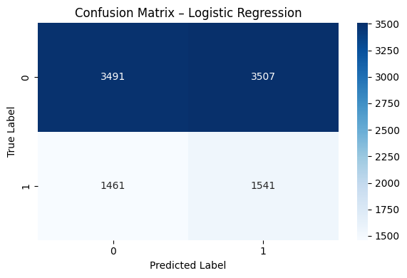
FIGURE 6. Confusion matrix of the Logistic Regression model with class balancing applied.

The ROC curve (Fig. 7) is located close to the diagonal, which once again confirms that the model's overall discriminatory ability is limited.
Although class imbalance mitigation has improved the full recall indicator, the logical regression model has limited discriminatory capability, indicating that the linear boundaries of the solution are insufficient to detect patterns related to malfunctions in existing sensory data.

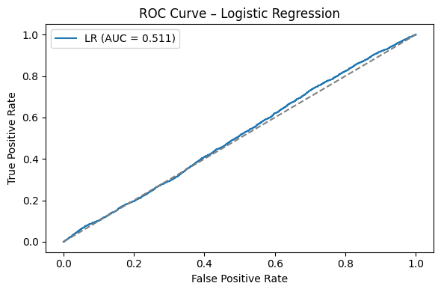
FIGURE 7. ROC curve of the Logistic Regression model, illustrating near-random discriminative performance (AUC ≈ 0.51).

Random Forest Model. As an ensemble model, we use the random forest algorithm. This model is capable of modeling nonlinear relationships by aggregating the results of multiple decision trees and is theoretically suitable for analyzing noise and multidimensional sensory data. The random forest model can form complex solution boundaries compared to logical regression [23].
During the model training process, we select a limited number of trees, maximum depth, and minimum division parameters, which is done to reduce the risk of overfitting. We also use class weight to account for class disproportions present in the dataset. Based on the experimental results, although we achieved an accuracy of ≈0.60 using the Random Forest model, we showed recall values of ≈0.25 and F1-score of ≈0.27 to determine the fault class. The ROC-AUC indicator is around 0.50, indicating that the model's ability to distinguish between failed and failed states does not exceed the level of random prediction. Analysis of the Confusion matrix (Figure 8) shows that the number of random forest models tends to favor the largest class, and the majority of failure cases remain “false negative”.

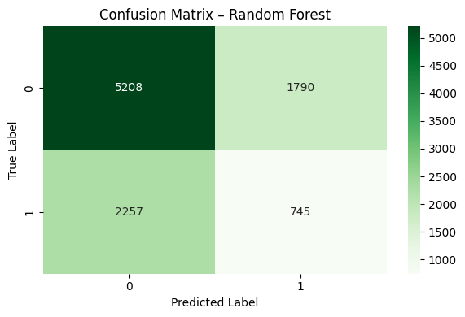
FIGURE 8. Confusion matrix of the Random Forest model with class balancing applied.

The ROC curve practically coincides with the diagonal and once again confirms that the overall discriminatory ability is limited, despite the use of the ensemble model (Figure 9).
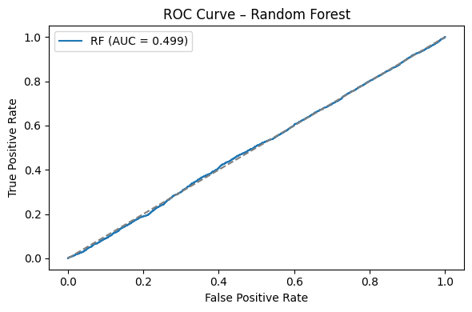
FIGURE 10. ROC curve of the Random Forest model, showing near-random discriminative performance (AUC ≈ 0.50).

Despite the possibility of modeling improper relationships, the Random Forest ensemble model did not show significant improvement in troubleshooting, indicating that the limitation is due not to the model's complexity, but to the lack of sufficient informative characteristics.
XGBoost model. To determine whether the model's power limits the predicted service, we will also conduct an assessment using a strong ensemble model based on gradient boosting - XGBoost. This model is known for its high efficiency in working with tabular data and can form more complex and illegal boundaries of solutions than the random forest model [24].
According to the experimental results, when we used the XGBoost model, the accuracy was ≈ 0.54, feedback ≈ 0.37, and F1-score ≈ 0.33. Compared to the Random Forest model, although the failure detection completeness indicator improved somewhat, the ROC-AUC remained around 0.50. This indicates that the model's ability to distinguish between faulty and faulty states does not significantly exceed the level of random forecasting. Analysis of the Confusion matrix shows that the XGBoost model also tends to give relative preference to many classes: a significant portion of malfunctions remain “false negative” (Fig. 10).

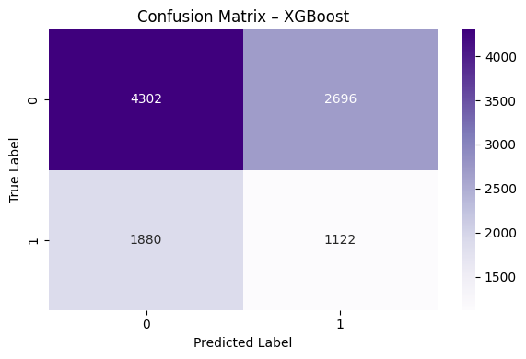
FIGURE 10. Confusion matrix of the XGBoost model illustrating prediction errors for fault and non-fault classes.

The ROC curve almost coincides with the diagonal and once again confirms that the overall discriminatory ability is limited, despite the use of an ensemble model with high expressiveness, such as gradient growth (Fig. 11).

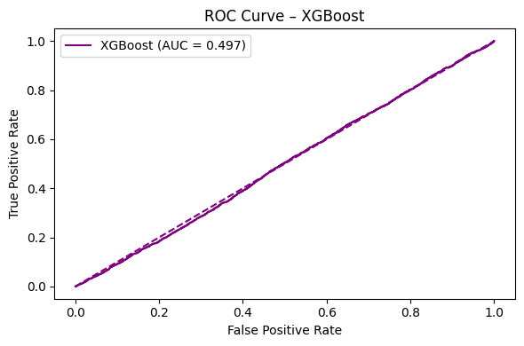
FIGURE 11. ROC curve of the XGBoost model, demonstrating near-random discriminative
performance (AUC ≈ 0.50).

Overall, these results indicate that even with the use of modern gradient amplification ensemble models, the existing sensor does not contain sufficient discriminatory information for reliable fault separation based on FFT and anomalously related characteristics. This once again confirms the main conclusion of the study - that the factor limiting the effectiveness of forecasting services is not the complexity of the model, but the informativeness of the characteristics.
COMPARATIVE ANALYSIS OF EXPERIMENTAL RESULTS
All models were trained and evaluated on the same pre-prepared data set and under conditions of dividing into the same training and testing set. This approach allows for direct and objective comparison of model results. Hyperparameters were set to the minimum level, as the main goal of our research was not to achieve maximum accuracy, but to determine to what extent existing sensory and derived characteristics can provide the task of predicted maintenance.
Now let's present the obtained results systematically and analyze the advantages and limitations of each model from a diagnostic point of view. Considering the presence of class imbalance in the data set, we evaluate the model's effectiveness not only with accuracy but also based on completeness, accuracy, F1-score, and ROC-AUC metrics. Table 2. The comparative effectiveness of machine learning models for troubleshooting is presented.

Table 2. Comparative efficiency of machine learning models for troubleshooting.
Model | Accuracy | Precision | Recall | F1-score | ROC-AUC
Logistic Regression | 0.503 | 0.305 | 0.513 | 0.383 | 0.511
Random Forest | 0.595 | 0.294 | 0.248 | 0.269 | 0.499
XGBoost | 0.542 | 0.294 | 0.374 | 0.329 | 0.497

The results presented in the table demonstrate the comparative effectiveness of logical regression, random forest, and XGBoost models in detecting malfunctions based on IoT sensor data. Although the logical regression model showed the highest completeness (0.513) considering class imbalance, its overall discriminatory ability was limited and remained within ROC-AUC = 0.511. This indicates that the model could not reliably distinguish faulty states despite detecting relatively more.
Although ensemble models such as random forest and XGBoost showed relatively higher accuracy results, their ROC-AUC indicators were formed within 0.5 and did not exceed the level of random prediction. In particular, the low completeness in the random model of the forest means that the majority of malfunction cases remained undetected. Although the XGBoost model showed some improvement in completeness, its overall discriminatory capability also remained limited. Overall, the results of this table confirm once again that increasing model complexity does not automatically improve the effectiveness of the predicted service, and the main limitation is related to the informativeness of the input properties.
CONCLUSIONS
The results of this study clearly showed that when solving the tasks of predicted service based on IoT sensory data, the decisive factor is the informativeness of the characteristics, and not the complexity of the model. Despite the use of different levels of models such as logical regression, random forest, and XGBoost, in all cases, ROC-AUC is around 0.5, indicating the absence of a strong discriminatory relationship between sensory data and malfunctions.
The low completeness state, along with the high accuracy observed in the basic logical regression model, confirms the accuracy paradox (paradox of accuracy), which is well-known in the field of forecasting services. Although the ability to detect malfunctions improved somewhat after applying the class balance, the practically unchanging ROC-AUC indicator opened up limited possibilities for the linear solution threshold. The fact that ensemble models with high expressiveness, such as random wood and XGBoost, also did not show significant advantages is explained by the lack of clear signals characteristic of the malfunction in the input characteristics, rather than the insufficient model architecture. This conclusion is further confirmed by the analysis of important features conducted based on a random forest model (Figure 12).

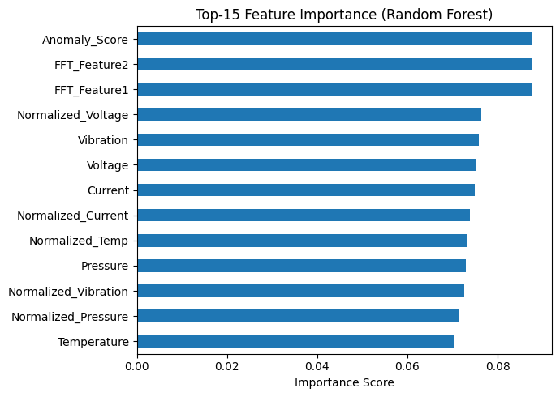
Figure 12. Top-15 Feature Importance Scores Estimated by the Random Forest Model.
As can be seen from the figure, the anomalies, FFT-based characteristics, as well as the significance levels of unprocessed and normalized sensory indicators are practically within the same range, and there is no clear indicator of the dominant malfunction in the model solutions.
Even relatively more significant FFT_Feature1 and FFT_Feature2 did not show significant advantages over other sensor parameters. This situation indicates a lack of sufficient discriminatory information in the data set to reliably identify failures and explains the main reason for the observed ROC-AUC ≈ 0.5 for all models.
Although FFT-based characteristics are often considered important in the literature on predicted services, their discriminatory power in this data set is limited. This may be due to the fact that the characteristics of FFT are presented in a very simplified or generalized form. In real industrial scenarios, characteristics based on time-evolutionary spectral energy, dominant frequencies, or phase changes tend to be more informative.
Also, the fact that the approach based on the detection of anomalous states did not exceed the level of random prediction in the issue of detecting malfunctions showed that the concepts of anomaly and malfunction do not always fully coincide. Overall, this study, based on empirical data, has shown that before selecting a model in the field of forecasting services, it is necessary to pay special attention to the sensor design, data quality and saturation, and the highlighting of target characteristics.
REFERENCES
- Zonta, T., da Costa, C. A., da Rosa Righi, R., de Lima, M. J., da Trindade, E. S., & Li, G. P. (2020). Predictive maintenance in the Industry 4.0: A systematic literature review. Computers & Industrial Engineering, 150, 106889. https://doi.org/10.1016/j.cie.2020.106889
- Yusuf Avazov, Marufjon Shodiev, Azamat Rajabov and Khurshid Turaev. Control of the lifecycle of a technological complex for the rectification of multicomponent mixtures under conditions of parameter uncertainty // E3S Web Conf., 417 (2023) 05010. DOI: https://doi.org/10.1051/e3sconf/202341705010
- Nadirbek Yusupbekov; Yusuf Avazov; Elyor Samadov; Nasiba Khojiyeva; Marufjon Shodiev; Qabilbek Bazarbaev. Study of the technological process of vegetable oil refining as an object of monitoring, control and management //AIP Conf. Proc.3268, 040044 (2025). https://doi.org/10.1063/5.0257158
- Djalolitdin Mukhitdinov, Yorkin Kadirov, Ildar Sultanov and Yusuf Avazov. Rectification process control by separation process efficiency evaluation using a predictive model / EPJ Web Conf., 321 (2025) 01013. DOI: https://doi.org/10.1051/epjconf/202532101013
- Fernandes et al., Fault Detection and Diagnosis in Industry 4.0: ML Methods Review, MDPI Sensors 2025.
- Hassan I. Predictive Maintenance in Industry 4.0: Review of Data-Driven Methods, 2025.
- N.R.Yusupbekov, Yu.Sh.Avazov, G.Kh.Rashidov. Application of neural networks for intelligent processing of sensor signals in the control of technological process parameters // International scientific and technical journal “Сhemical technology. Control and management” 2025, №4 (124). -PP. 33-44.
- Lei, Y., Yang, B., Jiang, X., Jia, F., Li, N., & Nandi, A. K. (2020). Applications of machine learning to machine fault diagnosis: A review and roadmap. Mechanical Systems and Signal Processing, 138, 106587. https://doi.org/10.1016/j.ymssp.2019.106587
- Zhang, W., Yang, D., & Wang, H. (2019). Data-driven methods for predictive maintenance of industrial equipment: A survey. IEEE Systems Journal, 13(3), 2213–2227. https://doi.org/10.1109/JSYST.2019.2905565
- Narkarunai Arasu M. et al., Predictive Maintenance using Machine Learning in Industrial IoT, Int. J. Innovative Sci. Res. Technology, 2024.
- Azeema N. & Rafasya N., Artificial Intelligence in Predictive Maintenance for Industrial IoT, 2023.
- Elkateb S., Machine learning and IoT-based predictive maintenance, 2024.
- Jardine, A. K. S., Lin, D., & Banjevic, D. (2006). A review on machinery diagnostics and prognostics implementing condition-based maintenance. Mechanical Systems and Signal Processing, 20(7), 1483–1510. https://doi.org/10.1016/j.ymssp.2005.09.012
- Susto, G. A., Schirru, A., Pampuri, S., McLoone, S., & Beghi, A. (2015). Machine learning for predictive maintenance: A multiple classifier approach. IEEE Transactions on Industrial Informatics, 11(3), 812–820. https://doi.org/10.1109/TII.2014.2349359
- Ran, Y., Zhou, X., Lin, P., Wen, Y., & Deng, R. (2019). A survey of predictive maintenance: Systems, purposes and approaches. IEEE Communications Surveys & Tutorials, 21(3), 2242–2272. https://doi.org/10.1109/COMST.2019.2898978
- Zero E., Predictive Maintenance in IoT-Monitored Systems for Fault Prediction, 2024.
- Zhang, Y., Qin, S. J., & Yao, Y. (2017). Fault detection and diagnosis with industrial big data // Journal of Process Control, 62, 15–26. https://doi.org/10.1016/j.jprocont.2017.10.004
- Carvalho, T. P., Soares, F. A. A. M. N., Vita, R., Francisco, R. P., Basto, J. P., &Alcalá, S. G. (2019). A systematic literature review of machine learning methods applied to predictive maintenance. Computers & Industrial Engineering, 137, 106024. https://doi.org/10.1016/j.cie.2019.106024
- Bousdekis, A., Magoutas, B., Apostolou, D., & Mentzas, G. (2018). Review, analysis and synthesis of prognostic-based decision support methods for condition based maintenance // Journal of Intelligent Manufacturing, 29, 1303–1316. https://doi.org/10.1007/s10845-016-1272-0
- Malhi, A., & Gao, R. X. (2004). PCA-based feature selection scheme for machine defect classification. IEEE Transactions on Instrumentation and Measurement, 53(6), 1517–1525. https://doi.org/10.1109/TIM.2004.838614
- https://www.kaggle.com/datasets/programmer3/iot-based-equipment-fault-prediction-dataset
- Sandhu, J., Mahapatra, B., Kulkarni, S., Bhatt, A. (2024). MetroPT Predictive Maintenance Using Logistic Regression and Random Forest with Isolation Forest Preprocessing. In: Pant, M., Deep, K., Nagar, A. (eds) Proceedings of the 12th International Conference on Soft Computing for Problem Solving. SocProS 2023. Lecture Notes in Networks and Systems, vol 994. Springer, Singapore. https://doi.org/10.1007/978-981-97-3180-0_33
- Ajithkumar, J., & Nelson Kennedy, C.B. (2025). Enhancing the accuracy in predictive maintenance of manufacturing in cars using random forest algorithm in comparison with artificial neural networks. AIP Conference Proceedings, 3270(1), 020182.
- Velasco-Loera, F.; Alcaraz-Mejia, M.; Chavez-Hurtado, J.L. An Interpretable Hybrid Fault Prediction Framework Using XGBoost and a Probabilistic Graphical Model for Predictive Maintenance: A Case Study in Textile Manufacturing. Appl. Sci. 2025, 15, 10164. https://doi.org/10.3390/app151810164

