The effect of nickel on the tensile strength of the iron–carbon (Fe–C) alloy
Sarvar Tursunbaev ^{1,a)}, Boburjon Ibrokhimov¹, Bekzod Yusupov², To‘ymurod Kenjayev ², Nuritdin Tadjiev¹
¹ Tashkent state technical university named after Islam Karimov, Tashkent, Uzbekistan
²Almalyk state technical institute, Almalyk, Uzbekistan
^{a)} Corresponding author: anvarovichsarvar908@gmail.com
Abstract. Iron–carbon alloys are among the key materials in the mechanical engineering industry. This article analyzes the effect of modifying malleable cast iron, a type of iron–carbon alloy, with varying amounts of nickel powder on its tensile strength. Specimens were melted in an induction furnace at 1560–1580 °C and cast into sand-clay molds. Modification was accomplished by introducing nickel into the molten alloy in a ladle at concentrations of 0.1%, 0.2%, 0.3%, 0.4%, and 0.5% relative to the charge. Malleable cast iron was obtained from the resulting castings through heat treatment. Specimens were produced from the heat-treated castings according to the standard and subjected to tensile testing on a WDW-100E tensile testing machine. During the study, the specimens were tested under loads of up to 100 kN. Based on the research results, the authors drew conclusions about the effect of nickel on tensile strength.
INTRODUCTION
In the mechanical engineering industry, the role of iron-carbon alloys is invaluable. With the increasing use of various alloys in mechanical engineering, aircraft manufacturing, and other industries, scientists worldwide are conducting research aimed at improving their properties [1–5]. Scientists in many countries have conducted significant research into the development of effective technologies for improving the mechanical properties of ductile iron mechanical engineering parts [6–9].
Finnish scientists E. Pagounis et al. investigated the influence of matrix structure on the mechanical properties of a white cast iron composite produced by hot isostatic pressing [10]. A high-chromium white cast iron composite was tested to evaluate its wear resistance and toughness after the addition of increased amounts of reinforcing elements. Nine white cast iron composites containing 10 vol.% titanium carbide (TiC), as well as three alloys without a reinforcing phase, were manufactured using the standard hot isostatic pressing (HIP) process. Next, the composite specimens were subjected to nine different heat treatment regimes, while the unreinforced alloy specimens were subjected to three heat treatment regimes.
A study by German scientists D. Franzen et al. [11] demonstrated that the silicon content in malleable cast iron can be partially replaced to improve impact energy characteristics and reduce the ductile-brittle transition temperature without degrading the static mechanical properties. Four series of castings were produced from SGI 500-14 alloy with varying silicon contents. The primary objective of the study was to increase impact toughness without reducing the static mechanical properties. During the study of the microstructure and static and dynamic properties of these alloys, the possibility of partially replacing silicon with molybdenum was assessed. Molybdenum was chosen due to its ability to stabilize ferrite and promote carbide formation. The study results showed that molybdenum promotes the formation of carbides in solidification zones, improves static mechanical properties, and reduces the ductile-brittle transition temperature from 60°C to 6°C, thereby increasing the material's toughness.
The work of Turkish scientist Z. Özdemir [12] focused on the fabrication and characterization of a bimetallic cast composite part consisting of high-chromium cast iron and low-carbon cast steel. The composite was produced using gravity sand casting with the addition of an activator consisting of sodium and boron powders to prevent oxidation. Heat treatment increased the hardness and impact toughness of the bimetallic material, while the presence of eutectic carbides Cr(Fe)₇C₃ in the high-chromium cast iron significantly improved its toughness. Carbon diffusion during annealing resulted in increased hardness and toughness, while shallow cryogenic treatment of both sides—high-chromium cast iron and low-carbon cast steel—ensured a stable interface and a uniform microstructure.
Despite the above studies, the mechanical properties of cast iron, particularly its tensile strength, remain a critical factor in the performance of cast parts. This paper examines the effect of nickel on the tensile strength of an iron-carbon alloy and analyzes changes in this characteristic.

MATERIALS
The chemical composition of the casting is given in Table 1. In this case, the burn-off and pick-up losses of elements must also be taken into account in order to obtain the required cast iron composition: +10% for C, −12% for Si, and −20% for Mn. Modification was carried out with nickel in the range from 0.1 to 0.5%, and the samples had a rectangular shape (Fig. 1). Before pouring the molten white cast iron into the sand–clay mold [13–16], a mass fraction of Ni from 0.1% to 0.5% was added into the ladle at a temperature interval of 1550–1620 °C. This process lasted for one minute, after which the melt was poured into the mold (Fig. 2).
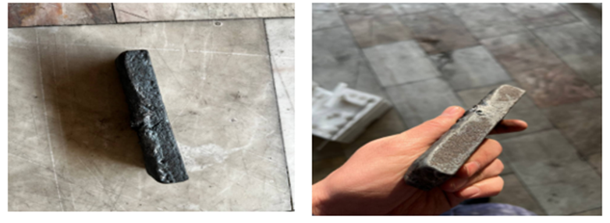
a) b)
FIGURE 1. Casting samples: a) nickel-free sample, b) nickel-added sample.

TABLE 1. Chemical composition of the casting sample.
C | Si | Mn | S | Others
2.49-2.57 | 1.29-1.42 | 0.43-0.49 | 0.129-0.14 | 0.5-1.0

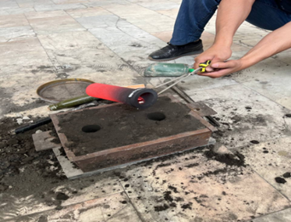
FIGURE 2. The process of pouring samples into sand-clay molds.

The temperature was measured using a DT-9862 hand-held pyrometer, which is designed for non-contact measurement of the sample surface temperature from -50 °C to 2200 °C [17-19].

RESEARCH AND RESULTS
Using GOST 1215-79, tensile test specimens were prepared with a calculated specimen diameter of 8 mm and an overall length of 105 mm (Fig. 3) [20]. Tensile testing was performed on a WDW-100E machine with a maximum load of 100 kN (Fig. 4). Foil strain gauges with electrical resistance were used for the measurements. These gauges were calibrated for room temperature during testing.

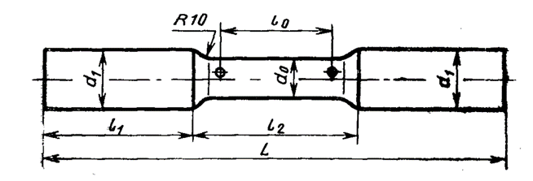
FIGURE 3. Tensile test specimen

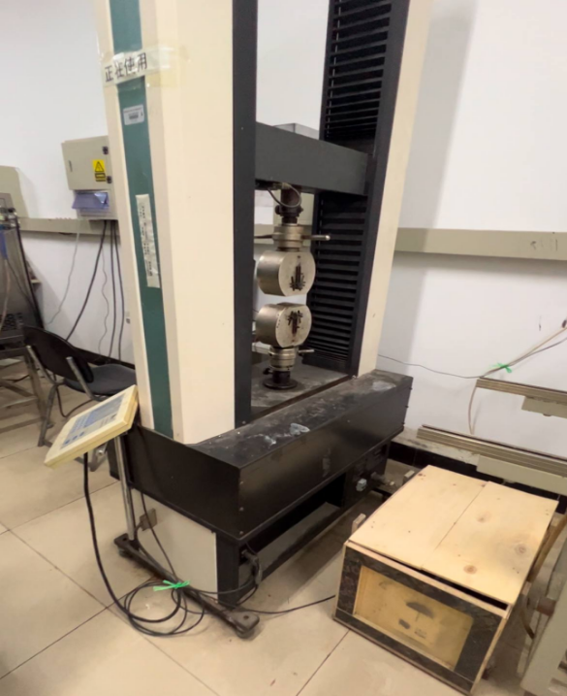
FIGURE 4. Tensile testing machine WDW-100E

After the specimens were securely clamped in the clamping device, the stretching process began with increasing load [21]. During the test, a uniform increase in load was observed, which reached 30 MPa [22,23]. Figure 5 shows the stress-strain curve for malleable cast iron modified with different nickel contents.

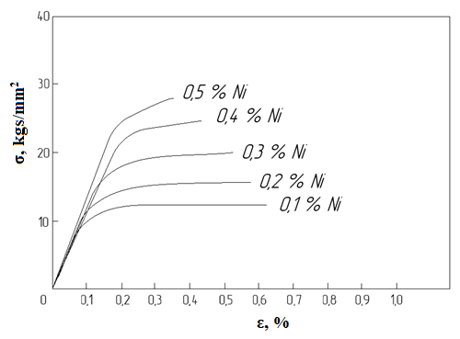
FIGURE 5. Stress-strain curve for cast iron with nickel
CONCLUSIONS
Based on the data obtained, it can be concluded that with an increase in nickel content from 0.1 to 0.5%, a steady increase in tensile strength and a moderate increase in yield strength are observed in malleable cast iron. Yield strength increases from 11 kgf/mm2 to 28-30 kgf/mm2, indicating a significant strengthening effect of nickel. Ductility changes slightly, remaining in the range of 0.3-0.4%. At a Ni content of 0.5%, maximum strengthening is achieved while maintaining the stress-strain curve shape characteristic of malleable cast iron. This indicates the full potential of nickel modification at this concentration.
REFERENCES
- Nur Hidajatullah, M., Sambas, A., & Sarah Puspita, K. (2019). Tellurium Effect on ASTM A 220 Graphite Malleable Cast Iron. Logic : Jurnal Rancang Bangun Dan Teknologi, 19(1). https://doi.org/10.31940/logic.v19i1.1274
- Alcón, J. M., Guillamón, M. P., García, L. S., & Vicente, F. S. (2021). Mechanical and microstructural analysis in the welding of ductile cast iron by TIG procedure, with different filler materials and air cooling. Revista de Metalurgia, 57(2). https://doi.org/10.3989/REVMETALM.194
- Sarvar, T., Nodir, T., Mardonov, U., Saydumarov, B., Kulmuradov, D., & Boltaeva, M. (2024). Effects of germanium (ge) on hardness and microstructure of al-mg, al-cu, al-mn system alloys. International Journal of Mechatronics and Applied Mechanics, 2024(16), 179–184. https://doi.org/10.17683/ijomam/issue16.21
- Malleable Cast Irons. (2025). In Atlas of Fractographs. https://doi.org/10.31399/asm.hb.v12a.a0007066
- Tursunbaev, S., Turakhodjaev, N., Zhang, L., Wang, Z., Mardonov, U., & Saidova, M. (2024). Mechanical properties and evolution of the microstructure of al-cu-mg system alloys under the influence of alloying elements (ge and si). International Journal of Mechatronics and Applied Mechanics, 2024(18), 164–169. https://doi.org/10.17683/ijomam/issue18.19
- Saidova, M., Alimova, F., Tursunbaev, S., Kulmuradov, D., & Boltaeva, M. (2023). Influence of the shape of the disc slots of the seeder on the suction force of the vacuum for precise sowing of seeds. IOP Conference Series: Earth and Environmental Science, 1284(1), 012014. https://doi.org/10.1088/1755-1315/1284/1/012014
- Zhang, D., Li, Y., Du, X., Fan, H., & Gao, F. (2022). Microstructure and tribological performance of boride layers on ductile cast iron under dry sliding conditions. Engineering Failure Analysis, 134. https://doi.org/10.1016/j.engfailanal.2022.106080
- Sertucha, J., & Lacaze, J. (2022). Casting Defects in Sand‐Mold Cast Irons—An Illustrated Review with Emphasis on Spheroidal Graphite Cast Irons. In Metals (Vol. 12, Issue 3). https://doi.org/10.3390/met12030504
- Dwulat, R., & Janerka, K. (2023). Evaluation of the Metallurgical Quality of Nodular Cast Iron in the Production Conditions of a Foundry. Journal of Manufacturing and Materials Processing, 7(1). https://doi.org/10.3390/jmmp7010018
- Pagounis, E., Talvitie, M., & Lindroos, V. K. (1996). Influence of matrix structure on the abrasion wear resistance and toughness of a hot isostatic pressed white iron matrix composite. Metallurgical and Materials Transactions A: Physical Metallurgy and Materials Science, 27(12). https://doi.org/10.1007/BF02595666
- D. Franzen, B. Pustal, and A. Buhrig-Polaczek. Mechanical properties and impact toughness of molybdenum alloyed ductile iron. International Journal of Metalcasting/Volume 15, Issue 3, 2021 https://doi.org/10.1007/s40962-020-00533-z
- Zafer O¨zdemir. Shallow cryogenic treatment (SCT) effects on the mechanical properties of high Cr cast iron: Low-carbon cast steel bimetallic casting. 2020 American Foundry Society https://doi.org/10.1007/s40962-020-00532-0
- Sertucha, J., & Lacaze, J. (2022). Casting Defects in Sand‐Mold Cast Irons—An Illustrated Review with Emphasis on Spheroidal Graphite Cast Irons. In Metals (Vol. 12, Issue 3). https://doi.org/10.3390/met12030504
- Tursunbaev, S., Turakhodjaev, N., Mardonakulov, S., & Toshmatova, S. (2024). Effect of germanium oxide on the properties of aluminum casting details in agricultural machinery. BIO Web of Conferences, 85. https://doi.org/10.1051/bioconf/20248501024
- Sertucha, J., & Lacaze, J. (2022). Casting Defects in Sand‐Mold Cast Irons—An Illustrated Review with Emphasis on Spheroidal Graphite Cast Irons. In Metals (Vol. 12, Issue 3). https://doi.org/10.3390/met12030504
- Turakhodjaev, N., Akramov, M., Turakhujaeva, S., Tursunbaev, S., Turakhujaeva, A., & Kamalov, J. (2021). Calculation of the heat exchange process for geometric parameters. International Journal of Mechatronics and Applied Mechanics, 1(9), 90–95. https://doi.org/10.17683/IJOMAM/ISSUE9.13
- Tursunbaev, S., Turakhujaeva, A., Mardonov, U., Mardonakulov, S., Saidova, M., Murodqosimov, R., & Kudratkhodjaeva, N. (2025). Analysing the alternations in the aluminium alloy properties under the influence of silicon and germanium alloying elements. International Journal of Mechatronics and Applied Mechanics, 1(21), 365–372. https://doi.org/10.17683/ijomam/issue21.34
- Haque, M. M. (2007). Investigation on properties and microstructures of spheroidal graphite Fe-C-2Si and Fe-C-2Al cast irons. Journal of Materials Processing Technology, 191(1–3). https://doi.org/10.1016/j.jmatprotec.2007.03.030
- Tursunbaev, S., Turakhodjaev, N., Wang, X., Shi, H.-L., Li, X., Karimov, K., Mardonov, U., Mardonakulov, S., Tadjiev, N., Turakhodjaeva, A., Turakhodjaeva, A., & Rakhmonova, M. (2025). Increasing the corrosion resistance of aluminum alloys (al-cu, al-mg, al-mn) by adding microalloying elements in its composition. International Journal of Mechatronics and Applied Mechanics, 1(19), 133–139. https://doi.org/10.17683/ijomam/issue19.15
- Aleksandrov, N. N., Kulikov, V. I., & Volkova, T. A. (1986). NEW ALL-UNION TECHNICAL SPECIFICATIONS ON IRON CASTINGS. Soviet Castings Technology (English Translation of Liteinoe Proizvodstvo), 6.
- Tada, N., Uemori, T., & Sakamoto, J. (2021). Prediction of the fracture location by tensile tests of gray cast iron based on the dimensional changes of graphite flakes. Journal of Pressure Vessel Technology, Transactions of the ASME, 143(2). https://doi.org/10.1115/1.4048063
- Tursunbaev, S., Turakhodjaev, N., Turakhujaeva, S., Ozodova, S., Hudoykulov, S., & Turakhujaeva, A. (2022). Reduction of gas porosity when alloying A000 grade aluminum with lithium fluoride. IOP Conference Series: Earth and Environmental Science, 1076(1). https://doi.org/10.1088/1755-1315/1076/1/012076
- Nilsson, K. F., & Vokál, V. (2009). Analysis of ductile cast iron tensile tests to relate ductility variation to casting defects and material microstructure. Materials Science and Engineering: A, 502(1–2). https://doi.org/10.1016/j.msea.2008.09.082

