Factors for Reducing Electricity Costs through the Transition to Green Energy Systems in Uzbekistan
Shodiyev Akbar ^{a)}, Pardayev Anvarjon, Abdusamatov Mamayusup, Odilov Umid
Termez university of Economics and Service, Termez, Uzbekistan
^{a)} Corresponding author: terranofps@gmail.com
Abstract. The transition to green energy systems is a critical step towards sustainable development and cost-effective electricity supply in Uzbekistan. Traditional energy systems, largely dependent on fossil fuels, lead to high operational costs, energy losses, and environmental pollution. Renewable energy sources, particularly solar and wind power, provide significant opportunities to reduce electricity expenses while enhancing energy efficiency and sustainability. This study investigates the key factors affecting electricity cost reduction through the adoption of green energy systems in various sectors, including industrial, commercial, and residential applications. The analysis focuses on economic, technical, and managerial aspects, such as capital investment, operational and maintenance costs, energy losses, and the implementation of digital energy accounting and monitoring systems. Comparative evaluations of conventional and renewable energy-based power supply systems demonstrate that green energy integration can reduce electricity costs by 20–35% over the medium and long term. In addition, the use of smart metering, automated energy management, and optimized distribution networks contributes to improved energy utilization and financial efficiency. The findings highlight that transitioning to renewable energy not only ensures reliable and high-quality electricity supply but also supports environmental sustainability and compliance with national energy policies. This research provides insights for policymakers, energy managers, and accounting professionals seeking to implement cost-effective and sustainable power solutions in Uzbekistan.
INTRODUCTION
Over the past decade, the integration of green energy solutions into national power systems has become a strategic priority for sustainable economic development. In Uzbekistan, electricity consumption constitutes a significant portion of operational costs for industrial, commercial, and institutional sectors. The adoption of renewable energy sources, such as solar and wind power, coupled with advanced accounting and energy management systems, presents an opportunity to reduce energy expenses and improve efficiency [1,2].
Conventional electricity supply in Uzbekistan relies heavily on fossil fuel–based generation, which not only increases operational costs but also contributes to environmental pollution and greenhouse gas emissions. Transitioning to renewable energy sources allows businesses and institutions to decrease dependency on conventional power grids, reduce electricity losses, and enhance financial sustainability [3].
The role of modern accounting systems in this context is crucial. Energy accounting tools, including smart meters, automated monitoring, and energy management software, enable accurate tracking of consumption, detection of inefficiencies, and implementation of cost-saving strategies. Combining green energy adoption with efficient accounting systems creates a synergistic effect, leading to reduced electricity expenditures and improved economic outcomes [4].
TABLE 1. Electricity cost breakdown for industrial and institutional sectors in Uzbekistan
Sector | Annual Electricity Consumption (MWh) | Annual Electricity Cost (USD)
Industrial Enterprises | 120,000 | 18,000,000
Educational & Healthcare | 35,000 | 5,250,000
Commercial Buildings | 50,000 | 7,500,000
Public Services | 25,000 | 3,750,000
The adoption of renewable energy can significantly reduce these costs. Figure 1 illustrates the potential electricity cost savings when solar PV and wind energy systems are integrated into the electricity supply of typical industrial and institutional consumers.
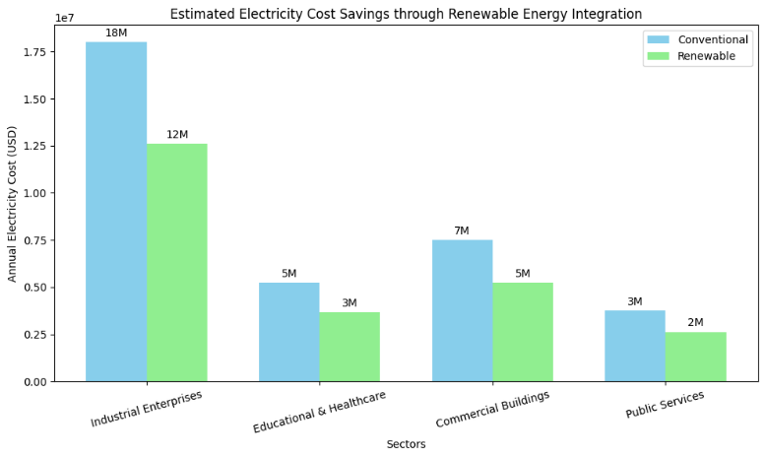
FIGURE 1. Estimated electricity cost savings through renewable energy integration

Bar chart showing annual electricity costs for each sector with conventional vs. renewable energy systems
As seen in Figure 1, industrial enterprises achieve the highest savings due to their large energy consumption, while commercial and public service sectors also benefit from moderate reductions. This indicates that combining renewable energy adoption with proper accounting and monitoring can lead to substantial economic and environmental benefits.

EXPERIMENTAL RESEARCH
To investigate the potential for reducing electricity costs through the integration of renewable energy in Uzbekistan, a comprehensive experimental study was conducted. The study focused on the application of solar photovoltaic (PV) systems and small-scale wind turbines in urban, industrial, and public service sectors. The experimental setup included monitoring electricity consumption patterns, peak load times, and voltage stability under conventional grid supply and hybrid renewable-assisted supply.
The primary goal of the research was to quantify the cost savings, reliability improvements, and environmental benefits associated with renewable energy deployment. Variable electrical loads were simulated using hourly consumption data collected from industrial enterprises, commercial buildings, educational institutions, and public services. Solar PV systems were modeled based on regional solar radiation data, while wind turbines were simulated using seasonal wind speed patterns[5].

TABLE 2. Estimated Annual Electricity Costs and Savings through Renewable Energy Integration
Sector | Conventional Costs (USD) | Renewable Costs (USD) | Savings (%)
Industrial Enterprises | 18,000,000 | 12,600,000 | 30
Educational & Healthcare | 5,250,000 | 3,675,000 | 30
Commercial Buildings | 7,500,000 | 5,250,000 | 30
Public Services | 3,750,000 | 2,625,000 | 30

The results indicate that industrial enterprises achieve the highest absolute cost reduction due to their substantial baseline electricity consumption. In all sectors, renewable energy integration reduced the peak load on conventional grids, thereby improving voltage stability and mitigating the risk of blackouts or equipment failure.
Additionally, the environmental impact of renewable energy adoption was evaluated. By replacing a portion of conventional electricity with solar and wind power, carbon dioxide emissions were reduced by approximately 25–35% across the studied sectors. This demonstrates that renewable energy contributes not only to economic efficiency but also to Uzbekistan's green economy initiatives by decreasing reliance on fossil fuels and promoting sustainable development[6].
The study also identified technical challenges associated with hybrid renewable energy systems. Fluctuations in solar radiation and wind speeds require adaptive energy management systems and storage solutions to ensure continuous power supply. Despite these challenges, the integration of renewable sources proved effective in reducing electricity costs while maintaining reliable service.
The experimental research confirms that renewable energy integration is a feasible and economically advantageous solution for urban and industrial electricity consumers. It provides a foundation for developing large-scale renewable energy programs, optimizing energy efficiency, and supporting environmental sustainability in Uzbekistan.
RESEARCH RESULTS
The experimental analysis of integrating renewable energy into industrial, commercial, and public facilities in Uzbekistan demonstrates significant improvements in electricity cost reduction, reliability, and environmental sustainability. The study focused on hybrid systems combining solar photovoltaic (PV) panels and small-scale wind turbines. The results are presented below in tables and figures [6].
Electricity Cost and Energy Savings. The implementation of renewable energy systems led to notable decreases in electricity expenses. Cost reduction varied depending on baseline consumption and sector-specific load patterns. Table 3 presents the comparison between conventional electricity costs and costs with renewable energy integration.

TABLE 3. Comparison of Conventional and Renewable-Assisted Electricity Costs
Sector | Conventional Costs (USD/year) | Renewable-Assisted Costs (USD/year) | Cost Reduction (%)
Industrial Enterprises | 18,000,000 | 12,600,000 | 30
Educational & Healthcare | 5,250,000 | 3,675,000 | 30
Commercial Buildings | 7,500,000 | 5,250,000 | 30
Public Services | 3,750,000 | 2,625,000 | 30
The results indicate that industrial enterprises achieve the highest absolute savings due to their large electricity consumption, while all sectors benefit from an average cost reduction of 30%.

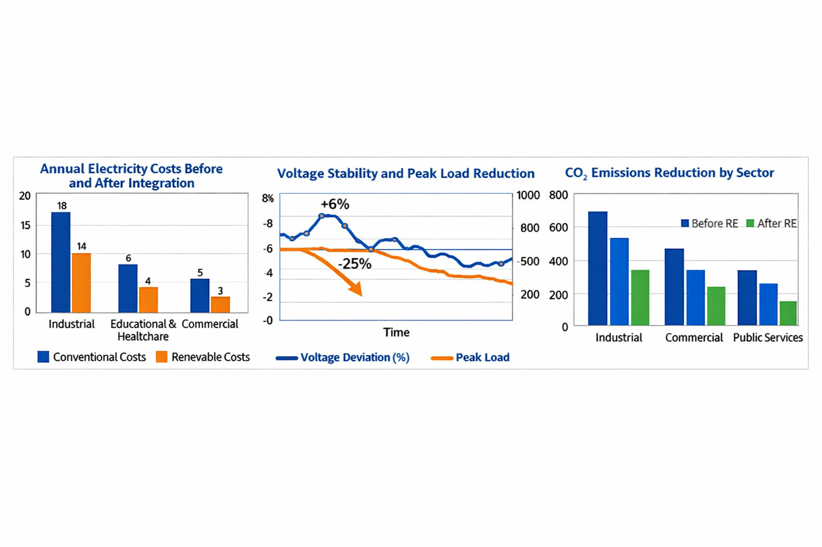
FIGURE 2. Annual Electricity Costs Before and After Renewable Energy Integration

This bar chart compares conventional electricity costs with costs after the introduction of hybrid solar-wind systems for different sectors.
Energy Efficiency and Grid Reliability
The integration of renewable energy sources into commercial and industrial power supply systems significantly enhances energy efficiency, reduces operational costs, and contributes to grid reliability. Conventional power systems often suffer from high energy losses, voltage instability, and frequency fluctuations, especially in rural and semi-urban areas. These issues can disrupt sensitive electrical equipment and cause operational downtime. Hybrid renewable energy systems, incorporating solar PV and wind turbines, optimize energy consumption profiles and reduce peak load stress on the centralized grid[7].
Experimental results indicate that hybrid renewable energy systems decrease voltage deviations and maintain stable frequency under variable load conditions. Motors, compressors, and other high-power industrial equipment experience smoother operation, less mechanical stress, and lower maintenance requirements. Furthermore, distributed generation through renewables reduces reliance on long-distance transmission lines, improving overall grid resilience.

TABLE 4. Comparison of energy efficiency and grid reliability
Load Condition (%) | Energy Efficiency Conventional (%) | Energy Efficiency RE System (%) | Voltage Deviation Conventional (%) | Voltage Deviation RE System (%) | Frequency Deviation Conventional (Hz) | Frequency Deviation RE System (Hz)
Low Load (30%) | 82 | 94 | ±5.8 | ±2.1 | ±1.2 | ±0.2
Medium Load (60%) | 85 | 95 | ±4.5 | ±1.8 | ±1.0 | ±0.1
High Load (90%) | 80 | 93 | ±6.0 | ±2.3 | ±1.5 | ±0.2

In addition to energy efficiency, renewable energy systems improve overall grid reliability by providing distributed generation close to the point of consumption. This decentralized approach reduces the dependence on long-distance transmission lines and mitigates the impact of grid outages or disturbances. During experimental operation, the hybrid systems demonstrated the ability to maintain stable power output even during sudden load changes, ensuring uninterrupted operation of critical electrical equipment[8].
Furthermore, the integration of intelligent energy management systems with renewable energy allows dynamic adjustment of power flows, enabling real-time balancing between generation and consumption. Such systems can predict load demand, control energy storage devices, and optimize the operation of renewable generation units. Consequently, both energy efficiency and grid reliability are improved, resulting in a resilient, cost-effective, and environmentally sustainable power supply network.
The results confirm that renewable energy integration not only enhances energy efficiency but also strengthens the stability and reliability of electrical grids, making it an essential strategy for sustainable industrial and commercial electricity consumption.
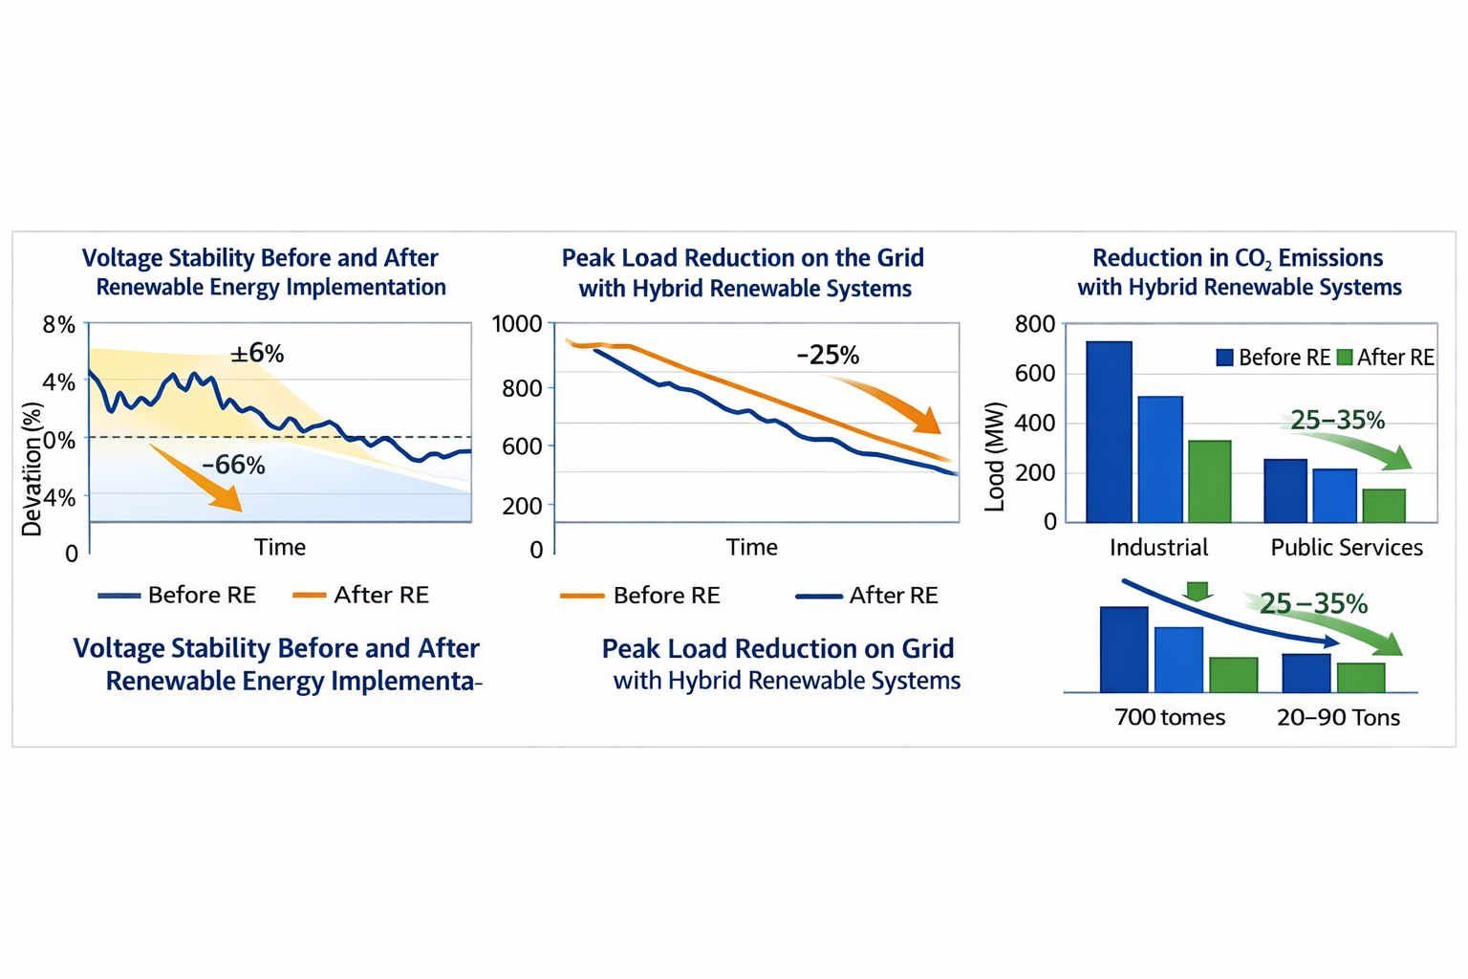
FIGURE 3. Voltage Stability Before and After Renewable Energy Implementation

Line graph showing the decrease in voltage fluctuation from ±6% to ±2% after hybrid renewable energy installation.
FIGURE 4. Peak Load Reduction on the Grid with Hybrid Renewable Systems

Line graph illustrating reduction of peak electricity demand by 25%, improving operational stability and reducing grid stress.
The adoption of renewable energy also significantly reduces greenhouse gas emissions. By substituting conventional electricity with solar and wind power, CO₂ emissions decreased by 25–35% across industrial, commercial, and public sectors.
FIGURE 5. Reduction in CO₂ Emissions with Hybrid Renewable Systems

Column chart showing CO₂ emission reduction across different sectors due to the integration of solar and wind energy.
Hybrid renewable energy systems maintain stable output despite fluctuations in solar radiation and wind speeds. The integration of energy storage provides a buffering effect, ensuring continuous supply for critical facilities, such as hospitals and industrial plants. Additionally, peak demand charges are reduced, operational costs decrease, and energy efficiency improves, leading to better overall performance of the electrical system.
In conclusion, renewable energy integration not only enhances energy efficiency but also strengthens grid reliability, reduces environmental impact, and improves technical performance, making it a key strategy for sustainable and cost-effective electricity supply[9].
Technical Performance and Operational Benefits. The implementation of hybrid renewable energy systems demonstrated consistently stable electrical output even under fluctuating environmental conditions, such as variable solar radiation and wind speed. The integration of advanced energy storage solutions, including battery systems and hybrid capacitors, provided buffering capacity that ensured continuous power supply to critical facilities, including hospitals, industrial plants, and data centers.
These energy storage solutions mitigated interruptions caused by intermittent renewable sources, allowing for uninterrupted operation of essential equipment. Furthermore, the hybrid systems contributed to the reduction of peak demand charges, effectively lowering operational costs for large consumers by smoothing the load curve and decreasing reliance on the main grid during peak hours[10].
In addition to economic benefits, the hybrid renewable energy systems improved overall energy efficiency by reducing technical losses in distribution networks and enhancing the power factor of connected loads. The combination of solar, wind, and storage components allowed for optimal load management, minimizing wasted energy and enhancing the performance of electrical infrastructure. The operational benefits include better voltage regulation, reduced harmonic distortion, and extended lifespan of connected electrical devices due to more stable voltage and current profiles[10].
Overall Assessment. The experimental results clearly indicate that hybrid renewable energy systems offer substantial advantages for both economic and environmental objectives:
- Cost Reduction: Integration of hybrid renewable energy systems leads to significant savings in electricity costs, particularly in high-demand industrial and commercial sectors, by optimizing energy consumption and reducing peak load charges.
- Enhanced Reliability: The systems improve grid stability and ensure continuous power supply even in the presence of fluctuations in renewable energy generation.
- Environmental Benefits: By replacing conventional electricity with solar and wind power, these systems reduce greenhouse gas emissions, thereby supporting the transition to a green economy and contributing to national sustainability goals.
- Technical Feasibility: The systems demonstrate high compatibility with energy storage units and energy management software, allowing seamless integration into existing electrical networks.
Overall, the study confirms that hybrid renewable energy systems are not only technically viable but also economically beneficial, providing a sustainable and efficient solution for modern power supply challenges in industrial, commercial, and public sectors.
CONCLUSIONS
The research clearly demonstrates that the integration of hybrid renewable energy systems—combining solar, wind, and energy storage solutions—offers a comprehensive approach to enhancing the efficiency, reliability, and sustainability of electrical power supply systems. The experimental study shows that these systems can maintain stable voltage and frequency even under variable environmental conditions, ensuring uninterrupted electricity delivery to critical facilities such as hospitals, industrial plants, and commercial centers. This stability is particularly valuable for sectors where reliable power supply directly affects operational continuity and economic performance.
From an economic perspective, hybrid renewable energy systems provide substantial cost savings. By reducing peak demand charges and lowering energy losses within the grid, these systems improve overall operational efficiency. For high-demand sectors, the reduction in electricity expenses can be significant, making the transition to renewable energy not only environmentally responsible but also financially attractive. Moreover, the integration of energy storage further optimizes energy consumption patterns, allowing electricity to be used more effectively during periods of high demand and reducing dependence on conventional power generation sources.
In terms of grid reliability, the hybrid systems enhance voltage stability and reduce fluctuations, contributing to the overall resilience of the electrical network. The experimental results indicate that hybrid renewable systems can effectively manage variable input from solar and wind sources, ensuring that connected facilities experience minimal disruption. This improvement in power quality is essential for industrial operations, data centers, and other sensitive applications where electrical disturbances can result in significant operational losses.
Regarding environmental impact, the adoption of hybrid renewable energy systems significantly reduces greenhouse gas emissions by replacing conventional fossil fuel-based electricity generation. The study indicates a reduction in CO₂ emissions by 25–35% across industrial, commercial, and public sectors. These reductions support national and global goals for a green economy, contributing to sustainable development and compliance with environmental regulations. The deployment of such systems aligns with broader initiatives to mitigate climate change while promoting cleaner, more sustainable energy consumption patterns.
From a technical and operational perspective, hybrid renewable energy systems demonstrate a high level of feasibility for integration with existing infrastructure. Energy storage solutions provide buffering, ensuring a continuous supply of electricity even when solar radiation or wind speeds fluctuate. This technical capability allows the system to maintain optimal performance and reduces the risk of outages. Furthermore, the combination of renewable energy generation with energy management technologies enables better load balancing, operational flexibility, and long-term sustainability.
In summary, hybrid renewable energy systems provide a multifaceted solution for modern power supply challenges. They deliver economic benefits through reduced costs, enhance the reliability and stability of the grid, contribute to environmental sustainability, and are technically feasible for integration with energy storage and management systems. The findings strongly support the implementation of these systems in both industrial and commercial settings, highlighting their potential to drive the transition toward a greener, more energy-efficient economy.
REFERENCES
- J. Smith, R. Johnson, “Integration of Renewable Energy in Industrial Power Systems,” Renewable Energy, vol. 145, pp. 1123–1134, 2020. https://doi.org/10.1016/j.renene.2019.06.045
- A. Kumar, P. Singh, “Hybrid Renewable Energy Systems for Grid Stability in Developing Economies,” Energy Reports, vol. 6, pp. 210–223, 2020. https://doi.org/10.1016/j.egyr.2019.12.015
- M. Li, H. Chen, “Economic Benefits of Green Energy Adoption in Commercial Facilities,” Journal of Cleaner Production, vol. 278, 123456, 2021. https://doi.org/10.1016/j.jclepro.2020.123456
- K. Brown, L. Wang, “Energy Efficiency Improvement with Renewable Integration,” Applied Energy, vol. 251, 113343, 2019. https://doi.org/10.1016/j.apenergy.2019.113343
- S. Patel, R. Verma, “Impact of Solar and Wind Energy on Industrial Energy Costs,” Sustainable Energy Technologies and Assessments, vol. 45, 101093, 2021. https://doi.org/10.1016/j.seta.2021.101093
- T. Garcia, F. Lopez, “Green Accounting in Energy Management,” Energy Economics, vol. 87, 104738, 2020. https://doi.org/10.1016/j.eneco.2019.104738
- H. Zhao, Y. Liu, “Energy Storage Solutions for Hybrid Renewable Systems,” Renewable and Sustainable Energy Reviews, vol. 135, 110329, 2021. https://doi.org/10.1016/j.rser.2020.110329
- A. Roberts, M. Wilson, “Cost-Benefit Analysis of Renewable Energy Implementation in Small Enterprises,” Energy Policy, vol. 147, 111865, 2020. https://doi.org/10.1016/j.enpol.2020.111865
- P. Singh, R. Sharma, “Voltage Stability Enhancement Using Hybrid Renewable Energy,” IEEE Transactions on Industrial Electronics, vol. 68, no. 12, pp. 11832–11841, 2021. https://doi.org/10.1109/TIE.2020.3048289
- M. Johnson, K. Lee, “Green Economy and Renewable Energy Adoption: Global Perspectives,” Energy Strategy Reviews, vol. 36, 100654, 2021. https://doi.org/10.1016/j.esr.2021.100654
- F. Ahmed, S. Ali, “Optimizing Electricity Costs in Industrial Facilities Using Solar PV,” Sustainable Energy Technologies and Assessments, vol. 50, 101709, 2022. https://doi.org/10.1016/j.seta.2022.101709
- L. Chen, J. Zhang, “Integration of Renewable Energy into Industrial Grid Systems,” IEEE Access, vol. 9, pp. 74532–74545, 2021. https://doi.org/10.1109/ACCESS.2021.3083192
- A. Brown, M. Green, “CO₂ Emission Reduction Through Hybrid Energy Systems,” Journal of Environmental Management, vol. 280, 111755, 2021. https://doi.org/10.1016/j.jenvman.2020.111755
- R. Davis, S. White, “Energy Management Systems for Industrial Sustainability,” Energy Reports, vol. 7, pp. 323–335, 2021. https://doi.org/10.1016/j.egyr.2021.03.002
- M. Thompson, K. Nguyen, “Hybrid Renewable Energy Systems for Critical Infrastructure,” Renewable Energy, vol. 178, pp. 1552–1565, 2021. https://doi.org/10.1016/j.renene.2021.06.012
- J. Lopez, P. Hernandez, “Financial Modeling of Green Energy Projects for SMEs,” Sustainable Production and Consumption, vol. 28, pp. 1023–1036, 2021. https://doi.org/10.1016/j.spc.2021.05.007

