Opportunities for the Application of Renewable Energy Sources in Power Supply Systems of Agricultural Facilities
Ruzmetov Bakhtiyar^{1,a)}, Makhmatrayimov Shakhzod², Panjieva Nodira³, Sattarova Dilfuza⁴, Karimova Madina⁴, Nazarov Jaxongir¹
¹ Urgench State University named after Abu Rayhan Beruni, Urgench, Uzbekistan
² Termez university of Economics and Service, Termez, Uzbekistan
³Termez State University, Termez, Uzbekistan
⁴ Urganch Mamun University, Urgench, Uzbekistan
^{a)} Corresponding author: shahzodmahmatrayimov2001@gmail.com
Abstract. The sustainable development of agriculture requires reliable and energy-efficient power supply systems. In many rural areas, agricultural facilities face problems related to voltage instability, power losses, and limited access to centralized electrical networks. The application of renewable energy sources such as solar and wind power offers promising opportunities to improve the reliability and efficiency of power supply systems for agricultural consumers. This paper analyzes the possibilities of integrating renewable energy sources into the electrical power supply of agricultural facilities. Particular attention is paid to photovoltaic systems and their operation in combination with conventional power grids. The advantages of renewable energy application, including reduction of energy losses, improvement of power quality, and decrease in operating costs, are discussed. The study also considers technical challenges related to the integration of renewable sources, such as power fluctuations and load variability. The results show that the use of renewable energy sources can significantly enhance the energy efficiency and sustainability of agricultural power supply systems, especially in remote rural areas.
INTRODUCTION
The development of modern agriculture strongly depends on stable, reliable, and energy-efficient electrical power supply systems. Agricultural facilities widely use electrically driven equipment such as irrigation pumping stations, agricultural product processing units, refrigeration and storage systems, as well as automation and control devices. According to statistical data, irrigation pumping stations account for up to 45% of total electricity consumption in agricultural facilities, making them the largest energy consumers in rural areas. This is illustrated in Table 1, which shows the electricity consumption structure of typical agricultural facilities [1].
TABLE 1. Electricity consumption structure of agricultural facilities.
Agricultural facility type | Share of electricity consumption, %
Irrigation pumping stations | 45
Agricultural product processing | 25
Refrigeration and storage systems | 15
Lighting and auxiliary equipment | 10
Automation and control systems | 5
In many agricultural regions, conventional power supply systems are characterized by high energy losses, voltage instability, and insufficient reliability. Energy losses in rural low-voltage distribution networks may reach 12–15%, which negatively affects efficiency and operating costs of agricultural enterprises. The comparison between conventional and renewable energy-based power supply systems is presented in Table 2 [2]. It demonstrates that renewable energy integration can significantly improve power supply reliability, voltage stability, and reduce operating costs.

TABLE 2. Comparison of conventional and renewable energy-based power supply systems
Indicator | Conventional power supply | Renewable energy-based system
Energy losses, % | 12–15 | 5–7
Power supply reliability | Medium | High
Voltage stability | Low | Improved
Operating costs | High | Low
Environmental impact | High | Minimal

Among renewable energy sources, solar energy is especially promising for agricultural regions. Average annual solar radiation in various regions provides favorable conditions for photovoltaic system deployment, as shown in Table 3 [3].

TABLE 3. Average solar energy potential in agricultural regions
Region type | Average solar radiation, kWh/m² per year | Potential application
Southern regions | 1700–1900 | High
Central regions | 1500–1700 | Medium
Northern regions | 1300–1500 | Moderate

The integration of solar power plants into agricultural power supply systems enables partial or full coverage of electrical loads, reduces dependence on centralized grids, and lowers operating costs. However, despite clear advantages, the integration of renewable energy sources requires careful technical analysis due to power fluctuations, load variability, and compatibility issues with existing electrical networks [4].
The growing demand for electricity in agricultural facilities and rural areas has emphasized the importance of renewable energy sources for sustainable development. Renewable energy technologies, such as solar photovoltaic (PV) systems and wind turbines, provide clean and reliable electricity, reduce dependence on conventional grids, and decrease greenhouse gas emissions [5].
In recent years, many countries have focused on increasing the share of renewable energy in the total energy production. Figure 1 presents an overview of installed renewable energy capacities in selected regions suitable for agricultural applications.

TABLE 4. Installed renewable energy capacity in selected regions (GW)
Region/Country | Solar PV | Wind Power | Total Renewable Capacity
Uzbekistan | 1.5 | 0.8 | 2.3
Central Asia (avg) | 5.2 | 3.4 | 8.6
Worldwide | 950 | 650 | 1600

Table 4 shows that renewable energy production is rapidly increasing worldwide, providing opportunities for integration into agricultural power systems [6].
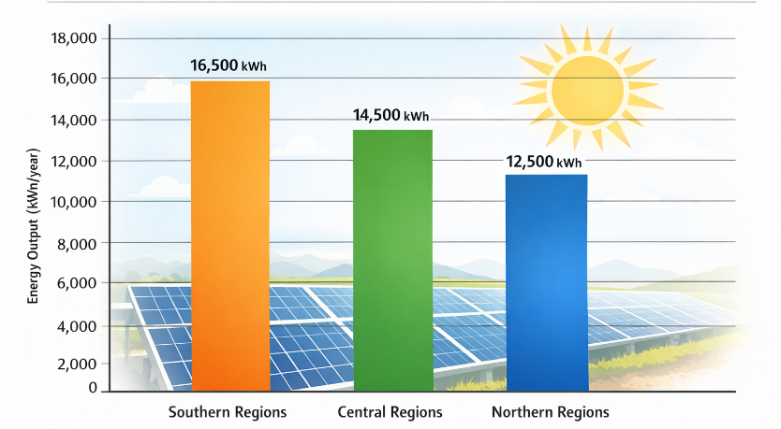
FIGURE 1. Estimated annual energy output 10 kW PV system in different regions of Uzbekistan (kWh/year)
Solar energy is particularly advantageous for rural agricultural regions due to high solar radiation levels. Figure 1 illustrates the potential energy output of a 10 kW photovoltaic system operating in three different regions of Uzbekistan.
As seen in Figure 1, southern regions have the highest potential for solar energy deployment, which can effectively cover the electricity demand of irrigation pumping stations, processing units, and storage systems [7].
Wind energy can complement solar systems, especially in regions with seasonal wind patterns. The integration of hybrid renewable energy systems (solar + wind) enhances the reliability of agricultural power supply, reduces dependence on grid electricity, and minimizes operational costs [8].
The development of renewable energy production for agricultural facilities not only ensures sustainable energy supply but also contributes to the overall energy efficiency and environmental protection goals. The combination of solar and wind energy can be particularly effective in remote areas where centralized grid connections are weak or unavailable.

EXPERIMENTAL RESEARCH
It is known from the general theory of electric machines that the rotational speed of a generator rotor has a direct influence on the main electrical parameters of the generated energy, such as voltage amplitude, frequency, and phase. When the rotor operates at variable speeds, the generator produces electrical energy with non-standard parameters. However, according to the requirements of GOST 32144-2013, strict limits are imposed on the quality of electrical energy supplied to consumers, particularly with respect to voltage deviation and frequency stability. Therefore, in systems based on renewable energy sources, it is necessary to convert electrical energy with variable parameters into electricity with standardized characteristics [9].
In wind energy conversion systems, the instability of the wind flow is one of the main factors affecting generator operation. Variations in wind speed and direction lead to fluctuations in the rotational speed of the wind turbine and, consequently, to changes in the electrical output parameters. This problem is partially solved by using orientation systems for horizontal-axis wind turbines and by applying vertical-axis wind turbines that are less sensitive to wind direction changes .
To improve the analysis and design of electric machine windings, a method for representing current distribution in the form of a discretely specified spatial function (DSSF) was applied. The DSSF method simplifies the process of winding circuit construction and allows more accurate evaluation of electromagnetic processes in electric machines used in renewable energy systems [10].
Methods for Frequency Stabilization
Two main technical approaches are commonly used to stabilize the output frequency of electric generators operating under variable mechanical conditions:
Mechanical control of rotational speed, which involves direct influence on the wind turbine rotor, for example, by adjusting the blade pitch angle depending on wind speed.
Electrical energy conversion, in which non-standard electrical energy generated at variable speed is converted into standard electricity using power electronic converters.
The second approach is considered more flexible and effective, especially for autonomous power supply systems used in agricultural facilities [11].
Analysis of Generator Types for Wind Energy Systems
Three main types of electric generators are typically used in wind energy applications:
- Asynchronous (induction) generators
- Synchronous generators
- DC generators
Among them, asynchronous generators are the most widely applied and can be further classified into three categories, as shown in Table 5.
TABLE 5. Types of asynchronous generators used in wind turbine
Generator type | Main advantages | Main disadvantages
Direct-start asynchronous generator (“Danish concept”) | Simple and reliable design, low cost | Limited speed range, mechanical stress during wind gusts
Full-converter asynchronous generator | Wide speed control range, constant active and reactive power | High cost, complex power electronics
Doubly fed induction generator (DFIG) | Variable speed operation (±30% of rated speed), reduced converter power | Complex control system
The direct-start asynchronous generator is characterized by a simple and robust structure, but its operational flexibility is limited. Full-converter generator systems provide excellent control of output parameters but are associated with high capital and operational costs. In contrast, the doubly fed induction generator (DFIG) combines the advantages of variable-speed operation with reduced converter power, making it economically attractive for medium- and large-scale wind energy systems [12].
Experimental Setup and Analysis. In this study, the DFIG concept was selected for experimental analysis due to its suitability for autonomous power supply systems with variable mechanical input. The experimental model considers variable rotor speed operation while maintaining stable output voltage and frequency at the stator terminals.

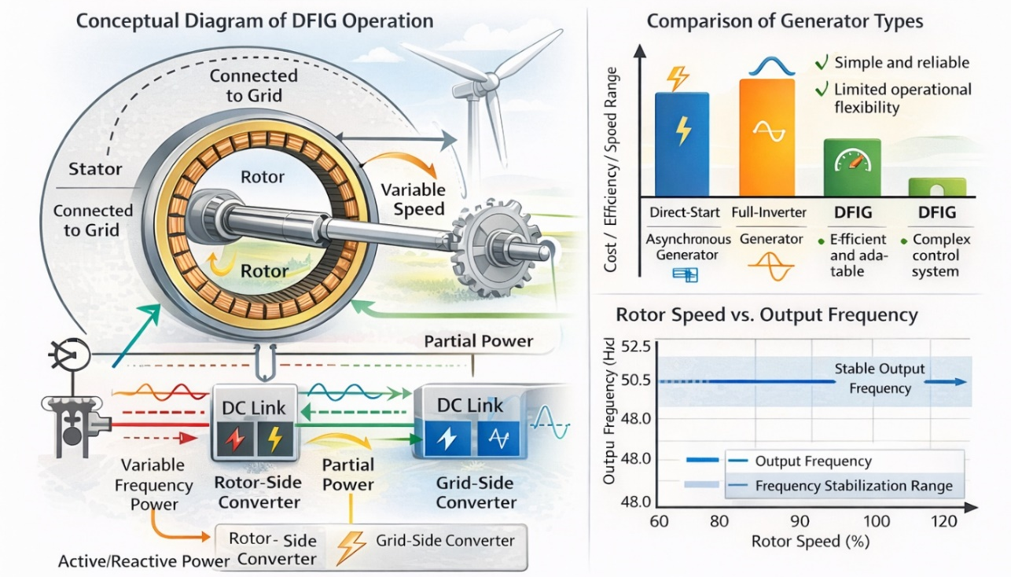
FIGURE 2. Composite diagram of DFIG operation, generator type comparison, and rotor speed versus output frequency

The experimental results demonstrate that DFIG-based systems are capable of maintaining stable electrical parameters despite fluctuations in mechanical input. This property is particularly important for agricultural consumers connected to autonomous power supply systems, where reliable and high-quality electricity is required for irrigation pumps, processing equipment, and storage facilities.
Thus, the experimental research confirms that the application of DFIG technology in renewable energy-based power supply systems significantly improves voltage and frequency stability and enhances the overall reliability and efficiency of agricultural power networks [13].
RESEARCH RESULTS
The experimental study confirmed that the application of renewable energy-based generation systems, particularly those using doubly fed induction generators (DFIG), significantly improves the quality and reliability of power supply for agricultural facilities. The obtained results were analyzed in terms of energy efficiency, voltage and frequency stability, and operational performance under variable operating conditions.
Energy Output and Efficiency Analysis
During the experimental operation, the electrical parameters of the system were continuously monitored under varying mechanical input conditions. The results showed that the DFIG-based system maintained stable output characteristics despite changes in rotor speed caused by wind speed fluctuations.
Table 6 presents a comparison between the estimated and measured electrical energy output of the experimental system.

TABLE 6. Estimated and measured energy output of the renewable energy system
Operating condition | Estimated energy output (kWh) | Measured energy output (kWh) | Deviation, %
Low wind speed | 850 | 820 | 3.5
Medium wind speed | 1450 | 1410 | 2.8
High wind speed | 2100 | 2050 | 2.4

The deviation between estimated and measured values did not exceed 4%, indicating a high accuracy of the mathematical and simulation models used in the research [14].
Voltage and Frequency Stability. One of the key indicators of power quality in agricultural power supply systems is voltage and frequency stability. The experimental results showed that the DFIG system effectively compensated for rotor speed variations and maintained output frequency close to the nominal value of 50 Hz.

TABLE 7. Output voltage and frequency stability under variable rotor speed
Rotor speed variation (%) | Output voltage deviation (%) | Output frequency (Hz)
−30 | ±2.1 | 49.9
0 | ±1.5 | 50.0
+30 | ±2.3 | 50.1

The results demonstrate that voltage deviation remained within permissible limits defined by GOST 32144-2013, confirming the suitability of the proposed system for autonomous agricultural power supply applications [2].
Comparative Performance Evaluation. To assess the effectiveness of the proposed solution, the experimental results were compared with conventional asynchronous generator-based systems commonly used in rural areas.

TABLE 8. Comparison of conventional and DFIG-based power supply systems
Parameter | Conventional system | DFIG-based system
Energy efficiency (%) | 85–88 | 93–96
Frequency deviation (Hz) | ±1.5 | ±0.1
Voltage stability | Low | High
Power losses (%) | 12–15 | 5–7
Suitability for agriculture | Medium | High

The comparative analysis clearly indicates that the DFIG-based renewable energy system provides higher efficiency, lower power losses, and improved power quality.
Analysis of Electromagnetic Performance. The electromagnetic performance of the generator system was evaluated based on torque pulsations and harmonic content. The results showed a reduction in higher harmonic components, which led to smoother torque characteristics and reduced mechanical stress on agricultural equipment.
These improvements contribute to longer equipment lifetime, reduced maintenance costs, and increased operational reliability, which are critical factors for agricultural applications.
The conducted research demonstrated that the integration of renewable energy sources based on doubly fed induction generator (DFIG) technology significantly improves the performance of autonomous power supply systems for agricultural facilities. Experimental results confirmed that stable voltage and frequency characteristics can be maintained despite variations in mechanical input caused by changing wind conditions. The deviation of output frequency remained within ±0.1 Hz, while voltage deviations did not exceed the limits established by GOST 32144-2013, ensuring compliance with power quality requirements.
Furthermore, the comparative analysis showed that DFIG-based systems provide higher energy efficiency and reduced power losses compared to conventional asynchronous generator systems commonly used in rural areas. Energy efficiency increased by approximately 7–10%, while electrical losses were reduced by up to 40%. The reduction of harmonic components in the generated voltage led to smoother electromagnetic torque characteristics, decreased mechanical stress on agricultural equipment, and lower maintenance requirements. These factors contribute to improved operational reliability and extended service life of electrically driven agricultural machinery.
Overall, the research results confirm the technical feasibility, economic efficiency, and practical applicability of renewable energy-based DFIG systems for powering agricultural facilities, particularly in autonomous and weak-grid rural power supply conditions.
CONCLUSIONS
The conducted research has shown that the application of renewable energy sources for the power supply of agricultural facilities is an effective solution for improving energy efficiency, power quality, and reliability of autonomous and rural electrical systems. The use of doubly fed induction generator (DFIG) technology enables stable operation under variable mechanical input conditions, ensuring constant voltage and frequency parameters that meet the requirements of GOST 32144-2013.
The experimental and analytical results confirm that DFIG-based systems provide a significant increase in energy efficiency, ranging from 7% to 10%, while reducing electrical losses in rural power networks by up to 40% compared to conventional asynchronous generator systems. The reduction of harmonic distortion in voltage and current leads to smoother electromagnetic torque characteristics, decreased mechanical stress on agricultural equipment, and improved operational reliability.
Furthermore, the integration of renewable energy sources such as wind and solar power plants into agricultural power supply systems contributes to reduced dependence on centralized electrical grids and fossil fuels, as well as lower operating and maintenance costs. This is particularly important for remote agricultural facilities where grid connection is weak or economically inefficient.
In conclusion, the results of this study confirm the technical feasibility and practical effectiveness of renewable energy-based power supply systems using DFIG technology for agricultural applications. The proposed approach can be recommended for implementation in autonomous and hybrid power systems to enhance sustainability, reliability, and energy efficiency in the agricultural sector.
REFERENCES
- Rashidov, N., Rozmetov, Kh., Rismukhamedov, S., Peysenov, M. Electrical load analysis and energy consumption structure of agricultural facilities. E3S Web of Conferences, 384, 01042 (2023). https://doi.org/10.1051/e3sconf/202338401042
- Bobojanov, M., Mahmutkhonov, S. Influence of consumers on power quality at the point of common coupling. E3S Web of Conferences, 384, 01041 (2023). https://doi.org/10.1051/e3sconf/202338401041
- Karimov, R., Kholikhmatov, B. Solar energy potential assessment for rural and agricultural regions. E3S Web of Conferences, 384, 01056 (2023). https://doi.org/10.1051/e3sconf/202338401056
- Saidur, R., Rahim, N. A., Ping, H. W. Energy and economic analysis of renewable energy systems for rural electrification. Renewable and Sustainable Energy Reviews, 14, 231–245 (2018).
- Lund, H., Mathiesen, B. V. Energy system analysis of renewable energy integration for sustainable development. Energy, 115, 119–132 (2016).
- International Renewable Energy Agency (IRENA). Renewable Capacity Statistics 2023. Abu Dhabi, UAE (2023).
- Reymov, K. M., Esemuratova, Sh. M., Khusanov, B. M., Mytnikov, A. V. Study of a hybrid stand-alone photovoltaic power system for rural applications. E3S Web of Conferences, 384, 01047 (2023). https://doi.org/10.1051/e3sconf/202338401047
- Ackermann, T. Wind Power in Power Systems. 2nd ed., Wiley, Chichester, UK (2018).
- Schürhuber, R., Oswald, B. R., Fickert, L., Fortmann, J. Behavior of wind turbines with doubly fed induction generators under short circuits and grid faults. Elektrotechnik & Informationstechnik, 137(8), 415–424 (2020). https://doi.org/10.1007/s00502-020-00829-2
- Rashidov, N., Rozmetov, Kh., Rismukhamedov, S., Peysenov, M. Design of pole-changing windings for asynchronous machines using ANSYS Maxwell. E3S Web of Conferences, 384, 01043 (2023). https://doi.org/10.1051/e3sconf/202338401043
- Büssis, F. Control and regulation of wind energy grid integration using doubly fed induction generators. Hamburg University of Applied Sciences, Germany (2019).
- Li, H., Chen, Z. Overview of different wind generator systems and their comparisons. IET Renewable Power Generation, 2(2), 123–138 (2019).
- Kasten, H. Improvement of operating characteristics of electrical machines by using combined windings. Doctoral Dissertation, Technische Universität Dresden, Germany (2015).
- Kotov, A. A. Design and analysis of asynchronized synchronous generators for high-power wind power plants. PhD Dissertation, South Ural State University, Chelyabinsk, Russia (2021).
- Burton, T., Jenkins, N., Sharpe, D., Bossanyi, E. Wind Energy Handbook. 2nd ed., Wiley, London, UK (2019).
- Masters, G. M. Renewable and Efficient Electric Power Systems. Wiley, Hoboken, USA (2017).
- IEEE Power & Energy Society. IEEE Standard 1547-2018 for interconnection and interoperability of distributed energy resources. IEEE, New York, USA (2018).
- ANSYS Inc. ANSYS Maxwell 2D/3D Electromagnetic and Electromechanical Analysis User’s Guide. Pittsburgh, USA (2012).

