Developing reflective skills of primary school students based on the 4c model
Sarbinaz Shukirullaev
Nukus State Pedagogical Institute named after Ajiniyaz, Nukus, Uzbekistan
Corresponding author: sarbinazalliyarovna@gmail.com
Abstract.This article explores the pedagogical potential of the 4C model (critical thinking, creativity, communication, and collaboration) in developing reflective skills among primary school students. The study focuses on identifying effective pedagogical conditions, methods, and instructional strategies that facilitate the development of reflective activity in the educational process. The findings demonstrate that instruction designed in accordance with the 4C model significantly enhances students’ self-assessment abilities, higher-order thinking skills, and conscious, purposeful engagement in learning activities.
INTRODUCTION
One of the most important tasks facing the modern education system is not limited to providing students with ready-made knowledge, but rather involves educating individuals who are capable of independent thinking, consciously organizing their learning activities, and analyzing and evaluating the outcomes they achieve. Such an approach in the educational process enhances students’ active participation, promotes deep understanding of knowledge, and expands opportunities for its practical application.
The primary school stage occupies a special place in students’ personal, psychological, and intellectual development. It is during this period that fundamental qualities such as attitudes toward learning, self-awareness, and the ability to evaluate the results of one’s own activities begin to form. Therefore, the development of reflective skills in primary education serves as a solid foundation for subsequent stages of learning. Reflection enables students to comprehend their own knowledge, identify learning difficulties, and determine effective ways to overcome them.
In recent years, within the process of renewing educational content and aligning it with international standards, the 4C model based on 21st-century skills has been widely implemented. This model is aimed at developing key competencies such as critical thinking, creativity, communication, and collaboration. These skills are directly related to the formation of reflective activity, as they encourage students to analyze their own thinking, draw conclusions, and actively engage in the learning process. However, practical experience shows that in traditional educational settings, reflection is often regarded as a secondary component or limited to brief question-and-answer activities at the end of a lesson. As a result, students’ abilities to analyze their own performance, recognize mistakes, and strive to correct them are not sufficiently developed. In contrast, instruction organized on the basis of the 4C model allows reflection to be integrated as an essential component of the lesson.
Thus, the issue of developing reflective skills in primary school students through the 4C model represents a relevant and pressing pedagogical problem in contemporary education. This study aims to identify and substantiate the pedagogical potential of the 4C model in fostering reflective activity from both theoretical and practical perspectives.
EXPERIMENTAL RESEARCH
The primary aim of this experimental study is to scientifically determine the pedagogical effectiveness of developing reflective skills in primary school students based on the 4C model, which includes creativity, critical thinking, communication, and collaboration.
1.The research objectives were:
To identify the initial level of reflective skills among primary school students;
To select and implement pedagogical methods and tools that foster reflective activity based on the 4C model;
To compare the results of the experimental and control groups;
To analyze the effectiveness of the applied methods and draw conclusions.
2. Object and Subject of the Study
Object: The educational process of primary school students.
Subject: Methods, forms, and pedagogical conditions for developing reflective skills within instruction based on the 4C model.
3. Organization of the Experimental Study
The study was conducted as a pedagogical experiment in primary classes of a general secondary school. Participants were randomly assigned to two groups:
Control group: traditional teaching methods were applied.
Experimental group: instruction was based on the 4C model with targeted activities to develop reflective skills.
The experiment was implemented in three stages:
Diagnostic (ascertaining) stage;
Formative (developmental) stage;
Final (control) stage.
4. Diagnostic (Ascertaining) Stage
At the diagnostic stage, students’ levels of reflective skills were assessed. Their abilities to analyze, evaluate, and consciously manage their learning activities were examined. Methods used included:
Pedagogical observation;
Questionnaires and interviews;
Self-assessment sheets;
Reflective tasks.
Results indicated that most students had low to moderate reflective skills. This confirmed the necessity of implementing a formative stage to enhance reflective activity.
RESEARCH RESULTS
This study examined the effectiveness of the 4C Model (critical thinking, creativity, communication, and collaboration) in developing reflective skills among primary school students. The experiment involved an experimental group taught using the 4C Model and a control group using traditional methods, conducted in three stages: diagnostic, formative, and final assessment.
Key Findings:
Reflective Skills: Students in the experimental group significantly improved their ability to analyze their learning, identify mistakes, and make conscious improvements, unlike the control group.
Critical and Creative Thinking: Lessons promoted systematic problem-solving and innovative thinking, enhancing higher-order cognitive skills.
Communication and Collaboration: Group and pair activities strengthened students’ social and cognitive skills through active peer interaction.
Learning Attitudes and Motivation: Reflection activities increased engagement, responsibility, and ownership of learning.
Personal Development: Independence, self-regulation, and confidence improved, showing holistic benefits of reflective practices.
Summary:
The results show that applying the 4C Model in primary education significantly improves students’ reflective skills and overall learning. Reflection becomes a core part of lessons, helping students evaluate their performance, recognize mistakes, and take responsibility for their learning. The model also enhances critical and creative thinking, encourages problem-solving, and promotes active collaboration and communication among peers. Furthermore, it supports personal development by increasing independence, confidence, and self-regulation. Overall, the 4C Model provides a comprehensive framework that prepares students to be thoughtful, responsible, and collaborative learners.
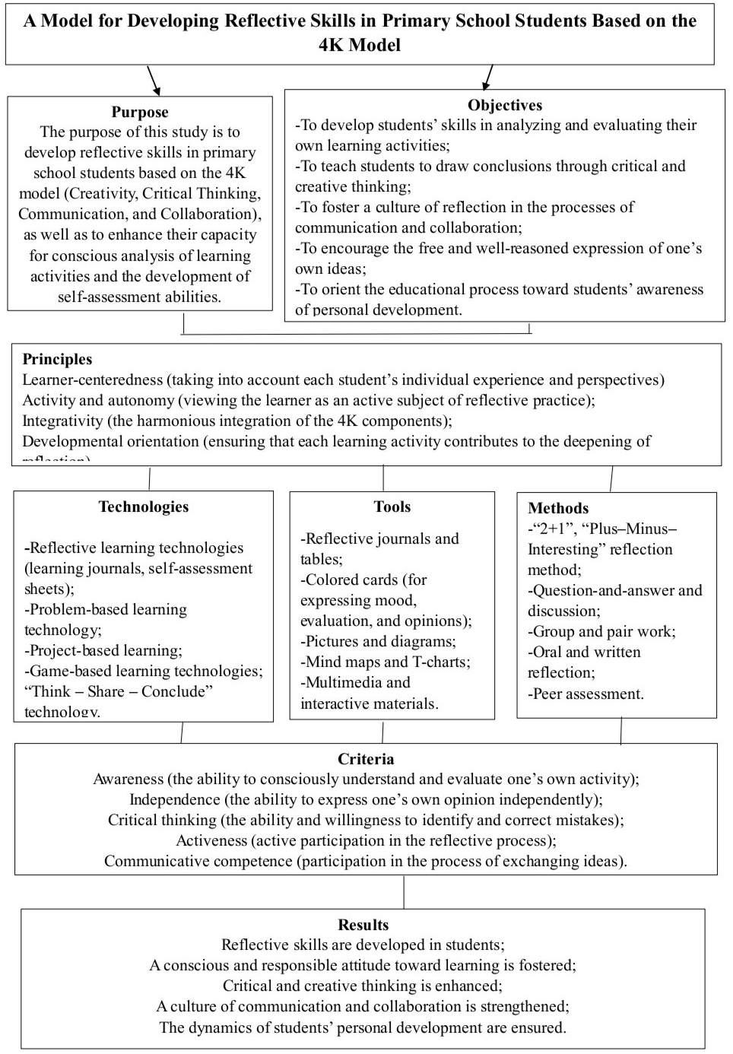
Figure 1. Model for Developing Reflective Skills in Primary School Students Based on the 4K Model
As can be seen from the above research, the implementation of the 4C Model in primary school classrooms significantly improves students’ reflective skills, learning attitudes, and communication abilities. Studies show that using the 4C Model leads to the following advantages:
- Students develop the ability to consciously evaluate and understand their own learning activities, which increases awareness and responsibility.
- Critical and creative thinking is enhanced, allowing students to analyze problems and propose innovative solutions.
- Active participation in reflection activities improves engagement and motivation in the learning process.
- Collaborative and communicative skills are strengthened through group and pair work, enhancing peer interaction.
- The personal development dynamics of students improve, including independence, confidence, and self-regulation.
Overall, the application of the 4C Model in primary education provides a comprehensive framework for fostering reflective thinking and holistic student development.
REFERENCES
1.Schürhuber, R., Oswald, B. R., Fickert, L., & Fortmann, J. Behavior of Wind Turbines with Doubly Fed Induction Generators (DFIG) under Short Circuits and Other Grid Faults. Elektrotechnik & Informationstechnik, 137(8), 415–424. 2020. https://doi.org/10.1007/s00502-020-00829-2
2.Kotov, A. A. Design and Analysis of an Asynchronized Synchronous Generator for High‑Power Wind Power Plants. Dissertation for the Degree of Candidate of Technical Sciences, Chelyabinsk. 2021.
3.Rashidov, N., Rozmetov, Kh., Rismukhamedov, S., & Peysenov, M. E3S Web of Conferences, 384, 01043. 2023. https://doi.org/10.1051/e3sconf/202338401043
4.Büssis, F. Control and Regulation of Wind Power Grid Integration with a Doubly Fed Induction Generator. Department of Information and Electrical Engineering, Faculty of Technology and Computer Science, Hamburg University of Applied Sciences.
5.Bobojanov, M., & Mahmutkhonov, S. Influence of the Consumer on Power Quality at the Point of Connection. E3S Web of Conferences, 384, 01041, 1–5. 2023. https://doi.org/10.1051/e3sconf/202338401041
6.Rasulov, A. N., & Ruzinazarov, M. R. Electrical Load Graphs and Indicators. E3S Web of Conferences, 384, 01042, 1–4. 2023. https://doi.org/10.1051/e3sconf/202338401042
7.Rakhmonova, I. Forming Reflective Skills as a Methodological Problem. Journal of Preschool and School Education, 3(6). 2025. https://doi.org/10.5281/zenodo.15698525
8.Abdusalimova, M. Methodology for Developing Reflective Skills of Primary School Students Based on Game Technology. Problems and Solutions of Scientific and Innovative Research. 2025. https://universalconference.us/universalconference/index.php/pssir/article/view/3
9.Sodiqova, S. U. Structure and Components of a Reflective Learning Environment in Pedagogical Education. Naqul Scientific Information Bulletin, 9(2), 3–10. 2025. https://inlibrary.uz/index.php/ifx/article/view/132724
10.Erdanova, Z. O., & Safarqulova, N. O. Improving Processes for Developing Reflective Skills in Primary School Teachers. International Conference on Modern Development of Pedagogy and Linguistics. 2024. https://universalconference.us/universalconference/index.php/icmdpl/article/download/510/953/959
11.Goyimov, U. E. Functions in Organizing the Process of Forming Reflective Skills in Teachers. Higher Education Resource of the Republic of Uzbekistan. 2024. https://uniwork.buxdu.uz/resurs/29996_1_071E67D881

