Investigation of the dynamics of the 3-methylpyridine molecule based on Raman scattering, infrared absorption spectra, and theoretical calculations
Dilafruz Khudoyberdieva ^{1,a)}, Shavkat Otajonov², Gulbahor Abdimalikova ¹
¹ Chirchik State Pedagogical University, Chirchik, Uzbekistan
²The National University of Uzbekistan named after Mirzo Ulugbek, Tashkent, Uzbekistan
^{a)} Corresponding author: xudoyberdiyevadilafruz915@gmail.com
Abstract. The structure and vibrational dynamics of the 3-methylpyridine (C₅H₄N(CH₃) molecule were investigated using Raman scattering and infrared absorption spectra, as well as theoretical calculation results based on the (DFT) method and the (B3LYP) HF/6-311G** basis set. The contribution of the CH₃ group to the Raman spectrum was studied by comparing the 3-methylpyridine molecule with pyridine. The shift of the spectral line associated with the vibration of the pyridine ring towards higher frequencies in the low-frequency range (100-1043 cm⁻¹) and the shift of the spectral lines resulting from the rotational-twisting movements of the pyridine ring towards lower frequencies were discussed.
INTRODUCTION
Obtaining accurate information about intermolecular interaction forces and their nature in condensed media, investigating the mechanisms of manifestation of optical spectra in molecules with complex atomic arrangements, and drawing scientifically grounded conclusions about molecular structures are among the fundamental and practical directions of spectroscopic research. Our research work is a logical continuation of studies in this direction, dedicated to investigating the relaxation regularities at energy levels.
Below, we will focus on the analysis of certain experimental and theoretical works relevant to our research.
Despite the extensive study of the structures of pyridine and its derivatives, which are considered organic heterocyclic compounds, the number of spectroscopic studies dedicated to them continues to grow annually due to their wide application in pharmacology, agrochemistry, and many other fields. The Raman scattering (RS) and infrared (IR) absorption spectra of various pyridine derivatives have been studied through both experimental and quantum-chemical theoretical calculations, analyzing the different characteristics of the spectra [1-6]. The spectral properties of pyridine for atmospheric monitoring have been identified using IR absorption spectra for the gas phase of pyridine [7]. The frequency shift of the Rayleigh scattering spectrums Mandelstam-Brillouin component in aqueous solutions of γ-picoline has been studied in relation to temperature and concentration [8]. The bond length and valence vibration frequency of the B-N bond in the pyridine-borane molecule, as well as the effect of complex formation on pyridine, have been demonstrated [9]. Molecular clustering regularities in pyridine, aniline, and their solutions have been studied using the RS spectra [10,11]. The frequency shifts and line width changes of the spectral lines in the 960-1080 cm⁻¹ and 2700-3650 cm⁻¹ ranges in mixtures of pyridine with methanol at various relative concentrations have been discussed in relation to pyridine concentration [12].
Raman spectra resulting from vibrational and rotational movements of molecules in aromatic hydrocarbons with symmetric and asymmetric polarizability tensors have been studied, providing detailed information on the mechanisms of optical spectrum manifestation based on the analysis of the obtained results. The frequencies of the RS spectra have been theoretically calculated and compared with experimental results based on these findings [13,14,15].
The Raman spectra of multi-atomic organic molecules such as acetone, neopentane, and ethylene explain several characteristic features of the vibrations of CH₃ and CH₂ groups [16].
For simple alcohols (from n-pentanol to n-decanol), it has been determined that the spectral lines in the Raman spectra in the low-frequency range of 200-600 cm⁻¹ are related to the twisting and bending vibrations of the groups formed by the increasing number of carbon atoms in the hydrocarbon chain [17]. The Raman spectrum of n-butane has spectral lines at 116.60 cm⁻¹ and 121.28 cm⁻¹ in the low-frequency range, which are associated with asymmetric twisting vibrations [18]. The following authors [19] have evaluated the short frequency range of 1550-1900 cm⁻¹ in Raman spectra as a “fingerprint within a fingerprint” region for identifying pharmaceutical ingredients in drugs.
Despite the abundance of experimental and theoretical data on the regularities of various physical properties of pyridines with a methyl group in the molecular structure, there is currently no unified view on the molecular-level processes occurring in these liquids and their manifestation in RS spectra. This indicates the need for further extensive research on these objects.
Based on the above considerations, this study investigates the structure and vibrational regularities of the 3-methylpyridine (C₅H₄N(CH₃) molecule by comparing its RS and IR absorption spectra, as well as theoretical quantum-chemical calculation results, with those of pyridine (C₅H₅N). The contribution of the CH₃ group to the Raman spectrum of the 3-methylpyridine molecule is examined.
EXPERIMENTAL RESEARCH
3-methylpyridine was purchased by the “Sigma-Aldrich” company in the USA. Its purity is 99.5%, and it was used for recording spectra without additional purification. The RS spectra of the research objects were recorded on a spectrometer created on the basis of the InVia Raman spectrometer from “Renishaw” company (in the frequency range of 100 – 4000 cm⁻¹). The spectral resolution of the Raman spectrometer is 0.3 cm⁻¹, and the spatial resolution is 0.25 μm. Lasers with a power of 100 mW and wavelengths of 532 nm and 785 nm were used as light sources. The IR absorption spectra were recorded on the Spectrum Two IQ-Fure spectrometer (in the range of 400 – 4000 cm⁻¹).
The optimal geometric parameters and theoretically calculated Raman spectrum of the 3-methylpyridine molecule were obtained using the ORCA software, based on the density functional theory (DFT) method and the (B3LYP) HF/6-311G** basis set [20].
RESEARCH RESULTS
Experimental RS spectra selected for analysis. The RS spectra for the research objects were recorded using laser radiation in the visible (λ=532 nm) and near-infrared (λ=785 nm) regions, with the frequency distribution of the spectra shown in Figures 1 and 2.
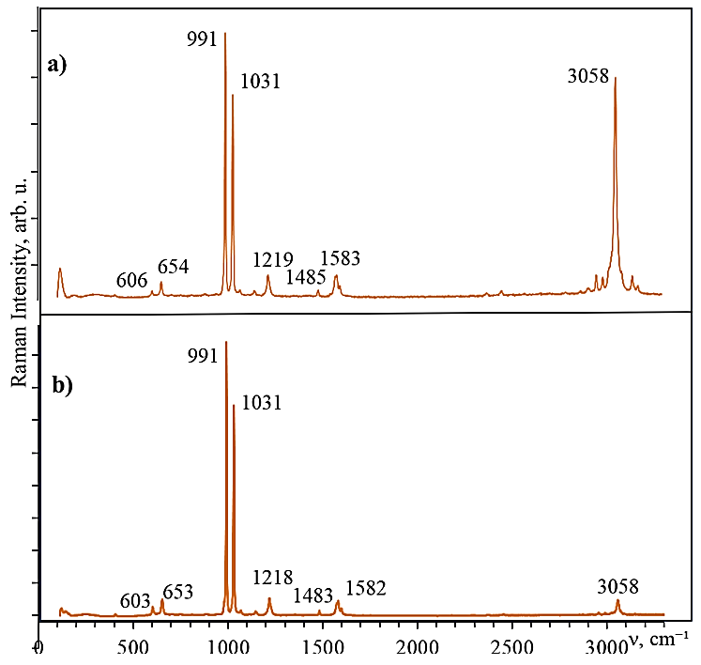
FIGURE 1. RS spectra for pyridine: a) laser-532 nm, laser power-10%; b) laser-785 nm, laser power 10%.
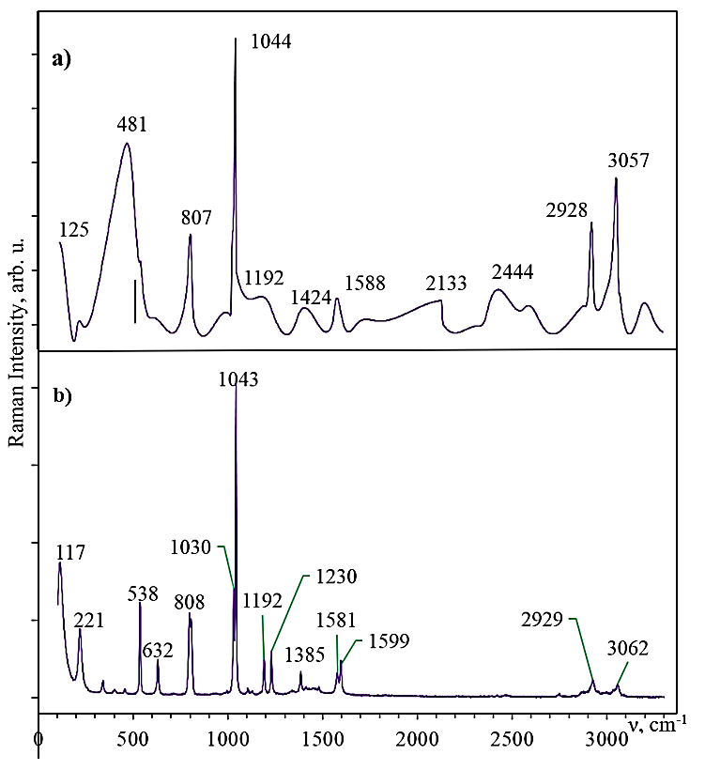
FIGURE 2. RS spectra for 3-methylpyridine: a) laser-532 nm, laser power-10%; b) laser-785 nm, laser power 10%.
According to the analysis of Figures 1 and 2, the fluorescence effects influence on the RS spectrum was observed in 3-methylpyridine, whereas no fluorescence was observed in pyridine. Therefore, in the analysis of the RS spectra, the spectrum obtained using laser radiation with a wavelength of 532 nm was used for pyridine, and the spectrum obtained using laser radiation with a wavelength of 785 nm was used for 3-methylpyridine.
Results of the calculation of the optimal geometric parameters of the 3-methylpyridine molecule. The 3-methylpyridine molecule is a derivative formed by the substitution of a methyl group (CH₃) for one hydrogen in the pyridine ring. Fig.3 shows the structural model of the 3-methylpyridine molecule. The optimized geometric parameters of the 3-methylpyridine molecule are given in Table 1.
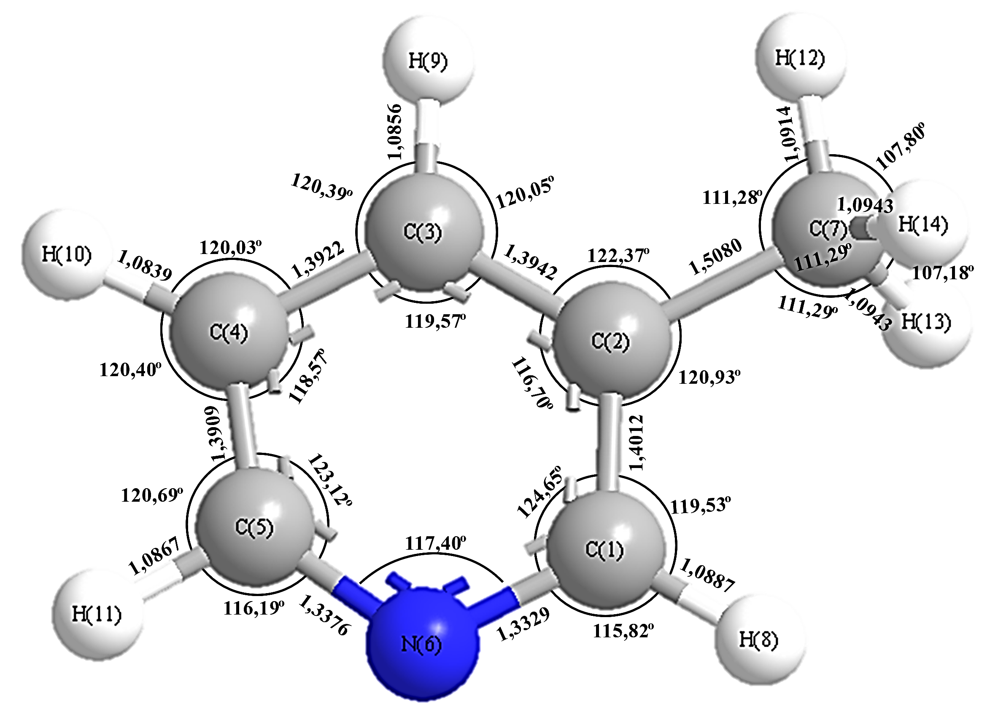
FIGURE 3. 3-Methylpyridine molecular structure model.
TABLE1. Theoretically calculated optimal geometric parameters of the 3-methylpyridine molecule
Bond between atoms | Bond length (Å) | Bond between atoms | Bond angle (⁰) | Bond  between  atoms | Dihedral angle  (⁰)
C1–C2 | 1.4012 | N6-C1-H8 | 115.82 | C3-C2-C1-H8 | -180
C2–C3 | 1.3942 | C2-C1-N6 | 124.65 | C3-C2-C1-N6 | 0
C3–C4 | 1.3922 | C2-C1-H8 | 119.53 | C7-C2-C1-H8 | 0
C4–C5 | 1.3909 | C1-C2-C3 | 116.70 | C7-C2-C1-N6 | -180
C5–N6 | 1.3376 | C3-C2-C7 | 122.37 | H9-C3-C2-C1 | 180
N6–C1 | 1.3329 | C1-C2-C7 | 120.93 | C4-C3-C2-C7 | 180
C2–C7 | 1.5080 | C4-C3-H9 | 120.39 | C4-C3-C2-C1 | -0
H8–C1 | 1.0887 | C2-C3-C4 | 119.57 | C4-C3-C2-C7 | -0
H9–C3 | 1.0856 | C2-C3-H9 | 120.05 | H10-C4-C3-H9 | 0
H10–C4 | 1.0839 | C5-C4-H10 | 120.40 | H10-C4-C3-C2 | 180
H11–C5 | 1.0867 | C3-C4-H10 | 121.03 | C5-C4-C3-H9 | -180
H12–C7 | 1.0914 | C3-C4-C5 | 118.57 | C5-C4-C3-C2 | 0
H13–C7 | 1.0943 | C4-C5-H11 | 120.69 | H11-C5-C4-С3 | 180
H14–C7 | 1.0943 | C4-C5-N6 | 123.12 | N6-C5-C4-H10 | -180
 |  | N6-C5-H11 | 116.19 | N6-C5-C4-С3 | 0
 |  | C1-N6-C5 | 117.40 | H11-C5-C4-H10 | 0
 |  | H13-C7-H14 | 107.18 | C1-N6-C5-H11 | -180
 |  | H12-C7-H14 | 107.80 | C1-N6-C5-C4 | -0
 |  | C2-C7-H14 | 111.29 | C5-N6-C1-H8 | 180
 |  | H12-C7-H13 | 107.80 | C5-N6-C1-C2 | -0
 |  | C2-C7-H13 | 111.29 | H14-C7-C2-C3 | 120.27
 |  | H12-C7-H12 | 111.28 | H14-C7-C2-C1 | -59.73
 |  |  |  | H13-C7-C2-C3 | -120.24
 |  |  |  | H13-C7-C2-C1 | 59.76
 |  |  |  | H12-C7-C2-C3 | 0.01
 |  |  |  | H12-C7-C2-C1 | -179.99

From the analysis of Table 1, it is evident that among the C–C bonds in the 3-methylpyridine molecule, the C2 - C3 and C1 - C2 bond lengths are the longest, extending by 0.0030 Å and 0.007 Å respectively compared to the bond lengths in the pyridine molecule [15]. The shortest bond is the C4 - C5 bond, which is shortened by 0.002 Å. The H9 – C3 and H8 - C1 bonds are extended by 0.001 Å. The N6 - C1 bond length is extended by 0.003 Å, while the C5 - N6 bond length is shortened by 0.004 Å. The angle of the methyl group introduced into the pyridine ring decreased by 2°, while the adjacent C2-C1-N6 and C2-C3-C4 angles increased by 1°. Among the bond distances, the distance between the C2 –C7 atoms is the largest, measured at 1.5080 Å. These changes in the pyridine ring are related to the introduction of the electron-donor CH₃ group.
Results of RS analysis, IR absorption and theoretical calculated spectra obtained for the 3-methylpyridine molecule. Fig.4 illustrates the general view of the experimental RS and IR absorption spectra in the wavenumber range of 0-3500 cm⁻¹ for the 3-methylpyridine molecule. An overview of the theoretically calculated and experimentally obtained Raman spectra of the 3-methylpyridine molecule is presented in Fig.5. The experimental results are included in Table 2.
FIGURE 4. for 3-methylpyridine obtained experimentally: a) IR absorption spectrum, b) RS spectrum

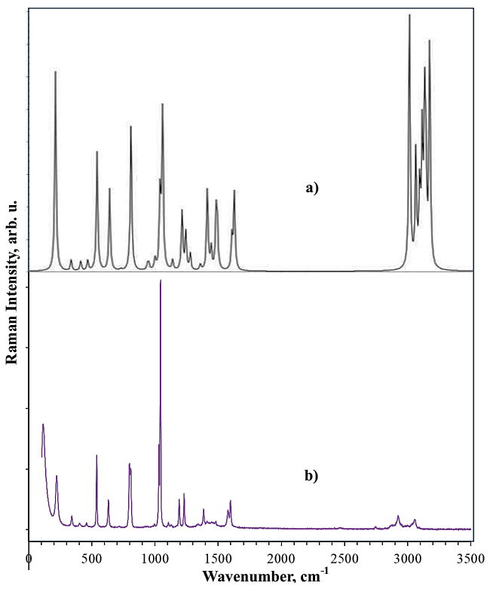
FIGURE 5. For 3-methylpyridine: a) Theoretically calculated RS spectrum, b) Experimentally obtained RS spectrum
TABLE 2. Experimental and theoretically calculated normal vibrational wavenumbers of the 3-methylpyridine molecule.
№ | Experimentally obtained wave number value, cm⁻¹ |  | Theoretically calculated wave number value ν, cm⁻¹
№ | RS | IR | ν | RS a. | IR a.
1 | 117 | - | - | 0 | 0
2 | 221 | - | 212 | 2.533 | 1.520
3 | 341 | - | 335 | 0.282 | 0.260
4 | 415 | 401 | 410 | 0.333 | 3.706
5 | 464 | 456 | 468 | 0.433 | 0.306
6 | 538 | 538 | 544 | 6.199 | 5.072
7 | 632 | 630 | 643 | 5.336 | 32,916
8 | - | 710 | 731 | 0.117 | 20,472
9 | - | 787 | 799 | 0.311 | 1.150
10 | 808 | - | 812 | 12,887 | 0.586
11 | - | - | 944 | 0.603 | 0.005
12 | - | - | 951 | 0.724 | 0.208
13 | - | - | 998 | 0.131 | 5.590
14 | - | - | 1001 | 1.166 | 11,562
15 | 1030 | 1029 | 1041 | 9.385 | 11,562
16 | 1043 | 1042 | 1064 | 20.491 | 0.304
17 | 1107 | 1107 | 1065 | 0.035 | 4.376
18 | 1127 | 1128 | 1142 | 1.440 | 8.0003
19 | 1192 | 1192 | 1216 | 9.134 | 4.905
20 | 1230 | 1230 | 1245 | 6.106 | 2.979
21 | - | - | 1283 | 2.712 | 1.045
22 | - | - | 1363 | 1.033 | 1.478
23 | 1385 | 1384 | 1416 | 15,690 | 0.547
24 | - | 1413 | 1445 | 4.315 | 11.013
25 | - | 1456 | 1487 | 12.041 | 9.404
26 | - | 1479 | 1497 | 7,973 | 18.336
27 | 1581 | 1578 | 1510 | 0.310 | 12,726
28 | 1596 | 1596 | 1613 | 7,958 | 16,791
29 | - | - | 1633 | 18,840 | 0.573
30 | 2929 | 2927 | 3023 | 194.316 | 22,592
31 | 3062 | 3028 | 3074 | 90.233 | 15.204
32 | - | - | 3101 | 59,796 | 14,969
33 | - | - | 3120 | 104.931 | 33,909
34 | - | - | 3141 | 127,942 | 9.6010
35 | - | - | 3154 | 70,570 | 17.362
36 | - | - | 3182 | 189.903 | 17.232

According to the research results, 13 spectral lines with varying intensities were observed in the RS spectrum of the 3-methylpyridine molecule in the frequency range of 100–3500 cm⁻¹. The analysis of these spectral lines is provided below.
For heterocyclic aromatic compounds, the spectral lines related to the valence vibrations of the C-H bond are found in the 3000–3100 cm⁻¹ frequency range in the RS spectrum [21, 22, 23]. The spectral line at 3062 cm⁻¹ in the RS spectrum corresponds to the valence vibrations of the C-H bonds in the pyridine ring, appearing at 3028 cm⁻¹ in the IR absorption spectrum and at 3074 cm⁻¹ in the theoretical calculations. Literature [21, 22] indicates that the spectral line associated with the valence vibrations of the CH₃ group is at a lower frequency range of 2870–2962 cm⁻¹ compared to the valence vibrations of the CH bonds in the pyridine ring. In the RS spectrum, the spectral line related to the symmetric valence vibrations of the methyl group is observed at 2929 cm⁻¹, at 2927 cm⁻¹ in the IR spectrum, and at 3023 cm⁻¹ in the theoretical spectrum.
The valence vibrations related to the CC bond of the pyridine ring should be observed in the frequency range of 1750–1450 cm⁻¹ [22, 23]. In our study, spectral lines related to these vibrations were observed at 1581 cm⁻¹ and 1596 cm⁻¹ in the RS spectrum, at 1479 cm⁻¹, 1578 cm⁻¹, and 1596 cm⁻¹ in the IR spectrum, and at 1487 cm⁻¹, 1497 cm⁻¹, and 1613 cm⁻¹ in the theoretical calculations.
The spectral line observed at 1385 cm⁻¹ in the RS spectrum is related to the symmetric deformation vibrations of the CH₃ group, corresponding to 1384 cm⁻¹ in the IR spectrum and 1416 cm⁻¹ in the theoretical spectrum, confirming that these lines are related to symmetric deformation vibrations.
In the frequency range of 1000–1250 cm⁻¹, the in-plane deformation vibrations of the aromatic ring CH bond are exhibited [22]. The spectral lines at 1192 cm⁻¹ and 1230 cm⁻¹ in the experimentally obtained RS spectrum, at 1192 cm⁻¹ and 1230 cm⁻¹ in the IR absorption spectrum, and at 1216 cm⁻¹ and 1245 cm⁻¹ in the theoretical calculations were considered to be related to the in-plane deformation vibrations of the CH bond.
The spectral lines at 1030 cm⁻¹ and 1043 cm⁻¹ in the experimental data correspond to the asymmetric and symmetric (ring breathing) stretching vibrations of the pyridine ring, respectively. The spectral line at 1043 cm⁻¹ in the Raman scattering (RS) of 3-methylpyridine corresponds to the spectral line at 992 cm⁻¹ in the Raman scattering (RS) of pyridine, showing a shift of +51 cm⁻¹ to higher frequencies. This blue shift in the spectral line may be due to intermolecular interactions between the N atom of the 3-methylpyridine molecule and the H atoms of the neighboring molecule's methyl group. These spectral lines correspond to frequencies of 1029 cm⁻¹ and 1041 cm⁻¹ in the IR absorption spectrum, and to frequencies of 1042 cm⁻¹ and 1064 cm⁻¹ in the theoretical calculations.
The spectral line at 808 cm⁻¹ is associated with out-of-plane deformation vibrations of the H atoms in the methyl group. In the theoretical calculations, this line appears at 812 cm⁻¹, showing good agreement between the experimental and theoretical results.
The spectral lines at 538 cm⁻¹ and 632 cm⁻¹, which fall within the lower frequency range, are related to the rotational-twisting movements of the pyridine ring in the studied molecule. These lines have shifted to lower frequencies by -68 cm⁻¹ and -22 cm⁻¹, respectively. Such a red shift in the spectral lines may be due to the substitution of one H atom in the pyridine ring with a CH₃ methyl group.
When comparing the experimentally obtained spectrum with the theoretically calculated spectrum, only small shifts in frequencies related to certain vibrations were observed. These discrepancies might be due to certain limitations in the theoretical calculations.
CONCLUSION
The structure and vibrational properties of the 3-methylpyridine (C₅H₄N(CH₃) molecule were investigated using Raman scattering and infrared absorption spectra, as well as theoretical calculations based on the Density Functional Theory (DFT) method and the (B3LYP) HF/6-311G** basis set. The contribution of the CH₃ group to the Raman spectrum was studied by comparing the 3-methylpyridine molecule to pyridine. It was noted that in the lower frequency range (100-1043 cm-1), the spectral line associated with the vibration of the pyridine ring shifted to higher frequencies, which is attributed to intermolecular H-bonding. The shift of the spectral lines formed by the rotational-twisting movements of the pyridine ring to lower frequencies was found to be related to the methyl substitution in the structure.
Acknowledgments: This work is supported by the World Bank Project "Modernizing Uzbekistan National Innovation System" and Subproject title is “Tunable optical harmonic generation and soliton transport in optoelectronic networks” (REP-04032022/206).
REFERENCES
- K.A. Bunding, John R. Lombardi, Ronald L. Birke, Surface enhanced Raman spectra of methylpyridines, Chemical Physics, Vol. 49, Issue 5, 1980, P. 53-58,
https://doi.org/10.1016/0301-0104(80)85038-5.
- Kazumasa Yoshikai, Toshikazu Hieida, Yoshinori Nibu, Hiroko Shimada, Ryoichi Shimada, Normal Vibrations of 4-Methyl- and 4-Methyl-d3-pyridines, Bulletin of the Chemical Society of Japan, Vol. 63, Issue 5, May 1990, P. 1529–1531. https://doi.org/10.1246/bcsj.63.1529
- M. Szafran, J. Koput, Ab initio and DFT calculations of structure and vibrational spectra of pyridine and its isotopomers, Journal of Molecular Structure, Vol. 565–566, 2001, P. 439-448,
https://doi.org/10.1016/S0022-2860(00)00934-0.
- N. Sundaraganesan, C. Meganathan, Mustafa Kurt, Molecular structure and vibrational spectra of 2-amino-5-methyl pyridine and 2-amino-6-methyl pyridine by density functional methods, Journal of Molecular Structure, Vol. 891, Issues 1–3, 2008, P. 284-291.
https://doi.org/10.1016/j.molstruc.2008.03.051.
- K.R. Santhy, M. Daniel Sweetlin, S. Muthu, Christina Susan Abraham, M. Raja, Molecular structure, spectroscopic (FT-IR, FT-Raman) studies, Homo–Lumo and Fukui function calculations of 2-Acetyl amino-5-bromo- 4 methyl pyridine by density functional theory, Chemical Data Collections, Vol.24, 2019,
https://doi.org/10.1016/j.cdc.2019.100291.
- S. Premkumar, A. Jawahar, T. Mathavan, M. Kumara Dhas, A. Milton Franklin Benial, Vibrational spectroscopic and DFT calculation studies of 2-amino-7-bromo-5-oxo- [1] benzopyrano [2,3-b] pyridine-3 carbonitrile, Spectrochimica Acta Part A: Molecular and Biomolecular Spectroscopy, Vol. 138, 2015, P. 252-263. https://doi.org/10.1016/j.saa.2014.11.029.
- T.J. Johnson, P.M. Aker, N.K. Scharko, S.D. Williams, Quantitative infrared and near-infrared gas-phase spectra for pyridine: Absolute intensities and vibrational assignments, Journal of Quantitative Spectroscopy and Radiative Transfer, Vol. 206, 2018, P. 355-366.
https://doi.org/10.1016/j.jqsrt.2017.11.023.
- Sabirov L.M., Semenov D.I., Khaidarov Kh.S. Mandelshtam-Brillouin scattering spectra of aqueous solutions of γ-picoline and manifestation of a phase transition of the structural type in these spectra at low concentrations of γ-picoline. Opt. and spectros., 2008, 105, pp. 369-376.
http://dx.doi.org/10.1134/S0030400X08090087
- Ethan С. Lambert, Benjamin W. Stratton, and Nathan I. Hammer. Raman Spectroscopic and Quantum Chemical Investigation of the Pyridine-Borane Complex and the Effects of Dative Bonding on the Normal Modes of Pyridine. ACS Omega, 2022/04/08. V.7, P.13189−13195.
http://dx.doi.org/10.1021/acsomega.2c00636
- F.H. Tukhvatullin, B.G. Hudayberdiev, A. Jumabaev, H.A. Hushvaktov, A.A. Absanov, Aggregation of molecules in liquid pyridine and its solutions: Raman spectra and quantum-chemical calculations, Journal of Molecular Liquids, Vol.155, Issue 1, 2010, P.67-70, ISSN 0167-7322,
https://doi.org/10.1016/j.molliq.2010.05.015.
- Abduvakhid Jumabaev, Bekzod Khudaykulov, Iryna Doroshenko, Hakim Hushvaktov, Ahmad Absanov, Raman and ab initio study of intermolecular interactions in aniline, Vibrational Spectroscopy, Vol.122, 2022, 103422, ISSN 0924-2031. https://doi.org/10.1016/j.vibspec.2022.103422.
- M. Kreyenschmidt, H.H. Eysel, B.P. Astana., Study of the Pyridine-Methanol System Using Four-Channel Raman Spectroscopy: Concentration Dependence of Frequencies, Line Widths and Integrated Intensities, Journal of Raman Spectroscopy, Vol.24, 1993, P.645-652. https://doi.org/10.1002/jrs.1250241003
- Eshchanov B., Otajonov SH. Kolebatelnaya i vrashatelnaya spektroskopiya molekul v jidkoy faze. Toshkent, 2019, S.178.
- Bakhodir Eshchanov, Shavkat Otajonov, Dilafruz Xudoyberdiyeva and others. Intermolecular dynamics of condensed state: study of temperature effect on anisotropy relaxation by vibration spectroscopy // Bulletin of National University of Uzbekistan: Mathematics and Natural Sciences. Vol.3, Issue 3, 2020. Pages 388-411. https://doi.org/10.56017/2181-1318.1119
- Dilafruz Khudoyberdieva, Shavkat Otajonov, Bakhodir Eshchanov, Husan Eshquvatov, Nuraddin Abdullayev, Mechanisms of Raman scattering spectrum of light from pyridine molecule in the lower frequency range, Results in Optics, 2024, Vol.16, 100685, ISSN 2666-9501.
https://doi.org/10.1016/j.rio.2024.100685.
- J. Sebek and Roie Knaanie and Brian Albee and Eric Olaf Potma and R. Benny Gerber, Spectroscopy of the C-H stretching vibrational band in selected organic molecules, The journal of physical chemistry A, 2013, Vol. 117. 32, P. 7442–7452. https://doi.org/10.1021/jp4014674
- G.А. Pitsevich, I.Yu. Doroshenko, V.Ye. Pogorelov, Е.N. Kozlovskaya, T. Borzda, V. Sablinskas, V. Balevicius, Long-wave Raman spectra of some normal alcohols, Vibrational Spectroscopy, 2014, Vol.72, P.26-32.
https://doi.org/10.1016/j.vibspec.2014.02.003
- J.R. Durig, A. Wang, W. Beshir, and T.S. Little. Barrier to asymmetric internal rotation, conformational stability, vibrational spectra and assignments, and Ab Initio calculations of n-butane-d0, d5 and d10. Journal of Raman Spectroscopy, 1991, Vol.22, P.683-704. https://doi.org/10.1002/jrs.1250221115
- Brittany Handzo, Jeremy Peters, Ravi Kalyanaraman. A Fingerprint in a Fingerprint: A Raman Spectral Analysis of Pharmaceutical Ingredients, Spectroscopy, March 2022, Vol.37, Issue 3, P. 24–30,45.
https://doi.org/10.56530/spectroscopy.cm2680s2
- Neese F. The ORCA program system. Wiley Interdisciplinary Reviews:
Computational Molecular Science. 2012. V.2. N.1. P. 73–78. https://doi.org/10.1002/wcms.81
- Peter larkin, Infrared and raman spectroscopy principles and spectral interpretation, Elsevier Inc. All rights reserved, 2011, P.226.
- James M. Thompson, Infrared Spectroscopy, Pan Stanford Publishing Pte. Ltd. 2018, Singapore, P.194.
- Peter Vandenabeele, Practical Raman spectroscopy: an introduction, Ghent University, Belgium. John Wiley & Sons, Ltd, 2013, P.161.

