Design of a mechanical drive for a gravitational energy storage system
Akram Mirzabaev^{1,a)}, Khusniddin Shamsutdinov², Sherzod Mirzabekov ², Bahrom Normuratov², Nodirbek Pulatov^{2,a)}
¹ Tashkent Institute of Irrigation and Agricultural Mechanization Engineers, Tashkent, Uzbekistan
²Tashkent state technical university named after Islam Karimov, Tashkent, Uzbekistan
^{a)} Corresponding author: nodirbekpulatov1993@gmail.com
Abstract. Gravitational energy storage systems represent a promising solution for mitigating the intermittency and variability of renewable energy sources in industrial power systems. This study presents the development and analysis of an electromechanical gravitational energy storage device based on mass lifting and energy recovery principles. A nonlinear state-space mathematical model describing the coupled mechanical and electrical dynamics of the system is formulated, incorporating load motion, motor–generator behavior, and power exchange with the electrical grid. The proposed system operates in two modes: charging, where electrical energy is converted into gravitational potential energy by lifting a mass, and discharging, where the stored potential energy is converted back into electrical energy. The model accounts for mechanical and electrical losses through efficiency coefficients and enables dynamic simulation of height variation, stored energy, motor current, angular speed, and power flow. Simulation results obtained using parameters of an experimental setup demonstrate the system’s capability to store and recover energy under realistic operating conditions. For a load of 275 kg lifted to a height of 18 m, the input energy of 0.1082 MJ and output energy of 0.048556 MJ yield a round-trip efficiency of approximately 44.89%. The results confirm the nonlinear nature of the system dynamics and highlight the influence of mass, height, and electromechanical coupling on overall performance. The presented modeling approach provides a useful framework for the design, optimization, and integration of gravitational energy storage systems in industrial applications and renewable energy-based power networks.
INTRODUCTION
Gravitational energy storage systems represent one of the key technologies for addressing the uncertainty and variability challenges inherent in renewable energy sources[1]. These systems operate by storing potential energy, whereby electrical energy is used to lift a mass to an elevated position and subsequently released by lowering the mass to recover the stored energy[2-3].
Mathematical models of gravitational energy storage play a fundamental role in analyzing and simulating these processes within power systems, as well as in the development of optimal control algorithms.
At present, one of the main shortcomings in ensuring the continuity of electricity consumption in modern power systems used by domestic industrial enterprises is the low level of integration of renewable energy resources[4-6]. Experience reported by leading international researchers indicates that extensive scientific studies have been conducted on the effective utilization of renewable energy resources in industrial facilities, which contributes to improving energy efficiency and reducing overall electricity consumption[7-9].
Based on the analysis of the relevant literature, the primary objective of this study is to propose the design of an electromechanical gravitational battery energy recovery device aimed at ensuring uninterrupted energy supply for industrial enterprises (Figure 1) [10-12].
The proposed system consists of a motor–generator unit (1), a rigid coupling (2), a gearbox (3), a driving pulley (4), a driven pulley (6), a rope providing pulley motion (5), and a suspended load (7) serving as the energy storage element.
The developed electromechanical gravitational battery energy recovery system operates in two distinct modes.
Mode 1: Charging mode. In this mode, mechanical work is performed using electrical energy. The motor–generator (1), supplied with electrical power from the grid, transmits rotational motion through the rigid coupling (2) to the gearbox (3). In turn, the driving motion of the gearbox is transferred via gear wheels to the driven shaft. The driving pulley (4), mounted on the driven shaft of the gearbox (3), generates tension in the rope (5), causing the driven pulley (6) of the mechanism to start rotating. As a result, the suspended load (7) attached to the rope (5) is lifted upward. This process continues until the load (7) reaches the required height.
Mode 2: Discharging mode. In this mode, the suspended load (7) begins to move downward under the action of its gravitational potential energy, enabling energy recovery in the electromechanical gravitational battery system. As the load descends, the attached rope (5) drives the rotation of pulleys (6) and (4). The rotational motion of the driving pulley (4) generates torque on the driven shaft of the gearbox (3). Due to the meshing of the gear wheels within the gearbox (3), the rotational speed is increased, resulting in the motion of the driving shaft of the gearbox. This motion is transmitted through the rigid coupling (2), which is mechanically connected to the gearbox (3), causing the rotor of the motor–generator (1) to rotate. Consequently, the gravitational potential energy of the suspended load (7) is converted into electrical energy by the motor–generator (1).
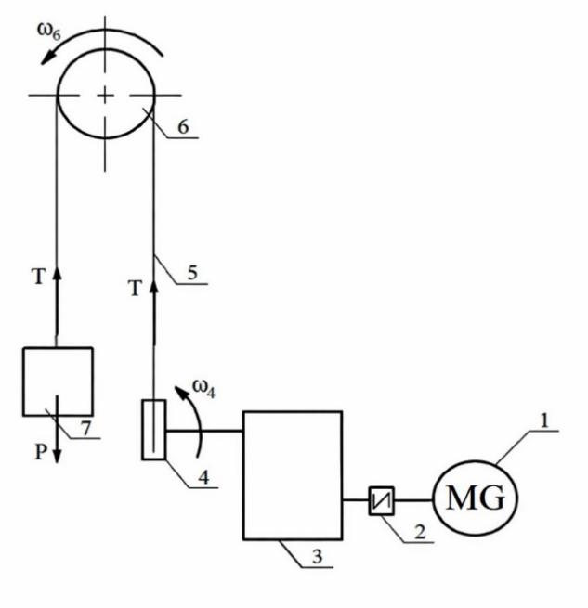
FIGURE 1. Electromechanical gravitational battery energy recovery system: 1–motor–generator (MG), 2–rigid coupling, 3–gearbox, 4–driving pulley, 5–rope (cable), 6–driven pulley, 7–suspended load.

By operating in these two modes, the proposed system enables stable delivery of electrical power generated by photovoltaic panels used in industrial enterprises to consumers, thereby ensuring continuity and reliability of power supply.
Ensuring reliable and stable operation of the electromechanical gravitational battery energy recovery system requires proper selection of the gearbox (3) and pulleys (4, 6), as well as their corresponding geometric parameters. In the proposed device, the selection of the gearbox primarily involves determining its optimal transmission ratio, while rational values of pulley diameters are selected using mathematical modeling techniques to achieve efficient energy conversion and mechanical compatibility.
Gravitational energy storage systems are fundamentally based on one of the most universal laws of nature-Newton’s law of universal gravitation. According to this law, any two bodies interact through a gravitational force, which governs their motion and can be expressed by the following equation:
, (1)
where, F - is the gravitational force between two bodies (N); G=6.674×10-11 m³/kgs² - is the gravitational constant; m₁ and m₂ are the masses of the bodies (kg); r - is the distance between the centers of the bodies (m).
One of the key parameters of a gravitational energy storage system is mass. Increasing the mass enhances the energy storage capacity and improves the overall efficiency of the system. For example, in various large-scale projects, the accumulated mass can reach several thousand tons.
When selecting the mass, the following factors are taken into account:
– the system power rating and the required energy capacity;
– installation and placement conditions;
– mechanical stability and safety requirements.
To evaluate the stored potential energy, mass and elevation height are the key parameters. The potential energy associated with the mass can be expressed by the following equation:
(2)
where m is the mass (kg), g is the acceleration due to gravity (9.81 m/s²), and h is the height (m)[13-15].
Height is one of the key parameters determining the energy storage capacity of a gravitational energy storage system. In any gravitational energy storage system, a greater elevation enables a larger amount of energy to be stored.
The dependence of gravitational energy on height can be expressed by the following equation[16]:
(3)
where $h_{0}$ - is the initial height, and Δh(𝑡) represents the time-dependent variation of height.
In gravitational energy storage systems, the primary working element is a high-mass body (e.g., a concrete block, a metal platform, or a water reservoir). Energy is stored and released through the controlled motion of this mass.
Accordingly, the starting point of the mathematical model is the evaluation of gravitational potential energy [17-20].

EXPERIMENTAL RESEARCH
To illustrate the practical significance of gravitational energy storage, a simple calculation is considered. For instance, if a load with a mass of m=275 kg is lifted to a height of 18 m, the stored energy can be determined as follows:
Although this value may appear relatively small, systematic lifting of multiple loads or application in large-scale industrial installations enables energy storage on the order of megajoules. For example, lifting a 30-ton mass to a height of 100 m allows approximately 29.4 MJ of energy to be stored, which is equivalent to 8.2 kWh of electrical energy.
In our experimental setup, examples of gravitational potential energy values corresponding to different mass and height combinations are presented as follows.

TABLE 1. Gravitational potential energy as a function of mass and height in the experimental setup
m (kg) | h(m) | E_{p} (kJ) | E_{r} (kWh)
100 | 18 | 17,658 | 0,004905
125 | 18 | 22,0725 | 0,00613125
150 | 18 | 26,487 | 0,0073575
175 | 18 | 30,9015 | 0,00858375
200 | 18 | 35,316 | 0,00981
225 | 18 | 39,7305 | 0,01103625
225 | 18 | 39,7305 | 0,01103625
275 | 18 | 48,5595 | 0,01348875

Increasing the mass enhances the energy storage capacity; however, mechanical losses in the lifting and rail systems also increase.
Figure 2 illustrates the amount of gravitational potential energy generated by lifting a load with a mass of 𝑚=275kg to a height of 18 m.
The application of hydromechanical principles in gravitational energy storage systems is effectively implemented in the following areas:
– integration with renewable energy sources;
– power balance regulation;
– prevention of electricity supply interruptions;
– energy efficiency improvement in industrial enterprises.
For example, the Energy Vault and Gravitricity projects employ mass-lifting systems based on hydromechanical principles.
Global experience demonstrates the practical feasibility of such systems. In the Energy Vault project, concrete blocks are lifted to heights of up to 35 m, achieving a maximum storage capacity of approximately 35 MWh [6]. In contrast, the Gravitricity project utilizes mine shaft elevators capable of lifting masses to heights of up to 150 m, providing an energy storage capacity of approximately 20 MWh [31].
Analysis of the literature indicates that, in the Energy Vault project, individual block masses typically range from 35 to 100 tons, whereas the Gravitricity project achieves energy storage capacities of approximately 4–20 MWh by utilizing deep mine shafts.
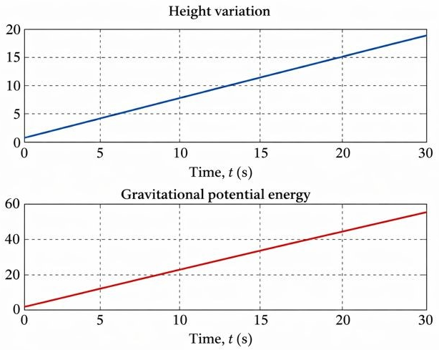
FIGURE 2. The gravitational potential energy generated by lifting a load with a mass of m=275 kg to a height of 18 m.

RESEARCH RESULTS
Electromechanical coupling. To connect the gravitational energy storage system to the electrical grid, a motor–generator unit is employed. Its dynamic behavior can be described as follows:
(4)
where i(t) is the electric current, L denotes the inductance, R is the electrical resistance, K_{e} represents the electromotive force (EMF) constant, and U(t) is the input voltage.
Motor–generator torque:
(5)
where K_{m} is the current-torque coefficient.
Electrical power:
(6)
mechanical power:
(7)
Nonlinear state-space model. System state vector:
(8)

System of equations:
(9)

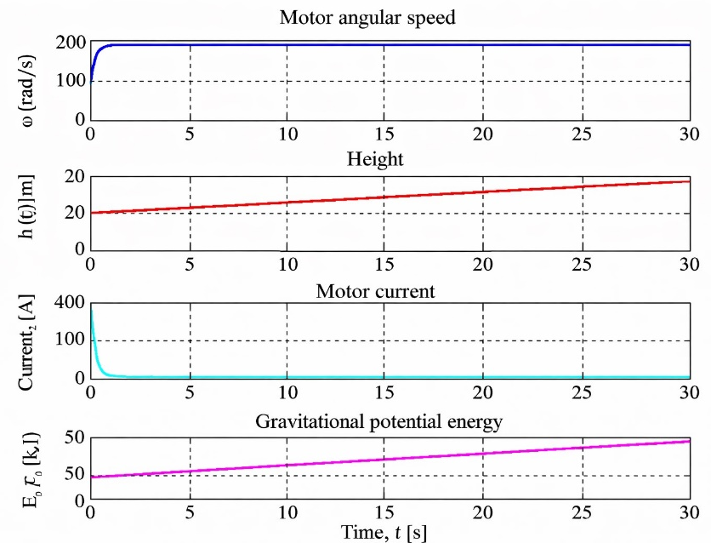
FIGURE 3. Results of nonlinear mechanical dynamic modeling of the gravitational energy storage system.

The model is classified as nonlinear due to the coupling between the state derivatives h, 𝜔, and 𝑖.

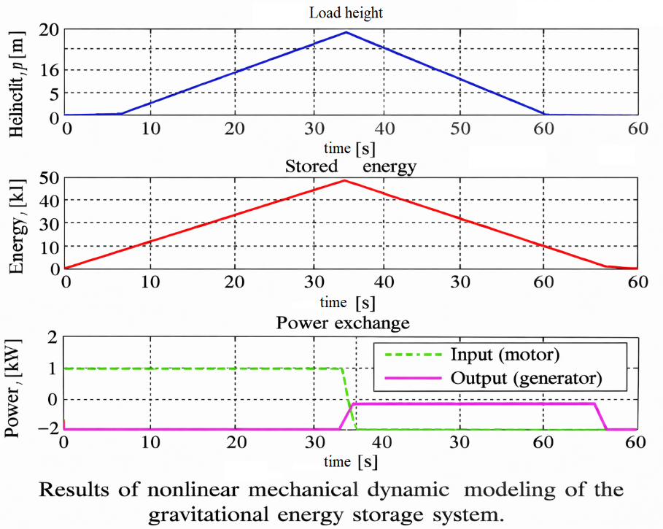
FIGURE 4. Results obtained using the mathematical model of the experimental gravitational energy storage device.
Figure 4 presents a model of the process of lifting a 275 kg load to a height of h=18 m using a gravitational energy storage device with a mechanical efficiency of η_{mech}=0.67 and an electrical efficiency of η_{elec}=0.67. In this case, the input energy is E_{in}=0.1082 MJ, while the output energy is E_{out}=0.048556 MJ, resulting in a round-trip efficiency of 44.89%.
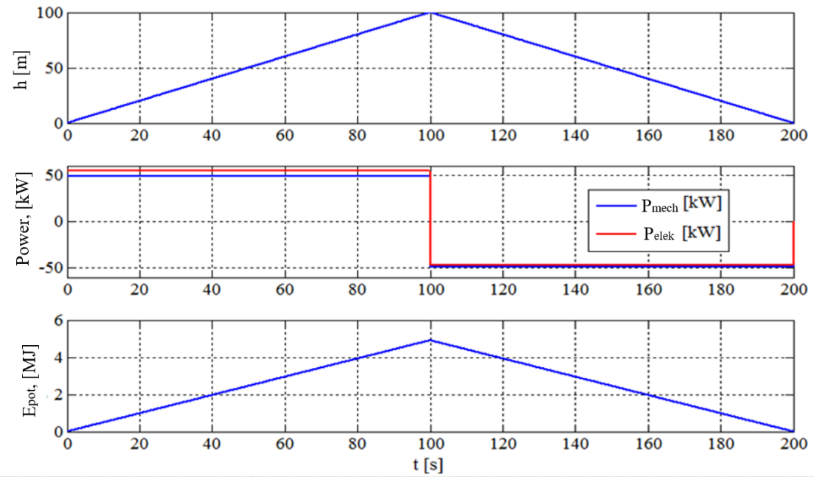
FIGURE 5. Model of the mass lifting (charging) and lowering (discharging) processes.

Figure 5 illustrates a model of the lifting process of a 5000 kg load to a height of h = 100 m using a gravitational energy storage system with a mechanical efficiency of ηₘₑₓ = 0.9 and an electrical efficiency of ηₑₗₑₖ = 0.95. In this system, the input energy is E₍ᵢₙ₎ = 5.447 MJ, while the output energy is E₍ₒᵤₜ₎ = 4.660 MJ. As a result, the round-trip efficiency of the energy storage cycle reaches 85.54%.
CONCLUSIONS
This study has presented the development and analysis of an electromechanical gravitational energy storage system intended for improving the stability and reliability of power supply in industrial applications with a high share of renewable energy sources. A comprehensive nonlinear state-space mathematical model was formulated to describe the coupled mechanical and electrical dynamics of the system, including mass motion, motor–generator behavior, and power exchange with the electrical grid.
The system operation was analyzed in both charging and discharging modes, demonstrating the feasibility of reversible energy conversion between electrical energy and gravitational potential energy. The results confirm that the system dynamics are inherently nonlinear due to the mutual coupling of height, angular speed, and electrical current, which must be considered in accurate modeling and control design.
Simulation results based on an experimental configuration showed that, for a load of 275 kg lifted to a height of 18 m, the system achieves a round-trip efficiency of approximately 44.89%, with input and output energies of 0.1082 MJ and 0.048556 MJ, respectively. These findings highlight the significant influence of mechanical and electrical efficiencies, as well as gearbox and pulley parameters, on the overall performance of the gravitational energy storage device.
The obtained results demonstrate that gravitational energy storage systems can provide effective short-term energy buffering and power balancing in industrial environments, particularly when integrated with renewable energy sources. The proposed mathematical modeling framework can be employed for further optimization of system parameters, efficiency enhancement, and the development of advanced control strategies for large-scale gravitational energy storage applications.

REFERENCES
- Gravitricity, Technical Overview, 2021.
- Gravitricity. Gravity Energy Storage. URL: https://www.gravitricity.com (data obraщyeniya: 20.09.2025).
- Mirzabaev, A., Mirzabekov, S., and Pulatov, N., “Using gravity systems as a backup in power systems containing renewable energy sources,” AIP Conference Proceedings 3331, 040086 (2025). https://doi.org/10.1063/5.0305738.
- C. Zhao, Optimization and modelling of gravitational energy storage systems, Journal of Energy Storage, 2022, 52, 105017.
- Gayibov, T., Uzakov, B., Shanazarov, A. Algorithm of Power System Mode Optimization Taking into Account Losses in Networks and Functional Constraints // Aip Conference ProceedingsOpen source preview, 2023, 2612, 050011 DOI: 10.1063/5.0117667.
- Pulatov, B., Alisher, S. Optimization of modes of the electric power systems by genetic algorithms // E3s Web of ConferencesOpen source preview, 2020, 216, 01099 DOI: 10.1051/e3sconf/202021601099.
- Rismukhamedov D., Shamsutdinov Kh., Rozmetov Kh., Khusanov Sh., Rismukhamedov S. Improvement of electromagnetic properties of pole-changing windings // AIP Conference Proceedings. 2025. Vol. 3331. Art. no. 040058. https://doi.org/10.1063/5.0305959.
- Method of orientation of solar panels of solar power plant // Mirzabekov Sh. // E3S Web of Conferences, 2023, 401, 04018. https://www.scopus.com/record/display.uri?eid=2-s2.0-85169702964&origin=resultslist.
- Latipov, Sh.Sh., Shanazarov, A.E., Ikramdjanov, I.B. Consideration of limitations in the form of inequalities in optimal planning of power systems regimes under uncertainty initial information // E3s Web of ConferencesOpen source preview, 2021, 289, 07005 DOI: 10.1051/e3sconf/202128907005.
- Nurmatov, O., Maxmudov, T., and Po‘latov, N.,Control of the excitation system of synchronous motors pumping stations, AIP Conference Proceedings 3152, 040008 (2024). https://doi.org/10.1063/5.0218781.
- Rismukhamedov D., Shamsutdinov Kh., Magdiev Kh., Peysenov M., Nurmatov O. Construction of pole-switchable windings for two-speed motors of mechanisms with a stress operating mode // AIP Conference Proceedings. 2025. Vol. 3331. Art. no. 040059. https://doi.org/10.1063/5.0305963.
- Patterning aspects of small solar power development in Uzbekistan // Sitdikov, O.R., Mirzabaev, A.M., Mahkamov, T.A., Mirzabekov, S. // E3S Web of Conferences, 2019, 139, 01010. https://www.scopus.com/record/display.uri?eid=2-s2.0-85077130476&origin=resultslist.
- T. Gayibov, A. Shanazarov, and B. Uzakov, “Algorithm for comprehersive optimization of operating modes of electric power systems,” AIP Conf. Proc. 3331(1), 040028 (2025). https://doi.org/10.1063/5.0305824.
- Bobojanov M. K., Rismukhamedov D. A., Tuychiev F. N., Shamsutdinov Kh. E., and Ganiev S. T., Construction methodology and analysis of electromagnetic properties of pole-changing winding, AIP Conference Proceedings 3331, 0267444 (2025). https://doi.org/10.1063/5.0267444.
- K. Shamsutdinov, Study on improving the asynchronous electric drive of ball mills, E3S Web of Conferences, 2024, Article No. 01001. https://doi.org/10.1051/e3sconf/202449701001.
- D. Rismukhamedov, Kh. Shamsutdinov, S. Ganiev, Kh. Magdiev, Sh. Khusanov, New pole-changing winding for electric drive of ball mills, E3S Web of Conferences 384, 01059 (2023). https://doi.org/10.1051/e3sconf/202338401059.
- Photovoltaic Plants for Water Lift Systems // Mirzabaev, A.M., Sytdykov, O.R., Makhkamov, T.A., Verchenko, P.E., Mirzabekov, S.M. // Applied Solar Energy (English translation of Geliotekhnika), 2018, 54(5), стр. 346–349. https://www.scopus.com/record/display.uri?eid=2-s2.0-85061633908&origin= resultslist.
- Photovoltaic Power Supply Unit for the Basic Stations of Cellular Companies // Mirzabaev, A.M., Kanonerov, V.P., Makhkamov, T.A., Sytdykov, O.R., Mirzabekov, S.M. // Applied Solar Energy (English translation of 040086-9-05 November 2025 04:15:32 Geliotekhnika), 2018, 54(3), стр. 224–226. https://www.scopus.com/record/display.uri?eid=2-s2.0-85053563686&origin=resultslist
- Analysis of photovoltaic power station (PPS) modeling using artificial neural network and PVsyst software // Mirzabaev, A., Mirzabekov, S., Kodirov, D., Makhkamov, T., Mirzaev, A. // E3S Web of Conferences, 2023, 434, 01019. (5 фоиз). https://www.scopus.com/record/display.uri?eid=2-s2.0-85174569165&origin=resultslist.
- V. Supraja1, K. Sri Sai Ram Chandh2, S. Sasi Nagendra et al. A review on gravity batteries // International Journal
of Advance Research and Innovative Ideas in Education, Vol-8 Issue-6, 2022, p. 434-439.

