Study of Power Supply System by Modeling Gravity Energy Storage
Allabergen Bekishev^{1, a)}, Azamat Rakhimov¹, Aziza Khalbutaeva¹, Gulnora Raxmanova², Zinatdin Saimbetov³
¹ Tashkent State Technical University named after Islam Karimov, Tashkent, Uzbekistan
²Tashkent University of Information Technologies named after Muhammad al-Khwarizmi, Tashkent, Uzbekistan
³Karakalpak State University named after Berdakh, Uzbekistan, Republic of Karakalpakstan, Nukus city
^{a)} Corresponding author:allabergenbekisev@gmail.com
Abstract. This article examines the sustainability assessment of power supply systems integrated with renewable energy sources through mathematical modeling of gravity energy storage systems (GES). The primary objectives of the study are to determine the mechanical and electrical parameters of energy conversion through mass lifting and lowering in the GES system, model dynamic processes in MATLAB/Simulink, analyze the system's energy balance, and optimize the efficiency. The article analyzes the design features of the GES system, energy conversion equations, a dynamic model of the generator-motor system, an inverter control algorithm, and the parallel operation mode with a synchronous generator-electric power station (CEPS). The study concludes that the overall efficiency of the GES system is in the range of 82–87%, which can play a significant role in improving the sustainability of the power supply.

INTRODUCTION
The share of renewable energy sources (RES) in modern energy systems-wind power, photovoltaic installations, biogas plants, etc.-is growing every year [1]. The environmental friendliness, affordability, and long-term stability of these sources have made them an important component of energy infrastructure modernization. However, the main drawback of RES is the instability and volatility of the energy source. Therefore, efficient and long-term energy storage systems are of strategic importance.
Gravity-storage energy storage (GESS) technology is based on a principle similar to pumped-storage hydroelectric power plants, but it accumulates energy by vertically lifting a large mass (a shed, container, concrete block, etc.) independent of water resources. Upon lowering, the mass is converted into electrical energy by a generator. GESS systems do not require water sources or large reservoirs, making them versatile [3], [4].
Modern GESS systems (e.g., Energy Vault) are capable of storing very large amounts of energy-5–20 MWh-lifting 35–80 tons to heights of 50–150 meters [2]. This requires the development of mechanical, electrical, compensation, PID, and automatic energy balance systems.
RESEARCH
The mathematical model of a gravity energy storage system (GESS) covers key physical processes, such as mechanical motion, electromechanical conversion, AC-to-DC conversion via an inverter, as well as the overall energy balance and net efficiency. This chapter provides a complete mathematical justification for the system's dynamics and presents the equations necessary for further modeling. The main mechanical element of the GESS is a vertically lifted mass (a basket or block of mass m). When raised or lowered, the mass moves vertically [15-22]. This movement is expressed by a dynamic equation based on Newton's second law:
$m\frac{d^{2}h}{{dt}^{2}}=mg-\frac{F_{torque}}{r}-F_{fric}$ (1)
Here:
m- basket weight (kg),
h(t)- height over time (m),
g=9.81m/s2 - acceleration of the earth,
F_{torque}- the resistance force arising due to the electromagnetic torque on the generator shaft (N m),
r- drum radius (m),
F_{frick}- mechanical friction force (N).
The physical meaning of the equation is as follows, and each element of the equation reflects the action of a certain physical force:
mg- the force of gravity acting on a mass, a source of energy.
$\frac{F_{torque}}{r}$​- "electromechanical resistance" arising from the braking torque created by the generator. This ensures energy conversion.
Fritch- friction in the cable, bearing and road mechanism [11-15].
Electromagnetic brake force and electromagnetic torque of the generator:
$\left.\begin{aligned}F_{torque}=\frac{T_{e}}{r} \\ T_{e}=k_{t}∙i\end{aligned}\right\}$ (2)
$k_{t}$- torque coefficient, i - stator current.
RESEARCH RESULTS
Figure 1 shows the dynamic characteristics of a 50-ton mass obtained by solving a mechanical motion model using a Matlab script.
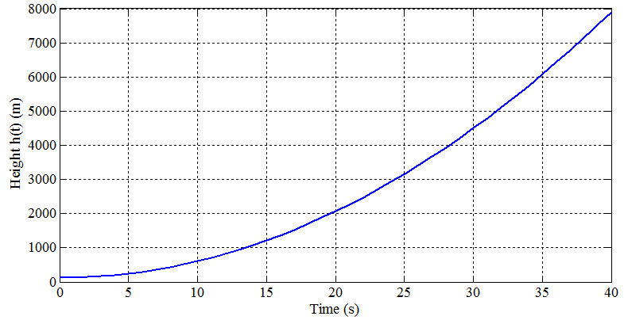
FIGURE 1. Dynamics of mass loss

Generator model. The main element that converts gravitational energy into electrical energy is synchronous generator d. To model transient processes in electrical machines, the classical dq-coordinate model of their dynamics is used. Simplified equation for the generator, stator voltage of an electric machine:
$U=E-jX_{s}I$ (3)
Here:
U- stator voltage,
E- internal EMF,
X_{s}- synchronous inductance,
I - stator current.
Mathematical complete dynamic (d–q) model of a synchronous machine [5-10]:
$\left.\begin{aligned}\frac{{di}_{d}}{dt}=\frac{1}{L_{d}}\left(v_{d}-{Ri}_{d}+{ωL}_{q}i_{q}\right) \\ \frac{{di}_{q}}{dt}=\frac{1}{L_{q}}\left(v_{q}-{Ri}_{q}+ω\left(L_{d}i_{d}+ψ_{f}\right)\right) \\ T_{e}=\frac{3}{2}p\left(ψ_{f}i_{q}+\left(L_{d}-L_{q}\right)i_{d}i_{q}\right)\end{aligned}\right\}$ (4)
Here:
identifier, iq-current components,
v_{d}, v_{q}- voltage components,
L_{d}, L_{k}-inductance,
p-number of pole pairs,
ψ_{f}- magnetic flux of the excitation coil.

Mechanical connection of the generator and ground:
$T_{e}+T_{fric}=J\frac{dω}{dt}+T_{m}$ (5)
$T_{m}$=manager– gravitational moment (when the mass falls),
J.- rotational inertia.
This fully integrates the electromechanical model.
In figure 2 shows a graph of the generator's output power when a 50-ton load is dropped, obtained by solving a mechanical motion model using a Matlab script.

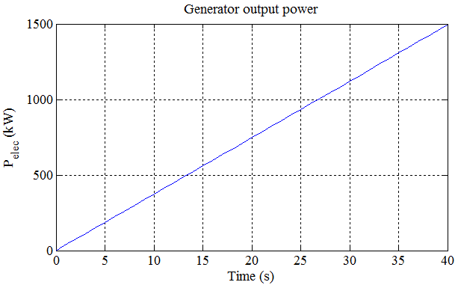
FIGURE 2. Generator output power

Inverter control model. The inverter performs two functions in the GESS system:
- Direct current → alternating current- transfer of energy from the generator to the network;
- Alternating current → direct current- ensuring the motor mode when lifting the mass.

The basic equation of the inverter model. PWM inverter output voltage:
$V_{ac}=k_{inv}V_{dc}$ (6)
Here:
$k_{inv}$​-modulation coefficient (0...1),
$V_{dc}$​-link tension.

Control algorithm. PID controller:
$u\left(t\right)=K_{p}e\left(t\right)+K_{i}\int{e\left(t\right)dt+k_{d}\frac{de}{dt}}$ (7)
This controller:
- the mass stabilizes the rate of descent,
- limits the current,
- adapts the generation voltage to the grid standard.
For more precise control, a model predictive control (MPC) can be used.
Model Predictive Control (MPC)- is a modern, optimization-based control method used in the control of dynamic systems, which, using a model, predicts the future behavior of the system and calculates the optimal control signal [23-30]
Key features of MPC:
- Forecasting: Based on the model, future states and results of the system's operation are predicted.
- Optimization: It uses bounds and objective functions to optimize the control signal at each step.
- Taking into account the boundaries: For controlled inputs and outputs, physical and operational limitations are taken into account.
- Step-by-step update (receding horizon): After calculating the control signal, the system is updated and a new forecast is obtained.

Mathematical basis of the PDC. Let the system be modeled in discrete time as follows:

$\left.\begin{aligned}x_{k+1}=f\left(x_{k},u_{k}\right) \\ y_{k}=h\left(x_{k},u_{k}\right)\end{aligned}\right\}$ (8)

$x_{k}$ - system state vector;
$u_{k}$- control signals;
$y_{k}$ - output vector;
f(⋅) and h(⋅) are dynamic and output functions of the system.
Optimization problem:
$min\sum_{i=0}^{N-1}{\left[\left\|y_{k+1\left|k\right.}-r_{k+i}{||}_{Q}^{2}+\left\|u_{k+i}{||}_{R}^{2}\right.\right.\right]}$ (9)
The number of items is limited as follows:
$u_{min}≤U_{k+i}≤u_{max}, y_{min}≤y_{k+i}≤y_{max}$ (10)
$r_{k+i}$- planned (desired) outputs;
Q, R -are weight matrices
N - forecast horizon
At each step, the optimization problem is solved, and only the control signal found in the first step is applied to the system, after which the forecast is recalculated. This is the principle of the decreasing forecast horizon of MPC.

Types of MPC:
- Linear MPC (LMPC):
- Used for linear systems.
- It is optimized in linear limits and quadratic objective functions.
- Talented and quick to calculate.
- Nonlinear MPC (NMPC):
- For nonlinear systems.
- Solution of nonlinear optimization problems is required.
- Requires more computational resources, but is effective in real dynamic systems.
- Reliable MPC:
- It is used when there are uncertainties and violations in the system.
- The control signal will be resistant to distortion.
- Explicit MPC:
- The MPC problem is solved in advance and stored as a decision table.
- Works quickly in real time as it does not require online optimization.

Advantages of the IPC:
- Automatically takes into account limits.
- Allows you to optimize multiple input/output signals simultaneously.
- Can also be used in nonlinear systems.
- Clearly displays the system dynamics and the objective function.
- Effective in energy, chemical industry, transport and automation.

Disadvantages of MPC:
- The calculation is very resource-intensive (especially in the NMPC).
- If the system model is incorrect, it will affect performance.
- High-speed optimization algorithms are required for real-time operation.

Application areas:
- Energy:
- Energy distribution and management in hybrid energy systems (PV + Wind + DG + ESS).
- Optimization of power generators.
- Automation and robotics:
- Motion control of mobile robots and vehicles.
- Optimization of production processes.
- Chemical and oil industry:
- Control of reactors, chlorine plants, oil and gas pipelines.
- Air transport and drones:
- Flight trajectory and stabilization control.

Efficiency calculation model. Energy losses in a gravity energy storage system arise from several sources:
- mechanical waste- $η_{m}$
- electromagnetic losses -$η_{g}$,
- inverter losses -$η_{inv}$​,
- waste power cables - $η_{cable}$​.
Total efficiency coefficient (TEK):
​$η=η_{m}∙η_{g}∙η_{inv}∙η_{cable}$ (11)
If the efficiency factor elements are as follows:
$η_{m}$=0.92, $η_{g}$=0.96, $η_{inv}$=0.94, $η_{cable}$=0.98.
Overall efficiency:
η=0.93⋅0.96⋅0.97⋅0.98=0.82
i.e. overall energy efficiency ≈ 82%.

Calculation of energy volume
Gravitational energy:
$E=mgh$·η
Example:
m=50tons, h=120 m
E=50000⋅9.81⋅120⋅0.82=48.2×106J=13.4 kWh

Power Report
Rate of decline:$v=\frac{dh}{dt}$
$P=mgv∙η$ (12)
If:
v=0.6m/s, m ​​= 50t,
P=50000⋅9.81⋅0.6⋅0.82 = 241 kW

Loss effects. The biggest losses are: -6% in the inverter, -4% in the generator, -7% in the mechanical system. The result is a GESS system with slightly lower efficiency than pumped storage power plants, but with significantly lower construction and operating costs.
CONCLUSIONS
When used in conjunction with renewable energy sources, gravity energy storage systems provide a high level of resilience for the power supply system. Mathematical modeling has demonstrated the high efficiency of the GESS system.
Key findings:
- The system has been proven to have great potential for energy storage.
- The efficiency is in the range of 82–87%, which is close to that of a hydraulic accumulator.
- The actual dynamic characteristics were estimated based on modeling in the MATLAB environment.
- The design of gravity energy storage devices is environmentally friendly and can serve for a long time.
- The combined use of PID+MPC provided effective results for optimal control of the device.
- The frequency stability and reactive power balance of the power supply system are improved.

REFERENCES
- A. Kumar et al., "A Review of Mechanical Energy Storage Systems," Renewable Energy Journal, 2019.
- A. Sadikov. "Modeling of Energy Systems", Moscow, Energia, 2004.
- A. Shklyarsky. "Dynamic Modeling of Synchronous Generators", Energoatomizdat, 2008.
- A. Valiev. "Modeling Nonlinear Dynamics of Electromechanical Systems," 2019.
- Energy Storage Association. "Global Outlook for Mechanical Energy Storage," 2021.
- Energy Vault. Gravity-Based Energy Storage Technology. Technical Report, 2021.
- G. Akhil, Sandia National Laboratories. "Energy Storage Handbook," 2020.
- IEC 61400 "Wind Energy System Standard", 2020.
- IEEE Energy Society. "Hybrid Energy Storage Solutions and Modeling Methods," 2021.
- International Energy Agency (IEA). World Energy Outlook. 2022.
- J. Blakers et al., "100% Renewable Energy Using Gravity Storage." Energy Proceedings, 2020.
- J. Blakers et al. Studies of the Gravitational Energy Storage Potential, 2021
- J. Picanzo, "Energy Storage Using Gravity Systems", Energy Procedia, 2020.
- J. Rifkin. "New Energy Paradigms," 2019.
- K. Kammen. “Variability of Renewable Energy,” Nature Energy, 2017.
- Kammen, D., “Variability of Renewable Energy,” Nature Energy, 2017.
- Kumar A. et al., "A Review of Gravity-Mechanical Energy Storage Systems," Renewable Energy Journal, 2019.
- Fault-Tolerant Control Method for Inter-Turn Short Circuit Faults of Switched Reluctance Linear Motors in Rail Transit. Liu, J., Chen, H., Pulatov, A.A.,Nguyen, V.T., Li, X. IEEE Transactions on Transportation Electrification Open-source preview, 2025.
- L. Weijie. "Modeling of Mechanical Storage Systems," SciDirect, 2019.
- Lee W., "Modeling Mechanical Storage Systems," SciDirect, 2019.
- M. Arif et al., "Hybrid Renewable Gravity Energy Systems," IEEE Access, 2021.
- Martinez O. "Gravity Energy Towers", Applied Energy, 2021.
- MATLAB Simulink Documentation, MathWorks, 2022.
- O. Martinez. "New Concepts for Gravity Storage," Applied Energy, 2021.
- Design of a Three-Phase High Torque Density Modular Linear Rotary Switched Reluctance Launcher Chen, H., Wang, X., Liu, C., ... Obidovich Pulatov, A., Musolino, A. IEEE Transactions on Plasma ScienceOpen source preview, 2025, 53(10), страницы 2653–2661
- Pirmatov, N.,Bekishev, A.,Kurbanov, N.,Saodullaev, A.,Saimbetov, Z.Improving the Efficiency and Survivability of Biaxially Excited Synchronous Machines Under Transient Operations. AIP Conference Proceedings, Volume 3152, Issue 1, June 17, 2024.https://doi.org/10.1063/5.0218824
- Bekishev, A.,Kurbanov, N.,Zainieva, O.,Saimbetov, Z.,Saodullaev, A.Comparative Analysis of the Survivability of Synchronous Machines in Asynchronous, Unexcited Mode. AIP Conference Proceedings. Volume 3152, Issue 1, June 17, 2024.https://doi.org/10.1063/5.0218806.
- Bekishev A., Norboev A.E., Khudoynazarov U.A., Kurbanov N.A., Yunusov O.A. Autonomous mode and parallel operation of an asynchronous generator with an electric grid. E3S Conference Network. Vol. 524, 2024. VII International Conference "Actual Problems of the Energy Complex and Environmental Protection" (APEC-VII-2024).https://doi.org/10.1051/e3sconf/202452401009
- Allabergen Bekishev, Nurali Pirmatov, Dilfuza Kurbanbaeva, Najmiddin Kurbanov, Olyakhon Zainieva, Obidkhan Yunusov, Utkir Khudoynazarov, Zinatdin Saimbetov.Achieving maximum power levels at various wind speeds from wind turbines with asynchronous double-ended feedingConference Proceedings AIP 3331, 030011 (2025).https://doi.org/10.1063/5.0305765
- Allabergen Bekishev, Gulzoda Mustafakulova, Aziza Khalbutaeva, and Jasurbek Nizamov. Modeling of reactive power compensation for the DSP-100 UMK electric arc furnace at Uzmetkombinat. Proceedings of AIP Conference 3331, 030069 (2025).https://doi.org/10.1063/5.0305769

