Regulation of ore loss and dilution for thin, bedded deposits
Dilmurod Makhmudov¹ Samandar Khidirov², Yorkin Nurboboev^{3, a)}, Shukhratulla Ochilov ³, Kushnazarov Ibrakhim³, Javokhir Rakhmatulloev²
¹ Tashkent State Technical University, Tashkent, Uzbekistan
² Institute of Mineral Resources, Tashkent, Uzbekistan
³ University of Geological Sciences, Tashkent, Uzbekistan
^{a)} Corresponding author: nurbek.kurbonov.96@gmail.com
Abstract. In this article information on the prospects for the development of wind power in Uzbekistan is given. The possibilities for the application of doubly fed induction generator in wind installations are stated. The use of new combined windings instead of standard windings in doubly fed induction generators used in wind turbines is described, and the possibilities of increasing the power factor and efficiency compared to the parameters of existing standard windings are analyzed.
INTRODUCTION
Although new energy sources and technologies for capturing natural energy have been developed worldwide, the growth of industrial and household demand is causing increased demand for coal mining. Although some developed countries are abandoning coal for environmental reasons, coal remains the primary raw material for producing low-cost electricity, and therefore global coal production continues to rise [1].

FIGURE 1. The graph of the global coal production, 2000-2022
Over the past quarter-century, alongside the rising demand for coal, regulatory requirements governing mining operations have become increasingly stringent. The full and safe extraction of mineral deposits and their use are matters of state policy. Integrated subsurface utilization, recovering economically viable reserves as completely as possible, and applying prudent, environmentally safe technologies are among the sector’s priority tasks. [2]

EXPERIMENTAL RESEARCH
One of the primary requirements for the extraction and processing of mineral deposits is to prevent ore losses and quality deterioration beyond permissible limits. Controlling permissible ore loss and quality degradation is achieved by selecting mining systems appropriate to the mine-geological and mine-technical conditions and choosing the safest and most economically efficient option among them [3].
Mining thick, steeply dipping coal beds poses difficulties due to several factors, including complex mine-geological conditions, limited opportunities for mechanizing extraction processes, and a high level of risk in work organization. Selecting mining method suited to these conditions and adapting them to a specific mine requires complex engineering solutions [4].
Room and pillar mining (Figure 2) and longwall mining (Figure 3) methods have been proposed for the extraction of coal in the Sharghun thick, inclined coal deposit. Indicators of loss and dilution occurring during the mining process have been identified for each mining method.
In room and pillar mining, the following are sources of loss and dilution: loss in the roof, contact of coal and country rock, unrecovered coal in support pillars, loss during transportation. The calculation of regulated coal loss and dilution amounts during extraction is performed per working unit, in accordance with the mentioned classification [5]. Coal losses in underground mining are usually determined by an indirect method. This method is due to the impossibility or high labor intensity of directly determining loss in the bed roof, during selective coal extraction, blasting operations, loading and transportation, as well as the complexity of measuring the thickness of layers in the bed floor and the parameters of pillars [6].

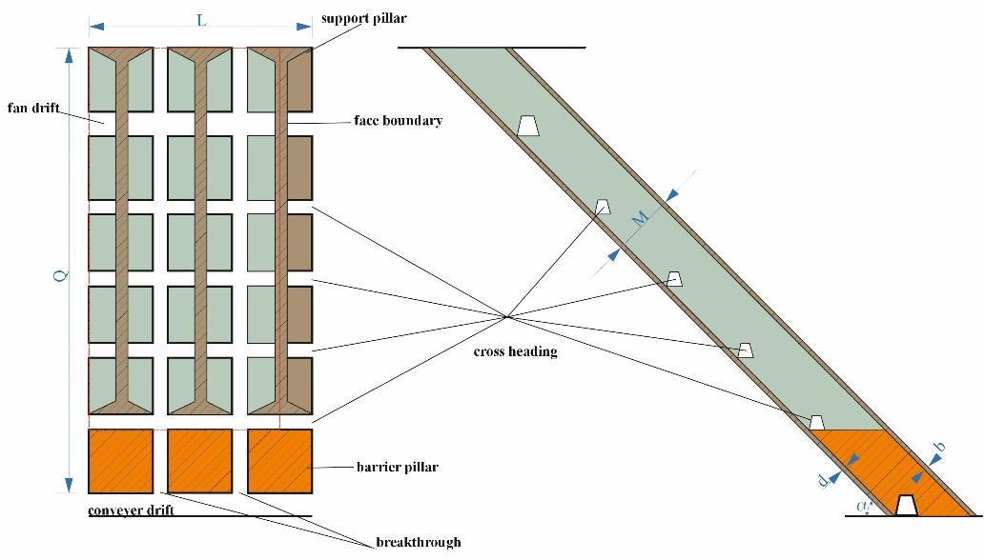
FIGURE 2. Room and pillar mining method

Coal loss in the bed roof occur as a result of leaving a coal layer beneath the mine roof. This layer is left in place to maintain the stability of the underground opening and to prevent roof collapse. However, the amount of coal remaining in the roof directly depends on the geological parameters of the coal bed, such as its thickness, dip angle, and degree of fracturing. It is important to note that leaving a portion of coal in the bed roof also contributes to a reduction in dilution. The higher the roof strength and the better the control over the extraction process, the less country rock enters the coal mass. This improves coal quality and reduces additional costs associated with coal cleaning and beneficiation.
Coal loss in the bed floor occur when a portion of the coal remains at the lower boundary of the bed. This can result from the bed being too thin for complete recovery or from the fact that full extraction could destabilize the mine workings. Retaining coal in the floor also reduces dilution.
Barrier pillars are temporarily left coal blocks that play a critical role in maintaining the stability of underground workings and preventing collapses. However, unlike other types of losses, the coal contained in barrier pillars is not regarded as permanently lost. These blocks are scheduled for extraction at later stages of mine development, when further advancement of mining operations allows. Therefore, losses associated with barrier pillars are not accounted for at the current stage, since this coal is intended to be recovered in the future.
Support pillars are coal blocks left in underground mines to maintain the stability of the entire extraction system. These pillars serve to prevent collapses and may be arranged both horizontally and vertically. The primary function of support pillars is to ensure the integrity of the mine workings, particularly in zones subjected to high roof loads. Losses associated with support pillars are unavoidable; however, they serve a critical purpose—ensuring safety and stability. Any attempts to minimize the size or number of support pillars must be based on thorough geological and geomechanical analysis, as any compromise to safety is unacceptable.
Coal loss in the bed roof occur as a result of leaving a coal layer beneath the mine roof. This layer is left in place to maintain the stability of the underground opening and to prevent roof collapse. However, the amount of coal remaining in the roof directly depends on the geological parameters of the coal bed, such as its thickness, dip angle, and degree of fracturing. It is important to note that leaving a portion of coal in the bed roof also contributes to a reduction in dilution. The higher the roof strength and the better the control over the extraction process, the less country rock enters the coal mass. This improves coal quality and reduces additional costs associated with coal cleaning and beneficiation.
Coal loss in the bed floor occur when a portion of the coal remains at the lower boundary of the bed. This can result from the bed being too thin for complete recovery or from the fact that full extraction could destabilize the mine workings. Retaining coal in the floor also reduces dilution.
Barrier pillars are temporarily left coal blocks that play a critical role in maintaining the stability of underground workings and preventing collapses. However, unlike other types of losses, the coal contained in barrier pillars is not regarded as permanently lost. These blocks are scheduled for extraction at later stages of mine development, when further advancement of mining operations allows. Therefore, losses associated with barrier pillars are not accounted for at the current stage, since this coal is intended to be recovered in the future.
Coal loss during underground transportation result from a variety of factors related to the characteristics of the transport systems employed and the mining conditions themselves. In underground coal extraction, material is conveyed along inclined and horizontal workings, which can lead to partial loss of coal at different stages of transportation.
Coal dilution during face cleaning and loading is an important performance indicator in underground mining, since it directly affects coal quality and subsequent processing. Dilution may arise from interaction between the coal and the rocks forming the roof and the floor, as well as at temporary storage and loading points.
In longwall mining, the following are sources of loss and dilution: loss in the roof, loss in the pillar, loss in the roof, loss in barrier pillars, loss during transportation, dilution of coal in left in the roof after collapse, dilution of coal during storage [7].
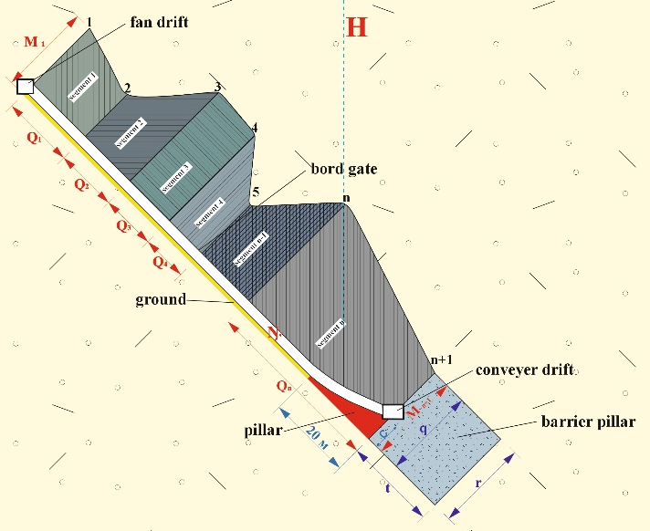
FIGURE 3. Longwall mining method

The calculation of standardized loss and coal quality-degradation indicators in coal extraction is carried out in the following sequence [6-9]:
in underground coal mining, the design and the actually implemented mining layouts, together with their principal technological parameters, are refined.
the regulating of coal loss and dilution in underground mining is based on a detailed model of the geological reserves of the mine field.
to minimize loss and reduce dilution in underground mining, selective extraction is applied, whereby coal is separated from the country rock with particular precision.
sampling data and the actual results of mining operations are used to calculate the regulated loss and dilution.
loss in the bed roof and floor are frequently governed by geological parameters, such as an unstable roof or weak floor strata.
loss in barrier pillars and support pillars are dictated by the requirement to ensure the safety of mining operations.
RESEARCH RESULTS
By processing the initial values obtained from the conducted experimental tests, the amounts of loss and dilution indicators occurring at various stages of extraction for the mining methods under consideration were determined. The technical and economic performance indicators of each mining method were compiled and compared with one another (Table 1).

TABLE 1. Technical and economic indicators
Parameters | Room and pillar mining method | Longwall mining method
Dip angle, ° | 45 | 45
Thickness, m | 6,42 | 6,42
Block width, m | 500 | 500
Block length, m | 100 | 100
Coal density, t/m³ | 1,35 | 1,35
Balance reserves, t | 424509,96 | 424509,96
Coal loss in the bed roof, % | 3,2 | 1,9
Coal loss in the bed floor, % | 3,2 | 9,6
Coal loss in support pillars, % | 22,7 | -
Coal loss in barrier pillars, % | - | 6,4
Dilution during storage, % | 1 | 1
Dilution from interlayers, % | 19,2 | 19,2
According to Table 1, the dilution indicator is the same for both mining systems and amounts to 20,2% in total. Coal losses, however, are 29,2% for the room-and-pillar mining method and 18,2% for the longwall mining method. The main reason for this difference is the necessity to leave support pillars in the room-and-pillar mining method. Following analysis of the technical and economic indicators, for the selected deposit conditions a regulated coal loss of 18,2% and a regulated dilution of 20,2% were established, and the implementation of a longwall mining method is recommended.
CONCLUSIONS
Based on the comparison of mining method for thick, steep coal beds, longwall mining method proved more efficient than the room-and-pillar method because of its superior production performance and higher degree of mechanization. Key advantages of the longwall mining include:
- Improved safety resulting from mechanized excavation operations.
- Higher labour productivity.
- Lower human-factor influence.
- Lower coal loss due to the reduced need for support pillars.
- Lower unit production cost.
- Reduced environmental impact compared with the drill-and-blast method.
REFERENCES
- Law of the Republic of Uzbekistan “On Subsoil”.
- Unified rules for subsoil protection during mineral extraction (Resolution No. 983, Appendix 5, Ministry of Justice of the Republic of Uzbekistan, 04.12.2018).
- Zhao, B.; Guo, Y.; Wang, W.; He, S. Impact of Underground Coal Seam Mining on Stability and Slippage of the Loess Slope. Sustainability 2023, 15, 6485. https://doi.org/10.3390/su15086485
- Öge, İ.F. Prediction of Top Coal Cavability Character of a Deep Coal Mine by Empirical and Numerical Methods. J Min Sci 54, 793–803 (2018). https://doi.org/10.1134/S1062739118054903
- Humphries, P; Poulsen, B (2008). Geological and Geotechnical Influences on the Caveability and Drawability of Top Coal in Longwalls. University of Wollongong. Conference contribution.
- Jangara, H., Ozturk, C.A. Longwall top coal caving design for thick coal seam in very poor strength surrounding strata. Int J Coal Sci Technol 8, 641–658 (2021). https://doi.org/10.1007/s40789-020-00397-y
- Wang, Z.; Tang, Y.; Gong, H. Longwall Top-Coal Caving Mechanism and Cavability Optimization with Hydraulic Fracturing in Thick Coal Seam: A Case Study. Energies 2021, 14, 4832. https://doi.org/10.3390/en14164832
- Purev, R., Tsedendorj, S., and Surmaajav, D. Study of coal losses and dilution. Mining Information and Analytical Bulletin (Scientific and Technical Journal), vol. 14, no. 1, 2008, pp. 201–214.
- Vokhmin, S. A., Zagirov, N. Kh., Trebush, Yu. P., Kurchin, G. S., and Maiorov, E. S. Standardization of losses and dilution as a mechanism of rational природопользование. Bulletin of the Magnitogorsk State Technical University named after G. I. Nosov, no. 1 (41), 2013, pp. 7–10.

