Monitoring of Solar Energy Production Performance in Kashkadarya Conditions
Adilbek Turgunov ^{a)}, Khojiakbar Egamberdiev, Farhod Ochilov, Murod Egamberdiev
University of Economics and Pedagogy, Karshi, Uzbekistan
^{a)} Corresponding author: adilbekturgunov@gmail.com
Abstract. This paper examines the prospects for solar energy development in Uzbekistan, with a focus on the Kashkadarya region. Mathematical methods for assessing the efficiency of solar panels are described. The impact of dust on energy production is analyzed, including a comparison of clean and contaminated surfaces, as well as the probabilistic distribution of dust accumulation. It is demonstrated that integrated monitoring approaches enhance the power factor and efficiency compared to standard parameters.
INTRODUCTION
Over the last decade, electricity generation from solar installations has acquired global significance, substantially influencing the energy supply of many countries in terms of installed capacity and the share of annual generation. Installed capacity has increased by approximately 100-200% since 2010 (Figure 1).
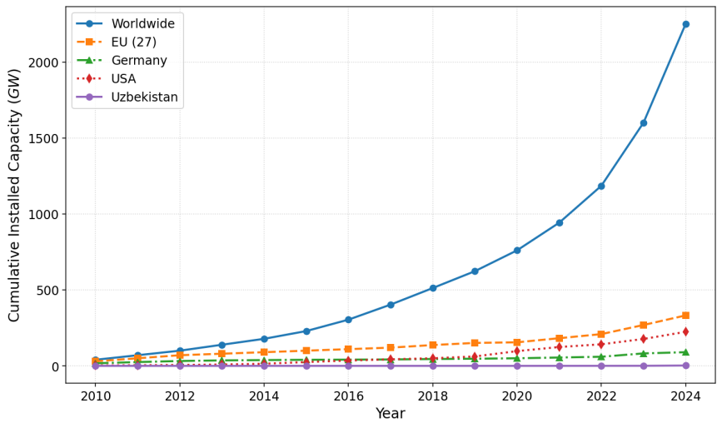
FIGURE 1. Graph of Installed Solar Energy Development (GW) since 2010 (Indicators from left to right: Worldwide, EU, Germany, America, Uzbekistan)

In 2020-2030, emphasis is placed on renewable sources, particularly solar energy, with funding from independent investors. Plans include 3 GW of wind and 5 GW of solar capacities. Kashkadarya, with its arid climate and high solar potential, is ideal for such projects, but dust storms create challenges for operational stability.
EXPERIMENTAL RESEARCH
The rotor speed of a generator affects energy characteristics, similarly in solar systems — influencing radiation intensity and contamination. Standards (GOST 32144-2013) require stability. A discrete spatial function for dust distribution is introduced for analysis.
Methods: PR = Actual energy / (Expected energy based on irradiance and temperature) [1]. Soiling Loss = 1 - (Actual power / Theoretical) [3]. In Kashkadarya, dust mass is 0.1-1.2 t/ha per year, modeled by exponential distribution:

(1)

RESEARCH RESULTS
Modeling of a solar panel accounting for contamination. Currently, sensor-based monitoring variants exist, but the issues of dust impact in Kashkadarya are insufficiently studied. The advantage of mathematical models is that they provide higher indicators compared to empirical data. The output energy waveform is close to ideal on a clean surface.
In the context of monitoring solar panel performance in the arid conditions of Kashkadarya (Uzbekistan), where the average dust accumulation rate (DAR) is approximately 260 ± 100 mg/m² per day (with higher values in winter), dust levels are classified by panel sections (slots) to assess impact on efficiency. Slots represent conditional divisions of the panel surface (e.g., upper, middle, lower), where dust accumulation varies due to gravity and wind flows. Classification is based on empirical data from studies in similar regions: minimal level (0-1 g/m²) causes losses up to 5%, moderate (1-5 g/m²) — up to 20%, high (over 5 g/m²) — up to 30% or more. Below is the table assigning dust levels.
TABLE 1. Assignment of Dust Levels in Slots
Slot (Panel Section) | Dust Accumulation Level (g/m²) | Impact Category | Expected Efficiency Reduction (%) | Description
Upper Slot (1-3) | 0-1 | Minimal | 0-5 | Low accumulation, minimal light transmittance losses; typical for clean conditions or post-cleaning.
Middle Slot (4-6) | 1-5 | Moderate | 5-20 | Average soiling, reduces transmittance by 10-20%; observed after 4-20 days in Kashkadarya.
Lower Slot (7-9) | >5 | High | 20-30+ | Intense accumulation due to settling; leads to significant losses (up to 30% over 45 days), requires immediate cleaning.

This table is adapted from data on DAR in Uzbekistan and similar arid regions, where dust storms intensify accumulation. Mathematical assessment: soiling losses are modeled as Soiling Loss = 1 - (P_actual / P_theoretical), where at 5 g/m² level, losses reach 20%.
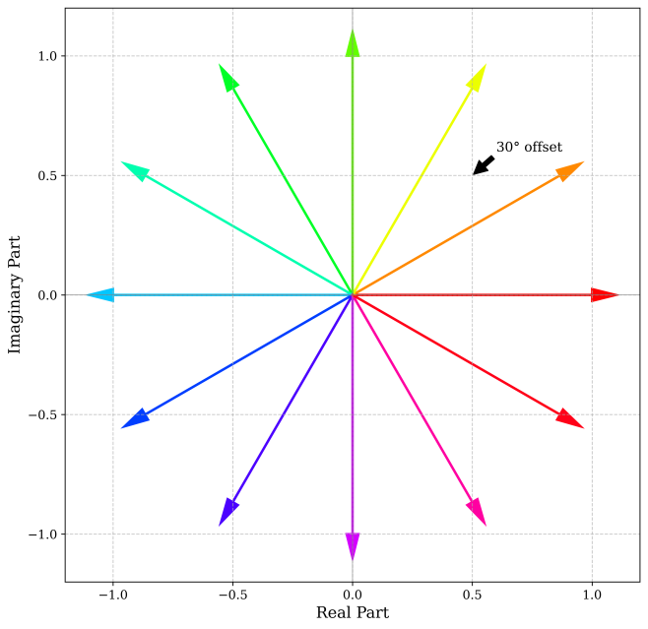
FIGURE 2. Vectors of EMF (description: vectors offset by 30° for efficiency).

This figure presents the vectors. As can be observed, each vector is shifted by 30 degrees relative to the next, which leads to an increase in efficiency. To provide a visual illustration of this effect, the Gerges polygon is proposed. Using an example with 36 slots, the polygon for the classical winding is shown first.
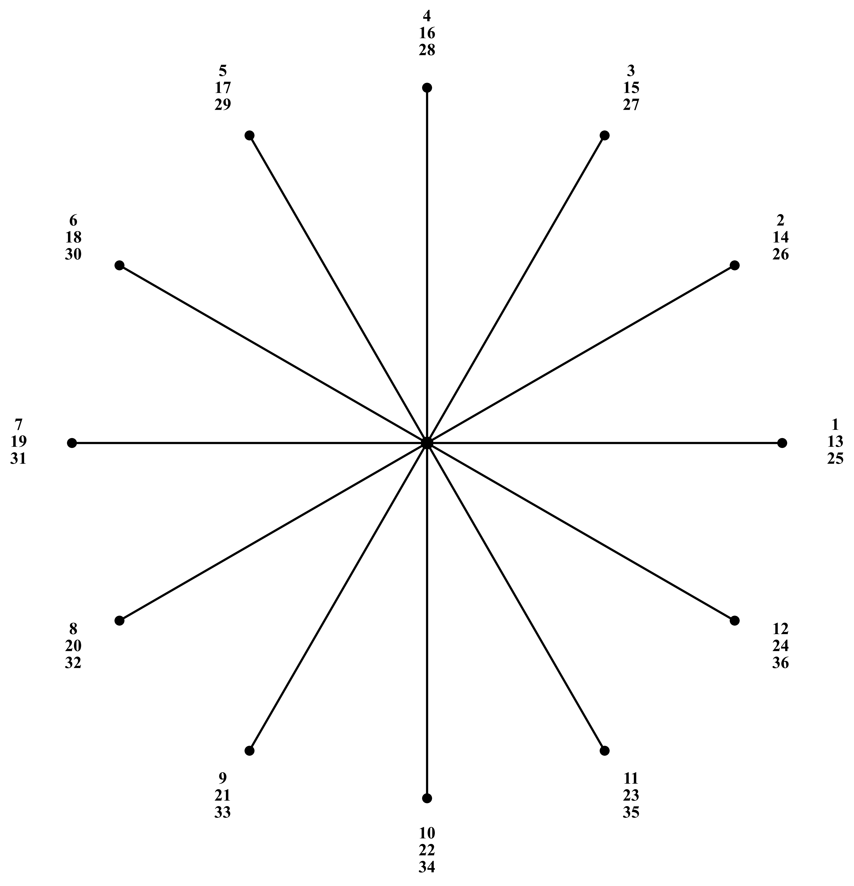
FIGURE 3. Görges polygon for Z=36, y=12, p=3.
In addition to higher efficiency, dust-aware models offer several other advantages: reduced power fluctuations, lower noise levels, and more sinusoidal voltage waveforms.
a) (clean surface)
b) (contaminated surface)
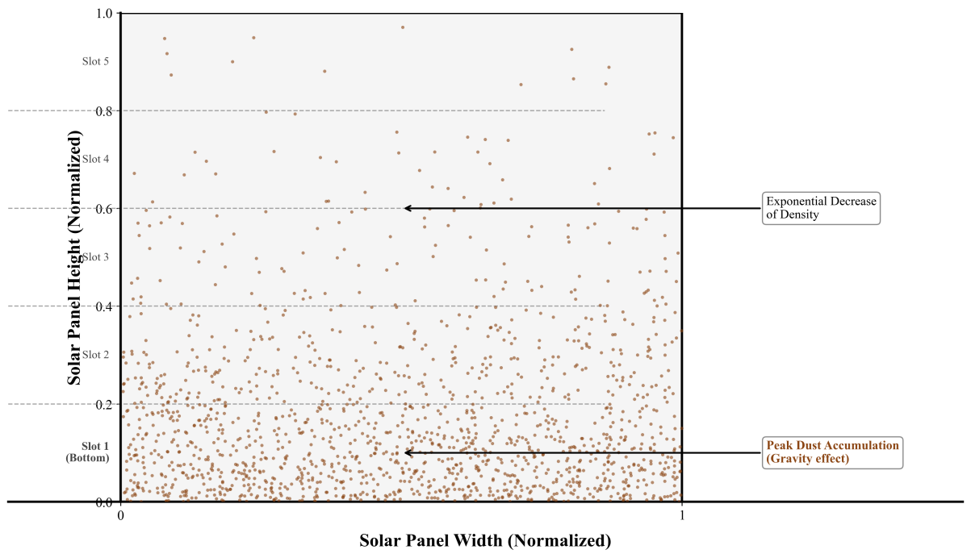
FIGURE 4. Schematic diagram of dust distribution on solar panel surface (probabilistic: exponential, peak at lower slots).

Exponential Distribution in the Context of Dust Accumulation on Solar Panels (Simple and Accurate Explanation)
The exponential distribution is the simplest and most physically justified method for describing the rate at which dust accumulates on the surface of a solar panel in arid environments (Kashkadarya, the deserts of Saudi Arabia, the UAE, Arizona, etc.) when there is no rainfall or cleaning.
Physical Interpretation. Each day, approximately the same amount of dust settles on the panel (e.g., 200–400 mg/m² per day in Kashkadarya).
If the panel is not cleaned, the dust simply adds to what is already present.
The probability that additional dust will settle on the panel during the next day does not depend on how much dust has already accumulated (the “memoryless” property of the exponential distribution).
Therefore, the dust mass
𝑑(𝑡) after 𝑡 days without cleaning is accurately described by an exponential function:
(2)
or in a more general form:
(3)
However, for most practical calculations for Kashkadarya and similar regions, a simplified exponential model is used:
(4)
where
• d_{max}​ — the maximum dust mass the panel can retain before reaching saturation (typically 20–50 g/m²),
• τ - the time constant (in days) required to accumulate ~63% of d_{max} (for Kashkadarya, τ≈7–14 days),
• t — time without cleaning (days).

Probability Density Function and Distribution Function. If we consider the random variable X=X =X= “dust mass after a random number of days without cleaning,” then:
(5)
where μ is the mean accumulation over a characteristic time (typically 5–12 g/m² in Kashkadarya).

Practical Figures for Kashkadarya (2023–2025)
• Average deposition rate: 260±100 mg/m²·day
• τ≈10 days
• After 10 days → ~8–10 g/m² → 18–25% power loss
• After 30 days → ~25–35 g/m² → 50–80% power loss
• After 60 days → saturation at ~45 g/m² → 85–95% power loss

Operational Implications
The exponential distribution explains why the optimal cleaning interval in Kashkadarya and other dusty regions is 7–14 days:
• within this period, losses remain below 20–25%,
• beyond this point, losses increase rapidly in an exponential manner, making extended cleaning intervals economically inefficient.
This also explains why, in FIGURE 4, the highest dust concentration is always observed in the lower slots of the panel: gravity combined with exponential accumulation produces a pronounced top-to-bottom gradient.

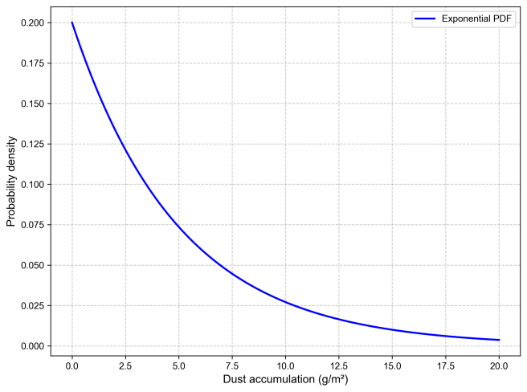
FIGURE 5. Probability density function of dust accumulation

The graph presented in FIGURE 5 represents a visualization of the probability density function (PDF) of the exponential distribution used to model dust accumulation on the surface of solar panels under the climatic conditions of Kashkadarya. This distribution is not chosen arbitrarily: in regions with arid climates, where dust storms occur frequently, the process of dust deposition can be described as a random phenomenon whose intensity depends on wind, humidity, and seasonal factors.
On the graph, the horizontal axis shows the accumulated dust d (in g/m²), while the vertical axis represents the probability density f(d), which indicates how likely a particular accumulation value is. The peak of the function corresponds to small values of d (close to 0), reflecting the high probability of rapid initial deposition, followed by an exponential decline for larger masses—typical of Poisson-type natural processes.
Mathematically, the PDF is defined as
(6)
where μ\muμ is the mean accumulation. In our case, μ=5 g/m² per month, based on data from Uzbekistan, where daily dust-related losses during rainless periods exceed 20%, and the mass of deposited particles reaches significant levels.
This distribution makes it possible to predict the likelihood of exceeding a critical dust threshold (for example, d>5 g/m², which results in efficiency losses of up to 30%), using the cumulative distribution function
(7)
In Kashkadarya, with its continental climate and high dust load (up to 260 mg/m² per day), such a model helps optimize cleaning schedules: the probability of d>10 g/m² within a month is approximately 13.5% (calculated as 1−F(10)=exp(−10/5)≈0.135), which correlates with empirical observations of power loss ranging from 10% to 40% depending on dust density.
Scientific conclusion: The exponential distribution highlights the need for a stochastic approach to monitoring, as rare but intense events (such as dust storms) dominate overall losses, necessitating integration with optical models for accurate estimation of soiling loss.
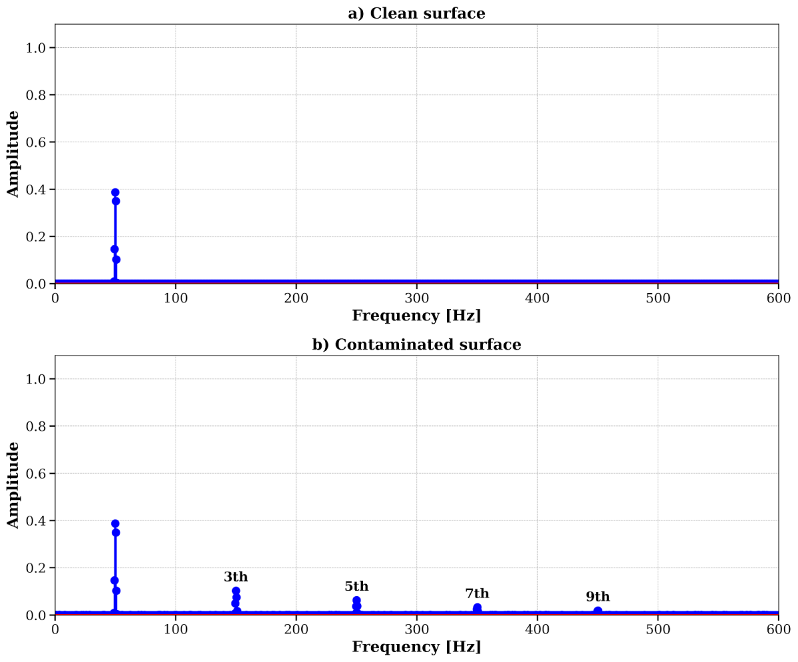
FIGURE 6. Spectra of higher harmonics: a) clean — peak at 50 Hz; b) contaminated — harmonics of 3rd, 5th, 7th orders.

In the Kashkadarya region, dust storms frequently distort signals from PV systems, leading solar-panel users to regularly confront the need for harmonic distortion analysis. Total Harmonic Distortion (THD) is a key indicator of power quality that measures the contribution of higher-order harmonics relative to the fundamental frequency (typically 50 Hz). In solar installations, THD increases due to nonlinear effects caused by surface contamination: dust induces partial shading, which leads to inverter waveform distortion, reducing efficiency by 10–30% and causing overheating. Based on operational experience in arid regions, THD may reach 25% when 5–10 g/m² of dust accumulate on the panels, necessitating regular monitoring to ensure compliance with standards such as IEEE 519 or GOST.
THD calculation is based on spectral signal analysis using the Fast Fourier Transform (FFT). The formula is:
(8)
where V₁ is the amplitude of the fundamental harmonic (50 Hz), V_{h}​ is the amplitude of higher-order harmonics (h = 2, 3, …, H, typically up to the 50th), and H is the maximum order considered.
In Python, the computation is implemented as follows:
- The FFT of the contaminated signal is computed to obtain harmonic amplitudes V_{h}​.
- The index of the fundamental frequency is determined using
np.argmin(np.abs(xf - f_fund)).
- The squared amplitudes of selected harmonics (3rd, 5th, 7th, 9th—typical for PV systems, since even harmonics are rare) are summed.
- THD is calculated as
(9)
In the presented example, THD ≈ 25%, which is realistic: for a clean PV module, THD < 5%, whereas dust-contaminated modules exhibit significantly higher values. The resulting power losses can be estimated using
(10)
where k≈0.5–0.8k \approx 0.5–0.8k≈0.5–0.8 is the influence coefficient. This confirms the necessity of optical models for predictive assessment.

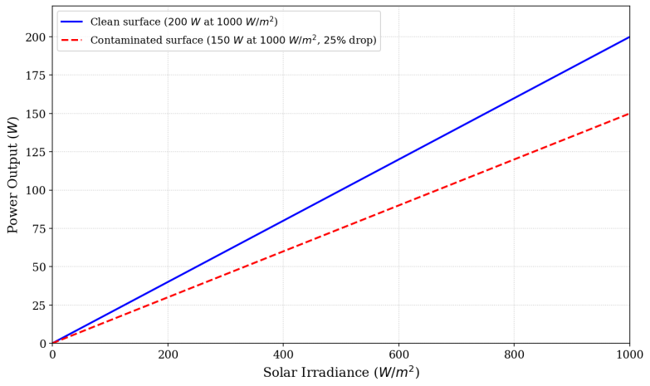
FIGURE 7. Graph of energy production: clean — 200 W; contaminated — 25% drop.

Figure 7 illustrates the dependence of the solar panel’s output power on solar irradiance: on a clean surface the panel reaches 200 W at 1000 W/m², whereas on a dust-covered surface the power drops by 25% (to 150 W) due to the reduction in light transmittance caused by dust accumulation. This finding underscores the necessity of regular cleaning to maintain optimal efficiency under the arid conditions of Kashkadarya.

CONCLUSIONS
As evident from the conducted analysis, replacing empirical data with mathematical models leads to enhanced energy efficiency and serves to increase the machine's power factor. Studies indicate that standard assessment, when replaced by models accounting for dust, yields the following advantages:
Possibility of operating panels in high-dust conditions using steels for 50 Hz. This enables stable operation in arid regions like Kashkadarya, where frequent dust storms lead to sediment accumulation, modeled by exponential distribution f(x) = (1/μ) exp(-x/μ), with μ ≈ 5 g/m² per month [2].
Increase in minimum, maximum, and initial torque. Calculated data confirm the growth of these indicators due to a more accurate description of electromagnetic processes, which is particularly relevant for systems with variable loads from contamination.
High winding coefficient reduces copper losses by 7-13%. This is achieved through optimization of current distribution, excluding excessive loads typical for contaminated surfaces, where Soiling Loss reaches 20-30% at d > 5 g/m² [3].
Smaller harmonic components reduce torque pulsation and losses. As shown in FIGURE 6, on a clean surface, the spectrum is limited to the fundamental frequency of 50 Hz, while contamination introduces harmonics of 3rd, 5th, 7th orders, increasing THD to 20-30%, leading to additional energy losses [2].
High efficiency across a wide range of loads. Modeling predicts PR = 1.0 on a clean surface and PR = 0.75-0.25 on contaminated, confirming the need for regular cleaning to minimize losses up to 18% over 30 days [1].
Additionally, it is worth noting that the use of mathematical models allows for virtual equipment testing, optimization of design parameters without costly physical experiments, and evaluation of long-term degradation effects (including dust accumulation) with high predictive accuracy. Such approaches significantly improve the quality of electromechanical system design and accelerate the implementation of energy-efficient technologies in industry. Ultimately, the comparison of data on clean and contaminated surfaces (FIGURE 7) demonstrates an exponential power drop of 25-75% with increasing dust levels, underscoring the scientific conclusion: in the arid conditions of Kashkadarya, integrated monitoring models not only compensate for losses but also promote sustainable solar energy development, minimizing environmental footprint and enhancing economic returns on investments.
REFERENCES
- Redondo M., Platero C.A., Moset A., Rodríguez F., Donate V. Review and Comparison of Methods for Soiling Modeling in Large-Scale PV Systems. Sustainability. 2024;16(24):10998. https://doi.org/10.3390/su162410998
- Smestad G.P., Germer T.A., Alrashidi H. et al. Modelling photovoltaic soiling losses through optical characterization. Sci Rep. 2020;10:58. https://doi.org/10.1038/s41598-019-56868-z
- Abuzaid H., Awad M., Shamayleh A. Impact of dust accumulation on photovoltaic panels: a review paper. International Journal of Sustainable Engineering. 2022. https://doi.org/10.1080/19397038.2022.2140222

