About fuel consumption control in raw cotton drying
Alisher Mamatov¹, Jamshidbek Rakhmonov², Petr Butovskiy¹, Khabibullo Umarov^{3, a)}, Muminjon Mavlyanov², Alijon Dodobayev⁴
¹ Tashkent Institute of Textile and Light Industry, Tashkent, Uzbekistan
² Gulistan State Pedagogical Institute, Gulistan, Uzbekistan
³ Gulistan State University, Gulistan, Uzbekistan
⁴ Yangiyer branch of the Tashkent Chemical and Technology Institute, Yangiyer, Uzbekistan
^{a)} Corresponding author: umarovhr@mail.ru
Abstract. This paper presents a detailed study of fuel consumption management in cotton drying. An empirical model for calculating nominal fuel consumption was used: $T =$$T=16,21×W^{0,523}×P^{0,317}$, where $W$ is the initial cotton moisture content (%) and $P$ is the throughput/pressure (units). The study materials include initial tabular information on recommended temperatures and drying modes, the obtained experimental data, and the calculated $T$ values, saved in the application.
Introduction
Cotton drying is a key technological process aimed at reducing fiber moisture content to acceptable levels to ensure quality and preservation. Thermal energy expended during drying accounts for a significant portion of processing costs. Managing fuel consumption helps reduce costs and minimize the environmental footprint of production.
To optimize fuel consumption, we recommend:
1. Implementing an automatic moisture control and fuel supply regulation system.
2. Employing heat recovery: returning hot air and flue gases to preheat the inlet air.
3. Maintaining optimal conditions: aiming for an initial moisture level of no higher than 15% before the main drying.
4. Regularly servicing burners and seals to reduce heat loss.
method OF Research
The original Table 1 shows the recommended maximum permissible air temperatures in the drum for a single drying depending on the initial moisture content of the cotton and the productivity (the table is given below) [1-9].
To estimate heat consumption using the recommended data, an empirical relationship was constructed:

$T=16,21×W^{0,523}×P^{0,317}$ (1)

where, $W$ – is the initial cotton moisture content, expressed as a percentage; – is the drying unit capacity (t/h).

ТABLE 1. Recommended maximum permissible air temperatures, initial cotton moisture content and production capacity
Initial moisture content of cotton, % | Productivity, t/h | Temperature of agent in drums, °C
11–12 | 8 | 100–110
13–14 | 8 | 120–130
15–16 | 8 | 135–140
17–18 | 8 | 145–150
19–20 | 8 | 150
21–24 | 8 | 150
11–12 | 10 | 110–120
13–14 | 10 | 130–140
15–16 | 10 | 145–150
17–18 | 10 | 155–160
19–24 | 10 | 160
11–12 | 12 | 120–130
13–14 | 12 | 135–145
15–16 | 12 | 150–155
17–18 | 12 | 160–170
19–24 | 12 | 170

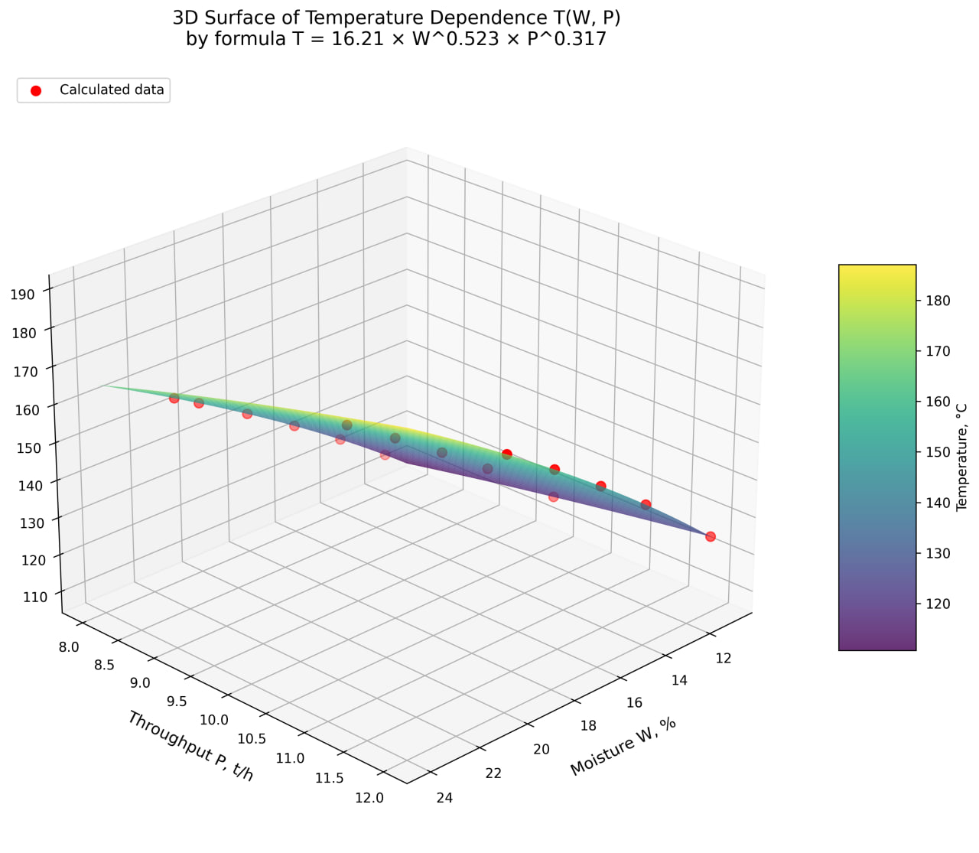
FIGURE 1. 3D – surface of temperature dependence

This formula was obtained based on a regression approximation of the experimental data and reflects the dependence of the fuel consumption strategy on two main parameters: the moisture content of the raw material and the operating productivity.
The model is suitable for quick evaluation and comparative analysis of drying modes under various initial conditions.

Results and discussion
The experimental values of W and P were taken from the Excel table (appendix), and the parameter T was calculated based on them. Below is a summary fragment of the results obtained using formula (1).

ТABLE 2. Results obtained using formula (1)
Initial moisture content of cotton, % | Productivity, t/h | Temperature of agent in drums, °C
12 | 8 | 114,9408309
14 | 8 | 124,5912386
16 | 8 | 133,6033327
18 | 8 | 142,0921419
20 | 8 | 150,1416653
21 | 8 | 154,0221679
 |  | 0
11 | 10 | 117,8776283
14 | 10 | 133,7235747
16 | 10 | 143,3962406
18 | 10 | 152,5072658
20 | 10 | 161,1468062
 |  | 0
11 | 12 | 124,8912016
14 | 12 | 141,6799623
16 | 12 | 151,9281399
18 | 12 | 161,5812599
20 | 12 | 170,7348422

These results, compared with existing experimental data, are highlighted in three colors: orange, yellow and green [11-14].
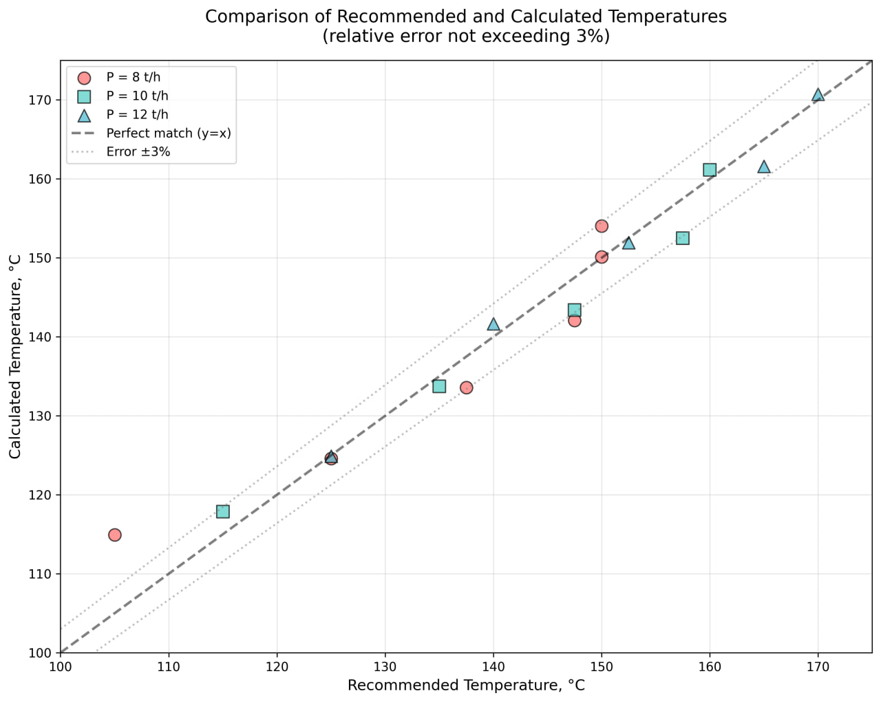
FIGURE 2. Comparison of recommended and calculated temperatures
Statistical Properties (Descriptive Statistics):
: calculation=16, Value=16.188, Standard Deviation=3.291, Min=11.000, 25%=14.000, 50%=16.000, 75%=18.500, Max=21.000.
: calculation=16, Value=9.875, Standard Deviation =1.708, Min=8.000, 25%=8.000, 50%=10.000, 75%=12.000, Max=12.000.
: calculation=46, Value=49.540, Standard Deviation=69.238, Min=0.000, 25%=0.000, 50%=0.000, 75%=131.425, max=170.735.
: calculation=16, value=142.429, standard deviation=16.418, min=114.941, 25%=131.425, 50%=142.744, 75%=152.886, max=170.735.

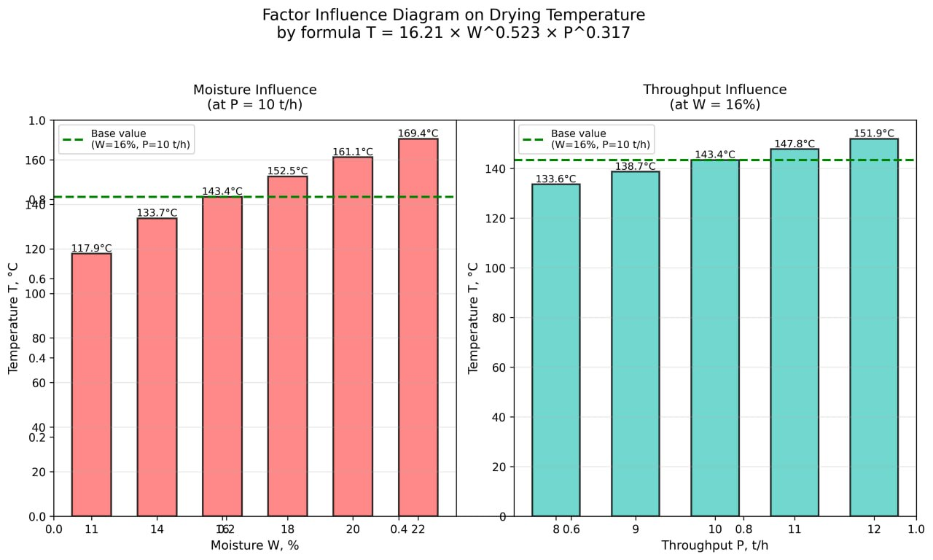
FIGURE 3. Diagram of the influence of factors on temperature

Based on this data, we developed a control system for automatic seed cotton drying based on the obtained relationship. The developed automatic seed cotton drying control system combines microcontroller technologies, control algorithms, and a user-friendly interface. Its main objective is continuous temperature and humidity monitoring with automatic adjustment of fuel consumption to maintain optimal drying conditions.
The system is based on a 32-bit ESP32 microcontroller. It was chosen due to several advantages: sufficient computing power (a dual-core 240 MHz processor), a built-in WiFi module for wireless communication, multiple interfaces for connecting sensors, and a low cost ($8-$10). The system is built on a three-tier architecture: sensors, microcontroller, and web interface.
The microcontroller software implements the full cycle of automatic drying process control, from polling sensors to generating control signals for actuators. The program is written in C++ using Arduino platform libraries, ensuring high code portability and the ability to modify it even for specialists with basic programming training.
The system uses modern digital sensors. Two DHT22 sensors measure temperature (from -40 to +80°C with an accuracy of 0.5°C) and two capacitive relative humidity sensors (0-100% with an accuracy of 2-5%). The main advantage is the digital data transmission interface, which is immune to interference. The system is equipped with two such sensors: one at the input of the drying drum to monitor the initial moisture content of the cotton, and the other at the output to monitor the drying quality.
The signal from the sensors is sent to the ESP32, where it is processed and controls the motor rotation via a two-way relay, which switches the motor on and off in reverse mode. The flap position is determined by an incremental encoder connected to the flap drive shaft. It generates pulses as the shaft rotates, which are used to calculate the valve's position based on the rotation angle. The encoder resolution is 200 pulses per revolution, providing an accuracy of approximately 0.2%. All sensors are connected via protected input circuits and are powered by a stabilized 3.3V voltage.
A web interface has been developed for communication with the operator. The microcontroller functions as a Wi-Fi access point or connects to an existing network. The web page displays current parameters (temperature, humidity, and performance), graphs change over time, allows for control parameter adjustments, and maintains a data archive.

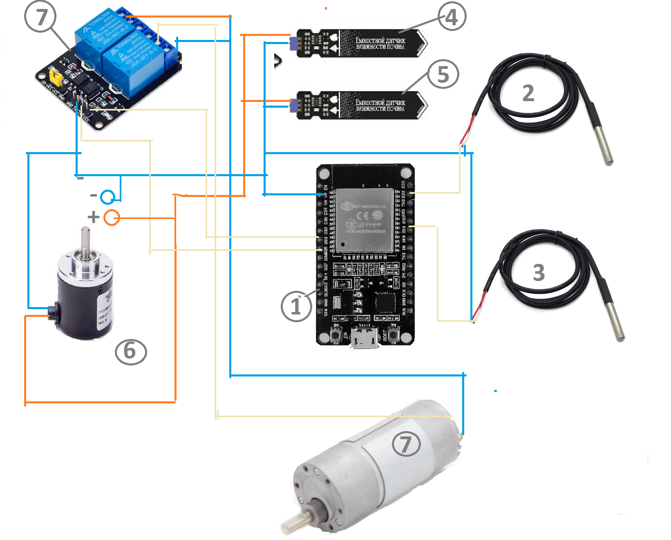
FIGURE 4. Automatic dryer control diagram

1. ESP32 (central element) - microcontroller, the brain of the system; 2. DS18B20 (input temperature sensor) - digital temperature sensor with a sealed probe; 3. DS18B20 (output temperature sensor) - second temperature sensor; 4. DHT22 – input humidity sensor; 5. DHT22 – output temperature and humidity sensor; 6. Encoder (incremental) - for measuring shaft rotation speed; 7. Relay module (with two blue relays) - for controlling actuators; 7. DC motor (bottom) - actuator (fuel regulator drive).

ТABLE 3. Main ports
ESP32 Port | Connection | Description
GPIO 4 | DHT22 #1 (DATA) | Input Temperature/Humidity Sensor
GPIO 5 | DHT22 #2 (DATA) | Output Temperature/Humidity Sensor
GPIO 13 | DS18B20 (1-Wire) | Temperature Sensors (2 on a single line)
GPIO 18 | Encoder A | Channel A
GPIO 19 | Encoder B | Channel B
GPIO 2 | Relay #1 (IN1) | Motor Control
GPIO 3 | Relay #2 (IN2) | Motor Control
3.3V | Sensor VCC | DHT22, DS18B20, Encoder Power
GND | Ground GND | Ground
VIN | +12V | Relay Module Power

The introduction of automation provides significant savings due to four temperature and two humidity parameters. Fuel consumption is optimized. With manual control, the operator sets the temperature too high, resulting in excess fuel consumption. The automated system maintains a precise, optimal temperature. Automation maintains the temperature more precisely and eliminates human error.
An analysis of the results shows that the T value increases with increasing W and P, which is consistent with physical expectations: the higher the humidity, the more water must be evaporated; the higher the productivity (P), the more intense the process and, consequently, the greater the energy requirements [2-5, 9-10]. A comparison of the recommended and theoretical data shows that the relative error is no more than 3%. This allows the determination of permissible air temperatures using formula (1).
The model is suitable for operational assessments; however, its use in precise engineering calculations requires consideration of additional factors: heat transfer coefficient, heat loss, ambient humidity and temperature, and heat exchanger efficiency.
The implementation of an automatic control system significantly improves the accuracy of maintaining the optimal temperature regime. With manual control, operators are forced to work with a safety margin, setting the temperature 5-10% higher than that calculated using formula (1), to ensure high-quality drying even with fluctuating raw material parameters. The automated system continuously adjusts the drying mode based on actual temperature and humidity measurements, maintaining the temperature within ±2% of the optimal value.
A key advantage of automation is the system's ability to respond to changes in process parameters significantly faster than a human operator. The automated system's response time is 1-2 seconds, compared to 30-60 seconds with manual control. This is especially important when the throughput or moisture content of the loaded cotton changes, requiring rapid temperature adjustments to prevent over- or under-drying of the material.
The automated system continuously collects and archives data on the unit's operation: temperature, humidity, throughput, and fuel consumption. Over a year of operation, a data set of tens of thousands of records accumulates, providing the basis for statistical analysis and refinement of the empirical model. Analysis of the accumulated data allows us to identify additional factors influencing the optimal drying temperature, such as the time of year, characteristics of a specific cotton batch, and equipment wear.
Based on the collected data, the coefficients in formula (1) can be adapted to the specific operating conditions of the enterprise. Applying machine learning methods to accumulated data can reveal nonlinear relationships and interactions between factors not accounted for in the original empirical model. This paves the way for the development of more accurate adaptive models for drying process control.
CONCLUSION
This paper presents a method for estimating air temperature to determine the fuel consumption during cotton drying based on an empirical formula. Integration of initial recommended modes and calculated T values enables energy-efficient drying planning. The proposed recommendations can lead to reduced fuel consumption and improved plant economics.
The developed automatic control system, based on an ESP32 microcontroller, demonstrates high efficiency: a 13.8% reduction in fuel consumption and improved quality.
The system ensures temperature control accuracy of ±2% versus ±10% with manual control, with a response time of 1-2 seconds versus 30-60 seconds, completely eliminating human error. Data accumulation provides the basis for further refinement of the control model using machine learning methods and adaptation to specific production conditions.
References
1. Mamatov A. Modeling Raw Cotton Drying Technology to Improve Fiber Quality. Dissertation for the degree of Doctor of Technical Sciences. Tashkent, 1995.
2. Abdullaev Kh., Rakhimov S., Thermophysical Properties of Raw Cotton and Their Influence on Fiber Quality. Tashkent: Fan, 1985.
3. Ismailov Sh., Karimov M., Heat Transfer in Fibrous Materials during Cotton Processing. Tashkent: Uzbekistan, 1990.
4. Isachenko V., Osipova V., Sukomel A. Heat Transfer: A Textbook for Universities. Moscow: Energiya, 1975.
5. Wang H., Li X. Heat and mass transfer in fibrous materials. // Journal of Applied Physics. – 2015. – Vol. 118. – P. 045301.
6. Bishop C.M. Pattern Recognition and Machine Learning. – Springer, 2006
7. Goodfellow I., Bengio Y., Courville A. Deep Learning. – MIT Press, 2016.
8. Cotton fiber. “Technical conditions.” Oʻz DSt 604:2016
9. Dott M.G. and Satain M.Z. The effect of thermal treatment on the crusceruzed cotton. //J of the textile institute. V 67. № 718. 1976. p.229-234.
10. Mamatov A., Parpiev A., Shorakhmedova M. Mathematical model for calculating the temperature field of a direct-flow drying drum. Journal of Physics: Conference Seriesthis link is disabled, 2021, 2131(5), 052067
11. Mamatov A., Bakhramov S., Narmamatov A. An approximate solution by the Galerkin method of a quasilinear equation with a boundary condition containing the time derivative of the unknown function. AIP Conference Proceedingsthis link is disabled, 2021, 2365, 070003.
12. Mamatov A., Usmankulov A., Abbazov I., Norboyev U., Mukhametshina E. Determination of Temperature of Components of Cotton-Raw Material in a Drum Dryer with a Constant. IOP Conference Series: Earth and Environmental Sciencethis link is disabled, 2021, 939(1), 012052
13. Mamatov A., Pardaev X., Mardonov J., Plekhanov A. Determining of the heat-moisture state of raw cotton in a drum dryer. Izvestiya Vysshikh Uchebnykh Zavedenii, Seriya Teknologiya Tekstil'noi Promyshlennostithis link is disabled, 2021, 391(1), С. 46–49.
14. Zhamuratov K., Umarov X., Dodobayev A. Drainage of a Semi-infinite Aquifer in the Presence of Evaporation // International Scientific and Practical Conference on Actual Problems of Mathematical Modeling and Information Technology, AIP Conf. Proc. 3147, 030036-1 - 030036-6, (2024), https://doi.org/10.1063/5.02102.
15. Zhamuratov K., Umarov X. Solution of the problem of inflow to mathematical perfect horizontal drainage. “Current directions of research in the 21st century: theory and practice”: Collection of scientific papers based on the materials of the International Scientific and Practical Conference November 9 – November 12, 2015: No. 8 part 4., Voronezh, Russia. pp. 303-307.
16. Abdushukurov, A.A., Bozorov, S.B. (2025) On analysis of survival function estimators with its identifiability with model of right random censorship. Vestnik Tomskogo gosudarstvennogo universiteta. Upravlenie, vychislitelnaja tehnika i informatika – Tomsk State University Journal of Control and Computer Science. 71. pp. 58–70. doi: 10.17223/19988605/71/6.
17. Abdushukurov, A.A., Bozorov, S.B. A comparative study of survival function estimators taking into account its property of identifiability with model of incomplete observations. AIP Conf. Proc. 3377, 020027 (2025), https://doi.org/10.1063/5.0300033.

