Development and performance evaluation of the uzjurnal.uz platform for automated peer review and scientific publishing
Elmira Nazirova¹, Shokhrukh Erkinov^{1,2 a)}, Sukhrob Khajiyev¹
¹ Tashkent University of Information Technologies named after Muhammad al-Khwarizmi, Tashkent, Uzbekistan
²Scientific research institute for development of digital technologies and artificial intelligence, Tashkent, Uzbekistan
^{a)} Corresponding author: sherkinov@tuit.uz
Abstract. This paper presents the development and implementation of the Uzjurnal.uz digital platform designed to automate the submission, peer review, and publication processes of scientific journals in Uzbekistan. The proposed system is based on a multi-layer client–server architecture integrated with RESTful APIs, email services, and Telegram bots to improve communication efficiency and workflow automation. The system architecture ensures secure data transmission and scalability for high-load environments. Platform performance was evaluated using monitoring data collected from 2022 to 2025, including user activity and geographical access analysis based on SQL queries. The results demonstrate a transition from predominantly local usage to increased international engagement from the United States, Russia, and European countries. This growth enhances the global visibility of national scientific publications and creates favorable conditions for improving citation metrics and H-index indicators.
INTRODUCTION
In the era of digital transformation, the visibility and accessibility of scientific research are paramount for the development of national science [1]. The transition from traditional publishing to digital platforms has revolutionized how knowledge is disseminated and archived [2]. Critical metrics such as the H-index and Impact Factor, which determine the prestige of researchers and journals, rely heavily on the accessibility of articles in international databases like Scopus and Web of Science [3], [4].
However, many developing nations face challenges in aligning their local journals with international standards due to a lack of robust digital infrastructure [5]. The "Blind Review" process, essential for maintaining scientific integrity, requires complex management systems to ensure anonymity and efficiency [6]. Existing solutions often lack the specific localization or integration required for regional needs [7].
To address these issues, the "Uzjurnal.uz" platform was developed. Previous studies have established the theoretical data models using IDEF1 standards [8]. This paper expands on that foundation by presenting the technical system architecture and analyzing the statistical results of the platform's usage. The study demonstrates how automated notifications and API integrations can enhance the peer review workflow [9] and connect Uzbek scientists with the global community [10].

EXPERIMENTAL RESEARCH
The core of the research involves the architectural design of the platform, ensuring scalability, security, and user-friendly interaction. The system architecture is built upon a multi-layered client-server model, designed to support high-load traffic and secure data transmission [11].
System architecture of the platform
The architecture supports various user roles: Authors, Editors, Reviewers, and Administrators.
- Basic Connectivity: The fundamental layer consists of the database and the server application. The web-server acts as a bridge, processing requests from the client side and retrieving data from the structured database (see Fig.1).
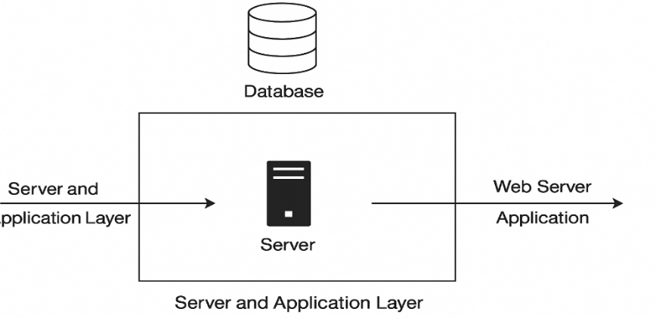
FIGURE 1. Basic database and server connection model

- Admin and Control Layer: A Server Admin layer is introduced for monitoring changes and maintaining site integrity (see Figure 2).
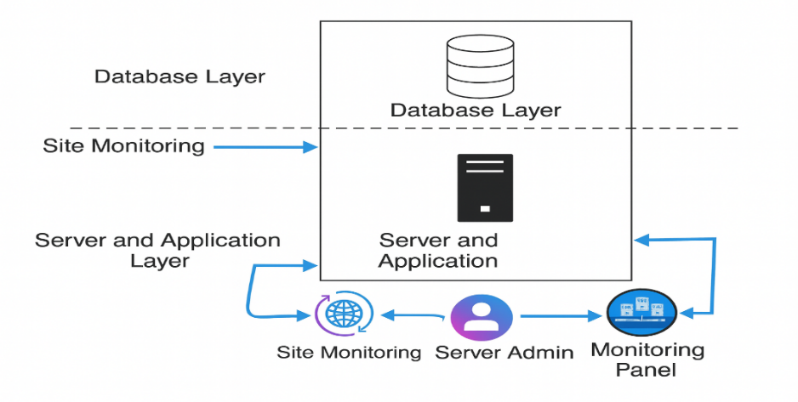
FIGURE 2. Server administration and monitoring structure

- Journal Administration: "Journal Admins" are responsible for creating new journals, managing article flows, and overseeing the interaction between editors and reviewers (see Figure 3).
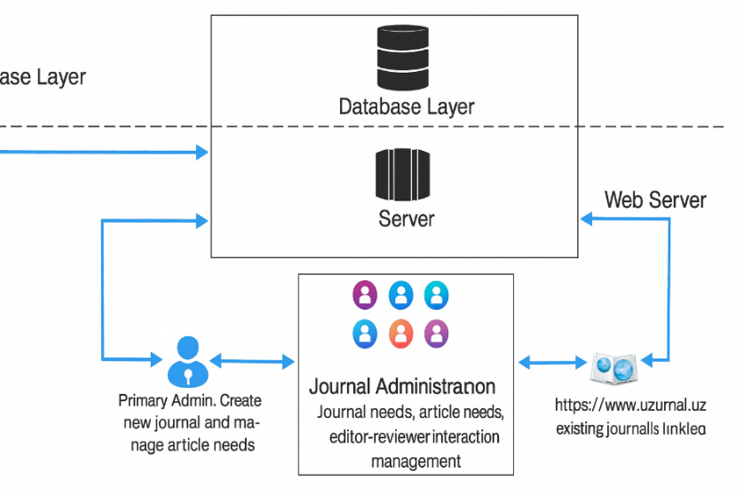
FIGURE 3. Journal administration and article management workflow

- API and Notification Integration: To ensure timely communication, the system integrates an Application Programming Interface (API) that connects with email services and a specialized Telegram bot [12]. This allows reviewers to receive instant notifications (see Figure 4).

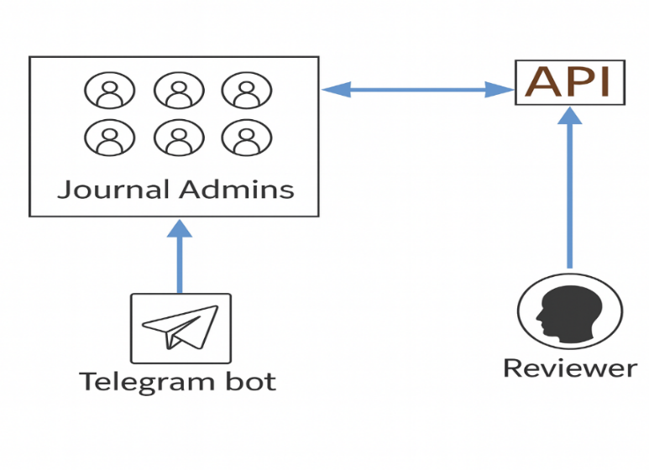
FIGURE 4. API integration for Email and Reviewer notifications

- Full Ecosystem: Figures 5 and 6 demonstrate the complex interaction between the Web-Server, API, Payment systems, and the Client side (Authors), ensuring data flows securely via HTTPS (TCP/IP) protocols.

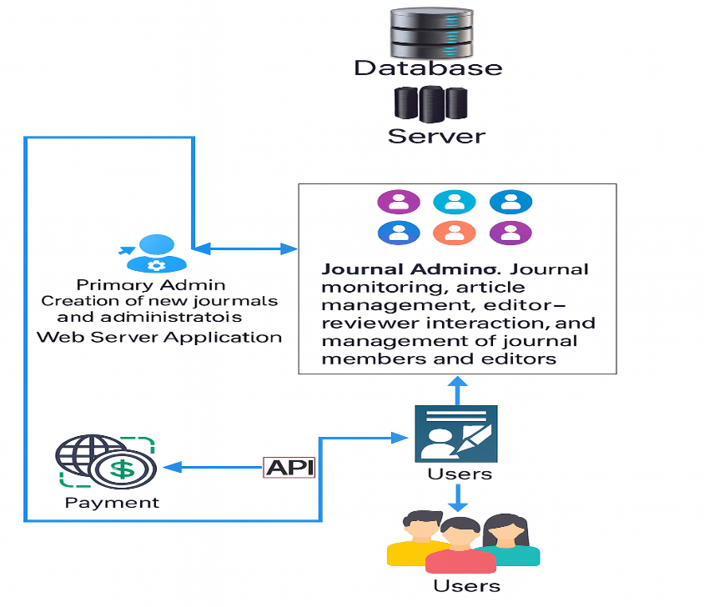
FIGURE 5. Architecture of author interaction and payment system integration via API within the journal management platform
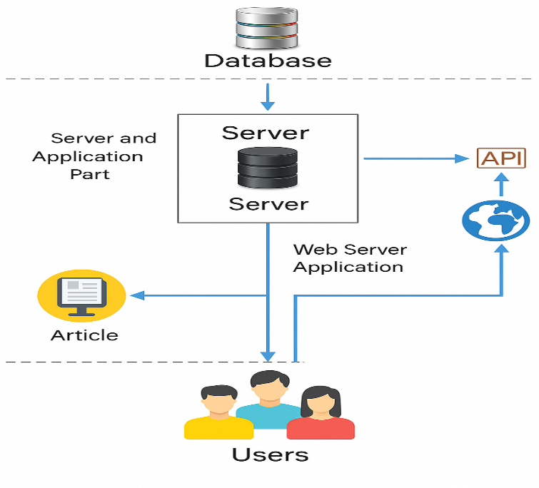
FIGURE 6. Comprehensive system architecture including all modules
RESEARCH RESULTS
The performance of the Uzjurnal.uz platform was evaluated using system monitoring data collected from 2022 to 2025. The analysis focuses on user activity, international accessibility, and the effectiveness of the implemented system architecture and automated workflows.
During the initial operational period (2022–2023), platform usage was mainly limited to local users within Uzbekistan. Following the deployment of the multi-layer client–server architecture and API-based integrations (Figs. 1–6), a steady increase in platform activity was observed. Recent monitoring results indicate a significant growth in international access, particularly from the United States, Russia, and several European countries.
The implementation of automated peer review management and notification mechanisms improved the efficiency of editorial workflows. The integration of RESTful APIs with email services and Telegram bots (Fig. 4) reduced reviewer response times and enhanced communication between editors and reviewers. The journal administration module (Fig. 3) enabled centralized control of manuscript submission, reviewer assignment, and editorial decision-making.
Author interaction and payment system integration via API (Fig. 5) ensured secure and transparent communication between authors and the platform. The use of HTTPS (TCP/IP) protocols provided reliable data transmission and contributed to increased user trust. As a result, submission rates increased, and the overall usability of the platform improved.
The comprehensive system architecture (Fig. 6) demonstrated scalability and stability under increasing load conditions. The observed increase in international traffic and article visibility confirms the platform’s effectiveness in promoting national scientific journals and creating favorable conditions for improving citation metrics and H-index indicators.
CONCLUSIONS
This study analyzed the architectural implementation and performance characteristics of the Uzjurnal.uz scientific publishing platform based on monitoring data and system usage statistics. The results confirm that the proposed client–server architecture integrated with RESTful APIs provides a stable and reliable environment for managing peer review and publication workflows [16].
The platform ensures data transparency by effectively visualizing key performance indicators, enabling real-time monitoring of journal activity and editorial processes [17]. This functionality supports informed decision-making for journal administrators and improves overall system accountability.
A notable outcome of the analysis is the observed shift from predominantly local user traffic to increased international access from the United States, Russia, and European countries. This trend indicates successful internationalization of the platform and improved exposure of national scientific journals to the global research community [18].
Furthermore, the enhanced visibility and accessibility of published articles create favorable conditions for increasing citation rates and improving scientometric indicators, including the H-index of Uzbek scientists [19–21]. Overall, the Uzjurnal.uz platform contributes to the digital transformation of scientific publishing and strengthens the integration of national research outputs into the international scientific information space.
REFERENCES
- Hicks D., Wouters P., Waltman L., de Rijcke S., Rafols I. Bibliometrics: The Leiden Manifesto for research metrics // Nature. 2015. Vol. 520, № 7548. PP. 429–431. https://doi.org/10.1038/520429a
- Willinsky J. The Access Principle: The Case for Open Access to Research and Scholarship. MIT Press, 2006.
- Hirsch J.E. An index to quantify an individual’s scientific research output // Proceedings of the National Academy of Sciences. 2005. Vol. 102, № 46. PP. 16569–16572. https://doi.org/10.1073/pnas.0806977105
- Garfield E. The history and meaning of the journal impact factor // JAMA. 2006. Vol. 295, № 1. PP. 90–93. https://doi.org/10.1001/jama.295.1.90
- Kumar T.V.S. Academic journal publishing in developing countries: Issues and challenges // Information Development. 2014. Vol. 30, № 4. PP. 367–372.
- Weller A.C. Editorial Peer Review: Its Strengths and Weaknesses. Information Today, Inc., 2001.
- Tenant S.P. et al. A multi-disciplinary perspective on emergent and future innovations in peer review // F1000Research. 2017. Vol. 6. P. 1151.
- Nazirova E., Erkinov S. Modeling the data flow of scientific journals using IDEF1 methodologies // Proc. of the Int. Conf. on Digital Technologies. Tashkent, 2023. PP. 112–116.
- Ware M., Mabe M. The STM Report: An overview of scientific and scholarly journal publishing. STM: International Association of Scientific, Technical and Medical Publishers, 2015.
- Björk B.-C. The hybrid model for open access publication of scholarly articles: A failed experiment? // Journal of the American Society for Information Science and Technology. 2012. Vol. 63, № 8. PP. 1496–1504. https://doi.org/10.1002/asi.22709
- Fielding R., Taylor R. Principled design of the modern Web architecture // ACM Transactions on Internet Technology. 2002. Vol. 2, № 2. PP. 115–150. https://doi.org/10.1145/514183.514185
- Dogadov V. Telegram Bot API for scientific notifications // Journal of Physics: Conference Series. 2018. Vol. 1015. P. 032034. https://doi.org/10.1088/1742-6596/1015/3/032034
- Tenopir C. et al. Trustworthiness and authority of scholarly information in a digital age: Results of an international questionnaire // Journal of the Association for Information Science and Technology. 2016. Vol. 67, № 10. PP. 2344–2361. https://doi.org/10.1002/asi.23598
- Hirsch J.E. Does the h index have predictive power? // Proceedings of the National Academy of Sciences. 2007. Vol. 104, № 49. PP. 19193–19198. https://doi.org/10.1073/pnas.0707962104
- Radicchi F., Fortunato S., Castellano C. Universality of citation distributions: Toward an objective measure of scientific impact // Proceedings of the National Academy of Sciences. 2008. Vol. 105, № 45. PP. 17268–17272. https://doi.org/10.1073/pnas.0806977105
- Rigby P. Looking through the lens of peer review: A look at the history and future of the process // Journal of Scholarly Publishing. 2011. Vol. 42, № 3. PP. 386–399.
- Henzinger M., Suñol J., Weber I. The stability of the h-index // Scientometrics. 2010. Vol. 84, № 2. PP. 465–479. https://doi.org/10.1007/s11192-009-0105-9
- Fu S.C., Chan K.M. Ranking of orthopaedic journals: A challenge to the citation-based metrics // Journal of Orthopaedic Translation. 2014. Vol. 2, № 3. PP. 131–138. https://doi.org/10.1016/j.jot.2014.05.002
- Tóth I. et al. Mitigating ageing bias in article level metrics using citation network analysis // Journal of Informetrics. 2021. Vol. 15, № 1. P. 101105. https://doi.org/10.1016/j.joi.2020.101105
- McNutt M. The measure of research merit // Science. 2014. Vol. 346, № 6214. P. 1155. https://doi.org/10.1126/science.aaa3796
- Nazirova E., Erkinov S., Erkinov S., Khajiyev S. Development and implementation of a peer review system on the uzjurnal.uz platform using the IDEF1 model and algorithm // IV International Scientific and Technical Conference “Actual Issues of Power Supply Systems” (ICAIPSS2024). 2025. https://doi.org/10.1063/5.0307215

