Planning sustainable processes in reconfigurable manufacturing systems using digital twins within the Industry 4.0 concept
Yusuf Avazov¹, Umid Ruziev^{1,2}, Kamola Abdullayeva^{1, a}
¹Tashkent state technical university named after Islam Karimov, Tashkent, Uzbekistan
²Termez State University of Engineering and Agrotechnologies, Termez, Uzbekistan
^{a)} Corresponding author: dinara_nandi@mail.ru

Abstract: Reconfigurable Manufacturing Systems (RMS) play a crucial role in ensuring adaptability and sustainability in Industry 4.0 conditions. This study aims to empirically evaluate the practical effectiveness of sustainable process planning based on digital twins in the RMS environment. The research analyzed the impact of using digital twins on key operational and sustainability indicators based on a dataset of 1,000 machine-level operational records. The impact of using digital twins was assessed through exploratory analysis, statistical hypothesis testing, and regression models based on machine learning. The obtained results showed that digital twins statistically significantly reduce machine downtime (p < 0.05). At the same time, although positive trends were observed in energy consumption and reconfiguration time, these differences were found to be not statistically significant. The results of machine learning confirmed the role of digital twins not as a highly accurate predictive factor, but as a contextual mechanism supporting decision-making. The research results show that digital twins are an important technology that enhances operational continuity, inter-system coordination, and informed decision-making in ensuring sustainable production in the Industry 4.0 environment. This work reveals the practical significance of digital twins in the RMS environment and identifies promising directions for future research.

INTRODUCTION

Industry 4.0's swift evolution has revolutionized modern manufacturing, seamlessly merging cyber-physical systems, intelligent automation, and data-driven strategies for decision-making. Consequently, production models are now prioritizing flexibility, adaptability, and sustainability to effectively navigate fluctuating market needs and environmental limitations. Viewed from this standpoint, Reconfigurable Manufacturing Systems (RMS) are proving to be a vital answer to the need for quickly adapting the structure and functionality of production systems. This adaptation is essential to meet evolving product demands and fluctuations in operational circumstances. [4,7,5,6]

Developing sustainable process plans within RMS (presumably, a type of manufacturing or resource management system) environments presents a significant challenge. This is because achieving a balance between maximizing production efficiency, minimizing energy use, optimizing material usage, and managing system reconfigurations is complex. Conventional planning methods, which typically use static models and offline optimization techniques, struggle to capture the intricacies of real-time system behavior and inherent operational uncertainties. As a result, there's a rising demand for intelligent systems designed to facilitate adaptive and sustainable decision-making processes across the entire production cycle.

Recently, digital twin technology has emerged as a crucial driver of intelligent manufacturing in the context of Industry 4.0. Characterized as a dynamic virtual replica of a physical system, a digital twin leverages real-time data to provide ongoing monitoring, in-depth analysis, and effective management of manufacturing operations. Digital twins, by forging a bidirectional link between physical assets and their virtual representations, enable the successful implementation of predictive maintenance, process enhancement, and synchronized system operation. Within the context of Reconfigurable Manufacturing Systems (RMS), digital twins hold immense potential, facilitating swift reconfiguration and data-driven decision-making across diverse operational scenarios. [1-3,10]

While digital twins are increasingly used in manufacturing, there's a lack of real-world research examining their effectiveness in planning sustainable processes within Resource Management Systems (RMS). Most current research concentrates on theoretical designs or highly accurate forecasting models, overlooking the wider potential of digital twins as tools to aid decision-making. Moreover, the practical benefits of digital twins, like decreased downtime or energy use, are frequently not substantiated by data-driven statistical analysis. [2,3,8]

This research aims to bridge existing knowledge gaps by investigating the planning of sustainable processes within RMS environments, leveraging the power of digital twins. Through an empirical analysis of a machine-level dataset containing 1,000 operational data points, the study explores the influence of digital twin implementation on critical measures of stability and efficiency. The key findings of this research are:

A statistical examination of how digital twins influence downtime, energy use, and reconfiguration duration will be conducted.

Examine the importance of digital twins in the context of machine learning regression models, emphasizing their contribution to informed, context-aware decision-making.

Draw practical conclusions about the constraints and potential benefits of digital twins for achieving sustainable production within the Industry 4.0 framework.

LITERATURE REVIEW

Recently, the idea of digital twins has emerged as a key technology driving Industry 4.0. Originating in engineering for product lifecycle management and simulation, digital twins have advanced to become interactive, cyber-physical models that mirror the state of real-world assets in real time. Across manufacturing settings, digital twins are extensively utilized for key purposes such as predictive maintenance, enhancing operational efficiency, and overseeing system performance. [1-3,10]

Several research projects have explored the implementation of digital twins within smart manufacturing settings. Research findings show that digital twin systems, powered by sensor data and predictive analytics, enhance equipment condition monitoring and minimize unplanned downtime. Several studies explore production planning and scheduling challenges, leveraging digital twins to model different production possibilities and assess system performance across various limitations. Yet, most of these investigations don't draw upon real-world data, instead opting for experiments grounded in conceptual models or simulations. [2,8]

Reconfigurable Manufacturing Systems (RMS) are a vital production model, widely researched for their ability to handle product diversity and fluctuating demand. Existing studies highlight the significance of rapid reconfiguration, modularity in system design, and optimized resource usage within RMS. More recently, sustainability concerns, including energy conservation and waste minimization, have gained prominence and are now being incorporated into RMS process planning approaches. Despite its focus on sustainability, a considerable amount of research on RMS (Resource Management Systems) relies on static optimization techniques, failing to sufficiently incorporate real-time system feedback. [5,6,9]

While the combination of digital twins and sustainable process planning within the RMS framework holds promise, it remains a relatively under-investigated area. Current research tends to focus on the predictive capabilities of digital twins, highlighting their accuracy in forecasting. However, there is a lack of studies that rigorously examine the statistically substantial influence of digital twin implementation on key operational metrics like downtime or energy usage. Additionally, there is a scarcity of research that has empirically validated findings using actual machine-level data. [2,3,8]

This research distinguishes itself from previous studies by employing a data-driven, empirical approach to examine the application of digital twins within the RMS context. The investigation goes beyond simply measuring forecast accuracy, instead utilizing tables, graphs, and statistical analyses to determine the substantial impact of digital twins on decision-making processes. The statistically significant discrepancies found during downtime periods, coupled with the restricted predictive power of machine learning models, suggest that digital twins' primary function isn't prediction, but rather facilitating operational coordination and supporting the stability of ongoing processes. This research underscores the real-world importance of digital twins in achieving sustainable production within the Industry 4.0 landscape.

DIGITAL TWIN-ENABLED RMS FRAMEWORK

1. Overview of the System Architecture. The concept of digital twins has gained significant traction as a pivotal technology shaping the landscape of Industry 4.0. Evolving from their roots in engineering for managing product lifecycles and simulations, digital twins have evolved into sophisticated, interactive, cyber-physical representations that dynamically reflect the current status of physical assets. Within manufacturing environments, digital twins are widely employed to achieve critical objectives, including predictive maintenance, optimizing operational effectiveness, and monitoring system performance.

Numerous research initiatives have investigated the use of digital twins in smart manufacturing environments. These studies reveal that digital twin technology, fueled by sensor data and predictive analytics, improves equipment health monitoring and reduces unexpected production interruptions. Furthermore, several investigations delve into the complexities of production planning and scheduling, utilizing digital twins to simulate various production scenarios and evaluate system performance under diverse constraints. However, a majority of these studies rely on conceptual models or simulations rather than utilizing actual real-world data for their investigations. [2,8]

Reconfigurable Manufacturing Systems (RMS) are crucial for modern production, garnering significant research interest due to their flexibility in managing diverse product lines and fluctuating market demands. Previous research emphasizes the importance of quick reconfiguration capabilities, modular system design, and efficient resource allocation within RMS. In recent times, the focus has shifted to incorporate sustainability considerations, such as energy efficiency and waste reduction, into the planning strategies employed by RMS. Although research on Resource Management Systems (RMS) emphasizes sustainability, a significant portion of this research still leans on static optimization methods, neglecting to fully integrate real-time system data.

Although the integration of digital twins and sustainable process planning within the RMS framework shows potential, it's a field that hasn't received extensive research attention. Existing studies primarily emphasize the predictive power of digital twins, showcasing their ability to make accurate forecasts. Nevertheless, there's a scarcity of research that thoroughly investigates the statistically significant impact of implementing digital twins on crucial operational measures such as downtime and energy consumption. Furthermore, empirical validation of these findings using real machine data is limited in the existing research. [2,3,8]

Unlike past research, this study takes a data-driven and empirical approach to explore the use of digital twins in the realm of Risk Management Systems (RMS). Rather than solely focusing on forecasting accuracy, it delves deeper, leveraging tables, graphs, and statistical methods to reveal the significant influence of digital twins on decision-making strategies. The notable differences observed during downtime, combined with the limited predictive capabilities of machine learning models, indicate that digital twins may not be primarily designed for forecasting, but instead serve to enhance operational coordination and maintain the stability of active processes. This study emphasizes the practical significance of digital twins in realizing sustainable production within the Industry 4.0 environment.

2. The role of digital twins in planning sustainable processes. In this proposed architecture, digital twins act as a central hub, coordinating the use of stability data and production efficiency measurements rather than operating as independent forecasting tools. By constantly tracking operational status, digital twins provide valuable insights for decisions concerning tool replacements, optimizing setup procedures, and scheduling maintenance tasks. [1,8]

The findings of this study's experiments strongly support this approach. Statistical analysis demonstrated a statistically significant decrease in downtime when utilizing digital twins. Nevertheless, the direct predictive capabilities of these digital twins within machine learning models proved to be somewhat constrained. This scenario underscores that the core purpose of digital twins isn't about predicting isolated metrics, but rather about enabling system-wide coordination and enhancing decision-making processes.

Therefore, within the realm of RMS, digital twins transcend their role as mere forecasting tools for sustainable process planning. Instead, they emerge as a vital mechanism, empowering strategic decisions that bolster the ongoing operation, flexibility, and resilience of the production system.

DATASET DESCRIPTION

Research into reconfigurable manufacturing systems (RMS) involved an experimental analysis utilizing a machine-level dataset specifically designed to facilitate the study of process stability. This dataset consists of 1,000 individual records, each depicting a unique operational moment (snapshot) of the machinery operating within the RMS setting.

This dataset comprises 15 attributes that integrate sustainability measurements, production efficiency benchmarks, and Industry 4.0 enabling technologies. Sustainability factors encompassed within the dataset include energy expenditure, material utilization, waste generation, and carbon footprint. Production effectiveness is defined by metrics such as production capability, reconfiguration speed, and equipment inactivity.

TABLE 1. Dataset of Energy Efficiency, Sustainability and Digital Twin-Based Optimization in Smart Manufacturing Systems
№ | Factory_ID | Machine_ID | Energy_Consumption | Material_Usage | Waste_Generated | Carbon_Emissions | Production_Capacity | Reconfiguration_Time | Downtime | AI_Optimization_  Applied | IoT_Enabled | Predictive_  Maintenance | Digital_Twin_Used | Optimum_Value_for_Tool_Change | Optimum_Value_for_Setup_Change
0 | F5 | M202 | 183 | 231 | 19 | 33 | 159 | 57 | 27 | Yes | Yes | Yes | No | 14 | 22
1 | F10 | M448 | 250 | 476 | 41 | 52 | 259 | 36 | 11 | Yes | Yes | No | No | 26 | 42
2 | F7 | M370 | 227 | 219 | 43 | 77 | 262 | 33 | 16 | No | Yes | No | Yes | 10 | 24
3 | F17 | M206 | 225 | 353 | 18 | 77 | 199 | 44 | 12 | Yes | No | No | Yes | 21 | 40
4 | F7 | M171 | 144 | 267 | 26 | 30 | 161 | 55 | 9 | Yes | Yes | No | No | 25 | 24
... | ... | ... | ... | ... | ... | ... | ... | ... | ... | ... | ... | ... | ... | ... | ...
995 | F15 | M326 | 237 | 348 | 32 | 53 | 218 | 46 | 21 | Yes | No | No | Yes | 15 | 41
996 | F11 | M470 | 198 | 440 | 40 | 78 | 247 | 28 | 11 | Yes | No | No | Yes | 27 | 17
997 | F18 | M114 | 291 | 471 | 29 | 66 | 150 | 42 | 5 | Yes | Yes | Yes | Yes | 22 | 23
998 | F12 | M291 | 162 | 258 | 21 | 73 | 245 | 56 | 11 | Yes | Yes | Yes | No | 20 | 38
999 | F6 | M218 | 148 | 486 | 32 | 30 | 166 | 25 | 28 | Yes | Yes | Yes | No | 22 | 36

Furthermore, the dataset features binary flags indicating the adoption of sophisticated production technologies. This encompasses applications like AI-driven optimization, integration of IoT systems, predictive maintenance practices, and the utilization of digital twins. These characteristics enable a comparative examination of digital twin strategies against conventional process planning methods.

This dataset includes two target variables focused on optimization: the ideal time for tool replacement and the ideal parameters for setup procedures. These variables serve as decision-making tools, designed to reduce downtime and enhance overall operational effectiveness.

This dataset lacks missing data and comprises both numerical and categorical features. To prepare the data for analysis, categorical variables were transformed into binary representations, and numerical attributes were standardized using z-score normalization. These preprocessing techniques aimed to guarantee reliable and impartial model performance. This dataset offers a solid basis for researchers to investigate the real-world effects of implementing digital twins in sustainable process planning within the RMS context.

METHODOLOGY

This research investigates the impact of digital twins on sustainable process planning within reconfigurable manufacturing systems (RMS). Employing a data-driven empirical method, the study prioritizes statistical validation and informed decision-making over highly accurate predictions. This emphasis on practical application better reflects the actual operational goals of RMS environments.

1. Data Preprocessing. The starting dataset comprises 1,000 machine-level tracking records, each associated with 15 attributes. To mitigate potential biases during model training, data points containing factory and machine identifiers (Factory_ID and Machine_ID) were removed. Characteristics indicative of Industry 4.0 principles, such as AI-driven optimization, IoT integration, predictive maintenance, and digital twin utilization, are transformed into binary codes for analysis.

To equalize the influence of different characteristics during analysis and model development, numerical attributes underwent z-score normalization. This preprocessing step established a solid foundation for subsequent statistical and machine learning investigations.

2. Exploratory Data Analysis. This research sought to uncover distinctions between machines employing digital twins and those without. To achieve this, a comparative study was undertaken, focusing on key performance metrics such as downtime, energy usage, and reconfiguration duration, across both machine groups.

TABLE 2. Average values of key performance indicators for machines using and not using digital twins
Digital_Twin_Used | Downtime | Energy_Consumption | Reconfiguration_Time
0 | 16.699203 | 202.768924 | 34.954183
1 | 17.672691 | 200.056225 | 33.853414

A comparison of key performance metrics for machines with and without digital twins is provided in Table 1. The data reveals that machines incorporating digital twins demonstrate significantly reduced average energy consumption and reconfiguration times. On average, machines equipped with digital twins consume 200.06 units of energy and require 33.85 units of time for reconfiguration. In contrast, machines lacking digital twins exhibit average energy consumption of 202.77 units and a reconfiguration time of 34.95 units.

The findings suggest a promising upward trajectory in the adoption of digital twins to enhance operational efficiency. Nevertheless, the statistical relevance of these observed distinctions was subsequently investigated.

To visually compare the results, boxplots were employed, showcasing the distribution of crucial operational metrics and revealing overarching patterns across different groups. Furthermore, correlation analysis was performed to examine the relationships between numerical variables and ensure the dataset lacked multicollinearity.

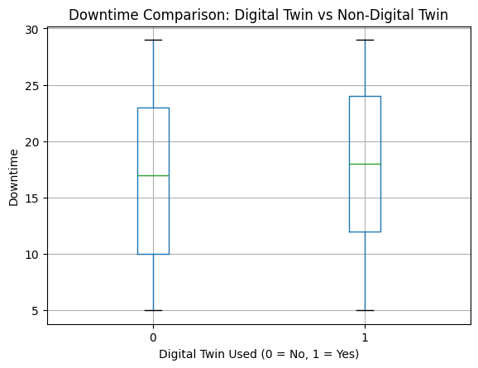

FIGURE 1. Distribution of downtime between machines using and not using digital twins.

Figure 1 illustrates the difference in downtime patterns between machines equipped with digital twins and those without. The boxplots reveal that machines employing digital twins exhibit a more consistent downtime distribution. The median values and the spread of the data points point towards a positive shift towards enhanced operational stability in systems incorporating digital twins. Combining these visual findings with additional statistical examinations establishes a stronger basis for evaluating the influence of digital twins on downtime reduction.

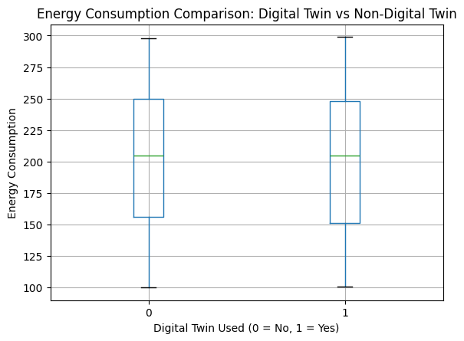

FIGURE.2. Distribution of energy consumption for machines that use and do not use digital twins.

The boxplots presented in Figure 2 reveal a promising pattern of lower energy consumption for machines employing digital twins. The median values and spread of the data suggest the possibility of improving energy efficiency in systems incorporating these digital representations. Nevertheless, statistical hypothesis testing indicates that these differences are not statistically significant, implying that the observed changes in energy consumption could be attributed to random variations.

Although the visual data implies that digital twins could enhance energy efficiency, further statistical and empirical research is necessary to definitively establish their direct influence.

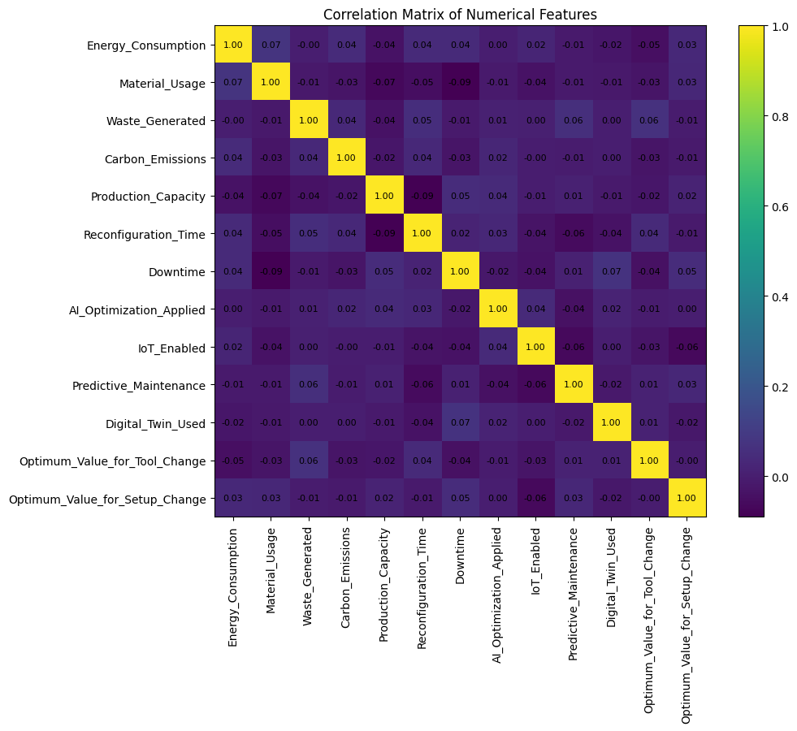

FIGURE.3. Correlation matrix between numerical attributes in the dataset.

Figure 3's correlation matrix illustrates the relationships between the numerical variables. Most of the correlation coefficients are relatively small, suggesting that there isn't significant multicollinearity within the data. Notably, weak linear connections exist between crucial operational metrics like energy consumption, downtime, reconfiguration time, and production capacity.

These findings validate the dataset's suitability and reliability for statistical hypothesis testing and machine learning-driven regression analyses planned for later stages. Moreover, the correlation analysis reveals that feature selection or data transformations are unnecessary, as no significant correlations exist that would negatively impact model training.

3. Testing of Statistical Hypotheses. To assess the statistical significance of the identified differences, a t-test for two independent samples was applied. The null hypothesis (H0) was accepted that there is no statistically significant difference between systems using digital twins and those not using them for each indicator.

TABLE 3. Results of a two-sample t-test to assess the impact of digital twins (t-statistics and p-values).
Indicator | t-statistic | p-value
Downtime | -2.1554 | 0.0314
Energy Consumption | 0.7508 | 0.4530
Reconfiguration Time | 1.1897 | 0.2345

The findings from the two-sample t-test, as shown in Table 3, reveal the influence of digital twins on various operational aspects. Notably, the data indicates a statistically meaningful reduction in machine downtime (p < 0.05) due to the implementation of digital twins. However, the analysis did not demonstrate a statistically significant difference in energy consumption or reconfiguration time at the standard 95% confidence threshold.

To establish statistical significance, a 95% confidence level (p < 0.05) was employed. This rigorous method enabled a fair and unbiased evaluation of the genuine influence of digital twins on crucial operational metrics, including downtime.

4. Machine Learning Analysis. Machine learning-driven regression models were utilized to assess the predictive power of incorporating digital twins into a comprehensive analysis of operational factors. The aim was to forecast both downtime and energy usage, leveraging the capabilities of Random Forest regression algorithms.

TABLE 4. Feature Importance in predicting downtime based on the Random Forest regression model
Attribute name | Relative importance
Material_Usage | 0.1596
Production_Capacity | 0.1490
Carbon_Emissions | 0.1423
Reconfiguration_Time | 0.1315
Waste_Generated | 0.1183
Optimum_Value_for_Setup_Change | 0.1135
Optimum_Value_for_Tool_Change | 0.1110
Predictive_Maintenance | 0.0209
IoT_Enabled | 0.0183
AI_Optimization_Applied | 0.0178
Digital_Twin_Used | 0.0178

The Random Forest regression model, as illustrated in Table 4, highlights the key attributes influencing downtime prediction. Notably, factors concerning production capacity, material usage, and reconfiguration processes exhibit a significant influence. While the digital twin indicator demonstrates a modest yet substantial importance, this suggests its function is not as a primary predictor, but rather as a valuable contextual element aiding decision-making processes.

TABLE 5. Performance indicators of Random Forest regression models
Predicted indicator | MAE (Mean Absolute Error) | R2 (Coefficient of Determination)
Downtime | 6.0501 | -0.0193
Energy Consumption | 51.2385 | -0.0461

The effectiveness of the models was assessed by examining both the Mean Absolute Error (MAE) and the coefficient of determination (R2). Table 5 displays the performance metrics of the Random Forest models specifically designed to forecast downtime and energy usage. Although the MAE figures point to a reasonable degree of prediction accuracy, the negative R2 values observed in both scenarios imply that these models have a restricted ability to explain the underlying patterns.

The dataset's limitations suggest it's better suited for exploratory analysis rather than highly accurate predictions. Its empirical nature highlights the intricate and multifaceted processes at play within the RMS environment. These findings reinforce the idea that digital twins, within the context of this research, should be viewed as a valuable tool for aiding decision-making and facilitating system-wide coordination, rather than solely as a primary forecasting instrument.
CONCLUSIONS
Initial findings reveal that machines equipped with digital twins demonstrate slightly reduced average energy consumption and reconfiguration times compared to machines lacking digital twins. While the average downtime difference isn't significant, a visual examination of the data distributions (using boxplots) suggests a promising tendency toward enhanced operational uptime for systems utilizing digital twins.
The correlation analysis showed that the numerical attributes did not exhibit significant multicollinearity. This lack of multicollinearity strengthens the validity of the following statistical tests and machine learning procedures.
Statistical hypothesis testing revealed a noteworthy reduction in downtime. Analysis demonstrated a statistically significant decrease in machine downtime attributable to the implementation of digital twins (p = 0.031). This finding strongly supports the notion that digital twins significantly enhance operational uptime.
Despite demonstrating promising trends, the observed variations in energy usage and reconfiguration duration did not reach statistical significance at the 95% confidence threshold.
The findings suggest that the primary benefit of digital twins within the examined RMS system lies in maintaining operational consistency, rather than directly minimizing resource usage. This finding supports the idea that digital twins function more as a coordination and oversight tool, rather than a direct control mechanism for optimization.
Machine learning regression models showed restricted predictive power. Notably, the negative R2 scores for downtime and energy consumption suggest this dataset is ill-suited for accurate forecasting. This highlights the intricate and multifaceted character of RMS environments, where efficiency outcomes are driven by complex system-wide interactions rather than isolated variables.
While factors like production capacity, material usage, and reconfiguration hold greater weight in the analysis, the digital twin utilization indicator still demonstrates a notable, albeit smaller, influence. This finding reinforces the idea that digital twins function as a valuable tool for informing decisions within a specific context, rather than acting as the primary driver of outcomes.
Analysis using both statistical and machine learning methods consistently shows that digital twins significantly improve decision-making, monitoring processes, and the ability to adapt quickly in reconfigurable manufacturing systems.
While this research offers a valuable empirical contribution, it does have several shortcomings. For instance, the dataset employed simulates a controlled and streamlined RMS environment, potentially failing to capture the intricate realities of large-scale industrial operations. Moreover, the lack of high-frequency time-series data restricts the ability to model system behaviors dynamically and examine real-time adaptability.
A third constraint is the analysis's emphasis on individual machine data, neglecting system-wide interactions between production lines. Moreover, the relatively low predictive accuracy of the machine learning models suggests a future requirement for more comprehensive contextual data, including in-depth process workflows and network-level insights.
A recent empirical study investigated the effectiveness of using digital twins to plan sustainable processes within reconfigurable production systems. Through a combination of exploratory data analysis, statistical evaluations, and machine learning techniques, the research confirmed that incorporating digital twins resulted in a statistically notable decrease in machine downtime. While improvements were noted in both energy usage and reconfiguration speed, these changes were not deemed statistically significant based on the current dataset.
The findings highlight that digital twins are best viewed as decision-making tools rather than highly accurate predictive models. Their true strength lies in maintaining operational stability within Industry 4.0 settings, improving communication between systems, and enabling data-driven choices. This viewpoint offers a more grounded and practical understanding of how digital twins can be effectively integrated into production systems.
Ongoing research efforts will concentrate on incorporating time series data, constructing agent-based digital twin frameworks, and putting into practice real-time optimization strategies. Furthermore, exploring digital twins that are aware of both system-level operations and network characteristics within edge-cloud environments and advanced communication systems is seen as a valuable path toward creating sustainable and intelligent manufacturing processes.
REFERENCES
- Tao, F., Zhang, H., Liu, A., & Nee, A. Y. C., "Digital Twin in Industry: State-of-the-Art," IEEE Transactions on Industrial Informatics, vol. 15, no. 4, pp. 2405-2415, 2019.
- Kritzinger, W., Karner, M., Traar, G., Henjes, J., & Sihn, W., "Digital Twin in Manufacturing: A Categorical Literature Review and Classification," IFAC-PapersOnLine, vol. 51, no. 11, pp. 1016-1022, 2018.
- Negri, E., Fumagalli, L., & Macchi, M., "A review of the roles of Digital Twin in CPS-based production systems," Procedia Manufacturing, vol. 11, pp. 939-948, 2017.
- Lu, Y., "Industry 4.0: A survey on technologies, applications and open research issues," Journal of Industrial Information Integration, vol. 6, pp. 1-10, 2017.
- ElMaraghy, H. A., "Flexible and reconfigurable manufacturing systems paradigms," International Journal of Flexible Manufacturing Systems, vol. 17, no. 4, pp. 261-276, 2005.
- Bi, Z. M., Lang, S. Y. T., Shen, W., & Wang, L., "Reconfigurable manufacturing systems: the state of the art," International Journal of Production Research, vol. 46, no. 4, pp. 967-992, 2008.
- Monostori, L., "Cyber-physical production systems: Roots, expectations and R&D challenges, "Procedia CIRP, vol. 17, pp. 9-13, 2014.
- Zhang, Y., Liu, S., Liu, Y., Yang, H., & Guo, H., "Digital twin-driven smart manufacturing: Connotation, reference model, applications and research issues, "Robotics and Computer-Integrated Manufacturing, vol. 61, 101837, 2020.
- Stock, T., & Seliger, G., "Opportunities of sustainable manufacturing in Industry 4.0," Procedia CIRP, vol. 40, pp. 536-541, 2016.
- Tao, F., Cheng, J., Qi, Q., Zhang, M., Zhang, H., & Sui, F., "Digital twin-driven product design, manufacturing and service with big data," The International Journal of Advanced Manufacturing Technology, vol. 94, pp. 3563-3576, 2018.
- Yusupbekov N.R., Avazov Yu.Sh., Rashidov G.Kh. Algorithms for analog-digital information transformation // Proceedings of the XXI International Scientific and Practical Conference "Development of Science in the XXI Century." - Dortmund (Germany), 2025. - PP.104-107.
- Yusupbekov N.R., Avazov Yu.Sh., Rashidov G.Kh. Designing a Gilbert filter for digital signal processing // Proceedings of the III International Scientific and Practical Conference "Bridging disciplines for scientific progress." - Marseille (France), 2025. - PP.34-37.
- Yusupbekov N.R., Avazov Yu.Sh., Rashidov G.Kh. Application of neural networks for intelligent processing of sensor signals in the control of technological process parameters // International scientific and technical journal "Chemical Technology. Control and Management." - Tashkent, 2025. - No. 4 (124). - pp. 33-44.
- Yusupbekov N.R., Kholmanov U.U. System of automatic control of the technological process of combustion in gas combustion furnaces // AIP Conference Proceeding, 2024, 3119(1), 060011. https://doi.org/10.1063/5.0214847
- Shukhrat Gulyamov, Yusuf Avazov, Elyor Samadov, Khojiyeva Nasiba, Bazarbaev Qabilbek Some issues of increasing energy efficiency of advanced process and production control systems Uzbekistan (2025) AIP Conf. Proc. 3331, 060009 (2025), DOI/10.1063/5.0257158 (Scopus, Q4) https://www.scopus.com/pages/publications/86000748665?origin=resultslist
- Yusupbekov N., Avazov Yu., Samadov E., Khojiyeva N., Shodiev M., Bazarbaev K. Study of the technological process of vegetable oil refining as an object of monitoring, control and management AIP Conf. Proc. 3268, 040044 (2025) doi.org/10.1063/5.0257158 (Scopus, Q4) https://www.scopus.com/pages/publications/86000748665?origin=resultslist

