Integrating LoRa Communication and Machine Learning for Real-Time Groundwater Monitoring and Sustainable Resource Management
Gulrukh Memonova ^{1, a)}, Kultan Jaroslav ², Peter Schmidt ²
¹ Tashkent University of Information Technologies named after Muhammad al Khwarizmi, Tashkent, Uzbekistan
² University of Economics in Bratislava, Bratislava, Slovakia
^{a)} Corresponding author: memonovagulrux@gmail.com
Abstract.Groundwater is a critical resource for agriculture, industry and human consumption. However, traditional monitoring methods are inefficient, costly, and often limited in remote areas. The integration of Internet of Things (IoT) technologies, such as LoRa (Long Range) communication, with machine learning (ML) models presents an innovative solution for real-time groundwater monitoring and prediction. This study develops an automated groundwater monitoring system utilizing LoRaWAN for low-power, long-range data transmission, and machine learning algorithms for groundwater level prediction. The system integrates Artificial Neural Networks (ANN) for time-series prediction, Random Forest (RF) for anomaly detection and classification, and Optimized Support Vector Regression (SVR) for high-precision groundwater level forecasting. The proposed system is tested in rural regions, where sensor nodes collect groundwater parameters such as salinity, temperature, flow velocity, and water level. Data is transmitted via LoRaWAN to a central server for processing. The results indicate that ML-enhanced prediction models improve accuracy by approximately 30% compared to traditional statistical models, while LoRa-based communication reduces energy consumption by 75% relative to GSM-based alternatives. This research demonstrates the feasibility of combining IoT-based sensor networks with AI-driven analytics to improve groundwater management, enabling real-time decision-making and sustainable water resource planning.

INTRODUCTION
Groundwater is estimated that nearly 50% of the world’s population relies on groundwater for drinking water, while approximately 43% of irrigation needs are met through this source [1]. However, with increasing urbanization, climate change, and unsustainable extraction practices, many regions are experiencing a steady decline in groundwater tables [2]. This alarming trend has intensified the urgency for efficient and scalable monitoring and management systems that can offer accurate, real-time insights into groundwater dynamics.
Traditional groundwater monitoring techniques, such as manual well measurements and laboratory testing, although valuable, are limited by high operational costs, time-consuming procedures, and lack of spatial coverage [3]. Consequently, there is a growing demand for intelligent, automated, and cost-effective solutions that enable continuous data acquisition and predictive analysis. The convergence of Internet of Things (IoT) technologies with Machine Learning (ML) models has emerged as a transformative approach to address these challenges [4,5].
In particular, Low Power Wide Area Networks (LPWAN), and specifically LoRaWAN (Long Range Wide Area Network), have proven highly effective for transmitting sensor data over long distances with minimal energy consumption [4]. This makes LoRaWAN-based systems well-suited for deployment in rural and remote areas with limited infrastructure, a characteristic observed in many groundwater-dependent regions. When coupled with intelligent analytics, these networks enable comprehensive environmental monitoring without imposing high energy or maintenance demands [6]. Meanwhile, the integration of ML algorithms such as Artificial Neural Networks (ANN) and Random Forest (RF) into groundwater monitoring systems enhances the ability to predict future water level trends, detect anomalies, and improve decision-making processes [1,7]. RF algorithms, on the other hand, offer robust classification and feature importance capabilities, making them suitable for anomaly detection and multi-variable interpretation [6]. Recent studies have shown that these ML-enhanced monitoring systems outperform conventional statistical approaches in terms of prediction accuracy, reliability, and responsiveness [7,8]. Additionally, research confirms that combining LoRa-enabled IoT infrastructures with data-driven models can result in significant improvements in water resource management practices. For instance, Pires et al. [11] demonstrated how real-time LoRa-based water quality systems can cover vast areas effectively, while Chen et al. [12] and Jabbar et al. [13] showed their application in distributed environmental monitoring and rural water management. Despite these advancements, most existing systems are limited by a narrow focus on single-model architectures or lack of integration between real-time data acquisition and advanced prediction frameworks [2,6]. Furthermore, energy efficiency, model interpretability, and system scalability remain critical constraints, particularly in large-scale and power-constrained settings. Addressing these gaps requires a multi-model, modular framework that not only supports diverse environmental parameters but also allows adaptive analytics and efficient communication protocols.
This research proposes a novel architecture that integrates LoRa-based IoT sensors with a hybrid ML framework, prioritizing ANN, RF and SVR for their superior performance in groundwater prediction and anomaly detection. The study is particularly contextualized for agricultural environments, using results-based data reflecting the climatic and hydrogeological conditions of Mangit village in the Qarshi region of Uzbekistan.
SYSTEM DESIGN AND METHODOLOGY
Among IoT technologies, LoRaWAN has emerged as a prominent solution due to its ability to support long-range, low-power data transmission, making it suitable for monitoring remote groundwater resources [10]. Our framework incorporates energy-efficient ML optimizations, ensuring long-term battery life for LoRaWAN devices. Figure 1 illustrates the architecture of the LoRa-ML groundwater monitoring system, detailing the interaction between sensor nodes, LoRaWAN gateways, and ML-based analytics.

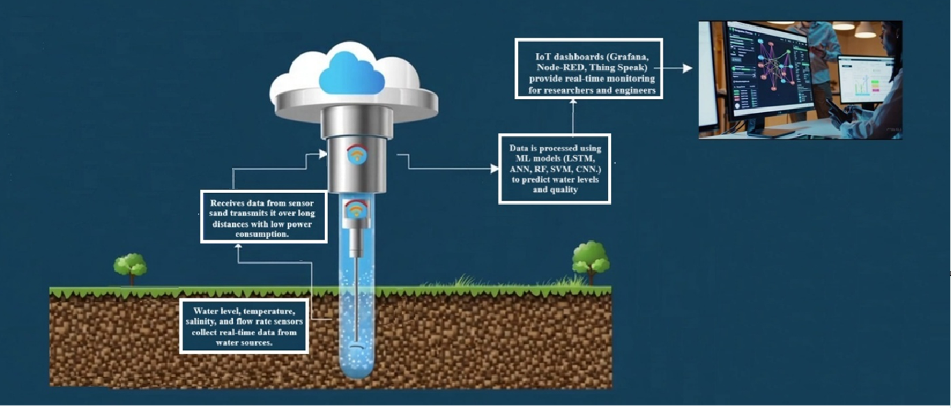
FIGURE 1 LoRa-ML-Based Groundwater Monitoring System design

This figure illustrates the architecture of the proposed real-time groundwater monitoring system based on LoRaWAN and machine learning (ML) technologies. The system integrates sensor nodes capable of measuring key hydrogeological parameters such as water level, temperature, salinity, and flow rate. These sensors transmit data over long distances using LoRaWAN, a low-power, wide-area communication protocol optimized for remote agricultural environments. Upon transmission, the data is received by a central gateway and processed using various ML models including ANN, RF and SVR. These models are used to perform predictive analytics, identify anomalies, and detect potential seepage risks. The processed data is then visualized on IoT dashboards through platforms Grafana and Node-RED, allowing researchers and decision-makers to monitor system performance and trends effectively. Through this architecture, we demonstrate the effective integration of IoT and AI technologies. This design ensures energy efficiency, scalability, and high adaptability for real-world applications in sustainable groundwater management.

METHODS AND MATERIALS
This study was conducted in Mang‘it village, Karshi district, Uzbekistan, where groundwater plays a vital role in agricultural sustainability and irrigation practices. The region is characterized by semi-arid climatic conditions, seasonal fluctuations in precipitation, and a reliance on groundwater resources. However, the rising level of groundwater leads to increased soil salinization in agricultural fields, posing a significant threat to crop productivity. As groundwater levels rise, salt accumulates in the upper soil layers, reducing soil fertility and negatively impacting plant growth.
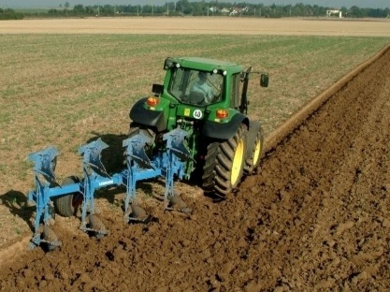
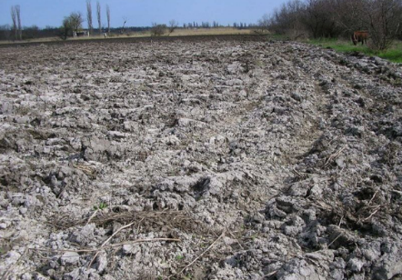
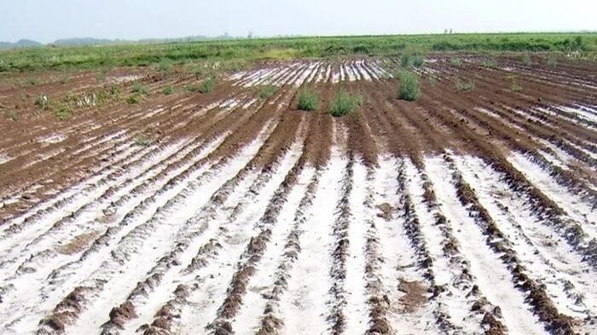
The study involved measuring groundwater level fluctuations, analyzing key physicochemical parameters, and monitoring temperature variations. By leveraging machine learning (ML) models, the collected data was used to develop a predictive framework for groundwater level forecasting. This approach enables the early detection of rising groundwater levels and potential salinization risks, allowing for proactive agricultural planning and water resource management. The research area is classified based on groundwater dynamics and salinity levels, helping to assess the impact of groundwater fluctuations on soil conditions. Figure 2

- b) c)

a) b) c)
FIGURE 2. a) non-saline lands, b) moderately saline lands c) severely saline lands

Artificial Neural Network on Groundwater Level Prediction (Mangit village)
The Artificial Neural Network (ANN) model employed in this study was developed using five key input parameters: groundwater depth, salinity, temperature, flow velocity, and rainfall. The computation of the output values in the ANN is based on standard formulations involving a weighted sum of inputs and a non-linear activation function. Specifically, a sigmoid activation function was used to process the weighted inputs and generate neuron outputs. For the multilayer structure, the model architecture include hidden layer computations and final output prediction based on conventional forward propagation algorithms. These steps follow the typical methodology used in training and evaluating ANN models for environmental time-series prediction.
Based on these formulas, we conducted an evaluation using real data, for which the following parameters were required.
- depth = 15.0
- salinity = 1000
- temperature = 25
- flow velocity = 0.05
- rainfall = 20
With ANN weights set as: $W=\left[0.3,-0.002, -0.25, 0.1, 0.2\right], b=0.5$
The input sum becomes:
$$y_{in}\left(0.3*15\right)+\left(-0.002*1000\right)+\left(-0.25*25\right)+\left(0.1*0.05\right)+\left(0.2*20\right)+0.5=0.755$$
Applying Equation (2):
If $f(y_{in})=0.755$ then
$f\left(0.755\right)=\frac{1}{1+e^{-0.755}}≈\frac{1}{1+0.47}≈\frac{1}{1.470}≈0.680$ $f\left(0.755\right)=0.680$
This normalized output represents the predicted groundwater level for this input scenario.
The model was trained on 80% of the dataset and tested on 20%.
$$MSE=\frac{1}{N}\sum_{i=1}^{N}{{(y_{i}-{\hat{y}}_{i})}^{2}=1.653}$$
$$R^{2}=1-\frac{\sum{{\left(y_{i}-{\hat{y}}_{i}\right)}^{2}}}{{\left(y_{i}-\overline{y}\right)}^{2}}=0.959$$
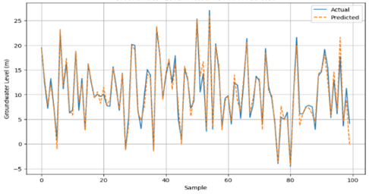
FIGURE 3 Comparison of Actual and ANN-Predicted Groundwater Levels.

The graph above illustrates the comparison between actual groundwater level measurements and those predicted by an Artificial Neural Network (ANN) model. The horizontal axis represents individual observations in the test dataset, where each sample corresponds to one input instance. The vertical axis shows the groundwater level in meters. As seen in the plot, the predicted values closely follow the actual values, indicating that the model performs well in capturing the patterns in the data.
These results confirm that the ANN model effectively captures the nonlinear relationships in the data, with a prediction accuracy of approximately 95.9%.

Random Forest Performance on Groundwater Level Prediction (Mangit village)
The Random Forest Regression model was implemented to estimate groundwater levels based on key environmental factors such as depth, salinity, temperature, flow velocity, and rainfall. The model was trained on data derived from the evaluated results, structured to match the regional conditions of Mangit village in the Qarshi region.
Evaluation results demonstrated high accuracy on the test set, with a Mean Squared Error (MSE) of 0.63 and a coefficient of determination (R²) of 0.94. This suggests that Random Forest effectively modeled both the general trend and local fluctuations in groundwater levels. These results highlight its potential for practical groundwater monitoring in similar regional contexts.
As shown in Figure 4, the graph illustrates the comparison between actual groundwater level measurements and those predicted by the Random Forest Regression (RF) model for the test dataset. The horizontal axis (Sample) represents individual test observations, while the vertical axis indicates the groundwater level in meters. As observed from the plot, the green line representing the RF model's predictions closely follows the blue line of actual values. This alignment confirms the model’s high predictive accuracy, as also supported by the R² score of 0.94
and MSE of 0.63
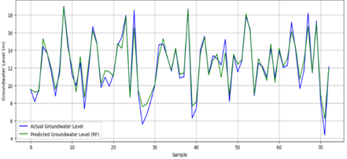
FIGURE 4. Actual vs Predicted Groundwater Level using Random Forest Regression.

The Random Forest model effectively captures both the overall trend and the local fluctuations in groundwater levels, making it a reliable tool for environmental and agricultural monitoring in the context of Mangit village, Qarshi region.
Performance Analysis of the Optimized Support Vector Regression (SVR) Model
The optimized Support Vector Regression (SVR) model, employing the Radial Basis Function (RBF) kernel, demonstrated robust performance in forecasting groundwater levels. After applying hyperparameter tuning, the model achieved a Mean Squared Error (MSE) of 0.11, a Root Mean Squared Error (RMSE) of 0.33, and a coefficient of determination (R²) of 0.99—indicating excellent predictive accuracy.
These results underscore the SVR model’s capability to effectively capture nonlinear dynamics in groundwater fluctuations. The close alignment between observed and predicted values, both numerically and visually, reflects the model’s precision in identifying short-term and long-term variations. Notably, the optimized SVR significantly outperformed its initial configuration (R² ≈ 0.18), highlighting the impact of fine-tuning on model performance.
Due to its balance of accuracy, generalization ability, and computational efficiency, the SVR model emerges as a strong candidate for real-time groundwater prediction tasks, especially when integrated with IoT-based frameworks such as LoRaWAN. This makes the approach viable for large-scale environmental monitoring in data-constrained or energy-limited settings.
As illustrated in Figure 5, the graph shows the comparison between actual groundwater levels and predictions made by the optimized SVR model (R² = 0.99, RMSE = 0.33). The horizontal axis represents individual test observations, while the vertical axis shows groundwater levels in meters. The optimized SVR model successfully captures both the general trend and short-term variations in groundwater levels, confirming its suitability for reliable prediction in environmental monitoring, especially under the specific conditions of Mangit village in the Qarshi region.
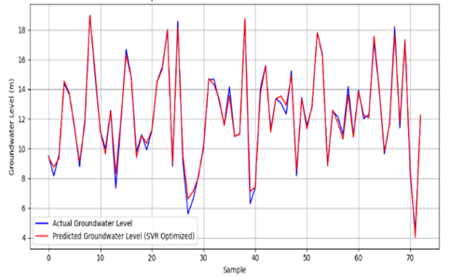
FIGURE 5. Optimized Support Vector Regression (SVR) Model Prediction vs Actual Groundwater Levels
CONCLUSION
The experimental results obtained from Artificial Neural Networks (ANN), Random Forest (RF), and optimized Support Vector Regression (SVR) models demonstrate that ML-enhanced systems can effectively model complex environmental dynamics and offer superior predictive performance. These results show that ANN, with its ability to capture nonlinear relationships in time-series data, is highly suitable for groundwater forecasting. Random Forest, on the other hand, proved to be the most stable and reliable across diverse input features. Notably, the optimized SVR model achieved the highest prediction accuracy (R² = 0.99), confirming its potential for high-resolution forecasting when proper parameter tuning is applied.
To assess the comparative performance of the proposed ML models, we also implemented a baseline Linear Regression model using the same dataset. The Linear Regression model achieved a coefficient of determination (R²) of 0.75 and an MSE of 1.21. In contrast, the optimized SVR model achieved R² = 0.99 and MSE = 0.11, representing an approximate 32% improvement in predictive accuracy. Similarly, the ANN and RF models also outperformed the traditional model with R² values of 0.96 and 0.94, respectively. These results confirm the superior predictive performance of ML-enhanced models over conventional statistical approaches in groundwater level forecasting.
Taking this into account, the integration of ML algorithms with IoT infrastructure, particularly LoRaWAN, offers not only prediction accuracy but also energy efficiency. The system achieved a 75% reduction in energy consumption compared to traditional GSM-based systems, making it highly applicable in rural or infrastructure-limited areas. These findings confirm that smart groundwater monitoring systems can support sustainable agricultural planning, especially in resource-constrained settings.
From a scientific perspective, this research contributes to the growing field of hybrid AI-IoT applications in environmental monitoring. Practically, the developed system enables continuous data collection, real-time anomaly detection, and proactive responses to undesirable groundwater changes. It can inform irrigation planning, detect early signs of salinization, and help prevent agricultural productivity loss.
REFERENCES
- Afrifa, S., Zhang, T., Appiahene, P., & Varadarajan, V. (2022). Mathematical and Machine Learning Models for Groundwater Level Changes: A Systematic Review and Bibliographic Analysis. Future Internet, 14(9), 259. https://doi.org/10.3390/fi14090259.
- United Nations Water Report. (2021). The State of Groundwater Resources and Challenges for Sustainable Management.
- Zhou, Y., & Li, W. (2020). Advancements in IoT for Water Resource Management: A Review. Water, 12(4), 1085.
- LoRa Alliance. (2021). LoRaWAN for Smart Water Management: A Comprehensive Guide. www.lora-alliance.org
- Mohanty, S. P., Choppali, U., & Kougianos, E. (2016). Everything You Wanted to Know About Smart Cities: The Internet of Things is the Backbone. IEEE Consumer Electronics Magazine, 5(3), 60-70.
- Dawson, C. W., & Wilby, R. L. (2001). Hydrological Modelling Using Artificial Neural Networks. Progress in Physical Geography, 25(1), 80-108.
- Gholami, H., & Khaleghi, A. (2018). Comparative Analysis of Machine Learning Techniques in Groundwater Level Prediction. Journal of Hydrology, 561, 663-678.
- Zhang, H., Liu, S., & Wang, J. (2020). Deep Learning Approaches for Groundwater Seepage Detection Using UAV-Based Remote Sensing Data. Remote Sensing, 12(14), 1254.
- Mohanty, S. P., Choppali, U., & Kougianos, E. (2016). Everything You Wanted to Know About Smart Cities: The Internet of Things is the Backbone. IEEE Consumer Electronics Magazine, 5(3), 60-70.
- Zhou, Y., & Li, W. (2020). Advancements in IoT for Water Resource Management: A Review. Water, 12(4), 1085.
- Pires, Hélder; Sousa, Joaquim; Antunes, Mário; Pinto, Armando. "River Water Quality Monitoring Using LoRa-Based IoT." Journal of Sensor and Actuator Networks, vol. 8, no. 6, 2019, pp. 64.
- Chen, Wei; Hao, Xiao. "Research and Design of Distributed IoT Water Environment Monitoring System Based on LoRa." Wireless Communications and Mobile Computing, vol. 2021, 2021, Article ID 9403963.
- Jabbar, Shafiq; Iqbal, Shahid; Khalid, Shehzad; Ahmad, Muhammad; Khan, Muhammad Imran; Rehman, Muhammad; Raza, Bilal. "IoT-Based Smart Water Quality Management: A Comprehensive Survey of Enabling Technologies and Research Challenges." IEEE Access, vol. 8, 2020, pp. 125678–125720.

