Dynamic Modeling and MATLAB/Simulink Implementation of a Permanent Magnet Synchronous Motor
Furkat Tuychiev^{1 a)}, Abdumannop Abdukhalilov², Akmal Pardayev ², Begzod Karimov², Rivojiddin Teshaboyev ³
¹Tashkent state technical university named after Islam Karimov, Tashkent, Uzbekistan
² Almalyk State Technical Institute, Almalyk, Uzbekistan
³Andijan State Technical Institute, Andijan, Uzbekistan
^{a)} Corresponding author: tuychievfn@gmail.com
Abstract. This paper presents a dynamic mathematical model of a three-phase Permanent Magnet Synchronous Motor (PMSM) developed using the dq-coordinate transformation. The proposed modeling approach transforms three-phase stator variables from the stationary abc reference frame into a rotating dq reference frame by means of Park transformation, which significantly simplifies the analysis of the motor’s electrical behavior. The derived model accounts for stator resistance, dq-axis inductances, permanent magnet flux linkage, and electromechanical coupling effects. The mathematical model is implemented in the MATLAB/Simulink environment, focusing primarily on the electrical subsystem of the PMSM. Simulation results confirm stable dq-axis current responses and balanced sinusoidal phase currents reconstructed using inverse Park transformation. The proposed approach provides a clear and effective framework for analyzing PMSM behavior and serves as a reliable basis for vector-controlled drive system analysis and control-oriented studies.
INTRODUCTION
Modern electric drive systems widely rely on vector control techniques to achieve high dynamic performance, fast transient response, and accurate current regulation. Among various electric machines, Permanent Magnet Synchronous Motors (PMSMs) have gained widespread acceptance in industrial and transportation applications due to their high efficiency, high power density, and reliable operation. The effectiveness of PMSM-based drive systems strongly depends on the accuracy of their mathematical models.
Modeling three-phase electric machines directly in the stationary abc coordinate system results in time-varying differential equations caused by the sinusoidal nature of phase quantities. Such representations complicate system analysis and controller design. To address this issue, coordinate transformation techniques are commonly employed. In particular, Park transformation converts three-phase variables into a rotating dq reference frame aligned with the rotor magnetic field, yielding a more tractable mathematical representation.
When expressed in the dq reference frame, the PMSM equations become time-invariant under steady-state operating conditions. This property allows simplified analysis of stator current dynamics and forms the theoretical foundation of vector control and field-oriented control strategies. Consequently, dq-based modeling has become a standard approach in PMSM analysis.
This study focuses on the development and simulation-based validation of a dq-axis mathematical model of a three-phase PMSM. The proposed model describes the electrical behavior of the motor using differential equations that incorporate stator resistance, dq-axis inductances, permanent magnet flux, and coupling terms. The model is implemented in MATLAB/Simulink to evaluate dq-axis current behavior and verify phase current reconstruction through inverse Park transformation. Extensive research has been conducted on the modeling and control of Permanent Magnet Synchronous Motors, demonstrating their suitability for high-performance electric drive applications. PMSMs are widely used in industrial drives and electric vehicles, where precise modeling of electromagnetic processes is essential. Classical works by Chapman [1] and Krause et al. [2] provide a solid theoretical foundation for synchronous machine modeling, including stator voltage equations, flux linkages, and electromagnetic interactions.
Coordinate transformation methods play a central role in simplifying PMSM models. Park transformation enables the conversion of three-phase stationary variables into a rotating dq reference frame, resulting in time-invariant equations under steady-state conditions. This transformation forms the basis of vector control and field-oriented control strategies.
More recent studies by Bose [4] and Chen and Guerrero [3] emphasize the advantages of PMSMs in terms of efficiency and dynamic response, as well as the effectiveness of dq-based control techniques. Reviews on Park and Clarke transformations further confirm their practical relevance in real-time control systems. Additionally, several applied studies investigate PMSM parameter selection and MATLAB/Simulink-based implementations, highlighting the importance of accurate dq-axis modeling. These works collectively motivate the present study, which focuses on a clear and structured dq-based PMSM implementation [6-8].

EXPERIMENTAL RESEARCH
Physical Description of the Machine. Stator and Rotor Structure. A Permanent Magnet Synchronous Motor consists of a stator and a rotor. The stator is made of laminated electrical steel and houses three-phase windings that produce a rotating magnetic field when supplied with alternating current. The rotor contains permanent magnets, typically fabricated from high-energy materials such as neodymium–iron–boron (NdFeB), which generate a constant magnetic field. Depending on the motor design, the magnets may be mounted on the rotor surface or embedded within the rotor core. The interaction between the stator-generated magnetic field and the rotor magnetic field results in synchronous rotation [9-11].
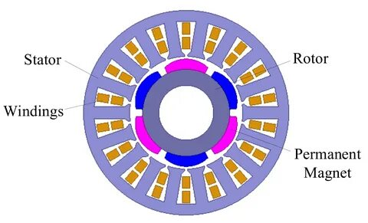
FIGURE 1. Stator–rotor configuration of a PMSM with permanent magnets
Difference Between Permanent Magnet and Electromagnetic Excitation. In PMSMs, the rotor magnetic field is produced by permanent magnets, eliminating the need for rotor excitation windings and external power supply. This reduces losses and simplifies the machine structure. In contrast, electromagnetically excited synchronous machines rely on rotor windings supplied with direct current, which increases system complexity and losses. As a result, PMSMs exhibit higher efficiency, greater power density, and superior dynamic performance, making them well suited for modern electric drive systems [9-11].
MATHEMATICAL MODEL AND MATLAB/SIMULINK IMPLEMENTATION
This section presents the mathematical formulation and simulation-based validation of a three-phase Permanent Magnet Synchronous Motor (PMSM) using the dq reference frame [6]. The modeling procedure starts from the fundamental stator voltage equations in the stationary abc coordinate system:
$\begin{matrix}v_{a} & =R_{s}i_{a}+\frac{dψ_{a}}{dt}, \\ v_{b} & =R_{s}i_{b}+\frac{dψ_{b}}{dt}, \\ v_{c} & =R_{s}i_{c}+\frac{dψ_{c}}{dt}.\end{matrix}$ (1) Since the abc-phase variables are sinusoidal, the resulting model is time-varying and less convenient for control-oriented analysis. Therefore, Park transformation is applied to convert the three-phase variables into the rotating dq reference frame aligned with the rotor magnetic field. As a result, the PMSM electrical dynamics can be described by the dq-axis stator voltage equations:
$\begin{matrix}v_{d} & =R_{s}i_{d}+L_{d}\frac{di_{d}}{dt}-ω_{e}L_{q}i_{q}, \\ v_{q} & =R_{s}i_{q}+L_{q}\frac{di_{q}}{dt}+ω_{e}L_{d}i_{d}+ω_{e}Φ_{f},\end{matrix}$ (2)
where $v_{d},v_{q}$are the dq-axis stator voltages, $i_{d},i_{q}$are the dq-axis stator currents, $R_{s}$is the stator resistance, $L_{d}$and $L_{q}$are dq-axis inductances, $Φ_{f}$is the permanent magnet flux linkage, and $ω_{e}$is the electrical angular speed.[9-11]
FIGURE 2. Conceptual representation of magnetic field interaction in a PMSM

For simulation purposes, the model is implemented in MATLAB/Simulink as shown in Figure 3. Three-phase input voltages $\left(v_{a} , v_{b} , v_{c}\right)$are converted to dq components using the Park block. The dq current dynamics are realized using gain blocks representing resistive and coupling terms and integrators to obtain current states. The electrical angular speed is provided as an input to the Park transformation and coupling blocks, and the inverse Park block reconstructs phase currents $\left(i_{a} , i_{b} , i_{c}\right)$for waveform validation.
It is important to note that electromagnetic torque and the complete mechanical dynamics are not included in this model. In this work, the rotor speed (and hence $ω_{e}$) is treated as a known input signal rather than being generated from a torque-based mechanical subsystem. This assumption is adopted intentionally to focus on validating the electrical dq-axis model and the correctness of abc–dq and dq–abc transformations in a control-oriented framework.
Simulation results confirm that the dq-axis currents remain stable under the selected operating conditions, and the reconstructed phase currents exhibit balanced sinusoidal waveforms. These observations validate the correctness of the developed dq-based PMSM electrical model and its MATLAB/Simulink implementation.

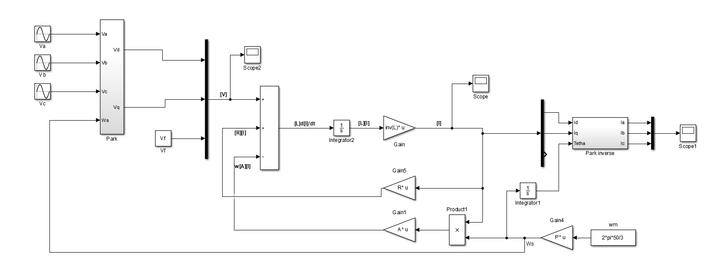FIGURE 3. MATLAB/Simulink implementation of the dq-axis PMSM electrical model using Park and inverse Park transformations.
SIMULATION RESULTS AND DISCUSSION
This section presents the simulation results obtained from the dq-axis electrical model of the Permanent Magnet Synchronous Motor (PMSM) implemented in the MATLAB/Simulink environment. The results are analyzed using three observation blocks (Scope2, Scope, and Scope1) in order to evaluate the correctness of the Park and inverse Park transformations as well as the dynamic behavior of the dq-axis currents.

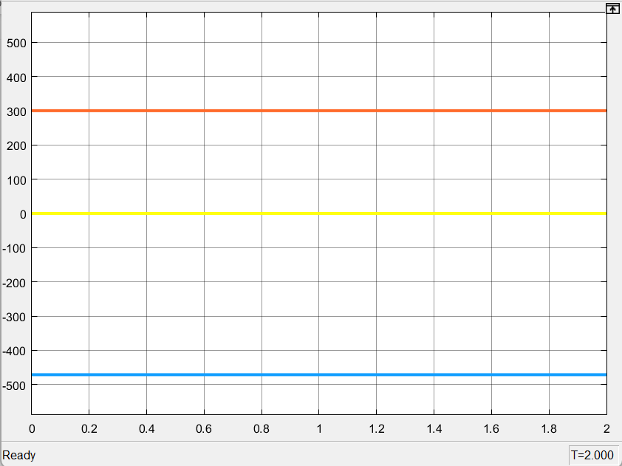
FIGURE 4. dq-Axis Voltage Components

Scope2 illustrates the time-domain responses of the stator voltage components in the d- and q-axes. As observed from the plots, the dq-axis voltages remain at steady and constant levels throughout the simulation interval. This behavior confirms the correct operation of the Park transformation and indicates that the three-phase input voltages are properly mapped into the rotating dq reference frame. The constant nature of the dq-axis voltages is consistent with the theoretical characteristics of the dq-based PMSM model under steady-state conditions.
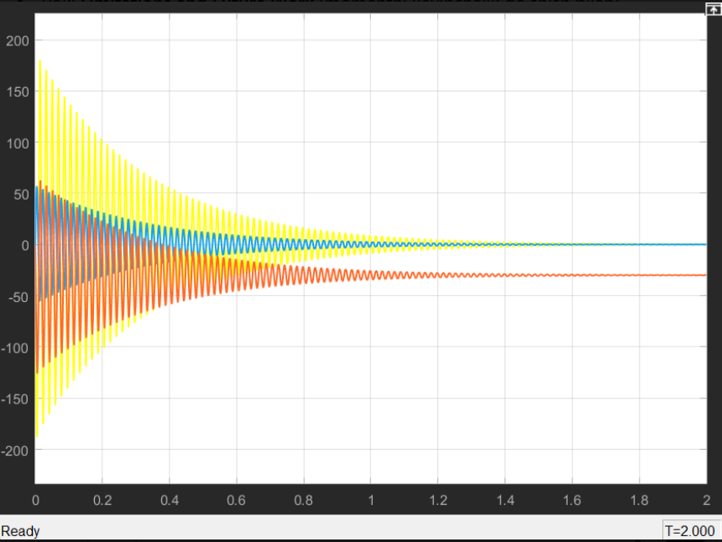
FIGURE 5. Dynamic Response of dq-Axis Currents

Scope presents the transient and steady-state responses of the stator currents in the d- and q-axes. At the beginning of the simulation, the currents exhibit high-amplitude oscillations, which are attributed to initial conditions and transient effects of the electrical subsystem. As time progresses, the oscillations gradually decay, and the dq-axis currents converge toward steady-state values.
The d-axis current remains relatively small, which is typical for permanent magnet synchronous motors where the rotor flux is provided by permanent magnets. In contrast, the q-axis current represents the dominant active component and governs the dynamic behavior of the system. These results demonstrate the stability of the developed dq-axis electrical model and confirm its correct implementation.

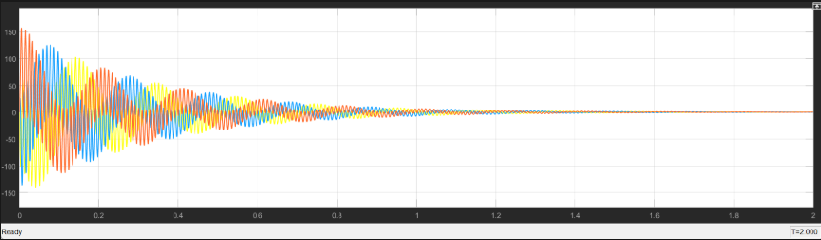
FIGURE 6. Reconstructed Phase Currents Using Inverse Park Transformation

Scope1 shows the three-phase stator currents $i_{a}$, $i_{b}$, and $i_{c}$reconstructed from the dq-axis currents using the inverse Park transformation. The waveforms exhibit balanced sinusoidal shapes with an approximate 120° phase shift between the phases. This observation verifies the consistency and accuracy of the Park and inverse Park transformations.
During the initial simulation interval, transient oscillations with higher amplitudes are observed in the phase currents. These oscillations gradually decay, and the currents settle into steady sinusoidal waveforms. This behavior further confirms the mathematical coherence of the dq-based model and the reliability of the coordinate transformation process.
It is important to note that electromagnetic torque and mechanical load dynamics are not included in the present simulation model. The rotor speed is treated as an externally imposed input signal and is used solely to generate the speed-dependent coupling terms in the dq-axis equations. Therefore, the obtained results focus exclusively on the electrical behavior of the PMSM rather than its mechanical dynamics.
Overall, the simulation results obtained from Scope2, Scope, and Scope1 demonstrate that the developed dq-axis electrical model accurately captures the dynamic behavior of stator currents and validates the correctness of the abc–dq and dq–abc coordinate transformations. The proposed model provides a reliable foundation for analyzing PMSM electrical characteristics and serves as an effective tool for control-oriented studies and MATLAB/Simulink-based investigations.
CONCLUSION
This study investigated a dq-axis mathematical model of a three-phase Permanent Magnet Synchronous Motor (PMSM) and its implementation in the MATLAB/Simulink environment. The application of the Park transformation enabled the conversion of three-phase stator variables into the dq reference frame, significantly simplifying the analysis of the motor’s electrical behavior.
The developed model focused on the electrical subsystem of the PMSM, incorporating stator resistance, dq-axis inductances, and permanent magnet flux linkage. Electromagnetic torque and mechanical dynamics were intentionally excluded, and the rotor speed was treated as an external input parameter. Simulation results confirmed stable dq-axis current responses and balanced sinusoidal phase currents reconstructed through inverse Park transformation.
The proposed dq-axis electrical model provides an effective framework for analyzing PMSM electrical characteristics and serves as a useful basis for vector control development and control-oriented studies. Future work will focus on extending the model by including electromagnetic torque computation and mechanical dynamics to enable comprehensive performance evaluation of PMSM drive systems.
REFERENCES
- Chapman, S. J., Electric Machinery Fundamentals, 5th ed., McGraw-Hill Education, New York, USA, 2011.
- Krause, P. C., Wasynczuk, O., Sudhoff, S. D., Analysis of Electric Machinery and Drive Systems, 3rd ed., IEEE Press, Wiley, Hoboken, USA, 2013.
- Chen, Z., Guerrero, J. M., “Control of PMSM-Based Drive Systems for Industrial Applications,” IEEE Transactions on Industrial Electronics, vol. 64, no. 5, pp. 3811–3820, 2017.
doi:10.1109/TIE.2016.2635142
- Bose, B. K., Modern Power Electronics and AC Drives, Prentice Hall, Upper Saddle River, USA, 2002.
- Leonhard, W., Control of Electrical Drives, 3rd ed., Springer-Verlag, Berlin, Germany, 2001.
- Bobojanov, M. Furkat, T. Hamid, N. Torayev, S. Husen, A. Javahir, H. Determining the optimal steps of the number of fields with variable windings E3S Web of Conferences 2024 | Conference paper DOI: 10.1051/e3sconf/202449701014
- Bobojanov M.K., Rismukhamedov D.A., Tuychiev F.N., Shamsutdinov Kh.F. Development of new pole-changing winding for lifting and transport mechanisms // E3S Web of Conferences 365. 2023. РР, 04024, 1-10. https://doi.org/10.1051/e3sconf/202336504024.
- Bobojanov, M.; Rismuxamedov, D.; Tuychiev, F.; Shamsutdinov, K.; Magdiev, K. Pole-changing motor for lift installation E3S Web of Conferences 2020 | Conference paper DOI: 10.1051/e3sconf/202021601164EID: 2-s2.0-85098457020 Part of ISSN: 22671242 25550403
- Timur Petrov. Determination of the Objective Function of Topology Optimization for a Synchronous Generator with Replacement by Ferrite Magnets 2025 | Book chapter DOI: 10.1007/978-3-031-95649-2_4
- Timur Petrov. Feasibility of Using Topology Optimization for Permanent Magnet Synchronous Generators 2025 | Book chapter DOI: 10.1007/978-3-031-95649-2_2
- Ibatullin, E.; Petrov, T. Current Trends in Modernization of Stator Design of Permanent Magnet Synchronous Motors Proceedings - 2024 International Ural Conference on Electrical Power Engineering, UralCon 2024 2024 | Conference paper DOI: 10.1109/UralCon62137.2024.10718932
- E Yuldashev; M Yuldasheva; A Togayev; J Abdullayev; R Choriyevich. Energy efficiency research of conveyor transport AIP Conf. Proc. 3331, 040030 (2025) https://doi.org/10.1063/5.0305742

