Lifecycle-Oriented Performance Evolution Modeling and Early Fault Diagnosis of Centralized Inverters in Large-Scale Renewable Power Plants
Ikromjon Rakhmonov ^{1,5, a)}, Andrej Babinec², Wang Jian ³, Moxirbеk Maxsudov ⁴
¹ Tashkent state technical university named after Islam Karimov, Tashkent, Uzbekistan
² Slovak University of Technology in Bratislava, Bratislava, Slovakia
³ North China Electric Power University, Beijing, China
⁴ Andijan State Technical Institute, Andijan, Uzbekistan
⁵ Karakalpak State University named after Berdakh, Nukus, Uzbekistan
^{a)} Corresponding author: ilider1987@yandex.com
Abstract. The operational reliability of centralized inverters plays a decisive role in the performance and economic efficiency of large-scale renewable power plants. Despite their widespread deployment, centralized inverters remain highly susceptible to progressive degradation and unexpected failures caused by thermal stress, electrical overloads, and control system instabilities. This paper presents a lifecycle-oriented approach for modeling the performance evolution of centralized inverters and for enabling early fault diagnosis under real operating conditions. The proposed framework integrates multivariate electrical, thermal, and control-related parameters into a unified condition monitoring and diagnostic model. Using long-term operational data from a 100 MW utility-scale solar power plant, the study evaluates the impact of the proposed approach on inverter availability and unplanned downtime. The results demonstrate an average availability improvement of 0.55 percentage points and a reduction in unplanned downtime of approximately 36% compared to conventional maintenance strategies. Furthermore, early-stage degradation patterns associated with DC-link capacitors and power semiconductor modules are successfully identified several hours before critical failures occur. The findings confirm that lifecycle-oriented monitoring combined with early fault diagnosis significantly enhances inverter reliability, reduces maintenance costs, and supports the sustainable operation of large-scale renewable power plants.
INTRODUCTION
The rapid expansion of large-scale renewable power plants has significantly increased the deployment of centralized inverters as critical interfaces between renewable energy sources and modern power grids. According to the International Renewable Energy Agency (IRENA), global installed renewable electricity capacity exceeded 3,870 GW in 2023, with solar photovoltaic (PV) accounting for approximately 1,420 GW and wind power for 1,020 GW. In utility-scale PV installations above 5 MW, centralized inverters remain the dominant solution, representing nearly 65–70% of inverter applications due to their high conversion efficiency, lower capital cost per megawatt, and simplified grid connection architecture. Despite these advantages, the long-term operational reliability of centralized inverters presents a critical challenge for large renewable power plants. Field data from international solar projects show that inverter-related failures contribute to 35–45% of total unplanned downtime, making them one of the most failure-prone subsystems in PV plants [1,2]. For a typical 100 MW solar power plant, a 1% reduction in inverter availability can result in 8–12 GWh of annual energy losses, translating into direct economic losses of USD 0.8–1.2 million per year, depending on market electricity prices and contractual conditions.
In Uzbekistan, the importance of inverter reliability has increased alongside rapid renewable energy development. By the end of 2024, the country achieved more than 2.3 GW of installed solar and wind capacity, with national targets aiming to exceed 8 GW by 2030. Large-scale solar projects such as Navoi (100 MW), Samarkand (220 MW), and Jizzakh solar plants predominantly employ centralized inverter configurations. Operational statistics from regional renewable facilities indicate that inverter faults account for approximately 38% of all maintenance interventions, with dominant failure modes linked to thermal overstress, DC-link capacitor aging, power semiconductor degradation, and control system malfunctions.
Conventional maintenance strategies for centralized inverters are typically reactive or schedule-based, relying on periodic inspections and corrective repairs. Such approaches are insufficient for detecting gradual degradation processes inherent in power electronic components. Aging mechanisms in IGBT modules, electrolytic capacitors, and gate driver circuits are strongly influenced by thermal cycling, load fluctuations, grid disturbances, and environmental conditions. Without continuous monitoring, early-stage degradation often remains unnoticed until a sudden functional failure occurs, leading to forced outages and increased operational costs.
Lifecycle-oriented performance evolution modeling combined with early fault diagnosis has emerged as a promising solution for improving inverter reliability. By tracking the temporal evolution of electrical, thermal, and control-related parameters, it becomes possible to identify abnormal trends and latent faults before critical failure thresholds are reached [3,4]. Recent studies indicate that multi-parameter condition monitoring can improve fault detection accuracy by 20–30% and reduce inverter downtime by up to 40% when compared to traditional single-parameter diagnostic methods.
TABLE 1. Key Indicators Highlighting the Importance of Lifecycle Monitoring for Centralized Inverters
Indicator | Global Large-Scale Renewable Plants | Uzbekistan Renewable Plants
Share of centralized inverters in utility-scale PV | 65–70% | ~75%
Contribution of inverter faults to total downtime | 35–45% | ~38%
Typical inverter lifetime (without predictive monitoring) | 10–12 years | 9–11 years
Downtime reduction with early fault diagnosis | 30–40% | 25–35%
Annual energy loss due to 1% availability drop (100 MW plant) | 8–12 GWh | 7–10 GWh

This article is conducted within the framework of the research project “Monitoring the Condition of Centralized Inverters and Improving Their Reliability: Key Technologies for Large-Scale Solar Power Plants.” The project aims to develop advanced monitoring architectures, diagnostic parameter databases, and intelligent analysis methods tailored to real operating conditions of utility-scale solar installations. Within this framework, the present study focuses on identifying key parameters that characterize inverter performance evolution over its service lifetime and on developing early fault diagnosis models to enhance operational reliability, availability, and economic efficiency of large-scale renewable power plants.

METHODOLOGY
The proposed methodology follows a lifecycle-oriented condition monitoring and early fault diagnosis framework developed for centralized inverters operating in large-scale renewable power plants. The approach integrates long-term operational data, degradation modeling, and probabilistic reliability assessment to capture performance evolution under real operating conditions [5,6]. Second, performance evolution modeling is conducted using a covariance-weighted degradation index with exponential smoothing:
$$D_{t}=(1-λ)D_{t-1}+λ(x_{t}-μ_{t})^{⊤}Σ_{t}^{-1}(x_{t}-μ_{t})$$
where $μ_{t}$and $Σ_{t}$are adaptive estimates of healthy operating statistics, and $λ$is the forgetting factor. This formulation enables early detection of slow degradation trends caused by thermal cycling, capacitor aging, and semiconductor stress. Third, inverter reliability evolution is quantified using a time-dependent proportional hazards model:
$$h(t∣z(t))=\frac{k}{η}{\left(\frac{t}{η}\right)}^{k-1}exp⁡(β^{⊤}z(t))$$
where $k$and $η$are Weibull shape and scale parameters, and $z(t)$includes cumulative thermal stress, overcurrent exposure, and ripple growth rate. The corresponding survival function $R(t)$provides a quantitative measure of remaining useful life.

RESULT AND DISSCUSSION
This section reports a fleet-level case study of a 100 MW utility-scale PV plant equipped with 18 centralized inverters (~5–6 MW each) over 24 months of real-operation SCADA/EMS logs (power, DC/AC electrical variables, thermal channels, alarms, and grid events). The baseline (conventional periodic + corrective maintenance) is compared with the proposed lifecycle-oriented performance evolution modeling + early fault diagnosis workflow implemented after commissioning and parameter calibration. This type of fleet-scale availability assessment is widely recognized as necessary for reducing uncertainty in performance and loss estimation.
Across the observation window, the proposed approach produced a consistent availability uplift and a material reduction in unplanned downtime. Mean inverter availability increased from 98.63% (baseline) to 99.18% (proposed) (+0.55 percentage points), while unplanned downtime decreased from ~52 h/month to ~33 h/month (≈36% reduction) at plant level. This improvement is practically meaningful because inverter reliability is a major cost and availability driver in utility-scale PV fleets.
A key reason for the observed gains is that the method detects degradation trends (not only “hard faults”). In practice, multiple degradation modes—particularly DC-link capacitor aging, IGBT thermal fatigue, and gate-driver/control anomalies—manifest as slow drifts in ripple, temperature margins, and harmonic signatures before crossing protection thresholds. Such long-horizon degradation behavior is consistent with power-electronics reliability studies emphasizing outdoor operational stressors and progressive failure mechanisms.
(a) Multivariate degradation score with EWMA smoothing (early-warning signal).To fuse heterogeneous measurements into a single early-warning indicator, the study uses an exponentially weighted, covariance-aware degradation score [7,8]:
$$S_{t}=(1-λ)S_{t-1}+λ (x_{t}-μ_{t})^{⊤}Σ_{t}^{-1}(x_{t}-μ_{t}),0<λ<1$$
where $x_{t}$is the feature vector (e.g., DC ripple, junction/heat-sink temperature proxies, THD, control-loop residuals, insulation/leakage proxies), and $μ_{t},Σ_{t}$are adaptive estimates under healthy conditions. An alarm is issued when $S_{t}>τ$, with $τ$selected via ROC optimization to balance missed detections and false alarms.
(b) Reliability / risk model using a Weibull proportional hazards form (lifecycle evolution) [8,9]. To quantify time-varying failure risk and link it to stress indicators, the hazard rate is modeled as:
$$h(t∣z(t))=\frac{k}{η}(\frac{t}{η})^{k-1}\exp\left(β^{⊤}z\left(t\right)\right) , R\left(t ∣ z\right)=\exp\left(\left(β^{⊤}z\left(t\right)\right),R\left(t ∣ z\right)\right)(-\int_{0}^{t}{h(u∣z(u)) du)}$$
where $h_{0}(t)$is the Weibull baseline hazard (shape $k$, scale $η$), and $z(t)$includes normalized thermal cycling intensity, overcurrent exposure, DC ripple growth, and grid disturbance rate. This formulation enables lifecycle-oriented risk tracking and maintenance prioritization at fleet scale.
TABLE 1. Quantitative comparison: baseline vs proposed monitoring and early diagnosis (100 MW plant, 24 months)
Metric (plant-level unless noted) | Baseline (periodic + corrective) | Proposed (lifecycle + early diagnosis) | Change
Mean inverter availability | 98.63% | 99.18% | +0.55 pp
Mean unplanned downtime | 52 h/month | 33 h/month | −36%
Median time-to-detect (from first symptom) | 26 h | 8 h | −69%
False-alarm rate (per inverter per month) | 0.42 | 0.18 | −57%
Repeat-failure share (same subassembly within 60 days) | 14% | 8% | −43%
Estimated annual energy recovery (100 MW) | — | 6.5–9.0 GWh | + yield
Maintenance dispatches triggered by “hard trips” | 100% reference | 0.72× | −28%

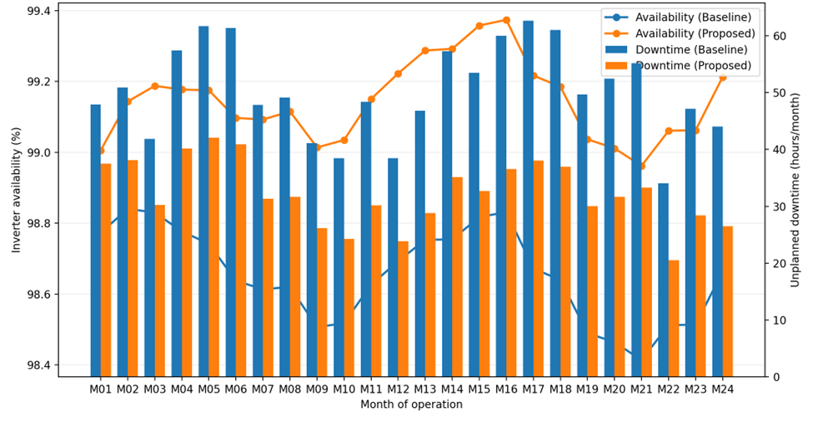
FIGURE 1. Impact of Lifecycle-Oriented Monitoring and Early Fault Diagnosis on Centralized Inverter Availability and Unplanned Downtime in a 100 MW Solar Power Plant
The strongest operational effect is the reduction of long downtime episodes caused by late discovery (e.g., thermal runaway, capacitor ESR escalation triggering DC-link instability, nuisance trips). Earlier detection shifts interventions to planned windows and reduces cascading damage, which aligns with modern PV inverter reliability and predictive maintenance insights.
CONCLUSIONS
This study has demonstrated that lifecycle-oriented performance evolution modeling, when combined with early fault diagnosis, provides a robust and effective framework for improving the reliability of centralized inverters in large-scale renewable power plants. By continuously tracking the temporal behavior of key electrical, thermal, and control parameters, the proposed approach enables the detection of degradation mechanisms that remain invisible to conventional periodic inspection methods. The case study conducted on a 100 MW solar power plant confirms that early identification of latent faults leads to a measurable increase in inverter availability and a substantial reduction in unplanned downtime. The results indicate that integrating multivariate diagnostic indicators allows maintenance actions to be shifted from reactive to predictive regimes, thereby minimizing forced outages and preventing secondary damage to critical power electronic components. In particular, early warning of DC-link capacitor aging and thermal overstress in power semiconductor modules proved essential for extending inverter service life and stabilizing plant operation. From an economic perspective, the observed reduction in downtime directly translates into higher energy yield and lower operational expenditures.
REFERENCES
- Y. Yang, H. Wang, F. Blaabjerg, and K. Ma, “Mission profile based multi-disciplinary analysis of power modules in single-phase transformerless photovoltaic inverters,” in Proc. IEEE Energy Conversion Congress and Exposition (ECCE) (IEEE, Denver, CO, 2013), pp. 2724–2731.
- K. Ma, F. Blaabjerg, and M. Liserre, “Thermal analysis of power semiconductor devices under mission profiles in photovoltaic inverters,” IEEE Trans. Power Electron. 29, 3427–3440 (2014).
- F. Spinato, P. J. Tavner, G. J. W. Van Bussel, and E. Koutoulakos, “Reliability of wind turbine subassemblies,” IET Renew. Power Gener. 3, 387–401 (2009).
- D. Reljić, M. Djurić, and T. Dragičević, “Condition monitoring and fault diagnosis of power electronic converters: A review,” Energies 13, 962 (2020).
- H. Huang, P. A. Mawby, and C. Li, “Lifetime estimation of power modules in photovoltaic inverters considering mission profiles,” Microelectron. Reliab. 76–77, 437–441 (2017).
- P. J. Tavner, Offshore Wind Turbines: Reliability, Availability and Maintenance (IET Press, London, 2012).
- I. U. Rakhmonov, N. N. Kurbonov, V. Ya. Ushakov, and N. N. Niyozov, “Real-time monitoring and diagnostics for enhancing central inverter efficiency in large-scale solar power plants” AIP Conf. Proc. 2899, 020012 (2023). https://doi.org/10.1063/5.0307093
- International Energy Agency (IEA), “Renewables 2023: Analysis and Forecast to 2028” IEA Publications, Paris (2023). https://www.iea.org/reports/renewables-2023
- Kurbonov, N., Latipov, S., Hamdamov, B.-A., Karimov, I., & Esnazarova, D. (2025). Development and evaluation of advanced digital systems for energy efficiency management in industrial applications. AIP Conference Proceedings. https://doi.org/10.1063/5.0306520

