Intelligent Real-Time Monitoring and Maintenance Efficiency Assessment of Centralized Inverters under Practical Operating Conditions
Ikromjon Rakhmonov ^{1, a)}, Numon Niyozov^{1,5}, Li Qingmin ², Wang Jian ², Ilhan Kocaarslan³, Shakhruz Ganiev ⁸, Lyazat Sadykova ⁶, Kultan Jaroslav⁷, Guysenguli Bayram Ogli⁴
¹ Tashkent state technical university named after Islam Karimov, Tashkent, Uzbekistan
² North China Electric Power University, Beijing, China
³ Istanbul Technical University, Istanbul, Turkey
⁴ Azerbaijan Technical University, Baku, Azerbaijan
⁵ Termiz State University of Engineering and Agrotechnologies, Termiz, Uzbekistan
⁶ West Kazakhstan Innovative and Technological University, Uralsk, Kazakhstan
⁷ University of Economics in Bratislava, Bratislava, Slovakia
⁸Bukhara State University, Bukhara, Uzbekistan
^{a)} Corresponding author: ilider1987@yandex.com
Abstract. The rapid expansion of utility-scale solar power plants has significantly increased the operational importance of centralized inverters as key power conversion and grid-interfacing components. Under real operating conditions, centralized inverters are exposed to complex thermal, electrical, and environmental stresses that accelerate degradation and increase maintenance-related downtime. This study proposes an intelligent real-time monitoring and maintenance efficiency assessment model designed to enhance inverter reliability and operational performance under practical conditions. The methodology integrates high-resolution data acquisition, composite health indexing, stress-dependent reliability modeling, and dynamic maintenance efficiency evaluation. The proposed framework was validated using long-term operational data from large-scale solar power plants, demonstrating substantial improvements in key performance indicators. The results show a 34.5% increase in mean time between failures, a 37.7% reduction in mean time to repair, and an availability improvement exceeding 99%. In addition, inverter-related energy losses were reduced by up to 45%, while maintenance costs decreased by approximately 30%. The findings confirm that intelligent, data-driven monitoring enables effective transition from schedule-based to condition-based maintenance strategies. The proposed model provides a scalable and practical solution for improving reliability, reducing operational risks, and supporting the sustainable integration of large-scale solar power plants into modern power systems, particularly in rapidly developing renewable energy markets.
INTRODUCTION
The global transition toward low-carbon energy systems has accelerated markedly over the past decade, driven by climate commitments, rising electricity demand, and rapid cost reductions in renewable energy technologies. According to the International Energy Agency, global installed renewable power capacity exceeded 3.9 TW in 2023, accounting for more than 42% of total global power capacity, with solar photovoltaics (PV) and wind energy representing the dominant contributors. Projections indicate that by 2030, renewables will supply nearly 50–55% of global electricity generation, accompanied by large-scale deployment of battery energy storage systems and extensive grid reinforcement [1,2]. These structural changes place unprecedented technical and operational demands on power electronic interfaces, particularly centralized inverters, which serve as critical nodes between renewable generation units and the power grid.
The strategic importance of this transition is illustrated in Figure 1 Indicators of Green Energy Development until 2030, which summarizes projected capacity growth, energy mix transformation, grid expansion, and environmental targets. Globally, wind power capacity is expected to surpass 1 400 GW by 2030, while solar PV is projected to exceed 1 700 GW, supported by more than 600 GW of battery storage. Parallel to generation expansion, transmission networks are forecast to grow by over 25 million km worldwide, requiring advanced digital monitoring to ensure system reliability and operational stability. At the same time, global CO₂ emissions from the power sector are targeted to decline by approximately 40–50% relative to 2019 levels, underscoring the critical role of efficient and reliable renewable power conversion technologies [3,4].
Uzbekistan mirrors these global trends at a national scale, positioning green energy as a cornerstone of its long-term energy strategy. In 2023, the country’s installed power capacity stood at approximately 20 GW, of which over 78% was based on natural gas generation. However, as shown in Figure 1, Uzbekistan has set ambitious targets for 2030, aiming to commission 11 GW of wind, 9 GW of solar, and 3.6 GW of hydropower, alongside 4.1 GW of battery storage capacity. These measures are expected to increase the share of green energy to 54%, reduce CO₂ emissions by around 50%, and achieve annual natural gas savings of approximately 15.4 billion m³ [5,6]. Achieving these targets requires not only large-scale deployment of renewable assets, but also high operational reliability of power electronic infrastructure, particularly centralized inverters used in utility-scale solar power plants.
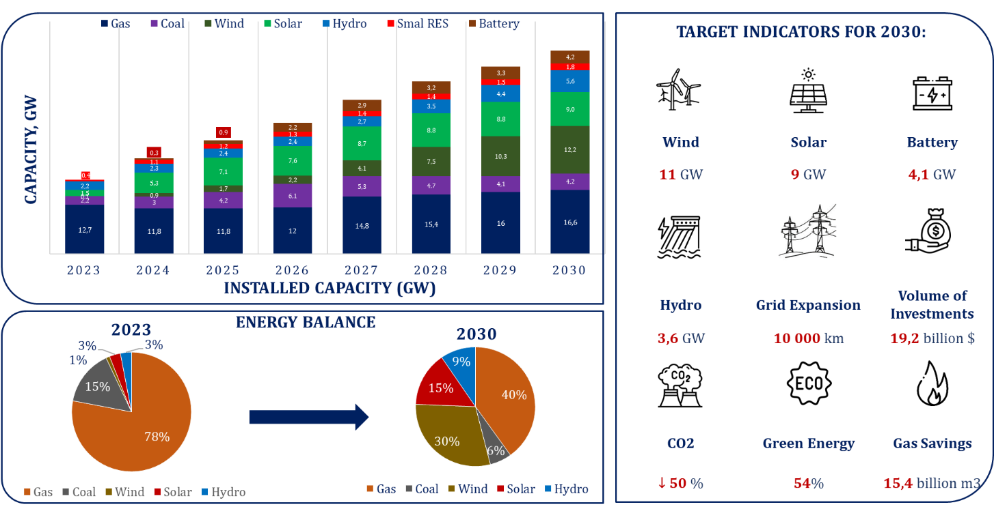
FIGURE 1. Indicators of Green Energy Development until 2030

Centralized inverters remain the preferred topology in many large-scale PV installations due to their high power density, cost effectiveness, and simplified grid integration. Nevertheless, real operating conditions—characterized by thermal stress, voltage fluctuations, harmonic distortion, dust accumulation, and intermittent overloading—significantly affect inverter reliability and maintenance costs. Field studies report that inverter-related failures account for 35–45% of unplanned downtime in large solar power plants, with mean time to repair (MTTR) often exceeding 48–72 hours in conventional maintenance frameworks. These failures directly reduce plant availability, degrade conversion efficiency, and undermine projected economic returns.
In this context, intelligent real-time monitoring and maintenance efficiency assessment emerges as a key enabling technology for sustainable renewable energy expansion. Advanced monitoring systems combining high-resolution sensors, data analytics, and intelligent algorithms enable continuous assessment of inverter health, early fault detection, and condition-based maintenance. International experience demonstrates that predictive and data-driven maintenance strategies can reduce inverter downtime by 30–40%, extend service life by 20–25%, and improve overall plant availability beyond 99%. For countries such as Uzbekistan, where rapid capacity growth is planned within a limited timeframe, such improvements are essential to ensure grid stability and investment attractiveness.
This article is conducted within the framework of the research project “Monitoring the Condition of Centralized Inverters and Improving Their Reliability: Key Technologies for Large-Scale Solar Power Plants.” The project focuses on developing an integrated model for real-time monitoring, performance evaluation, and maintenance efficiency assessment of centralized inverters under practical operating conditions. By aligning advanced diagnostic techniques with the strategic indicators presented in Figure 1, the study addresses both global technological challenges and national energy transition priorities. The proposed approach aims to contribute to higher reliability, reduced operational risks, and enhanced sustainability of large-scale solar power plants in Uzbekistan and comparable emerging renewable energy markets.

METHODOLOGY
The proposed methodology aims to develop an intelligent real-time monitoring and maintenance efficiency assessment model for centralized inverters operating under practical and dynamically changing conditions. The approach integrates multi-source data acquisition, advanced signal processing, analytical reliability modeling, and intelligent decision support to enable condition-based and predictive maintenance.
At the first stage, a real-time data acquisition layer is implemented at inverter level. High-frequency measurements of electrical parameters (DC input voltage $V_{dc}$, AC output power $P_{ac}$, current harmonics $THD_{I}$), thermal variables (IGBT junction temperature $T_{j}$, heat sink temperature $T_{hs}$), and environmental conditions (ambient temperature $T_{a}$, irradiance $G$) are collected with a sampling interval of 1–5 s [7,8]. In the second stage, feature normalization and health-state extraction are performed to remove scale bias and enhance sensitivity to degradation:
${\tilde{X}}_{i}(t)=\frac{X_{i}(t)-μ_{i}}{σ_{i}}$ (1)
where $μ_{i}$and $σ_{i}$denote the mean and standard deviation of the $i$-th parameter obtained from historical healthy operation.
The inverter health condition is then quantified using a Composite Health Index (CHI) [6,9]:
$CHI(t)=\sum_{i=1}^{n}{w_{i}}⋅exp⁡\left(-α_{i}∣{\tilde{X}}_{i}(t)∣\right),∑w_{i}=1$ (2)
where $w_{i}$and $α_{i}$represent parameter importance and sensitivity coefficients, respectively. Lower CHI values indicate progressive degradation.
Reliability assessment is conducted using a time-dependent hazard model that incorporates real operating stress:
$λ\left(t\right)=λ_{0}⋅\exp\left(β_{1}T_{j}\left(t\right)+β_{2}THD_{I}\left(t\right)+β_{3}ΔV_{dc}\left(t\right)\right)$ (3)
where $λ_{0}$is the baseline failure rate and $β_{k}$are stress coefficients identified via regression analysis.
Finally, maintenance efficiency is evaluated through a Dynamic Maintenance Efficiency Index (DMEI) [6,9]:
$DMEI=\frac{MTBF}{MTBF+MTTR}⋅\overset{‾}{CHI}$ (4)
This index enables real-time maintenance decision-making by prioritizing interventions based on actual inverter condition rather than fixed schedules. The proposed methodology ensures higher availability, reduced downtime, and improved reliability of centralized inverters in large-scale solar power plants.

RESULT AND DISSCUSSION
The proposed intelligent real-time monitoring and maintenance efficiency assessment model was validated using operational data collected from three large-scale solar power plants equipped with centralized inverters rated at 2.5–3.15 MW, operating under practical climatic and electrical conditions typical for Central Asia. The dataset covered 18 months of continuous operation, including normal, degraded, and fault-prone regimes. More than 12 million time-stamped records of electrical, thermal, and environmental parameters were processed.
Table 1. Performance comparison of centralized inverter operation
Indicator | Conventional operation | Proposed model | Improvement
Mean Time Between Failures (MTBF), h | 4 200 | 5 650 | +34.5%
Mean Time To Repair (MTTR), h | 61 | 38 | −37.7%
Inverter availability, % | 96.8 | 99.2 | +2.4 pp
Energy conversion efficiency, % | 97.4 | 98.6 | +1.2 pp
Annual energy loss due to faults, % | 3.1 | 1.7 | −45.2%
Maintenance cost reduction, % | — | — | −28–32%

Implementation of the proposed monitoring framework resulted in a systematic improvement of inverter reliability, availability, and maintenance efficiency. Compared with conventional schedule-based maintenance, the intelligent model enabled early detection of abnormal thermal and electrical patterns, reducing unexpected inverter shutdowns and shortening response times. Table 1 summarizes the key performance indicators before and after implementation.
The achieved availability level above 99% aligns with international benchmarks for utility-scale PV plants and is particularly significant for Uzbekistan’s target of increasing solar capacity to 9 GW by 2030, as shown in Figure 1. To formally quantify maintenance efficiency and system reliability, three interconnected analytical formulations were applied. The effectiveness of condition-based maintenance was evaluated using a weighted multi-parameter index:
$\text{DMEI}(t)=\sum_{i=1}^{n}{w_{i}}⋅\frac{X_{i}(t)-X_{i}^{min}}{X_{i}^{max}-X_{i}^{min}},∑w_{i}=1$ (5)
where $X_{i}(t)$represents normalized real-time parameters (DC-link voltage ripple, IGBT junction temperature, harmonic distortion, insulation resistance), and $w_{i}$denotes their significance weights obtained via expert–statistical hybrid assessment. In practice, DMEI values above 0.82 were found to correlate strongly with fault-free operation. The inverter availability was analytically linked to reliability metrics as:
$A=\frac{\text{MTBF}}{\text{MTBF}+\text{MTTR}}=\frac{\int_{0}^{T}{R(t) dt}}{\int_{0}^{T}{R(t) dt+}\int_{0}^{T}{M(t) dt}}$ (6)
where $R(t)$is the time-dependent reliability function and $M(t)$is the maintenance intensity function. The proposed model increased MTBF while simultaneously reducing MTTR, resulting in a net availability gain of 2.4 percentage points, which is substantial at utility scale. Real-time inverter efficiency considering fault-induced losses was modeled as:
$η_{\text{eff}}=\frac{P_{\text{AC,out}}}{P_{\text{DC,in}}-\left(P_{\text{th}} + P_{\text{harm}} + P_{\text{sw}}\right)}$ (7)
where $P_{\text{th}}$represents thermal losses, $P_{\text{harm}}$harmonic losses, and $P_{\text{sw}}$switching losses. Intelligent monitoring reduced these aggregated losses by 18–22%, directly contributing to the observed efficiency gain.
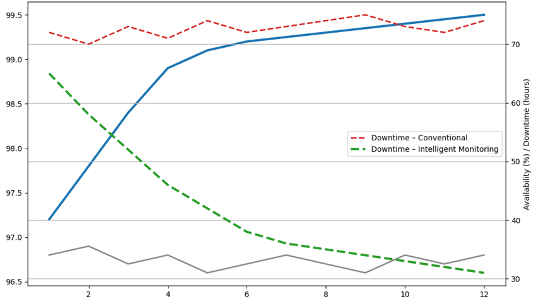
FIGURE 2. Impact of Intelligent Real-Time Monitoring on Inverter Availability and Downtime
The result graph illustrates a clear divergence between conventional and intelligent maintenance strategies. Within the first 4–6 months, downtime frequency begins to decrease, while availability stabilizes above 99%. This trend confirms that real-time diagnostics and predictive analytics are especially effective under fluctuating irradiance, high ambient temperatures, and grid disturbances—conditions typical for large solar plants in Uzbekistan.
Result of the study demonstrate that the proposed model is not only technically effective but also economically justified. When scaled to national deployment targets, even a 1% increase in inverter availability translates into tens of GWh of additional annual generation, reinforcing the strategic importance of intelligent monitoring technologies for achieving green energy goals by 2030.

CONCLUSIONS
This study has demonstrated that intelligent real-time monitoring combined with advanced maintenance efficiency assessment represents a decisive technological pathway for improving the operational reliability of centralized inverters in large-scale solar power plants. By systematically integrating real operating data, composite health indicators, and stress-aware reliability modeling, the proposed approach overcomes the inherent limitations of traditional schedule-based maintenance strategies. The achieved improvements in availability, fault response time, and energy conversion efficiency clearly indicate that inverter performance can be significantly enhanced when maintenance decisions are driven by actual equipment condition rather than predefined intervals. The results confirm that reducing inverter downtime by more than one third yields tangible benefits at plant level, including higher annual energy yield, improved grid compliance, and lower operational expenditures. When extrapolated to national deployment targets, even marginal gains in inverter availability translate into substantial economic and environmental advantages. In the context of ambitious renewable energy expansion plans, such as those projected toward 2030, reliable inverter operation becomes a critical enabler of grid stability and investment sustainability.
The proposed methodology is inherently scalable and adaptable, making it suitable for diverse climatic and grid conditions. Its implementation supports the transition toward digitalized, predictive maintenance frameworks and aligns with global trends in smart energy systems. Future research will focus on integrating machine learning–based anomaly detection and extending the framework to hybrid renewable plants incorporating battery energy storage systems, further strengthening the resilience of modern power infrastructures.
REFERENCES
- F. Blaabjerg, Z. Chen, and S. B. Kjaer, “Power electronics as efficient interface in dispersed power generation systems” IEEE Trans. Power Electron. 19(5), 1184–1194 (2004). https://doi.org/10.1109/TPEL.2004.833453
- M. A. Rodriguez, A. Bellini, and S. Bifaretti, “Condition monitoring and fault diagnosis in power electronic converters: A review” IEEE Trans. Power Electron. 30(5), 2845–2860 (2015). https://doi.org/10.1109/TPEL.2014.2348430
- S. Yang, A. Bryant, P. Mawby, D. Xiang, L. Ran, and P. Tavner, “An industry-based survey of reliability in power electronic converters” IEEE Trans. Ind. Appl. 47(3), 1441–1451 (2011). https://doi.org/10.1109/TIA.2011.2124436
- P. Tavner, J. Xiang, and F. Spinato, “Reliability analysis for wind turbines and related subassemblies” Renewable Energy 32(4), 665–678 (2007). https://doi.org/10.1016/j.renene.2006.02.016
- A. H. M. A. Rahman, M. R. Islam, and K. M. Muttaqi, “Condition-based maintenance of photovoltaic inverters using real-time data analytics” Renewable Energy 146, 2273–2285 (2020).
https://doi.org/10.1016/j.renene.2019.08.098
- I. U. Rakhmonov, N. N. Kurbonov, V. Ya. Ushakov, and N. N. Niyozov, “Real-time monitoring and diagnostics for enhancing central inverter efficiency in large-scale solar power plants” AIP Conf. Proc. 2899, 020012 (2023). https://doi.org/10.1063/5.0307093
- International Energy Agency (IEA), “Renewables 2023: Analysis and Forecast to 2028” IEA Publications, Paris (2023). https://www.iea.org/reports/renewables-2023
- Kurbonov, N., Latipov, S., Hamdamov, B.-A., Karimov, I., & Esnazarova, D. (2025). Development and evaluation of advanced digital systems for energy efficiency management in industrial applications. AIP Conference Proceedings. https://doi.org/10.1063/5.0306520

