Modern proposals and a mathematical model for increasing the efficiency of the cooling system of the compressor unit of quarry drilling machines
Zokhidov Odil^{1,a)}, Atakulov Lazizjon¹, Ismatov Adkhamjon¹,
Umirzakov Utamurod^{1,2}
¹ Navai State Mining and Technology University, Navai, Uzbekistan
² Termiz State University of Engineering and Agrotechnologies, Termiz, Uzbekistan
^{a)} Corresponding author: odil_boss85@mail.ru
Abstract. The article scientifically substantiates the existing problems in the cooling systems of compressor units of mining machines used in the mining industry, theoretical and experimental methods for their solution. The effectiveness of the proposed method was analyzed using the existing traditional system of air cooling of the compressor unit and the proposed cooling method using the liquid spraying method by the author using comparative methods using theoretical and mathematical models.
INTRODUCTION
Today, the main machines and mechanisms used in mining enterprises are mining machines operating on hydraulic fuel and electricity. One of the main high-power and important functional mechanisms of compression machines is the compressor unit. Compressor units are devices that compress air at a certain pressure and deliver it to the desired object, currently used in mining, chemical, oil and gas processing facilities, and industrial enterprises. In excavators used in the mining industry for extracting and loading minerals into vehicles, the compressor unit is used to cool the hydraulic systems of the machine. In mineral deposits with high rock hardness, drilling rigs are used for drilling and blasting rock fragmentation. In drilling rigs, in addition to cooling the hydraulic system, the compressor unit is used in the drilling process to remove fine particles of the rock being crushed by the drill bit from the drilling well under high pressure, clean the well, and cool the drill bit.
Currently, Rotary Drilling Rig with Roller Bits and Percussion-Rotary Drilling types of drilling rigs are widely used in mineral deposits located in the territory of the Republic of Uzbekistan due to their resistance to object hardness, high productivity, and significantly higher energy efficiency compared to other drilling rigs.
The main function of compressor units is to continuously supply the object to which the unit is applied with compressed air at the required pressure. Continuous operation of the compressor unit is considered effective for the enterprise. Most mining machines used in the mining industry operate in continuous mode, therefore, if the operating modes of the compressors in these machines or the equipment itself stop for a short time, there is a risk of significant damage to the productivity of the entire mining, loading, and transportation system of the enterprise. Ensuring the uninterrupted operation of compressor units at mining, production, and industrial enterprises, reducing the repair time in the event of an accidental shutdown of the unit and extending the operating period until the next repair, as well as modernizing the outdated systems of existing compressor stations and diagnosing the condition of the unit, in addition, improving the cooling systems of the unit are among the most pressing problems existing today at mining and industrial enterprises [1-12].

EXPERIMENTAL RESEARCH
The operating conditions of mining machines used in mining industry enterprises, mainly in open-pit mining enterprises - quarries, are very difficult, that is, in winter the external temperature is very cold, and in summer the temperature is very hot. In the hydraulic systems of mining machines, special hydraulic fluids - hydraulic oils - are used to set the machine mechanisms in motion under high pressure using various operating modes. The temperature of oil in the hydraulic parts of mining machines increases due to high pressure and loads. In summer, a sharp increase in the temperature of the external environment leads to a further increase in the temperature of the oil moving in the special hoses of the hydraulic system [1-12].
Today, the hydraulic systems of mining machines, as well as special electrical and mechanical parts, are cooled by airflow using special air fans. These traditional cooling systems have been used for many years, and in recent years, due to a sharp increase in the temperature of the external environment at mining enterprises, the cooling capacity of hydraulic systems with conventional fans is decreasing [3, 4].
Analysis of scientific and practical research and literature conducted in the mining industry today shows that the issues of increasing the efficiency of air-ventilated cooling systems of machines used in quarry conditions, in particular, compressor units of drilling rigs, are one of the most pressing problems today [5, 6-34].
Figure 1 below shows the most commonly used, inexpensive, and efficient cooling system in the cooling systems of compressor units of mining machines, i.e., the cooling system of compressors of mining machines using air fans:

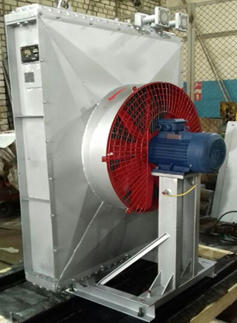 | 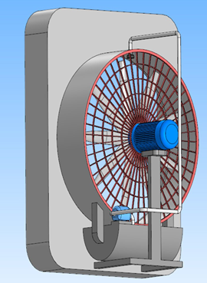 | 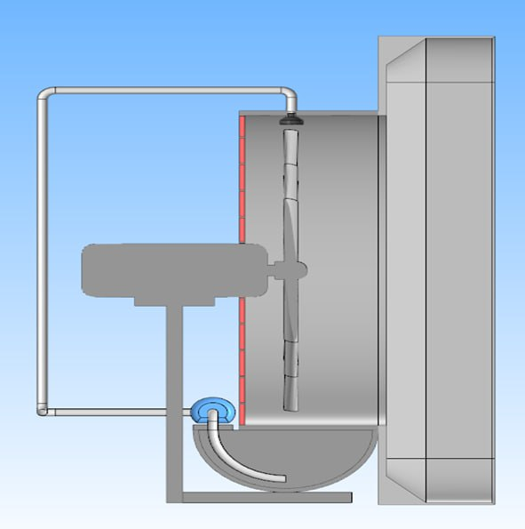
- drilling machine compressor and existing fan cooling system | b) proposed fan rear cooling system for the drilling machine compressor | c) side view of the proposed fan for cooling the drilling machine compressor
Figure 1. View of the fan used and proposed in the cooling system of the compressor unit

Cooling with a conventional airflow through a fan leads to insufficient cooling efficiency in high-temperature mining conditions. The limitations of this system are explained physically by the low heat capacity of the air and a decrease in the aerodynamic conductivity of the radiator in a dusty environment.
Therefore, a proposal and a project for the use of fine-particle spraying of water on the radiator surface have been developed.
With the implementation of the proposed modern cooling system, it is possible to reduce the air temperature of the compressor units of mining machines by a minimum of 8-15°C, increase the heat transfer coefficient by an average of 2-3 times, and reliably protect the engines and hydraulic systems of mining machines from overheating [7, 8].
The proposed technology is an effective solution that significantly increases the reliability of mining machines used in open-pit mining conditions. The proposed design, shown in Fig. 1, creates a combined cooling system for the radiator of mining machines, using forced airflow and spraying water particles from above. The main task of this system is the rapid and efficient removal of heat from the radiator surface in high-temperature conditions, preventing engine overheating. The main air flow source of the fan is a fan with a diameter located in the front part of Figure 1, which creates an airflow directed towards the radiator. This flow passes to the radiator surface and carries the heat from there with the flow of water sprayed into the external environment [9, 10-34].
Water is supplied through a bottom-up pipe. The water pressure is supplied by a pump and directed parallel to the airflow to the injection zone. The nozzle is installed above the fan and sprays water into microdrops. This prevents water from flowing in large droplets and ensures its complete decomposition in the airflow supplied by the fan. The sprayed water, located in the front part of the fan, collides with the radiator of the compressor unit with a stream of hot air and cools through a physical process with the stream of water and air. There is a need for theoretical analysis of this physical process between the fan and radiator [1-11, 12-34].
RESEARCH RESULTS
Below, the proposed solutions for improving the cooling systems of the compressor unit of mining machines are proven using special laws and mathematical expressions. Considering that the productivity of the proposed water sprayer is the same parameter, we accept the condition (1≤n) for water spraying.
If Q=const.
$Q=\frac{V}{t}=\frac{S⋅h}{t}=S⋅v$ (1)
here; S-surface of the nozzle opening (${mm}^{2}$), $v$ - velocity of the liquid exiting the slit (m/s), $t$- time (seconds), $Q$-liquid capacity (m³/s), $V$- liquid volume (m³).
Figure 2 below shows the physical parameters between the fan and radiator.
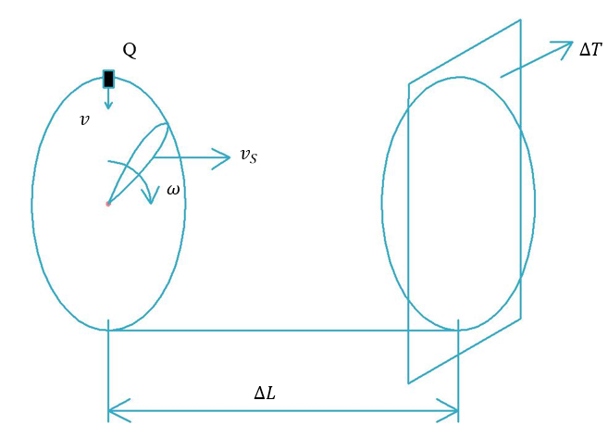
Figure 2. The state of arrangement of physical parameters in the proposed scheme

The velocity and direction of the water exiting the opening depend on the angle of the opening. Let's assume the flow rate of the liquid and the direction of the blade's rotation as follows.

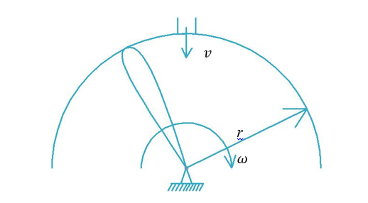
Figure 3. Direction of the liquid velocity exiting the intake installed on the fan

The speed of the blade is geometrically related to the point of impact of water. This is expressed by the following formula. rotational speed of the blade.
$v_{p}=ω(r-x)$ (2)
Here; $v_{p}$- rotational speed of the blade (m/s), $ω$-parrakning burchak tezligi (rad/s). r-blade radius (m), x- distance from the blade center to the point of impact of the liquid (m) [20-34].
Let's determine the absolute velocity of the liquid after hitting the blade. We will represent it in Figure 4, inserting the coordinate axis as follows.
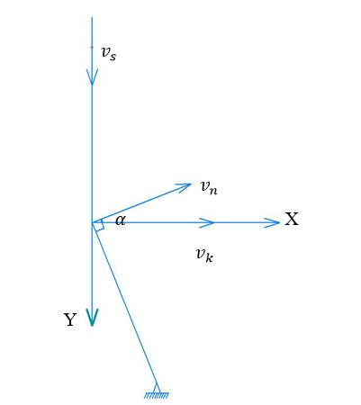
Figure 4. Direction of fluid velocities

We determine the absolute velocity of the liquid after hitting the blade. By projecting onto the abscissa and ordinate axes, we construct the following system [13].
$\left\{\begin{aligned}v_{x}=v_{k}+v_{n}⋅\cos{φ} \\ v_{y}=-v_{s}+v_{n}\sin{φ}\end{aligned}\right.$ (3)
From the above system 3, we solve the following expression.
$$v_{abs}=\sqrt{v_{x}^{2}+v_{y}^{2} }=\sqrt{{\left(v_{k}+v_{n}\cos{φ}\right)}^{2}+{\left(-v_{s}+v_{n}\sin{φ}\right)}^{2}}=$$
$$=\sqrt{v_{k}^{2}+2v_{n}⋅v_{k}\cos{φ}+v_{n}^{2}\cos^{2}{φ}+v_{s}^{2}+v_{n}^{2}\sin^{2}{φ}-2v_{s}⋅v_{n}\sin{φ}}=$$
$$=\sqrt{v_{k}^{2}+v_{s}^{2}+v_{n}^{2}-2v_{n}(v_{k}\cos{φ}-v_{s}\sin{φ)}}$$
$v_{abs}=\sqrt{v_{k}^{2}+v_{s}^{2}+v_{n}^{2}-2v_{n}(v_{k}\cos{φ}-v_{s}\sin{φ})}$ (4)

Here; $v_{k}$- propulsion velocity of the blade (m/s), $v_{s}$-liquid velocity (m/s), $v_{n}$-elative velocity of the blade (m/s).
At the moment when the energy of the liquid is absorbed by the blade, it has internal and external energy. Due to the fact that fluid motion occurs in space, differential equations based on Euler's D'Alembert principle exist [14-34].

$\left\{\begin{aligned}\frac{dv_{x}}{dt}=X-\frac{dρ}{ρ⋅dx} \\ \frac{dv_{y}}{dt}=Y-\frac{dρ}{ρ⋅dy} \\ \frac{dv_{z}}{dt}=Z-\frac{dρ}{ρ⋅dz}\end{aligned}\right.$ (5)
Considering the randomness of fluid movement and the variability of its density, the initial velocity of its movement in all states depends on the angle of rotation in the fan.

$β=arctg(\frac{v_{n}}{v_{abs}})$ (6)

The number of blades is determined by the following diameter.
$Z=\frac{πD}{S}; Z=\frac{π⋅r}{2⋅S}$ (7)
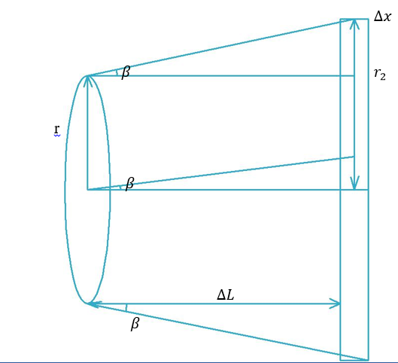
Figure 5. Location and distance of physical parameters between the fan and radiator

Considering that the liquid changes the temperature of the radiator, we introduce two main parameters between the fan and radiator as functions in the following steps 8 and 9.
$ΔL=f_{1}\left(Z,β,Q,m,n,ΔT\right)$ (8)
$ΔT=f_{2}\left(Q,T_{1},T_{2},C\right)$ (9)
From the parameters in Figure 5, we express the relationship between the distance between the fan and radiator as follows.
If; $L⋅\cos{β}=∆L$ $=> r_{2}-r_{1}=∆x$ $=>ΔL^{2}+∆x^{2}=L^{2}$ $=>{\left(L⋅\cos{β}\right)}^{2}+{\left(r_{2}-r_{1}\right)}^{2}=L^{2}$ $=>$
$=>L=\sqrt{{\left(L⋅\cos{β}\right)}^{2}+{\left(r_{2}-r_{1}\right)}^{2}}$ (10)
The energy of the liquid exiting the fan represents the kinetic energy and heat capacity. In the radiator, there is heat capacity and fluid loss at the intermediate distance.
We write the kinetic energy of the liquid as follows.
$E_{k}=\frac{mv_{abs}^{2}}{2}$ (11)
We construct the initial and subsequent amounts of heat in expressions 12 and 13.
$Q_{1}=cm∆t_{1}$ (12)
$Q_{2}=cm∆t_{2}$ (13)
Expressing the work done in the system as follows, we derive the change in distance.
$\sum{A=E_{k}-Q_{1} }=>$ $A=-∆Q$ $=>$ $A=mg⋅∆L$ $=>mg∆L=\frac{mv^{2}}{2}-cm∆t_{1}$ $=> L=\frac{v^{2}}{2g}-C\frac{T_{2}-T_{1}}{g}$ $=>$
$=>L=\frac{v_{abc}^{2}}{2g}-C\frac{∆T}{g}=\sqrt{{\left(L⋅\cos{β}\right)}^{2}+{\left(r_{2}-r_{1}\right)}^{2}}$ $=>$ $\frac{v_{k}^{2}+v_{s}^{2}+v_{n}^{2}-2v_{n}\left(v_{k}\cos{φ}-v_{s}\sin{φ}\right)}{2g}-C\frac{∆T}{g}=$
$=\sqrt{{\left(L⋅arct\left(\frac{v_{n}}{v_{abc}}\right)\right)}^{2}+{\left(r_{2}-\frac{2z⋅S}{π}\right)}^{2} }=>$ $L=\frac{\sqrt{{\left(\frac{v_{abs}^{2}}{2}-C∆T\right)}^{2}⋅g^{2}-{\left(\frac{r_{2}-2⋅Z⋅S}{π}\right)}^{2}}}{\cos{β}}$ (14)
Mathematical model that determines the temperature supplied from the fan to the radiator depending on the distance.
$∆T=T_{2}-T_{1}=\frac{v_{abs}^{2}}{2⋅C}-\frac{g}{C}\sqrt{L^{2}⋅arctg{\left(\frac{v_{n}}{v_{abs}}\right)}^{2}+{\left(\frac{r_{2}-2⋅Z⋅S}{π}\right)}^{2}}$ (15)
here; $C$ – heat capacity of the radiator $(\frac{J}{kg⋅C})$, $∆T$-temperature change $(℃)$ $g$ – acceleration due to gravity (m/s²), $∆L$ – distance (m), $v_{n}$ – relative velocity of the blade (m/s), $r_{2}$ - radius of the radiator contact surface (m), $β$ – angle of inclination of the blade ($℃$), Z – number of blades (pcs), $S$ – blade surface area (m²). n-sprayer number (pcs).

Figure 6. Liquid and dry air cooling

From the difference in the obtained graphs of air and liquid cooling systems of compressor units of mining machines, it was proven that cooling through a conventional air fan is insufficiently effective for a machine compressor. By installing an additional water injection nozzle on the fan, the cooling intensity is significantly increased. Therefore, the use of a combined air + liquid cooling system in compressor and industrial installations with high heat generation is technically and energetically feasible.
Regular air cooling (blue, dashed line) where the temperature gradually increases over time. By 60-70 minutes, the temperature remains relatively low (around 25-30°C).
This situation shows that creating airflow only with the help of a fan is not capable of removing heat sufficiently. Due to low air density and low heat capacity, heat exchange occurs slowly.
Liquid (water) cooling - with a nozzle (orange line) An additional nozzle is installed on the fan, and water is sprayed in small droplets. The graph shows a rather rapid and high temperature increase (≈60-70 °C in 40-50 minutes). This may seem paradoxical, but it actually means that the intensity of heat extraction from the compressor has increased [15-34].
When water is sprayed, a process of evaporation occurs and a large amount of heat is absorbed, as a result of which heat exchange is sharply activated. Air has low thermal conductivity, therefore cooling with a conventional fan has limited efficiency. The heat capacity of water is several times greater than that of air, therefore spraying through a nozzle intensifies the cooling process. Conversely, during drip spraying, convective and spatial heat exchange occurs simultaneously due to surface moisture and evaporation. From the mathematical model of the temperature change depending on the distance of cooling depending on the number of springs in expression 9, we construct a graph in Fig. 7.

Figure 7. Difference in temperature and distance when the number of sprayers is different
Analysis of the graph above shows that the temperature difference in one nozzle remains at relatively low values compared to others. The cooling zone is narrow and uneven, and water droplets are not evenly distributed across the surface. Significant cooling is observed only in the central part of the compressor surface, while efficiency sharply decreases in peripheral areas. If there was a double nozzle, the temperature difference increased significantly. The cooling area expands, and the water droplets begin to spread more evenly relative to the surface. The intensity of heat removal is significantly improved compared to 1 injector, but the maximum value is still limited. In the case of a triple nozzle, the highest temperature difference on the graph is observed in the case of a triple nozzle. The cooling zone is wide and stable, and high efficiency is maintained almost throughout the entire distance. Due to the fine and uniform spraying of water droplets: the evaporation process intensifies and the heat exchange surface increases, and of course, heat is intensively removed from the compressor surface. In general, when increasing and decreasing the number of constraints, from the point of view of a mathematical model, when finding the most optimal value of the intermediate distance with a change in temperature, in addition to these three parameters, we include all constant physical and geometric quantities in the condition and construct the graph shown in Figure 8 below in the Mathcad program.

Figure 8. Temperature vs. distance graph

On the graph, on the horizontal axis, the distance is given in centimeters, and on the vertical axis, the temperature difference is given in degrees Celsius.
At a distance of 0-6 cm, the temperature difference is about 3-4°C, and the cooling effect is very low. This is due to the fact that in this area, the droplets of liquid sprayed through the nozzle are not yet sufficiently crushed, and the evaporation process does not fully begin. As a result, heat exchange with the air flow is weak, and the cooling effect of the compressor is insignificant.
At a distance of 6-18 cm, the temperature difference increases sharply, reaching approximately 35°C. In this zone, the droplets become fine and intensively evaporate. During evaporation, a large amount of latent heat is absorbed, the droplets mix well with the fan airflow, and the cooling process enters an active phase. This region is considered a zone where the cooling effect grows rapidly.
At a distance of 18-30 cm, the temperature difference reaches its maximum value, i.e., approximately 41-42°C. At this distance, the evaporation of liquid droplets is almost complete, heat exchange is at its highest level, and the cooling of the compressor reaches its most effective state. Therefore, this intermediate compressor is the optimal operating zone for the cooling system.
At a distance of 30-38 cm, the temperature difference gradually decreases and drops to approximately 32°C. This is due to the fact that the droplets have already evaporated and the cooled air stream, mixing with the external environment, begins to lose its low temperature. As a result, the cooling efficiency decreases slowly.
At distances of 38-46 cm and further, the temperature difference sharply decreases, remaining around 2-3°C. In this zone, the cooling effect is practically absent, since the cooled air stream disperses and does not reach the compressor zone. Therefore, at this distance, nozzle cooling is practically inefficient.
In general, the graph confirms the classical principles of evaporative cooling processes: the cooling effect increases up to a certain optimal distance and then decreases. From a practical standpoint, it is most appropriate to select a distance of approximately 25-30 cm between the nozzle and the fan. Positioning the nozzle too close or too far leads to liquid and energy waste and reduces the cooling efficiency of the compressor.
CONCLUSIONS
The results of this study show that in high-temperature mining conditions, the cooling of compressors and other heat-generating units by airflow alone does not provide sufficient efficiency. Low air heat capacity, partial blockage of radiator channels in a dusty environment, and increased aerodynamic resistance significantly limit the heat exchange process. The application of finely dispersed water spraying technology in addition to the fan takes the cooling process to a qualitatively new level. As a result of the evaporation of water droplets, intensive absorption of latent heat occurs, the rate of heat removal from the radiator surface increases sharply, and the overall heat transfer coefficient increases several times.
The proposed mathematical model and graphical analysis prove that the cooling efficiency strongly depends on the distance between the fan and radiator, the number of nozzles, and the spraying parameters. In particular, the optimal zone is 25-30 cm, and it is at this distance that the temperature difference reaches its maximum value. An increase in the number of nozzles ensures uniform distribution of water droplets on the surface, expands the cooling area, and increases the intensity of heat removal. In general, the combined air-liquid cooling system is assessed as a scientifically and practically based effective solution for increasing the reliability, long-term operational stability, and energy efficiency of mining equipment.
In conclusion, it can be said that by applying dynamic pressure to the liquid by injecting air into the fan, the radiator can be cooled to a certain limit. In this case, it is necessary to geometrically justify the blades of the fan, taking into account the amount, speed, temperature of the liquid coming out of the nozzle, and the number of nozzles, and express the dependence of the radiator temperature and distance from the fan using a formula. Due to the uncertainty of such parameters, we can construct a mathematical model to determine the necessary values.
REFERENCES
- Zokhidov O.U., Khoshimov O.O., Khalilov Sh.Sh. Experimental analysis of microges installation for existing water flows in industrial plants. III International Conference on Improving Energy Efficiency, Environmental Safety and Sustainable Development in Agriculture (EESTE2023), E3S Web of Conferences. Volume 463. 02023 pp. 2023. https://doi.org/10.1051/e3sconf/202346302023.
- Zokhidov O.U., Khoshimov O.O., Sunnatov S.Z. Selection of the type and design of special water turbines based on the nominal parameters of Navoi mine metallurgical combine engineering structures. AIP Conf. Proc. 3331, 050022 (2025). https://doi.org/10.1063/5.0306554.
- Xiuliang Liu, Jianye Yang, Qifan Zou, Yongyan Hu, Pengkun Li, Li Tan, Nenad Miljkovic, and Ronggui Yang ACS Nano 2025 19 (10), 9513-9589 DOI: 10.1021/acsnano.4c15277R. Schürhuber, B. R. Oswald, L. Fickert, J. Fortmann. Verhalten von Windkraftanlagen mit doppelt speisenden Asynchron generatoren (DFIG) bei Kurzschlüssen und anderen Netzfehlern. Elektrotechnik & Informationstechnik (2020) 137/8: 415–424. https://doi.org/10.1007/s00502-020-00829-2.
- Wang, Cuihua, et al. "Effects of temperature-dependent viscosity on fluid flow and heat transfer in a helical rectangular duct with a finite pitch." Brazilian Journal of Chemical Engineering 31 (2014): 787-797. https://doi.org/10.1590/0104-6632.20140313s00002676.
- Ismatov Adkhamjon Alibek ugli, Rakhmatov Ramazonjon Ravshan ugli. Development of a mathematical model of fluid leakage from internal faults in hydraulic systems based on friction forces. Diversity Research: Journal of Analysis and Trends. Vol. 2, pp. 46-49, https://academiaone.org/index.php/2/article/view/854.
- Nabijon Abduazizov, Kamol Khakimov, Sardor Turdiyev, Akbar Zhuraev, Adham Ismatov. The impact of the amount of pollution of the fluid in the hydraulic system on the working resource of the quarry excavator. E3S Web of Conferences, 2025. https://doi.org/10.1051/e3sconf/202562705001.
- Rabatuly M., Myrzathan S.A., Toshov J.B., Nasimov J., Khamzaev A. Views on drilling effectiveness and sampling estimation for solid ore minerals. Integrated Use of Mineral Raw Materials. №1(336), 2026. https://doi.org/10.31643/2026/6445.01
- Toshov J.B., Rabatuly M., Khaydarov Sh., Kenetayeva A.A., Khamzayev A., Usmonov M., Zheldikbayeva A.T. Methods for Analysis and Improvement of Dynamic Loads on the Steel Wire Rope Holding the Boom of Steel Wire Rope Excavators. Integrated Use of Mineral Raw Materials Complex Use of Mineral Resources 2026; 339(4):87-96 https://doi.org/10.31643/2026/6445.43
- Khamzaev A.A., Mambetsheripova A., Arislanbek N. Thyristor-based control for high-power and high-voltage synchronous electric drives in ball mill operations/ E3S Web Conf. Volume 498, 2024/ III International Conference on Actual Problems of the Energy Complex: Mining, Production, Transmission, Processing and Environmental Protection (ICAPE2024) DOI: https://doi.org/10.1051/e3sconf/202449801011
- Toshov B.R., Khamzaev A.A. Development of Technical Solutions for the Improvement of the Smooth Starting Method of High Voltage and Powerful Asynchronous Motors/AIP Conference Proceedings 2552, 040018 (2023); https://doi.org/10.1063/5.0116131 Volume 2552, Issue 1; 5 January 2023
- Toshov B.R., Khamzaev A.A., Sadovnikov M.E., Rakhmatov B., Abdurakhmanov U./ Automation measures for mine fan installations/ SPIE 12986, Third International Scientific and Practical Symposium on Materials Science and Technology (MST-III 2023), 129860R (19 January 2024); doi: 10.1117/12.3017728. Third International Scientific and Practical Symposium on Materials Science and Technology (MST-III 2023), 2023, Dushanbe, Tajikistan.
- Toshov B.R., Khamzaev A.A., Namozova Sh.R.Development of a circuit for automatic control of an electric ball mill drive. AIP Conference Proceedings 2552, 040017 (2023) Volume 2552, Issue 1; 5 January 2023.
- Toirov, O.,Pirmatov, N.,Khalbutaeva, A.,Jumaeva, D.,Khamzaev, A. Method of calculation of the magnetic induction of the stator winding of a spiritual synchronous motor. E3S Web of Conferences., 2023, 401, 04033
- A. S. Zhuraev, S. A. Turdiyev, S. T. Jurayev, and S.S. Q. Salimova, “Characteristics of packing gland seals in hydraulic systems of quarry excavators and results of comparative analysis of experimental tests” Vol. 54, pp. 252–257, Apr. 2024, https://doi.org/10.21595/vp.2024.24051
- Akbar Zhuraev, Sardorjon Turdiyev; Analyses and studies of working fluid flow in the hydraulic system of hydraulic excavators at the Auminzo-Amantaytau open pit mine. AIP Conf. Proc. 4 November 2025; 3331 (1): 030067. https://doi.org/10.1063/5.0305703
- Mislibaev I.T., Makhmudov A.M., Makhmudov Sh.A. Theoretical generalisation of functioning modes and modelling of operational indicators of excavators. // Mining information-analytical bulletin. - 2021. №1. p. 102-110. DOI: 10.25018/0236-1493-2021-1-0-102-110
- Makhmudov Sh, Makhmudov A, Khudojberdiev L, Izzat Rakhmonov, “Criteria for assessing the performance of mining and transport equipment of mining enterprises,” Proc. SPIE 12986, Third International Scientific and Practical Symposium on Materials Science and Technology (MST-III 2023), 129860P (19 January 2024); doi: 10.1117/12.3017722
- Ataqulov L.N., Haydarov Sh.B., Polvonov N.O. Impact forces on side and middle rollers. SPIE 12986, Third International Scientific and Practical Symposium on Materials Science and Technology (MST-III 2023), 129860Q (19 January 2024); doi: 10.1117/12.3017724
- Atakulov L.N., Kakharov S.K., Khaidarov S.B. Selection of optimal jointing method for rubber conveyor belts. Gornyl Zhurnal, 2018. (9), 97-100. DOI:10.17580/gzh.2018.09.16
- Mahmudov A, Musurmanov E, Chorikulov A, Tukhtaev Sh. Justification of the development of the ventilation network and increasing the efficiency of ventilation equipment by controlling themovement of air flow. Third International Scientific and Practical Symposium on Materials Science and Technology (MST-III 2023), Proc. of SPIE Vol. 12986, 1298610. doi: 10.1117/12.3017914
- Alisher Ruzibaev Buri Toshov, Rashid Muminov, Bobirjon Tukhtaev, Xalim Kadirov and Zuxra Namozova. Methods for increasing wear resistance of working bodies of single-bucket excavators. E3S Web of Conferences 627, 05005 (2025) GEOTECH-2025. https://doi.org/10.1051/e3sconf/202562705005
- Rashid Muminov, Bobirjon Tukhtaev, Bahodir Qayumov, Alisher Ruzibaev, Faxriddin Kushimov, and Fotima Namozova. Analysis and theory of the prospects for the development of anchor support technology in gold and coal mines in foreign countries. E3S Web of Conferences 627, 01005 (2025) GEOTECH-2025 https://doi.org/10.1051/e3sconf/202562701005
- Boboqulov J., Narzullayev B. Development of a model for diagnosing rotor conditions in the parallel connection of synchronous generators with the network // E3S Web of Conferences. – EDP Sciences, 2024. – Т. 525. – С. 06001. https://doi.org/10.1051/e3sconf/202452506001
- Khasan Murodov, Askarbek Karshibayev, and Shukhrat Abdullayev, Analysis of the process of balanced charging of the battery group with high capacity, E3S Web of Conferences 548, 03012 (2024) https://doi.org/10.1051/e3sconf/202454803012
- Numon Niyozov, Anvar Akhmedov, Shukhrat Djurayev, Botir Tukhtamishev, Asliddin Norqulov, Development of a method for forecasting the specific consumption indicator of electric energy, AIP Conf. Proc. 3331, 080008 (2025) https://doi.org/10.1063/5.0305729
- Akram Tovbaev, Muxtarxan Ibadullayev and Mohinur Davronova. Study of subharmonic oscillation processes in ferroresonance circuits. E3S Web of Conf. Volume 525, 2024. IV International Conference on Geotechnology, Mining and Rational Use of Natural Resources (GEOTECH-2024). https://doi.org/10.1051/e3sconf/202452503008
- Narzullayev B. S., Eshmirzaev M. A, Causes of the appearance of current waves in high voltage electric arc furnaces, and methods of their reduction, E3S Web of Conferences. – EDP Sciences, 2023. – Т. 417. – С. 03003. https://doi.org/10.1051/e3sconf/202341703003
- Akram Tovbaev., Islom Togaev., Uktam Usarov.,Gulom Nodirov, Reactive power compensation helps maintain a stable voltage profile across the network, AIP Conf. Proc. 3331, 060014 (2025). https://doi.org/10.1063/5.0307209
- Bobur Narzullayev; Javokhir Boboqulov, Improving reliability based on diagnostics of the technical condition of electric motor stator gutters, AIP Conf. Proc. 3331, 030032 (2025). https://doi.org/10.1063/5.0305735
- Abdurakhim Taslimov., Feruz Raximov., Farrukh Rakhimov., Iles Bakhadirov, Optimal parameters and selection criteria for neutral grounding resistors in 20 kv electrical networks, AIP Conf. Proc. 3331, 030048 (2025) https://doi.org/10.1063/5.0306108
- Raximov, F., Taslimov, A., Majidov, A., & Norqulov, A. (2024). Optimization of losses by switching to higher voltage in distribution networks. In E3S Web of Conferences (Vol. 525, p. 03009). EDP Sciences. https://doi.org/10.1051/e3sconf/202452503009
- N.Ataullayev, A.Norqulov, B.Muxammadov, A.Majidov, I.Tog’ayev. Principles of protection against single phase earth faults in networks with capacitive current compensation. E3S Web of Conferences, 548, 06008 (2024). https://doi.org/10.1051/e3sconf/202454806008
- Ataullaev N. O., Dziaruhina A. A., Murodov K. S. Static Characteristics of Magnetic Modulation DC Converters with Analog Filter //Наука и техника. – 2023. – Т. 22. – №. 5. – С. 428-432. https://doi.org/10.21122/2227-1031-2023-22-5-428-432
- Murodov K., Karshibayev A., Abdullayev S. Analysis of the process of balanced charging of the battery group with high capacity //E3S Web of Conferences. – EDP Sciences, 2024. – Т. 548. – С. 03012. https://doi.org/10.1051/e3sconf/202454803012

