Mathematical model and modern solutions for increasing the efficiency of cleaning air filters of mining machines
Bakhtiyor Shomurodov^{1,a)}, Atakulov Lazizjon¹, Zokhidov Odil¹,
Ismatov Adkhamjon¹, Umirzakov Utamurod^{1,2}
¹ Navai State Mining and Technology University, Navai, Uzbekistan
² Termiz State University of Engineering and Agrotechnologies, Termiz, Uzbekistan
^{a)} Corresponding author: odil_boss85@mail.ru
Abstract. The article provides information on improving the efficiency of cleaning air filters of mining machines in Uzbekistan and methods of their mathematical modeling. Analysis of single-injector and double-injector methods for cleaning air filters of mining machines has been carried out, and the existing shortcomings of these methods have been proven based on mathematical modeling and graphs obtained using them. The possibilities of increasing productivity and the efficiency of cleaning reliability compared to the methods used in the cleaning of air filters have been scientifically analyzed.
INTRODUCTION

Due to the shortcomings observed in the processes of capturing dust particles of air filters during the operation of mining machines used in mining enterprises in recent years, many malfunctions are occurring in the operating modes of internal combustion engines of mining machines. Based on research conducted at mining enterprise facilities and analysis of literature, the article initially conducted theoretical analyses as measures to improve the efficiency of cleaning the air filters of mining machines, and measures to eliminate these shortcomings were substantiated using theoretical and mathematical expressions [1, 2-34].

Figure 1 below shows the air filters of the main mining machines used today in mining enterprises:

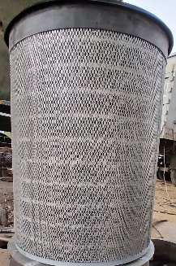  a) | 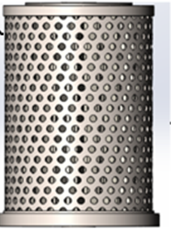  b) | 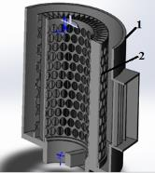  c)
FIGURE 1. Air filters used in mining machines
a) View of the actual air filter used by mining machines | b) air filter prepared for the experiment in computer graphics | c) air filter cross-section appearance. 1 - shell;  2 - filter

Today, at mining enterprises, work on preparing minerals for extraction, that is, drilling wells for drilling and blasting hard rocks, is carried out using hydraulic and electric drilling rigs, and the task of extraction and loading onto vehicles is mainly carried out using hydraulic and electric excavators. Figure 1 above shows the main and prepared views of the air filters of mining machines for experimental testing. Below, using mathematical expressions, we will develop mathematical models for increasing the efficiency of air filter purification, shown in Figure 1:

EXPERIMENTAL RESEARCH
Below we will compose mathematical expressions for increasing the efficiency of cleaning the air filters of mining machines. The main task in cleaning air filters is the uniform distribution of air supplied from the compressor using harmless and rotary motion for effective cleaning of the filters [3, 4-34].
There are various theories for considering the dynamic and kinematic parameters affecting filter operation in different ways, as well as their driving laws and formulas. Establishing the laws of rotational and linear motion of a filter with a proposed new structural design, developing solutions based on them, and obtaining results based on analysis is a pressing issue. From the following expression, we form the equation of motion.
$$\left\{\begin{aligned}φ_{z}=φ_{z}(t) \\ z_{e}=z_{e}(t)\end{aligned}\right. t≠0 φ_{z}≠0 (1)$$
If we connect the motion with the following parameters;
$$\left\{\begin{aligned}φ_{z}=ω⋅t \\ z_{e}=z_{e}^{'}⋅\sin{φ_{x}}\end{aligned}⇒ {φ_{z}=\frac{2πn}{T}⋅t \atop z_{e}=z_{e}^{'}⋅\sin{ωt}} (2)\right.$$
Let's formulate the law of change of the angle of rotation of the filter around its axis depending on time as follows.
$$φ_{Z}=2π⋅t (3)$$
We formulate the equation of upward and downward movement of the filter under the action of a spring as follows.
$$z_{e}=z_{e}^{'}⋅\sin{ωt } ⇒ t=\frac{φ_{z}}{2π} (4)$$
From the expression of time in the laws of angular and translational-return motion, we derive formula 5.
$$z_{e}=z_{e}^{'}⋅\sin\left(ω⋅\frac{φ_{z}}{2π} \right) (5)$$
To determine the particle velocity at an arbitrary point due to the formation of complex motion in the filter, we derive the following expression for the analysis of dynamic and static states.
$$φ_{e}=φ_{e}^{'}=ω_{e}=2π (6)$$
As a result of obtaining the first derivative of the law of angular change above, we express the angular velocity of the filter axis in rotational motion.
$z_{e}={\left(z_{e}^{'}\right)}^{'}=v_{e}=z_{e}^{'}⋅ω⋅\cos{ωt}$ (7)
As a result of obtaining the first derivative of the law of change of reciprocating motion from expression 7 above, we express the angular velocity of the moving filter axis.

$\left\{\begin{aligned}v_{r}=ω_{e}⋅\left(r_{x}\right) \\ v_{e}=z_{e}⋅ω⋅\cos{ωt}\end{aligned}\right.$ (8)
Absolute velocity of a particle,
$v_{a}=\sqrt{v_{r}^{2}+v_{e}^{2}+2v_{r}v_{e}\cos{φ}}$ (9)

${\left(φ_{e}\right)}^{''}=E_{e}=0 ω=const.$ (10)
${\left(z_{e}\right)}^{''}=a_{e}=z_{e}⋅ω^{2}⋅\sin{ωt}$ (11)
Absolute particle acceleration,
$a_{e}^{n}=ω_{e}^{2}⋅r= {\left(2π\right)}^{2}⋅r$ (12)
$a_{a}=\sqrt{a_{e}^{2}+{{(a}_{e}^{n})}^{2}}$ (13)
Here; $z_{e}$-coordinates of translational and reciprocal motion (m), $φ_{z}$- change in angle during rotational motion (rad), t - time (second), $ω$ - angular velocity (rad/s), $φ_{x}$ -angle of oscillation (rad), -rotational frequency (1/r), $v_{e}$- rotational speed (m/s), $v_{r}$-reciprocating speed (m/s), $v_{a}$ -absolute velocity in the filter (m/s), $E_{e}$- angular acceleration of the filter (rad/s²), $a_{e}$- tangential acceleration (m/s²), $a_{e}^{n}$ - normal acceleration (m/s²), $a_{a}$- absolute acceleration (m/s²).
Analysis of the spatial coordinates of the forces acting on the unit mass in dynamic processes occurring in the filter is shown in the figure below.

$\left\{\begin{aligned}\sum{F{}_{x}=P_{2}+F_{n}-P_{1}-F_{q}=max} \\ \sum{F_{y}=F_{T}=ma_{y}} \\ \sum{F_{z}=F_{I}-G=ma_{z}}\end{aligned}\right.$ (14)
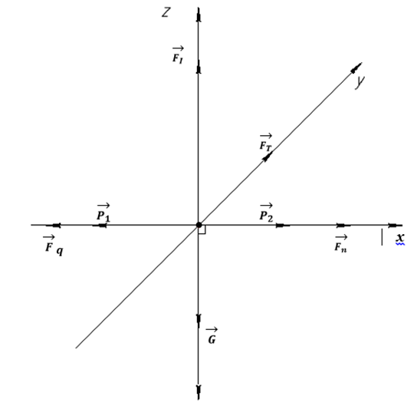
FIGURE 2. Directions of forces generated in the filter

$m=\frac{P_{2}+F_{n}-P_{1}-F_{q}}{a_{x}}⇒m=\frac{F_{T}}{a_{y}}⇒m=\frac{F_{I}-G}{a_{z}}$ (15)
$a=\frac{1}{m}\sqrt{F_{T}^{2}+{\left(F_{I}-G\right)}^{2}+{\left(P_{2}+F_{n}-P_{1}-F_{q}\right)}^{2} }$ (16)
$m=\sqrt{\frac{F_{T}^{2}+{\left(F_{I}-G\right)}^{2}+{\left(P_{2}+F_{n}-P_{1}-F_{q}\right)}^{2}}{a_{e}^{2}+{\left(a_{e}^{n}\right)}^{2}}}$ (17)
$m=f(F_{T}, F_{I},ω, x_{e}, t,φ)$ (18)
Here: $m$ - mass of the particle emitted from the filter (kg), $F_{T}$ - tangential force (N),
$F_{I}$- force arising during translational motion (N),$P_{2}$ - pressure supplied by the pump (Pa),
$x_{e}$- walking distance (m);
We compile the following formula for the mass of dust released in the filter [7,8,9].
$m=\sqrt{\frac{F_{T}^{2}+{\left(z_{e}⋅\sin\left(\frac{ω⋅φ_{z}}{2π}\right)-G\right)}^{2}+{\left(P_{2}+F_{n}-P_{1}-Rv^{2}\right)}^{2}}{a_{e}^{2}+{\left(a_{e}^{n}\right)}^{2}}}$ (19)
Based on the above formula, we can construct the function of the amount of dust released as a function of time, pressure, travel distance, and forces using expression 20.
$\left\{\begin{aligned}φ_{z}=φ_{z}(t) \\ m=f(z_{e}, φ_{z}, ∆P)\end{aligned}\right.$ (20)

RESEARCH RESULTS
Today, at mining enterprises, various types of air filters are purified by each mining enterprise using various methods and devices based on its internal needs. Figure 3 below shows 4 types of air filter purification of mining machines:

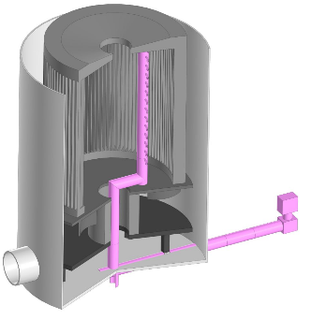 | 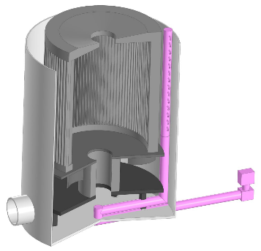 | 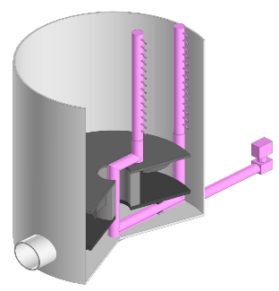 | 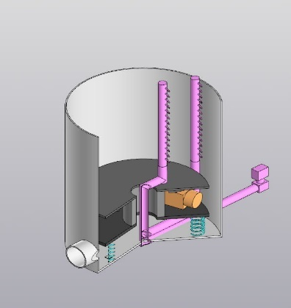
a) device for cleaning by supplying air from the inner part of the filter | b) device for air purification from the outer part of the filter | c) device for cleaning by supplying air from the inner and outer parts of the filter | d) the proposed improved spring filter cleaning device
FIGURE 3. Existing and proposed filter cleaning devices

In this analysis, various analyses were carried out for four different designs of air filter dust cleaning: a device for cleaning air from the inner part of a simple filter (Fig. a), a device for cleaning air from the outer part of a filter (Fig. b), a device for cleaning air from the inner and outer parts of a filter (Fig. c), and a proposed improved spring filter cleaning device (Fig. d). In each case, there is rotational motion inside the filter, which significantly influences the process of dust separation from the filter surface.
In a simple rotating filter, only rotational motion is present, and no additional mechanical vibrations or elastic elements are used. As a result of rotational motion, a centrifugal force is created, and dust particles adhere to the filter surface under pressure. Over time, a dense dust layer forms on the filter surface. Rotational movement contributes to the partial displacement of dust, but the destruction of the layer is limited. Therefore, the intensity of dust separation is relatively low, and there is a possibility of dust particles getting stuck in the filter [1-6].
In a rotating filter without springs, but with channels of complex shape and direction, along with rotational motion, the direction of the airflow is changed. The channels and guide elements inside the filter create unevenness in the dust flow. This leads to the loosening of the dust layer on the filter surface in some places. However, due to the absence of an elastic element, the dense layer formed on the filter surface is not completely destroyed. As a result, dust separation is higher than that of a simple rotating filter, but the process is unstable and efficiency decreases over time [7, 8].
Based on ongoing analyses and calculations, it has been proven that a special filter cleaning device with a double-sided air spraying device without a spring has higher productivity and efficiency compared to the above devices with only internal and only external air spraying devices, but the result of cleaning air filters using this device also shows cases of decreasing its efficiency over time, since the air spraying process is only a circular trajectory [9-34].
In the proposed device for cleaning a rotating filter, moving with the help of a spring, the rotational movement is carried out in combination with mechanical vibration. The spring gives elastic motion to the filter elements, causing their periodic displacement. As a result, a continuous process of deformation and cracking occurs in the dust layer formed on the filter surface. The centrifugal force generated as a result of rotational motion, combined with mechanical vibration, ensures the rapid and effective separation of dust particles from the filter surface. Therefore, in this case, the intensity of dust separation is highest, and the self-cleaning capacity of the filter increases [1-15].
In general, in all cases, rotational motion is the main factor in the process of dust separation. However, in simple filter cleaning devices, limited only by rotation, the efficiency remains low. Combining the direction of the rotational flow with the direction of the rotational flow improves the cleaning efficiency of air filters, but the highest efficiency is observed when the rotational flow is used in combination with mechanical vibration, i.e., movement through a spring. This situation is the most optimal solution in terms of extending the service life of the filter and increasing the efficiency of dust separation in air filter purification systems at mining enterprises and industrial enterprises. From the analysis of formula 19 above, based on the graph in Figure 4 below, we analyze the dependence of the amount of dust released in filters in 5 different states on time:

FIGURE 4. Graph of the time dependence of the amount of dust released from the filter

In all cases, the mass of the released dust increases monotonically over time. This is explained by the gradual accumulation of dust on the filter surface and its subsequent release under various mechanical and aerodynamic influences. However, the intensity of dust removal directly depends on the filter design [12, 13-34].
The graph shows the change in the mass of dust emitted by the filter over time for five different design cases. In general, in all cases, the amount of dust released gradually increases over time. This is explained by the accumulation of dust on the filter surface and its subsequent release as a result of various aerodynamic and mechanical influences. However, the intensity of dust removal directly depends on the filter design and the type of impact applied to it.
In simple air filter cleaning devices, due to the absence of additional air injection or mechanical movement, dust forms a dense layer on the filter surface. As a result, the dust separation process is slow, and the lowest values were observed on the graph above. This situation indicates that the efficiency of the filter cleaning device, which has a purge nozzle, is relatively low [14].
In the filter cleaning device, where air is supplied through an external nozzle, an external aerodynamic influence is exerted on the filter surface. The airflow partially loosens the dust layer and contributes to its release. Therefore, the amount of dust released will be slightly higher compared to a filter cleaning device by supplying air from the inside. However, due to the fact that the influence is only external, the effectiveness remains limited.
Aerodynamic influence is exerted on the filters from both sides by supplying air together with the internal and external nozzles. As a result, the process of deformation and splitting in the dust layer increases. On the graph, this situation is represented by high values, indicating that double-sided air injection significantly increases dust emissions. However, since air supply occurs only with the help of rotational motion, the productivity and cleaning efficiency of this cleaning device also decrease over time.
For the purpose of effective cleaning of the air filters of mining machines at mining enterprises, the proposed filter cleaning device, moving with a spring oscillation along with internal and external nozzles, is the most effective cleaning device. In this case, the aerodynamic effect is combined with mechanical vibration. The oscillatory movement of the filter continuously disrupts the dust layer, causing its rapid and abundant release. Therefore, the largest dust mass in all time intervals is observed in this case [15, 16-34].
In general, the efficiency of cleaning air filters from accumulating dust ranges from simple filter cleaning devices to external air spray and internal air spray, internal and external. Air-jet and internal and external and internal the cleaning efficiency increases depending on the effectiveness of the spring-operated filter cleaning devices with air sprayers. This shows that not only air flow, but also mechanical movement is important in the process of effective dust separation. These results are practically important for the ventilation of the mining industry, compressors, and devices operating in a dusty environment.
CONCLUSION
The article presents theoretical and mathematical analyses conducted to enhance the efficiency of air filtration systems in mining machinery. Deficiencies that occur during air filtration, particularly the accumulation of dust particles on filter surfaces and system blockage, adversely affect the performance of internal combustion engines in mining equipment. To address these issues, the study proposes one or two injector systems and describes their motion patterns using mathematical models.
The possibilities of increasing filter efficiency using three analyzed types of filter cleaning device designs were considered. The results show that the efficiency of the dust removal process in simple rotating filter cleaning devices is low. Spring-loaded rotating filters significantly increase efficiency under the influence of mechanical vibrations. In this case, the integration of mechanical motion and aerodynamic influences, that is, the combination of a two-way airflow and a spring, demonstrates the highest and most effective cleaning performance.
Thus, the mathematical models and design modifications proposed in the article play an important role in enhancing the efficiency of air filtration systems in mining machines. This approach has practical significance for ventilation systems in the mining industry, compressors, and devices operating in dusty environments, allowing for an extended filter service life and improved dust separation efficiency.
REFERENCE
- Zokhidov O.U., Khoshimov O.O., Khalilov Sh.Sh. Experimental analysis of microges installation for existing water flows in industrial plants. III International Conference on Improving Energy Efficiency, Environmental Safety and Sustainable Development in Agriculture (EESTE2023), E3S Web of Conferences. Volume 463. 02023 pp. 2023. https://doi.org/10.1051/e3sconf/202346302023.
- Zokhidov O.U., Khoshimov O.O., Sunnatov S.Z. Selection of the type and design of special water turbines based on the nominal parameters of Navoi mine metallurgical combine engineering structures. AIP Conf. Proc. 3331, 050022 (2025). https://doi.org/10.1063/5.0306554.
- Xiuliang Liu, Jianye Yang, Qifan Zou, Yongyan Hu, Pengkun Li, Li Tan, Nenad Miljkovic, and Ronggui Yang ACS Nano 2025 19 (10), 9513-9589 DOI: 10.1021/acsnano.4c15277R. Schürhuber, B. R. Oswald, L. Fickert, J. Fortmann. Verhalten von Windkraftanlagen mit doppelt speisenden Asynchron generatoren (DFIG) bei Kurzschlüssen und anderen Netzfehlern. Elektrotechnik & Informationstechnik (2020) 137/8: 415–424. https://doi.org/10.1007/s00502-020-00829-2.
- Wang, Cuihua, et al. "Effects of temperature-dependent viscosity on fluid flow and heat transfer in a helical rectangular duct with a finite pitch." Brazilian Journal of Chemical Engineering 31 (2014): 787-797. https://doi.org/10.1590/0104-6632.20140313s00002676.
- Ismatov Adkhamjon Alibek ugli, Rakhmatov Ramazonjon Ravshan ugli. Development of a mathematical model of fluid leakage from internal faults in hydraulic systems based on friction forces. Diversity Research: Journal of Analysis and Trends. Vol. 2, pp. 46-49, https://academiaone.org/index.php/2/article/view/854.
- Nabijon Abduazizov, Kamol Khakimov, Sardor Turdiyev, Akbar Zhuraev, Adham Ismatov. The impact of the amount of pollution of the fluid in the hydraulic system on the working resource of the quarry excavator. E3S Web of Conferences, 2025. https://doi.org/10.1051/e3sconf/202562705001.
- Rabatuly M., Myrzathan S.A., Toshov J.B., Nasimov J., Khamzaev A. Views on drilling effectiveness and sampling estimation for solid ore minerals. Integrated Use of Mineral Raw Materials. №1(336), 2026. https://doi.org/10.31643/2026/6445.01
- Toshov J.B., Rabatuly M., Khaydarov Sh., Kenetayeva A.A., Khamzayev A., Usmonov M., Zheldikbayeva A.T. Methods for Analysis and Improvement of Dynamic Loads on the Steel Wire Rope Holding the Boom of Steel Wire Rope Excavators. Integrated Use of Mineral Raw Materials Complex Use of Mineral Resources 2026; 339(4):87-96 https://doi.org/10.31643/2026/6445.43
- Khamzaev A.A., Mambetsheripova A., Arislanbek N. Thyristor-based control for high-power and high-voltage synchronous electric drives in ball mill operations/ E3S Web Conf. Volume 498, 2024/ III International Conference on Actual Problems of the Energy Complex: Mining, Production, Transmission, Processing and Environmental Protection (ICAPE2024) DOI: https://doi.org/10.1051/e3sconf/202449801011
- Toshov B.R., Khamzaev A.A. Development of Technical Solutions for the Improvement of the Smooth Starting Method of High Voltage and Powerful Asynchronous Motors/AIP Conference Proceedings 2552, 040018 (2023); https://doi.org/10.1063/5.0116131 Volume 2552, Issue 1; 5 January 2023
- Toshov B.R., Khamzaev A.A., Sadovnikov M.E., Rakhmatov B., Abdurakhmanov U./ Automation measures for mine fan installations/ SPIE 12986, Third International Scientific and Practical Symposium on Materials Science and Technology (MST-III 2023), 129860R (19 January 2024); doi: 10.1117/12.3017728. Third International Scientific and Practical Symposium on Materials Science and Technology (MST-III 2023), 2023, Dushanbe, Tajikistan.
- Toshov B.R., Khamzaev A.A., Namozova Sh.R.Development of a circuit for automatic control of an electric ball mill drive. AIP Conference Proceedings 2552, 040017 (2023) Volume 2552, Issue 1; 5 January 2023.
- Toirov, O.,Pirmatov, N.,Khalbutaeva, A.,Jumaeva, D.,Khamzaev, A. Method of calculation of the magnetic induction of the stator winding of a spiritual synchronous motor. E3S Web of Conferences., 2023, 401, 04033
- A. S. Zhuraev, S. A. Turdiyev, S. T. Jurayev, and S.S. Q. Salimova, “Characteristics of packing gland seals in hydraulic systems of quarry excavators and results of comparative analysis of experimental tests” Vol. 54, pp. 252–257, Apr. 2024, https://doi.org/10.21595/vp.2024.24051
- Akbar Zhuraev, Sardorjon Turdiyev; Analyses and studies of working fluid flow in the hydraulic system of hydraulic excavators at the Auminzo-Amantaytau open pit mine. AIP Conf. Proc. 4 November 2025; 3331 (1): 030067. https://doi.org/10.1063/5.0305703
- Mislibaev I.T., Makhmudov A.M., Makhmudov Sh.A. Theoretical generalisation of functioning modes and modelling of operational indicators of excavators. // Mining information-analytical bulletin. - 2021. №1. p. 102-110. DOI: 10.25018/0236-1493-2021-1-0-102-110
- Makhmudov Sh, Makhmudov A, Khudojberdiev L, Izzat Rakhmonov, “Criteria for assessing the performance of mining and transport equipment of mining enterprises,” Proc. SPIE 12986, Third International Scientific and Practical Symposium on Materials Science and Technology (MST-III 2023), 129860P (19 January 2024); doi: 10.1117/12.3017722
- Ataqulov L.N., Haydarov Sh.B., Polvonov N.O. Impact forces on side and middle rollers. SPIE 12986, Third International Scientific and Practical Symposium on Materials Science and Technology (MST-III 2023), 129860Q (19 January 2024); doi: 10.1117/12.3017724
- Atakulov L.N., Kakharov S.K., Khaidarov S.B. Selection of optimal jointing method for rubber conveyor belts. Gornyl Zhurnal, 2018. (9), 97-100. DOI:10.17580/gzh.2018.09.16
- Mahmudov A, Musurmanov E, Chorikulov A, Tukhtaev Sh. Justification of the development of the ventilation network and increasing the efficiency of ventilation equipment by controlling themovement of air flow. Third International Scientific and Practical Symposium on Materials Science and Technology (MST-III 2023), Proc. of SPIE Vol. 12986, 1298610. doi: 10.1117/12.3017914
- Alisher Ruzibaev Buri Toshov, Rashid Muminov, Bobirjon Tukhtaev, Xalim Kadirov and Zuxra Namozova. Methods for increasing wear resistance of working bodies of single-bucket excavators. E3S Web of Conferences 627, 05005 (2025) GEOTECH-2025. https://doi.org/10.1051/e3sconf/202562705005
- Rashid Muminov, Bobirjon Tukhtaev, Bahodir Qayumov, Alisher Ruzibaev, Faxriddin Kushimov, and Fotima Namozova. Analysis and theory of the prospects for the development of anchor support technology in gold and coal mines in foreign countries. E3S Web of Conferences 627, 01005 (2025) GEOTECH-2025 https://doi.org/10.1051/e3sconf/202562701005
- Boboqulov J., Narzullayev B. Development of a model for diagnosing rotor conditions in the parallel connection of synchronous generators with the network // E3S Web of Conferences. – EDP Sciences, 2024. – Т. 525. – С. 06001. https://doi.org/10.1051/e3sconf/202452506001
- Khasan Murodov, Askarbek Karshibayev, and Shukhrat Abdullayev, Analysis of the process of balanced charging of the battery group with high capacity, E3S Web of Conferences 548, 03012 (2024) https://doi.org/10.1051/e3sconf/202454803012
- Numon Niyozov, Anvar Akhmedov, Shukhrat Djurayev, Botir Tukhtamishev, Asliddin Norqulov, Development of a method for forecasting the specific consumption indicator of electric energy, AIP Conf. Proc. 3331, 080008 (2025) https://doi.org/10.1063/5.0305729
- Akram Tovbaev, Muxtarxan Ibadullayev and Mohinur Davronova. Study of subharmonic oscillation processes in ferroresonance circuits. E3S Web of Conf. Volume 525, 2024. IV International Conference on Geotechnology, Mining and Rational Use of Natural Resources (GEOTECH-2024). https://doi.org/10.1051/e3sconf/202452503008
- Narzullayev B. S., Eshmirzaev M. A, Causes of the appearance of current waves in high voltage electric arc furnaces, and methods of their reduction, E3S Web of Conferences. – EDP Sciences, 2023. – Т. 417. – С. 03003. https://doi.org/10.1051/e3sconf/202341703003
- Akram Tovbaev., Islom Togaev., Uktam Usarov.,Gulom Nodirov, Reactive power compensation helps maintain a stable voltage profile across the network, AIP Conf. Proc. 3331, 060014 (2025). https://doi.org/10.1063/5.0307209
- Bobur Narzullayev; Javokhir Boboqulov, Improving reliability based on diagnostics of the technical condition of electric motor stator gutters, AIP Conf. Proc. 3331, 030032 (2025). https://doi.org/10.1063/5.0305735
- Abdurakhim Taslimov., Feruz Raximov., Farrukh Rakhimov., Iles Bakhadirov, Optimal parameters and selection criteria for neutral grounding resistors in 20 kv electrical networks, AIP Conf. Proc. 3331, 030048 (2025) https://doi.org/10.1063/5.0306108
- Raximov, F., Taslimov, A., Majidov, A., & Norqulov, A. (2024). Optimization of losses by switching to higher voltage in distribution networks. In E3S Web of Conferences (Vol. 525, p. 03009). EDP Sciences. https://doi.org/10.1051/e3sconf/202452503009
- N.Ataullayev, A.Norqulov, B.Muxammadov, A.Majidov, I.Tog’ayev. Principles of protection against single phase earth faults in networks with capacitive current compensation. E3S Web of Conferences, 548, 06008 (2024). https://doi.org/10.1051/e3sconf/202454806008
- Ataullaev N. O., Dziaruhina A. A., Murodov K. S. Static Characteristics of Magnetic Modulation DC Converters with Analog Filter //Наука и техника. – 2023. – Т. 22. – №. 5. – С. 428-432. https://doi.org/10.21122/2227-1031-2023-22-5-428-432
- Murodov K., Karshibayev A., Abdullayev S. Analysis of the process of balanced charging of the battery group with high capacity //E3S Web of Conferences. – EDP Sciences, 2024. – Т. 548. – С. 03012. https://doi.org/10.1051/e3sconf/202454803012

