Development of a porous filter device that reduces the level of pollution in hydraulic systems and research of its technical indicators
Akbar Zhuraev^{1a)}, Sardorjon Turdiyev^{1,4}, Khamroev Sherzod¹, Arslanbek Nietbaev² and Sherbek Tursunov^{1,3}
¹Navoi State University of Mining and Technologies, Navoi, Uzbekistan
²Nukus State Technical University, Nukus, Uzbekistan
³ Termiz State University of Engineering and Agrotechnologies, Termiz, Uzbekistan
⁴ Termiz State University of Engineering and Agrotechnologies, Termiz, Uzbekistan
^{a)} Corresponding author: jurayevakbar@mail.ru
Abstract. In this article, one of the main factors influencing the reliability of hydraulic equipment operating in open-pit mining conditions - the issue of contamination of hydraulic working fluids - is scientifically analyzed. Due to the high dustiness of the mining environment, abrasive wear in hydraulic system parts increases, which leads to a reduction in the service life of equipment and an increase in operating costs. To eliminate this problem, a new composition of a porous filter material based on ammonium bicarbonate, polyorganosiloxane, acrylic emulsion, and copolymers was developed. Experimental tests were conducted using the example of the Tellus-46 hydraulic thinner, and it was established that the degree of filtration porosity significantly affects the liquid flow rate and particle capture indicators. According to the research results, it was noted that the optimal porosity was 40%, which ensured maximum filtration efficiency. The developed filter has high practical significance in reducing the level of contamination in hydraulic systems, protecting parts, and increasing the operational reliability of equipment.
INTRODUCTION

Open-pit mining of minerals is impossible to imagine without a complex of reliable mining machines and mechanisms. High dustiness and pollution in open-pit mines reduce the reliability of mining machinery. Therefore, the development of technical solutions that ensure the reliability of mining equipment with minimal costs and technical operation is one of the urgent tasks of the mining industry [1,2,3].

One of the components that ensures reliable operation of quarry hydraulic equipment is its hydraulic system, the satisfactory operation of which ensures the reliability of the entire equipment.

The technical indicators of the hydraulic system depend on the purity of the hydraulic working fluids used in it. Contamination of the hydraulic working fluid leads to abrasive wear of elements in the hydraulic system, as well as to widening of the gaps due to abrasive wear of friction pairs in the gaps of the hydraulic drive. This, in turn, worsens the technical characteristics of the equipment due to a drop in pressure in the hydraulic system and increases operating costs [4,5].

Most failures in the hydraulic system occur due to contamination of the working fluid. Working fluids become contaminated during transportation, due to improper storage, during equipment filling, and during operation.

An increase in the concentration of pollutants in the hydraulic working fluid above the specified indicators reduces the efficiency of hydraulic pumps by up to 10 times, and hydroelectric parts by up to 8 times. Thus, the organization of reliable and efficient operation of mine hydraulic equipment is achieved by ensuring the purity of the hydraulic working fluids used in it, which is achieved by pouring them into the equipment and effective filtration during operation [6,7,8-38].

Consequently, the development of affordable and high-quality filters to ensure the purity of hydraulic working fluids is one of the urgent tasks.

By ensuring the cleanliness of hydraulic working fluids, it is possible to increase the reliability of hydraulic drives, and ensuring the cleanliness of hydraulic working fluids should be carried out during the pouring of working fluid into vessels, their transportation, pouring into equipment, and operation [9].

For the purification of hydraulic working fluids, several types of filters are used today; according to the method of purifying hydraulic working fluids, filters are divided into filters for coarse purification of oils, i.e., for separating larger volumes of contaminants in the oil, filters for cleaning oils from small particles, and clarifiers [10-38].

The main tasks of hydraulic working fluid filters include maintaining the optimal viscosity of the fluid by reducing the volume of contaminants in the oil, preventing burns, abrasive wear of parts of the hydraulic system, the formation of alkaline soot on the inner surfaces of parts, maintaining the working properties of lubricants, and reducing the coefficient of friction of parts [11,12-38].

EXPERIMENTAL RESEARCH
In order to effectively ensure the cleanliness and performance of the working fluid of the hydraulic system of mining equipment, a porous filter with a special composition was developed.
The search for a porous filter is widely covered in the works of G.V. Golubev and G.G. Tumashev. In our republic, our goal and task is to use porous filters made from local raw materials as a separate filtration system in the working fluid. One of the main tasks of our article is to analyze the microscopic structure of the porous filter and the results obtained during the purification of the working fluid in the hydraulic system from the porous filter [13-38].
Any porous partitions can have 3 media during filtration. (Figure 1)
1. Pores with holes, i.e., wall cracks, consist of microtubules with varying diameters. As a result, it allows for the capture of solid particles.
2. Inserted pores, i.e., pores that are closed on all sides and do not affect particles.
3. Closed pores, that is, one side is open, and the other side is closed. As a result, particles accumulate in these pores [14-30].

FIGURE 1. Microscopic view of a porous filter

Purification of the working fluid in a porous filter occurs only in pores with openings. In this case, we can see a barrier filter with a common coefficient in the classification of pores.
$m_{n}=\frac{Vn}{V}$ (1)
where m_{n} is the total porosity coefficient of filter barriers.
Vn - total pore volume of the porous filter.
V-filter volume.
In this case, if we expand V further, it becomes V=Vn+Vm.
Vm - material volume of the filter.
m_{n}, there are calculations with external and internal porous coefficients, and only the filtration method with external porous coefficients can be taken into account. Because the filtration process does not occur at the internal porosity coefficient.
In this case, the filtration coefficient with an external porous barrier looks like this.
$m_{1}=\frac{Vt.g^{'}+Vb.t.g^{'}}{V}$ (2)
$Vt.g^{'},Vb.t.g^{'}$ here, - porous pores; - Inscribed pores.
In porous filters, the structure of the pores is irregular, which makes it impossible to construct a mathematical model of the working fluid from it. Therefore, it is considered by determining the average velocity of the working fluid through the porous filter.
$v_{g'}=\frac{\frac{W}{t}}{\frac{V_{t.g^{'}.}+V_{b.t.g^{'}.}}{V_{n}+V_{m}} *S}$ (3)
$WtS$ here, - the volume of liquid flowing out of the porous filter; - time of liquid outflow from the porous filter; -porous filter surface.
This is also called the Dupuis-Forchheimer hypothesis.
Based on the above theoretical data, we can conclude that a large number of penetrating pores improves the filtration rate and the flow rate of the working fluid.
The Borusa-Beholda method, i.e., the bubble method, is used to determine the pore size of porous filters. In this process, pore sizes are determined under pressure. In this case, the porous filter begins to exit through the pores under the influence of air pressure, saturating the required amount of liquid. The outlet of the initial bubbles is considered the maximum pressure under pressure. The appearance of bubbles on the entire surface of the filters is considered average pressure.
These results are determined by the following formula.
$d_{n}=\frac{4α}{P}$ (4)
$d_{n}$where, - is the pore diameter, m
$4α$- coefficient of surface tension, N/m
$P$-air pressure Pa.
Porosity is the ratio of the pore volume to the total volume of the body. In a broad sense, the concept of porosity includes information about the morphology of the porous body. Structural properties (the size of the holes, the distribution of their sizes, the size of the hole, the specific surface area) are often referred to as "porous body structure." Porous substances are widespread in nature (minerals, plant organisms) and technology (adsorbents, catalysts, foams, building materials, filters, fillers, pigments, etc.) [15,19-38].
The developed porous filter consists of ammonium bicarbonate (NH₅CO₃), polyorganosiloxane (p₂SiO), acrylic emulsion, copolymers, and vinyl chloride.
Preparation of the porous filter was carried out as follows: ammonium bicarbonate (NH₅CO₃), polyorganosiloxane (p₂SiO), acrylic emulsion, copolymers, and vinyl chloride were mixed in the required volume to form a mixture. The prepared mixture is placed in water at 96°C, then the mixture reacts with the water and a bubbling process occurs. The mixture is left in water until the bubbling process is complete [13-38].
The main goal of conducting pilot tests of the developed porous filter is to determine the effectiveness of the use of these filters in the purification of hydraulic working fluids, as well as to determine the filter parameters.
To date, a number of scientists have worked on issues related to porous filters [16,17,18,19-38], they proposed formulas for determining the passage of liquid through the filter, the capture of pollutants by the amount of porosity of the filter, and the capture of particles of a given size relative to the size of the pores. However, determining the quantity and size of particles trapped during the passage of liquid through a porous filter requires experimental work.
The following materials and equipment were used in the experimental work:
- samples of porous filters with pore sizes from 1 μm to 4 μm, thickness from 50 mm to 90 mm;
- Hydraulic working fluid of the "Tellus-46" brand (3088 engine-hours of operation);
- filtration stand of hydraulic working fluids;
- digital microscope (DMX-4);
- micrometer calibration ruler;
- Electronic scales HR-300i;
- instruments for measuring temperature, pressure, and time.
The stand for filtering hydraulic working fluids consists of an electric motor, a hydraulic pump, a filter casing, control and measuring instruments, and a container, the general view of the stand is shown in Figure 2.

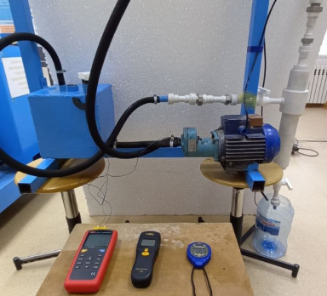
FIGURE 2. Hydraulic working fluid filtration stand

The general schematic view of the experimental setup is shown in Figure 3.

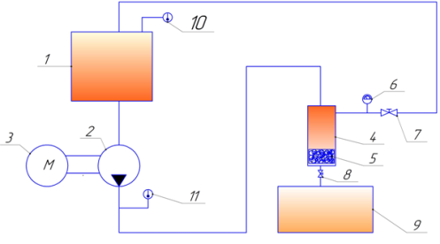
1 - tank; 2 - hydraulic pump; 3 - hydraulic pump electric drive; 4 - filter casing; 5 - developed porous filter; 6 - manometer; 7 - gate valve; 8 - vinyl; 9 - filtered liquid tank; 10.11 - thermometer
FIGURE 3. Schematic representation of the experimental setup
RESEARCH RESULTS
Based on the results of the experimental work, the dependence of the flow rate of the working fluid through the filter and the amount of particles retained in the filter on the porosity of the filter material was established, which are shown in Figures 4 and 5.
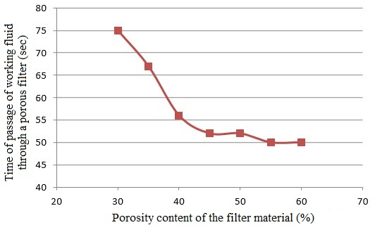
FIGURE 4. Dependence of the flow time of the working fluid through the filter on the porosity of the filter material

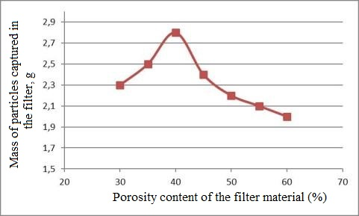
FIGURE 5. Dependence of the amount of particles trapped in the filter on the amount of porosity of the filter material

The dependencies presented in Fig. 4 and 5 show that the flow rate of the working fluid in a porous filter averaged 50-55 seconds with a filter porosity in the range from 45% to 60%, and with a decrease in porosity from 45% to every 5%, the flow rate of the working fluid decreased by 10-12%. In addition, the maximum indicator was 2.8 grams at a filter particle content of 40%, and 2.2 and 2.0 grams at a porosity content of 50% and 60%. The porosity content was 2.3 and 2.5 grams, respectively, with an indicator of 30%, 35%.
Based on the foregoing, it can be concluded that the optimal porosity of porous filters used for cleaning working fluids of hydraulic systems is 40%. In this case, the amount of trapped pollutants in the filter and the speed of passage of the hydraulic working fluid through the filter are proportional to each other.

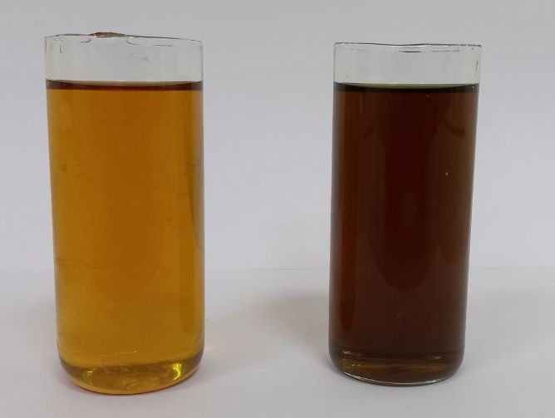
a - Hydraulic working fluid passed through the developed porous filter; b - Hydraulic working fluid passed through the hydraulic filter used in the excavator
FIGURE 6. Hydraulic working fluid samples
At the end of the experimental work, the amount of pollutants trapped in the body of the porous filter was studied using a microscope and a micrometer calibration line, and the amount of particles trapped in the filter was determined using an electronic scale of the HR-300i brand.
Fig. 6 shows a photograph of samples of hydraulic working fluid, purified from the developed porous filter (Fig. 6a) and passed through a hydraulic filter (Fig. 6b), used in quarry equipment, after 3088 motor-hours of operation.
CONCLUSIONS
The research results confirmed that the main factor directly affecting the performance of hydraulic systems is the cleanliness of the working fluid. It has been established that the developed composition of the porous filter (ammonium bicarbonate, polyorganosiloxane, acrylic emulsion, and copolymers) allows for the effective retention of abrasive particles in hydraulic oil. Experimental tests have shown that the porosity of the filter is closely related to the liquid flow rate and particle capture efficiency: the optimal porosity is 40%, while the filter captures the maximum (2.8 g) pollutant particle and maintains flow stability. Thus, the proposed porous filter allows to increase the operational reliability of hydraulic systems, reduce the number of failures, and reduce maintenance costs.
REFERENCES
- Iliashenko I. Development and substantiation of technical solutions for dust suppression during mining operations at the open pit mines of the Kirovsk branch of JSC" Apatit". – 2022. https://pureadmin.unileoben.ac.at/ws/portalfiles/portal/18550905/AC16853881.pdf
- P A Pobegailo et al 2021 IOP Conf. Ser.: Mater. Sci. Eng. 1023 012021 DOI 10.1088/1757-899X/1023/1/012021
- Du, S.; Chen, H.; Ding, X.; Liao, Z.; Lu, X. Development of Dust Emission Prediction Model for Open-Pit Mines Based on SHPB Experiment and Image Recognition Method. Atmosphere 2024, 15, 1118. https://doi.org/10.3390/atmos15091118
- Abduazizov, Nabijon, et al. "Analysis of the dependence of the hydraulic system training coefficient in quarry excavators on the concentration of contaminated particles in the working fluid." E3S Web of Conferences. Vol. 627. EDP Sciences, 2025. https://doi.org/10.1051/e3sconf/202562705022
- Rakhutin M.G., Giang Quoc Khanh, Krivenko A.E., Tran Van Hiep. Evaluation of the influence of the hydraulic fluid temperature on power loss of the mining hydraulic excavator. Journal of Mining Institute. 2023. Vol. 261, p. 374–383. https://pmi.spmi.ru/pmi/article/view/16193
- Tkáč, Z.; Kosiba, J.; Skladaný, D.; Nagy, M.; Jablonický, J.; Tulík, J.; Čurgaliová, G.; Danis, S. Degradation Processes of Transmission–Hydraulic Fluid During an Operational Trial. Lubricants 2025, 13, 477. https://doi.org/10.3390/lubricants13110477
- Salimova Shaxrizoda Sanjar kizi “Research of the influence of the quality of the working fluid on the efficiency of the hydraulic system”. Web of Scientists and Scholars: Journal of Multidisciplinary Research, vol. 2, no. 2, Feb. 2024, pp. 82-87, https://webofjournals.com/index.php/12/article/view/830.
- Novaković, B., Radovanović, L., Zuber, N., Radosav, D., Đorđević, L. & Kavalić, M. (2022). Analysis of the influence of hydraulic fluid quality on external gear pump performance. Eksploatacja i Niezawodność – Maintenance and Reliability, 24(2), 260–268. https://doi.org/10.17531/ein.2022.2.7
- Deuster, S.; Schmitz, K. Bio-Based Hydraulic Fluids and the Influence of Hydraulic Oil Viscosity on the Efficiency of Mobile Machinery. Sustainability 2021, 13, 7570. https://doi.org/10.3390/su13147570
- Burenin, V.V. Filters for purifying the working liquids in hydraulic machine tools. Russ. Engin. Res. 31, 918–921 (2011). https://doi.org/10.3103/S1068798X11090085
- Werbinska-Wojciechowska, S.; Rogowski, R. Proactive Maintenance of Pump Systems Operating in the Mining Industry—A Systematic Review. Sensors 2025, 25, 2365. https://doi.org/10.3390/s25082365
- Rîpă, I.C. & Popescu, D. Bulletin of the Polytechnic Institute of Iași. Machine constructions Section, 70(4), 2024. 117-127. https://doi.org/10.2478/bipcm-2024-0025
- Shavkatovich, Dzhuraev Akbar. "Development and use of a porous filter for cleaning hydraulic oil in a hydraulic system." ACADEMICIA: An International Multidisciplinary Research Journal 11.8 (2021): 347-360. DOI: 10.5958/2249-7137.2021.01821.8
- Cummings, Linda J., Binan Gu, and Lou Kondic. "Filtration in Pore Networks." Annual Review of Fluid Mechanics 58 (2026). https://doi.org/10.1146/annurev-fluid-112723-054759
- Ferreira, Filipe V., et al. "Porous nanocellulose gels and foams: Breakthrough status in the development of scaffolds for tissue engineering." Materials Today 37 (2020): 126-141. https://doi.org/10.1016/j.mattod.2020.03.003
- Werbinska-Wojciechowska, S.; Rogowski, R. Proactive Maintenance of Pump Systems Operating in the Mining Industry—A Systematic Review. Sensors 2025, 25, 2365. https://doi.org/10.3390/s25082365
- Rîpă, I.C. & Popescu, D. Hydraulic Manifold Blocks Manufactured Using 3D Printing Technology. Bulletin of the Polytechnic Institute of Iași. Machine constructions Section, 70(4), 2024. 117-127. https://doi.org/10.2478/bipcm-2024-0025
- Remache, A.; Pérez-Sánchez, M.; Hidalgo, V.H.; Ramos, H.M.; Sánchez-Romero, F.-J. Towards Sustainability in Hydraulic Machinery Manufacturing by 3D Printing. Processes 2024, 12, 2664. https://doi.org/10.3390/pr12122664
- A. S. Zhuraev, S. A. Turdiyev, S. T. Jurayev, and S.S. Q. Salimova, "Characteristics of packing gland seals in hydraulic systems of quarry excavators and results of comparative analysis of experimental tests," Vibroengineering Procedia, Vol. 54, pp. 252–257, Apr. 2024, https://doi.org/10.21595/vp.2024.24051
- Rabatuly M., Myrzathan S.A., Toshov J.B., Nasimov J., Khamzaev A. Views on drilling effectiveness and sampling estimation for solid ore minerals. Integrated Use of Mineral Raw Materials. №1(336), 2026. https://doi.org/10.31643/2026/6445.01
- Toshov J.B., Rabatuly M., Khaydarov Sh., Kenetayeva A.A., Khamzayev A., Usmonov M., Zheldikbayeva A.T. Methods for Analysis and Improvement of Dynamic Loads on the Steel Wire Rope Holding the Boom of Steel Wire Rope Excavators. Integrated Use of Mineral Raw Materials Complex Use of Mineral Resources 2026; 339(4):87-96 https://doi.org/10.31643/2026/6445.43
- Zokhidov O.U., Khoshimov O.O., Khalilov Sh.Sh. Experimental analysis of microges installation for existing water flows in industrial plants. III International Conference on Improving Energy Efficiency, Environmental Safety and Sustainable Development in Agriculture (EESTE2023), E3S Web of Conferences. 2023. https://doi.org/10.1051/e3sconf/202346302023
- Zokhidov O.U., Khoshimov O.O., Sunnatov S.Z. Selection of the type and design of special water turbines based on the nominal parameters of Navoi mine metallurgical combine engineering structures. AIP Conf. Proc. 3331, 050022 (2025). https://doi.org/10.1063/5.0306554
- Toshov B.R., Khamzaev A.A. Development of Technical Solutions for the Improvement of the Smooth Starting Method of High Voltage and Powerful Asynchronous Motors/AIP Conference Proceedings 2552, 040018 (2023); https://doi.org/10.1063/5.0116131
- Toshov B.R., Khamzaev A.A., Sadovnikov M.E., Rakhmatov B., Abdurakhmanov U./ Automation measures for mine fan installations/ SPIE 12986, Third International Scientific and Practical Symposium on Materials Science and Technology (MST-III 2023), 129860R (19 January 2024); https://doi.org/10.1117/12.3017728 .
- Mislibaev I.T., Makhmudov A.M., Makhmudov Sh.A. Theoretical generalisation of functioning modes and modelling of operational indicators of excavators. // Mining information-analytical bulletin. - 2021. №1. p. 102-110. https://doi.org//10.25018/0236-1493-2021-1-0-102-110
- Makhmudov Sh, Makhmudov A, Khudojberdiev L, Izzat Rakhmonov, “Criteria for assessing the performance of mining and transport equipment of mining enterprises,” Proc. SPIE 12986, Third International Scientific and Practical Symposium on Materials Science and Technology (MST-III 2023), 129860P (19 January 2024); https://doi.org/10.1117/12.3017722
- Ataqulov L.N., Haydarov Sh.B., Polvonov N.O. Impact forces on side and middle rollers. SPIE 12986, Third International Scientific and Practical Symposium on Materials Science and Technology (MST-III 2023), 129860Q (19 January 2024); https://doi.org//10.1117/12.3017724
- Mahmudov A, Musurmanov E, Chorikulov A, Tukhtaev Sh. Justification of the development of the ventilation network and increasing the efficiency of ventilation equipment by controlling the movement of air flow. Third International Scientific and Practical Symposium on Materials Science and Technology (MST-III 2023), Proc. of SPIE Vol. 12986, 1298610. https://doi.org//10.1117/12.3017914
- Boboqulov J., Narzullayev B. Development of a model for diagnosing rotor conditions in the parallel connection of synchronous generators with the network // E3S Web of Conferences. – EDP Sciences, 2024. – Т. 525. – С. 06001. https://doi.org/10.1051/e3sconf/202452506001
- Muzaffar Xolmurodov., Shaxzod Hakimov., Umida Oripova, Improving energy efficiency in public buildings: Modern technologies and methods, AIP Conf. Proc. 3331, 040060 (2025) https://doi.org/10.1063/5.0306935
- Akram Tovbaev, Muxtarxan Ibadullayev and Mohinur Davronova. Study of subharmonic oscillation processes in ferroresonance circuits. E3S Web of Conf. Volume 525, 2024. IV International Conference on Geotechnology, Mining and Rational Use of Natural Resources (GEOTECH-2024). https://doi.org/10.1051/e3sconf/202452503008
- Narzullayev B. S., Eshmirzaev M. A, Causes of the appearance of current waves in high voltage electric arc furnaces, and methods of their reduction, E3S Web of Conferences. – EDP Sciences, 2023. – Т. 417. – С. 03003. https://doi.org/10.1051/e3sconf/202341703003
- Ataullayev N.O., Muxammadov B.Q., Idieva A.A., Research of dynamic characteristics of magnetic modulation current converter with negative feedback // International Journal of Advanced Research in Science, Engineering and Technology, India, 2020, November, Vol. 7, Issue 11. – P. 15749-15752. http://www.ijarset.com/volume-7-issue-11.html?utm_source=chatgpt.com
- N.Ataullayev, A.Norqulov, B.Muxammadov, A.Majidov, I.Tog’ayev. Principles of protection against single phase earth faults in networks with capacitive current compensation. E3S Web of Conferences, 548, 06008 (2024). https://doi.org/10.1051/e3sconf/202454806008
- Shirinov S.G., J.S. Olimov, I.Z. Jumayev, M.K. Sayidov Analysis of patterns of electricity consumption in mining and processing enterprises. Vibroeng. Procedia 2024, 54, 308–313. https://doi.org/10.21595/vp.2024.24073
- Jumayev, Z.I., Karshibayev, A.I., Sayidov, M.K., & Shirinov, S.G. Analysis of climate-meteorological and technological factors affecting electricity consumption of mining enterprises. Vibroengineering Procedia, Vol. 54, pp. 293-299 (Apr. 4 2024). https://doi.org/10.21595/vp.2024.24047
- Amirov S.F., Ataullayev N.O., Ataullayev A.O., Muxammadov A.O., Majidov B.Q., A.U. Methods for reducing the temperature components of magnetomodulation DC converter errors. E3S Web of Conferences, 417, 03011 (2023). https://doi.org/10.1051/e3sconf/202341703011

