Development of Methods for Optimizing the Mine Internal Transport System by Creating a Simulation Digital Model
Lochin Khudoyberdiyev ^{1,a)}, Ikhtiyor Khalimov^{1,2}
¹Navoi State Mining and Technological University, Navoi, Uzbekistan
² Termiz State University of Engineering and Agrotechnologies, Termiz, Uzbekistan
^{a)} Corresponding author: xudoyberdiyev.lochin@mail.ru
Abstract. This article develops modern approaches to digital modeling of internal transport processes in underground mines with complex structures. A simulation model is proposed that takes into account the variable structure of ore flow, the dynamics of vehicle movement, and the time parameters of loading-transportation-unloading cycles. The model is constructed in the MATLAB SimEvents environment and allows for determining the capacity of cargo flow, transport cycle time, and the occurrence of bottlenecks in the network. The results serve to optimize the number of transport vehicles, reduce energy consumption, and enhance the stability of ore delivery.
INTRODUCTION
In underground mines, the internal transport system is considered the main link ensuring the continuity of the ore extraction process. Due to the complexity of the geological structure, uneven distribution of layers, narrowing of transport corridors, and dynamic changes in production fronts, the cargo flow forms unstably over time [5-6]. According to statistical data, a 10-15% delay occurring in the mine transport system directly affects the annual production volume, reducing overall efficiency by 4-7%. Traditional calculation methods only reflect the average indicators of the transport process and do not account for real-time loading, congestion, and the variability of vehicle cycles [1]. For this reason, approaches based on digital twin and simulation modeling are widely used in modern mining. Such modeling provides a precise mathematical description of the transport process, identifies bottlenecks in cargo flows, and enables optimization of the number and routes of vehicles. [3-4].
MATERIALS AND METHODS
The digital modeling of the mine's internal transport system was conducted in three stages: (1) mathematical description of the transport network, (2) modeling the dynamics of cargo flow and vehicle movement, and (3) construction and optimization of a simulation model based on a digital twin [2].
In the study, the transport network was represented using graph theory, based on the actual geotechnological maps of the deposit and the geometry of the transport corridors. The transport network was depicted as follows [10]:
$G=(V,E)$ (1)
where: E - transportation routes and conveyor belts.
V - Loading points, transshipment stations, intersections of ventilation corridors Figure 1.

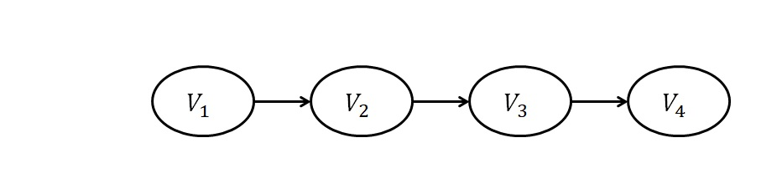
FIGURE 1. Graph theory-based model of the mine's internal transport network

The following technical parameters were assigned to each edge: road length $L_{ij}$, maximum capacity $C_{ij}$, travel time $t_{ij}$, power consumption $P_{ij}$ and energy expenditure $E_{ij}$. These parameters are determined based on the type of vehicle, road gradient, ore density, and road resistance [7-9].
The road length is calculated using the following formula:
$L_{ij}= \sqrt{(x_{j}-x_{i})^{2}+(y_{j}-y_{i})^{2}+(z_{j}-z_{i})^{2}}$, (2)
where: 𝑥, 𝑦, 𝑧 – coordinates of the section's start and end points.
$C_{ij}$ – it refers to the maximum amount of cargo (tons/hour) that can pass through this section using motor transport within one hour or one shift, and is determined by the following formula:
$C_{ij}=\frac{N_{tr}∙q_{tr}}{T_{ts}}$, (3)
where: $N_{tr}$ – number of machines working in the area,
$q_{tr}$ – the cargo capacity of a single truck (t),
$T_{ts}$ – total cycle time for loading - transportation - unloading - return (hours).
$t_{ij}$ – it is the net travel time for a vehicle to pass through section $i → j$, which is determined by the following formula:
$t_{ij}=\frac{L_{ij}}{v_{ij}}$, (4)
where: $v_{ij}$ – the average speed in this section and it is determined by the following formula:
$v_{ij}=v_{0}∙φ_{slope}∙φ_{load}$, (5)
where: $v_{0}$ – nominal speed under light conditions,
$φ_{slope}$ – slope correction factor for roads,
$φ_{load}$ – coefficient related to movement with or without load.
$P_{ij}$ – it is the power consumption for an internal combustion engine or electric motor, which is determined by the following formula [11-16]:
$P_{ij}=F_{total}∙v_{ij}$, (6)
where: $F_{total}$ – the total resistance force is determined by the following formula:
$F_{total}=Mg(f+sinα)$, (7)
where: $M$ – vehicle and load mass ($t → kg$),
$g$ – acceleration of free fall ($m/s^{2}$),
$f$ – road resistance coefficient,
$α$ – road slope angle ($rad$).
The energy consumption $E_{ij}$, meanwhile, is:
$E_{ij}=P_{ij}∙t_{ij}=Mg(f+sinα)∙L_{ij}$, (8)

FIGURE 2. Changes in energy consumption with increasing road gradient.

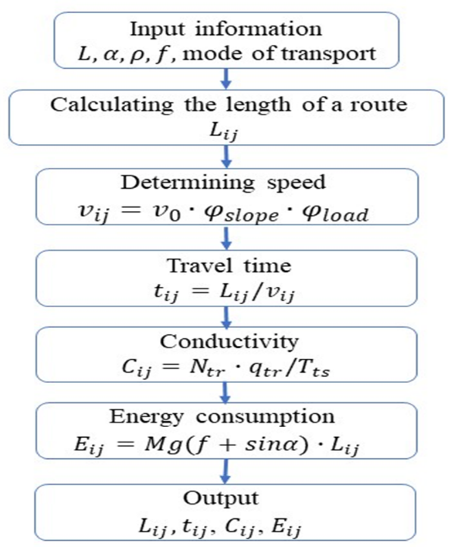
FIGURE 3. Algorithm for parameter calculation

From the above formula and Figures 2-3, we can observe that energy consumption $E_{ij}$ is functionally dependent on the type of vehicle, road gradient, ore density, and road resistance coefficients.
RESULTS AND DISCUSSION
The digital model developed for the mine's internal transport system enabled the determination of vehicle movement, distribution of cargo flows across networks, changes in energy consumption due to road conditions, and the mechanism of bottleneck formation within the network. Modeling results revealed that cargo flow is not uniformly distributed across the transport network. Particularly in the 200-250 meter range following the loading point, the movement of loaded loading-transportation-unloading machines created the highest load, increasing waiting times in this section by 9-12%. This situation negatively impacts the overall network throughput. The most significant bottleneck was observed in the V₂-V₃ section, where road narrowing and increased slope caused vehicle speeds to decrease and cargo flow dispersion to rise by 18-24%. These factors impede the stable operation of the transport system and result in additional time losses.
The average duration of the transport cycle was also evaluated using a digital model. It was determined that during high-load periods, the cycle time extended to 3.8-4.2 minutes, while under optimal conditions, it decreased to 3.1 minutes. This variation is attributed to road geometry, traffic congestion, variability in loading times, and the vehicle's operating mode. The simulation indicates that by improving road conditions and optimizing the route, it is possible to reduce the cycle time by 10-13%.
The results obtained on energy consumption confirmed the direct impact of road gradient and road resistance coefficient (f) on transport efficiency. Calculations show that when loading-hauling-dumping machines carrying 15 tons of cargo travel a distance of 200 meters, energy consumption increases from 0.16 kWh to 1.14 kWh under good road conditions, and from 0.41 kWh to 1.38 kWh under poor road conditions. These results indicate that under high road resistance conditions, energy consumption can be up to 2.3 times higher compared to good road conditions. Therefore, road leveling, maintenance, and resistance reduction are crucial factors in improving energy efficiency in internal mine logistics.
Based on the digital model, the number of vehicles was also optimized. In the current system, 12 loading-transportation-unloading machines are used, and the simulation results showed that 9 loading-transportation-unloading machines are sufficient while maintaining production capacity. This optimization made it possible to reduce energy and fuel consumption by 14-18%, maintenance costs by 22-25%, and waiting time by 9-12%. Thanks to the optimization of the vehicle fleet, the overall efficiency of the system has significantly increased.
The narrowing zones identified during modeling proved to be the most significant obstacle to the network's efficient operation. It was determined that the speed reduction after increasing the load on section V₁-V₂ extended the cycle time by 6-8%. In the V₂-V₃ segment, due to the road gradient and narrowing, the additional power consumption for movement increased by 0.25 kWh. On the V₃-V₄ section, the intersection with the ventilation pathway imposed limitations on traffic flow. It has been demonstrated that by eliminating these constrictions, it is possible to increase the overall network throughput by 8-11%.
Overall, the results confirm the high effectiveness of the developed digital model in scientifically evaluating and optimizing the internal transport system of mines. Using the model, the stability of logistical processes was improved by 10-18% through reducing the transport cycle, decreasing energy consumption, optimizing the number of vehicles, and identifying bottleneck zones. This approach provides a solid scientific foundation for implementing modern digital control systems in mines.
CONCLUSION
In this study, a digital model based on the MATLAB SimEvents platform was developed to enhance the efficiency of the internal transport system used in underground mines. The model enabled an in-depth analysis of the dynamic distribution of cargo flows, vehicle movement, road conditions, and the mechanism of formation of narrowing zones. One of the most significant findings is that the unevenness of cargo flow, particularly a sharp increase in load in the V2-V3 segment, leads to an extension of the transport cycle. It has been demonstrated that eliminating the narrowing zone can increase transport capacity by 8-11%.
The simulation results confirmed that road gradient and road resistance coefficient significantly impact energy consumption. It was determined that energy consumption on poor road conditions is 2.3 times higher compared to good roads, demonstrating that road leveling and regular maintenance are crucial factors in improving transport system efficiency. Furthermore, the existing fleet (12 loading-hauling-dumping machines) was found to be heavily overloaded. Digital modeling revealed that, in optimal conditions, 9 loading-hauling-dumping machines could fully meet production demands. This finding allowed for a substantial reduction in energy, fuel, and maintenance costs.
In general, the developed digital model is significant because it can reflect the real work processes of the internal mine transport system with high accuracy, provides effective solutions for increasing the stability of cargo flows, reducing energy consumption, and optimizing the number of vehicles. The proposed approach has important practical significance in the digitalization of logistics management in underground mines and in making scientifically based decisions and can be applied in the future for more complex mining conditions.
REFERENCES
- Atakulov L.N., Kakharov S.K., Khaidarov S.B. Selection of optimal jointing method for rubber conveyor belts. Gornyl Zhurnal, 2018. (9), ct 97-100. DOI: 10.17580/gzh.2018.09.16
- Azamatovich, N., Abdullayev, S., Zhuraev, A., Turdiyev, S. Experimental study of improved constructions increasing the efficiency of ball mill protective coatings used in enrichment factories. E3S Web of Conferences., 2024, 525, 06006. https://doi.org/10.1051/e3sconf/202452506006
- Zhuraev, A.S., Turdiyev, S.A., Jurayev, S.T., Salimova, S.S.Q. Characteristics of packing gland seals in hydraulic systems of quarry excavators and results of comparative analysis of experimental tests Vibroengineering Procedi., 2024, 54, Pages 252–257. https://doi.org/10.21595/vp.2024.24051
- Mahmudov A, Musurmanov E, Chorikulov A, Tukhtaev Sh. Justification of the development of the ventilation network and increasing the efficiency of ventilation equipment by controlling themovement of air flow. Third International Scientific and Practical Symposium on Materials Science and Technology (MST-III 2023), Proc. of SPIE Vol. 12986, 1298610.
- Sherzod Makhmudov, Azamat Makhmudov, Lochin Khudojberdiev, Izzat Rakhmonov, "Criteria for assessing the performance of mining and transport equipment of mining enterprises," Proc. SPIE 12986, Third International Scientific and Practical Symposium on Materials Science and Technology (MST-III 2023), 129860P (19 January 2024); doi: 10.1117/12.3017722
- Rabatuly M., Myrzathan S.A., Toshov J.B., Nasimov J., Khamzaev A. Views on drilling effectiveness and sampling estimation for solid ore minerals. Kompleksnoe Ispolzovanie Mineralnogo Syra = Complex Use of Mineral Resources, №1(336), 2026. https://doi.org/10.31643/2026/6445.01
- Mislibaev I.T., Makhmudov A.M., Makhmudov Sh.A. Theoretical generalisation of functioning modes and modelling of operational indicators of excavators. // Mining information-analytical bulletin. - 2021. №1. с. 102-110. DOI: 10.25018/0236-1493-2021-1-0-102-110
- Toshov J.B., Rabatuly M., Khaydarov Sh., Kenetayeva A.A., Khamzayev A., Usmonov M., Zheldikbayeva A.T. Methods for Analysis and Improvement of Dynamic Loads on the Steel Wire Rope Holding the Boom of Steel Wire Rope Excavators. Kompleksnoe Ispolzovanie Mineralnogo Syra = Complex Use of Mineral Resources 2026; 339(4):87-96 https://doi.org/10.31643/2026/6445.43
- Zokhidov O.U., Khoshimov O.O., Khalilov Sh.Sh. Experimental analysis of microges installation for existing water flows in industrial plants. III International Conference on Improving Energy Efficiency, Environmental Safety and Sustainable Development in Agriculture (EESTE2023), E3S Web of Conferences. Volume 463. Pages 02023. 2023. https://doi.org/10.1051/e3sconf/202346302023
- Zokhidov O.U., Khoshimov O.O., Sunnatov S.Z. Selection of the type and design of special water turbines based on the nominal parameters of Navoi mine metallurgical combine engineering structures. AIP Conf. Proc. 3331, 050022 (2025). https://doi.org/10.1063/5.0306554
- Khamzaev A.A., Mambetsheripova A., Arislanbek N. Thyristor-based control for high-power and high-voltage synchronous electric drives in ball mill operations/ E3S Web Conf. Volume 498, 2024/ III International Conference on Actual Problems of the Energy Complex: Mining, Production, Transmission, Processing and Environmental Protection (ICAPE2024) DOI: https://doi.org/10.1051/e3sconf/202449801011
- Toshov B.R., Khamzaev A.A. Development of Technical Solutions for the Improvement of the Smooth Starting Method of High Voltage and Powerful Asynchronous Motors/AIP Conference Proceedings 2552, 040018 (2023); https://doi.org/10.1063/5.0116131 Volume 2552, Issue 1; 5 January 2023
- Toshov B.R., Khamzaev A.A., Sadovnikov M.E., Rakhmatov B., Abdurakhmanov U./ Automation measures for mine fan installations/ SPIE 12986, Third International Scientific and Practical Symposium on Materials Science and Technology (MST-III 2023), 129860R (19 January 2024); doi: 10.1117/12.3017728. Third International Scientific and Practical Symposium on Materials Science and Technology (MST-III 2023), 2023, Dushanbe, Tajikistan.
- Toshov B.R., Khamzaev A.A., Namozova Sh.R.Development of a circuit for automatic control of an electric ball mill drive. AIP Conference Proceedings 2552, 040017 (2023) Volume 2552, Issue 1; 5 January 2023.
- Toirov, O., Pirmatov, N., Khalbutaeva, A., Jumaeva, D., Khamzaev, A. Method of calculation of the magnetic induction of the stator winding of a spiritual synchronous motor. E3S Web of Conferences, 2023, 401, 04033
- Ataqulov L.N., Haydarov Sh.B., Polvonov N.O. Impact forces on side and middle rollers. SPIE 12986, Third International Scientific and Practical Symposium on Materials Science and Technology (MST-III 2023), 129860Q (19 January 2024); doi: 10.1117/12.3017724

