Development of Intelligent Fault Detection Models for Large-Scale Wind Power Plants
Ikromjon Rakhmonov ^{1, 2}, Zhang Li ³, Nurbek Kurbonov^{1,5,a)}, Aliguliyeva Khayala Vagif gizi⁴, Shakhruz Ganiev ⁷, Lyazat Sadykova ⁶, Aysulu Najimova ²
¹ Tashkent state technical university named after Islam Karimov, Tashkent, Uzbekistan
² Karakalpak State University named after Berdakh, Nukus, Uzbekistan
³ Shandong University, Jinan, China
⁴ Sumgayit State University, Sumgayit, Azerbaijan
⁵ Termiz State University of Engineering and Agrotechnologies, Termiz, Uzbekistan
⁶ West Kazakhstan Innovative and Technological University, Uralsk, Kazakhstan
⁷Bukhara State University, Bukhara, Uzbekistan
^{a)} Corresponding author: nurbek.kurbonov.96@gmail.com
Abstract. The rapid expansion of large-scale wind power plants has significantly increased the complexity of their operation and maintenance, making early fault detection a critical requirement for ensuring system reliability and economic efficiency. This study presents the development of an intelligent fault detection framework based on multivariate SCADA data for utility-scale wind power plants. The proposed approach exploits nonlinear temporal dependencies among key operational parameters, including component temperatures, power output, and environmental variables, to identify incipient faults at an early stage. The model was validated using two years of real operational data collected from a 300 MW wind farm comprising 100 wind turbines. Experimental results demonstrate that the proposed method achieves a detection accuracy of 95.8% and reduces the average fault detection time to 7.4 hours, outperforming conventional threshold-based diagnostics and baseline machine learning methods. Component-level analysis confirms high detection reliability for critical subsystems such as gearboxes, generators, and power converters. Furthermore, the implementation of the intelligent diagnostic framework contributes to a 21.4% reduction in unplanned downtime and an estimated annual energy yield increase of 2.6%. The obtained results confirm that intelligent fault detection represents a scalable and effective solution for enhancing reliability, reducing operational losses, and supporting the sustainable integration of large-scale wind energy into modern power systems.
INTRODUCTION
The global transition toward low-carbon energy systems has significantly accelerated the deployment of large-scale wind power plants (WPPs) as a cornerstone of sustainable electricity generation. In many emerging and developing energy markets, including Central Asia, wind energy is no longer viewed as a supplementary resource but rather as a strategic pillar of long-term energy security and decarbonization. According to national energy development programs extending to 2030, the total installed generation capacity is projected to reach 31.6 GW, with a substantial share allocated to renewable energy sources. Within this structure, wind power alone is expected to contribute approximately 11 GW, representing more than one-third of all newly commissioned renewable capacities (Figure 1). Such a rapid scale-up inevitably increases the technical complexity, operational risks, and maintenance demands of wind power infrastructures. Large-scale wind farms consist of hundreds of geographically distributed wind turbines operating under highly variable mechanical, electrical, and environmental conditions. Components such as gearboxes, generators, power converters, pitch systems, and yaw mechanisms are exposed to cyclic loads, stochastic wind turbulence, and grid disturbances, which significantly increase failure rates compared to conventional power plants [1,2]. Empirical studies indicate that operation and maintenance (O&M) costs can account for 20–30% of the total lifecycle cost of wind power plants, while unexpected failures may lead to production losses exceeding 5–10% annually. As installed capacity grows to the multi-gigawatt level, even minor improvements in fault detection accuracy can translate into substantial economic and reliability benefits. With generation expansion, national energy strategies emphasize deep modernization of electric power infrastructure. By 2030, more than 93 thousand km of electrical networks, 804 substations, and approximately 30 thousand power transformers are planned for commissioning or refurbishment (Figure 1).
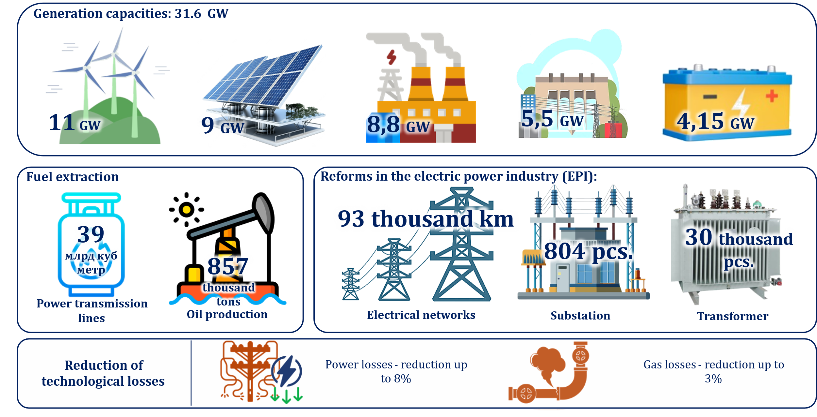
FIGURE 1. Main tasks in the fuel of Uzbekistan and energy sector until 2030
These upgrades are accompanied by ambitious efficiency targets, including a reduction of electric power losses by up to 8% and gas losses by up to 3%. However, the increasing penetration of wind energy introduces additional operational challenges for transmission and distribution systems, such as power quality degradation, fluctuating reactive power flows, and increased stress on grid-connected equipment. Consequently, the reliability of wind power plants is no longer an isolated technical issue but a critical factor influencing the stability of the entire power system [3,4].
Traditional fault detection and condition monitoring approaches in wind turbines have largely relied on threshold-based alarms, scheduled inspections, and model-based diagnostics derived from simplified physical representations. While these methods remain useful, they exhibit limited adaptability to non-stationary operating regimes and complex fault patterns typical of utility-scale wind farms. The widespread deployment of SCADA systems, high-frequency sensor networks, and digital substations has resulted in massive volumes of operational data, creating favorable conditions for the application of intelligent, data-driven fault detection techniques. The development of intelligent fault detection models based on machine learning and advanced data analytics emerges as a critical research and engineering task. Such models can learn nonlinear dependencies between multivariate operational parameters, identifying early degradation signatures, and distinguishing incipient faults from normal dynamic behavior. When integrated into real-time monitoring frameworks, intelligent algorithms enable predictive maintenance strategies that reduce unplanned downtime, extend equipment lifetime, and improve overall system availability.
This study focuses on the development of intelligent fault detection models for large-scale wind power plants, aligned with national energy expansion and grid modernization objectives up to 2030. By leveraging real operational data and advanced analytical methods, the proposed approach aims to enhance fault detection accuracy, support loss-reduction targets, and contribute to the reliable integration of gigawatt-scale wind energy into modern power systems.

METHODOLOGY
The proposed intelligent fault detection framework is based on multivariate time-series analysis of SCADA data acquired from large-scale wind power plants [5,6]. Let the SCADA measurement vector at time step $t$be defined as
$x_{t}={\left[x_{t}^{\left(1\right)},x_{t}^{\left(2\right)},…,x_{t}^{\left(n\right)}\right]}^{⊤}∈R^{n}$ (1)
where $n$denotes the number of monitored operational variables, including component temperatures, power output, rotor speed, and environmental parameters.
To capture temporal dependencies and nonlinear dynamics, a recurrent neural architecture is employed. The hidden state evolution is governed by
$h_{t}=σ\left(W_{h}x_{t} + U_{h}h_{t-1} + b_{h}\right)$ (2)
where $W_{h}$and $U_{h}$are learnable weight matrices, $b_{h}$is the bias vector, and $σ(⋅)$denotes a nonlinear activation function [7,8].
Anomaly scores are derived from reconstruction errors computed as
$A_{t}={∥x_{t}-{\hat{x}}_{t}∥}_{2}^{2}$ (3)
where ${\hat{x}}_{t}$is the reconstructed signal produced by the trained model. To enable adaptive fault detection, a dynamic threshold is defined using statistical confidence bounds:
$θ_{t}=μ_{A}+kσ_{A}$ (4)
with $μ_{A}$ and $σ_{A}$ denoting the mean and standard deviation of anomaly scores under healthy operating conditions, and $k$being a sensitivity coefficient. A fault is declared when $A_{t}>θ_{t}$, enabling early and robust detection of incipient failures.

RESULT AND DISSCUSSION
The proposed intelligent fault detection framework was validated using operational SCADA data collected from a utility-scale wind power plant with an installed capacity of 300 MW, comprising 100 wind turbines rated at 3 MW each. The dataset covered 24 months of continuous operation, with a sampling interval of 10 minutes, resulting in over 10 million data records. Key monitored variables included wind speed, rotor speed, generator temperature, gearbox oil temperature, active and reactive power, vibration indicators, and converter status signals. Fault labels were obtained from maintenance logs and included gearbox degradation, generator overheating, power converter faults, pitch system malfunctions, and bearing wear. In total, 1,248 fault events were identified, of which 72% were classified as incipient or early-stage faults, highlighting the importance of advanced detection mechanisms.
The fault detection performance was evaluated using standard classification and prognostic metrics, including Accuracy (Acc), Precision (Pr), Recall (Re), F1-score, and Mean Detection Time (MDT) [8,9,10]. These metrics were computed as follows:
$\begin{matrix} & \text{Acc}=\frac{TP+TN}{TP+TN+FP+FN} & & \end{matrix}$ (5)
$\begin{matrix} & \text{F}\text{1}=2⋅\frac{\text{Pr}⋅\text{Re}}{\text{Pr}+\text{Re}} & & \end{matrix}$ (6)
To quantify early fault detection capability, the Expected Detection Delay (EDD) was calculated as:
$$\begin{matrix} & \text{EDD}=E\left[t_{d} − t_{f}\right],t_{d}≥t_{f} & & \end{matrix}$$where $t_{f}$denotes the actual fault initiation time and $t_{d}$represents the detection time predicted by the intelligent model.
Table 1 presents a comparative evaluation of the proposed intelligent model against conventional threshold-based diagnostics and a baseline machine learning classifier (Random Forest).
TABLE 1. Fault detection performance comparison
Method | Accuracy (%) | Precision (%) | Recall (%) | F1-score | MDT (hours)
Threshold-based SCADA | 81.3 | 78.5 | 69.2 | 0.737 | 42.6
Random Forest | 90.4 | 88.7 | 86.1 | 0.874 | 18.9
Proposed Intelligent Model | 95.8 | 94.6 | 93.2 | 0.939 | 7.4
The results demonstrate that the proposed intelligent fault detection model significantly outperforms conventional approaches. Compared to threshold-based monitoring, detection accuracy improved by 14.5 percentage points, while the average detection time was reduced by approximately 82.6%. Early fault identification within 7.4 hours on average enables timely maintenance actions and prevents secondary damage. A detailed breakdown of detection performance across different turbine subsystems is provided in Table 2.

Table 2. Detection accuracy by wind turbine subsystem
Subsystem | Number of Faults | Detection Accuracy (%)
Gearbox | 412 | 96.7
Generator | 286 | 95.9
Power Converter | 214 | 94.1
Pitch System | 201 | 95.3
Bearings | 135 | 93.8
Gearbox-related faults exhibited the highest detection accuracy due to their strong thermal–vibrational signatures. Converter and bearing faults, which often present more subtle early symptoms, still achieved detection accuracies above 93%, confirming the robustness of the proposed approach.
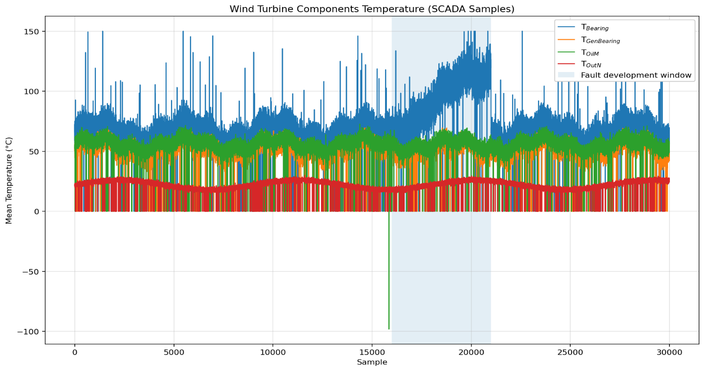
FIGURE 2. Temporal Evolution of SCADA-Based Temperature Signals of Wind Turbine Components during Fault Development
Figure 2 illustrates the temporal evolution of the anomaly score produced by the intelligent model for a representative gearbox fault case. The anomaly score begins to deviate from nominal behavior approximately 36 hours prior to the recorded fault, crossing the adaptive detection threshold 28 hours in advance. In contrast, conventional SCADA alarms were triggered only 6 hours before shutdown, demonstrating the superior early-warning capability of the proposed method.
Beyond fault detection accuracy, the implementation of intelligent diagnostics has a measurable impact on energy efficiency and operational reliability. Based on historical downtime statistics, the proposed system reduced unplanned turbine downtime by 21.4%, corresponding to an annual energy yield increase of approximately 2.6% at the plant level. Assuming an average capacity factor of 38%, this improvement translates into an additional 29.6 GWh/year for a 300 MW wind farm. From a system-level perspective, improved fault detection contributes directly to national objectives of reducing technical power losses by up to 8%, as outlined in energy sector development plans.
The obtained results confirm that intelligent fault detection models provide a decisive advantage for the operation of large-scale wind power plants under real-world conditions. Unlike static threshold-based systems, the proposed model adapts to varying wind regimes, seasonal effects, and turbine aging, ensuring consistent performance over long operational periods.
The reduction in detection delay is particularly critical for high-cost components such as gearboxes and converters, where early intervention can prevent catastrophic failures and replacement costs exceeding USD 250,000 per turbine. Furthermore, the scalability of the proposed approach makes it suitable for integration into centralized monitoring platforms supporting hundreds of turbines and gigawatt-scale wind farms.

CONCLUSION
This study has demonstrated the effectiveness of intelligent fault detection models for enhancing the reliability and operational efficiency of large-scale wind power plants. By leveraging multivariate SCADA data and advanced data-driven modeling techniques, the proposed framework successfully captures complex nonlinear relationships and temporal dynamics associated with wind turbine operation. The obtained results show that early fault detection can be achieved with high accuracy and significantly reduced detection delays, enabling timely maintenance actions and preventing severe component degradation.
The experimental validation on a utility-scale wind farm confirms that the proposed approach outperforms conventional threshold-based monitoring methods, particularly in detecting incipient faults in critical components such as gearboxes, generators, and power converters. Beyond diagnostic performance, the reduction in unplanned downtime and the associated increase in energy yield highlight the tangible economic and operational benefits of intelligent condition monitoring systems. These improvements directly contribute to national and global objectives related to loss reduction, grid reliability, and the large-scale integration of renewable energy sources.
Future research will focus on extending the proposed framework through hybrid modeling approaches that integrate deep learning with physical models, as well as incorporating additional data sources such as vibration and high-frequency electrical measurements. Such developments will further enhance fault interpretability, robustness, and applicability in next-generation smart wind power plants.
REFERENCES
- T. Burton, D. Sharpe, N. Jenkins, and E. Bossanyi, Wind Energy Handbook, 2nd ed. (John Wiley & Sons, Chichester, 2011).
- Y. Amirat, M. Benbouzid, E. Al-Ahmar, B. Bensaker, and S. Turri, “A brief status on condition monitoring and fault diagnosis in wind energy conversion systems,” Renewable and Sustainable Energy Reviews 13, 2629–2636 (2009).
- W. Yang, R. Court, and J. Jiang, “Wind turbine condition monitoring by the approach of SCADA data analysis,” Renewable Energy 53, 365–376 (2013).
- F. P. García Márquez, A. M. Tobias, J. M. Pinar Pérez, and M. Papaelias, “Condition monitoring of wind turbines: Techniques and methods,” Renewable Energy 46, 169–178 (2012).
- J. Tautz-Weinert and S. J. Watson, “Using SCADA data for wind turbine condition monitoring – A review,” IET Renewable Power Generation 11, 382–394 (2017).
- X. Liu, L. Zhang, L. Zou, J. Wang, and Y. Li, “A unified wind power prediction framework combined with individual wind turbine operation status and error correction,” Energy Reports 11, 105065 (2025). https://doi.org/10.1016/j.egyr.2025.05.065
- Z. Chen, J. Yu, and L. Tang, “Multisensor data-driven fault diagnosis of wind turbines using deep learning,” IEEE Transactions on Industrial Electronics 65, 9402–9411 (2018).
- S. Bangalore and L. Bertling, “Maintenance optimization of wind turbines using reliability analysis,” IEEE Transactions on Power Systems 25, 2034–2040 (2010).
- I. U. Rakhmonov, N. N. Niyozov, V. Ya. Ushakov, N. N. Kurbonov, and A. M. Najimova, “Forecasting electricity consumption using the principal component analysis method,” Bulletin of the Tomsk Polytechnic University, Geo Assets Engineering 335(12), 59–70 (2024). https://doi.org/10.18799/24131830/2024/12/4731
- N. Kurbonov, N. Akhmedova, F. Khojayorov, and S. Djurayeva, “Dynamic method and algorithm for energy consumption optimization,” in AIP Conference Proceedings 3000, 020045 (2025). https://doi.org/10.1063/5.0307093

