Evaluation of the Dispersive Composition of Diesel Fuel Under the Influence of Coagulants
Usmonali Sodikov^{1, a)}, Sadokat Mamadalieva¹, Bobomurod Khaydarov², Sodir Makhmudov¹, Sodikjon Kadirov ¹
¹ Fergana State Technical University, Fergana, Uzbekistan
² “Hududgaz Farg’ona” GTF, Fergana, Uzbekistan
^{a)} Corresponding author: numonniezov2@gmail.com
Abstract. When purifying high-resin diesel fuel using an aqueous solution of acid and urea, impurities enlarge and coagulate. In the initial stage of the process, "strong" conglomerates are insufficient, which may be destroyed or fragmented due to high velocity gradients. Therefore, it is crucial to ensure that the high-pressure safety valve does not release gas and that the fuel does not leak into the container. As noted above, the viscosity of the fuel may change accordingly, increasing the pressure in the hydraulic network, which leads to the activation of the fuel injection valve and fragmentation of coagulated impurity particles. To eliminate such effects during the research process, an improved hydraulic network scheme was proposed.
INTRODUCTION
The use of fuel in diesel engines enables the implementation of a high compression ratio, reducing specific fuel consumption by 25-30% compared to carburetor engines. The most important performance indicators of diesel fuel include cetane number, fractional composition, low-temperature and lubrication properties, cleanliness level, viscosity, sulfur compounds, hydrocarbons, and the presence of metals, as well as the flash point, which determines safety [1-3].
The cetane number determines the combustion process severity, fuel consumption, and exhaust gas pollution. The higher the cetane number, the more rigidly the engine operates. The higher the cetane number of diesel fuel, the faster the mixture burns, and the engine starts. However, increasing the cetane number deteriorates engine efficiency and increases exhaust gas smoke [1-8].
The cetane number of diesel fuel depends on its hydrocarbon composition. Naphthenic hydrocarbons have a lower cetane number compared to aromatic hydrocarbons. It has been found that the higher the boiling point of the fuel, the higher its cetane number, and this dependence is linear [1].
Using diesel fuel with a cetane number below 40 in engines leads to harsh operation of the internal combustion engine (ICE). In contrast, fuel with a cetane number of 47-50 significantly increases specific fuel consumption [8-10].
To increase the cetane number of diesel fuel, special additives can be introduced both during the production stage and when using fuel in automotive engines [11-13].
However, in both cases, negative side effects may occur due to the influence of additives on fuel properties, such as increased fuel carbonization [14-15].
When directly used in operational conditions, fuel additives that increase the cetane number may lead to extremely negative results and cause emergency engine failure [16].
METHODS
The methodology for studying the dispersive composition of contaminants and impurities in diesel fuel was based on determining particle sizes using microscopy, an FS-151 device, and photon correlation spectroscopy. The analysis was conducted on fuel stored at an oil depot, fuel from agricultural enterprises, and fuel after exposure to coagulants—an aqueous solution of sulfuric acid and urea.
Fuel characteristics were analyzed according to the following indicators:
- Fractional composition according to GOST 217-99.
- Kinematic viscosity according to GOST 33-82.
- Cloud point according to GOST 5066-91.
- Pour point according to GOST 20287-91.
- Limit temperature of filterability according to GOST 22254-92.
- Flash point in a closed crucible according to GOST 6356-75.
- Mass fraction of sulfur according to GOST 51947-2002.
- Concentration of actual resins according to GOST 8489-85.
- Acidity according to GOST 5985-79.
- Ash content according to GOST 1401-85.
- Density according to GOST 3900-85.
- Content of mechanical impurities according to GOST 6370-83.
- Water content according to GOST 2477-65.
System analysis revealed that the most important characteristics of diesel fuel are its low-temperature properties.
During transitional operation of tractors in autumn and winter, discrepancies between the maximum filtration temperature and freezing temperature of the fuel frequently arise.
To improve these characteristics, it is recommended to add depressant additives to the fuel. The recommended concentrations of additives and mixing processes are generalized without analysis, considering the properties of the original diesel fuel.
It was found that fuels can be produced from oils of different origins and different hydrocarbon compositions, which, accordingly, have different structures. Changing the paraffin content in fuel is difficult, but its dispersive composition can be modified by introducing depressant additives.
RESULTS AND DISCUSSION
If fuel is considered an ultradispersed system in which heavy hydrocarbon fractions, sulfur compounds from petroleum, and other substances are dissolved, then the stability of this system can be significantly altered by introducing small amounts of electrolytes. In lyophobic systems, the addition of electrolytes significantly increases the rate of coagulation. Based on certain theoretical principles of coagulation processes and research results on destabilization of lubricant dispersion systems, urea—a widely used mineral fertilizer in agricultural production—was employed to evaluate the coagulation ability of dissolved impurities in fuel.

Table 1 - Specific electrical conductivity of an aqueous solution of urea depending on the content of dry matter
No.  p/p | Amount of urea in water, mass % | Specific electrical conductivity of an aqueous solution of urea,  (ohm ⁻¹ cм⁻¹)10 ⁻⁶
1  2  3  4  5  6  7  8  9  10  11  12  13  14  15 | 0.1  0,5  1.0  2.0  3.0  6.0  10.0  15.0  20.0  30.0  40,0  50,0  60,0  70,0  80,0 | 3.0  5.0  7.0  16.5  17.3  21.2  27.0  31.4  35.6  42.4  46,0  49,0  50,0  51,0  53,0

To assess the electrolytic properties of urea, it was crushed and dissolved in water.
Table 1 presents data on changes in the specific electrical conductivity of an aqueous urea solution depending on the amount of dry substance in the solution.
The data in Table 1 confirm the electrolytic capability of urea. When the concentration of urea in water exceeds 50%, electrical conductivity slightly increases, which may indicate the onset of equilibrium in the electrolytic dissociation process.
Practical studies on the ability of urea aqueous solutions to coagulate dissolved impurities in diesel fuel were conducted using fuel containing 60 mg/100 cm3 of actual resins. The fuel stored at a commercial oil depot in the Tambov region and in the Ural Republic of Kazakhstan contained more than 70 mg/100 cm3 of actual resins.
The initial fuel was heated to temperatures of 80, 90, 100, and 110°C, and a 50% aqueous solution of urea was added at concentrations of 0.1%, 0.5%, 1%, 2%, and 3% by weight. Subsequently, the fuel was stirred and allowed to settle for 180 minutes, with samples taken every 30 minutes to assess the coagulation process under a microscope.
The results of studies evaluating the coagulation ability of urea aqueous solutions at different temperatures and concentrations based on sedimentation time are presented in Table 4.2.
Considering the importance of the lubricating properties of fuel, research was conducted on improving these properties by adding anti-wear additives and urea compounds. Theoretical studies have shown that even a small amount of urea aqueous solution can positively impact lubricity and reduce the amount of actual resins and sulfur in the fuel purified by physical methods.
The initial fuel was analyzed for fractional composition, kinematic viscosity, actual resin content, and total sulfur content.
An aqueous solution of urea consisting of 50% water and 50% granular urea was added to the fuel. The mixture was stirred at 15-20°C until complete dissolution of the urea. The urea aqueous solution was added to the fuel at concentrations of 0.05%, 0.1%, 0.2%, 0.3%, 0.4%, and 0.5% by fuel weight.
The mixture was stirred and heated to 100°C. The temperature was maintained at 100°C for 10 to 30 minutes before allowing the fuel to settle. Changes were observed every 5 minutes under a Biolam-70 microscope with photographic documentation. The fuel was left to settle for 120 minutes.
If globule formation and sedimentation processes were observed, the studied mixture was placed in a laboratory centrifuge, where the fuel was purified from suspensions at different speeds -for 15 minutes.
In the next stage of the study, the viscosity, fractional composition, and actual resin content of the purified fuel were analyzed.
The selection of coagulants for the aggregation of resins, asphaltenes, and oxidation products in diesel fuel was carried out based on theoretical research and analysis of known purification methods.
In the initial stage of fuel purification, the primary reagents considered were sulfuric acid, hydroxide, and urea.
To remove resins from petroleum distillation products, sulfuric acid was added to diesel fuel at temperatures of 10-30°C, with stirring for 5-10 minutes. The acid was added at concentrations of 0.1%, 0.2%, 0.3%, 0.4%, and 0.5% by fuel mass.
After completing the acid mixing process, the mixture was stirred and allowed to settle. The aggregation process of impurities was observed under a Biolam-70 microscope every 5 minutes.
An aqueous solution of soda ash (commercial grade) was used as a coagulant to aggregate resins and oxidation products using hydroxide. The water-to-soda concentration was 1:1, and the hydroxide solution was added to the diesel fuel at a concentration of 0.3%.
Before adding the hydroxide aqueous solution, the fuel was preheated, after which the hydroxide solution was introduced, and the coagulation efficiency was evaluated under a microscope using a drop sample.
Urea was selected as the primary coagulant for fuel purification from resins.
To examine the coagulation process of resins, asphaltenes, and oxidation products in fuel, urea, commonly used as a mineral fertilizer in agriculture, was employed. Urea was dissolved in water in a 50:50 ratio.
Aqueous urea solutions at concentrations of 0.1%, 0.2%, 0.3%, 0.4%, 0.5%, 0.6%, 0.7%, 0.8%, 0.9%, and 1% by weight were added to diesel fuel. The mixture was stirred and heated to temperatures of 60, 70, 80, 90, and 100°C, with stirring times of 5-10 minutes. The mixture was then allowed to settle for 0.5-1.5 hours. Every 10 minutes during the sedimentation process, drop samples were examined under a microscope to observe the aggregation of resins and impurities.
Research was conducted to assess the electrolytic properties of the urea aqueous solution, which involved determining the specific electrical conductivity of the liquid depending on its dry matter content.
To analyze changes and evaluate the dispersion composition of impurities, fuel mixed with a urea aqueous solution was studied using photon spectroscopy according to Method 3.2.
During studies assessing the coagulation ability of reagents, changes in the actual resin content in the fuel were examined according to the methodology of GOST 8489-85.
Based on the obtained results, the optimal concentrations of coagulants, the duration of the coagulation process and sedimentation, the rational temperature for fuel coagulation processes, and the preliminary evaluation of resin and oxidation product aggregation were determined.
When selecting sulfuric acid as a coagulant, the acidity of the fuel was determined according to GOST 5985-79.
Data processing was carried out using recognized statistical methods for analyzing and processing research results.
In accordance with the research objectives of removing mechanical impurities, dissolved contaminants, and water, their dispersion composition was examined. This allows for the selection of technical means for purifying fuel from all types of contaminants.
Diesel fuel, in its original form, does not contain mechanical impurities or water. However, during transportation and especially storage, various contaminants, impurities, oxidation products, and water accumulate in it.
Research conducted using the FS-151 device found that fuel stored at a commercial oil depot contained almost no contamination. However, fuel stored at agricultural enterprise depots contained mechanical impurities in the dispersed composition ranging from 5 to 100 microns (Table 2).

Table 2. The result of the analysis of the dispersed composition of pollutant particles of diesel fuel (using the FS-151 device).
Diesel fuel sampling site | The number of pollutant particles in 1 ml of fuel by volume, µm
Diesel fuel sampling site | 5-10 | 10-15 | 15-20 | 20-30 | 30-40 | 40-50 | More than 50
Oil products supplier organization (1) | 1 | - | 2 | 5 | 1 | - | -
Fuel from a storage tank of an agricultural enterprise (2) | 185 | 155 | 237 | 69 | 47 | 18 | 12

Analysis of the Data in Table 2 It should be noted that almost all particles can be removed from the fuel by centrifugation or filtration.
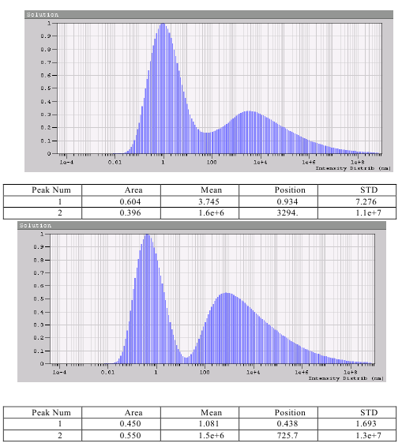
FIGURE 1. Oil products supplier organization

Table 3. Peak analysis results of particle size distribution based on intensity
Peak num | Area | Mean | Position | STD
1 | 0.604 | 3.745 | 0.934 | 7.276
2 | 0.396 | 1.6×10⁶ | 3294 | 1.1×10⁷

FIGURE 2. Diesel fuel from an agricultural enterprise
Table 4. Peak parameters obtained from intensity-based particle size distribution analysis
Peak No. | Area | Mean | Position | STD
1 | 0.450 | 1.081 | 0.438 | 1.693
2 | 0.550 | 1.5 × 10⁶ | 725.7 | 1.3 × 10⁷

In our case, the fuel purification process aims at a deeper improvement of its operational properties, which includes not only the removal of mechanical impurities but also the removal of dissolved resins and asphaltenes from diesel fuel.
The particle sizes in the analyzed fuels were studied using the dynamic light scattering method (Method 3.3) (Tables 3 and 4).
As seen in Figures 1 and 2, both fuels have two peaks with areas of 0.450 and 0.501, indicating the presence of a large amount of organic compounds—such as resins and asphaltenes—in the analyzed fuel.
It is difficult to associate the impurities in the fuel with oxidation products, i.e., degradation products due to improper storage. Most likely, this suggests violations in the fuel production technology according to EN 590 and even GOST 305-82.
In the next stage of the research, the change in spectra during precipitation after adding sulfuric acid to the fuel was examined.
After adding sulfuric acid to the fuel, the nature of the peaks changes, and their areas also vary (Figure 3). This can be attributed to the reaction between the sulfuric acid and the components in the fuel. An increase in the number of particles with a size greater than 100 nm is observed. The process of conglomeration of the smallest particles is also present.
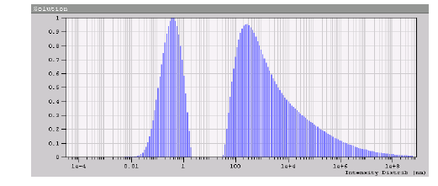
FIGURE 3. Spectrum of diesel fuel after adding sulfuric acid

Table 5. Peak parameters obtained from intensity-based particle size distribution analysis
Peak Num. | Area | Mean | Position | STD
1 | 0.317 | 0.437 | 0.408 | 0.354
2 | 0.683 | 9.3 × 10⁵ | 272.7 | 8.8 × 10⁶

A similar picture can be observed when an aqueous solution of urea is added to the fuel (Table 6.).

Table 6. The spectrum of diesel fuel after the addition of an aqueous solution of urea
Peak Num | Area | Mean | Position | STD
1 | 0.389 | 0.284 | 0.259 | 0.214
2 | 0.611 | 6.2e+5 | 148.9 | 5.0e+6

Analyzing the spectra in Tables 5 and 6, it should be noted that the dispersion composition of the fuel changes upwards. At the same time, it is difficult to definitively state that the conglomerates formed can be easily removed using physical purification methods without special ultracentrifuges and filters with a purification precision of less than 1 micron.
To conduct a detailed analysis of the qualitative and quantitative composition of contaminants and develop a diesel fuel purification method, changes in the dispersion composition of the impurities were observed under a microscope through microphotography when acid, an aqueous solution of urea, and their combination were added. The coagulation process of the impurities was monitored every 10 minutes under different concentrations of the applied solutions. The mixing of fuel with acid was carried out at a temperature of 20°C. When mixed with an aqueous solution of urea, the fuel was heated to a temperature of 90-100°C. The process of impurity coagulation in diesel fuel upon the addition of sulfuric acid and subsequent addition of an aqueous solution of urea was studied at temperatures of 20°C and 100°C.
This type of analysis showed that the most effective impurity coagulation process in fuel occurs within the first 20 minutes after adding 0.1% sulfuric acid. After 30 minutes of mixing, the particle growth process stops. Increasing the acid concentration enhances particle growth, but the increase in concentration alone is not sufficient to be considered the main factor in the coagulation process.
Studying the coagulation processes of contaminants and impurities in fuel under acid influence, as well as its potential negative impact on the fuel (such as a significant increase in acidity), led to the selection of a minimal yet sufficient sulfuric acid concentration. This concentration allows the particles to grow to a size where they can be captured by intermolecular forces and subsequently removed in centrifugal force fields.
The effect of an aqueous solution of urea on the dispersion composition of the fuel was found to be less effective compared to acid. When the fuel was heated to 100°C and mixed with an aqueous solution of urea for 10 minutes, particles with a size of 1-3 microns were observed. After 20 minutes, particle growth became noticeable, reaching 10-20 microns. However, further mixing (up to 30 minutes) did not lead to significant aggregation or "grouping" of particles.
The combination of coagulants, i.e., mixing acid with an aqueous solution of urea before adding it to the fuel, slightly enhances the coagulation effect compared to the individual influence of sulfuric acid or urea solution alone. In this case, as in the first scenario with acid, maximum coagulation occurs within the first 20 minutes of mixing. Subsequently, no significant changes are observed, and an active sedimentation process of the coagulated particles in diesel fuel begins.
By evaluating the dispersion composition of coagulated diesel fuel particles using a microscope ocular micrometer, it can be stated with some confidence that introducing a combined composition allows for a transformation of the liquid fuel structure from a uniform monodisperse to a polydisperse system, incorporating particles of 5-10 microns in size.

Influence of Fuel Viscosity. Fuel viscosity significantly influences the formation of the fuel-air mixture and the evaporation processes in diesel engines. The structure of the fuel spray, the size of the fuel droplets, and the distance they travel in the combustion chamber depend on it. Lower viscosity ensures better atomization of the fuel, while increasing viscosity leads to an increase in droplet diameter (Figure 5), thereby reducing combustion efficiency. This results in higher specific fuel consumption and an increase in the opacity of exhaust gases [1].
At the same time, it is logical to assume that viscosity is functionally related to the lubricating properties of the fuel. The lower the viscosity, the thinner the lubricating film on friction surfaces, which affects wear conditions and component durability. Fuel viscosity has a significant impact on the operation of fuel injection equipment, determining the internal friction of fuel flow and thus influencing hydraulic energy losses in the fuel supply system. It also affects the leakage of fuel through the precision clearances in fuel system components [2,3,4,8].

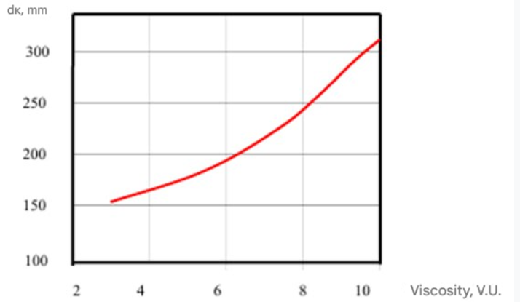

FIGURE 5. The fineness of fuel atomization (Dk - average droplet diameter) in relation to its conditional viscosity

A decrease in viscosity leads to the following:
- Increases fuel consumption to compensate for changes in cyclic supply and reduced injection pressure.
- Worsens the lubricating properties of the fuel, accelerating wear in piston pairs.
- Increases carbon formation and smoke in exhaust gases, as well as leakage in injectors.
The anti-wear properties of diesel fuel deteriorate almost linearly with decreasing viscosity [1].
Fuel viscosity increases as ambient temperature decreases. The higher the viscosity value at 20°C (standardized by technical specifications), the stronger its dependence on temperature [1,3,4,5,8].
The low-temperature properties of diesel fuel are characterized by the cloud point (tp), the pour point (tz), and the maximum filtration temperature (tpf) [1]. The cloud point is the temperature at which the fuel loses its phase uniformity due to the appearance of kerosene and ice crystals. Paraffin crystals can clog fuel filters, disrupting fuel supply to the high-pressure pump and injectors [1,7].
At low temperatures, winter diesel fuels may solidify at -30 to -40°C, while summer diesel fuels solidify above -5°C, losing fluidity [1].
Mixing summer and winter diesel fuels worsens their low-temperature and anti-wear properties [3,5,7].
It has been proven that the better the low-temperature properties, the lower the cetane number [1].
The maximum filtration temperature (tpf) is a crucial operational indicator of fuel. In some cases, tpf may equal the cloud point. Adding depressant additives to fuel can reduce the filtration limit temperature by 10-15°C and the pour point by 15-20°C. However, additives do not affect the cloud point. This is due to the mechanism of depressant additives, which modify the structure of crystallizing paraffins rather than reducing their quantity [1]. This means that kerosene content remains unchanged, but the dispersion size of the paraffins decreases. Consequently, fuel can pass through filter pores without clogging them.
Reducing kerosene content in fuel is only possible through processes such as de-waxing, zeolite treatment, urea treatment, and catalytic fuel purification.
In many cases, to improve the low-temperature properties of fuel in operational environments, especially in agricultural production, summer diesel fuel is mixed with gasoline. However, this leads to increased engine component wear and a decrease in cetane number.
It should be noted that the actual resins in the fuel (Figure 5) decrease depending on the concentration of the aqueous urea solution added. However, when the concentration exceeds 0.5%, the changes in resin content become insignificant.

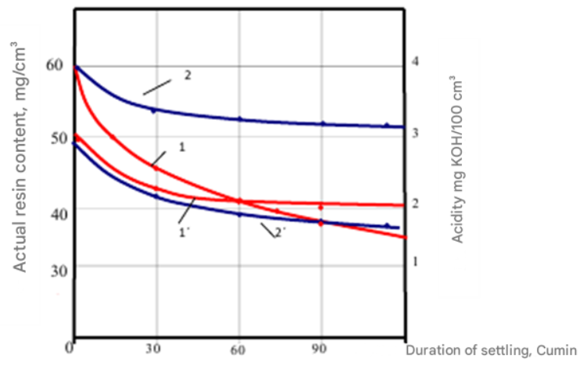
1.1g - acid + urea solution; 2.2g - acid + alkali.
FIGURE 6. The dependence of the acidity and composition of the real resins in the fuel on the duration of the curd (Addition = 90 ° C) for different compounds

Furthermore, after exposure to acid, the actual resin content in the fuel decreases to 25-30 mg/100 cm³, whereas treatment with an aqueous urea solution result in a resin content of up to 40 mg/100 cm³. However, acid increases fuel acidity, while urea reduces it by 40-45%.
In this regard, research was conducted on combined reactive compositions. Specifically, the feasibility of introducing the following combinations was considered:
- 0.1% acid + 0.5% (50%) aqueous urea solution.
- 0.1% acid + 0.5% aqueous hydroxide solution.
The changes in fuel acidity and actual resin content based on the sedimentation time of different compound mixtures are illustrated in Figure 6.
It can be seen from figure 6 that the mixture of sulfuric acid and urea solution in water, when added to diesel fuel, allows the reduction of the real amount of resins in it from 60 mg/100 cm³ to 35 mg/100 cm³, while the acidity of the fuel decreases from 3 mg KOH/100 cm³ to 2 mg KOH/100 cm³. Compared to the effect of just the acid, the addition of the combined composition reduces the amount of real resins in the fuel almost equally, and the acidity of the fuel does not increase, but rather decreases.
Taking into account the combination of sulfuric acid-hydroxide (2-2 line), we emphasize that adding 0.1% acid and 0.5% aqueous hydroxide solution to the fuel does not significantly reduce the amount of real resins, as compared to the first compound, but significantly reduces the acidity of the fuel. This fact is likely explained by the neutralizing effect of the acid with the alkali.
Analyzing the results of the research, we can conclude that among the examined agents, the mixture’s coagulation effect in the fuel is most pronounced when it interacts with the urea solution in water, and a small amount of sulfuric acid is added to activate the process.
The optimal composition of the agent (coagulant) is a mixture made of a 50% urea solution in water, with 0.5% sulfuric acid added to the fuel. The results of the experiments on the removal of coagulated mixtures using cleaning agents confirm this, and further analysis is needed to examine the removal of dissolved water and the lubricating properties of the fuel.
The results of the research align with theoretical foundations and confirm the adequacy of the method of cleaning fuel with coagulants to increase the size of the mixtures.
While positively evaluating the research results, we also emphasize that the coagulated mixtures settle over time, and the "gravimetric method" is not very effective, which requires the search for technical tools that activate the precipitation process.
To determine the parameters of the sedimentation process, for example, in the radial area, further research is needed to evaluate the dispersed composition of the fuel mixtures after the influence of coagulant substances, as well as the dispersed composition of mechanical mixtures and water in the original fuel.
Depressant additives, which are added in the range of 0.01-0.1% by weight, not only improve low-temperature properties but may also possess lubricating properties.
The technical conditions for diesel fuel, as specified by GOST 305-82, GOST R 52368, and the technical conditions for tractor engines, do not allow for the presence of mechanical impurities in the fuel.
Fueld sold from petroleum bases usually meets the required standards, but contamination often arises due to violations during transport, storage, refueling, and other processes.
In particular, solid mechanical impurities, such as sand, dust, etc., lead to abrasive wear of the metal. As a result, normal fuel supply to the engine cylinders is disrupted, which reduces power. The wear of the equipment parts, especially the delicate pump pairs, increases, and filters become clogged. Depending on the contamination of the fuel, the service life of a high-pressure pump can be reduced by 5-6 times.
The operational lifetime of an engine is determined by the wear of 80% of its parts. Using contaminated diesel fuel can cause local wear on the piston (up to 30-35 µm), liner (15-17 µm), and exhaust valve (25-30 µm). Changing the clearance in the nozzle and piston pairs significantly affects engine performance. The increase in contaminants in the diesel fuel leads to clogged fuel filters, increased wear of pumps and injectors, leakage and spillage of fuel in the engine cylinders. The clogging of the nozzle holes with harmful substances leads to malfunctioning and failure.
Small amounts of mechanical impurities and carbon compounds that settle on carefully processed surfaces may result in traces and scratches with a depth of up to 0.005 mm.
The technical conditions for fuel and GOST do not allow water in diesel fuel, as it increases the corrosion rate, disrupts the normal combustion process, and worsens its pumpability and filtration. All of these factors significantly increase engine wear.
The presence of dissolved water in fuel, at 0.1% or more, leads to an increase in the filtration coefficient. However, the effect of this fact has not been clearly determined. The presence of surface-active substances, naphthenic acid soaps, and resinous compounds in the fuel mixture intensifies the negative impact on the filtration of emulsified water in the fuel. To increase the filtration coefficient from 2 to 5, a 10-4% content of naphthenic acid soaps produced during fuel alkalinization is sufficient (15-20).
The carbon-forming properties describe a tendency to form specific deposits on parts of the cylinder-piston group.
The following characteristics of diesel fuel affect the formation of carbon: its fractional composition, the presence of asphalt-resin compounds, the sulfur content, and mechanical impurities. The presence of sulfur compounds in these components significantly affects the corrosive aggressiveness of diesel fuels.
It is known that the boiling point of organic sulfur compounds in oil is higher than 200°C, which is why the sulfur content in diesel fuel is higher than in gasoline. These compounds interact slightly with the metal directly, but during combustion, they form aggressive sulfur oxides, CO2, and SO3. When interacting with water, these oxides form sulfuric acid and sulfur dioxide.
The aggressiveness of diesel fuels is greatly influenced by their hydrotreating depth, as this removes surface-active substances together with sulfur and aromatic compounds, which leads to a deterioration in the protective properties of the fuel. The removal of surface-active substances reduces the ability of the fuel to expel water from metal surfaces and form protective films.
The corrosion of diesel fuels is primarily dependent on mercaptan sulfur content. Thus, increasing the mercaptan sulfur content from 0.01% to 0.06% more than doubles the corrosion rate. The corrosive activity of mercaptan sulfur in diesel fuel is significantly influenced by the presence of water and dissolved oxygen, accelerating the formation of mercaptans.
Fuel acts as a lubricating material for the moving parts of fuel equipment. The anti-wear characteristics of fuels improve with higher viscosity, higher boiling points, and increased amounts of surface-active substances.
Due to the strengthening of sulfur content standards and the transition to the production of environmentally clean fuel (Euro), they are hydrotreating under severe conditions. In this case, compounds containing sulfur, oxygen, and nitrogen are removed from the fuel, which negatively affects its lubricating properties.
The chemical stability of diesel fuel is the ability to resist oxidation processes that occur during storage. This problem arose when secondary petroleum refining introduced medium distillate fractions, such as catalytic cracking and coking products, into commercial diesel fuel. The latter is enriched with unsaturated hydrocarbons and contains high amounts of sulfur and resinous compounds. The presence of these compounds along with unsaturated hydrocarbons aids their oxidative polymerization, thus influencing the formation of resins and sediments.
The increase in sulfur content in diesel fuel increases carbon formation, deteriorates the cooling conditions of the cylinder-piston group, and leads to a decrease in power. Moreover, the oxidation and aging processes of motor oil accelerate.
An analysis of the main operational characteristics of diesel fuels has shown that most of them are interconnected. For example, the viscosity of the fuel is related to its fractional composition. The latter, in turn, is related to anti-wear characteristics and chemical stability. Depending on the distillation conditions and fractional composition, the fuel may contain small amounts of sulfur, which affects the lubricating properties of the fuel. The lubricating properties are also influenced by the fuel's viscosity and fractional composition. The corrosion of fuel depends on the sulfur and hydrogen sulfide content, as well as the presence of water in the fuel. The low-temperature properties of the fuel are related to its fractional composition, which is especially important for the operational conditions of transport vehicles in the winter season.
CONCLUSION
The dispersive composition of the fuel, when removed from the area of centrifugal forces, allows approaching the selection and determination of the most effective cleaning agents for the process of removing impurities. Based on the theoretical concept of improving the performance characteristics of diesel fuel, this hypothesis requires verification and further investigation to determine the lubricating and anti-wear characteristics of the fuel after the removal of centrifugal force-based impurities. Research is needed to remove both free and dissolved water from diesel fuel.
REFERENCES
- B. P. Tonkonogov, et al., “Development of a proximate IR spectrometric method for the determination of base oil viscosity, viscosity index, and pour point,” Chemistry and Technology of Fuels and Oils 52(1), 76–84 (2016).
- V. V. Ostrikov, A. P. Ukhanov, O. A. Kleimenov, K. U. Safarov, S. A. Nagornov, and V. D. Prokhorenkov, Fuels, Lubricants, and Technical Fluids (UGHA, Ulyanovsk, 2009), 576 pp.
- C. V. Horie, Materials for Conservation (Routledge, London, 2013).
- S. P. Srivastava and J. Hancsok, Fuels and Fuel-Additives (John Wiley & Sons, Hoboken, 2014).
- L. B. Getsov, Materials and Strength of Gas Turbine Parts, Vol. 1: Materials, Properties, Damage, Deformation and Fracture Models (Springer Nature, Cham, 2021).
- G. P. Lyshko, Fuel, Lubricants, and Technical Fluids (Kolos, Moscow, 1979).
- M. Balakrishnan, et al., “Novel pathways for fuels and lubricants from biomass optimized using life-cycle greenhouse gas assessment,” Proceedings of the National Academy of Sciences 112(25), 7645–7649 (2015).
- Z. A. Mansurov, et al., Mechanochemical Synthesis of Composite Materials (Jenny Stanford Publishing, Singapore, 2022).
- V. Zentsov, et al., “Cleaning of wastewater contaminated with petroleum products,” Journal of Hazardous, Toxic, and Radioactive Waste 30(1), 04025030 (2026).
- H. Helms, M. Jamet, and C. Heidt, Renewable Fuel Alternatives for Mobile Machinery (Institut für Energie- und Umweltforschung, Heidelberg, 2017), pp. 11–12.
- V. Singh, R. K. Srivastava, and A. K. Bhatt, “Prevention and control of air pollution,” in Battling Air and Water Pollution: Protecting Our Planet's Vital Resources (Springer Nature Singapore, Singapore, 2025), pp. 77–93.
- E. A. Karpova, “Methodology for determining the financial condition of an organization in the conditions of the new economy of Russia,” APK Rossii 75(1), 195–206 (2016).
- F. J. Dechow and F. K. Dechow, Separation and Purification Techniques in Biotechnology (Noyes Publications, Park Ridge, 1989), pp. 357–358.
- K. N. Graham, Evaluation of Analytical Methodologies for Diesel Fuel Contaminants in Soil (Master’s thesis, 1998).
- S. Burlaka, “Diesel fuel spills and their elimination methods,” Tekhnika, Energetika, Transport APK 3(118), 26–30 (2022).
- V. V. Popp and V. D. Dinulescu, “Dehydration and desalting of heavy and viscous crude oil produced by in-situ combustion,” SPE Production & Facilities 12(2), 95–99 (1997).

