Modeling of the Measuring Unit with MMD for Ground Faults in Power System
Nodir Ataullaev ^{1,a)}, Amin Ataullaev¹, Bobur Muxammadov¹, Amin Ataullaev²
¹Navoi State University of Mining and Technologies, Navoiy, Uzbekistan
² Andijan State Technical Institute, Andijan, Uzbekistan
^{a)} Corresponding author: nodir-82@list.ru
Abstract. A measuring unit with a magnetically modulated device (MMD) for selective ground-fault detection in power systems is modeled. The unit extracts the differential current ∆Idiff from a high-frequency modulation signal and processes it using gain scaling, moving-average filtering, stability check, and synchronous detection. A trip signal is allowed only when both ∆Idiff exceeds the setting and the zero-sequence voltage U0 is above threshold, which prevents false trips under noise and capacitive unbalance. MATLAB/Simulink results show high sensitivity, fast response (<10 ms), and improved selectivity for mining power networks with variable parameters.
INTRODUCTION
The measuring unit with a magnetically modulated device (MMD) consists of two main subsystems: The measuring section, which includes two magnetic systems. The logical section, which implements algorithms for signal processing and filtering [1]. This unit generates the differential current signal ∆I_{diff} based on the high-frequency amplitude-modulated voltage that arises during the saturation of the MMD core. The resulting signal contains: the fundamental modulation frequency (10–20 kHz), the second harmonic (2× excitation frequency), and a low-frequency component proportional to ∆I_{diff.}
To extract ∆I_{diff}, a synchronous detector is employed, which multiplies the signal by the reference frequency and integrates the result over one period, thereby producing a voltage:
$U_{дет}=\frac{1}{T}\int_{0}^{T}{U_{2}}∙sin\left(2πf_{m}t\right)dt$ (1)
where T– is the period, adapted for real-time operation in power systems (response time < 10 ms).

EXPERIMENTAL RESEARCH
High-frequency noise arising from switching events and induced disturbances necessitates the use of sequential filtering logic, which integrates conventional approaches (low-pass filtering LPF) and amplification) with adaptive algorithms (analysis of U₀). The sequential filtering logic (Fig. 1) is designed as a multi-stage algorithm for processing the signals I₀._{start} and I_{0.end} from two magnetic systems. It includes the following stages:
1.Signal synchronization: The signals are aligned with respect to inherent delays to ensure temporal coherence, which is critical for differential analysis.
2.Preliminary amplification and scaling: Within this framework, the signals pass through a cascaded amplification stage with coefficients analogous to Gain (0.01) and Gain (10), enabling normalization and amplitude compensation.
$I_{0.norm}\left(n\right)=0.01∙{∆I}_{diff}\left(n\right)$, (2)
$I_{0.forced}\left(n\right)=10∙I_{0.norm}\left(n\right)=0.1∙{∆I}_{diff}\left(n\right)$ (3)
3.Filtering of high-frequency noise: A moving average with a window of N=5N = 5N=5 samples is applied to suppress components above 200 Hz.
$I_{0.filter}\left(n\right)=\frac{1}{N}\sum_{k=n-N+1}^{n}{I_{0.forced}\left(k\right)}$ (4)
Stability analysis: The difference between the current and the previous values is verified.
${∆I}_{0.stab}=\left|I_{0.filter}\left(n\right)-I_{0.filter}\left(n-1\right)\right|$ (5)

If ΔI_{0.stab}<ε I (where ε=0.01 A), the signal is considered to be free from noise. Computation of the differential current: The filtered signals are used for:
4. Computation of the differential current: The filtered signals are used for:
${∆I}_{0.filter}=I_{0.filter.begin}-I_{0.filter.end}$ (6)
5.Transfer to the control block: ΔI_{0.filter} U₀are transmitted for the formation of the trip signal.
The model of the measuring unit is presented in Fig. 1 and includes:
Two MMD magnetic systems: Modeled as Controlled Current Sources with S=0.1 V/, located at the input and output of the line [29-58].
Sequential filtering logic: A subsystem consisting of Gain (0.01), Gain (10), Moving Average (N=5N = 5N=5), Subtract for ΔI_{0.stab} and a Relational Operator for ε
Control block: Combines ΔI_{0.filter} and U₀for analysis.
Scope: Displays I_{0.filter}and ΔI_{0.filter}
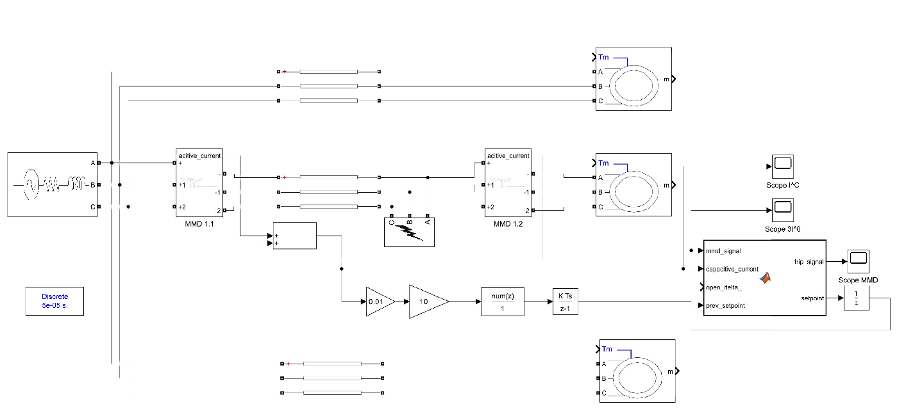
FIGURE 1. Diagram of the measuring unit with MMD for selective detection of single-phase-to-ground fault location in power systems (adapted: two MMDs at the line ends, filtering logic for energy complexes with RES, integration with SCADA).

The event of a single-phase-to-ground fault (phase A short-circuited through for 0.02 s), ΔI_{diff} increases, with the differential current:
${∆I}_{diff}=I_{0.begin}-I_{0.end}$ (7)
where I_{0.start} and I_{0.end} I₀ are the currents at the line ends. In the normal operating mode, ΔI₀<I_{set}=1.2⋅ΔI_{diff} ΔI₀<I_{set}=1.2⋅ΔI_{diff.} The filter attenuates noise (amplitude 0.05 A, 200 Hz) to a level suitable for analysis.
RESEARCH RESULTS
Synchronization with U₀ confirms the combined approach: the trip signal is generated only when (U₀>U_{th})↔(ΔI_{diff}>I_{set}) leftrightarrow, thereby avoiding false tripping.
The filtering logic is integrated with the control block. The setting value and trip signal are defined as:
I_{set}=1.2⋅ΔI_{diff}.I
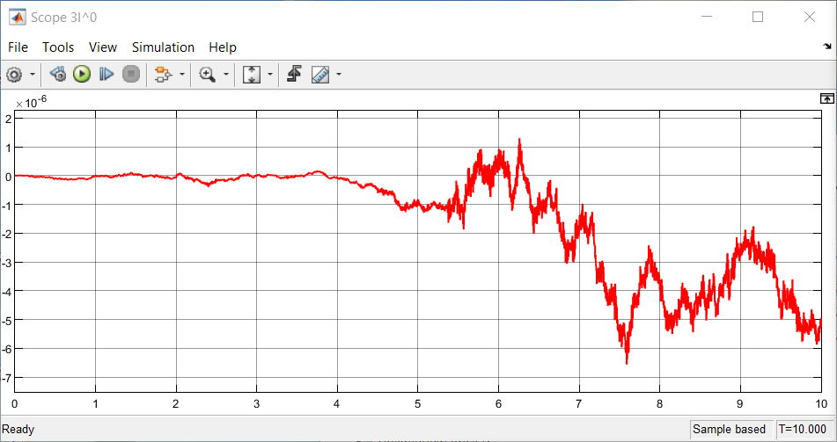
a)
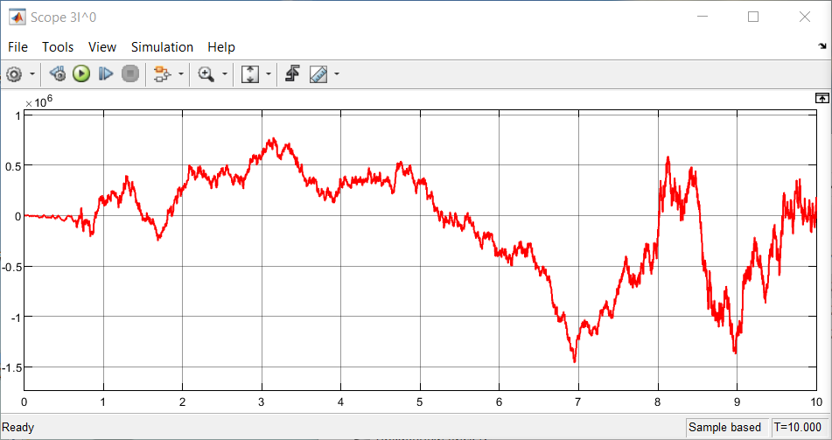
b)
FIGURE 2. Characteristic with ground fault (b) and without ground fault (a) in power systems (adapted: increase of ΔI_{diff} under ground fault conditions).

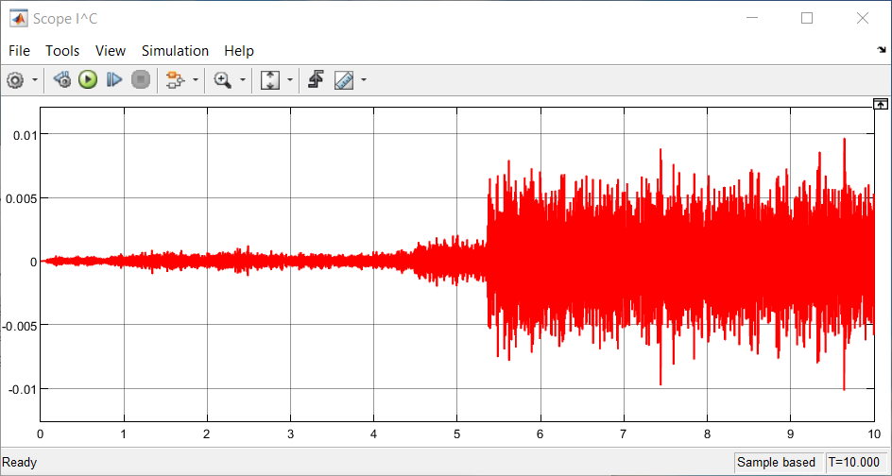
a)
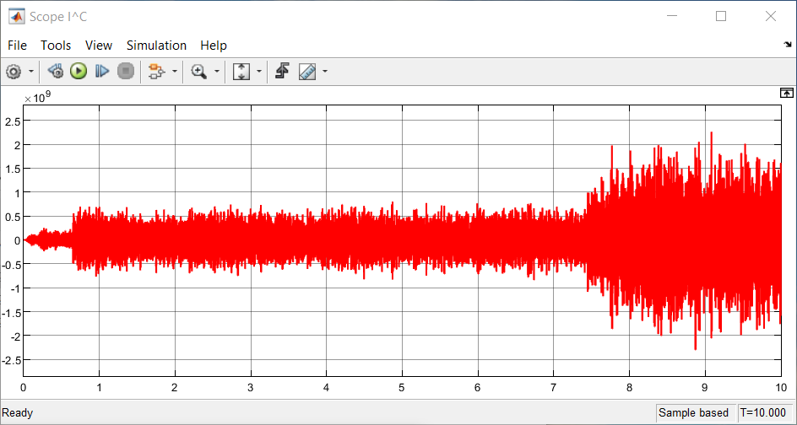
b)
FIGURE 3. Characteristic of the MMD current with ground fault (b) and without ground fault (a) (adapted: differential analysis for energy complexes).

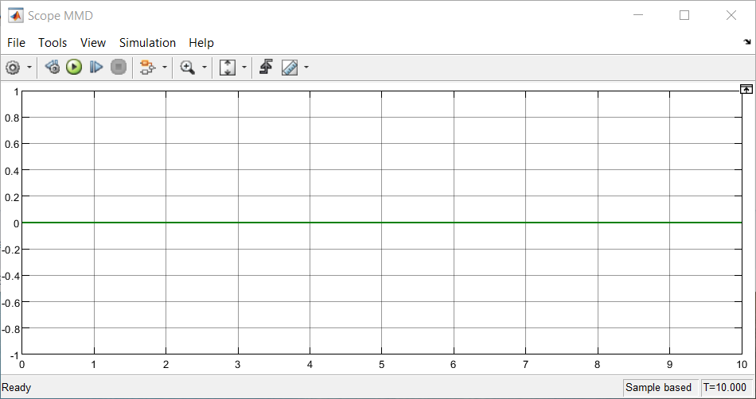
a)
b)
FIGURE 4. Characteristic of the measuring block signal with ground fault (b) and without ground fault (a) (adapted: filtering in substations under load increase of 6–7%).
The results of the analyses carried out in the MATLAB Simulink environment for the measuring block with MMD, designed for selective detection of ground faults, demonstrate that without a signal from the open-delta connection of the voltage transformer—i.e., when the zero-sequence voltage is below the threshold value U_{th}>U₀ the control block does not transmit the signal to the subsequent stage.
It was found that the control block does not forward the signal for tripping unless the zero-sequence voltage U₀ is present. This ensures the avoidance of false operations of the protection system in power networks of the mining industry, particularly in complexes with variable capacitance.
As shown in Table 1, the developed measuring block of the microprocessor-based measuring system with MMD for ground fault protection provides improved sensitivity and selectivity, along with minimal protection operation time for mining power systems, which is essential under conditions of unstable network parameters.

TABLE 1. Simulation results of the measuring block in power systems
Mode | ${∆I}_{diff}$ (А) | Sensitivity  (MkА) | Selective  (%) | Hour (h)
Normal | <0.01 | - | 100 | -
SLG | 0.1 | 1 | 98 | 0.02
Noise (200 Hz) | 0.05 | 10 | 95 | 0.03
CONCLUSIONS
The modeled MMD-based measuring unit has been shown to ensure high sensitivity and reliability in the selective detection of ground faults. Due to the sequential filtering, synchronous detection, and the combined logic with the zero-sequence voltage U0U_0U0, false tripping under noise, transient processes, and capacitive imbalance is effectively eliminated. The Simulink results confirm fast response (≤10 ms), selectivity in the range of 95–98%, and stable operation even under variable network parameters typical for mining power systems. Thus, the developed MMD-based measurement block is suitable for practical application, providing fast, accurate, and reliable ground-fault detection in real power networks.
REFERENCES
- Ataullayev N.O., Muxammadov B.Q., Idieva A.A., Research of dynamic characteristics of magnetic modulation current converter with negative feedback // International Journal of Advanced Research in Science, Engineering and Technology, India, 2020, November, Vol. 7, Issue 11. – P. 15749-15752. http://www.ijarset.com/volume-7-issue-11.html?utm_source=chatgpt.com
- N.Ataullayev, A.Norqulov, B.Muxammadov, A.Majidov, I.Tog’ayev. Principles of protection against single phase earth faults in networks with capacitive current compensation. E3S Web of Conferences, 548, 06008 (2024). https://doi.org/10.1051/e3sconf/202454806008
- Shirinov S.G., J.S. Olimov, I.Z. Jumayev, M.K. Sayidov Analysis of patterns of electricity consumption in mining and processing enterprises. Vibroeng. Procedia 2024, 54, 308–313. https://doi.org/10.21595/vp.2024.24073
- Jumayev, Z.I., Karshibayev, A.I., Sayidov, M.K., & Shirinov, S.G. Analysis of climate-meteorological and technological factors affecting electricity consumption of mining enterprises. Vibroengineering Procedia, Vol. 54, pp. 293-299 (Apr. 4 2024). https://doi.org/10.21595/vp.2024.24047
- H. Huang, F. Ma, L. Fu, W. Zhu, C. Li. An overview of grounding design and ground fault detection and location methods for a multiphase rectifier generator power supply system. Machines, 11, 985 (2023). https://doi.org/10.3390/machines11110985
- G. Wan, X. Li, Y. Liu, Z. Zhang. Research on single-phase grounding detection method in small-current grounding systems. Frontiers in Energy Research, 12, 1473472 (2024). https://doi.org/10.3389/fenrg.2024.1473472
- E. Mazaheri-Tehrani, P. Marinov, L. Li. Air-gap and stray magnetic flux monitoring techniques for fault detection in electrical machines. IET Electrical Power Applications, 16(8), 785–794 (2022). https://doi.org/10.1049/elp2.12157
- W. Wang, X. Zeng, L. Yan, Y. Luo. Principle and control design of active ground-fault arc suppression device. IEEE Transactions on Industrial Electronics, 63(11), 6804–6813 (2016). https://doi.org/10.1109/TIE.2016.2531771
- R. Karimov. Improving the quality of 0.4 kV electricity in household appliances due to voltage regulation. E3S Web of Conferences, 384, 01056 (2023). https://doi.org/10.1051/e3sconf/202338401056
- X. Wan, H. Fan, M. Li, X. Wei. Single-Phase Ground Fault Detection Method in Three-Phase Four-Wire Distribution Systems Using Optuna-Optimized TabNet. Electronics, 14(18), 3659 (2025). https://doi.org/10.3390/electronics14183659 MDPI
- H. Zhang. Research and Application of High-Sensitivity Grounding Fault Detection Based on Zero-Sequence Voltage. IET Generation, Transmission & Distribution, (2025). https://doi.org/10.1049/gtd2.70093
- Numon Niyozov, Anvar Akhmedov, Shukhrat Djurayev, Botir Tukhtamishev, Asliddin Norqulov. AIP Conf. Proc. 3331, 080008 (2025) https://doi.org/10.1063/5.0305729
- Tursunova A. et al. Researching localization of vertical axis wind generators //E3S Web of Conferences. – EDP Sciences, 2023. – Т. 417. – С. 03005. https://doi.org/10.1051/e3sconf/202341703005
- Narzullayev B. S., Eshmirzaev M. A, Causes of the appearance of current waves in high voltage electric arc furnaces, and methods of their reduction, E3S Web of Conferences. – EDP Sciences, 2023. – Т. 417. – С. 03003. https://doi.org/10.1051/e3sconf/202341703003
- Akram Tovbaev., Islom Togaev., Uktam Usarov.,Gulom Nodirov, Reactive power compensation helps maintain a stable voltage profile across the network, AIP Conf. Proc. 3331, 060014 (2025). https://doi.org/10.1063/5.0307209
- Asliddin Norqulov, Feruz Raximov, Methods for evaluating financial and economic effectiveness of investment projects in the energy sector with time factor considerations, AIP Conf. Proc. 3331, 030070-1–030070-6. https://doi.org/10.1063/5.0306104
- Shukhrat Abdullaev., Ziyodullo Eshmurodov., Islom Togaev, A systematic analysis of the gradual increase in quality indicators of electricity using reactive power sources involves several steps, AIP Conf. Proc. 3331, 040051 (2025). https://doi.org/10.1063/5.0306786
- Bobur Narzullayev; Javokhir Boboqulov, Improving reliability based on diagnostics of the technical condition of electric motor stator gutters, AIP Conf. Proc. 3331, 030032 (2025). https://doi.org/10.1063/5.0305735
- Abdurakhim Taslimov., Feruz Raximov., Farrukh Rakhimov., Iles Bakhadirov, Optimal parameters and selection criteria for neutral grounding resistors in 20 kv electrical networks, AIP Conf. Proc. 3331, 030048 (2025) https://doi.org/10.1063/5.0306108
- Islom Togaev., Akram Tovbaev., Gulom Nodirov, Systematic analysis of reactive power compensation in electric networks is essential for improving electricity quality enhancing system stability, and reducing operational costs, AIP Conf. Proc. 3331, 030099 (2025) https://doi.org/10.1063/5.0305740
- Abdurakhim Taslimov., Farrukh Rakhimov., Feruz Rakhimov., Vaxobiddin Mo’minov, Analysis of the results of sampling the surfaces of sections of rural electric networks, AIP Conf. Proc. 3331, 030041 (2025) https://doi.org/10.1063/5.0305783
- Sulton Amirov, Aminjon Ataullayev, Sine-cosine rotating transformers in zenith angle converters, E3S Web of Conferences 525, 03010 (2024) GEOTECH-2024, https://doi.org/10.1051/e3sconf/202452503010
- Sultan F. Amirov, Nodir O. Ataullayev, Amin O. Ataullayev, Bobur Q. Muxammadov, and Ahror U. Majidov, Methods for reducing the temperature components of magnetomodulation DC convertors errors, E3S Web of Conferences 417, 03011 (2023) GEOTECH-2023 https://doi.org/10.1051/e3sconf/202341703011
- Raximov, F., Taslimov, A., Majidov, A., & Norqulov, A. (2024). Optimization of losses by switching to higher voltage in distribution networks. In E3S Web of Conferences (Vol. 525, p. 03009). EDP Sciences. https://doi.org/10.1051/e3sconf/202452503009
- A.Tovboyev, I.Togayev, I.Uzoqov, G. Nodirov, Use of reactive power sources in improving the quality of electricity, E3S Web of Conferences 417, 03001 (2023) https://doi.org/10.1051/e3sconf/202341703001
- I.Togayev, A.Tovbaev, G. Nodirov, Assessment of the quality of electricity by applying reactive power sources, E3S Web of Conferences, 525, 03004 (2024) https://doi.org/10.1051/e3sconf/202452503004
- G.Boynazarov, A. Tovbaev, U. Usarov, Methology of experimental research of voltage quality in electrical circuit, E3S Web of Conferences 548, 03009 (2024) https://doi.org/10.1051/e3sconf/202454803009
- O.Jumaev, M. Ismoilov, D. Rahmatov, A. Qalandarov, Enhancing abrasion resistance testing for linoleum and rubber products: A proposal for improved device operation, E3S Web of Conferences 525, 05012 (2024) https://doi.org/10.1051/e3sconf/202452505012
- Melikuziev M.V., Fayzrakhmanova Z., Akhmedov A., Kasimova G. Development of an Educational Simulator's Working Logic for the Course 'Fundamentals of Power Supply'. AIP Conference Proceedings 3152, 050025 (2024). https://doi.org/10.1063/5.0218875
- Melikuziev M.V., Nematov L.A., Novikov A.N., Baymuratov K.K. Technical and economic analysis of parameters of city distribution electric network up to 1000 V. E3S Web of Conferences 289, 07016 (2021) Energy Systems Research. https://doi.org/10.1051/e3sconf/202128907016
- L.Jing, J.Guo, T.Feng, L.Han, Z.Zhou and M.Melikuziev, "Research on Energy Optimization Scheduling Methods for Systems with Multiple Microgrids in Urban Areas," 2024 IEEE 4th International Conference on Digital Twins and Parallel Intelligence (DTPI), Wuhan, China, 2024, pp. 706-711, https://ieeexplore.ieee.org/abstract/document/10778839
- Shukhrat Umarov, Murot Tulyaganov. Peculiarities of simulation of steady modes of valve converters with periodic power circuit structure. III International Scientific and Technical Conference “Actual Issues of Power Supply Systems” (ICAIPSS2023). AIP Conf. Proc. 3152, 050004-1–050004-7; https://doi.org/10.1063/5.0218869
- Murot Tulyaganov, Shukhrat Umarov. Improving the energy and operational efficiency of an asynchronous electric drive. III International Scientific and Technical Conference “Actual Issues of Power Supply Systems” (ICAIPSS2023); https://doi.org/10.1063/5.0218876
- Shukhrat Umarov, Khushnud Sapaev, Islambek Abdullabekov. The Implicit Formulas of Numerical Integration Digital Models of Nonlinear Transformers. AIP Conf. Proc. 3331, 030105 (2025); https://doi.org/10.1063/5.0305793
- Shukhrat Umarov, Murat Tulyaganov, Saidamir Oripov, Ubaydulla Boqijonov. Using a modified laplace transform to simulate valve converters with periodic topology. AIP Conf. Proc. 3331, 030104 (2025); https://doi.org/10.1063/5.0305792
- Murat Tulyaganov, Shukhrat Umarov, Islambek Abdullabekov, Shakhnoza Sobirova. Optimization of modes of an asynchronous electric drive. AIP Conf. Proc. 3331, 030084 (2025); https://doi.org/10.1063/5.0305786
- Islombek Abdullabekov, Murakam Mirsaidov, Shukhrat Umarov, Murot Tulyaganov, Saidamirkhon Oripov. Optimizing energy efficiency in water pumping stations: A case study of the Chilonzor water distribution facility; AIP Conf. Proc. 3331, 030107 (2025); https://doi.org/10.1063/5.0305780
- Kobilov, N., Khamidov, B., Rakhmatov, K., Abdukarimov, M., Daminov, O., Shukurov, A., Kodirov, S., Omonov, S. Investigation and study of oil sludge of oil refinery company in Uzbekistan. AIP Conference Proceedings, 3304, 040076, (2025), https://doi.org/10.1063/5.0269039
- Kobilov, N., Khamidov, B., Rakhmatov, K., Daminov, O., Ganieva, S., Shukurov, A., Kodirov, S., Omonov, S. Development of effective chemicals for drilling fluid based on local and raw materials of Uzbekistan. AIP Conference Proceedings, 3304, 040077, (2025), https://doi.org/10.1063/5.0269403
- Umerov, F., Daminov, O., Khakimov, J., Yangibaev, A., Asanov, S. Validation of performance indicators and theoretical aspects of the use of compressed natural gas (CNG) equipment as a main energy supply source on turbocharged internal combustion engines vehicles. AIP Conference Proceedings, 3152, 030017, (2024), https://doi.org/10.1063/5.0219381
- Matmurodov, F.M., Daminov, O.O., Sobirov, B.Sh., Abdurakxmanova, M.M., Atakhanov, F.U.M. Dynamic simulation of force loading of drives of mobile power facilities with variable external resistance. E3s Web of Conferences, 486, 03001, (2024), https://doi.org/10.1051/e3sconf/202448603001
- Musabekov, Z., Daminov, O., Ismatov, A. Structural solutions of the supercharged engine in the output and input system. E3s Web of Conferences, 419, 01015, (2023), https://doi.org/10.1051/e3sconf/202341901015
- Musabekov, Z., Ergashev, B., Daminov, O., Khushnaev O., Kurbanov, A., Kukharonok, G. Efficiency and environmental indicators of diesel engine operation when using water injection. IOP Conference Series Earth and Environmental Science, 1142, 012024, (2023), https://doi.org/10.1088/1755-1315/1142/1/012024
- Tulaev, B.R., Musabekov, Z.E., Daminov, O.O., Khakimov, J.O. Application of Supercharged to Internal Combustion Engines and Increase Efficiency in Achieving High Environmental Standards. AIP Conference Proceedings, 2432, 030012, (2022), https://doi.org/ 10.1063/5.0090304
- Matmurodov, F., Yunusov, B., Khakimov, J., Daminov, O., Gapurov, B. Mathematical Modeling and Numerical Determination of Kinetic and Power Parameters of Loaded Power Mechanisms of a Combined Machine. AIP Conference Proceedings, 2432, 040013, (2022), https://doi.org/ 10.1063/5.0090304
- Ma’ruf, K., Tursoat, A., Dilnavoz, K., Bekmurodjon, R., Ra'no, A., Saida, T., ... & Toshbekov, B. (2025). ZnO Nanoparticles Incorporated on Multi-Walled Carbon Nanotubes as A Robust Heterogeneous Nano-catalyst for Biodiesel Production from Oil. Journal of Nanostructures, 15(3), 1050-1060.
- Safarov J., Khujakulov A., Sultanova Sh., Khujakulov U., Sunil Verma. Research on energy efficient kinetics of drying raw material. // E3S Web of Conferences: Rudenko International Conference “Methodological problems in reliability study of large energy systems” (RSES 2020). Vol. 216, 2020. P.1-5. doi.org/10.1051/e3sconf/202021601093
- Safarov J., Sultanova Sh., Dadayev G.T., Zulponov Sh.U. Influence of the structure of coolant flows on the temperature profile by phases in a water heating dryer. // IOP Conf. Series: Materials Science and Engineering. Dynamics of Technical Systems (DTS 2020). Vol.1029, 2021. №012019. P.1-11. doi:10.1088/1757-899X/1029/1/012019
- Sultanova Sh.A., Artikov A.A., Masharipova Z.A., Abhijit Tarawade, Safarov J.E. Results of experiments conducted in a helio water heating convective drying plant. // International conference AEGIS-2021 «Agricultural Engineering and Green Infrastructure Solutions». IOP Conf. Series: Earth and Environmental Science 868 (2021) 012045. P.1-6. doi:10.1088/1755-1315/868/1/012045
- Sultanova Sh., Safarov J., Usenov A., Samandarov D., Azimov T. Ultrasonic extraction and determination of flavonoids. XVII International scientific-technical conference “Dynamics of technical systems” (DTS-2021). AIP Conference Proceedings 2507, 050005. 2023. P.1-5. doi.org/10.1063/5.0110524
- Saparov Dj.E., Sultonova S.A., Guven E.С., Samandarov D.I., Rakhimov A.M. Theoretical study of characteristics and mathematical model of convective drying of foods. // RSES 2023. E3S Web of Conferences 461, 01057 (2023). P.1-5. https://doi.org/10.1051/e3sconf/202346101057
- Safarov J.E., Sultanova Sh.A., Dadayev G.T., Samandarov D.I. Method for drying fruits of rose hips. // International Journal of Innovative Technology and Exploring Engineering (Scopus). Volume-9, Issue-1, November, 2019. Р.3765-3768. doi: 10.35940/ijitee.A4716.119119
- Safarov J.E., Sultanova Sh.A., Dadayev G.T., Samandarov D.I. Method for the primary processing of silkworm cocoons (Bombyx mori). // International Journal of Innovative Technology and Exploring Engineering (Scopus). Volume-9, Issue-1, November, 2019. Р.4562-4565. DOI: 10.35940/ijitee.A5089.119119
- Sultanova Sh., Safarov J., Usenov A., Raxmanova T. Definitions of useful energy and temperature at the outlet of solar collectors. // E3S Web of Conferences: Rudenko International Conference “Methodological problems in reliability study of large energy systems” (RSES 2020). Vol. 216, 2020. P.1-5. doi.org/10.1051/e3sconf/202021601094
- Usenov A.B., Sultanova Sh.A., Safarov J.E., Azimov A.T. Experimental-statistic modelling of temperature dependence of solubility in the extraction of ocimum basilicum plants. // International conference AEGIS-2021 «Agricultural Engineering and Green Infrastructure Solutions». IOP Conf. Series: Earth and Environmental Science 868 (2021) 012047. P.1-5. doi:10.1088/1755-1315/868/1/012047
- 1Sultanova Sh.A., Safarov J.E., Usenov A.B., Muminova D. Analysis of the design of ultrasonic electronic generators. // Journal of Physics: Conference Series. International Conference "High-tech and Innovations in Research and Manufacturing" (HIRM 2021). 2176 (2022) 012007. doi:10.1088/1742-6596/2176/1/012007
- Zulpanov Sh.U., Samandarov D.I., Dadayev G.T., Sultonova S.A., Safarov J.E. Research of the influence of mulberry silkworm cocoon structure on drying kinetics. // IOP Conf. Series: Earth and Environmental Science (AEGIS-2022). 1076 (2022) 012059. Р.1-6. doi:10.1088/1755-1315/1076/1/012059
- Tarawade A., Samandarov D.I., Azimov T.Dj., Sultanova Sh.A., Safarov J.E. Theoretical and experimental study of the drying process of mulberry fruits by infrared radiation. // IOP Conf. Series: Earth and Environmental Science (ETESD). 1112 (2022) 012098. P.1-9. doi:10.1088/1755-1315/1112/1/012098

