Detection Of Early Signs of High-Voltage Circuit Breaker Contact Failures Based on Temperature Monitoring and Neural Networks
Jonibek Mavlonov¹, Muzaffar Sayidov^{1,a)}, Mukhriddin Tuyqulov¹, Muhammadsodiq Matqosimov ²
¹Navoi State University of Mining and Technologies, Navoiy, Uzbekistan
² Andijan State Technical Institute, Andijan, Uzbekistan
^{a)} Corresponding author: sayidov2024@mail.ru
Abstract:The article discusses a method for early detection of contact defects in high-voltage circuit breakers in 6–10 kV distribution systems using a system of temperature sensors and neural networks.It is shown that localized heating of contact groups is the main precursor to switching device failure. A diagnostic system structure is proposed, including distributed temperature sensors and a data collection module, a neural network analysis unit, and a service life prediction subsystem.The obtained results confirm the system’s ability to detect high-voltage circuit breaker emergency situations and increase the substation’s operational reliability.
INTRODUCTION
High-voltage circuit breakers are the most critical pieces of equipment in a substation. Due to this equipment's failure, it can cause severe and unrecoverable disruptions, disconnect the power source, and risk damage to adjacent equipment. In energy companies, statistics show that up to 40% of all switch failures are due to the degradation of contact connections—weakening of contact forces, transient resistance, wear, and contamination of the contact surface [1-5].
New types of temperature sensors and data analysis methods open up new possibilities for automated high-voltage circuit breaker monitoring. Particularly promising is the use of neural networks, which can identify complex dependencies, recognize anomalies, and detect the first signs of failure based on small temperature changes. Temperature time series analysis makes it possible to detect increases in transient resistance long before critical values are reached. This paper proposes a method for diagnosing the condition of high-voltage circuit breaker contacts based on continuous temperature monitoring and the use of neural networks to detect anomalies. This approach aims to detect early signs of contact degradation and generate a warning signal before an emergency occurs [6-8]. The implementation of such a system increases the reliability of substation equipment and facilitates the transition to predictive maintenance [9-11]

EXPERIMENTAL RESEARCH
The research packages included general experimental work aimed at analyzing the impact of temperature parameters on the reliability of substation power equipment. The goal of the experiment was to identify early failure modes caused by temperature changes in high-voltage circuit breaker contacts and contact connections. The study was conducted at an operating substation, where, during normal operation, additional measuring devices were installed in key components and archival documents and equipment failure investigation materials were used [12-18].
Based on the processed information, temperature profiles were constructed, critical heating zones were identified, and areas requiring increased attention during maintenance planning were determined. The experiment showed that localized temperature peaks directly correlate with an increased probability of defects, especially in contact joints and oil-filled components. This approach requires individual solutions, including expert opinions on the equipment's operability based on certain indicators of its condition. Using non-destructive testing methods, early symptoms of potential failures can be identified. As part of the operation of 6-35 kV distribution networks at the "Network Workshops and Substations" enterprise, located in the Zarafshan district, from 2021 to 2025. An analysis of 28 technological failures of high-voltage circuit breakers of the VMPE-10, MKP-35, VMG-133 and VBE-35 types was conducted.

TABLE 1. Causes of failure of high-voltage circuit breakers 6–35 kV
№. | Reason for refusal | Number of cases | Share, % | Consequences
1 | Overheating and destruction of contact connections and main contacts (loosening of bolts, oxidation, scorching) | 11 | 39.3 | Short circuit in the cell, substation shutdown
2 | Oil leakage from bushings and tanks, insulation moisture | 6 | 21.4 | Insulation breakdown, switching failure
3 | Drive failures (spring-load and electromagnetic) | 5 | 17.9 | Short circuit trip failure
4 | Mechanical damage to porcelain bushings | 4 | 14.3 | Destruction of the input, tripping of the circuit breaker
5 | Others (secondary circuits, corrosion) | 2 | 7.1 | -

Table 1 shows that 39.3% of all failures are directly related to overheating of contact connections, and in 8 out of 11 cases the defect developed gradually over 2–11 months and could have been detected at an early stage if continuous temperature monitoring had been in place. In 2023–2025, temperature sensors were installed on the main contacts and bolted connections of the high-voltage busbar of 6–35 kV circuit breakers in a pilot-scale test mode at stations (M, M1, M2, M3). During this period, five cases of persistent abnormal increases in contact connection temperature were recorded, with a circuit breaker load factor of no more than 0.8 [25-54].
RESEARCH RESULTS
In two major severe cases of PS-M (March 2025, phase B 7 – cell temperature reached 88.5 ) and PS-M1 (March 2025, phase B 4 – cell temperature reached 90.5 ), prompt detection prevented the development of a short circuit in 6–35 kV cells. In this regard, the neural network method can be effectively used to assess the technical condition of a high-voltage circuit breaker. The operation of one functional system of a neutron can be described as follows$℃$
$y_{i}=F(\sum{w_{ij}x_{i}})$ (1)

Where $y_{i}-$neuron output signal;$j$ $w_{ij}-$ connection weight between i and j neurons; xi– output signal of the i-th neuron; F– neuron activation function.
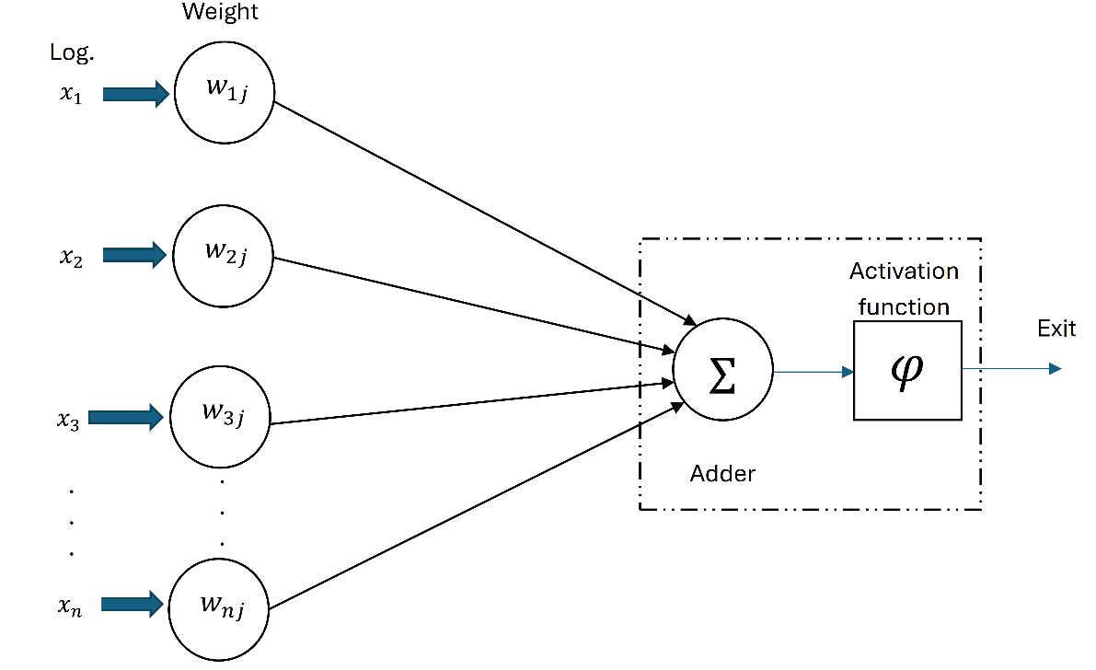
FIGURE 1. Structural architecture of a single-layer neural network
In the task of diagnosing the technical condition of a high-voltage circuit breaker, a single-layer neural network is used primarily to classify the equipment condition based on temperature parameters and their dynamics (Figure 1). The initial data includes a time series of temperature in the measured contacts of the circuit breakers. However, a single-layer network is usually insufficient for the correct recognition of hidden patterns in temperature processes [19-24]. Therefore, to determine the state of contact connections of high-voltage circuit breakers 6-35 kV, we use a multilayer direct propagation perceptron and enter the main characteristics of the artificial neural network in Table 2.

TABLE 2. Characteristics of a neural network
Item №. | Network parameter | The meaning of the characteristic
1 | Network type | Multilayer forward propagation perceptron
2 | Number of input neurons | 15
3 | Number of hidden layers | 3
4 | Number of neurons in hidden layers | 100 – 50 – 25
5 | Number of output neurons | 3
6 | Hidden layers activation function | ReLU
7 | Output layer activation function | Softmax
8 | Regularization method | Dropout (p = 0.2) + L2-regularization (λ = 0.001)
9 | Optimizer | Adam
10 | Initial learning rate | 0.001
11 | Mini package size | 64
12 | Number of epochs | 50
13 | Loss function | Categorical cross-entropy
14 | Software environment | MATLAB R2025a, Deep Learning Toolbox

The parameters presented in Table 2 above define the architecture and training algorithm for a multilayer forward-propagating perceptron in the contact state of a high-voltage circuit breaker.

a)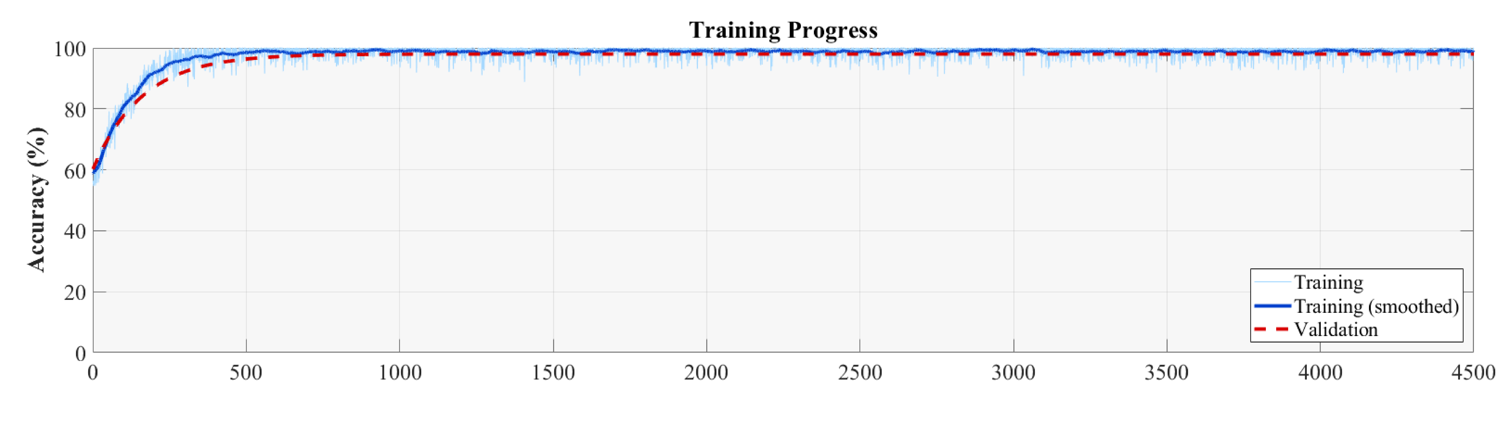

b) 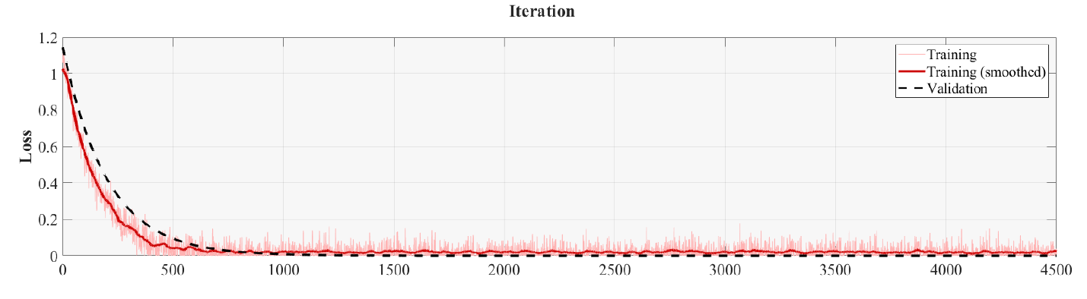
FIGURE 2. Results of training an artificial neural network in Matlab: a) training progress, b) iteration

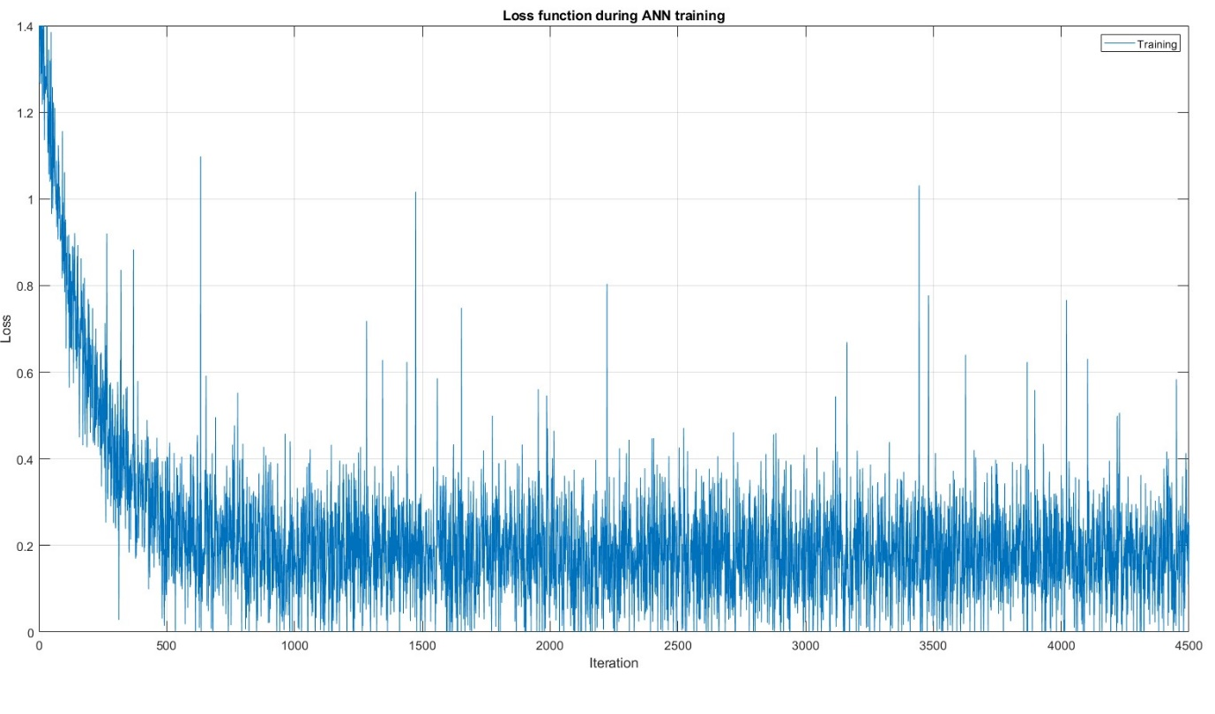
FIGURE 3. Dynamics of change in the loss function of a neural network during the Matlab training process.

In addition to the main training metrics shown in Figure 2, a separate analysis of the neural network loss function is presented in Figure 3. This graph allows for a more detailed assessment of the training sample behavior for a given network architecture and the regularization parameters specified in Table 2, and shows a clear and monotonous decrease in the loss function both during the training period and throughout all 4500 iterations. This indicates the correctness of the choice of the model architecture and its ability to determine the state of the contact connections of high-voltage circuit breakers based on a series of temperatures over time.
CONCLUSIONS
During the study, an approach to diagnosing the technical condition of 6–35 kV high-voltage circuit breakers was developed and substantiated based on changes in contact connection temperature and the use of artificial intelligence methods. The obtained results prove that the use of intelligent systems for high-voltage circuit breaker repair enables highly effective early detection of equipment malfunctions, i.e., allows for timely planning of repair measures and significantly increases the reliability of power supply systems.
In the future, the use of advanced deep learning architectures, the integration of emission diagnostics, current and gas analysis data will allow for the accurate determination of the technical condition of the substation's electrical equipment.
REFERENCES
- Jumayev, Z.I., Karshibayev, A.I., Sayidov, M.K., & Shirinov, S.G. Analysis of climate-meteorological and technological factors affecting electricity consumption of mining enterprises. Vibroengineering Procedia, Vol. 54, pp. 293-299 (Apr. 4 2024). https://doi.org/10.21595/vp.2024.24047
- Galyautdinova, A. R. Intelligent system for online monitoring and control of the technical condition of oil-filled power transformers of 35/6(10) kV distribution networks. PhD diss., Kazan State Power Engineering University, Kazan, 2024, 171 p. URL: https://www.dissercat.com/content/intellektualnaya-sistema-onlain-monitoringa-i-kontrolya-tekhnicheskogo-sostoyaniya-silovykh
- Yang, M., Wei, L., Qiu, P., Hu, G., Liu, X. и др. “Research on Fault Diagnosis of High-Voltage Circuit Breakers Using Gramian-Angular-Field-Based Dual-Channel Convolutional Neural Network.” Energies, vol. 18, no. 14, 2025, article 3837. https://doi.org/10.3390/en18143837
- Olimov J., Ramazonov B., Sayfiyev S. Increasing efficiency of induction motor by predictive control system //E3S Web of Conferences. – EDP Sciences, 2024. – Т. 525. – С. 03006. https://doi.org/10.1051/e3sconf/202452503006
- N.Ataullayev, A.Norqulov, B.Muxammadov, A.Majidov, I.Tog’ayev. Principles of protection against single phase earth faults in networks with capacitive current compensation. E3S Web of Conferences, 548, 06008 (2024). https://doi.org/10.1051/e3sconf/202454806008
- Amirov S.F., Ataullayev N.O., Ataullayev A.O., Muxammadov A.O., Majidov B.Q., A.U. Methods for reducing the temperature components of magnetomodulation DC converter errors. E3S Web of Conferences, 417, 03011 (2023). https://doi.org/10.1051/e3sconf/202341703011
- Amirov S.F., Ataullayev A.O., Sayidov M.K., Togayev I.B. Methods of reduction of interference signals in electromagnetic conductors that measure fluid flow Journal of Physics: Conference Series, 2094(5), 052053 (2021) 10.1088/1742-6596/2094/5/052053
- Bobur Narzullayev; Javokhir Boboqulov, Improving reliability based on diagnostics of the technical condition of electric motor stator gutters, AIP Conf. Proc. 3331, 030032 (2025). https://doi.org/10.1063/5.0305735
- Tatkeyeva, G., Kurabayev, I., Ataullaev, N., & Murodov, X. (2022, July). Experimental research of the developed method to determine the network insulation for ungrounded AC systems in laboratory conditions. In 2022 International Conference on Electrical, Computer and Energy Technologies (ICECET) (pp. 1-4). IEEE. DOI: 10.1109/ICECET55527.2022.9873012
- Abdullaev, S., Eshmurodov, Z., & Togaev, I. (2025, November). A systematic analysis of the gradual increase in quality indicators of electricity using reactive power sources involves several steps. In AIP Conference Proceedings (Vol. 3331, No. 1, p. 040051). AIP Publishing LLC. https://doi.org/10.1063/5.0306786
- Nazirova, H., Nazirova, O., Toshxoʻjayeva, M., Badalova, D., & Ramazonov, B. (2025, November). Optimization of electricity loss forecasting using ANN. In AIP Conference Proceedings (Vol. 3331, No. 1, p. 060027). AIP Publishing LLC. https://doi.org/10.1063/5.0305944
- Olimov, J. S., Fayziyev, S. S., Raximov, F. M., Majidov, A. U., & Muxammadov, B. Q. (2023). Controlling power of short circuited induction motor via modern sensors without speed change. In E3S Web of Conferences (Vol. 417, p. 03007). EDP Sciences. https://doi.org/10.1051/e3sconf/202341703007
- Rakhimov, F., Rakhimov, F., Samiev, S., & Abdukhalilov, D. (2024, June). Justification of technical and economic effectiveness of application of 20 kV voltage in overhead electric networks. In AIP Conference Proceedings (Vol. 3152, No. 1, p. 030023). AIP Publishing LLC. https://doi.org/10.1063/5.0218921
- Tovbaev, A., Boynazarov, G., & Togaev, I. (2023). Improving the quality of electricity using the application of reactive power sources. In E3S Web of Conferences (Vol. 390, p. 06032). EDP Sciences. https://doi.org/10.1051/e3sconf/202339006032
- Ataullaev, N. O., Dziaruhina, A. A., & Murodov, K. S. (2023). Static Characteristics of Magnetic Modulation DC Converters with Analog Filter. Science and technology, 22(5), 428-432. https://doi.org/10.21122/2227-1031-2023-22-5-428-432
- Qarshibaev, A. I., Narzullaev, B. S., & Murodov, H. S. (2020, November). Models and methods of optimization of electricity consumption control in industrial enterprises. In Journal of Physics: Conference Series (Vol. 1679, No. 2, p. 022074). IOP Publishing. DOI 10.1088/1742-6596/1679/2/022074
- Eshmurodov, Z., & Holboiv, F. (2018). Modernization of Control Systems of Electric Drives of Mine Lifting Machines. In E3S Web of Conferences (Vol. 41, p. 03006). EDP Sciences. https://doi.org/10.1051/e3sconf/20184103006
- Rakhmonov, I., Jalilova, D., Shayumova, Z., Karimova, N., Abidova, G., & Khalikova, K. (2025, November). Voltage regulation issues in spinning enterprises. In AIP Conference Proceedings (Vol. 3331, No. 1, p. 080009). AIP Publishing LLC. https://doi.org/10.1063/5.0306210
- Jalilova, D., Kasimova, G., Shayumova, Z., & Abidova, G. (2025, November). Current status of ensuring power quality in spinning mills. In AIP Conference Proceedings (Vol. 3331, No. 1, p. 070021). AIP Publishing LLC. https://doi.org/10.1063/5.0306211
- Eshmurodov, Z., Bobojanov, M., & Abdullaev, S. (2025, November). Investigation of factors affecting the efficiency of mining transport systems. In AIP Conference Proceedings (Vol. 3331, No. 1, p. 040013). AIP Publishing LLC. https://doi.org/10.1063/5.0306591
- Ataullaev, N., Nizomova, D., & Norqulov, A. (2023). Monitoring and control of the protection system of electric drives with the method of pulse-width modulation. In E3S Web of Conferences (Vol. 417, p. 03009). EDP Sciences. https://doi.org/10.1051/e3sconf/202341703009
- Ataullaev, A. O., & Sayidov, M. K. (2023). Investigation of multi loop linear magnetic circuits of electromagnetic flow converters with ring channels. In E3S Web of Conferences (Vol. 417, p. 03006). EDP Sciences. https://doi.org/10.1051/e3sconf/202341703006
- Khudayarov, M., & Sherzod, F. (2024, June). Methodology for evaluating the efficiency of electrical networks of power supply systems. In AIP Conference Proceedings (Vol. 3152, No. 1, p. 030002). AIP Publishing LLC. https://doi.org/10.1063/5.0218810
- Eshmurodov, Z. O., & Arziyev, E. I. (2023). Choice of energy-saving electric drives in quasi-stationary transport systems. In E3S Web of Conferences (Vol. 417, p. 03010). EDP Sciences. https://doi.org/10.1051/e3sconf/202341703010
- Urishev, B., and Fakhriddin Nosirov. 2025. “Hydraulic Energy Storage of Wind Power Plants.” Proceedings of the International Conference on Applied Innovation in IT.
- Mukhammadiev, M., K. Dzhuraev, and Fakhriddin Nosirov. 2025. “Prospects for the Development of the Use of Pumped Storage Power Plants in the Energy System of the Republic of Uzbekistan.” Proceedings of the International Conference on Applied Innovation in IT.
- Urishev, B., Fakhriddin Nosirov, and N. Ruzikulova. 2023. “Hydraulic Energy Storage of Wind Power Plants.” E3S Web of Conferences, 383. https://doi.org/10.1051/e3sconf/202338304052
- Urishev, B., S. Eshev, Fakhriddin Nosirov, and U. Kuvatov. 2024. “A Device for Reducing the Siltation of the Front Chamber of the Pumping Station in Irrigation Systems.” E3S Web of Conferences, 274. https://doi.org/10.1051/e3sconf/202127403001
- Turabdjanov, S., Sh. Dungboyev, Fakhriddin Nosirov, A. Juraev, and I. Karabaev. 2021. “Application of a Two-Axle Synchronous Generator Excitations in Small Hydropower Engineering and Wind Power Plants.” AIP Conference Proceedings. https://doi.org/10.1063/5.0130649
- Urishev, B., Fakhriddin Nosirov, Obid Nurmatov, S. Amirov, and D. Urishova. 2021. “Local Energy System Based on Thermal, Photovoltaic, Hydroelectric Stations and Energy Storage System.” AIP Conference Proceedings. https://doi.org/10.1063/5.0306446
- Nurmatov, Obid, Fakhriddin Nosirov, Khusniddin Shamsutdinov, and Dildora Obidjonova. 2025. “Research on Control Systems for Automatic Excitation Regulation Utilizing Fuzzy Logic Methodology.” AIP Conference Proceedings. https://doi.org/10.1063/5.0306119
- Nurmatov O. Large pumping stations as regulators of power systems modes. Rudenko International Conference “Methodological problems in reliability study of large energy systems” (RSES 2020), E3S Web of Conferences 216, 01098(2020) https://doi.org/10.1051/e3sconf/202021601098
- Nurmatov O., Makhmudov T.: Pulatov N. Сontrol of the excitation system of synchronous motors pumping stations //AIP Conference Proceedings, 3152, 040008 (2024) https://doi.org/10.1063/5.0218781
- Nurmatov O., Nosirov F., Shamsutdinov K., Obidjonova D.Research on control systems for automatic excitation regulation utilizing fuzzy logic methodology. AIP Conference Proceedings AIP Conf. Proc. 3331, 040081 (2025) https://doi.org/10.1063/5.0306119
- Makhmudov T.: Nurmatov O., Ramatov A.N., Site Selection for Solar Photovoltaic Power Plants Using GIS and Remote Sensing Techniques//AIP Conference Proceedings, 3152, 060002 (2024) https://doi.org/10.1063/5.0218779
- Urishev B., Nosirov F., Nurmatov O., Amirov Sh.,Urishova D. Local energy system based on thermal, photovoltaic, hydroelectric stations and energy storage system AIP Conf. Proc. 3331, 070015 (2025) https://doi.org/10.1063/5.0306446
- Rismukhamedov D., Shamsutdinov K., Magdiev K., Peysenov M., Nurmatov O. Construction of pole-switchable windings for two-speed motors of mechanisms with a stress operating modeAIP Conference Proceedings AIP Conf. Proc. 3331, 040059 (2025) https://doi.org/10.1063/5.0305963
- Rabatuly M., Myrzathan S.A., Toshov J.B., Nasimov J., Khamzaev A. Views on drilling effectiveness and sampling estimation for solid ore minerals. Комплексное Использование Минерального Сырья. №1(336), 2026. https://doi.org/10.31643/2026/6445.01
- Toshov J.B., Rabatuly M., Khaydarov Sh., Kenetayeva A.A., Khamzayev A., Usmonov M., Zheldikbayeva A.T. Methods for Analysis and Improvement of Dynamic Loads on the Steel Wire Rope Holding the Boom of Steel Wire Rope Excavators. Kompleksnoe Ispolzovanie Mineralnogo Syra = Complex Use of Mineral Resources 2026; 339(4):87-96 https://doi.org/10.31643/2026/6445.43
- Zokhidov O.U., Khoshimov O.O., Khalilov Sh.Sh. Experimental analysis of microges installation for existing water flows in industrial plants. III International Conference on Improving Energy Efficiency, Environmental Safety and Sustainable Development in Agriculture (EESTE2023), E3S Web of Conferences. Том 463. Страницы 02023. 2023. https://doi.org/10.1051/e3sconf/202346302023
- Zokhidov O.U., Khoshimov O.O., Sunnatov S.Z. Selection of the type and design of special water turbines based on the nominal parameters of Navoi mine metallurgical combine engineering structures. AIP Conf. Proc. 3331, 050022 (2025). https://doi.org/10.1063/5.0306554
- Khamzaev A.A., Mambetsheripova A., Arislanbek N. Thyristor-based control for high-power and high-voltage synchronous electric drives in ball mill operations/ E3S Web Conf. Volume 498, 2024/ III International Conference on Actual Problems of the Energy Complex: Mining, Production, Transmission, Processing and Environmental Protection (ICAPE2024) DOI: https://doi.org/10.1051/e3sconf/202449801011
- Toshov B.R., Khamzaev A.A. Development of Technical Solutions for the Improvement of the Smooth Starting Method of High Voltage and Powerful Asynchronous Motors/AIP Conference Proceedings 2552, 040018 (2023); https://doi.org/10.1063/5.0116131 Volume 2552, Issue 1; 5 January 2023
- Toshov B.R., Khamzaev A.A., Sadovnikov M.E., Rakhmatov B., Abdurakhmanov U./ Automation measures for mine fan installations/ SPIE 12986, Third International Scientific and Practical Symposium on Materials Science and Technology (MST-III 2023), 129860R (19 January 2024); doi: 10.1117/12.3017728. Third International Scientific and Practical Symposium on Materials Science and Technology (MST-III 2023), 2023, Dushanbe, Tajikistan.
- Toshov B.R., Khamzaev A.A., Namozova Sh.R.Development of a circuit for automatic control of an electric ball mill drive. AIP Conference Proceedings 2552, 040017 (2023) Volume 2552, Issue 1; 5 January 2023.
- Toirov, O., Pirmatov, N., Khalbutaeva, A., Jumaeva, D., Khamzaev, A. Method of calculation of the magnetic induction of the stator winding of a spiritual synchronous motor. E3S Web of ConferencesЭта ссылка отключена., 2023, 401, 04033
- O. Toirov, A. Khalbutaeva, Z. Toirov. Calculation of the magnetic flux with considering nonlinearities of saturation of the magnetic circuit of synchronous motors, // 3rd International Scientific and Technical Conference on Actual Issues of Power Supply Systems, ICAIPSS 040022, (2023). https://doi.org/10.1063/5.0218821
- O. Toirov, S. Khalikov. Research and Evaluation of the Reliability Indicators of Pumping Units for Mechanical Irrigation of the Pumping Station “Kyzyl-Tepa”, // Power Technology and Engineering, 57 (5), (2024). https://doi.org/10.1007/s10749-024-01720-2
- O. Toirov, M. Taniev, B. Safarov, Z. Toirov. Simulation model of an asynchronous generator integrated with a power supply system at different wind speeds, // AIP Conference Proceedings, 3331 (1), 060025, (2025). https://doi.org/10.1063/5.0305672
- O. Toirov, Sh. Azimov, Z. Toirov. Improving the cooling system of reactive power compensation devices used in railway power supply // AIP Conference Proceedings, 3331, 1, 050030, (2025). https://doi.org/10.1063/5.0305670
- O. Toirov, W. Yu. Non-Intrusive Load Monitoring Based on Image Load Signatures and Continual Learning
// Proceedings of 2025 2nd International Conference on Digital Society and Artificial Intelligence, (2025) https://doi.org/10.10.1145/3748825.3748963
- O. Toirov, Sh. Azimov, Z. Najmitdinov, M. Sharipov, Z. Toirov. Improvement of the cooling system of reactive power compensating devices used in railway power supply // E3S Web of Conferences, 497, 01015, (2024). https://doi.org/10.1051/e3sconf/202449701015
- Melikuziev M.V. Determination of the service area and location of transformer substations in the city power supply system. E3S Web of Conferences 384, 01033 (2023) RSES 2022. https://doi.org/10.1051/e3sconf/202338401033
- Melikuziev M.V., Usmonaliev S., Khudoyberdiev N., Sodikov J., Imomaliev Z. Issues of the design procedure for the power supply system. AIP Conference Proceedings 3152, 040031 (2024). https://doi.org/10.1063/5.0218873

