Impact of mechanical stresses caused by differential protection operation on power transformer lifetime
Sanat Togaymurodov¹, Ataullayev Nodir^{1,a)}, Amin Ataullaev¹, Sodiqjon Mahamadjonov ²
¹Navoi State University of Mining and Technologies, Navoiy, Uzbekistan
² Andijan State Technical Institute, Andijan, Uzbekistan
^{a)} Corresponding author: togaymurodovsanat1509@gmail.com
Abstract. Power transformers play a critical role in the stability of the power system; their reliability over a long period of time is important. Even ultra-fast differential protection (10 40 ms clearing time) results in very large short-circuit currents, subjecting the windings to large radial and axial electromagnetic forces, and resulting in significant mechanical stresses. The stresses cause winding deformation, make the insulation weaker over time, and mechanical fatigue increased. The study involved an in-depth examination of a transformer of 20 MVA that used oil as the coolant. The magnitude of short-circuit current, the equivalent mechanical stresses (radial, axial and resultant) and cumulative damage were determined analytically. The linear damage accumulation rule of Miner was used to determine the loss of the remaining useful life due to mechanical action of a difference protection activity only.
INTRODUCTION
Power transformers are among the most critical equipment in electric power generation, transmission and distribution systems. Therefore, their reliable and long-term operation directly guarantees the stable functioning of the entire power system. Among the main factors determining the technical resource of transformers, the following play a key role in assessing the remaining serviceability of oil-immersed transformers: variations in thermal loading, aging of paper insulation in the windings, cumulative damage caused by mechanical stresses arising from short-circuit currents [1-4].
In transformers with oil filled in them, the current within the windings during a short-circuit fault can be tens of times that of the nominal value. This causes the windings to be exposed to very high mechanical forces both radial and axial (horizontal and vertical) forces. As a result, winding deformation, insulation breakdown, and mechanical fatigue actions are enhanced in the internal structural components of the transformer. That is why, despite the operation of fast-acting protection systems, short-circuit incidences still result in the observed decrease of the total service life of the transformer [5-9].
However, one of the most significant and dependable types of power transformer protection against short circuits inside the transformer is the existence of differential protection. It acts also in very short period (10 – 40 ms), thus eliminating serious emergencies. Nevertheless, the process of the protection actuation generates high-level mechanical stresses in the transformer structure. Thus, the scientific and practical significance of investigating the effectiveness of these momentary, but heavily loaded overloads which are manifested when a current differential occurs on the work of the transformer and its service life is enormous [10-12].

EXPERIMENTAL RESEARCH
To determine the cumulative damage occurring in the internal structure of an oil-immersed transformer due to the operation of differential protection, the primary passport parameters of the transformer are required. The present research was carried out on a 20 MVA power transformer [13]. Its specific technical parameters are fully listed in Table 1, and all calculations were performed based on the data provided in Table 1.
Table 1. Technical parameters of the 20 MVA power transformer
Designation | Parameter value | Note
Sₙ | 20 MVA | nominal power
U₁ | 110 kV | high voltage
U₂ | 6 kV | low voltage
Uₖ% | 10 % | short circuit voltage
μ₀ | 4π × 10⁻⁷ H/m | magnetic constant
N | 220 ta | number of turns
r | 0.25 m | radius of turns
h | 0.5 m | hight of turns

Based on Table 1, the short-circuit current magnitude (I_{s.c}) occurring during differential protection operation, as well as the resultant equivalent short-circuit current across the phases, were first determined [14].
$I_{s.c}$=$\frac{I_{n}}{\frac{U_{k\%}}{100}}$ (1)
I_{sh.c} – instantaneous short-circuit current, A; I_{n} – transformer rated current, A; U_{k%} – short-circuit voltage of the transformer, %.
Seeing that the total mechanical loading can be calculated by the algebraic (vector) sum of the currents in each of the three phases, a short-circuit event in a transformer can be caused by a short-circuit in a single or two or all three phases [28-30]. Thus, equation was used to work out the equivalent short-circuit current that produces the total mechanical stress in all three phases (2):
I²_{ekv}= I²_{sc.a} + I²_{sc.b} + I²_{sc.c} (2)

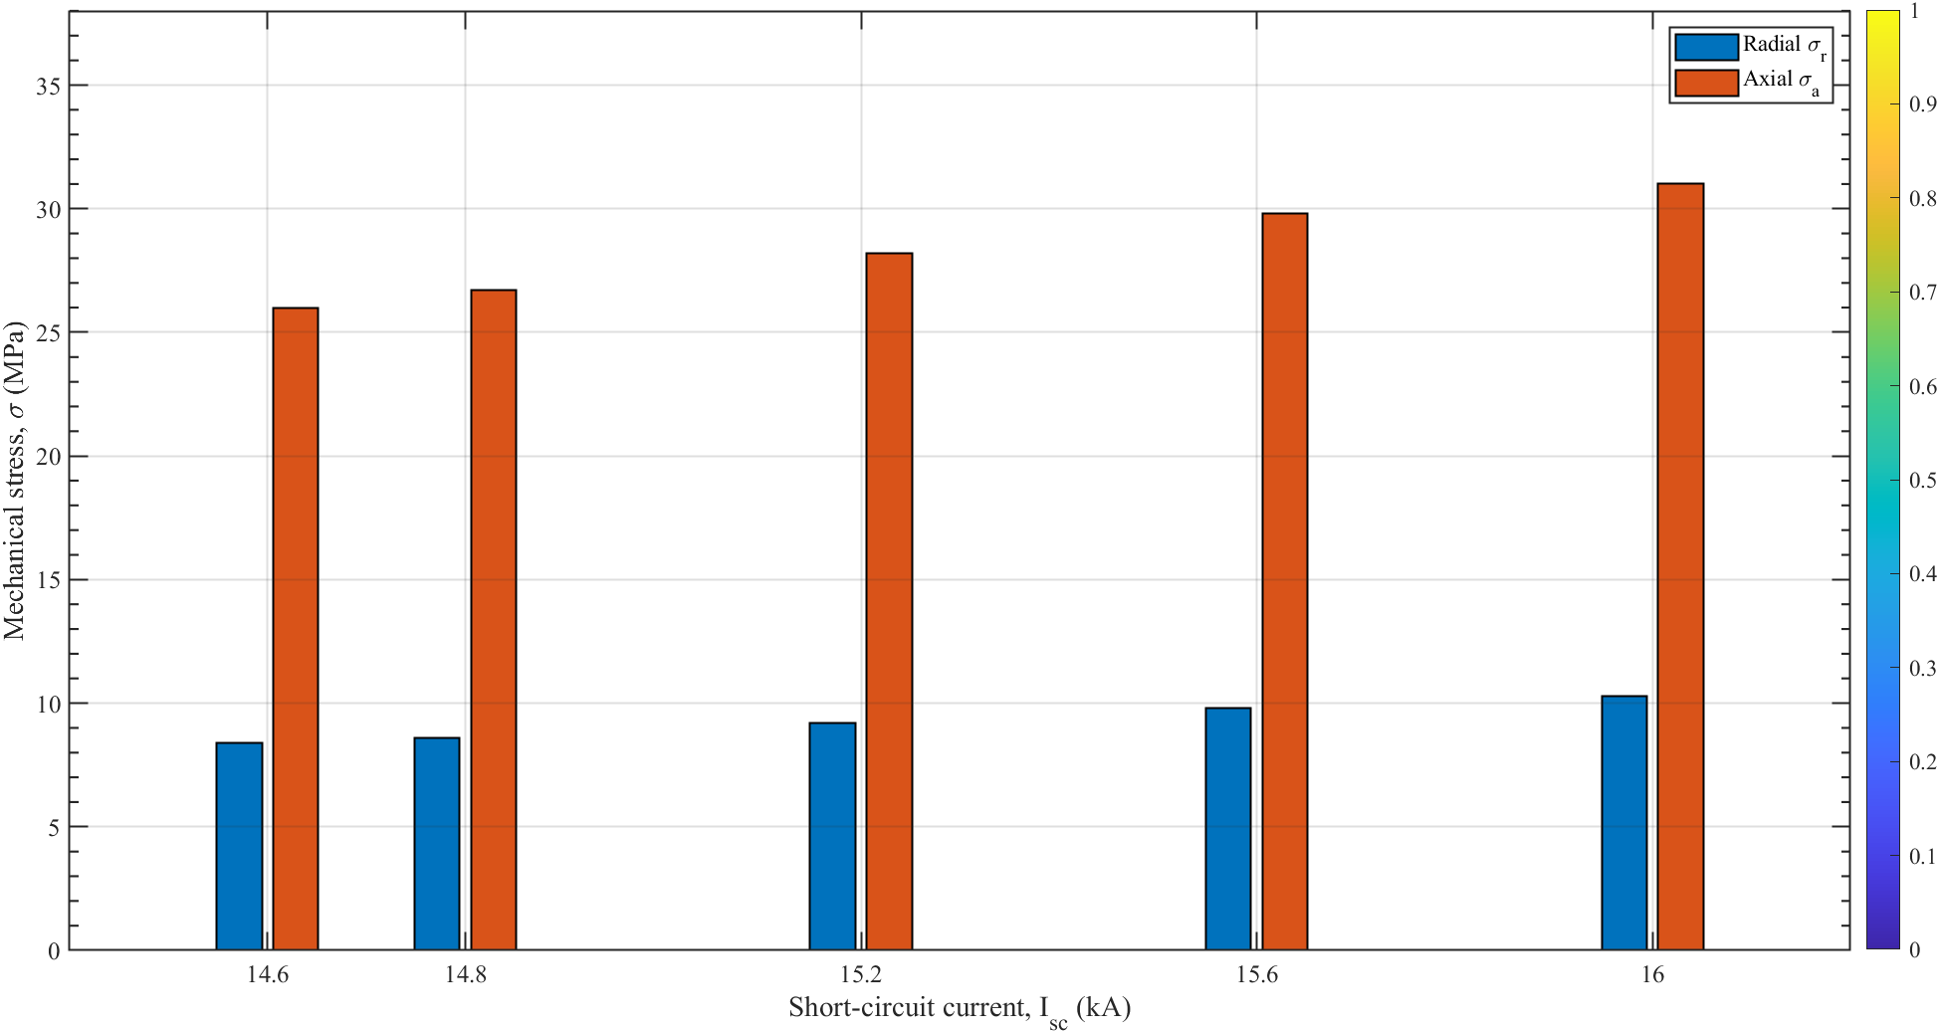
Figure 1. Correlation between short-circuit current and radial/axial mechanical stresses

Radial and axial (horizontal and vertical) electromagnetic forces are highest in a few milliseconds during short-circuit occurrence in transformer cores and windings which creates major mechanical strains in windings. The calibrated values of radial and axial forces have to be first determined to calculate the mechanical stresses in the inside structure of the transformer. The vertical (axial) and horizontal (radial) mechanical stresses of the windings of the transformer were obtained by equation (5) and (6) and calibrated to obtain the calculated values:
$σ_{a}$=k_{a} I²_{ekv} (3)
$σ_{r}$=k_{r} I²_{ekv} (4)
where: σ_{a} – mechanical stress acting in the axial direction, N/m²; σ_{r} – mechanical stress acting in the radial direction, N/m²; k_{a}, k_{r} – axial and radial mechanical stress coefficients arising from the inductive current in the transformer windings, respectively.
Since the axial and radial mechanical stress coefficients depend on the internal structural design of the transformer, their values were calculated as functions of the number of winding turns, winding radius, and winding height using Equations (5) and (6):
k_{r} = $\frac{μ_{0}N^{2}}{2πr}$ (5)
k_{a} = $\frac{μ_{0}N^{2}}{2h^{2}}$ (6)
where: k_{r} and k_{a} – radial and axial mechanical stress coefficients resulting from the inductive current in the transformer windings; N – number of winding turns; μ₀ – permeability of free space, 4π × 10⁻⁷ H/m; h – height of the winding, m; r – mean radius of the winding, m.
Based on the derived expressions, the resultant mechanical stress was determined using the Pythagorean theorem. Figure 3.1 presents the characteristic dependence of radial and axial stresses on short-circuit current in the form of a bar chart constructed from the final calculated results for the 20 MVA transformer [15].
$σ_{n}$ =$I_{ekv}*μ_{0}*\frac{1}{2}\sqrt{({\frac{N^{2}}{πr})}^{2}+{(\frac{N^{2}}{h^{2}})}^{2}}$ (7)
where: σ_{n} – resultant mechanical stress, N/m²; I_{ekv} – equivalent short-circuit current, A; μ₀ – permeability of free space, 4π × 10⁻⁷ H/m; N, h, r – number of winding turns, winding height, and mean winding radius, respectively, m.
Graphical determination of the functional relationship between the resultant mechanical stress and the corresponding short-circuit current was made by use of equation (7). Using the resulting mechanical stress value of this equation, the extent of mechanical fatigue realized by the transformer was measured relative to the fatigue theory per incidence of short circuit. The transformer has a definite strength capacity of every material it is composed of, which is consumed gradually with constant mechanical stress and strains [25-54]. The expression of the ratio between the current mechanical stress to which the material is subjected and the fatigue strength limit of a material itself represents as a fraction of cumulative damage that has been accredited in the identical material. A deflection of this damage fraction must be calculated after establishing ultimate tensile strength (yield strength) of aluminum that is used in transformer windings first [16].
$σ_{ch}$=$kσ_{m}$ (8)
where: tensile strength (yield strength) of material, MPa; k coefficient depending on the material, in case of aluminum conductors commonly used in transformer windings, k = 0.35 is assumed; 0break tensile strength of material, assumed to be the pressure needed to rupture an aluminum., N/m² (or MPa).
RESEARCH RESULTS
The cumulative damage fraction is determined using the time-dependent integral of the mechanical stress ratio:
D(t)=$\int_{0}^{t}{(\frac{I_{ekv}*μ_{0}*\frac{1}{2}\sqrt{({\frac{N^{2}}{πr})}^{2}+{(\frac{N^{2}}{h^{2}})}^{2}}}{σ_{ch}}}$)^{1/b}d(t) (9)
where: σ_{n} – resultant mechanical stress caused by the operation of differential protection, N/m²; σ_{ult} – ultimate tensile strength (yield strength) of the material used in the transformer windings, N/m²; b – fatigue strength exponent of the material [38-40].

Table 3. Cumulative damage fraction after observed short-circuit events
Type of short circuit | I_{sh.c} (kA) | I_{ekv} (kA) | σ_{a} (M N/m²) | σ_{r} (M N/m²) | σ_{n} (M N/m²) | D(t)  fraction | Cumulative damage(%)
1 phase | 16 | 16.00 | 31.14 | 9.91 | 32.68 | 0.024963 | 2.50 %
1 phase | 14.8 | 14.80 | 26.64 | 8.48 | 27.96 | 0.038339 | 1.34 %
1 phase | 15.2 | 15.20 | 28.10 | 8.95 | 29.49 | 0.157482 | 1.66 %
1 phase | 15.6 | 15.60 | 29.60 | 9.42 | 31.07 | 0.177878 | 2.04 %
1 phase | 14.6 | 14.60 | 25.93 | 8.25 | 27.21 | 0.884591 | 1.20 %

Using the procedure outlined above, the equivalent short-circuit current, the resulting mechanical stress, and the cumulative damage fraction due to radial and axial stresses were evaluated for five registered short-circuit events cleared by differential protection. The influence of this cumulative damage on the transformer’s remaining technical lifetime is presented in table 3.
Using the computed value of the cumulative damage fraction $D_{d.p}(t)$, one can estimate the remaining operating life of the transformer under continuing mechanical stress. As the damage is normalized to the total lifetime, multiplying this fraction by the nominal design lifetime directly yields the reduction in residual life in calendar units (days, months, or years).
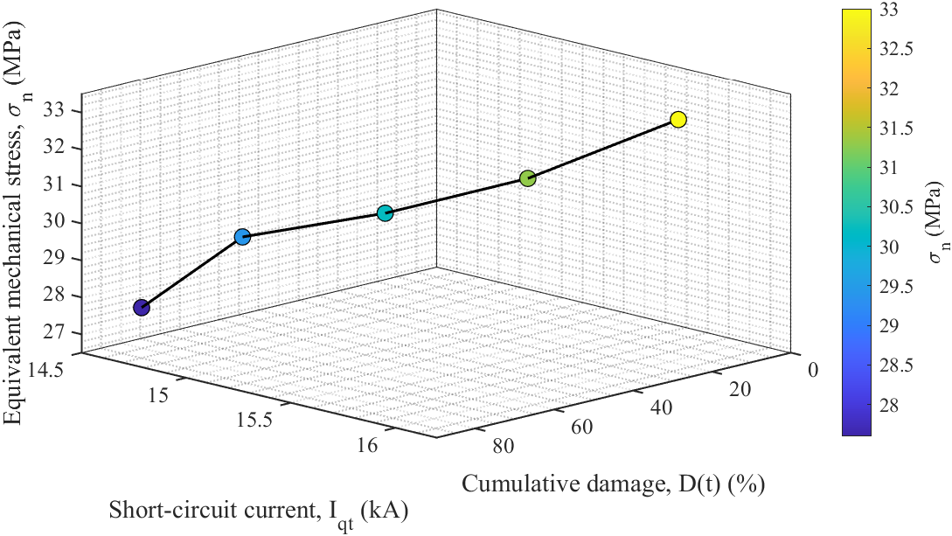
Figure 3. Relationship between cumulative damage and equivalent mechanical stress

To evaluate the residual lifetime of an oil-immersed transformer following the operation of differential protection, the remaining life can be expressed in terms of the cumulative damage fraction, as given by equation (10).
L_{l.l}= L₀ (1-D(t)) (10)
where: L_{l.l} – remaining service life of the transformer after the short-circuit event, years; L₀ – guaranteed (design) service life of the transformer, years; D(t) – cumulative damage fraction.
On the basis of equation (10), the study shows that mechanical stresses, alongside insulation aging, must be taken into account in any realistic assessment of transformer residual life. The decline in service life is treated as an inverse function of accumulated damage and is modeled using Miner’s linear damage accumulation rule coupled with mechanical fatigue theory. This method provides a quantitative measure of the lifetime lost after each operation of the differential protection [17-22].

Table 4. Change in transformer service life following observed short-circuit events
σ_{n} (M N/m²) | D_{d.p}(t) fraction | Cumulative damage(%) | I_{ekv} (kA) | D (year) | L_{l} (year)
32.68 | 0.024963 | 2.50 % | 16.00 | 0.6250 | 24.375
27.96 | 0.038339 | 1.34 % | 14.80 | 0.3266 | 24.048
29.49 | 0.157482 | 1.66 % | 15.20 | 0.399 | 23.648
31.07 | 0.177878 | 2.04 % | 15.60 | 0.472 | 23.165
27.21 | 0.884591 | 1.20 % | 14.60 | 0.277 | 22.887

The results presented in table 4 clearly show that the cumulative mechanical damage caused by short-circuit events is inversely proportional to the remaining service life of oil-immersed transformers. As the equivalent short-circuit current and the resultant mechanical stress increase, the reduction in the transformer’s service life becomes more pronounced.
Figure 3.4 is a change in the remaining service life of a 20 MVA power transformer as a result of short circuit events observed over the past year. Despite the fact that the structural elements of the studied transformer (Scrolls, magnetic core, insulation system) are in an almost new state, the input cable lines connected to it are much more outdated. For this reason, a large number of single-phase ground short-circuit events have occurred within a year in connection with this transformer. According to calculations carried out according to IEC 60076-5 and IEEE heat aging models, the five recorded one-phase short circuit events reduced the remaining service life of the transformer to 2,113 years (771 days).
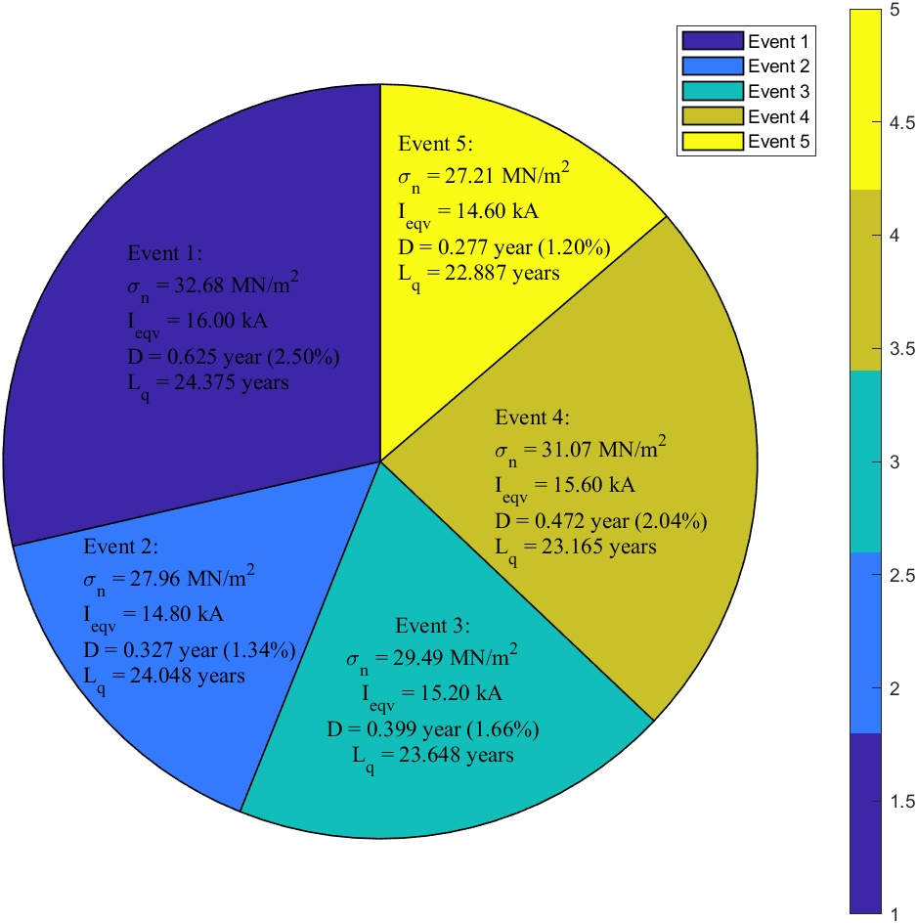
Figure 4. Dependence of the cumulative loss-of-life percentage of a 20 MVA power transformer on its service life

This means that the oil transformer is required to be replaced earlier than originally planned by 2,113 years (771 days). The indicated 2,113-year life loss corresponds only to cumulative insulation aging caused by thermal effects of external short circuit currents when differential protection is activated. The actual reduction in service life can be even greater if additional factors such as mechanical degradation of the scrolls, overloading hot spot temperature, moisture penetration are taken into account [23,24].
CONCLUSIONS
A understandable analysis on a 20 MVA power oil transformer indicated that even though the extremely fast (10-40 ms) start time of differential protection, repetitive short circuit events lead to very harmful and irreplaceable mechanical damage in the winding structure. When the electromagnetic force calculation method was applied in conjunction with Miner's linear damage cumulative rule and material fatigue theory, it was found that five one-phase Earth short-circuit events that occurred over a year reduced the remaining useful life of the transformer to 2,113 years (771 days) due to cumulative mechanical fatigue in wraps alone, then the electromagnetic force calculation method was applied in conjunction with Miner's linear damage cumulative rule and material fatigue theory, it was found that five one-phase Earth short-circuit events that occurred over a year reduced the remaining useful life of the transformer to 2,113 years (771 days) due to cumulative mechanical fatigue in wraps alone. The results clearly show that mechanical damage from external short circuit currents is a very important, but often overlooked, factor in assessing the end of life of Transformers. The insulation system is in an almost new state, and even when no visible thermal degradation is observed, concentrated mechanical stresses significantly accelerate the overall aging process, gradually weakening the winding fastening structures, distancing elements and conductors.
Therefore, when accurately assessing the remaining service life of power transformers in service, it is necessary to forcibly take into account the cumulative mechanical effects of all historical and ongoing short circuit events caused by the start-up of differential or other fast protections, other than traditional hot spot temperature and isolation degradation models (IEEE C57.91, IEC 60076-7). If mechanical damage is ignored, the lifetime of transformer can be predicted optimistically which may increase the unexpected failures in the future The method we developed, based on the analytical determination of Radial and axial forces, equivalent mechanical stress and fatigue-based damage totals, provides a practical and scientifically based tool for energy organizations for quantitative assessment of the mechanical life resource and optimization of transformer replacement or overhaul strategies. Heat-mechanical aging models are introduced to inform the significance of reliability of electrical systems Asset management and expensive unwanted interruptions are prevented.

REFERENCES
- Togaymurodov S, Analysis of existing studies carried out on the early diagnosis of oil-immersed transformers // International Journal of Advanced Research in Science, Engineering and Technology Vol. 12, Issue 10, October 2025. http://www.ijarset.com/upload/2025/october/13-togaymurdovsanat-18.pdf
- Togaymurodov S, Ataullayev A, Calculation of the impact of mechanical stress caused by differential protection operation on the service life of a power transformer, International Journal of Advanced Research in Science, Engineering and Technology Vol. 12, Issue 10, October 2025, http://www.ijarset.com/upload/2025/october/12-togaymurdovsanat-16.pdf
- Bakhodir Ramazonov, Shakhzodbek Sayfiev, Khasan Muradov, Mathematical modeling and research of high capacity lead-acid stabilized accumulator battery, AIP Conf. Proc. 3268, 020043 (2025) https://doi.org/10.1063/5.0257860
- O.O. Zaripov, S.J. Nimatov, Y.M. Yeralieva, S.O. Zaripova, M.A. Zakirov, D.M. Nomozova, J.T. Akhmedov, Akram Tovbaev. Calculation of the nominal power and еlectrical еnergy of the hydro power plant on an еlectronic calculator. E3S Web Conf. Volume 486, 2024. IX International Conference on Advanced Agritechnologies, Environmental Engineering and Sustainable Development (AGRITECH-IX 2023). https://doi.org/10.1051/e3sconf/202448601027
- Mukhtorkhon Ibadullayev; Shavkat Begmatov; Akram Tovbaev. Subharmonic resonance in three-phase ferroresonant circuits with common magnetic cores. AIP Conf. Proc. 3152, 050019 (2024) https://doi.org/10.1063/5.0218907
- Akram Tovbaev, Muxtarxan Ibadullayev and Mohinur Davronova. Study of subharmonic oscillation processes in ferroresonance circuits. E3S Web of Conf. Volume 525, 2024. IV International Conference on Geotechnology, Mining and Rational Use of Natural Resources (GEOTECH-2024). https://doi.org/10.1051/e3sconf/202452503008
- Akram Tovbaev., Islom Togaev., Uktam Usarov.,Gulom Nodirov, Reactive power compensation helps maintain a stable voltage profile across the network, AIP Conf. Proc. 3331, 060014 (2025). https://doi.org/10.1063/5.0307209
- Shukhrat Abdullaev., Ziyodullo Eshmurodov., Islom Togaev, A systematic analysis of the gradual increase in quality indicators of electricity using reactive power sources involves several steps, AIP Conf. Proc. 3331, 040051 (2025). https://doi.org/10.1063/5.0306786
- Sulton Amirov, Aminjon Ataullayev, Sine-cosine rotating transformers in zenith angle converters, E3S Web of Conferences 525, 03010 (2024) GEOTECH-2024, https://doi.org/10.1051/e3sconf/202452503010
- Ataullayev N.O., Muxammadov B.Q., Idieva A.A., Research of dynamic characteristics of magnetic modulation current converter with negative feedback // International Journal of Advanced Research in Science, Engineering and Technology, India, 2020, November, Vol. 7, Issue 11. – P. 15749-15752. http://www.ijarset.com/volume-7-issue-11.html?utm_source=chatgpt.com
- N.Ataullayev, A.Norqulov, B.Muxammadov, A.Majidov, I.Tog’ayev. Principles of protection against single phase earth faults in networks with capacitive current compensation. E3S Web of Conferences, 548, 06008 (2024). https://doi.org/10.1051/e3sconf/202454806008
- Amirov S.F., Ataullayev A.O., Sayidov M.K., Togayev I.B. Methods of reduction of interference signals in electromagnetic conductors that measure fluid flow Journal of Physics: Conference Series, 2094(5), 052053 (2021) 10.1088/1742-6596/2094/5/052053
- Murodov K., Karshibayev A. Development of the management system of technical indications of high-power charger-discharger rectifier device //E3S Web of Conferences. – EDP Sciences, 2023. – Т. 417. – С. 03012. https://doi.org/10.1051/e3sconf/202341703012
- Tatkeyeva G. et al. Experimental research of the developed method to determine the network insulation for ungrounded AC systems in laboratory conditions //2022 International Conference on Electrical, Computer and Energy Technologies (ICECET). – IEEE, 2022. – С. 1-4. 10.1109/ICECET55527.2022.9873012
- Ataullaev N. O., Dziaruhina A. A., Murodov K. S. Static Characteristics of Magnetic Modulation DC Converters with Analog Filter // Science and Technical. – 2023. – Т. 22. – №. 5. – С. 428-432. https://doi.org/10.21122/2227-1031-2023-22-5-428-432
- Ikromjon Rakhmonov; Zamira Shayumova; Kamal Reymov; Laziz Nematov Energy efficiency indicators // AIP Conf. Proc. 3152, 020002 (2024) https://doi.org/10.1063/5.0218763
- Ikromjon Rakhmonov; Dinora Jalilova; Zamira Shayumova; Nargiza Karimova; Gulmira Abidova; Khurshida Khalikova Voltage regulation issues in spinning enterprises // AIP Conf. Proc. 3331, 080009 (2025) https://doi.org/10.1063/5.0306210
- Dinora Jalilova; Gulnora Kasimova; Zamira Shayumova; Gulmira Abidova Current status of ensuring power quality in spinning mills // AIP Conf. Proc. 3331, 070021 (2025) https://doi.org/10.1063/5.0306211
- Eshmurodov, Z., & Holboiv, F. (2018). Modernization of Control Systems of Electric Drives of Mine Lifting Machines. In E3S Web of Conferences (Vol. 41, p. 03006). EDP Sciences. https://doi.org/10.1051/e3sconf/20184103006
- Eshmurodov, Z. O., & Arziyev, E. I. (2023). Choice of energy-saving electric drives in quasi-stationary transport systems. In E3S Web of Conferences (Vol. 417, p. 03010). EDP Sciences. https://doi.org/10.1051/e3sconf/202341703010
- Rakhimov, F. (2024). Study of reliability indicators of cable lines in rural areas. In E3S Web of Conferences (Vol. 525, p. 03014). EDP Sciences. https://doi.org/10.1051/e3sconf/202452503014
- Karshibayev, A. I., & Jumayev, Z. I. (2023). Expanding the level of forecasting and operational planning of electric consumption at mining enterprise. In E3S Web of Conferences (Vol. 417, p. 03015). EDP Sciences. https://doi.org/10.1051/e3sconf/202341703015
- Eshpulatov, N., Khalmuradov, T., Rakhimov, F., Abdurayimov, S., Khurramov, A., Ruziyeva, U., ... & Maftuna, I. (2023, March). Influence of the parameters of the impact of electrical impulses on the yield of juice from the pulp. In IOP Conference Series: Earth and Environmental Science (Vol. 1142, No. 1, p. 012006). IOP Publishing. DOI 10.1088/1755-1315/1142/1/012006
- Eshpulatov, N., Khalmuradov, T., Rakhimov, F., Abdurayimov, S., Khurramov, A., Mullajonov, I., & Vorisova, R. (2023, March). The influence of the impact of electrical impulses on the juice outputting of the pulp. In IOP Conference Series: Earth and Environmental Science (Vol. 1142, No. 1, p. 012017). IOP Publishing. DOI 10.1088/1755-1315/1142/1/012017
- Urishev, B., and Fakhriddin Nosirov. 2025. “Hydraulic Energy Storage of Wind Power Plants.” Proceedings of the International Conference on Applied Innovation in IT.
- Mukhammadiev, M., K. Dzhuraev, and Fakhriddin Nosirov. 2025. “Prospects for the Development of the Use of Pumped Storage Power Plants in the Energy System of the Republic of Uzbekistan.” Proceedings of the International Conference on Applied Innovation in IT.
- Urishev, B., Fakhriddin Nosirov, and N. Ruzikulova. 2023. “Hydraulic Energy Storage of Wind Power Plants.” E3S Web of Conferences, 383. https://doi.org/10.1051/e3sconf/202338304052
- Urishev, B., S. Eshev, Fakhriddin Nosirov, and U. Kuvatov. 2024. “A Device for Reducing the Siltation of the Front Chamber of the Pumping Station in Irrigation Systems.” E3S Web of Conferences, 274. https://doi.org/10.1051/e3sconf/202127403001
- Turabdjanov, S., Sh. Dungboyev, Fakhriddin Nosirov, A. Juraev, and I. Karabaev. 2021. “Application of a Two-Axle Synchronous Generator Excitations in Small Hydropower Engineering and Wind Power Plants.” AIP Conference Proceedings. https://doi.org/10.1063/5.0130649
- Urishev, B., Fakhriddin Nosirov, Obid Nurmatov, S. Amirov, and D. Urishova. 2021. “Local Energy System Based on Thermal, Photovoltaic, Hydroelectric Stations and Energy Storage System.” AIP Conference Proceedings. https://doi.org/10.1063/5.0306446
- Nurmatov, Obid, Fakhriddin Nosirov, Khusniddin Shamsutdinov, and Dildora Obidjonova. 2025. “Research on Control Systems for Automatic Excitation Regulation Utilizing Fuzzy Logic Methodology.” AIP Conference Proceedings. https://doi.org/10.1063/5.0306119
- Nurmatov O. Large pumping stations as regulators of power systems modes. Rudenko International Conference “Methodological problems in reliability study of large energy systems” (RSES 2020), E3S Web of Conferences 216, 01098(2020) https://doi.org/10.1051/e3sconf/202021601098
- Nurmatov O., Makhmudov T.: Pulatov N. Сontrol of the excitation system of synchronous motors pumping stations //AIP Conference Proceedings, 3152, 040008 (2024) https://doi.org/10.1063/5.0218781
- Nurmatov O., Nosirov F., Shamsutdinov K., Obidjonova D.Research on control systems for automatic excitation regulation utilizing fuzzy logic methodology. AIP Conference Proceedings AIP Conf. Proc. 3331, 040081 (2025) https://doi.org/10.1063/5.0306119
- Makhmudov T.: Nurmatov O., Ramatov A.N., Site Selection for Solar Photovoltaic Power Plants Using GIS and Remote Sensing Techniques//AIP Conference Proceedings, 3152, 060002 (2024) https://doi.org/10.1063/5.0218779
- Urishev B., Nosirov F., Nurmatov O., Amirov Sh.,Urishova D. Local energy system based on thermal, photovoltaic, hydroelectric stations and energy storage system AIP Conf. Proc. 3331, 070015 (2025) https://doi.org/10.1063/5.0306446
- Rismukhamedov D., Shamsutdinov K., Magdiev K., Peysenov M., Nurmatov O. Construction of pole-switchable windings for two-speed motors of mechanisms with a stress operating modeAIP Conference Proceedings AIP Conf. Proc. 3331, 040059 (2025) https://doi.org/10.1063/5.0305963
- Rabatuly M., Myrzathan S.A., Toshov J.B., Nasimov J., Khamzaev A. Views on drilling effectiveness and sampling estimation for solid ore minerals. Комплексное Использование Минерального Сырья. №1(336), 2026. https://doi.org/10.31643/2026/6445.01
- Toshov J.B., Rabatuly M., Khaydarov Sh., Kenetayeva A.A., Khamzayev A., Usmonov M., Zheldikbayeva A.T. Methods for Analysis and Improvement of Dynamic Loads on the Steel Wire Rope Holding the Boom of Steel Wire Rope Excavators. Kompleksnoe Ispolzovanie Mineralnogo Syra = Complex Use of Mineral Resources 2026; 339(4):87-96 https://doi.org/10.31643/2026/6445.43
- Zokhidov O.U., Khoshimov O.O., Khalilov Sh.Sh. Experimental analysis of microges installation for existing water flows in industrial plants. III International Conference on Improving Energy Efficiency, Environmental Safety and Sustainable Development in Agriculture (EESTE2023), E3S Web of Conferences. Том 463. Страницы 02023. 2023. https://doi.org/10.1051/e3sconf/202346302023
- Zokhidov O.U., Khoshimov O.O., Sunnatov S.Z. Selection of the type and design of special water turbines based on the nominal parameters of Navoi mine metallurgical combine engineering structures. AIP Conf. Proc. 3331, 050022 (2025). https://doi.org/10.1063/5.0306554
- Khamzaev A.A., Mambetsheripova A., Arislanbek N. Thyristor-based control for high-power and high-voltage synchronous electric drives in ball mill operations/ E3S Web Conf. Volume 498, 2024/ III International Conference on Actual Problems of the Energy Complex: Mining, Production, Transmission, Processing and Environmental Protection (ICAPE2024) DOI: https://doi.org/10.1051/e3sconf/202449801011
- Toshov B.R., Khamzaev A.A. Development of Technical Solutions for the Improvement of the Smooth Starting Method of High Voltage and Powerful Asynchronous Motors/AIP Conference Proceedings 2552, 040018 (2023); https://doi.org/10.1063/5.0116131 Volume 2552, Issue 1; 5 January 2023
- Toshov B.R., Khamzaev A.A., Sadovnikov M.E., Rakhmatov B., Abdurakhmanov U./ Automation measures for mine fan installations/ SPIE 12986, Third International Scientific and Practical Symposium on Materials Science and Technology (MST-III 2023), 129860R (19 January 2024); doi: 10.1117/12.3017728. Third International Scientific and Practical Symposium on Materials Science and Technology (MST-III 2023), 2023, Dushanbe, Tajikistan.
- Toshov B.R., Khamzaev A.A., Namozova Sh.R.Development of a circuit for automatic control of an electric ball mill drive. AIP Conference Proceedings 2552, 040017 (2023) Volume 2552, Issue 1; 5 January 2023.
- Toirov, O., Pirmatov, N., Khalbutaeva, A., Jumaeva, D., Khamzaev, A. Method of calculation of the magnetic induction of the stator winding of a spiritual synchronous motor. E3S Web of ConferencesЭта ссылка отключена., 2023, 401, 04033
- O. Toirov, A. Khalbutaeva, Z. Toirov. Calculation of the magnetic flux with considering nonlinearities of saturation of the magnetic circuit of synchronous motors, // 3rd International Scientific and Technical Conference on Actual Issues of Power Supply Systems, ICAIPSS 040022, (2023). https://doi.org/10.1063/5.0218821
- O. Toirov, S. Khalikov. Research and Evaluation of the Reliability Indicators of Pumping Units for Mechanical Irrigation of the Pumping Station “Kyzyl-Tepa”, // Power Technology and Engineering, 57 (5), (2024). https://doi.org/10.1007/s10749-024-01720-2
- O. Toirov, M. Taniev, B. Safarov, Z. Toirov. Simulation model of an asynchronous generator integrated with a power supply system at different wind speeds, // AIP Conference Proceedings, 3331 (1), 060025, (2025). https://doi.org/10.1063/5.0305672
- O. Toirov, Sh. Azimov, Z. Toirov. Improving the cooling system of reactive power compensation devices used in railway power supply // AIP Conference Proceedings, 3331, 1, 050030, (2025). https://doi.org/10.1063/5.0305670
- O. Toirov, W. Yu. Non-Intrusive Load Monitoring Based on Image Load Signatures and Continual Learning
// Proceedings of 2025 2nd International Conference on Digital Society and Artificial Intelligence, (2025) https://doi.org/10.10.1145/3748825.3748963
- O. Toirov, Sh. Azimov, Z. Najmitdinov, M. Sharipov, Z. Toirov. Improvement of the cooling system of reactive power compensating devices used in railway power supply // E3S Web of Conferences, 497, 01015, (2024). https://doi.org/10.1051/e3sconf/202449701015
- Melikuziev M.V. Determination of the service area and location of transformer substations in the city power supply system. E3S Web of Conferences 384, 01033 (2023) RSES 2022. https://doi.org/10.1051/e3sconf/202338401033
- Melikuziev M.V., Usmonaliev S., Khudoyberdiev N., Sodikov J., Imomaliev Z. Issues of the design procedure for the power supply system. AIP Conference Proceedings 3152, 040031 (2024). https://doi.org/10.1063/5.0218873

